# Ideation Phase

## Empathize & Discover

|  |  |
| --- | --- |
| Date | 30 October 2025 |
| Team ID | NM2025TMID01330 |
| Project Name | Educational Organization Using ServiceNow |
| Maximum Marks | 4 Marks |

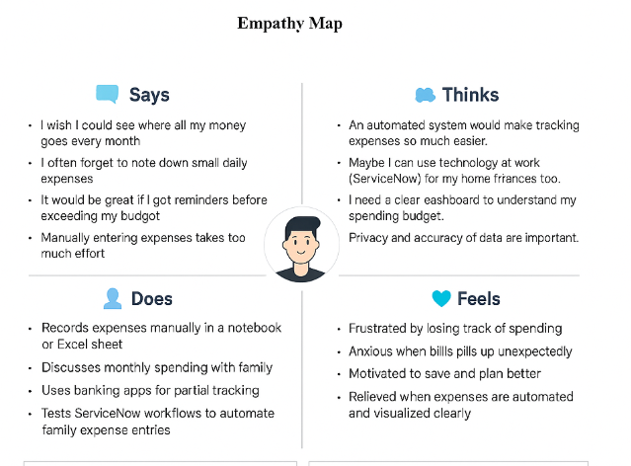

## Pain

• Manual processes cause delays and errors in student data management.

• No central system to manage admissions, progress, and attendance.

• Difficulty generating real-time performance reports.

• Poor data security and inconsistent record-keeping.

• Lack of reminders or notifications for pending approvals.

## Gain

• Centralized automation of educational workflows using ServiceNow.

• Real-time dashboards and reports for teachers and administrators.

• Improved data accuracy and reduced workload.

• Instant notifications and approvals enhance decision-making.

• Enhanced data security and accessibility with controlled permissions.