1. Git bash is installed.
2. Git hub account is created.
3. Data is downloaded from kaddle.
4. Open Git bash and



**pwd**-command check the path.

1. 

**git branch-** to check the branch.

1. 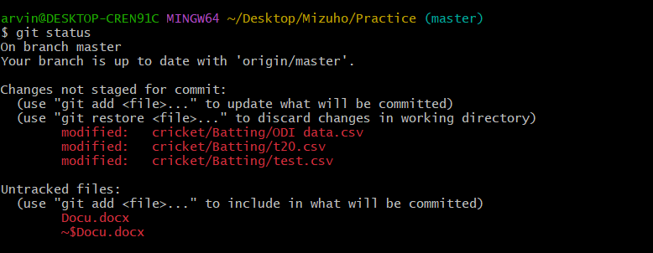

**git status –** check the changes in the folder

1. 

**git add-** add the folder/ data to git .

8.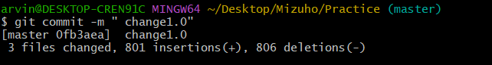

**Git commit -m “NOTE/ COMMENT”** - To save changes / version changes.

9.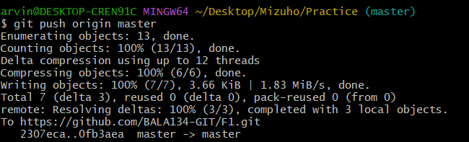

**git push origin [branch name] –** To upload/ Share the changes on Git.

10. Go to Github/git and click on repositary .

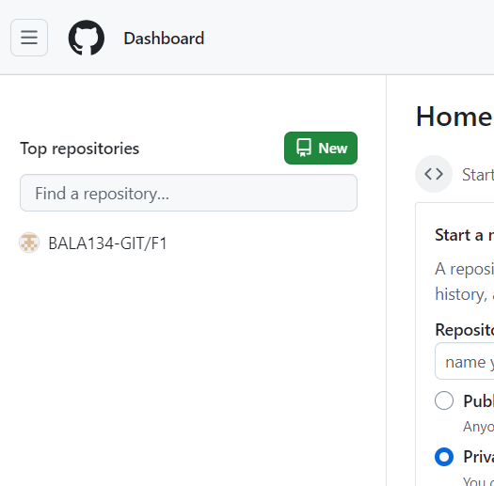

11.Click on the folder

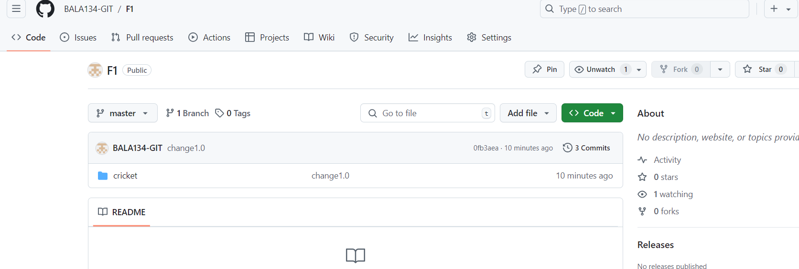

12. Click on History on top right corner.

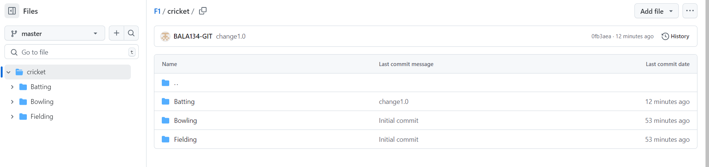

13.We can see the Commits.Click on one commit.

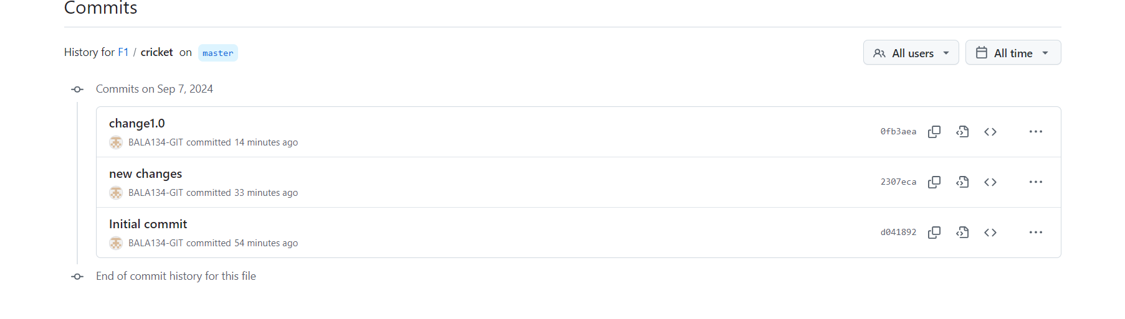

14.Changs – added in green and deleted in red is shown.

