

School of Computing

Department of Artificial Intelligence and Machine Learning

DATA ANALYSIS ESSENTIALS
CERTIFICATE

This is to certify that the Cornerstone project work entitled “File Data Analysis System” is submitted by

K. BALA ADITYA | (25B11AI581)
M. MOHITH NAIK | (25B11AI765)
P. VAISHANTH | (25B11AI893)
G. DILEEP | (25B11AI361)
M. SUJANA | (25B11AI768)

in partial fulfilment of the requirements for the award of the B.Tech. degree in Artificial intelligence and machine learning the academic year 2026-2027.

Project Guide Head of the Department
Dr. Mallireddy Naresh Dr. K. Naga Bhargavi, Ph.D,
Assistant Professor, Associate Professor & HOD
Department of AIML Department of AIML

DECLARATION

We hereby declare that the project entitled “ FILE DATA ANALYSIS SYSTEM” is our original work and is submitted to ADITYA UNIVERSITY, Surampalem, in partial fulfillment of the requirements for the award of the B.Tech. degree in Artificial Intelligence and Machine learning-
We further declare that this project work has not been submitted, either in full or in part, for the award of any degree or diploma in this or any other institution. We also confirm that this work has been carried out with academic honesty and complies with the Institutional Academic Integrity and AI Usage Policy.
Place:
Surampalem
Date: 03-04-2026

By
K. BALA ADITYA | (25B11AI581)
M. MOHITH NAIK | (25B11AI765)
P. VAISHANTH | (25B11AI893)
G. DILEEP | (25B11AI361)
M. SUJANA | (25B11AI768)

ACKNOWLEDGEMENT

It is with immense pleasure that we express our sincere gratitude to our Cornerstone Project Guide, Dr. Mallireddy Naresh, Assistant Professor, who has guided us throughout the project. Her valuable support, encouragement, and guidance have greatly contributed to the successful completion of this work.
We would like to thank our Deputy Heads of the Department, *Dr. Bollu Manikyala Rao*, Associate Professor, *Dr. R Suneetha*, Assistant Professor and *Dr. Dasari Veeraswamy*, Assistant Professor, Department of AIML, for their support and valuable suggestions.
Our deepest thanks to our Head of the Department, Dr. Kovvuri N Bhargavi, Associate Professor & HOD, for her inspiration and for providing all the necessary facilities and resources required for this project.
We also extend our sincere thanks to Dr. M.V. Rajesh, Associate Dean, School of Computing, for his encouragement and support during our project.
We would like to express our sincere gratitude to Dr. G. Suresh, Registrar; Dr. A. Ramesh, Pro Vice-Chancellor (Engineering & Sciences); Dr. S. Rama Sree, Pro Vice-Chancellor (Academics); Dr. M.B. Srinivas, Vice-Chancellor; and Dr. M. Sreenivasa Reddy, Deputy Pro Chancellor and Management, Aditya University, for providing excellent infrastructure and state-of-the-art laboratories.
Finally, we would like to thank the faculty members, lab technicians, non-teaching staff, and our friends who have directly or indirectly supported us in completing this Cornerstone project successfully.

ABSTRACT

The Largest Companies in India Data Analysis System is a data analysis project developed to analyze the financial profile of 270 of the largest companies in India. For every company the dataset records the revenue, profit, assets, company value, industry, and headquarters, together with its rank (the Forbes 2000 rank is available for the top 50 companies). In raw CSV form this information is difficult to read and compare, and calculating totals, averages, and rankings manually is time-consuming and error-prone.
The project uses the “List of largest companies in India.csv” dataset. Python, Google Colab, NumPy, Pandas, and Matplotlib were used to load, inspect, clean, and analyze the data. The raw file has 270 records and 10 columns; missing values and duplicate records were checked (220 missing Forbes 2000 ranks and one missing profit value; no duplicate rows), and the numeric columns and the derived Profit Margin (%) column were verified. The cleaned dataset has 270 records and 10 columns.
Descriptive statistics (mean, median, maximum, and minimum), top-10 rankings by revenue, profit, assets, company value, and profit margin, industry-wise and headquarters-wise analysis using groupby and value_counts, correlation analysis, and conditional filtering were performed. The results are presented using bar charts, scatter plots, and histograms, and the cleaned dataset was exported as a CSV file.
In the analyzed dataset the 270 companies together report revenue of approximately 1,496.22 billion US$ and profit of approximately 142.71 billion US$. Life Insurance Corporation of India has the highest revenue, Reliance Industries has the highest profit and company value, State Bank of India has the highest assets, Financials is the most common industry (36 companies, closely followed by Banking with 33), and Mumbai is the most common headquarters (98 companies). The correlation between revenue and profit is approximately 0.80. The project can be extended with multi-year data, interactive dashboards, additional financial ratios, and predictive models.

Table of contents

S.No. | Contents | Pages
1 | Title Page | 1
2 | Certificate | 1
3 | Declaration | 2
4 | Acknowledgement | 3
5 | Abstract | 4
6 | Table of Contents | 5
7 | List of Figures | 8
8 | List of Tables | 9

Chapter 1 | Introduction
1.1 | Introduction to the Project | 10
1.2 | Problem Statement | 10
1.3 | Objectives of the Project | 11
1.4 | Scope of the Project | 11
Chapter 2 | Dataset Description and Understanding
2.1 | Dataset Source | 12
2.2 | Dataset Description | 12
2.3 | Features / Attributes | 13
2.4 | Target Variable, if Applicable | 13
2.5 | Dataset Statistics / Initial Exploration | 14
Chapter 3 | Data Preprocessing
3.1 | Data Collection / Loading | 15
3.2 | Handling Missing Values | 15
3.3 | Handling Duplicate / Inconsistent Data | 15
3.4 | Feature Scaling | 16
3.5 | Standardization | 16
3.6 | Label Encoding | 16
3.7 | One-Hot Encoding | 16
3.8 | Other Project-Specific Preprocessing | 16
Chapter 4 | System Design and Methodology
4.1 | Proposed Methodology | 18
4.2 | System Workflow / Architecture | 18
4.3 | Flowchart | 20
4.4 | Tools and Technologies Used | 21
4.5 | Algorithm / Model Used | 21
Chapter 5 | Implementation
5.1 | Development Environment | 22
5.2 | Dataset Loading and Exploration | 22
5.3 | Preprocessing Implementation | 22
5.4 | Exploratory Data Analysis | 23
5.5 | Analysis Implementation | 24
5.6 | Important Code Explanation | 24
Chapter 6 | Data Visualization and Results
6.1 | Bar Graph | 26
6.2 | Industry Visualization | 26
6.3 | Histogram | 26
6.4 | Profit Margin Visualization | 26
6.5 | Revenue vs Profit Scatter Plot | 27
6.6 | Assets vs Value Scatter Plot | 27
6.7 | Project-Specific Visualizations | 27
6.8 | Interpretation of Visualizations | 28
Chapter 7 | Model Evaluation / Analysis of Results
7.1 | Evaluation Metrics | 29
7.2 | Experimental Results | 29
7.3 | Result Interpretation | 31
7.4 | Discussion | 32
Chapter 8 | Output Screenshots
8.1 | Input / Dataset Screenshots | 33
8.2 | Preprocessing Outputs | 35
8.3 | Visualization Outputs | 36
8.4 | Analysis Outputs | 42
Chapter 9 | Conclusion and Future Enhancements
9.1 | Conclusion | 45
9.2 | Limitations | 45
9.3 | Future Enhancements | 45
10 | References | 47
11 | Appendix – Source Code | 48
List of Figures
Figure No. | Title | Page
8.1 | First 5 records of the dataset | 33
8.2 | Last 5 records of the dataset | 33
8.3 | Dataset information, shape and column names | 34
8.4 | Missing-value and duplicate-record analysis | 35
8.5 | Data types before and after cleaning | 35
8.6 | Cleaned dataset with the derived Profit Margin (%) column | 36
8.7 | Top 10 Companies by Revenue – Bar Chart | 36
8.8 | Top 10 Companies by Profit – Bar Chart | 37
8.9 | Number of Companies by Industry – Bar Chart | 37
8.10 | Average Revenue by Industry – Bar Chart | 38
8.11 | Revenue vs Profit – Scatter Plot | 38
8.12 | Assets vs Company Value – Scatter Plot | 39
8.13 | Distribution of Company Revenue – Histogram | 40
8.14 | Distribution of Company Profit – Histogram | 41
8.15 | Top 10 Companies by Profit Margin – Bar Chart | 41
8.16 | Statistical summary of the numerical columns | 42
8.17 | Top 10 Companies by Revenue and by Profit | 42
8.18 | Industry-wise and headquarters-wise company counts | 43
8.19 | Correlation matrix and revenue–profit correlation | 44
8.20 | Filtering – high-revenue and high-profit companies | 44
8.21 | Final summary of important results | 44

List of Tables
Table No. | Title | Page
2.1 | Original attributes of the dataset | 13
2.2 | Changes made to the attributes during preprocessing | 13
4.1 | Tools and technologies used | 21
5.1 | Hardware and software requirements | 22
7.1 | Key performance indicators of the dataset | 29
7.2 | Descriptive observations from the analyzed dataset | 30
7.3 | Top 5 companies by revenue, profit, assets, and company value | 30
7.4 | Industry-wise summary (industries with ten or more companies) | 30

CHAPTER 1
INTRODUCTION

1.1 Introduction to the Project
Large companies publish financial information such as revenue, profit, assets, and company value. When this information is stored in a raw CSV file, it is difficult to read, compare, and summarize, especially when companies belong to different industries and cities.
Traditional methods of studying such data depend on spreadsheets and manual formulas. Totals, averages, and rankings have to be calculated again for every new question, charts are drawn separately, and data-quality problems such as missing values or duplicate rows can go unnoticed.
The Largest Companies in India Data Analysis System uses data analysis techniques to convert the raw company data into useful information. Python with the NumPy, Pandas, and Matplotlib libraries was used in Google Colab for data loading, inspection, cleaning, statistical analysis, grouping, filtering, correlation analysis, and visualization.
The project analyzes the “List of largest companies in India.csv” dataset, which contains 270 of India’s largest companies. The results are presented using statistical measures, ranking tables, and charts, which make it easier to understand the differences between companies, industries, and headquarters cities in the analyzed dataset.
1.2 Problem Statement
Company data is usually viewed in spreadsheets or on websites. Calculating totals, averages, and rankings by hand, repeating sorting and filtering for every new question, and drawing charts separately in spreadsheet tools takes considerable time and may result in formula and copy-paste errors. Raw data can also contain problems such as missing values, duplicate rows, and incorrect data types, which give wrong results if they are not detected.
It can also be difficult to identify:
- Companies with the highest revenue, profit, assets, and company value.
- The profit margin (Profit / Revenue × 100) of each company.
- The number of companies in each industry and in each headquarters city.
- Industry-wise average revenue and average profit.
- The relationship between revenue and profit, and between assets and company value.
- How revenue and profit are distributed across the companies.
- Companies with very high revenue or very high profit.

Therefore, there is a need for a system that can load the company data, clean it, calculate the required statistics, and present the results through rankings and visualizations in a repeatable way.
1.3 Objectives of the Project
The main objectives of the project are:
- To understand the structure of the List of largest companies in India dataset.
- To load the CSV file into a Pandas DataFrame and inspect it using head(), tail(), info(), and shape.
- To clean the data by checking for an unnecessary index column, missing values, and duplicates, and confirming that the numeric columns have the correct data types.
- To calculate the mean, median, maximum, and minimum of revenue, profit, assets, and company value using NumPy and Pandas.
- To identify the top 10 companies by revenue, profit, assets, company value, and profit margin.
- To analyze the companies by industry and by headquarters using groupby() and value_counts().
- To calculate the Profit Margin (%) of each company.
- To study the correlation between the numerical variables.
- To filter companies with revenue above 50 billion US$ and profit above 5 billion US$, and to create bar charts, scatter plots, and histograms using Matplotlib.
- To save the cleaned dataset as a new CSV file for reuse.

1.4 Scope of the Project
The scope of the project includes the analysis of financial and descriptive data of the 270 companies in the dataset. The project covers:
- Data loading, inspection, and cleaning.
- Statistical analysis and top-10 ranking analysis.
- Industry analysis and headquarters analysis.
- Profit margin analysis and correlation analysis.
- Data filtering and data visualization.
- Cleaned dataset export.

The scope is limited to descriptive and exploratory analysis of the single dataset provided. The system can be extended in the future to include data from multiple years, interactive dashboards, more financial ratios, and predictive models.
CHAPTER 2
DATASET DESCRIPTION AND UNDERSTANDING

2.1 Dataset Source
The dataset used for the project is the CSV file “List of largest companies in India.csv”. It contains a list of 270 of the largest companies in India together with their rank, Forbes 2000 rank (available for the top 50 companies), headquarters, industry, and financial measures expressed in billions of US dollars.
The file was uploaded to Google Colab using files.upload() and read into a Pandas DataFrame using pd.read_csv(). The raw file contains 270 rows and 10 columns, including a Profit Margin (%) column. No extra index column is present. After cleaning and recalculating the Profit Margin (%) column, the final dataset contains 270 rows and 10 columns and was saved as cleaned_largest_companies_india.csv.
2.2 Dataset Description
The dataset represents large Indian companies. Each record describes one company. The major data categories are:
Ranking Information
- Rank
- Forbes 2000 rank

Company Information
- Name
- Headquarters
- Industry

Financial Information (in billions US$)
- Revenue
- Profit
- Assets
- Value (company value)

Derived Information
- Profit Margin (%), calculated during analysis

The raw CSV file does not contain an extra index column (such as Unnamed: 0); the code checks for one and removes it only if it is present. The Profit Margin (%) column is already included in the file and is recalculated during analysis as (Profit / Revenue) × 100 to confirm its values.
2.3 Features / Attributes
The important attributes used in the project are:
Table 2.1: Original attributes of the dataset.
Attribute | Data Type | Description
Rank | int64 | Position of the company in the list (1 to 270)
Forbes 2000 rank | float64 | Position of the company in the Forbes 2000 ranking (available for the top 50 companies only; 220 values are blank)
Name | Text | Name of the company
Headquarters | Text | City where the company is headquartered
Revenue(billions US$) | float64 | Annual revenue in billion US$
Profit(billions US$) | float64 | Profit in billion US$ (1 missing value, for Tata Motors)
Assets(billions US$) | float64 | Total assets in billion US$
Value(billions US$) | float64 | Company value in billion US$
Industry | Text | Business sector of the company

The following changes were made to the attributes during preprocessing:
Table 2.2: Changes made to the attributes during preprocessing.
Attribute | Change | Description
Unnamed: 0 | Not present | The raw CSV file has no extra index column; the code removes one only if it exists
Profit(billions US$) | Checked | Already numeric (float64); converted with pd.to_numeric() as a safeguard; one value (Tata Motors) is missing
Profit Margin (%) | Recalculated | Already present in the file; recalculated as (Profit / Revenue) × 100 and found to match

Together, the nine original attributes and the Profit Margin (%) column form the 10 columns of the dataset.
2.4 Target Variable, if Applicable
This project is an exploratory and descriptive data analysis project. Therefore, there is no target variable in the implementation. The project focuses on understanding the revenue, profit, assets, company value, industry, and headquarters of the companies. No machine-learning model is trained, and no prediction target is defined.
2.5 Dataset Statistics / Initial Exploration
Initial exploration was performed before the detailed analysis. The following operations were used:
- Displaying the first 5 and last 5 records.
- Checking the number of rows and columns.
- Checking the column names.
- Checking the data types and non-null counts.
- Checking missing values.
- Checking duplicate records.
- Generating descriptive statistics.

Pandas commands used for the initial exploration include:
df.head()
df.tail()
df.info()
df.shape
df.columns
df.isnull().sum()
df.duplicated().sum()
df.describe()
The initial exploration showed that the raw file has 270 rows and 10 columns and contains no duplicate rows. Missing values were found in the Forbes 2000 rank column (220 missing, because only the top 50 companies have a Forbes 2000 rank) and in the Profit column (1 missing value, for Tata Motors), which also leaves its Profit Margin (%) blank. The descriptive statistics of the cleaned dataset are presented in Chapter 7.
CHAPTER 3
DATA PREPROCESSING

3.1 Data Collection / Loading
The dataset is uploaded to Google Colab and loaded into the Python environment using the Pandas library.
Example:
from google.colab import files
uploaded = files.upload()

import pandas as pd
df = pd.read_csv("List of largest companies in India.csv")
print(df.head())
print(df.shape)
After loading the dataset, its structure and data types are checked to understand the data before performing analysis.
3.2 Handling Missing Values
Missing values can affect statistical calculations and visualizations. Therefore, missing values were identified using:
df.isnull().sum()
The check showed that the Forbes 2000 rank column has 220 missing values, because only the top 50 companies of the list appear in the Forbes 2000 ranking, and that the Profit column has 1 missing value (Tata Motors), which also makes its Profit Margin (%) missing. All other columns are complete. The Forbes 2000 rank column is not used in the calculations, and the missing profit was not imputed with the mean, median, or mode because an invented profit would distort the results. Pandas and NumPy’s nan-functions skip the missing value, so Tata Motors is simply excluded from profit-based calculations.
The Profit column was loaded as numeric (float64), so no text-to-number conversion problem was found. pd.to_numeric() with errors="coerce" is still applied as a safeguard, so that any non-numeric entry would become a missing value rather than stop the analysis (see Section 3.8). As a result, the profit statistics are based on 269 values and the profit-based rankings and correlations exclude Tata Motors.
3.3 Handling Duplicate / Inconsistent Data
Duplicate records were identified using:
df.duplicated().sum()
The result was 0, so no duplicate rows were present and no rows had to be removed. No inconsistent data types were found; the only incomplete data are the missing values described in Section 3.2.
3.4 Feature Scaling
Feature scaling is used when numerical variables have significantly different ranges and when algorithms require comparable scales. In this dataset, for example, assets range from 0.35 to 696.51 billion US$ while profit ranges from −3.80 to 7.81 billion US$.
Because this is a descriptive data analysis project that works directly with the original values in billions of US dollars, feature scaling was not required and was not used. It becomes more important when machine-learning algorithms are introduced.
3.5 Standardization
Standardization transforms numerical variables so that they have a common scale. The standardization formula is:
Z = (X − μ) / σ
where:
- X = Original value
- μ = Mean
- σ = Standard deviation

Standardization was not required and was not used in this project, because the analysis works directly with the original revenue, profit, assets, and company value.
3.6 Label Encoding
Label encoding converts categorical values into numerical labels. It is mainly useful when categorical information needs to be supplied to a machine-learning algorithm. Label encoding was not required and was not used in this project. The Industry and Headquarters columns are used directly as text categories in groupby() and value_counts(), and no machine-learning model is part of the implementation.
3.7 One-Hot Encoding
One-hot encoding converts categorical variables into separate binary columns and is mainly useful when categorical variables are supplied to machine-learning algorithms. One-hot encoding was not required and was not used in this project.
3.8 Other Project-Specific Preprocessing
Project-specific preprocessing includes:
- Checking for an unnecessary index column (Unnamed: 0); none is present in this file.
- Checking missing values and duplicate records.
- Confirming that the Profit column is numeric using pd.to_numeric(); the one missing profit value (Tata Motors) is kept as missing.
- Checking the data types of all columns after conversion.
- Recalculating the derived column Profit Margin (%) = (Profit / Revenue) × 100.
- Exporting the cleaned dataset as cleaned_largest_companies_india.csv.

# Check for an extra index column (not present in this file)
if "Unnamed: 0" in df.columns:
df = df.drop("Unnamed: 0", axis=1)

# Make sure Profit is numeric (the one missing value stays NaN)
profit_column = "Profit(billions US$)"
df[profit_column] = pd.to_numeric(df[profit_column], errors="coerce")
print(df[profit_column].isnull().sum())
After preprocessing, the final dataset contains 270 rows and 10 columns. The only missing values are the Forbes 2000 rank of the 220 companies outside the top 50 and the profit (and profit margin) of Tata Motors.
CHAPTER 4
SYSTEM DESIGN AND METHODOLOGY

4.1 Proposed Methodology
The project follows a systematic data analysis methodology. The major stages are:
CSV Dataset → Data Loading → Data Inspection → Data Cleaning → Statistical Analysis → Ranking and Grouping → Visualization → Profit Margin and Correlation → Filtering → Cleaned CSV Export → Insights
The methodology consists of eight modules:
- Data Loading – upload the CSV file in Google Colab and read it into a Pandas DataFrame using read_csv().
- Data Inspection – view the data with head(), tail(), info(), and shape; check column names and data types.
- Data Cleaning – check for an index column, nulls and duplicates; confirm that Profit is numeric and recalculate Profit Margin (%).
- Statistical Analysis – use describe(), np.mean(), and np.median(); find the maximum and minimum of each measure.
- Ranking and Grouping – top 10 companies by revenue, profit, assets, and value; use groupby() and value_counts() for industry and headquarters.
- Visualization – draw bar charts, scatter plots, and histograms using Matplotlib (pyplot).
- Profit Margin and Correlation – calculate Profit Margin (%) and use corr() and np.corrcoef() for relationships.
- Filtering and Export – filter companies with revenue > 50 and profit > 5 billion US$; save the cleaned data using to_csv() and download it.

4.2 System Workflow / Architecture
The system architecture can be represented as:
List of largest companies in India.csv
↓
Python / Google Colab
↓
Pandas Data Loading (read_csv)
↓
Data Inspection and Cleaning
↓
Statistical Analysis (NumPy and Pandas)
↓
Group, Sort and Filter
↓
Visualization (Matplotlib)
↓
cleaned_largest_companies_india.csv
↓
Insights

4.3 Flowchart
START
↓
Upload and load the CSV file
↓
Inspect the dataset
(head, tail, info, shape)
↓
Check missing values and duplicates
↓
Clean the data
(check index column, nulls, duplicates; confirm Profit is numeric)
↓
Statistical analysis
(describe, mean, median, max, min)
↓
Ranking, industry and headquarters analysis
↓
Profit margin and correlation analysis
↓
Filter the companies
↓
Visualization
(bar charts, scatter plots, histograms)
↓
Save the cleaned dataset (to_csv)
↓
Generate insights
↓
END

The complete project workflow includes data loading, inspection, cleaning, statistical analysis, ranking and grouping, profit margin and correlation analysis, filtering, visualization, cleaned CSV export, and insight generation.
4.4 Tools and Technologies Used
Table 4.1: Tools and technologies used.
Tool / Technology | Purpose
Python 3 | Programming language for data processing and analysis
Google Colab | Cloud notebook environment used for the analysis
NumPy | Numerical calculations – mean, median, and correlation coefficient (corrcoef)
Pandas | Loading, cleaning, grouping, sorting, and filtering the data
Matplotlib | Data visualization – bar charts, scatter plots, and histograms
CSV | Dataset storage (input file and cleaned output file)

These are the tools and technologies used in the project.
4.5 Algorithm / Model Used
The primary approach used in this project is Exploratory Data Analysis (EDA) and descriptive statistical analysis rather than a machine-learning prediction algorithm. The analysis uses:
- Exploratory Data Analysis
- Descriptive statistics (mean, median, maximum, minimum)
- Sorting and ranking
- Group-by analysis and counting
- Conditional filtering
- Ratio calculation (Profit Margin)
- Correlation analysis (Pearson correlation coefficient)
- Histogram-based distribution analysis

No machine-learning model is part of the implementation. Machine-learning-based prediction is considered a future enhancement of the project.
CHAPTER 5
IMPLEMENTATION

5.1 Development Environment
The data analysis was implemented using Google Colab. The main programming language used is Python 3. The important Python libraries are:
import numpy as np
import pandas as pd
import matplotlib.pyplot as plt
The hardware and software requirements of the project are given in Table 5.1.
Table 5.1: Hardware and software requirements.
Requirement | Specification
Processor | Intel i3 or above
RAM | Minimum 4 GB
Storage | 20 GB
Operating system | Windows with a web browser
Platform | Google Colab / Jupyter Notebook
Language | Python 3
Libraries | NumPy, Pandas, and Matplotlib

5.2 Dataset Loading and Exploration
The dataset is uploaded and loaded using Pandas.
from google.colab import files
uploaded = files.upload()

file_name = "List of largest companies in India.csv"
df = pd.read_csv(file_name)

print(df.head())
print(df.tail())
df.info()
rows, columns = df.shape
print("Number of rows:", rows)
print("Number of columns:", columns)
print(df.columns)
The initial exploration shows 270 rows and 10 columns in the raw file. The outputs are shown in Figures 8.1 to 8.3.
5.3 Preprocessing Implementation
The preprocessing stage includes:
# Check for an extra index column (not present in this file)
if "Unnamed: 0" in df.columns:
df = df.drop("Unnamed: 0", axis=1)

# Check missing values and duplicate rows
print(df.isnull().sum())
print("Duplicate rows:", df.duplicated().sum())

# Make sure Profit is numeric (the one missing value stays NaN)
profit_column = "Profit(billions US$)"
df[profit_column] = pd.to_numeric(df[profit_column], errors="coerce")
print(df[profit_column].isnull().sum())
print(df.dtypes)
After these steps the dataset contains 10 columns with the correct data types (the Forbes 2000 rank is float64 because 220 of its values are blank). The derived column is recalculated as follows:
df["Profit Margin (%)"] = (df["Profit(billions US$)"] / df["Revenue(billions US$)"]) * 100
5.4 Exploratory Data Analysis
Exploratory Data Analysis is performed to understand the major patterns in the company data. The analysis includes:
Statistical Analysis
- Descriptive statistics using describe().
- Mean and median using NumPy.
- Maximum and minimum of each measure.

Company Ranking
- Top 10 companies by revenue.
- Top 10 companies by profit.
- Top 10 companies by assets.
- Top 10 companies by company value.
- Top 10 companies by profit margin.

Industry and Headquarters Analysis
- Number of companies in each industry.
- Industry-wise average revenue.
- Industry-wise average profit.
- Number of companies in each headquarters city.

Relationship Analysis
- Correlation matrix of the numerical columns.
- Correlation between revenue and profit.
- Filtering of high-revenue and high-profit companies.

5.5 Analysis Implementation
Since the main project is a data analysis project, the implementation focuses on statistical and exploratory analysis using NumPy functions, groupby, sorting, filtering, and calculated columns. For example:
# Mean and median
print(np.nanmean(df["Revenue(billions US$)"]))
print(np.nanmedian(df["Revenue(billions US$)"]))

# Top 10 companies by revenue
top_revenue = df.sort_values(by="Revenue(billions US$)", ascending=False).head(10)

# Industry analysis
industry_count = df["Industry"].value_counts()
industry_revenue = df.groupby("Industry")["Revenue(billions US$)"].mean().sort_values(ascending=False)

# Correlation
rp = df[["Revenue(billions US$)", "Profit(billions US$)"]].dropna()
print(np.corrcoef(rp["Revenue(billions US$)"], rp["Profit(billions US$)"])[0, 1])

# Filtering
high_revenue = df[df["Revenue(billions US$)"] > 50]
high_profit = df[df["Profit(billions US$)"] > 5]
The complete source code is given in the Appendix.
5.6 Important Code Explanation
Reading Dataset
df = pd.read_csv("List of largest companies in India.csv")
This statement loads the CSV dataset into a Pandas DataFrame.
Checking Dataset Size
df.shape
It returns the number of rows and columns.
Checking Missing Values
df.isnull().sum()
It displays the number of missing values in each column.
Checking Duplicates
df.duplicated().sum()
It returns the number of duplicate rows in the dataset.
Checking for the Index Column
df.drop("Unnamed: 0", axis=1)
It removes the unnecessary index column if one is present; axis=1 means that a column is dropped.
Converting Profit
pd.to_numeric(df[profit_column], errors="coerce")
It converts the values of the Profit column into numbers; values that cannot be converted become NaN.
Sorting and Ranking
df.sort_values(by="Revenue(billions US$)", ascending=False).head(10)
It sorts the companies from the highest to the lowest revenue and selects the first ten.
Grouping Data
df.groupby("Industry")["Revenue(billions US$)"].mean()
It calculates the average revenue of each industry.
Counting
df["Industry"].value_counts()
It counts the number of companies in each industry.
Profit Margin
Profit Margin (%) = (Profit / Revenue) × 100
It expresses the profit of a company as a percentage of its revenue.
Correlation
rp = df[["Revenue(billions US$)", "Profit(billions US$)"]].dropna()
np.corrcoef(rp["Revenue(billions US$)"], rp["Profit(billions US$)"])[0, 1]
It returns the correlation coefficient between revenue and profit (companies with a missing profit are dropped first); values near +1 indicate a strong positive relationship.
CHAPTER 6
DATA VISUALIZATION AND RESULTS

6.1 Bar Graph
A bar graph is used to compare categorical data. For example, the top 10 companies by revenue and by profit are visualized using:
plt.figure(figsize=(12, 6))
plt.bar(top_revenue["Name"], top_revenue["Revenue(billions US$)"])
plt.xlabel("Company")
plt.ylabel("Revenue (Billion US$)")
plt.title("Top 10 Indian Companies by Revenue")
plt.xticks(rotation=45, ha="right")
plt.tight_layout()
plt.show()
The bar graphs help compare the companies with the highest revenue (Figure 8.7) and the highest profit (Figure 8.8) in the dataset.
6.2 Industry Visualization
The number of companies in each industry and the average revenue of each industry are visualized using bar charts.
plt.bar(industry_count.index, industry_count.values)
plt.title("Number of Companies by Industry")

plt.bar(industry_revenue.index, industry_revenue.values)
plt.title("Average Revenue by Industry")
These charts show how the companies are distributed across industries (Figure 8.9) and which industries have the highest average revenue (Figure 8.10).
6.3 Histogram
A histogram shows how the values of a numerical variable are spread. The distributions of revenue and profit are visualized using 10 bins:
plt.hist(df["Revenue(billions US$)"], bins=10)
plt.xlabel("Revenue (Billion US$)")
plt.ylabel("Number of Companies")
plt.title("Distribution of Company Revenue")
plt.show()
The histograms (Figures 8.13 and 8.14) help identify how many companies fall into each revenue and profit range.
6.4 Profit Margin Visualization
The profit margin of each company is calculated as Profit / Revenue × 100, and the ten companies with the highest margin are visualized using a bar chart.
top_margin = df.sort_values(by="Profit Margin (%)", ascending=False).head(10)
plt.bar(top_margin["Name"], top_margin["Profit Margin (%)"])
plt.title("Top 10 Companies by Profit Margin")
The chart (Figure 8.15) helps compare how efficiently the companies convert revenue into profit.
6.5 Revenue vs Profit Scatter Plot
A scatter plot is used to analyze the relationship between two numerical variables. The relationship between revenue and profit is visualized using:
plt.scatter(df["Revenue(billions US$)"], df["Profit(billions US$)"])
plt.xlabel("Revenue (Billion US$)")
plt.ylabel("Profit (Billion US$)")
plt.title("Revenue vs Profit")
plt.grid(True)
plt.show()
This visualization (Figure 8.11) helps examine how the profit of the companies relates to their revenue.
6.6 Assets vs Value Scatter Plot
In the same way, the relationship between the assets of a company and its company value is visualized using a scatter plot:
plt.scatter(df["Assets(billions US$)"], df["Value(billions US$)"])
plt.title("Assets vs Company Value")
This visualization (Figure 8.12) helps examine whether companies with larger assets also have a larger company value.
6.7 Project-Specific Visualizations
The project-specific visualizations include:
- Top 10 companies by revenue.
- Top 10 companies by profit.
- Number of companies by industry.
- Average revenue by industry.
- Revenue vs Profit.
- Assets vs Company Value.
- Distribution of revenue.
- Distribution of profit.
- Top 10 companies by profit margin.

All nine visualizations are shown in Chapter 8 (Figures 8.7 to 8.15).
6.8 Interpretation of Visualizations
The visualizations make the analysis easier to understand. Bar charts help compare companies and industries, scatter plots help examine relationships between two measures, and histograms show how revenue and profit are spread across the companies.
The observations in this report apply to the analyzed dataset only. In this dataset, Life Insurance Corporation of India has the highest revenue (90.00 billion US$) and Reliance Industries has the highest profit (7.81 billion US$). Financials has the largest number of companies (36 of 270), followed by Banking (33). The revenue–profit scatter plot shows a generally positive relationship, with a correlation of about 0.80, while the assets–value relationship is moderate (about 0.40). The histograms show that 255 of the 270 companies have a revenue below 20 billion US$ and 260 have a profit below 3 billion US$, with a few very large companies on the right side. These are descriptive observations and do not predict the future performance of any company.
CHAPTER 7
MODEL EVALUATION / ANALYSIS OF RESULTS

7.1 Evaluation Metrics
Since the project is a descriptive and exploratory data analysis project, machine-learning evaluation metrics are not applicable and are not used. The results are instead evaluated using descriptive measures of the data. The analysis is evaluated using:
- Dataset size
- Descriptive statistics (mean, median, total, minimum, maximum)
- Top-10 rankings
- Industry-wise and headquarters-wise comparisons
- Profit margin
- Correlation coefficients
- Filtered company lists

These measures help understand the characteristics of the dataset.
7.2 Experimental Results
The key results obtained from the cleaned dataset are shown below.
Table 7.1: Key performance indicators of the dataset.
Measure | Value
Total companies (records) | 270
Columns in the final dataset | 10
Total revenue | 1,496.22 billion US$ (approx.)
Total profit | 142.71 billion US$ (approx., 269 companies)
Total assets | 5,402.69 billion US$ (approx.)
Total company value | 3,583.19 billion US$ (approx.)
Mean revenue / median revenue | 5.54 / 1.90 billion US$
Mean profit / median profit | 0.53 / 0.20 billion US$
Mean assets / median assets | 20.01 / 3.50 billion US$
Mean value / median value | 13.27 / 7.00 billion US$
Average profit margin / median profit margin | 14.75% / 12.76%
Correlation between revenue and profit | 0.804

The analysis also identified the following descriptive patterns in the dataset:
Table 7.2: Descriptive observations from the analyzed dataset.
Observation | Result in this dataset
Highest revenue | Life Insurance Corporation of India (90.00 billion US$)
Highest profit | Reliance Industries (7.81 billion US$)
Highest assets | State Bank of India (696.51 billion US$)
Highest company value | Reliance Industries (228.63 billion US$)
Highest profit margin | HDFC Asset Management Company (66.67%)
Loss-making companies | 2 (Vodafone Idea, −3.80; UPL Limited, −0.20 billion US$)
Most common industry | Financials (36 companies); Banking has 33
Most common headquarters | Mumbai (98 companies)
Companies with revenue > 50 billion US$ | 6 (Life Insurance Corporation of India, Reliance Industries, Indian Oil Corporation, Oil and Natural Gas Corporation, State Bank of India, Hindustan Petroleum Corporation)
Companies with profit > 5 billion US$ | 5 (Reliance Industries, Oil and Natural Gas Corporation, Tata Consultancy Services, HDFC Bank, Tata Steel)

Table 7.3: Top 5 companies by revenue, profit, assets, and company value (billion US$).
Rank | Revenue | Profit | Assets | Company Value
1 | Life Insurance Corporation of India  (90.00) | Reliance Industries  (7.81) | State Bank of India  (696.51) | Reliance Industries  (228.63)
2 | Reliance Industries  (86.85) | Oil and Natural Gas Corporation  (6.00) | Life Insurance Corporation of India  (500.00) | Tata Consultancy Services  (172.79)
3 | Indian Oil Corporation  (72.20) | Tata Consultancy Services  (5.14) | HDFC Bank  (280.16) | HDFC Bank  (98.28)
4 | Oil and Natural Gas Corporation  (66.28) | HDFC Bank  (5.11) | ICICI Bank  (226.39) | Infosys  (87.21)
5 | State Bank of India  (54.52) | Tata Steel  (5.01) | Reliance Industries  (192.59) | Life Insurance Corporation of India  (70.00)

Table 7.4: Industry-wise summary (industries with ten or more companies).
Industry | Companies | Average Revenue | Average Profit
Financials | 36 | 2.36 | 0.46
Banking | 33 | 6.83 | 0.74
Infotech | 27 | 3.34 | 0.55
Capital goods | 21 | 2.55 | 0.22
Automotive | 21 | 5.91 | 0.37
Consumer Goods | 18 | 2.88 | 0.33
Oil and gas | 15 | 18.73 | 1.15
Pharmaceuticals | 12 | 2.28 | 0.34
Utilities | 11 | 4.35 | 0.75
Metals and mining | 11 | 7.05 | 0.91
Chemicals | 10 | 2.19 | 0.15

These results are observations from this dataset only. Values of Average Revenue and Average Profit are in billion US$.
7.3 Result Interpretation
The analysis results can be interpreted using the generated tables and graphs. For example:
- The dataset size shows that 270 company records with 10 columns were available for analysis, with no duplicate rows. The only missing values are the Forbes 2000 rank (220 companies) and the profit of Tata Motors (1 company).
- The 270 companies together report about 1,496.22 billion US$ of revenue and 142.71 billion US$ of profit.
- The mean revenue (5.54) is almost three times the median revenue (1.90), and the mean assets (20.01) are almost six times the median assets (3.50), which shows that a few very large companies pull the averages upward.
- Life Insurance Corporation of India has the highest revenue, Reliance Industries has the highest profit and company value, and State Bank of India has the highest assets.
- Financials is the most common industry with 36 companies, followed by Banking with 33; the 33 banks hold about 50% of the total assets of the 270 companies.
- Mumbai is the headquarters of 98 companies (36%), followed by New Delhi with 35.
- The correlation between revenue and profit is about 0.80, a strong positive relationship, while the correlation between assets and company value is only about 0.40.
- Profit margins vary widely: HDFC Asset Management Company has the highest margin (66.67%), while Rajesh Exports has a high revenue (30 billion US$) but a margin of only 0.5%.
- Vodafone Idea (−3.80 billion US$) and UPL Limited (−0.20 billion US$) are the only companies with a negative profit, and Telecommunication is the only industry with a negative average profit (−0.59 billion US$).

7.4 Discussion
The project demonstrates how data analysis techniques can be applied to company data. The analysis converts a raw CSV file into meaningful information through cleaning, statistical analysis, ranking, grouping, correlation analysis, filtering, and visualization.
The results help in understanding which companies, industries, and cities are most prominent in the dataset and how the financial measures relate to each other. For example, revenue and profit move together to a fair extent, but company value is not explained by assets alone: Tata Consultancy Services and Infosys have small assets but a high company value, whereas several banks, for example Canara Bank, Bank of Baroda, and Punjab National Bank, have very large assets but a small company value.
The treatment of missing values also affects the results. The profit of Tata Motors is blank in the source file, so it is excluded from the profit statistics, the profit rankings, the profit margin analysis, and the revenue–profit correlation (which is calculated on the 269 companies that report a profit). Filling it with an estimated value was avoided so that no invented data enters the analysis.
The analysis uses only the fields available in the dataset, and the results describe this single list of companies. They do not predict the future performance of any company.
CHAPTER 8
OUTPUT SCREENSHOTS
The outputs shown in this chapter were produced by running the analysis code of Chapter 5 on the cleaned dataset.
8.1 Input / Dataset Screenshots
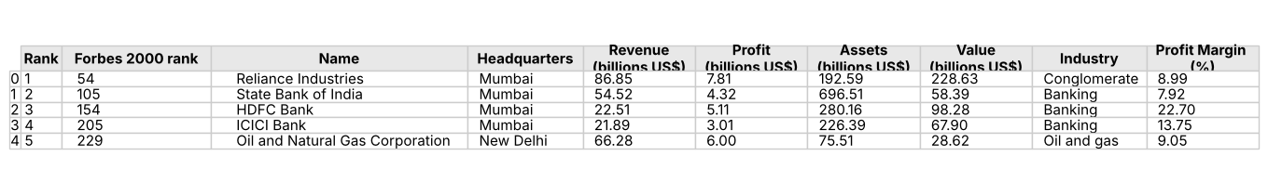
Figure 8.1: First 5 records of the dataset.
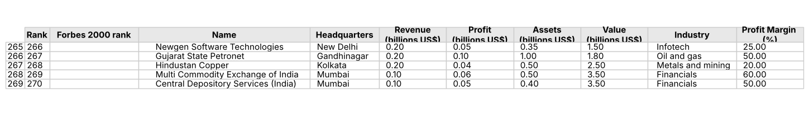
Figure 8.2: Last 5 records of the dataset.
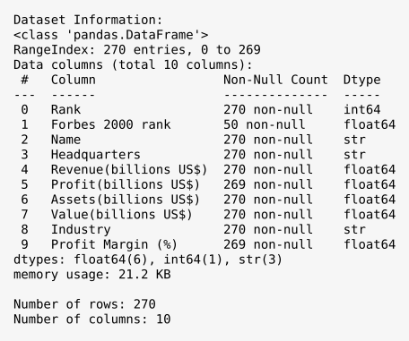
Figure 8.3: Dataset information, shape and column names.
8.2 Preprocessing Outputs
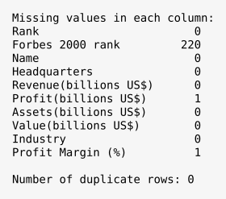
Figure 8.4: Missing-value and duplicate-record analysis.
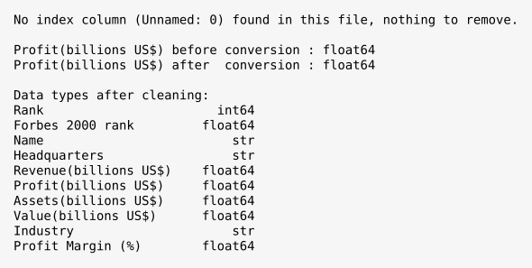
Figure 8.5: Data types before and after cleaning.
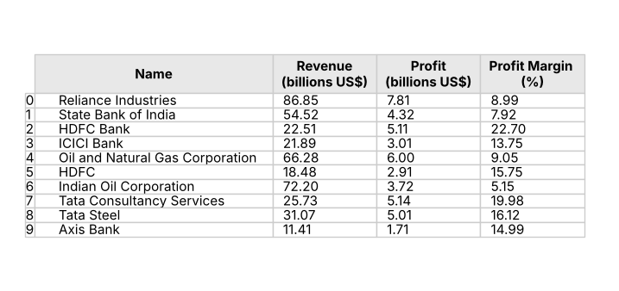
Figure 8.6: Cleaned dataset with the derived Profit Margin (%) column.
8.3 Visualization Outputs
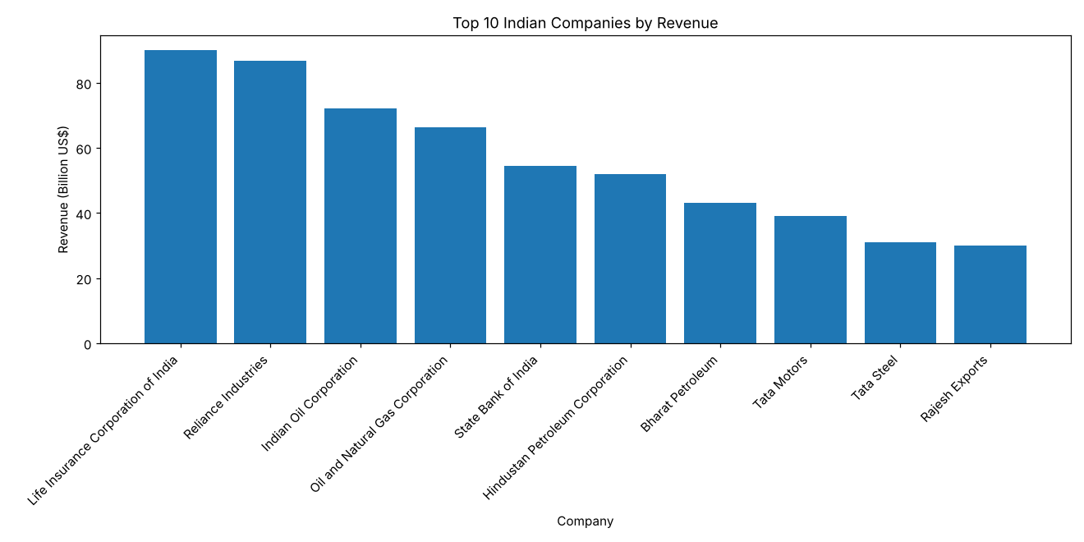
Figure 8.7: Top 10 Companies by Revenue – Bar Chart.
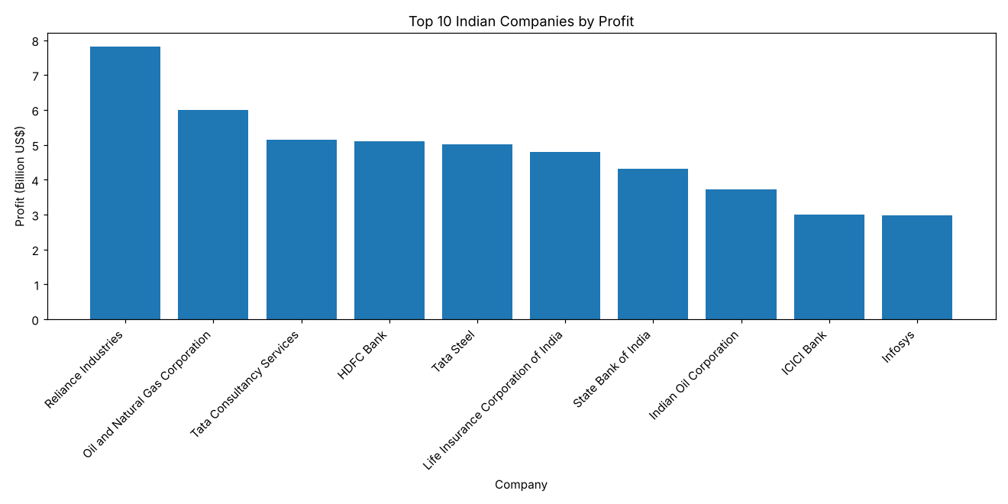
Figure 8.8: Top 10 Companies by Profit – Bar Chart.
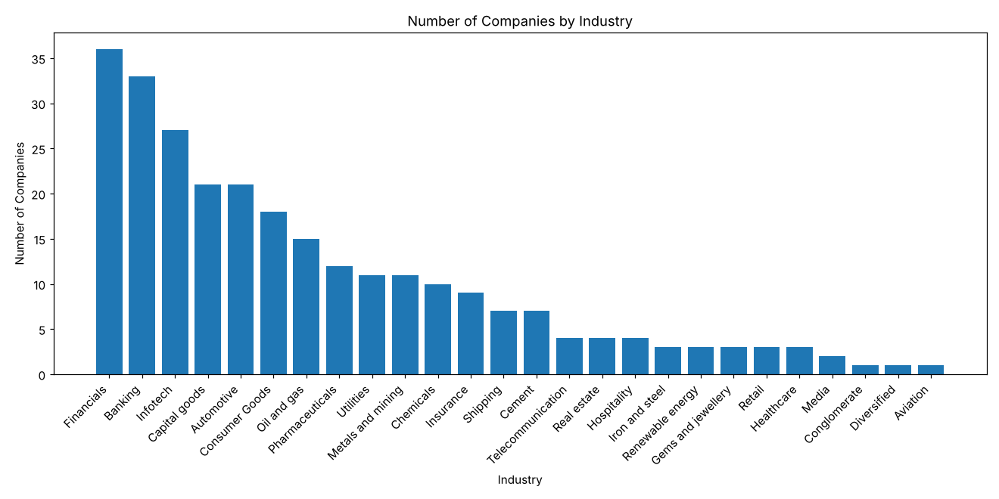
Figure 8.9: Number of Companies by Industry – Bar Chart.
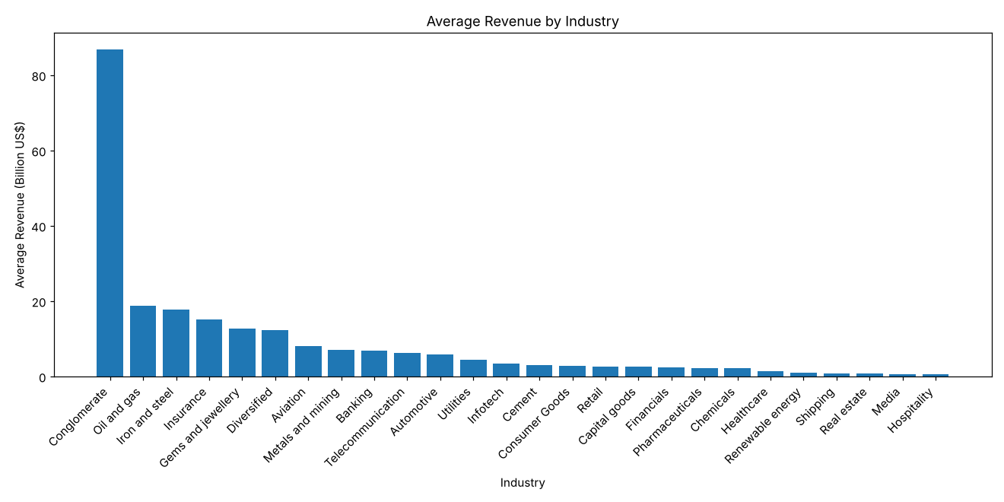
Figure 8.10: Average Revenue by Industry – Bar Chart.
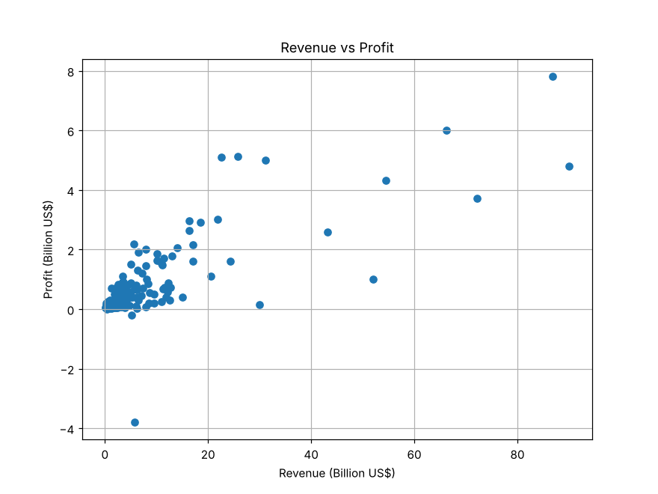
Figure 8.11: Revenue vs Profit – Scatter Plot.
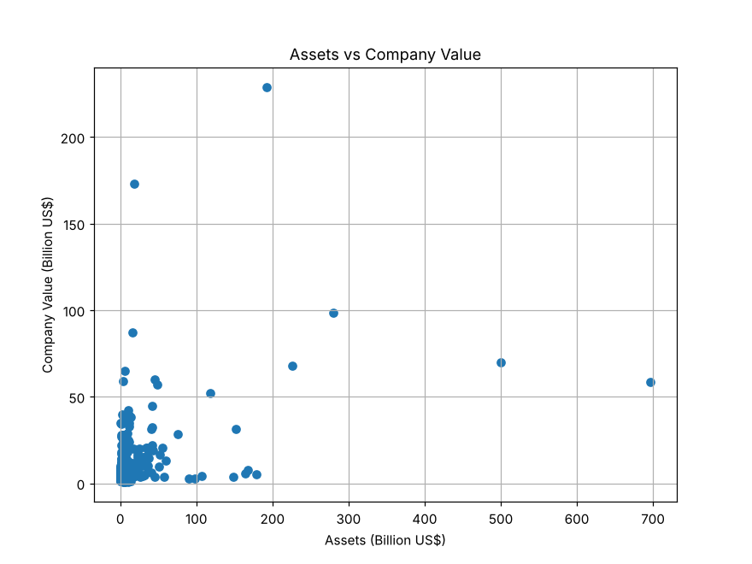
Figure 8.12: Assets vs Company Value – Scatter Plot.
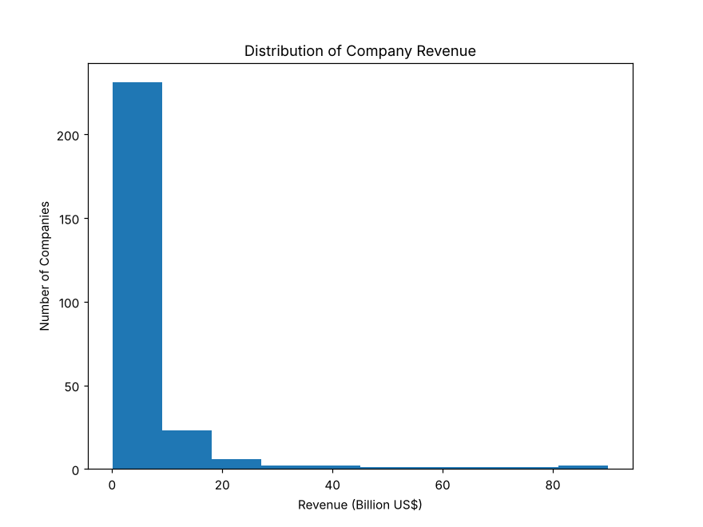
Figure 8.13: Distribution of Company Revenue – Histogram.
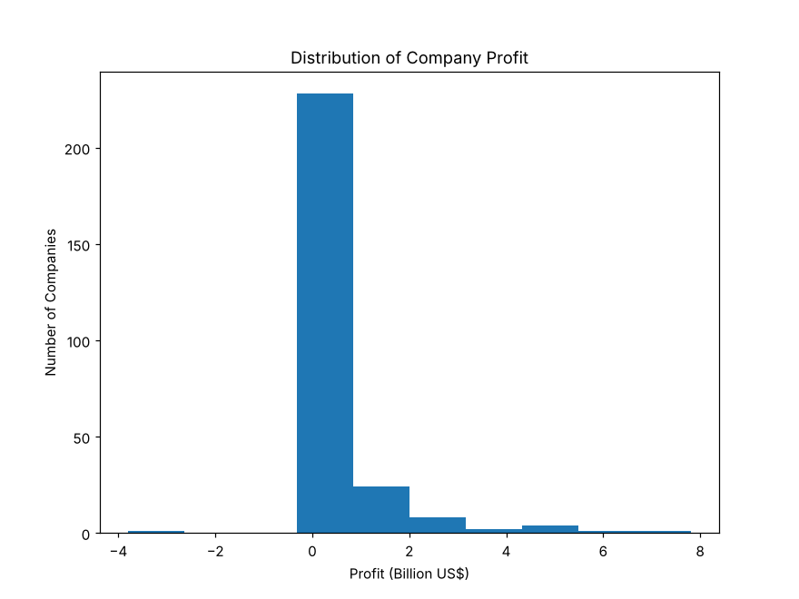
Figure 8.14: Distribution of Company Profit – Histogram.
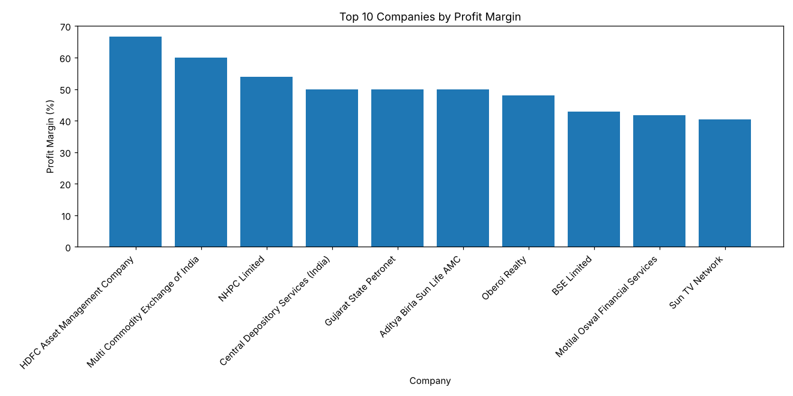
Figure 8.15: Top 10 Companies by Profit Margin – Bar Chart.
8.4 Analysis Outputs
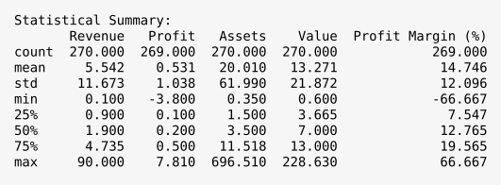
Figure 8.16: Statistical summary of the numerical columns.
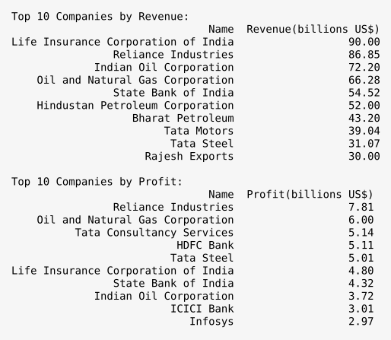
Figure 8.17: Top 10 Companies by Revenue and by Profit.
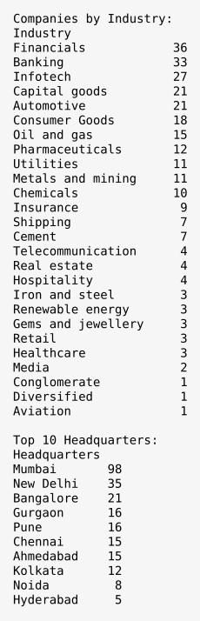
Figure 8.18: Industry-wise and headquarters-wise company counts.
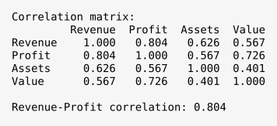
Figure 8.19: Correlation matrix and revenue–profit correlation.
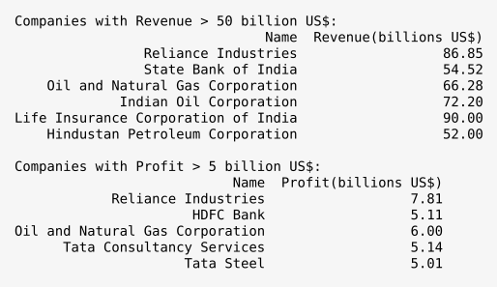
Figure 8.20: Filtering – high-revenue and high-profit companies.
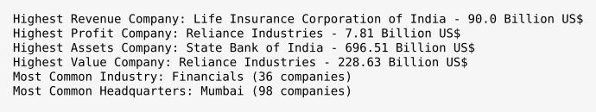
Figure 8.21: Final summary of important results.
CHAPTER 9
CONCLUSION AND FUTURE ENHANCEMENTS
9.1 Conclusion
The Largest Companies in India Data Analysis System provides an effective approach for analyzing company data. The project loaded, cleaned, and processed the List of largest companies in India dataset and produced a cleaned dataset of 270 records and 10 columns.
NumPy, Pandas, and Matplotlib were used for data cleaning, statistical analysis, ranking, grouping, correlation analysis, filtering, and visualization of the revenue, profit, assets, company value, industries, and headquarters of the companies.
The statistics, rankings, grouping, and filtering give quick insights into 270 of India’s largest companies, and the charts make the results easy to understand. The cleaned CSV file can be reused for further analysis.
Overall, the project demonstrates the practical application of data analysis to identify descriptive patterns in company data.
9.2 Limitations
The project has the following limitations:
- The dataset represents a single list of 270 companies for one period; it does not contain data from multiple years.
- The results depend on the quality and completeness of the dataset.
- The analysis does not predict the future performance of any company.
- Other financial measures such as debt, expenses, and employee numbers are not present in the dataset.
- The dataset does not represent every company in India.
- Some values in the dataset are missing (the Forbes 2000 rank of 220 companies and the profit of Tata Motors), so the results that depend on them cover only the companies that have the values.

9.3 Future Enhancements
The project can be enhanced in the future by implementing:
- Interactive dashboards for exploring the companies.
- Data from multiple years to study trends over time.
- More financial ratios, such as return on assets and asset turnover.
- Predictive models for revenue and profit.
- Automated dataset updates.
- Additional visualizations such as pie charts and box plots.
- Automated report generation.

These enhancements are not part of the current implementation.
REFERENCES
- Pandas Documentation – Python Data Analysis Library.
- NumPy Documentation – Fundamental Package for Scientific Computing with Python.
- Matplotlib Documentation – Python Data Visualization.
- Python Documentation – Python Programming Language.
- Google Colab – Cloud-based Python Notebook Environment.
- Project Dataset – List of largest companies in India.csv.

APPENDIX – SOURCE CODE
A. Import Required Libraries
import numpy as np
import pandas as pd
import matplotlib.pyplot as plt
B. Upload and Load Dataset
from google.colab import files
uploaded = files.upload()

file_name = "List of largest companies in India.csv"
df = pd.read_csv(file_name)

print("First 5 records:")
print(df.head())
print("Last 5 records:")
print(df.tail())
C. Dataset Information
df.info()
rows, columns = df.shape
print("Number of rows:", rows)
print("Number of columns:", columns)
print(df.columns)
D. Data Cleaning
# Check for an extra index column (not present in this file)
if "Unnamed: 0" in df.columns:
df = df.drop("Unnamed: 0", axis=1)

# Missing values and duplicates
print(df.isnull().sum())
print("Number of duplicate rows:", df.duplicated().sum())

# Make sure Profit is numeric (the one missing value stays NaN)
profit_column = "Profit(billions US$)"
df[profit_column] = pd.to_numeric(df[profit_column], errors="coerce")
print(df[profit_column].isnull().sum())
print(df.dtypes)
E. Statistical Analysis
print(df.describe())

for col in ["Revenue(billions US$)", "Profit(billions US$)", "Assets(billions US$)", "Value(billions US$)"]:
print(col, "- mean:", np.nanmean(df[col]), "median:", np.nanmedian(df[col]),
"max:", df[col].max(), "min:", df[col].min())
F. Top 10 Companies
top_revenue = df.sort_values(by="Revenue(billions US$)", ascending=False).head(10)
top_profit = df.sort_values(by="Profit(billions US$)", ascending=False).head(10)
top_assets = df.sort_values(by="Assets(billions US$)", ascending=False).head(10)
top_value = df.sort_values(by="Value(billions US$)", ascending=False).head(10)

print(top_revenue[["Name", "Revenue(billions US$)"]].to_string(index=False))
print(top_profit[["Name", "Profit(billions US$)"]].to_string(index=False))
print(top_assets[["Name", "Assets(billions US$)"]].to_string(index=False))
print(top_value[["Name", "Value(billions US$)"]].to_string(index=False))
G. Industry and Headquarters Analysis
industry_count = df["Industry"].value_counts()
print(industry_count)

industry_revenue = df.groupby("Industry")["Revenue(billions US$)"].mean().sort_values(ascending=False)
print(industry_revenue)

industry_profit = df.groupby("Industry")["Profit(billions US$)"].mean().sort_values(ascending=False)
print(industry_profit)

headquarters_count = df["Headquarters"].value_counts()
print(headquarters_count)
H. Visualization – Bar Charts
def bar_chart(x, y, xlabel, ylabel, title):
plt.figure(figsize=(12, 6))
plt.bar(x, y)
plt.xlabel(xlabel)
plt.ylabel(ylabel)
plt.title(title)
plt.xticks(rotation=45, ha="right")
plt.tight_layout()
plt.show()

bar_chart(top_revenue["Name"], top_revenue["Revenue(billions US$)"], "Company", "Revenue (Billion US$)", "Top 10 Indian Companies by Revenue")
bar_chart(top_profit["Name"], top_profit["Profit(billions US$)"], "Company", "Profit (Billion US$)", "Top 10 Indian Companies by Profit")
bar_chart(industry_count.index, industry_count.values, "Industry", "Number of Companies", "Number of Companies by Industry")
bar_chart(industry_revenue.index, industry_revenue.values, "Industry", "Average Revenue (Billion US$)", "Average Revenue by Industry")
I. Visualization – Scatter Plots
plt.figure(figsize=(8, 6))
plt.scatter(df["Revenue(billions US$)"], df["Profit(billions US$)"])
plt.xlabel("Revenue (Billion US$)")
plt.ylabel("Profit (Billion US$)")
plt.title("Revenue vs Profit")
plt.grid(True)
plt.show()

plt.figure(figsize=(8, 6))
plt.scatter(df["Assets(billions US$)"], df["Value(billions US$)"])
plt.xlabel("Assets (Billion US$)")
plt.ylabel("Company Value (Billion US$)")
plt.title("Assets vs Company Value")
plt.grid(True)
plt.show()
J. Visualization – Histograms
plt.figure(figsize=(8, 6))
plt.hist(df["Revenue(billions US$)"], bins=10)
plt.xlabel("Revenue (Billion US$)")
plt.ylabel("Number of Companies")
plt.title("Distribution of Company Revenue")
plt.show()

plt.figure(figsize=(8, 6))
plt.hist(df["Profit(billions US$)"], bins=10)
plt.xlabel("Profit (Billion US$)")
plt.ylabel("Number of Companies")
plt.title("Distribution of Company Profit")
plt.show()
K. Profit Margin
df["Profit Margin (%)"] = (df["Profit(billions US$)"] / df["Revenue(billions US$)"]) * 100

top_margin = df.sort_values(by="Profit Margin (%)", ascending=False).head(10)
print(top_margin[["Name", "Profit Margin (%)"]].to_string(index=False))

bar_chart(top_margin["Name"], top_margin["Profit Margin (%)"], "Company", "Profit Margin (%)", "Top 10 Companies by Profit Margin")
L. Correlation Analysis
numeric_data = df[["Rank", "Forbes 2000 rank", "Revenue(billions US$)", "Profit(billions US$)", "Assets(billions US$)", "Value(billions US$)"]]
print(numeric_data.corr())

rp = df[["Revenue(billions US$)", "Profit(billions US$)"]].dropna()
print(np.corrcoef(rp["Revenue(billions US$)"], rp["Profit(billions US$)"])[0, 1])
M. Filtering
high_revenue = df[df["Revenue(billions US$)"] > 50]
print(high_revenue[["Name", "Revenue(billions US$)"]].to_string(index=False))

high_profit = df[df["Profit(billions US$)"] > 5]
print(high_profit[["Name", "Profit(billions US$)"]].to_string(index=False))
N. Final Summary
for col, label in [("Revenue(billions US$)", "Revenue"), ("Profit(billions US$)", "Profit"), ("Assets(billions US$)", "Assets"), ("Value(billions US$)", "Value")]:
row = df.loc[df[col].idxmax()]
print("Highest", label, "Company:", row["Name"], "-", row[col], "Billion US$")

print("Most Common Industry:", industry_count.idxmax())
print("Most Common Headquarters:", headquarters_count.idxmax())
O. Save and Download the Cleaned Dataset
df.to_csv("cleaned_largest_companies_india.csv", index=False)
print("Cleaned dataset saved successfully!")

from google.colab import files
files.download("cleaned_largest_companies_india.csv")
END OF REPORT

