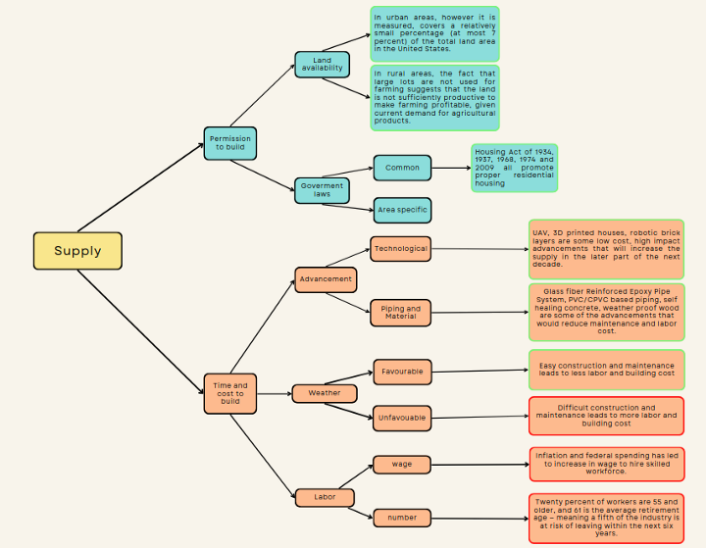
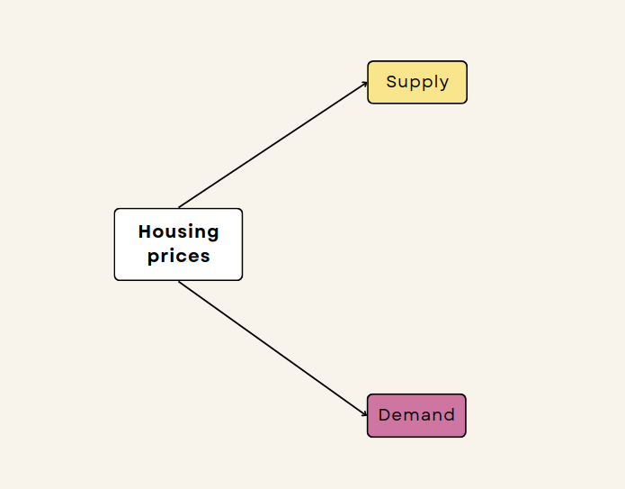

From the above figures, it's okay to conclude that most of the hypotheses support the increase in supply, so it's safe to say that price will decrease, right? Well, not really. Mainly because of two reasons:
- All the hypotheses are not equally weighted, which means some would matter more than others based on the time and situation. But that's not it...
- Remember, supply and demand are relative, so we would have to look at the demand for housing to take an educated guess on which hypothesis should be given more importance to make a final call.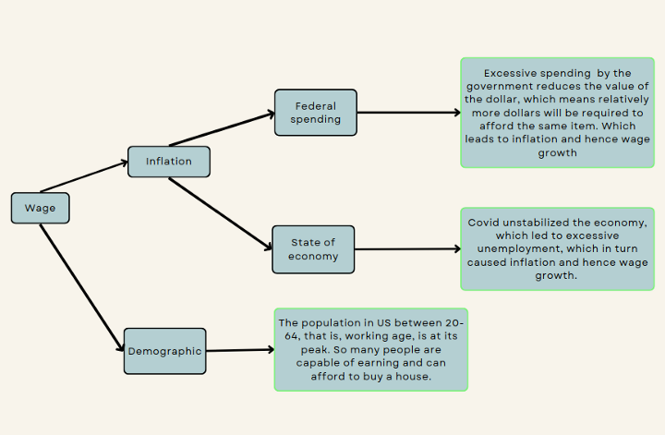
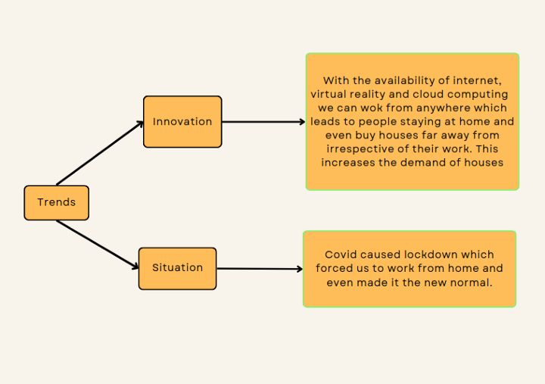

Supply vs Demand
One of the many and the most important factor in weighing the hypotheses is the urgency or, in other words, how fast will it come to fruition, is it affecting the market right now? In the case of demand, all the hypotheses have an immediate impact. For example, trends change fast, and due to covid, the whole world was pushed into the new normal of working remotely. Same for the wage growth, the demographic is affecting it right now, and inflation and recession are building up at this instant. But in the case of supply, there is only one factor with hypotheses that have an immediate impact, that too against the growth of supply, which is labor. All other factors supporting supply growth are slow growing and will have an impact in the near future.
In easy words, building houses, however great the technology gets and smooth the bills and permit processes get, will take time. Whereas the fluctuations in demands are immediate. Hence, the house market prices will go to the moon for now! Now, the next question is, when will this upward trend continue? For this, we need to understand the concept of Price Equilibrium. So let's get right at it!

