SWIFTSHIP TRACKER
Salesforce Implementation Documentation

Parcel Booking, Tracking & Delivery Management using Salesforce CRM, Flows and Agentforce AI

Project | SwiftShip Tracker (Salesforce)
Document Type | Project Implementation & Documentation
Institution | Anjalai Ammal Mahalingam Engineering College
Team ID | 2026-4244
Submission Date | 03/10/2026

Team Members
Name | Register No. | Mail ID
P.Balaji | 820423205016 | Balajipugal06@gmail.com

SWIFT SHIP TRACKER

User Story:
The SwiftShip Tracker is designed to provide a centralized Salesforce-based parcel management solution that enables customers to book parcels, track delivery status, and manage shipments through an intuitive interface and conversational AI support. The system manages Parcel, Delivery, Sender, and Receiver information using Salesforce custom objects and relationships. Flows automate parcel operations and notifications, while AgentForce AI and Prompt Builder enable customers to retrieve parcel information and interact with the system conversationally. Delivery agents can update parcel status in real time, while Experience Cloud, security controls, reports, and dashboards provide secure customer access and operational visibility.

- INTRODUCTION

  - Project Overview :
The SwiftShip Tracker is a Salesforce CRM solution developed to simplify parcel booking, shipment tracking, and delivery management. It supports the complete parcel lifecycle from booking and dispatch through tracking and delivery confirmation. Customers can access shipment information, while delivery agents can update parcel details and delivery status.

  - Purpose :

The purpose of SwiftShip Tracker is to:

    - Centralize parcel and delivery information.
    - Simplify parcel booking and tracking.
    - Provide real-time shipment visibility.
    - Automate delivery updates and customer notifications.
    - Enable conversational parcel tracking using AgentForce AI and Prompt Builder.
    - Improve agent efficiency through Salesforce Flows and dashboards.
    - Provide secure, role-based access to customers, agents, support staff, and administrators.

- IDEATION PHASE
  - Problem Statement (Customer Problem Statement Template)

PS | I am  (Customer) | I’m trying to | But | Because | Which makes me  feel
PS-1 | Customer /  Sender | book a parcel easily | booking requires support assistance or multiple applications | parcel operations are not centralized | frustrated
PS-2 | Customer /  Sender | track my parcel | I do not have a simple real-time tracking experience | shipment information  is difficult to access | confused
PS-3 | Delivery Agent | update parcel status | status updates  require manual handling | there is a need for centralized operational tracking | concerned
PS-4 | Customer | receive delivery updates | notifications may not be available at every delivery stage | communicat ion needs to be automated | uncertain
PS-5 | Admin | monitor parcel operations | parcel flow and delivery performance are difficult to monitor | operational data needs centralized reporting | concerned

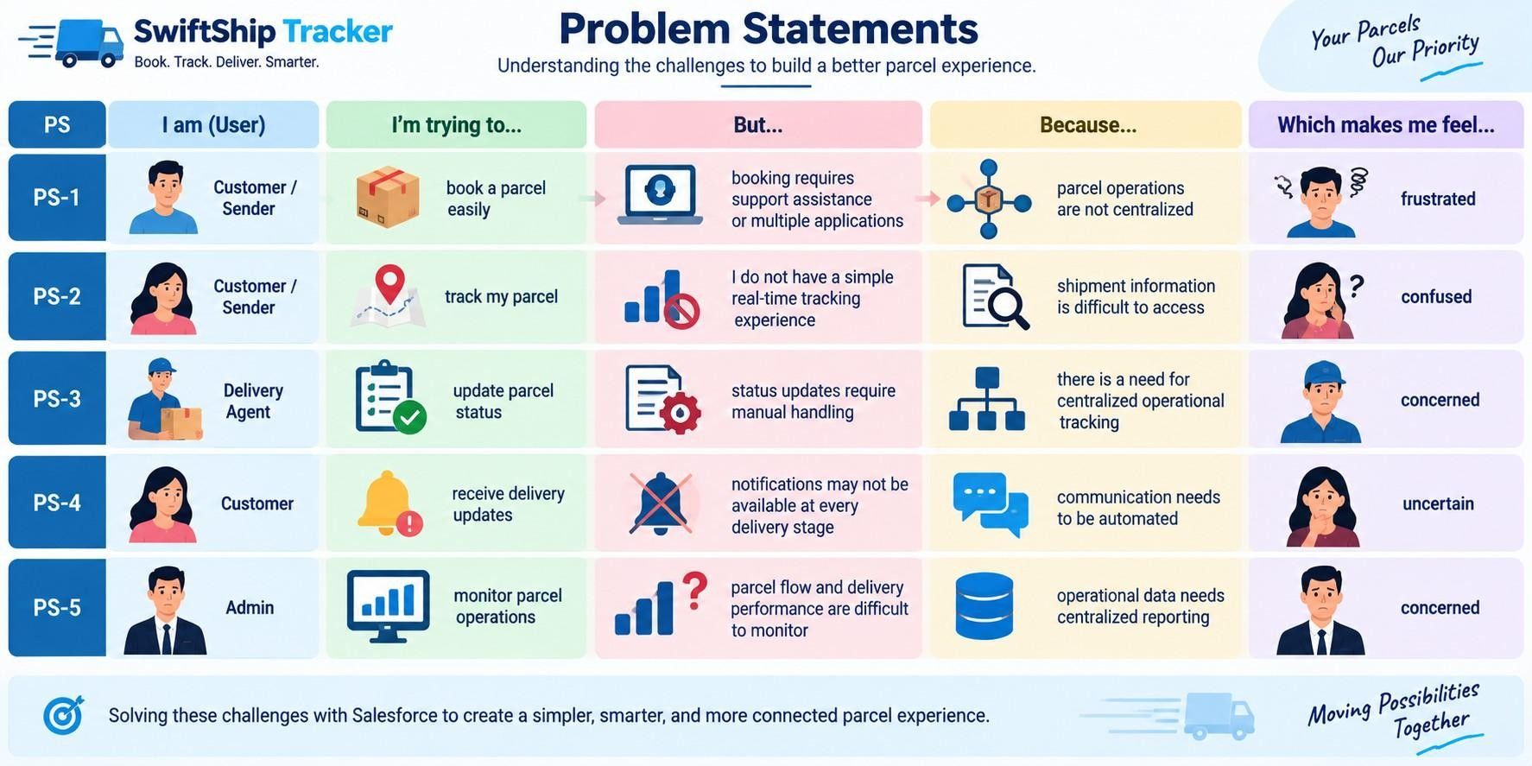

  - Empathy Map Canvas
User Persona: Customer / Sender
    - Think & Feel: Wants a simple way to book and track parcels without repeatedly contacting support.
    - Hear: Receives delivery information and status updates from the parcel service.
    - See: Parcel details, tracking status, estimated delivery date, and delivery information.
    - Say & Do: Books parcels, checks tracking information, and asks for delivery updates.
    - Pain: Delays, confusion, lack of easy tracking, and dependence on support or
multiple apps.
    - Gain: Real-time visibility, self-service tracking, convenient booking, and timely notifications.

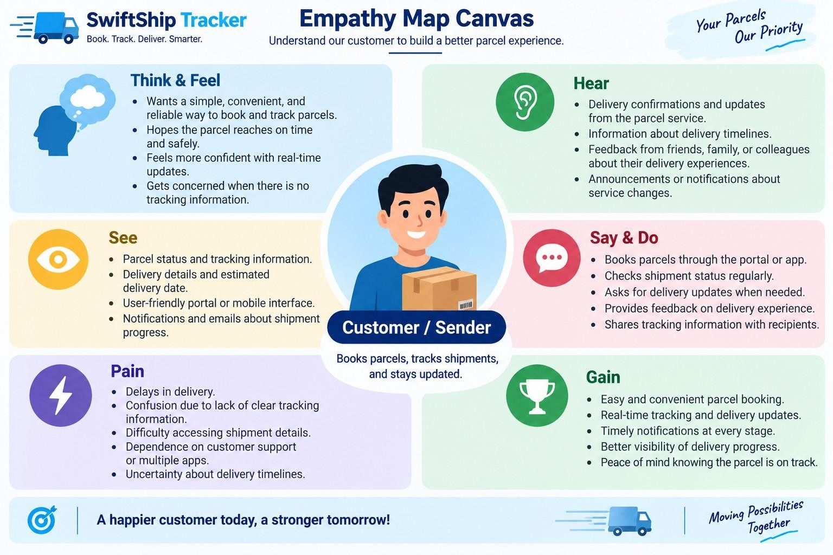

  - Brainstorming & Idea Prioritization
Ideas Considered
    - Manual registers
    - Spreadsheet tracking
    - Standalone parcel portal
    - Salesforce CRM with AgentForce AI

Final Selection
Salesforce CRM selected due to:
    - Centralized parcel management
    - Automation through Flows
    - Real-time tracking visibility
    - Conversational AI assistance
    - Secure role-based access
    - Reports and dashboards

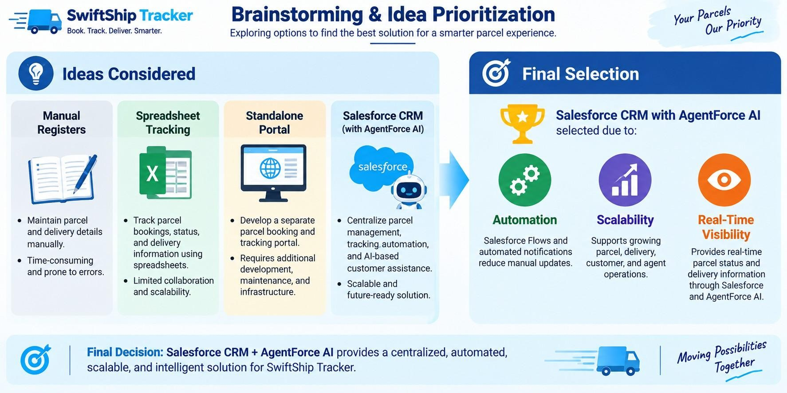

- REQUIREMENT ANALYSIS PHASE

  - Customer Journey Map
Stages:

● Parcel Booking
- Parcel Record Creation
- Dispatch & Shipment
- In-Transit Tracking
- Out for Delivery
- Delivery Confirmation
- Customer Notification
- Feedback / Support

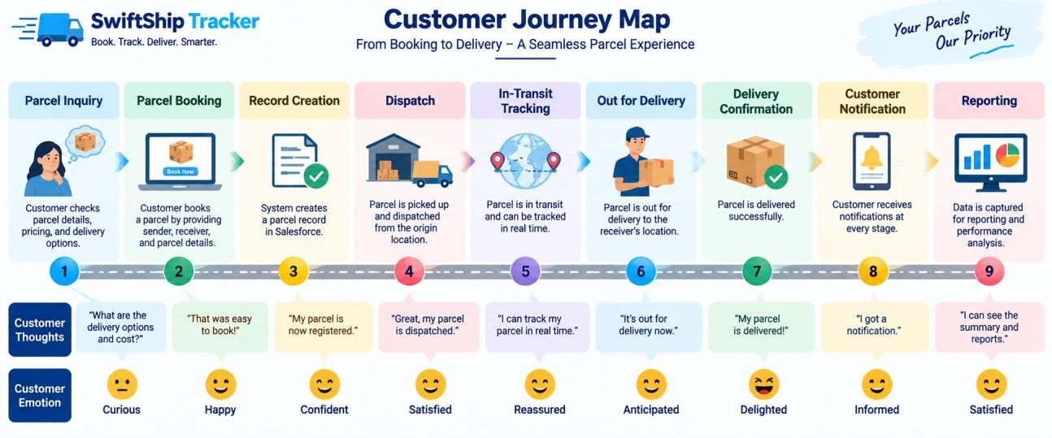

  - Solution Requirements
Functional Requirements

FR No | Requirement
FR-1 | Parcel booking and record creation
FR-2 | Parcel status tracking
FR-3 | Weight management
FR-4 | Estimated delivery date management
FR-5 | Sender information management
FR-6 | Receiver information management
FR-7 | Delivery and current-location tracking
FR-8 | Agent parcel status updates
FR-9 | Automated customer notifications
FR-10 | AI-powered parcel tracking
FR-11 | Reports and dashboards
FR-12 | Customer access through Experience Cloud

Non-Functional Requirements

NFR | Description
Usability | Intuitive Salesforce and customer-facing interface
Security | Role-based and field-level access control
Reliability | Accurate parcel status and delivery information
Performance | Timely Flow and AgentForce responses
Availability | Salesforce cloud-based access
Scalability | Supports growing parcel and delivery operations
Data Integrity | Controlled access and relationship-based parcel data
Maintainability | Flows, prompts, topics, and configurations can be updated

  - Data Flow Diagram Flow:
Customer / Sender
↓
Parcel Booking
↓
Parcel Record
↓
Sender + Receiver Information
↓
Delivery Record
↓
Parcel Status Update
↓
Current Location & Estimated Delivery
↓
Automated Notifications
↓
Customer Tracking / AgentForce AI
↓
Reports & Dashboards

AI Tracking Flow
Customer Query
↓
AgentForce AI
↓
Prompt Builder – Retrieve Parcel Details
↓
Parcel Record
↓
Status / Weight / Estimated Delivery
↓
Conversational Response
The Prompt Builder implementation retrieves Parcel ID, Status, Weight, and Estimated Delivery Date information for tracking responses.

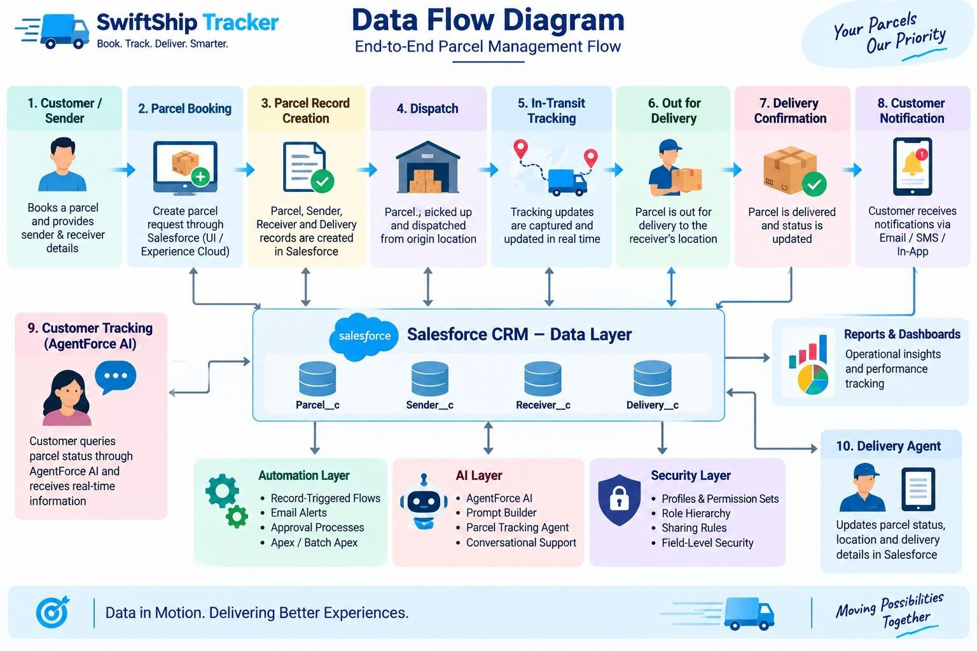
3.4 Technology Stack

Layer | Technology
Platform | Salesforce Developer Edition
UI | Lightning App Page, Lightning Record Pages, Experience Cloud
Database | Salesforce Custom & Standard Objects
Business Logic | Salesforce Flows, Apex Classes
Automation | Record-Triggered Flows, Auto-Launched Flows, Scheduled Flows
AI | AgentForce AI, Prompt Builder
Notifications | Email Alerts & Email Templates
Processing | Batch Apex
Security | Profiles, Permission Sets, Role Hierarchy, Field-Level Security, Sharing Rules
Reporting | Reports & Dashboards

- PROJECT DESIGN PHASE

  - Problem–Solution Fit

Problem | Solution | Benefit
Parcel booking is difficult | Salesforce Parcel management | Centralized booking
Tracking requires support | AgentForce AI + Prompt  Builder | Self-service tracking
Manual status updates | Salesforce Flows | Automated processes
Problem | Solution | Benefit
Delivery communication gaps | Email Alerts | Timely notifications
Scattered shipment information | Parcel, Delivery, Sender &  Receiver objects | Structured data
Difficult operational monitoring | Reports & Dashboards | Better visibility
Different users need different access | Profiles, Roles & Permission  Sets | Secure access

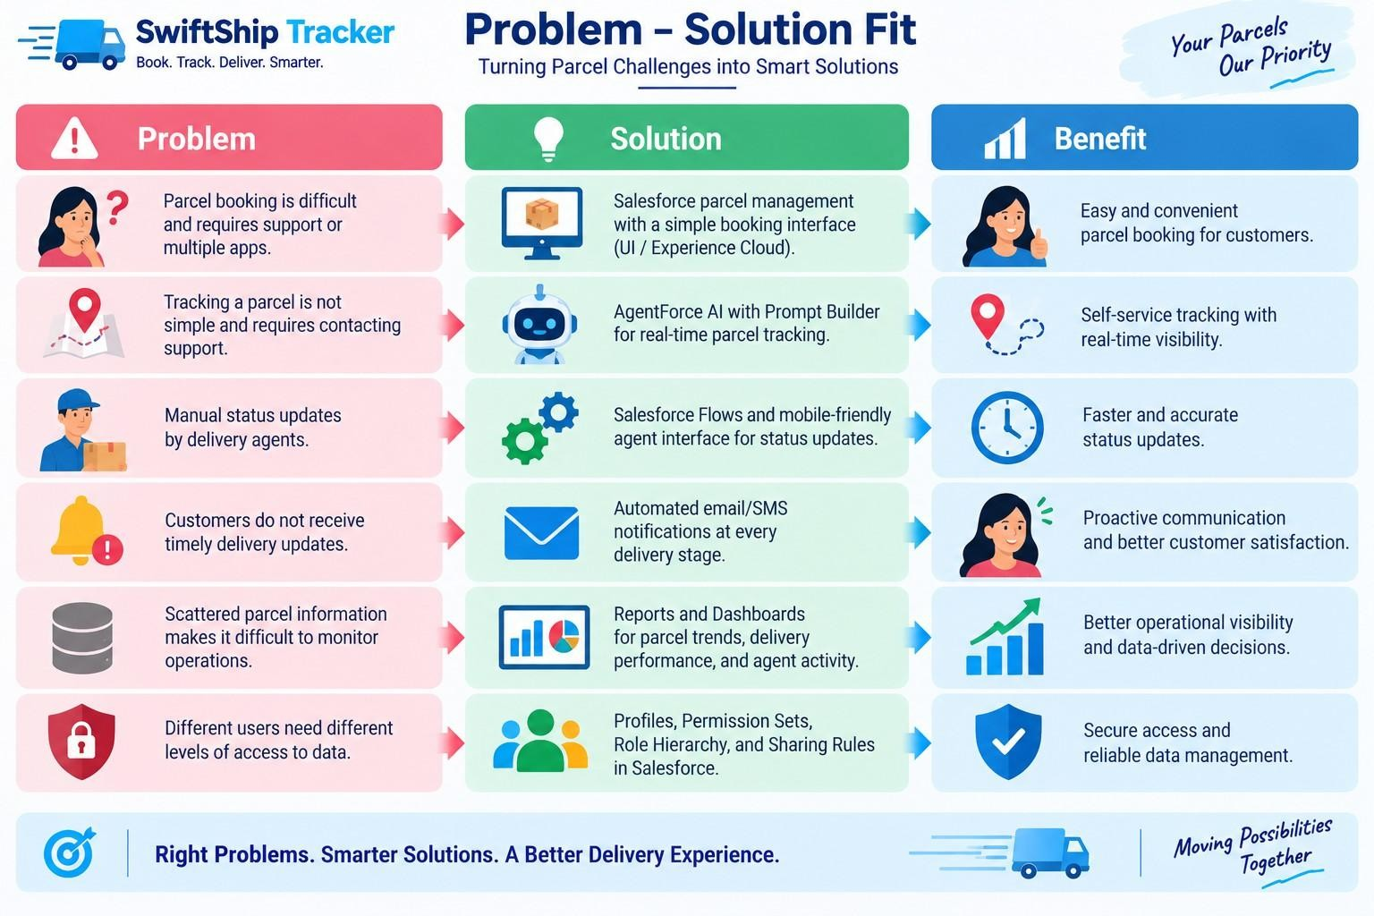

  - Proposed Solution
Functional Requirements
Parameter | Description
Problem | Difficult and inefficient parcel booking and tracking
Solution | Salesforce-based Parcel Management System
Innovation | AgentForce AI + Prompt Builder for conversational self-service tracking and automated Salesforce Flows
Impact | Centralized booking, real-time tracking visibility, timely notifications, and efficient delivery management
Business Model | Parcel, customer, delivery-agent, support, and administrator operations
Scalability | Supports growing parcel operations, Experience Cloud, and integration with external logistics systems

  - Solution Architecture

● Users
- Customer | Delivery Agent | Support Staff | Admin
↓
- Salesforce Lightning / Experience Cloud
↓
- SwiftShip Tracker Salesforce Platform ● Data Layer
  - Parcel
○ Delivery
○ Sender
○ Receiver
- Automation Layer
  - Flows
○ Approval Processes
○ Apex Classes
○ Batch Apex
○ Email Alerts
- AI Layer
○ AgentForce AI
○ Prompt Builder
○ Parcel Tracking Agent ● Security Layer
○ Profiles
○ Roles
○ Permission Sets
○ Sharing Rules
○ Field-Level Security
↓
- Reports & Dashboards
↓
- Parcel Tracking & Operational Insights
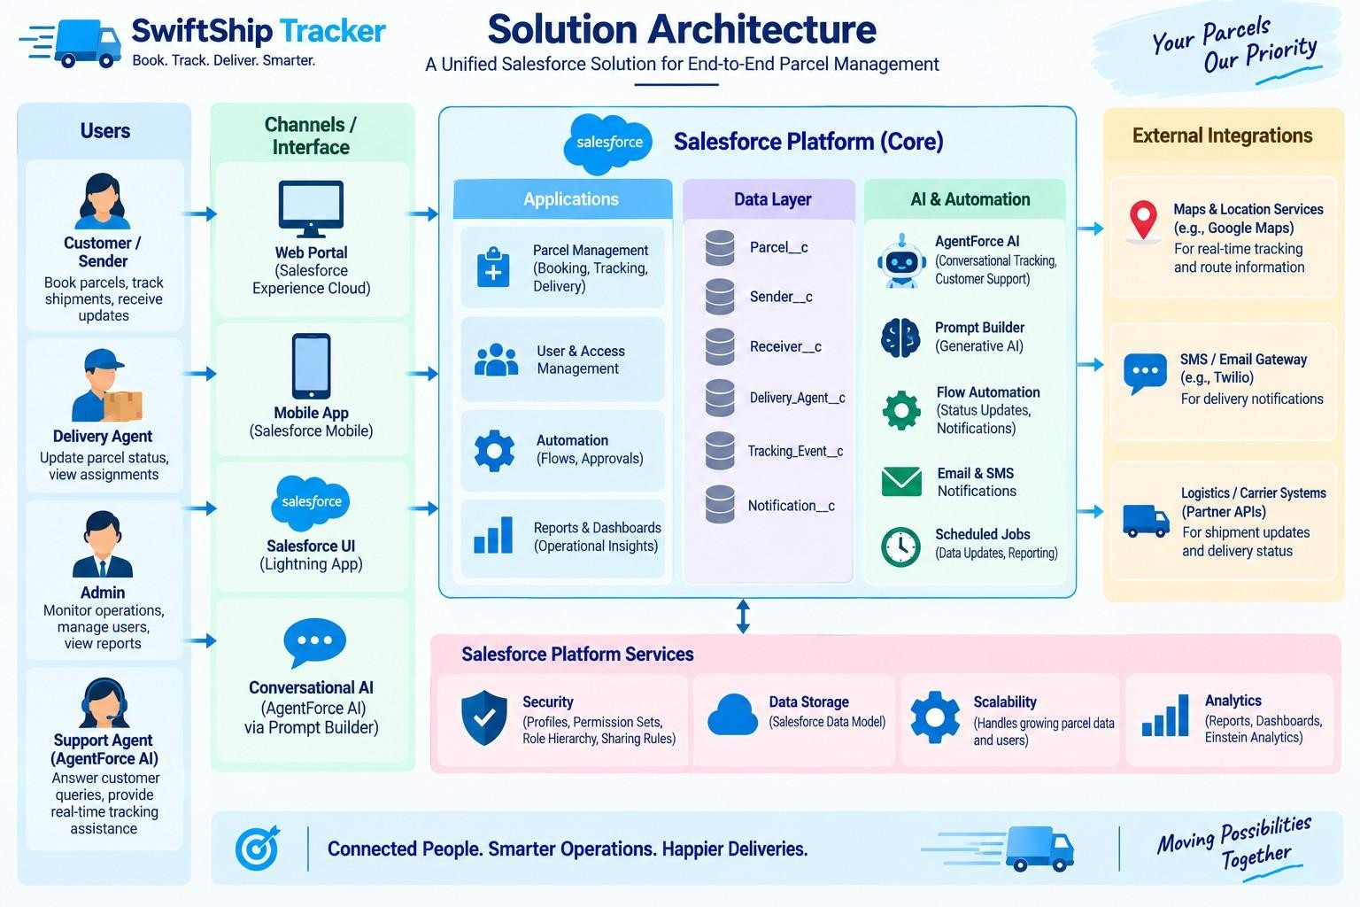
5. PROJECT PLANNING & SCHEDULING

5.1 Project Planning
- Agile methodology
Sprint | Functional  Requirement  (Epic) | User  Story  Number | User Story / Task | Story Points | Priority | Team Member  s
Sprint-1 | Developer Setup | USN-1 | As a system administrator, I want to create and configure the Salesforce environment so that I can build the SwiftShip Tracker parcel management system. | 3 | High | Member1
- Epics → Stories → Story Points
- Sprint-based execution
- Velocity calculation used for estimation
Product Backlog, Sprint Schedule, and Estimation (4 Marks)
Use the below template to create product backlog and sprint schedule

Sprint | Functional  Requirement  (Epic) | User  Story  Number | User Story / Task | Story Points | Priority | Team  Member  s
Sprint-2 | Data Modeling | USN-2 | As an admin, I want to create  Parcel, Delivery, Sender, and Receiver objects with proper relationships so that parcel and delivery data is stored and managed systematically. | 5 | High | Member2
Sprint-2 | Data Modeling | USN-3 | As a staff member, I want dedicated tabs and a Lightning App for SwiftShip modules so that I can easily navigate and manage parcel and delivery operations. | 5 | High | Member3
Sprint-3 | Automation | USN-4 | As a system, I want to validate parcel details, mandatory fields, and booking inputs so that invalid or incomplete parcel records are prevented. | 3 | High | Member4
Sprint-3 | Automation | USN-5 | As a delivery coordinator, I want automated Flows to update parcel status and delivery information so that parcel processing requires minimal manual effort. | 3 | High | Member4
Sprint-4 | Apex | USN-6 | As a system, I want Apex triggers and classes to automatically perform critical parcel and delivery actions so that important processes are handled accurately. | 5 | High | Member1
Sprint-4 | Apex | USN-7 | As an inventory/operations manager, I want Batch Apex jobs to process and update parcel or delivery records automatically so that operational data remains accurate and up to date. | 5 | High | Member2
Sprint-5 | Reports | USN-8 | As a manager, I want reports showing parcel status, delivery performance, and operational metrics so that I can monitor SwiftShip operations and make informed decisions. | 4 | High | Member3
Sprint-6 | Dashboards &  AI | USN-9 | As a manager, I want dashboards showing parcel status, delivery performance, and key metrics, while Agentforce provides AI-powered tracking assistance, so that I can monitor operations efficiently. | 4 | Medium | Member4

Project Tracker, Velocity & Burndown Chart: (4 Marks)

6. Project Development Phase:

Phase 1: Requirement Analysis & Planning
Objective:
Sprint | Total Story Points | Duratio n | Sprint Start Date | Sprint End Date (Planned) | Story Points  Completed  (as on  Planned End  Date) | Sprint Release Date (Actual)
Sprint-1 | 20 | 6 Days | 24 Oct 2022 | 29 Oct 2022 | 20 | 29 Oct 2022
Sprint-2 | 20 | 6 Days | 31 Oct 2022 | 05 Nov 2022
Sprint-3 | 20 | 6 Days | 07 Nov 2022 | 12 Nov 2022
Sprint-4 | 20 | 6 Days | 14 Nov 2022 | 19 Nov 2022
Sprint-5 | 20 | 6 Days | 21 Nov 2022 | 26 Nov 2022
Sprint-6 | 20 | 6 Days | 28 Nov 2022 | 03 Dec 2022
“Customers often face delays and confusion while booking, tracking, and managing parcel deliveries because they need to call support or use multiple apps. A conversational AI agent can simplify this by allowing customers to book parcels, get live tracking, and manage deliveries in one place.” Key Requirements:

- Requirement gathering from end users and delivery agents.

- Defining system scope and user personas (Customer, Agent, Admin).

- Designing the data model with relationships between Parcel, Sender, Receiver, and Delivery.

- Identifying use cases such as parcel booking, tracking, and delivery update automation.
- Selecting tools: Salesforce Flows, Prompt Builder, and AgentForce AI.

Defining Project Scope & Objectives

Project Scope:

  - Build a scalable CRM solution for parcel delivery businesses to manage customer bookings, shipments, and delivery operations efficiently.
  - Support the end-to-end parcel lifecycle — from parcel booking → dispatch → tracking → delivery confirmation.
  - Include comprehensive data model design, automation (Flows, Apex, Email Alerts), AI-powered prompt builder, and reporting dashboards for effective management.
  - Provide role-based access for admins, delivery agents, and customers through Salesforce profiles, permission sets, and Experience Cloud.
  - Ensure real-time parcel visibility for customers and simplified operational tracking for agents through AI-integrated conversational support.

Objectives Summary:

- Streamline parcel operations by automating booking, tracking, and delivery notifications to reduce manual updates.

- Improve customer satisfaction with transparent, real-time shipment status and self-service tracking options.

- Enhance agent efficiency through centralized dashboards and guided Flows for quick status updates.

- Enable business insights with reports and dashboards showing parcel trends, delivery performance, and agent activity.

- Ensure security and reliability by implementing Salesforce role hierarchies, sharing rules, and audit-based data access.

Gathering & Analysing User Needs Users Involved:

- Customers / Senders – End users who book parcels, track deliveries, and receive real-time updates through the portal or AI agent.
- Delivery Agents – Manage assigned parcels, update delivery status, and ensure timely handover to customers.
- Customer Support Team – Handle delivery-related issues, respond to customer queries, and ensure smooth communication.
- Admin Team – Configure the Salesforce environment, manage user roles, security settings, and monitor operational performance.
- System Integrator / Developer – Responsible for implementing automation, AI agent setup, and backend integrations.

Key Functional Needs:
- Seamless parcel booking and tracking interface for customers through Salesforce Experience Site or agent assistance.
- Ability for agents to update parcel status (Booked → In Transit → Out for Delivery → Delivered) in real time.
- Automated notifications and email alerts to customers on every delivery stage update.
- Support for Sender and Receiver details management with address, contact, and email fields for communication.
- AI Agent integration (via Prompt Builder) for real-time parcel status queries and automated assistance.
- Reports and dashboards to monitor parcel flow, delivery performance, and agent activity for admins.
- Security controls with role-based access, profiles, and permission sets for different user levels.

Tools Used:

- Salesforce Developer Org – For configuration, development, and testing.
- Prompt Builder (AgentForce AI) – To create intelligent parcel tracking prompts and responses.
- Salesforce Flow Builder – To automate booking, tracking, and delivery updates.
- Google Sheets / Docs – For initial data planning, requirement documentation, and system mapping.

Identifying Key Salesforce Features & Tools Required

Salesforce Features Planned:

- Custom Objects:

Parcel c, Delivery c, Sender c, Receiver c

- Standard Objects:
Account, Contact, Case, Task, EmailMessage, User

- Automations:

Record-Triggered Flows, Auto-Launched Flows, Approval Processes, Scheduled Flows

- Apex: Apex Classes for automated parcel operations (e.g., Lead-to-Parcel mapping, delivery notifications), Batch Apex for periodic updates or notifications

- UI: Lightning App Page (SwiftShip Tracker App), Dynamic Forms for Parcel Details, Lightning Record Pages, and Experience Cloud for Customer Access

- AgentForce AI & Prompt Builder: Integrated AI agent trained to fetch parcel data based on Parcel ID and respond to tracking or delivery status queries

- Email Services: Custom Email Alerts and Templates for booking confirmations, delivery updates, and completion acknowledgments

- Security: Profiles, Permission Sets, Role Hierarchies, Field-Level Security, and Sharing Rules to ensure controlled access for Admin, Agent, and Customer roles

Designing Data Model and Security Model Data Model Includes:

- Parcel c (Custom Object)
- Stores core parcel details such as Parcel ID, Status, Weight, and Estimated Delivery Date.
- Linked to Sender c and Receiver c objects to fetch sender and receiver details.
- Connected with Delivery c object to track real-time parcel location and status.
- Delivery c (Custom Object)
- Stores delivery-specific information such as current location, estimated delivery date, and linked parcel.
- Connected with Sender c and Parcel c for relationship-based tracking.
- Used by agents to update and monitor delivery status during the parcel lifecycle.
- Sender c (Custom Object)
- Captures sender-related information such as address, contact number, and email.
- Linked to multiple parcels to track sender history and associated deliveries.
- Used for sending booking confirmations and delivery updates via automated emails.
- Receiver c (Custom Object)
- Stores receiver details such as address, contact, and email for communication and delivery confirmation.
- Linked to Sender c and Parcel c to associate both ends of the shipment process.
- Used by agents for delivery reference and automated email notifications upon completion.

Security Model Design:

- Role Hierarchy:
Administrator → Delivery Manager → Agent → Customer

- Profiles:
Admin Profile: Full access to all objects and records.

Delivery Agent Profile: Read/Edit access to Parcel, Delivery, Sender, and Receiver objects.

Customer Profile: Read-only access to their own parcel details via Experience Cloud.
Support Staff Profile: Access to Cases and Parcel details for issue resolution.
- Permission Sets:
Used to grant additional privileges (e.g., “Update Delivery Status,” “Access Agent Console”).

- Record-Level Security:
Sharing Rules applied for Parcel c and Delivery c to allow controlled access for agents and managers.

Customers can only view records linked to their own Sender or Receiver details.

- Field-Level Security:
Sensitive fields like Sender Email, Receiver Contact, and Location Coordinates restricted to Admin and Agent profiles only.

Phase 2: Salesforce Development –Backend & Configurations
This phase focused on developing the core logic of SwiftShip Tracker. Custom objects were created for Parcel, Sender, Receiver, and Delivery with relationships. Automations were built using Flows for parcel status updates and approval processes.

Milestone 1- Salesforce Account Introduction:

Are you new to Salesforce? Not sure exactly what it is, or how to use it? Don’t know where you should start on your learning journey? If you’ve answered yes to any of these questions, then you’re in the right place. This module is for you.
Welcome to Salesforce! Salesforce is game-changing technology, with a host of productivity-boosting features, that will help you sell smarter and faster. As you work toward your badge for this module, we’ll take you through these features and answer the question, “What is Salesforce, anyway?”.
What Is Salesforce?

Salesforce is your customer success platform, designed to help you sell, service, market, analyse, and connect with your customers.
Creating Developer Account
Creating a developer org in salesforce.

- Go to https://developer.salesforce.com/signup

- On the sign-up form, enter the following details:
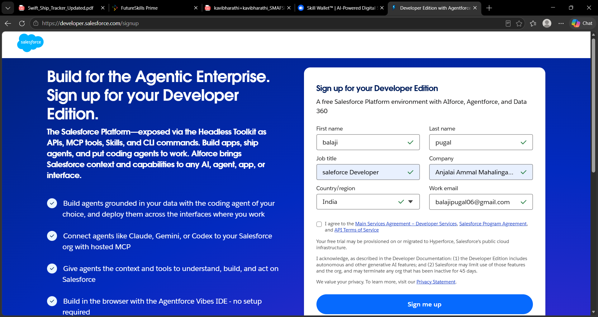
  - Email
  - Job Title: Developer
  - Company: College Name
  - Country: India

Click on sign me up after filling these.

- Go to the inbox of the email that you used while signing up. Click on the verify account to activate your account. The email may take 10-30mins and sometimes 2 hours.
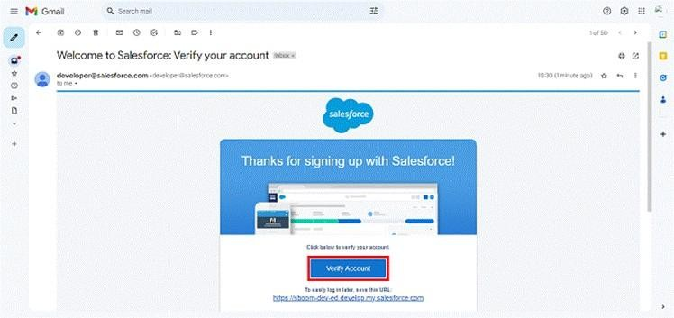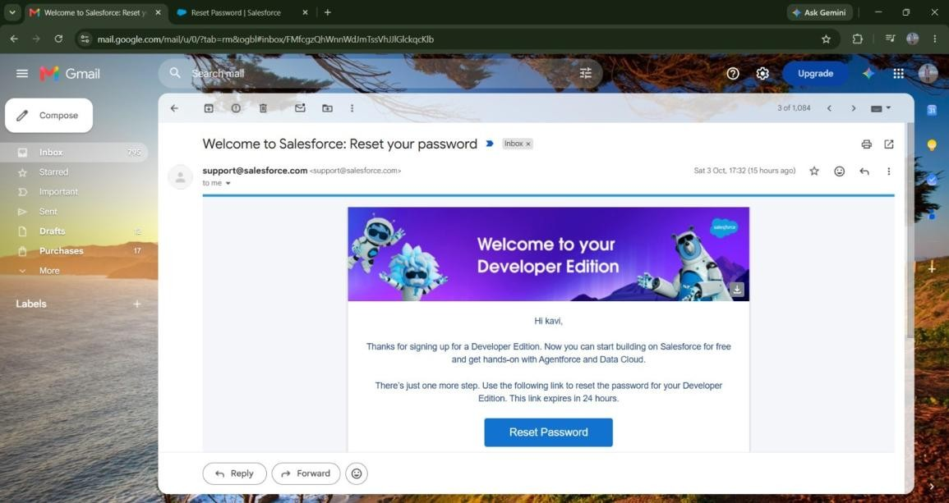

- Click on Verify Account

- Give a password and answer a security question and click on change password.

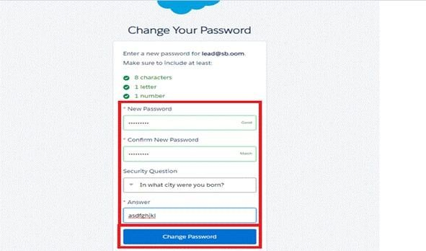

- Then you will redirect to your salesforce setup page.
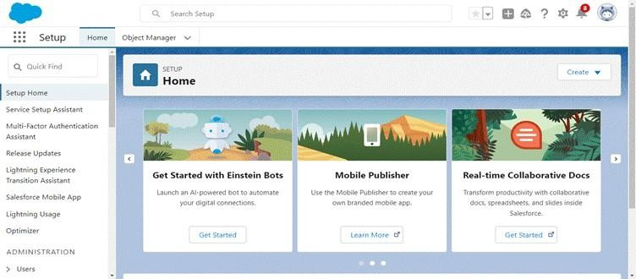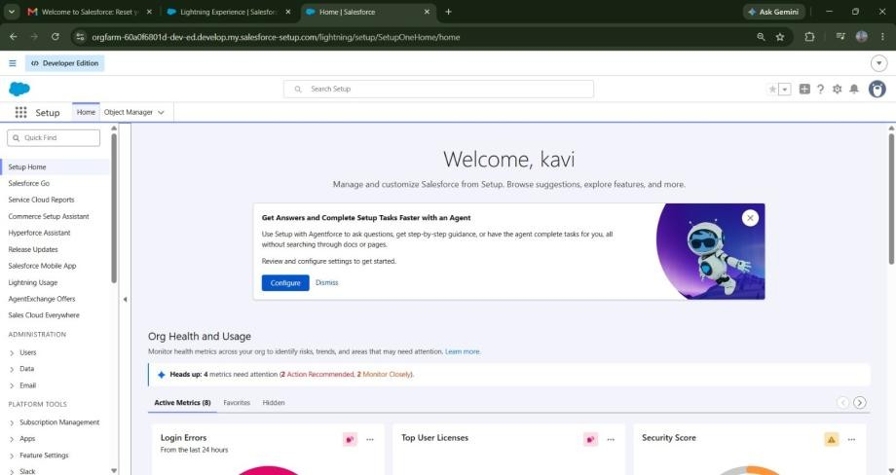

Milestone 2
-

Objects
Creation

To create an object:

- From the setup page
- Click on Object Manager
- Click on Create >> Click on Custom Object.
- Enter the label name as Parcel
- Enter Plural label name as Parcels
- Enter Record Name as Parcel Name 7. Select Data Type as Text: Parcel Name
- Select Allow reports.
- Select Allow search.
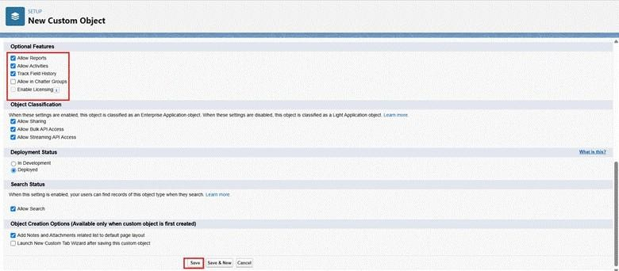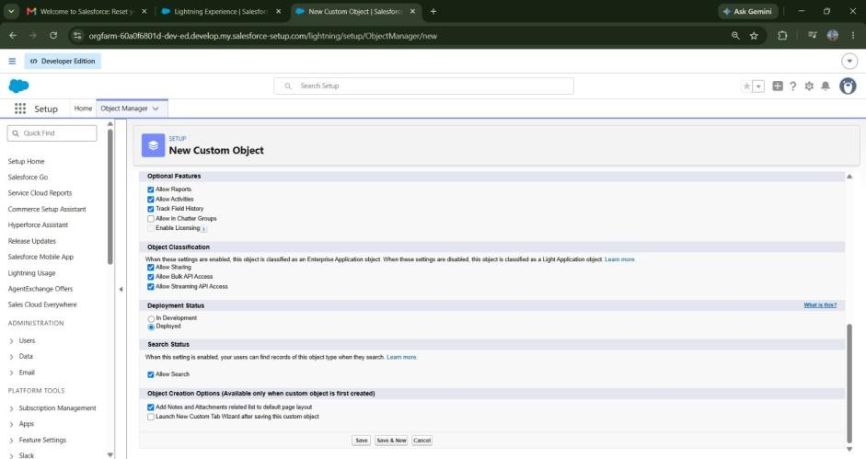
10.

Allow

Track

Field

History

11.

Click on Save and
New

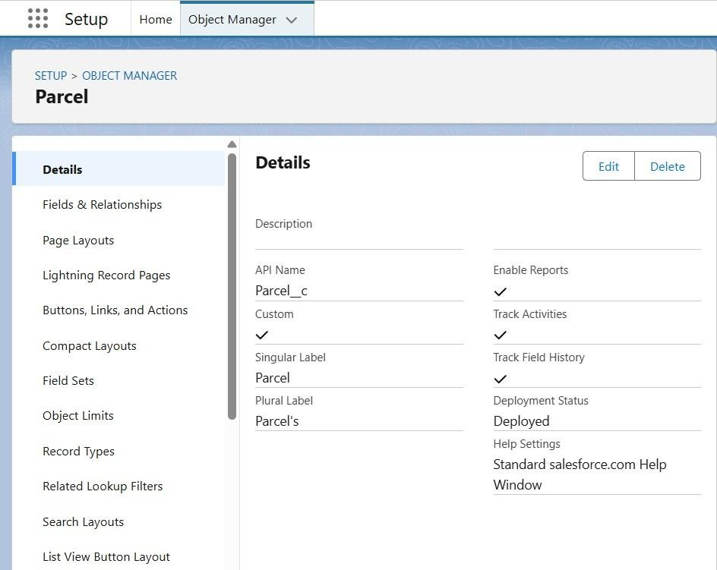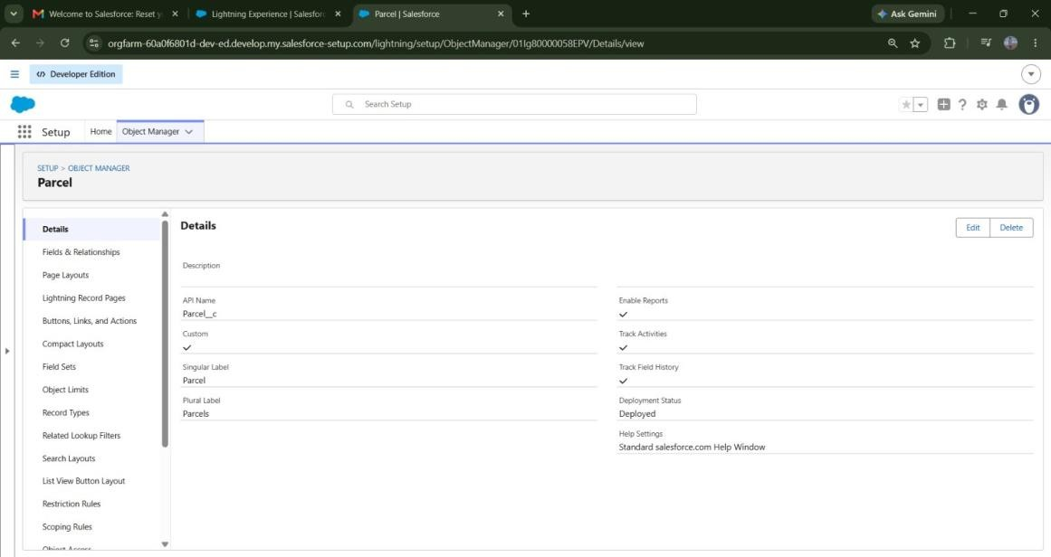

Creating Delivery
Object

To create an object:

- From the setup page

- Click on Object Manager

- Click on Create >> Click on Custom Object.

- Enter the label name as Delivery

- Enter Plural label name as Deliveries

- Enter Record Name as DeliveryName

- Select Data Type as Text: DeliveryName

- Select Allow reports.
- Select Allow search.

- Allow Track Field History

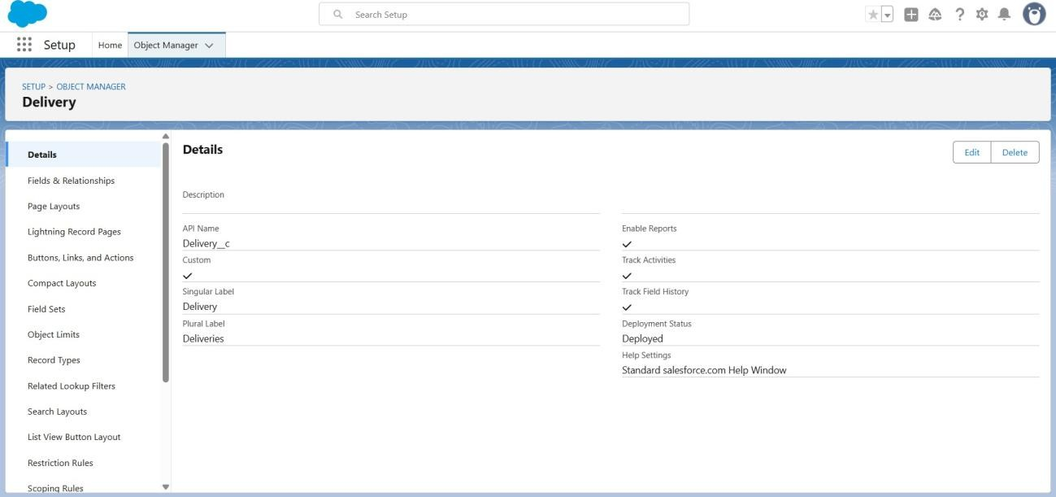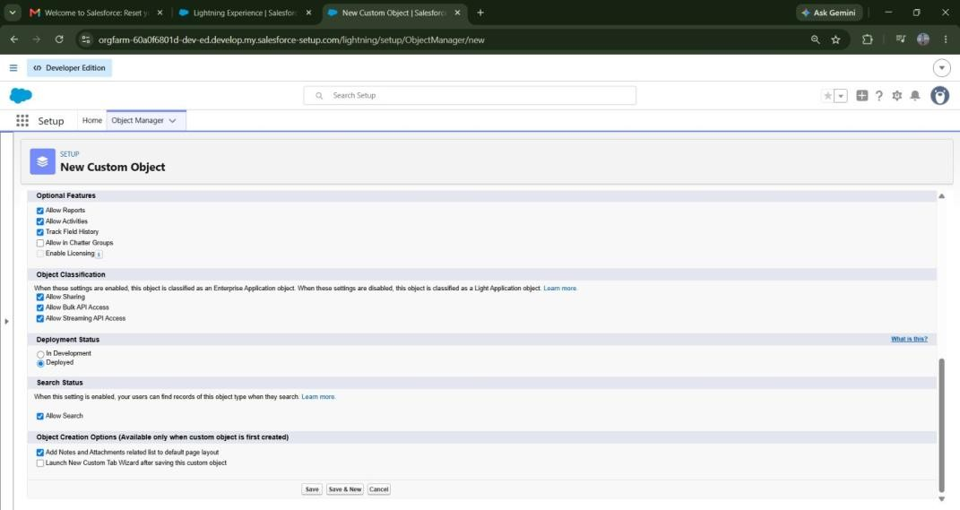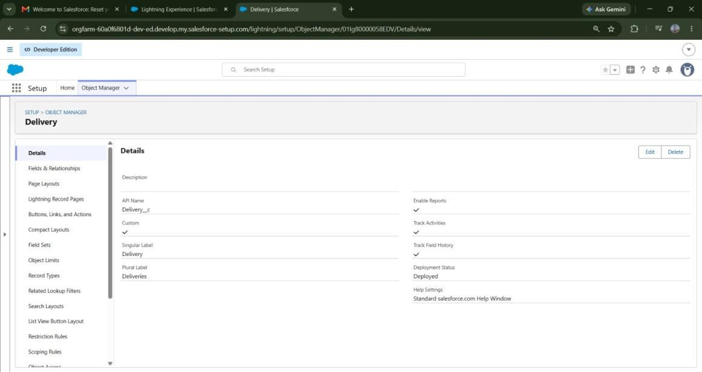
11.

Click on Save and
New

Creating Sender Object To create an object:

- From the setup page

- Click on Object Manager

- Click on Create >> Click on Custom Object.

- Enter the label name as Sender

- Enter Plural label name as Sender's

- Enter Record Name as SenderName

- Select Data Type as Text: SenderName

- Select Allow reports.

- Select Allow search.

- Allow Track Field History

11.

Click on Save and
New

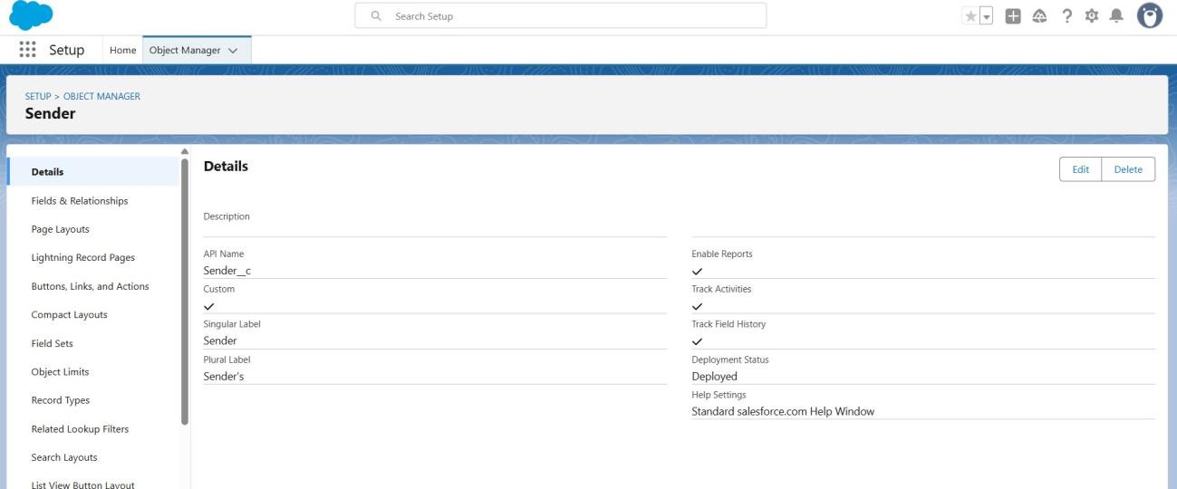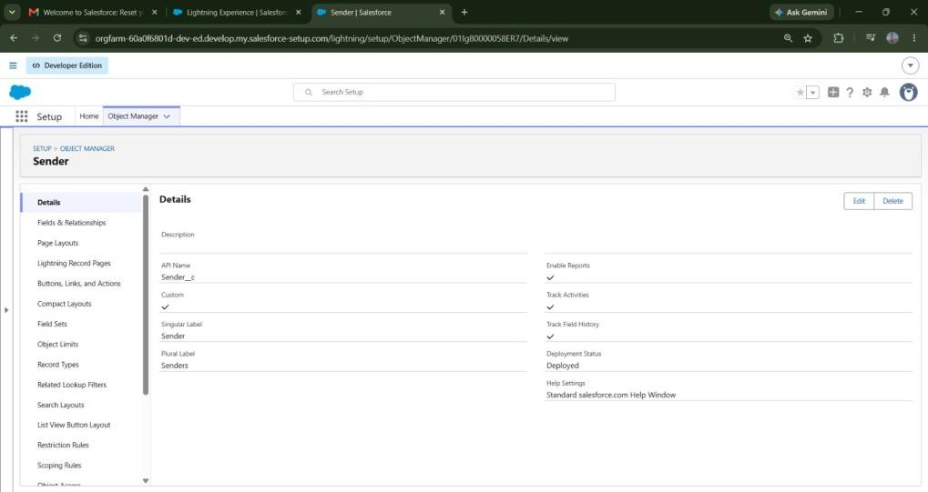

Creating Receiver Object To create an object:

- From the setup page

- Click on Object Manager

- Click on Create >> Click on Custom Object.

- Enter the label name as Receiver

- Enter Plural label name as Receiver's

- Enter Record Name as ReceiverName

- Select Data Type as Text: ReceiverName

- Select Allow reports.

- Select Allow search.

- Allow Track Field History

- Click on Save and New

Milestone 3 - Tabs

Creating a tab for Parecel Object
- Go to the setup page → type Tabs in Quick Find bar

- Click on tabs

- Click on New (under custom object tab).

- Select Object (Parcel) >> Select the tab style

- Click on Next >> (Add to profiles page) keep it as default >> Click on Next (Add to Custom App) uncheck the include tab.
- Make sure that the Append tab to the user's existing personal customizations is checked.
- Click save
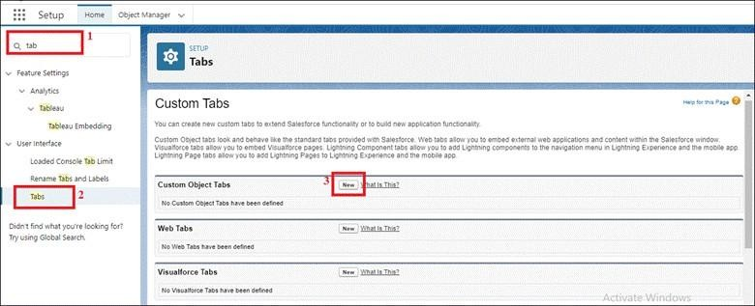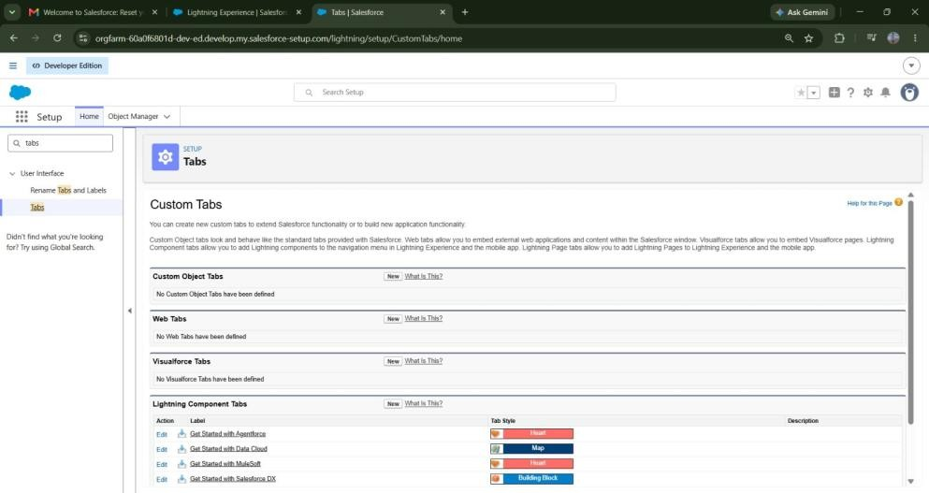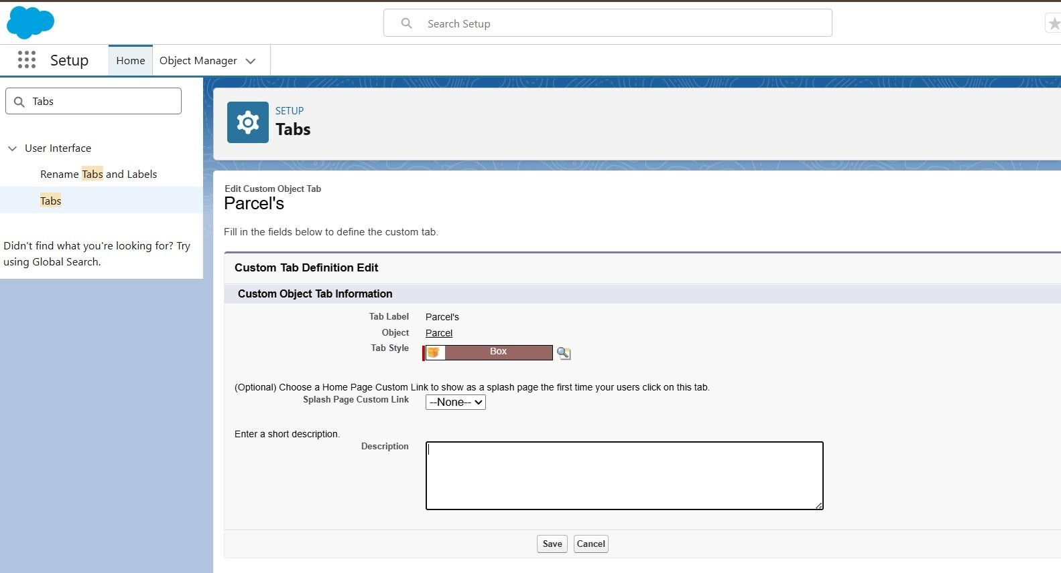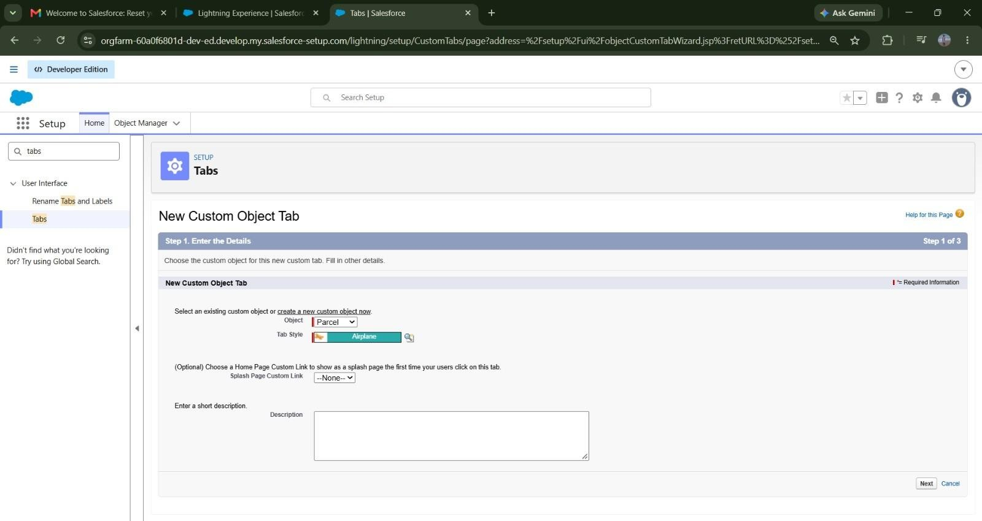

More Tab Creation

- Go to Setup → type Tabs in the Quick Find box.

- Click Tabs under the User Interface section.
- Click New under Custom Object Tabs.
- Select the object (Delivery, Sender, or Receiver) → choose a Tab Style.
- Click Next → keep the Add to Profiles settings as default → click Next.
- On the Add to Custom Apps page, uncheck “Include Tab.”
- Ensure Append tab to the user’s existing personal customizations is checked.
- Click Save and repeat the steps for each object (Delivery, Sender, Receiver).
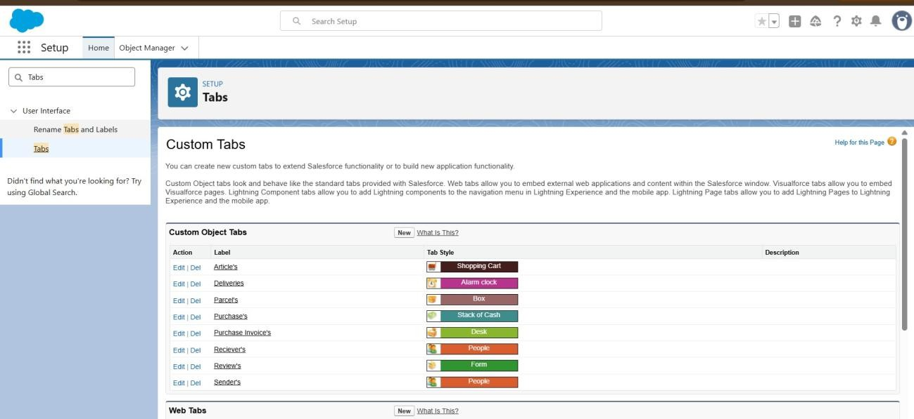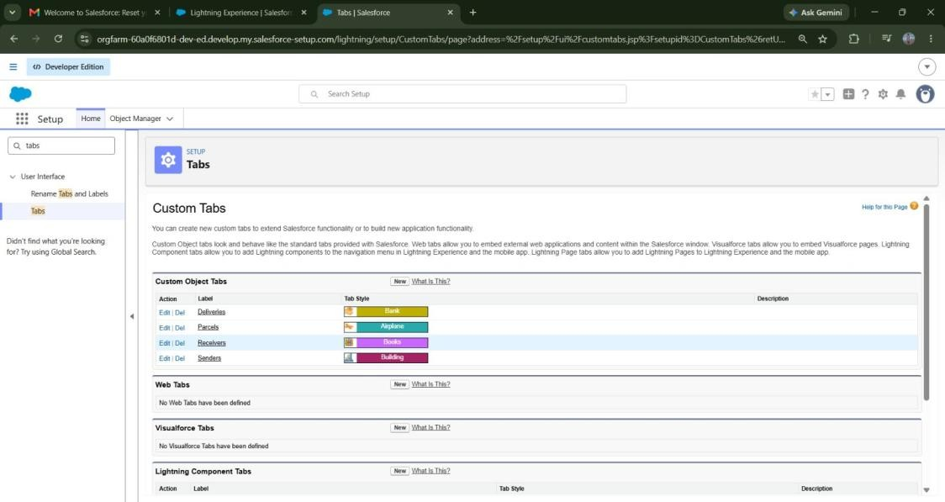

Milestone 4- Fields & Relationships
Create fields and Relationships for the custom objects created in the previous milestone.

Creating Fields and Relationships for Parcel Object

Beside the Quick Find box you have, Object Manager click on it.
1. Search for and select your Parcel object.

Field 1: Parcel ID
- Go to Fields & Relationships → click New Enter:
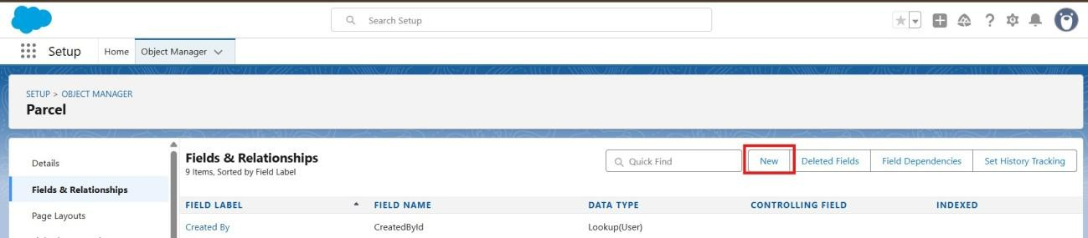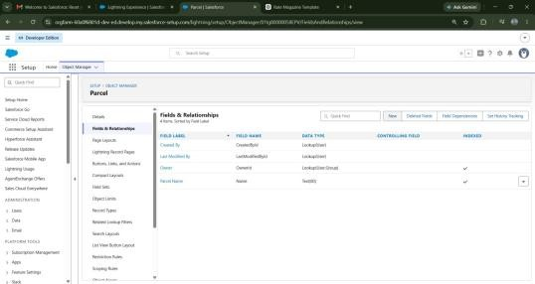
●

Data type== auto number→P
-
{000}

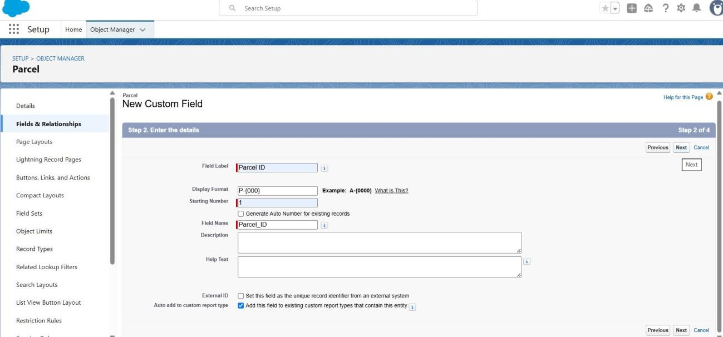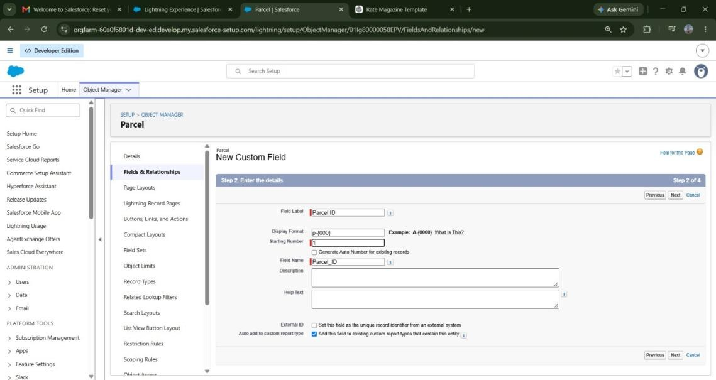

- Click Next → Next → Save & New.

3. Follow step 1 and 2 to create the remaining fields(Status, Weight, Estimated
Delivery, Sender) of the Parcel object mentioned in the table below.)
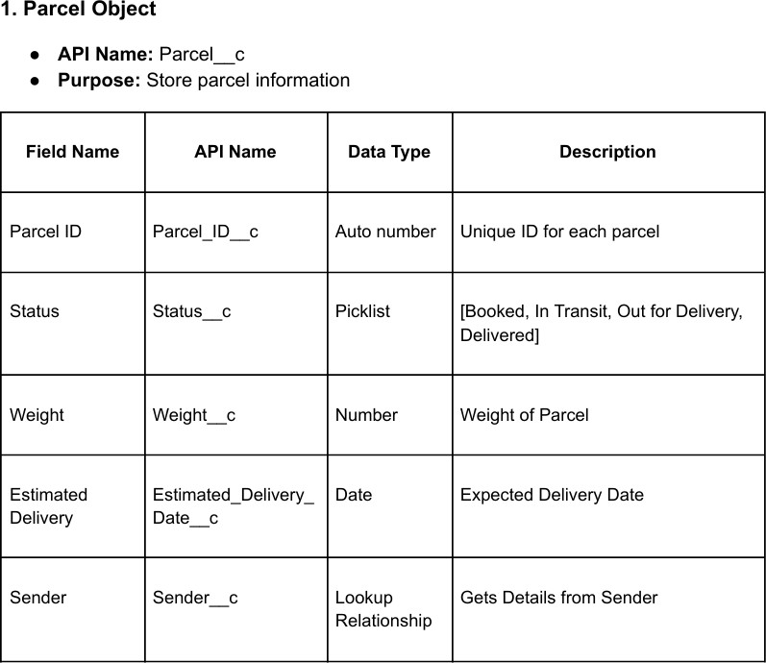

Creating Fields And Relationships For Delivery Object Beside the Quick Find box you have, Object Manager click on it.
1. Search for and select your Delivery object.

Field 1: Current Location

- Go to Fields & Relationships → click New

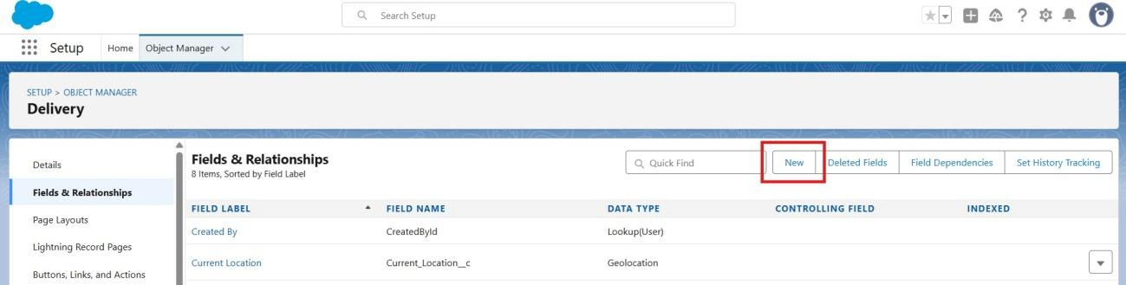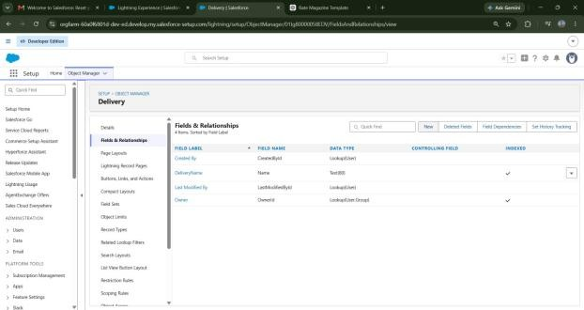
- Choose Data Type: Geolocation → click Next.
Field Label: Current Location
Click Next → Next → Save & New.

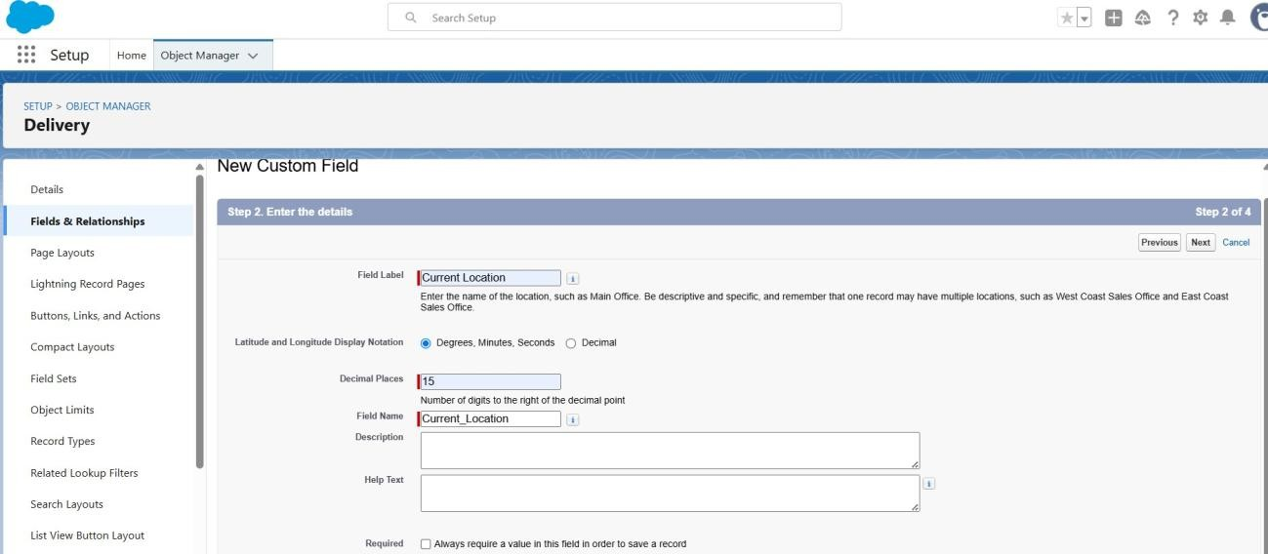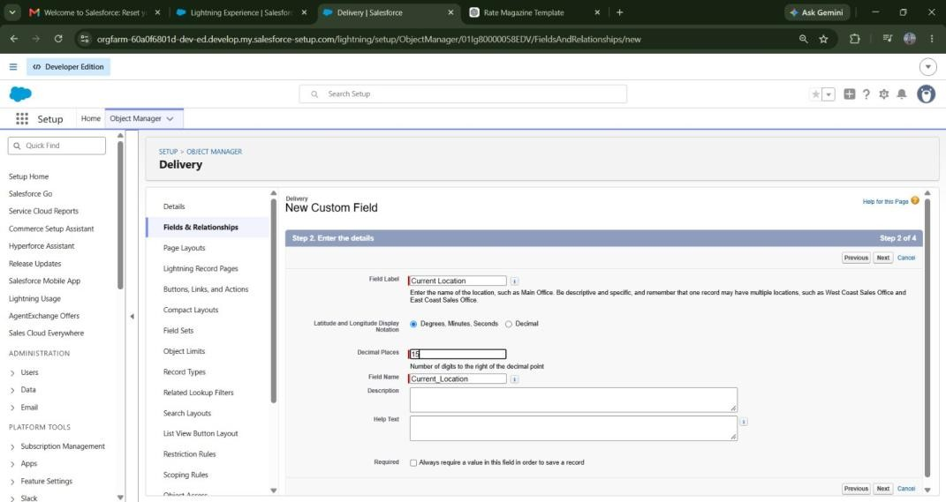

- 3. Follow step 1 and 2 to create the remaining fields(Estimated Delivery, Sender, Parcel) of the Delivery object mentioned in the table below.
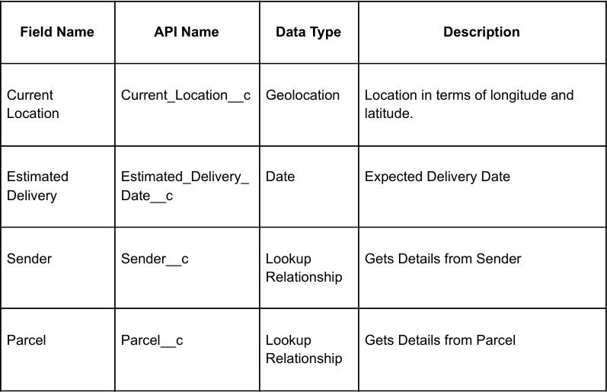

Creating Fields And Relationships For Sender Object
Beside the Quick Find box you have, Object Manager click on it.
1. Search for and select your Sender object.

Field 1: Sender Address

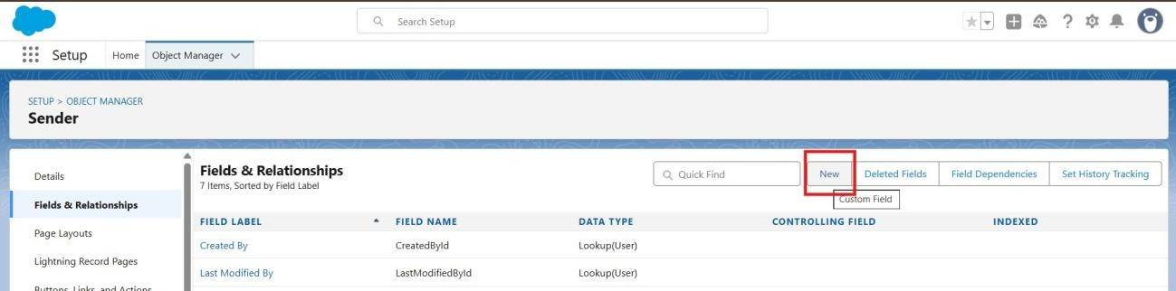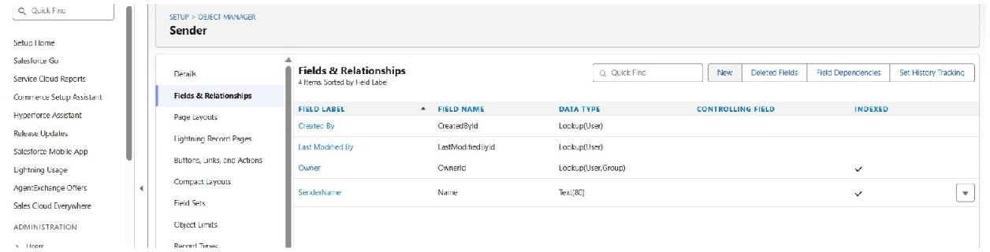
●

Go to Fields & Relationships → click
New

- Choose Data Type: Geolocation → click Next.
Field Label: Sender Address
Click Next → Next → Save & New.

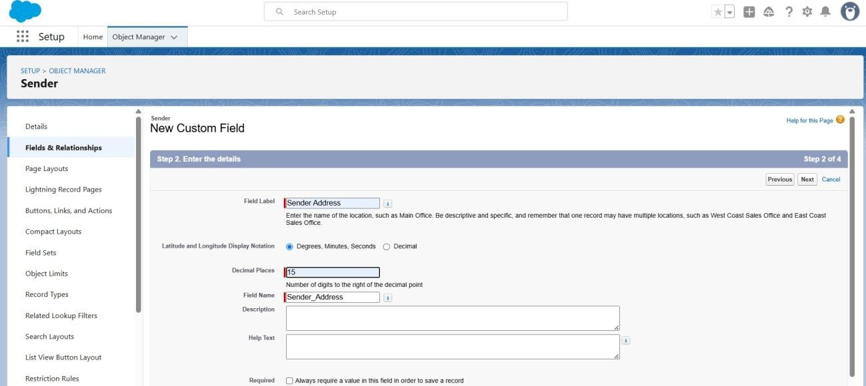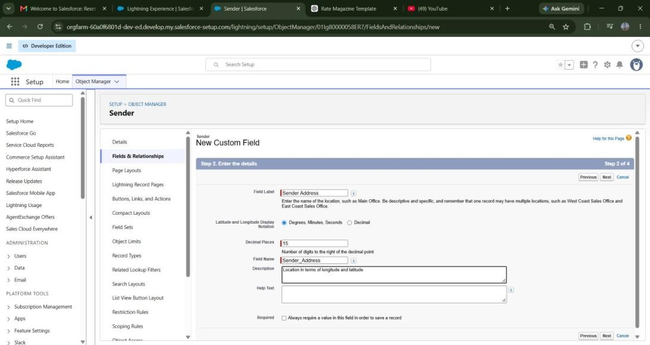

- 3. Follow step 1 and 2 to create the remaining fields (Sender Contact, Sender Email) of the Sender object mentioned in the table below.

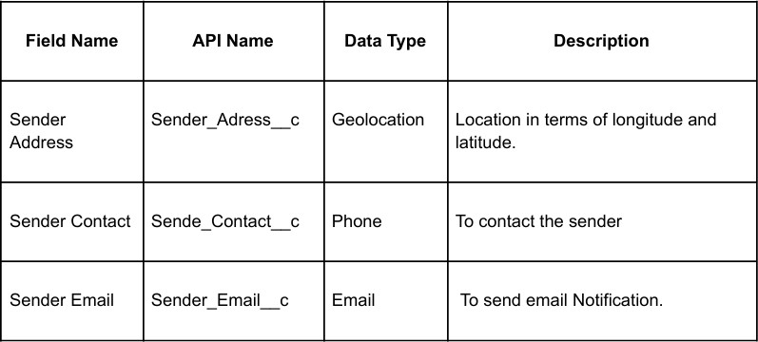

Creating Fields And Relationships For Receiver Object
Beside the Quick Find box you have, Object Manager click on it.
1. Search for and select your Receiver object.
Field 1: Receiver Address

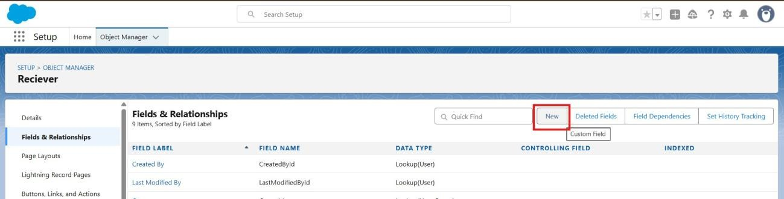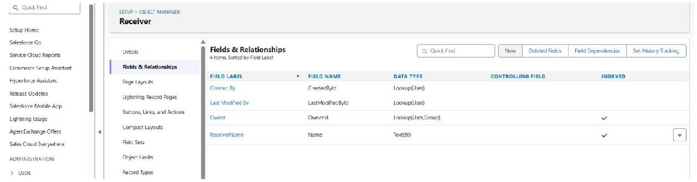
●

Go to Fields & Relationships → click
New

- Choose Data Type: Geolocation → click Next. Field Label: Receiver's Address
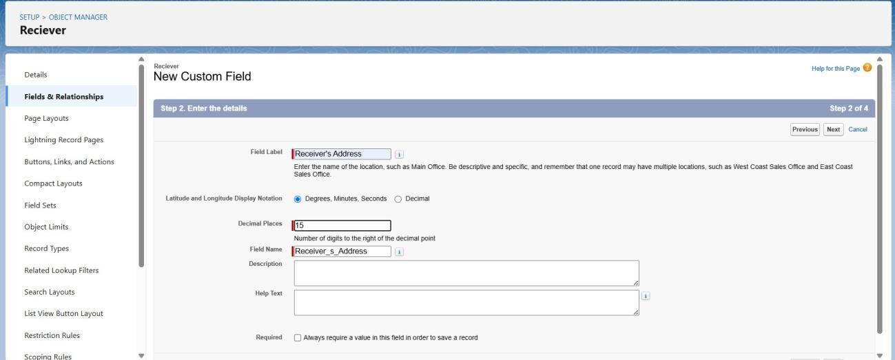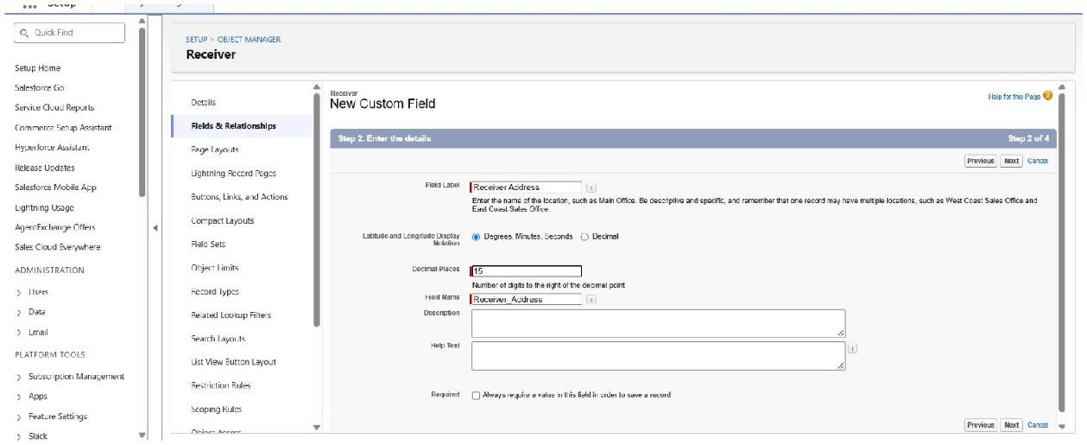
Click Next → Next → Save &
New.

- 3. Follow step 1 and 2 to create the remaining fields (Receiver Contact, Receiver Email, Sender, Parcel) of the Receiver object mentioned in the table below.
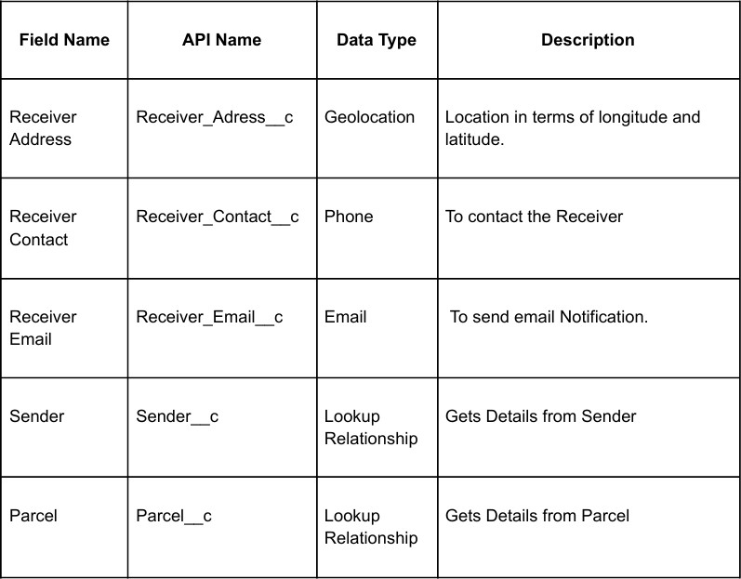

Milestone 5 - Prompt Builder Designing Prompts for Agent Building.
In Salesforce, go to Setup.

- In the Quick Find box, type Prompt Templates (or in Agent Console, go to Agent Builder → Prompt Templates).
- Click New Prompt Template.-- Record summary template
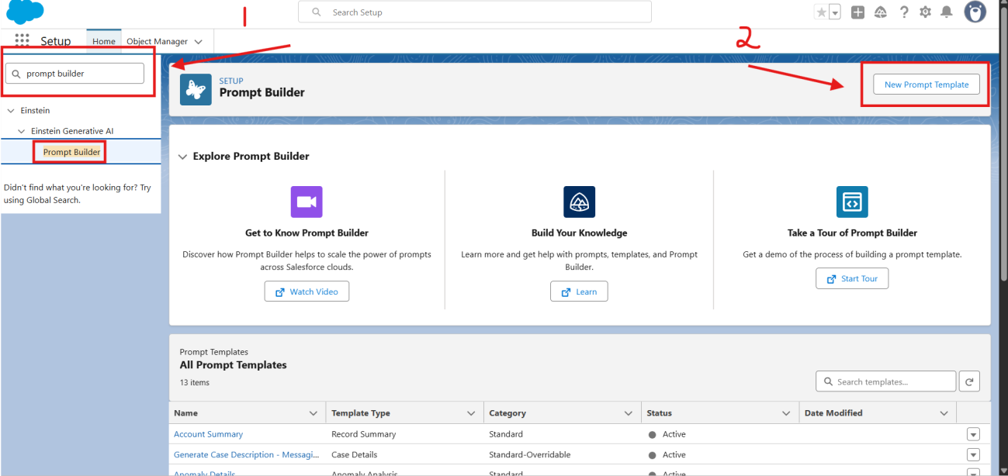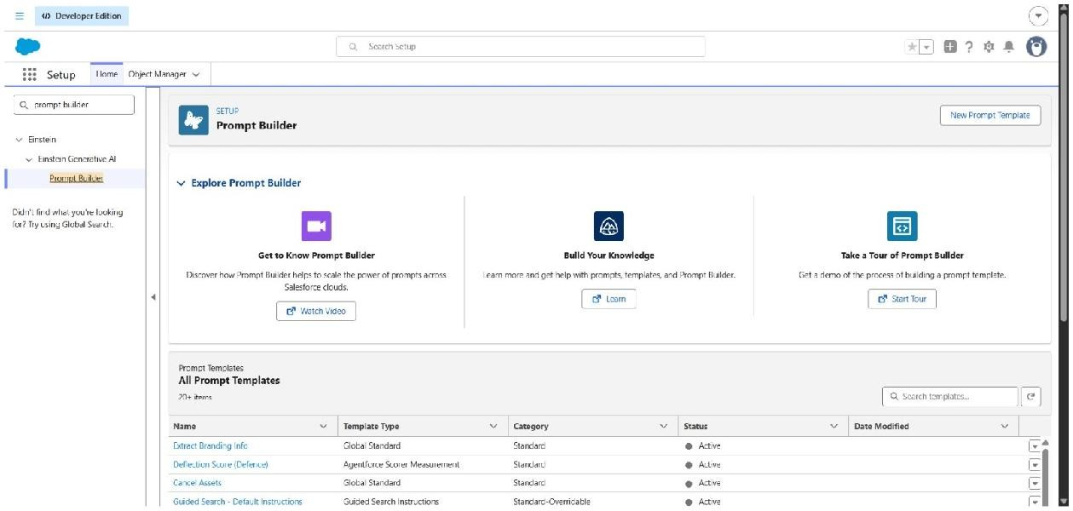

4. Enter the details
- Label: Retrieve Parcel Details
- API Name: Retrieve_Parcel_Details
- Description: Retrieves parcel details where Parcel_ID matches the user input.

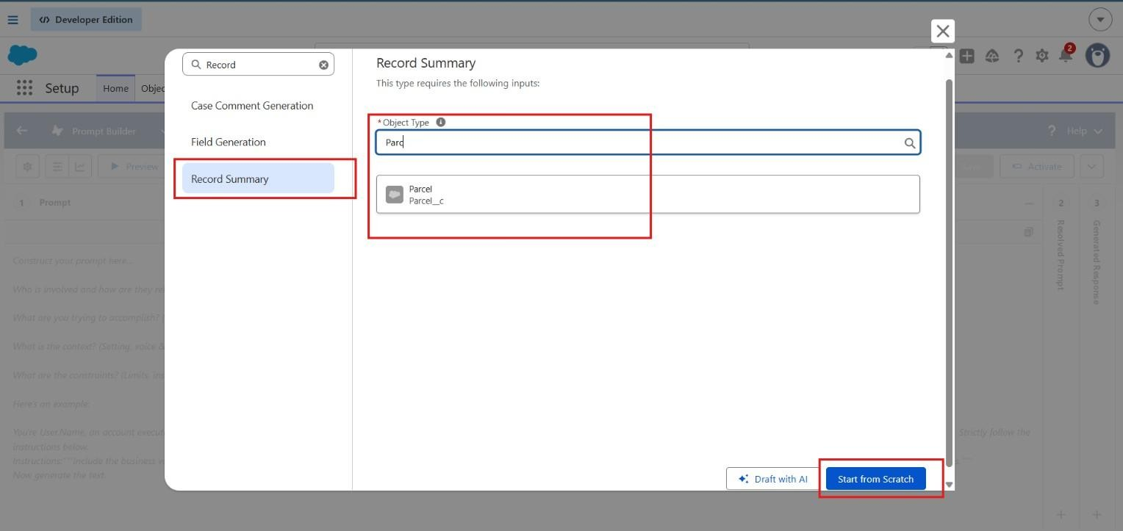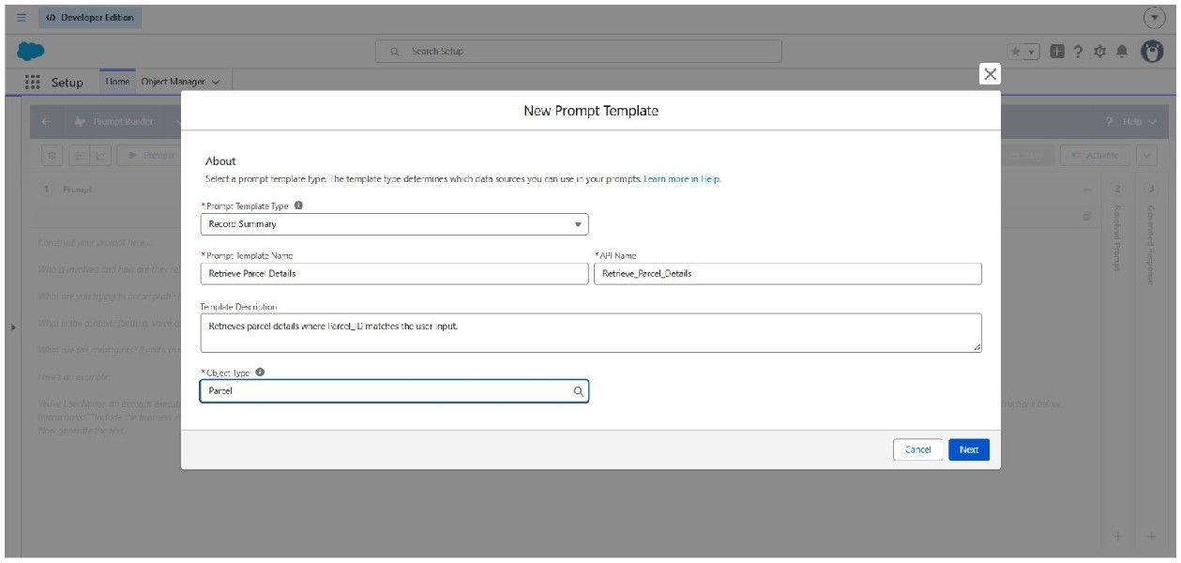

5. Enter the Prompt Template Content

In the Prompt Template Text area, paste the following exactly:
Retrieve details from Parcel c where Parcel_ID c matches user input. Return response in this format:
Parcel Tracking Update

Parcel Tracking Update

- Parcel Name:{!$Input:Parcel c.Name}

- Parcel ID:{!$Input:Parcel c.Parcel_ID c}

- Status:{!$Input:Parcel c.Status c}

- Weight:{!$Input:Parcel c.Weight c}

- Estimated Delivery Date:{!$Input:Parcel c.Estimated_Delivery_Date c}

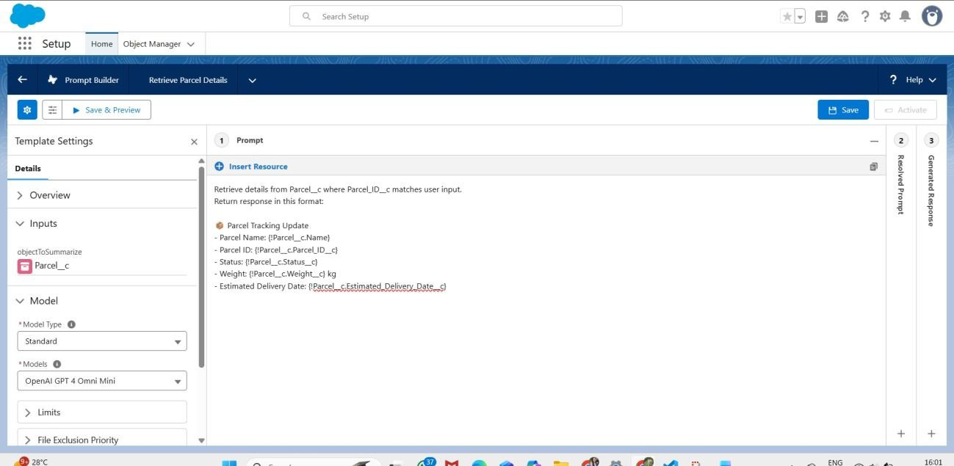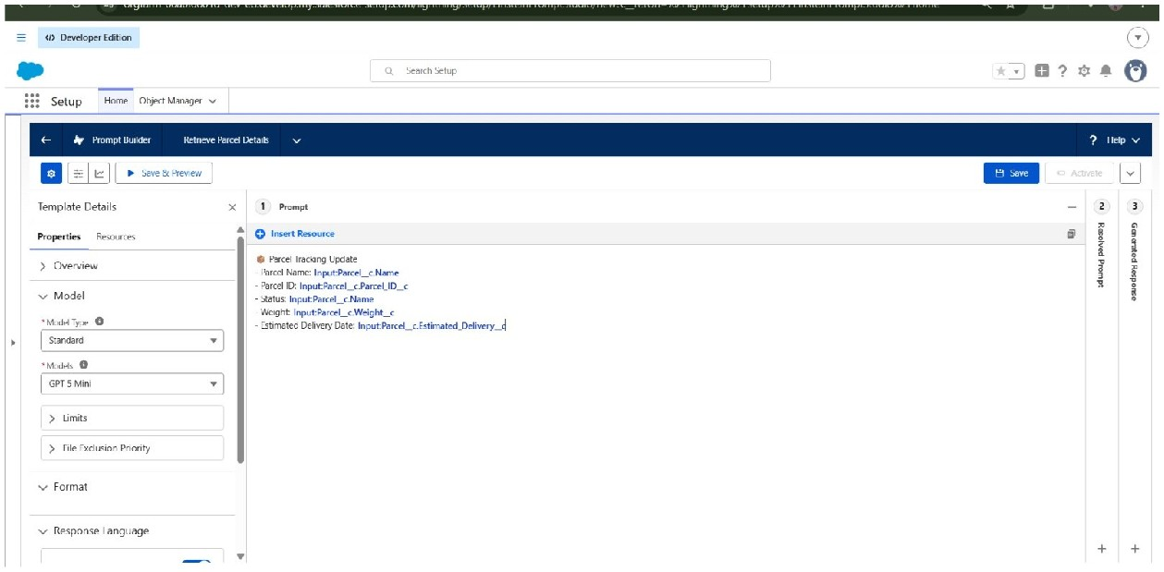

  - Add Resource Mapping
  - Scroll down to the Resources / Insert Resources section.
  - Click Insert Resource → choose Object.
  - Select Parcel c.
  - Add the following fields:
  - Name
  - Parcel_ID c
  - Status c
  - Weight c
  - Estimated_Delivery_Date c

Click Insert Resource (or Add) for each one.
- Click Save.
- Then click Activate to make this Prompt Template available for your agent or flow.
Testing the Prompt

Test the Prompt:

- Open your Agent preview.
- Type: “Track parcel P-12345”.
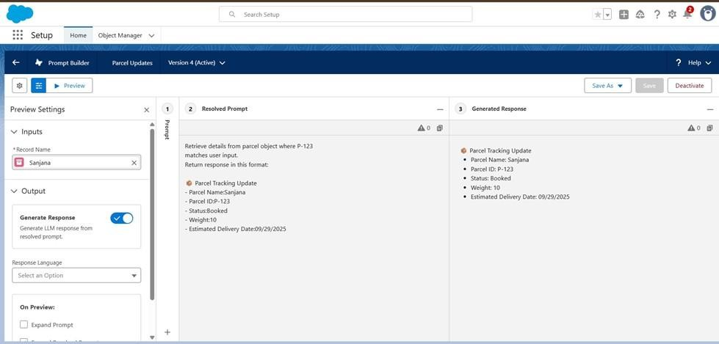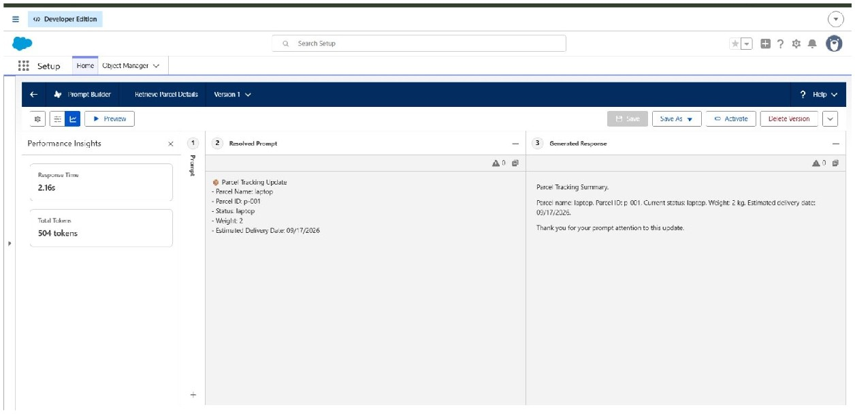
3.

It should return details from the Parcel
record.

Milestone 6 - Flows

Create flows for capturing the response as shown.

Go to Setup → search Flows → click New Flow.
1. Choose Auto-Launched Flow (No Trigger) → click Create
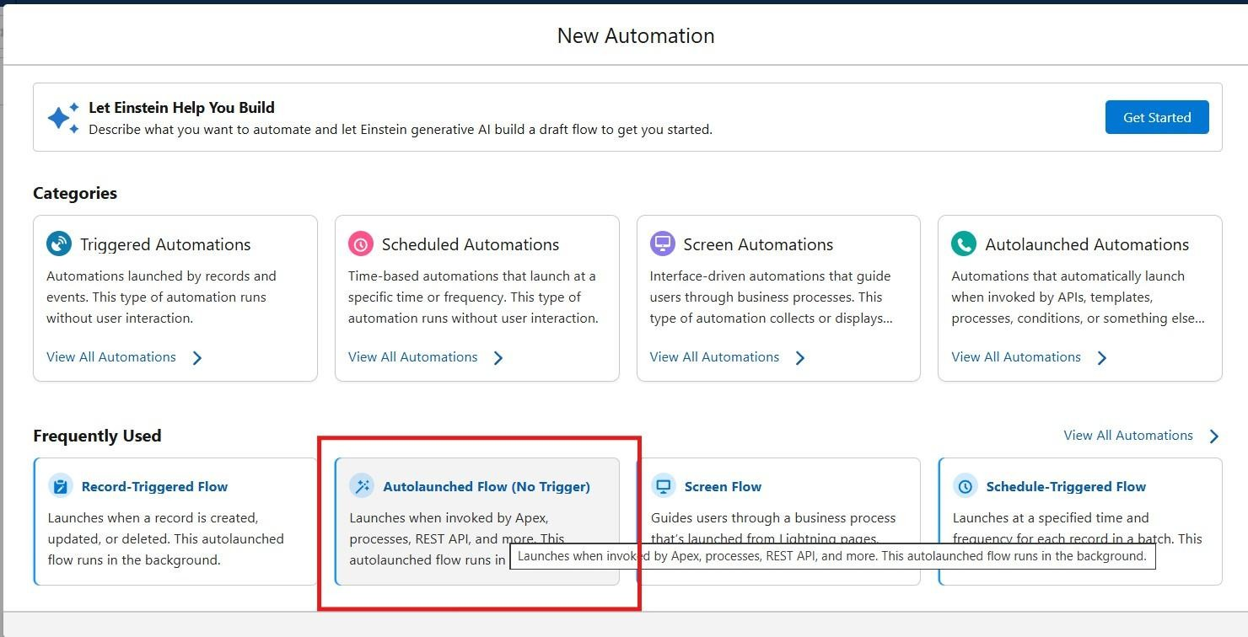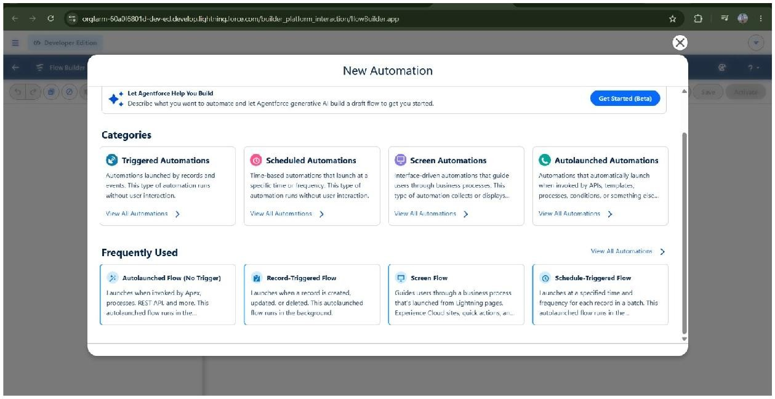

- Add Input Variables (to allow Agent to pass values):

  - Click On New Recourse →Variable → Available for Input.

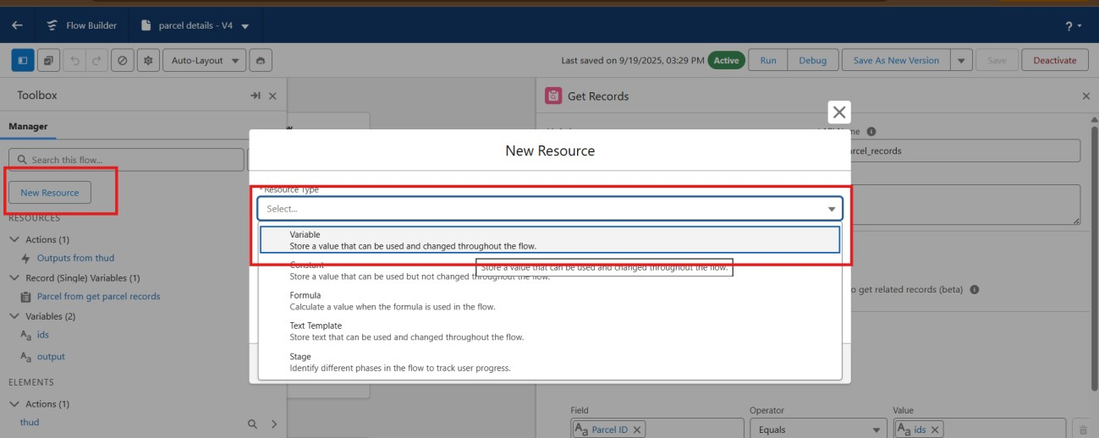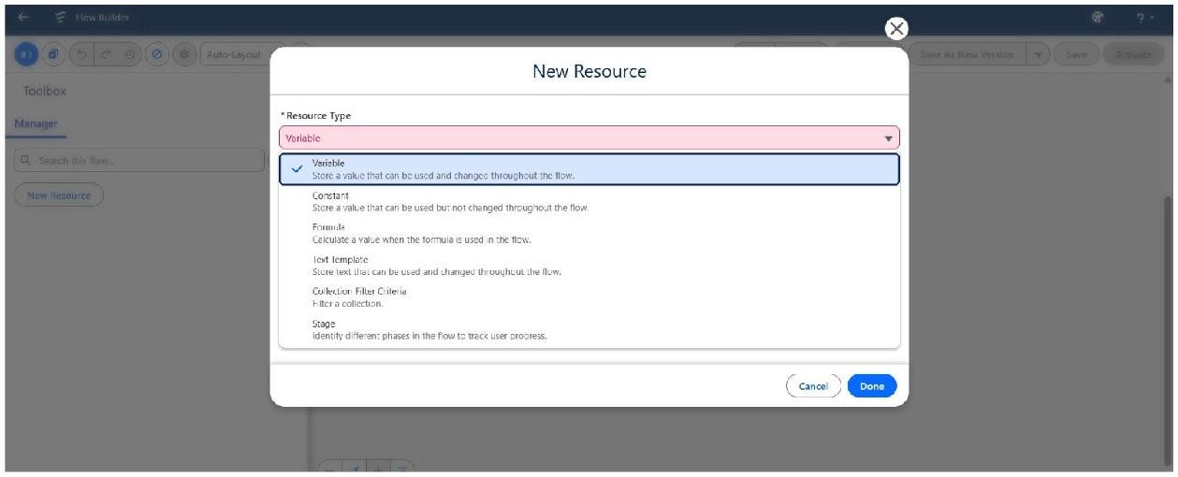

  - Ids → Data Type: Text → Available for Input.
  - Output → Data Type: Text → Available for Output.
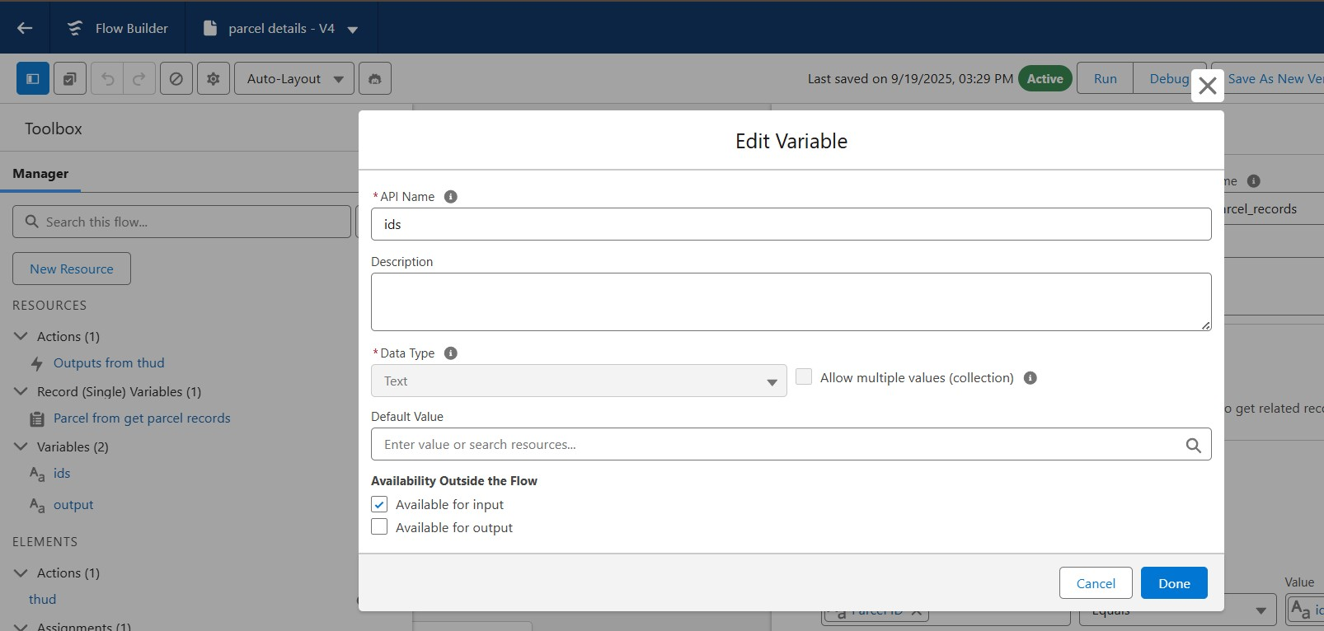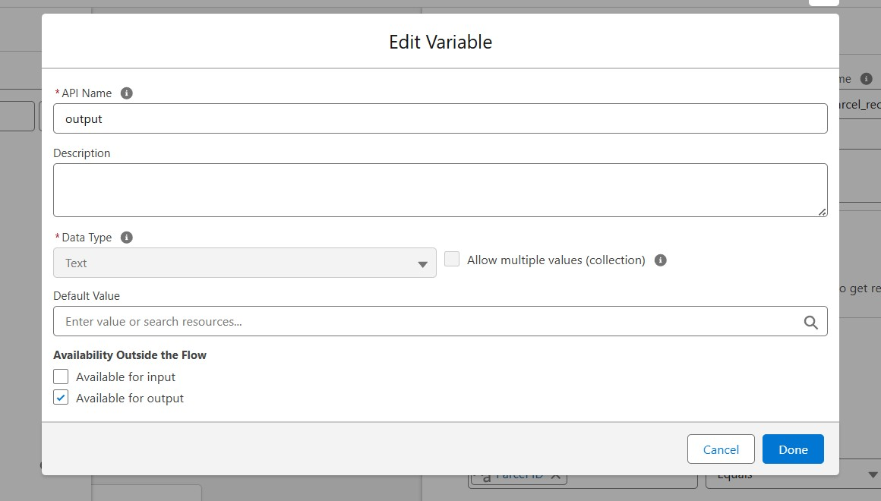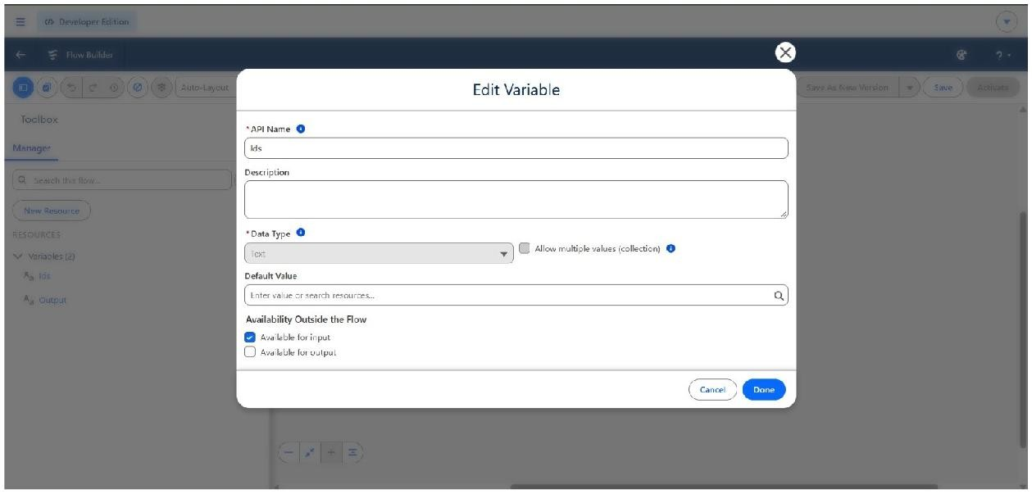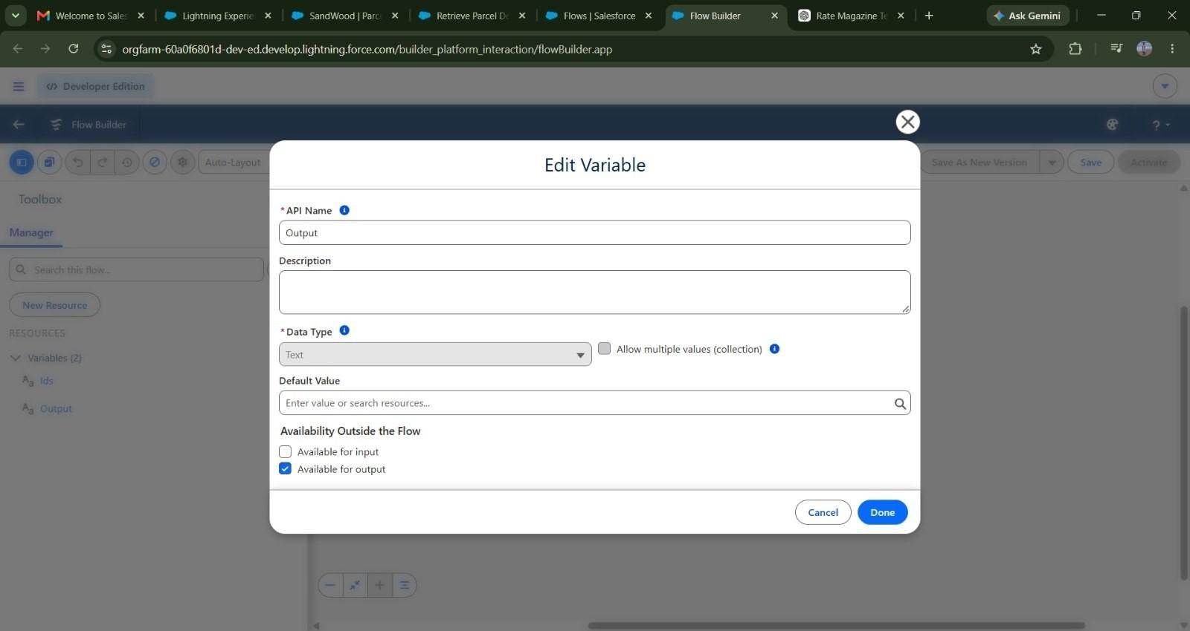

- Click on the Add icon to add Element: Get Records→ Label: Get Parcel Records
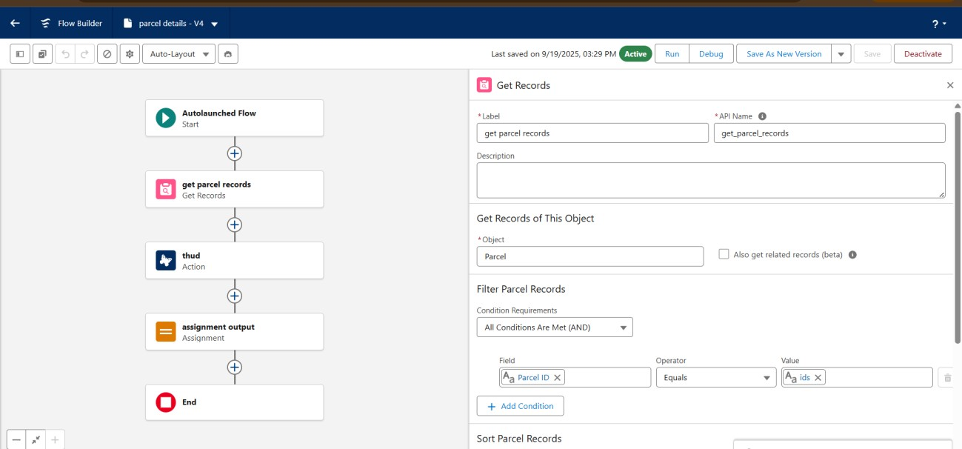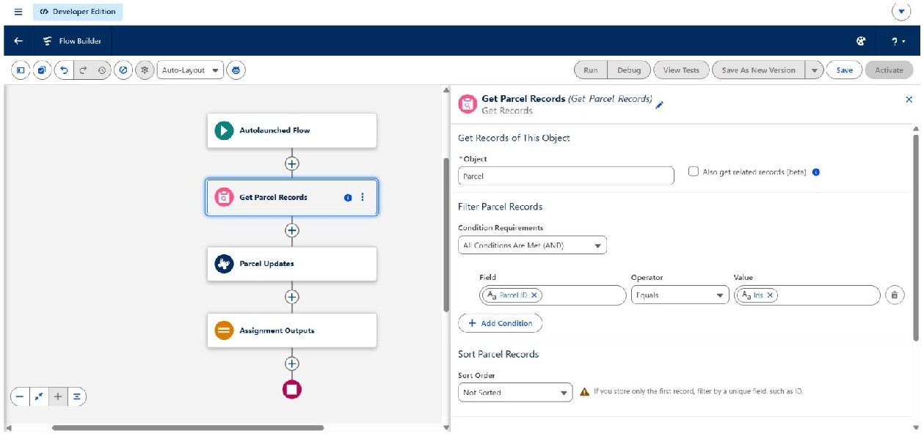

  - Object: Parcel
  - Field = Parcel_ID c
  - Operator = Equals
  - Value = ids

- Element : Action

1. Find Retrieve parcel details 2. Click Retrieve parcel details ● Label: Parcel Updates.
  - Object To Summarize : Parcel from get Parcel records.
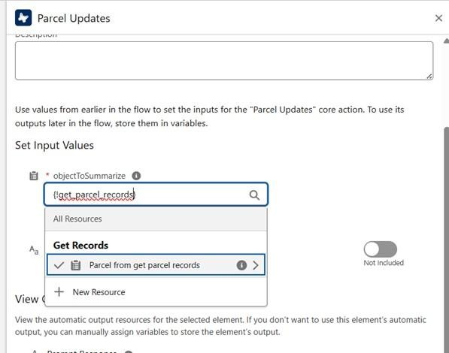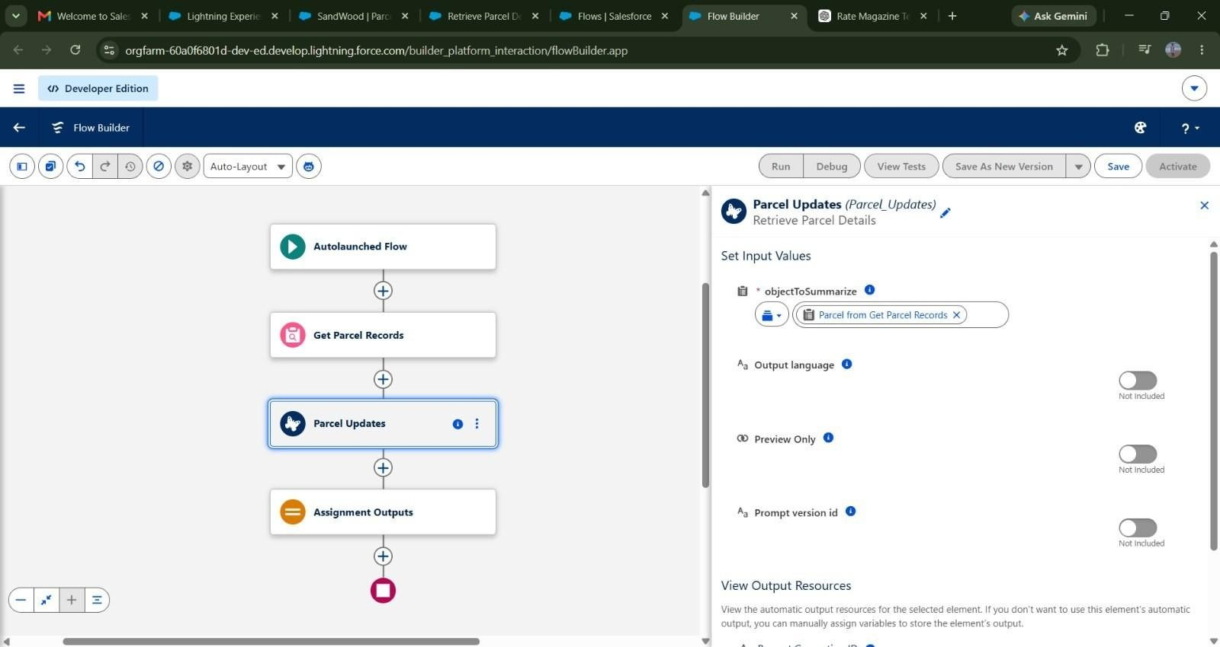

6.

Element :
Assignment

  - Label: Assignment Outputs.
  - Variable= Output
  - Operator = Equals
  - Value = Outputs from Action>Prompt Response
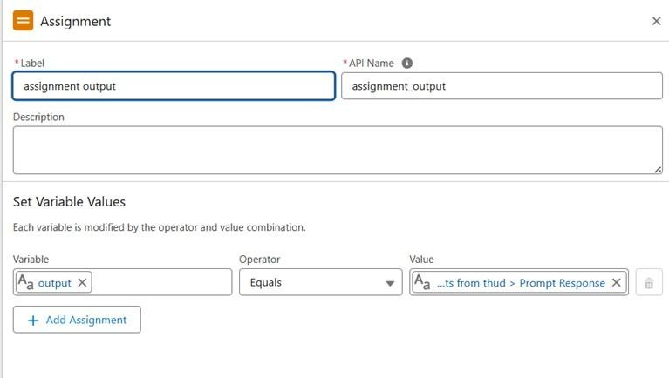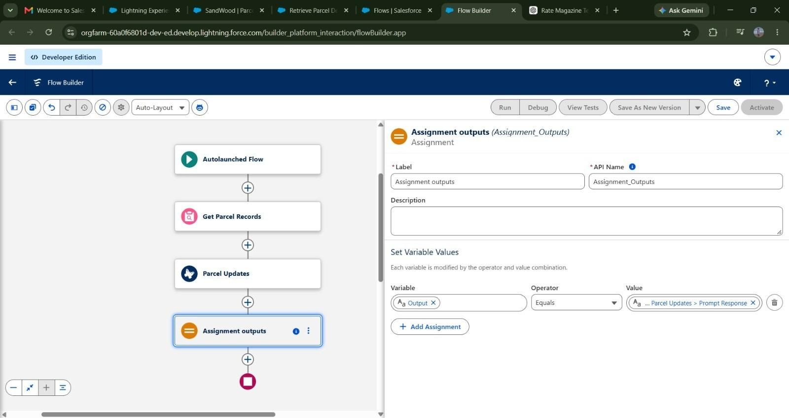

- Connect Start → Get Records → Action → Assignment → End.

- Save Flow → Name: Parcel Details.

- Activate Flow.
- Once the flow is saved go back to the flows, Click on the drop down near the flow that is just created, click on edit access.

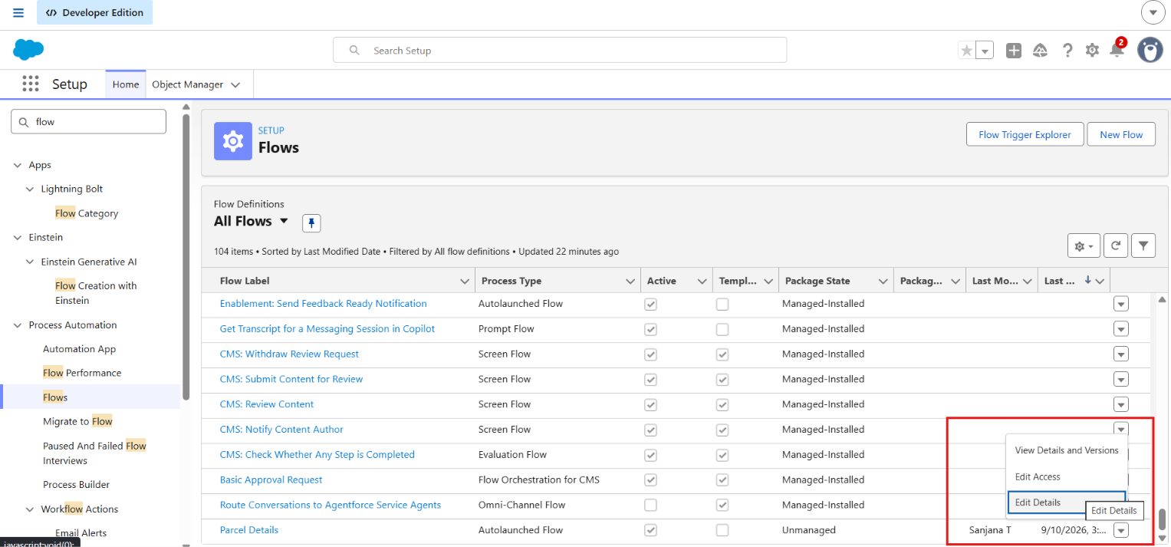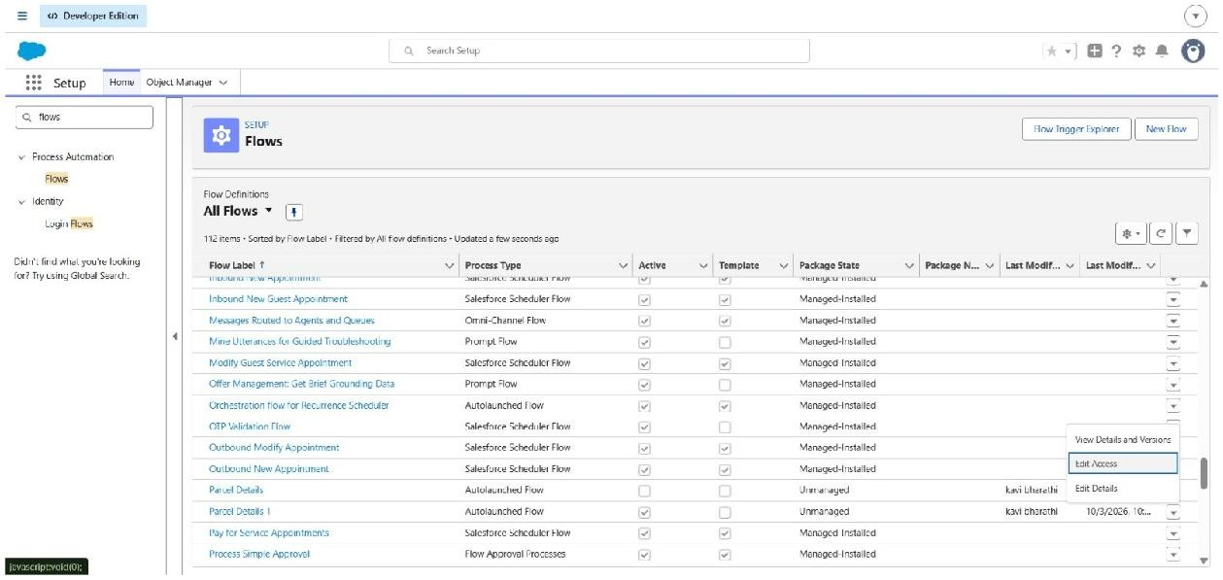
- On the top look for flow user access and then assign these available profiles, and click save.

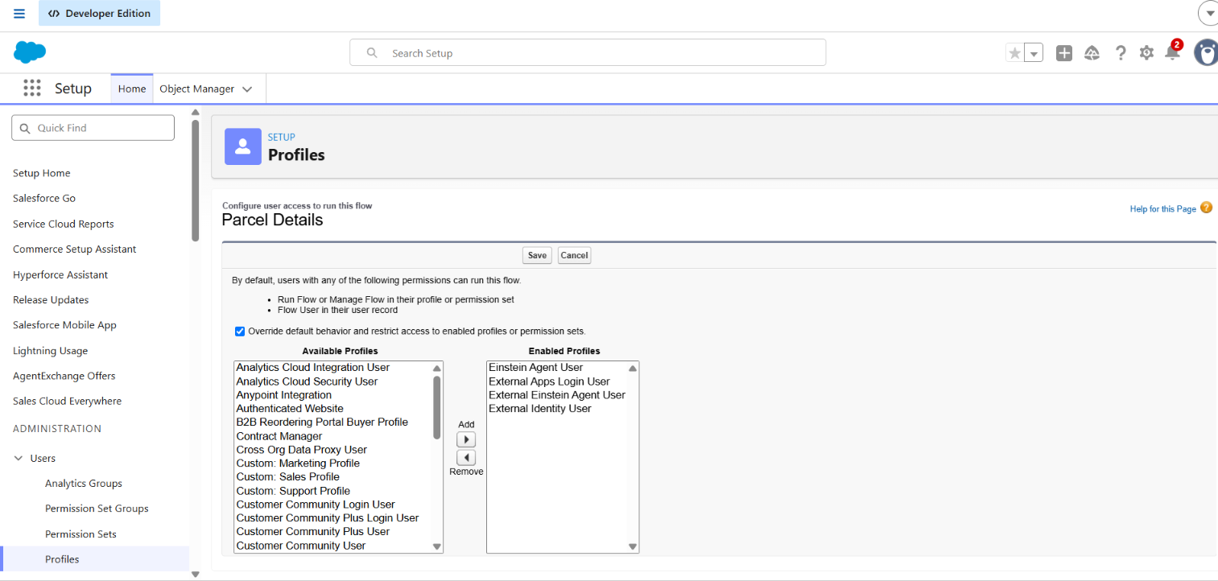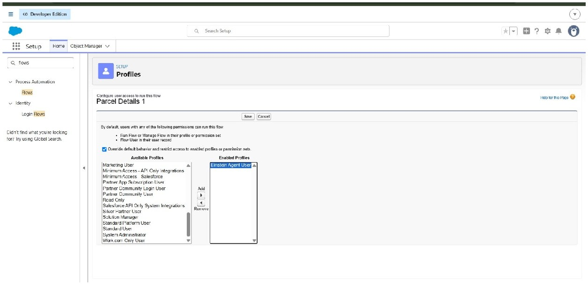

Phase 3: UI/UX Development & Customization

To enable agents to efficiently manage parcel operations and ensure secure access control using permission sets and AI-driven agent experiences built with AgentForce.

Milestone - 1 Creating Permission Sets
In the Quick Find box (left side), type Permission Sets.
1. Click Permission Sets under Users.

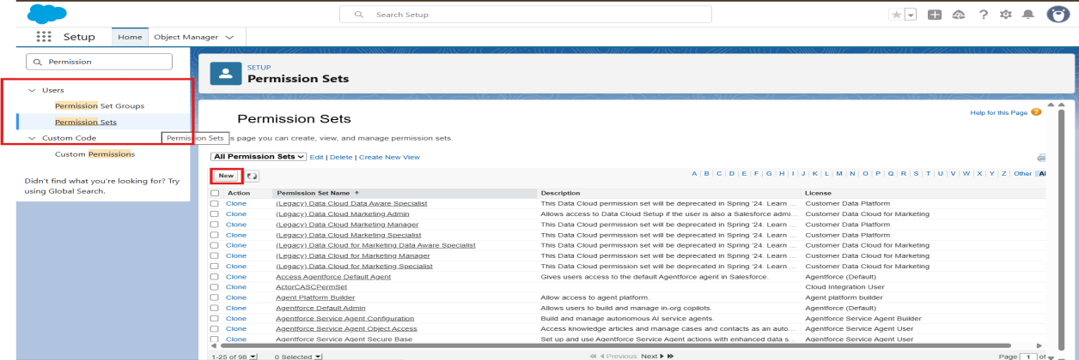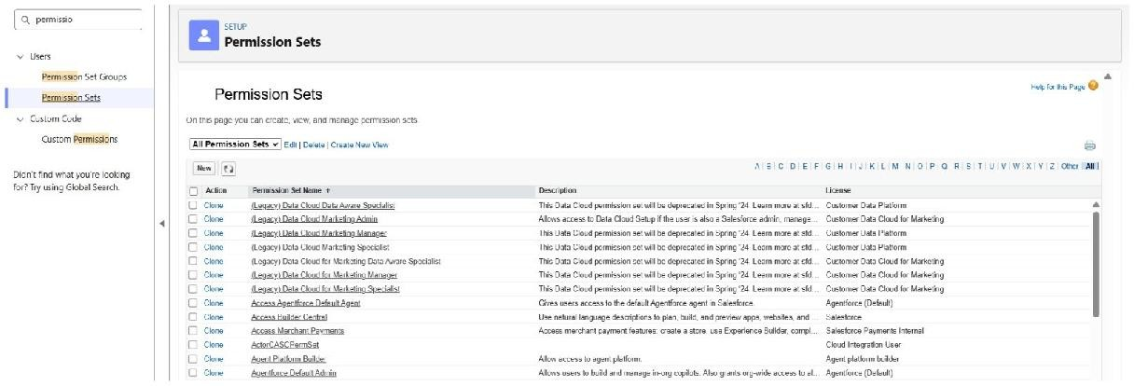

  - Click the New button.
  - Enter the following details:
  - Label: Swift Ship
  - API Name: auto-fills
  - License: Choose Einstein Agent.
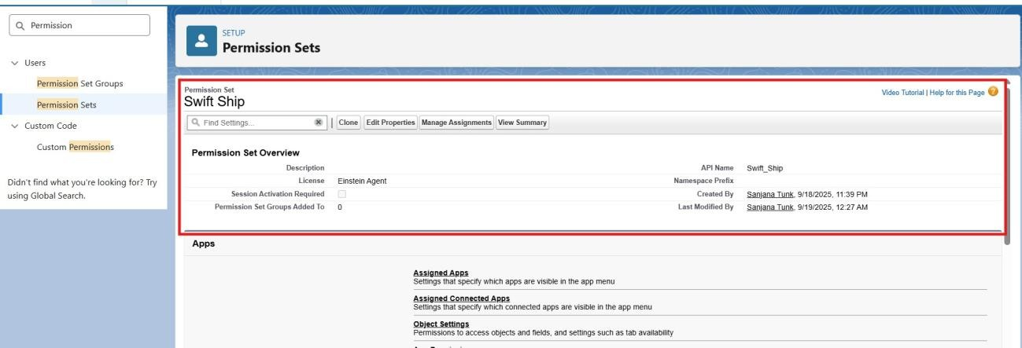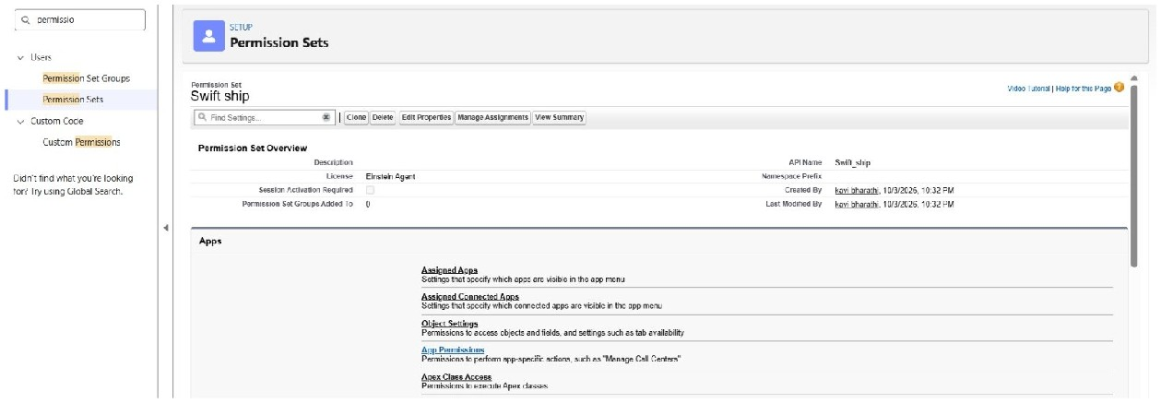
3.

Click
Save
.

1. Inside the Permission Set page → under Apps → Object Settings, click Object Settings.

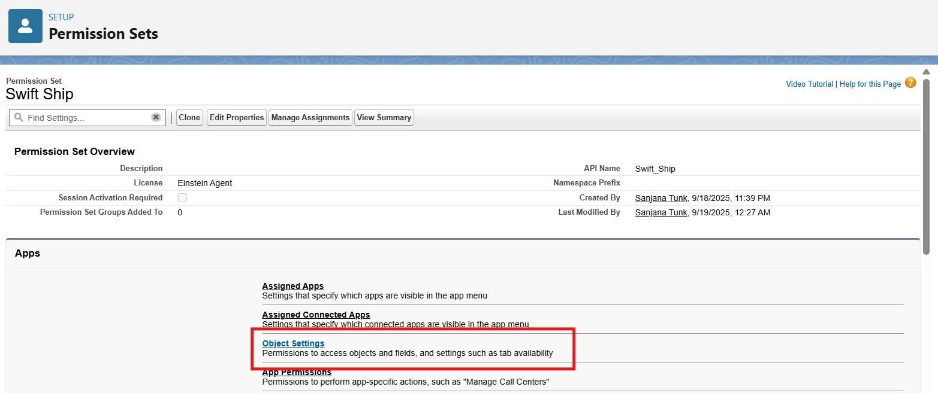

  - Search and click each object one by one
  - Click Edit.

Enable the following:
Read
Create
Edit
(Optional: Delete, if you want agents to remove records)

Under Field Permissions, ensure at least Visible is checked for all key fields.
Click Save after each object.
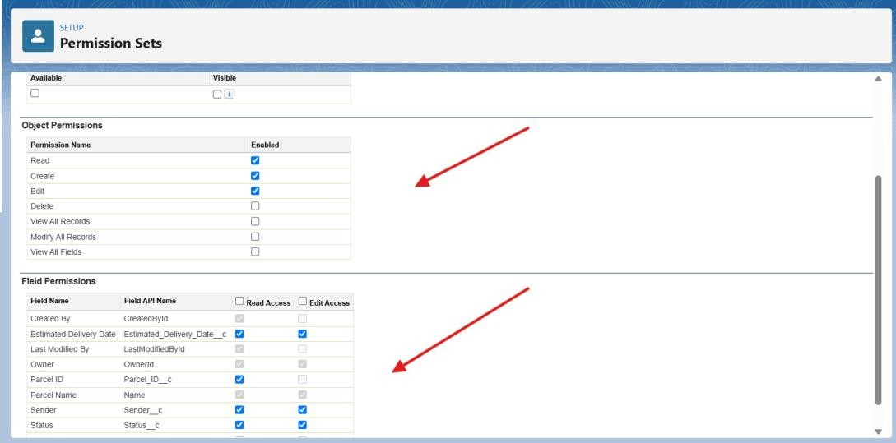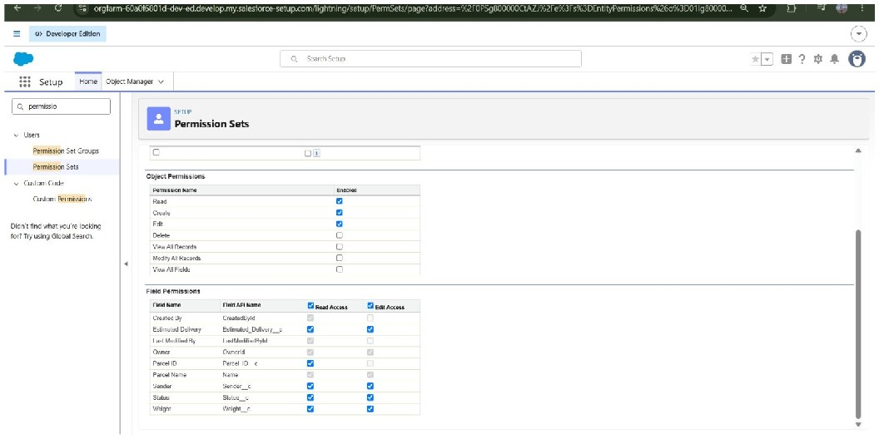
Parcel

c

Delivery

c

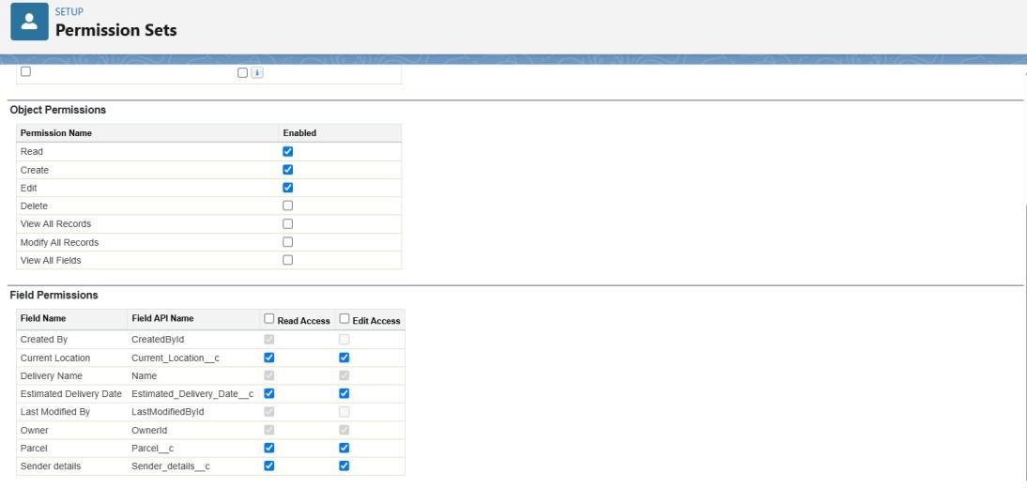

Sender c
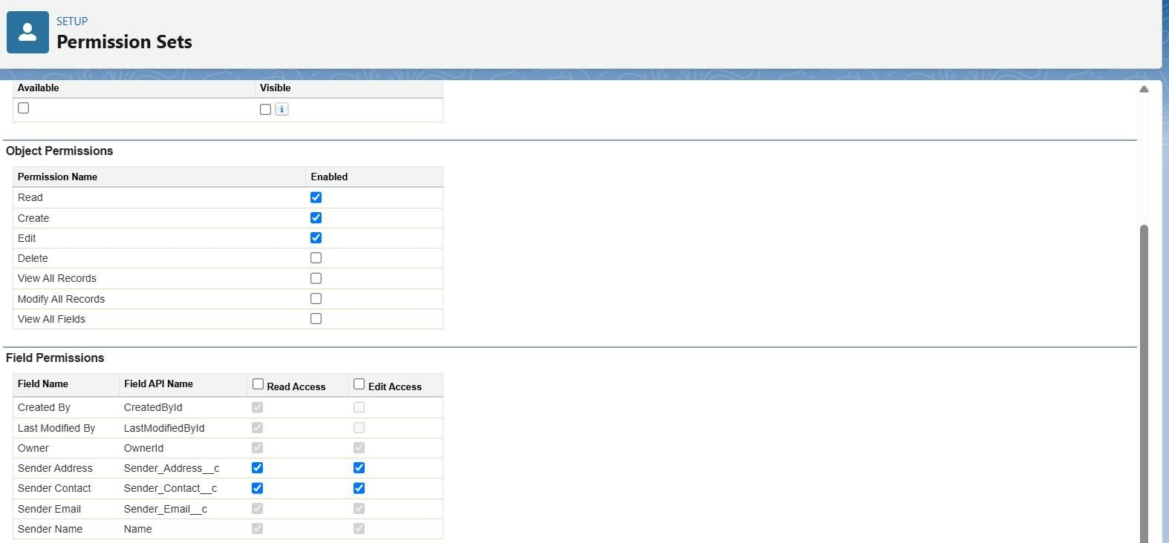

Receiver c

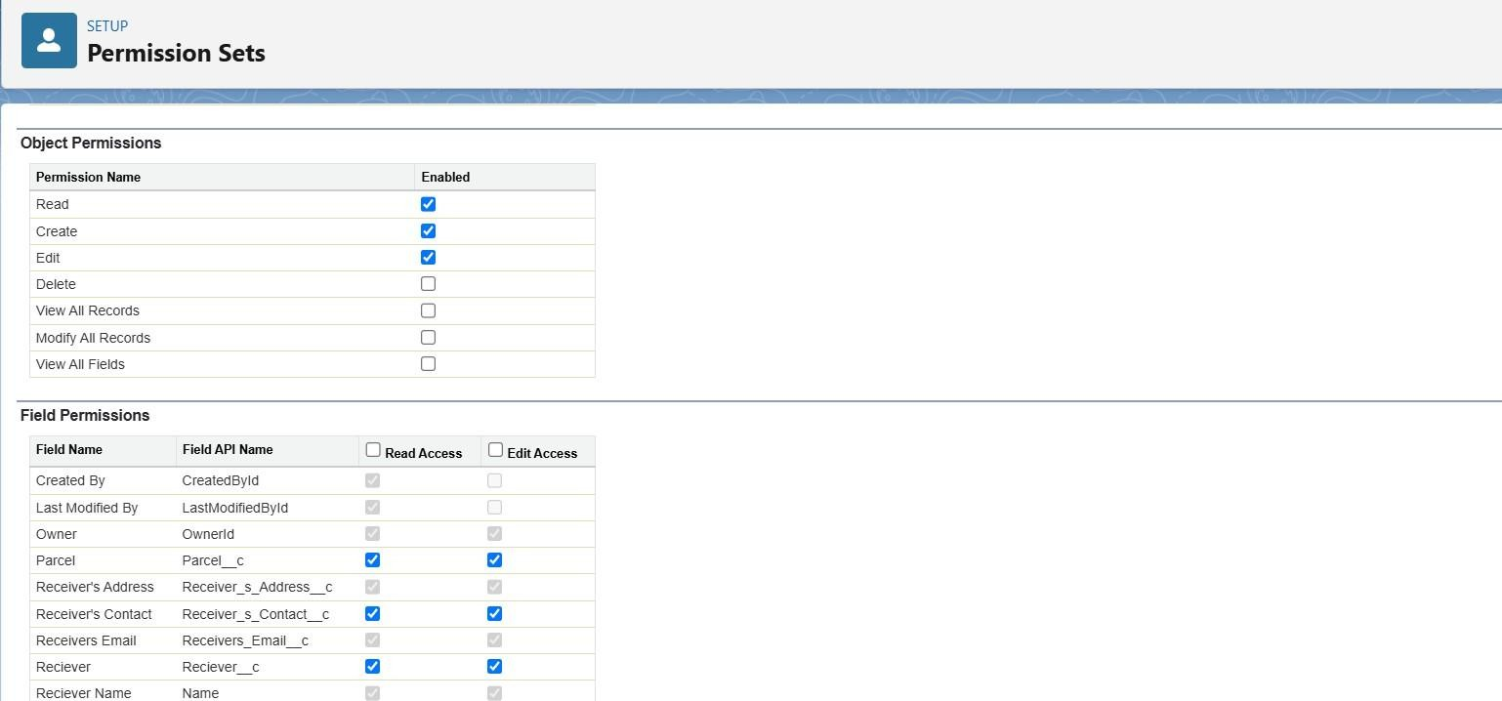

Milestone - 2 Assigning Permissions to your Agent user

In the Quick Find box on the left, type Users.
- Click Users under the Users section.
- Open the Agent User Record

From the list of users, find the Einstein Service Agent user to represent your Agent (e.g., “SwiftShip Agent”).
Click on the Full Name of that user to open the record.

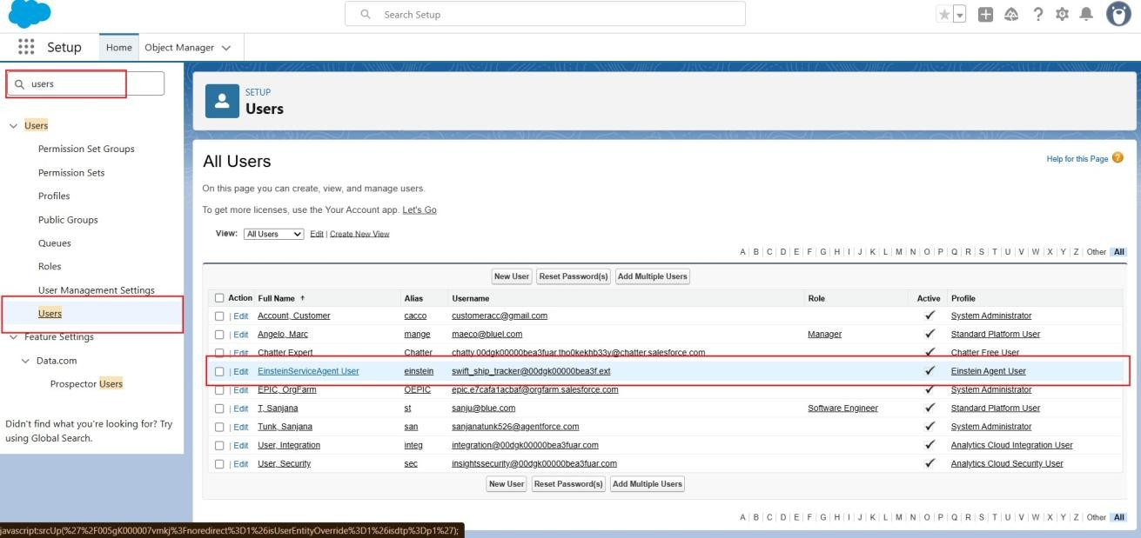

- Scroll down to the section named Permission Set Assignments.
- Click the Edit Assignments button.

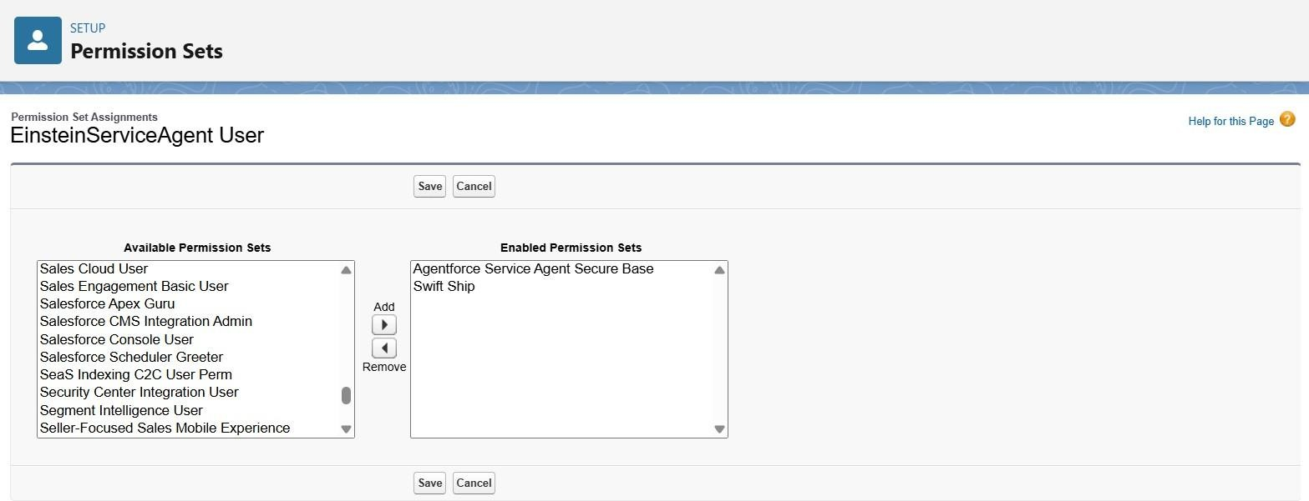

1. On the left side (Available Permission Sets), find and select your permission set: ● SwiftShip

Click the Add → button to move it to the right-side list (Enabled Permission Sets).
Click Save.
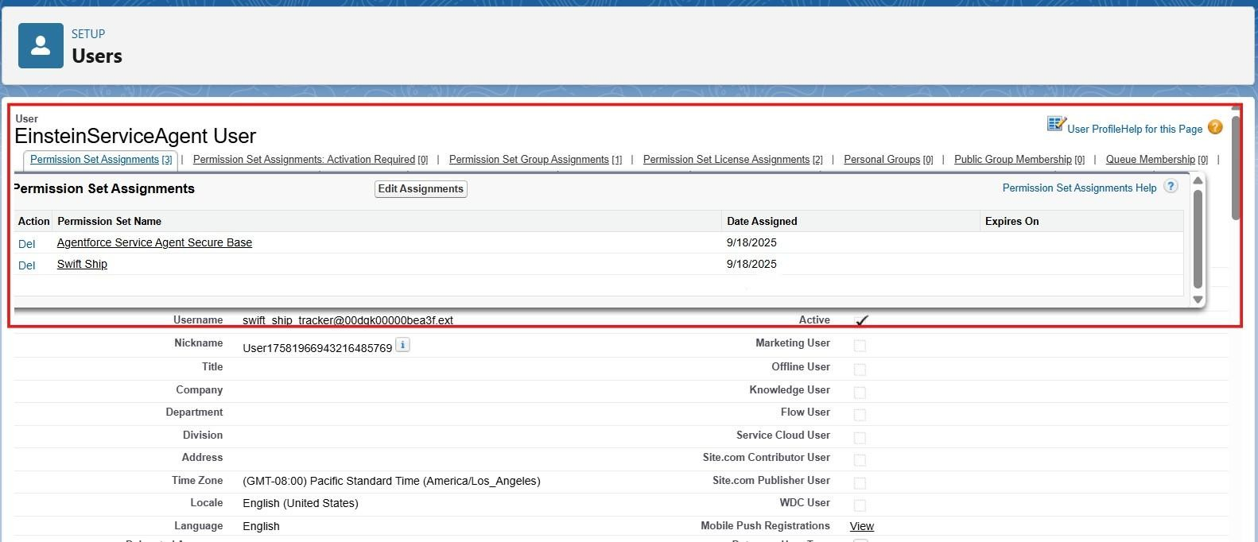

Milestone -3 Org Setup for AgentForce

Enable salesforce Default agent from Salesforce Go
- From Quick find box→ search “Salesforce Go” → Click on it
- Search for Default agent —> click get started→ and turn on
- And refresh the page
Enable Einstein Setup
Go to Setup → Quick Find → Einstein Setup.
1. Open Einstein Setup → click Get Started if prompted.

Toggle On these key services:

- Turn On Einstein
- Global Languages
- Deploy Prompt Template
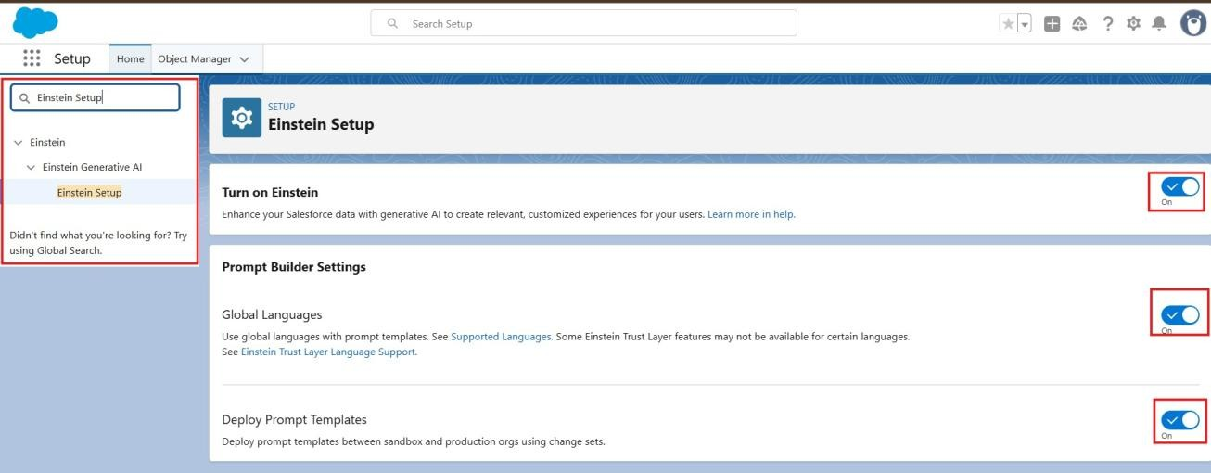

- Refresh your browser page.
- Go to Setup → Quick Find → AgentForce Agents. Toggle On these key services:

  - Agentforce
  - Enable Agentforce Default Agent

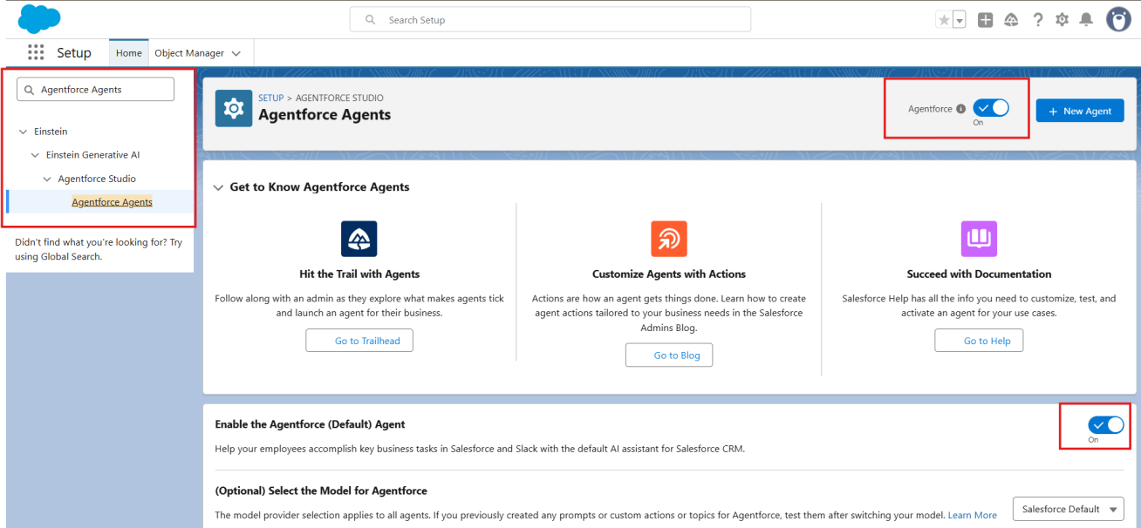

Milestone - 4 Building The Agent
- In Setup, search for Agentforce Agents in Quick Find.

- Click Agentforce Agents, then click on the default Agent, Then click on Open in Builder.
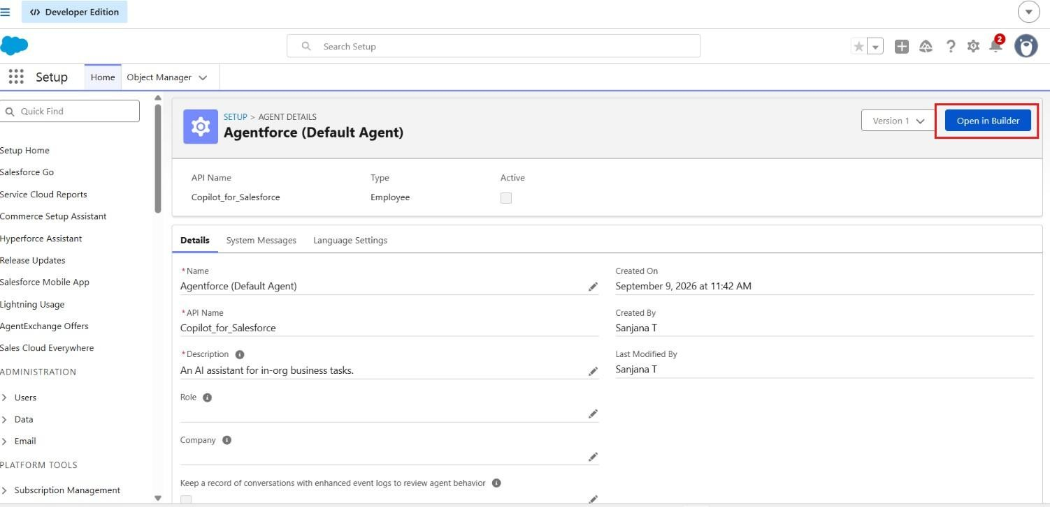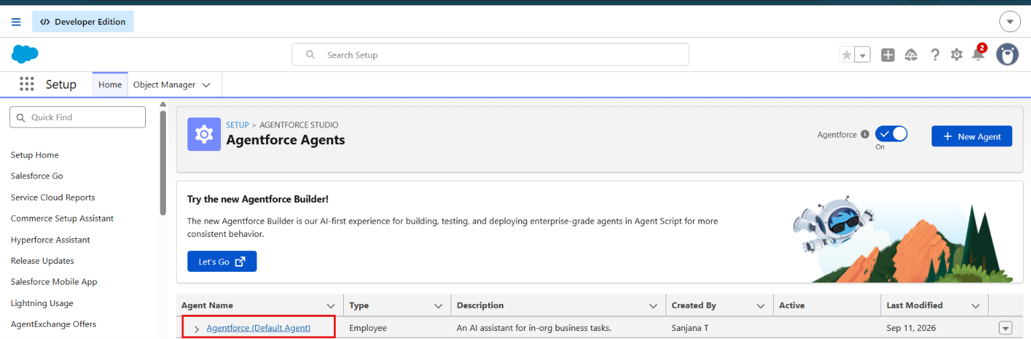

Assign Sub Agents to the Agent On the subagents Click on New.
1. Click New Subagent
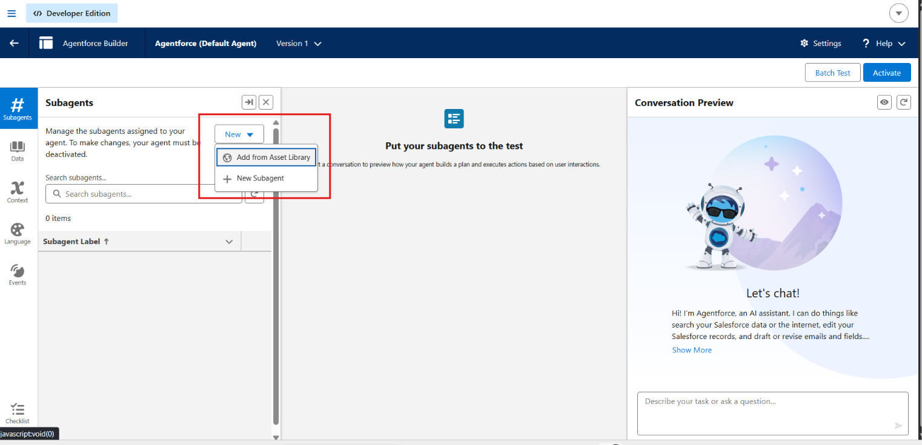

- Create a new subagent.
- Fill in the details as shown.

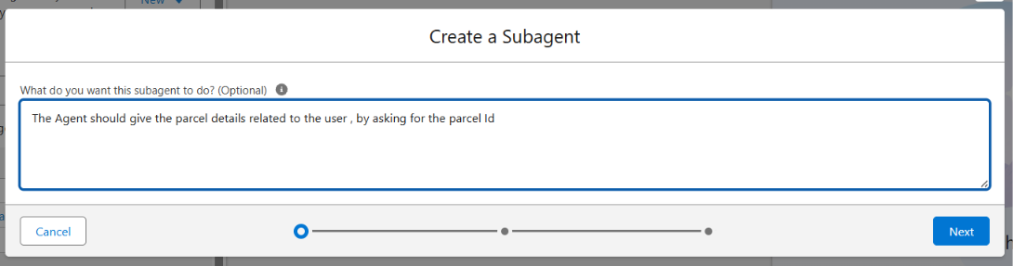

Adding Actions to Agentforce Assets
While still on the Agent Builder in the topics, Click on the Topics Actions
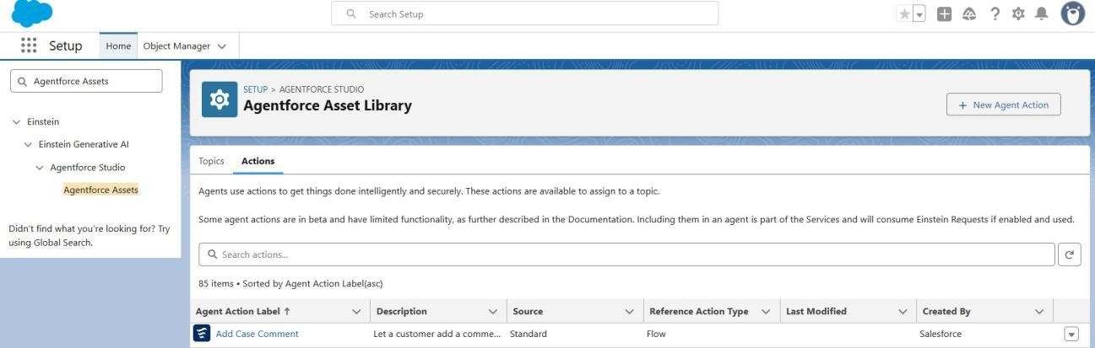

- Click on New Agent Action.
- For Action type, Click on Flow then Next.

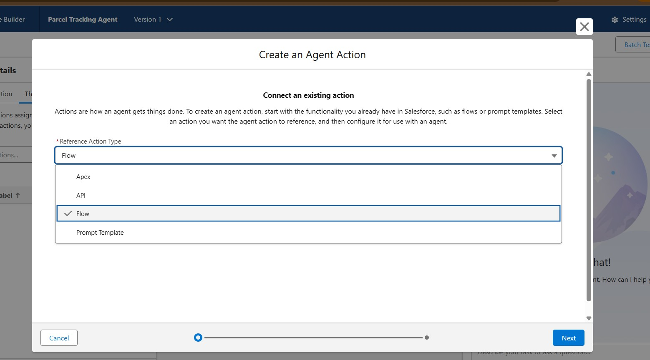

- For Reference Flow use the recently created flow, click Next.
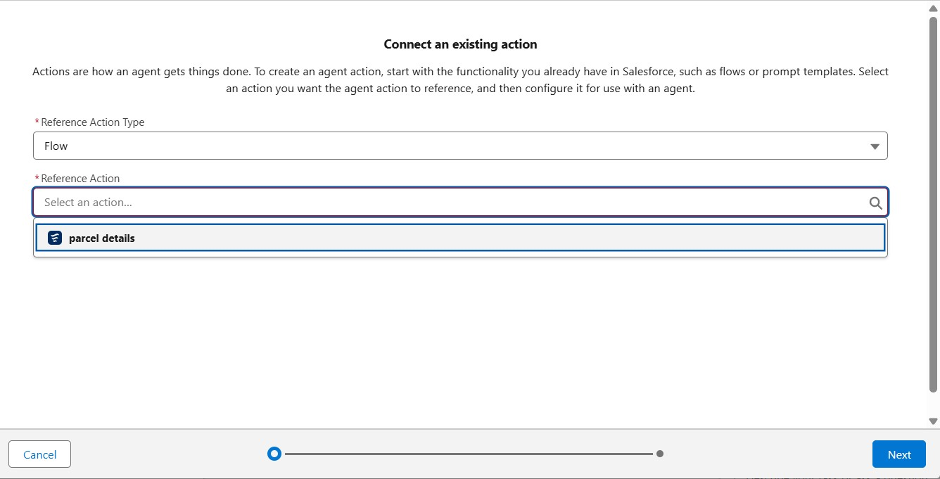

- Fill the details for Agent Configurations.

Assign Subagents Action

While on the Agent Builder in Subagent, Click on the Parcel Updates Subagent

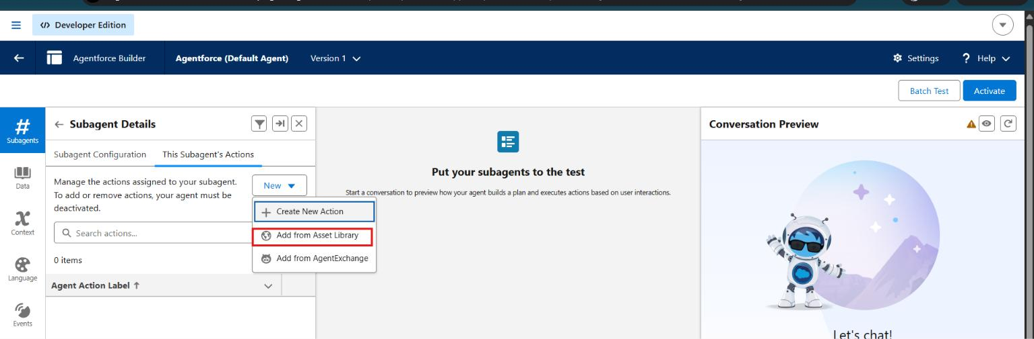

- Click on the subagents Actions, then select Add from asset library.
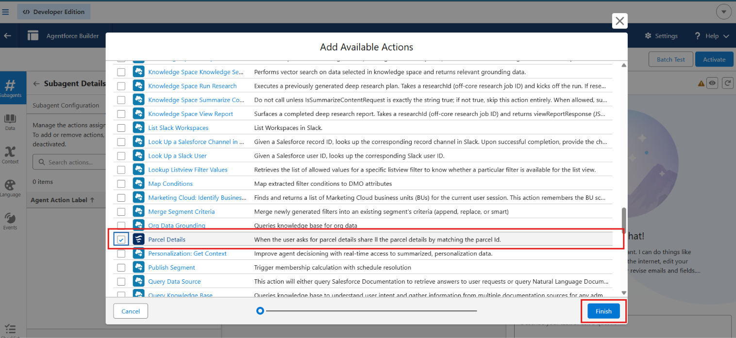

- Select the flow action that we created and click on finish.

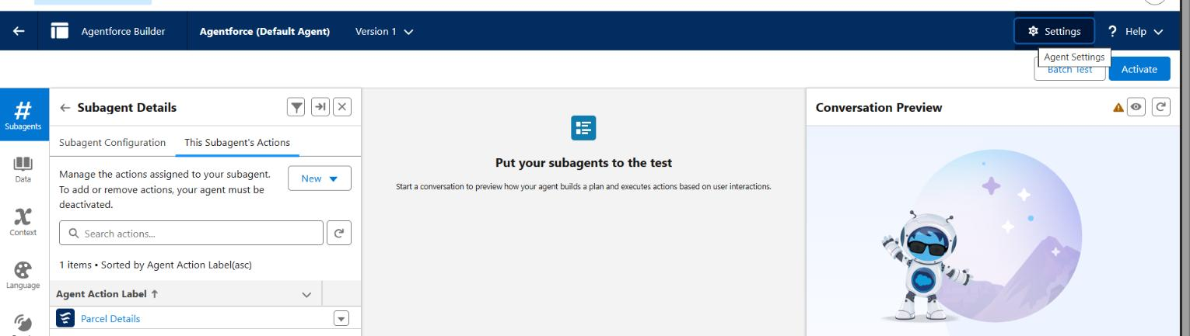

- Click on settings , and rename your agent to SwiftShip Tracker
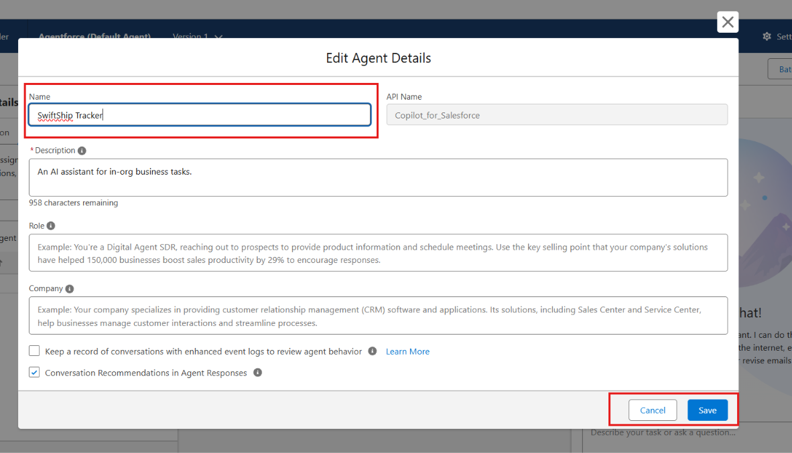

- Click Save.

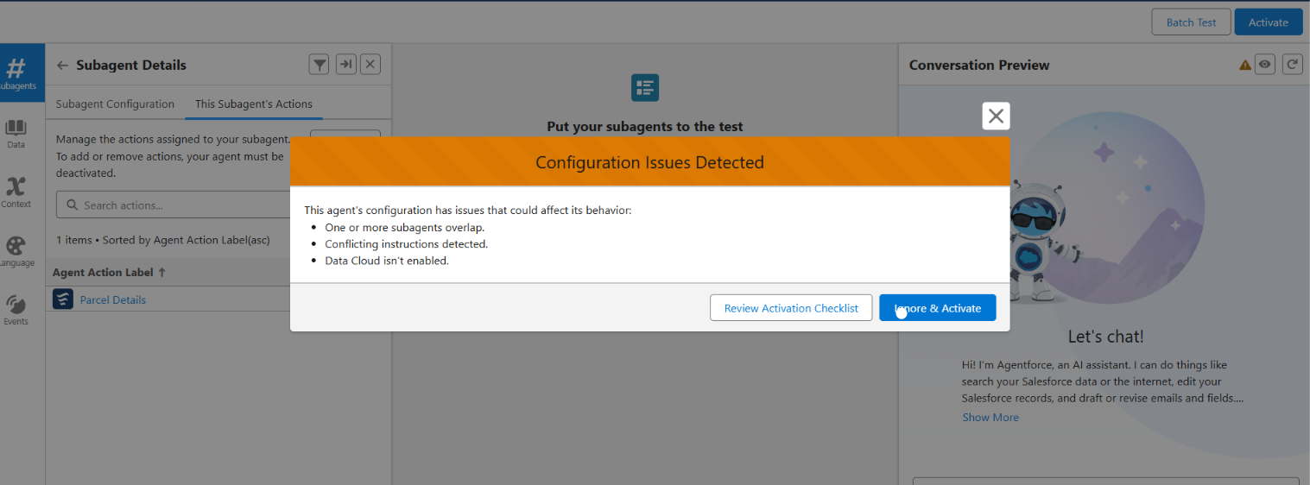

- Click on Ignore and Activate, then Activate.

Phase 4: Data Migration, Testing & Security
To validate the functionality and reliability of the Parcel Tracking Agent created in Agent Builder. This phase ensures that the agent correctly recognizes topics, triggers the assigned Flow (SwiftShip Tracker ), retrieves or updates parcel data, and performs all intended actions without access or permission issues. The goal is to confirm that the AI-driven agent operates seamlessly within Salesforce and provides accurate, real-time responses to parcel management queries.

Verify Agent
Go to Setup → Agentforce Agents.
1. Open the Agents list and confirm that your agent Name: Parcel Tracking Agent, appears

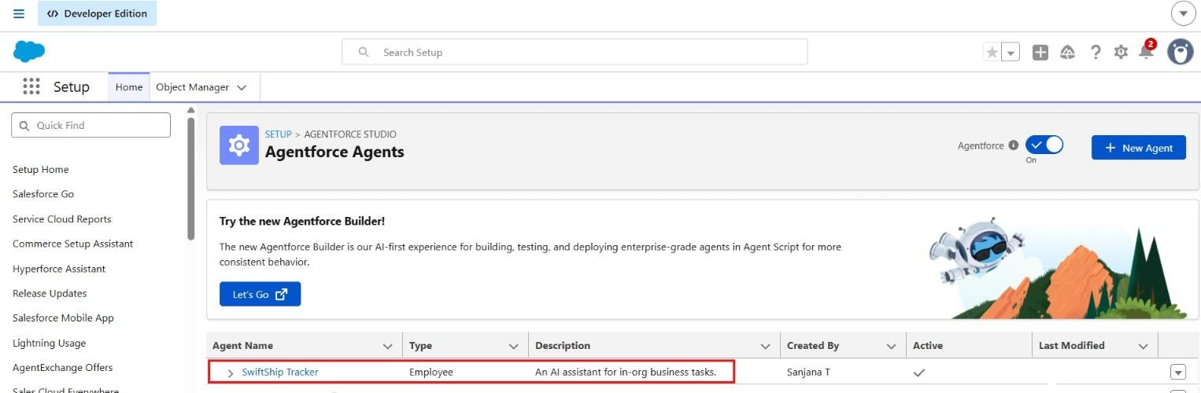

Validate Assigned Topic
In Agent Builder → SubAgent, confirm that the SubAgent you created (e.g., Parcel Tracking or SwiftShip Tracker) is listed.

Open the topic to verify:

- It contains a prompt or description related to parcel management.
- The Action/Flow (SwiftShip Tracker) is linked to this topic.

- Click Save and ensure the topic is Active.
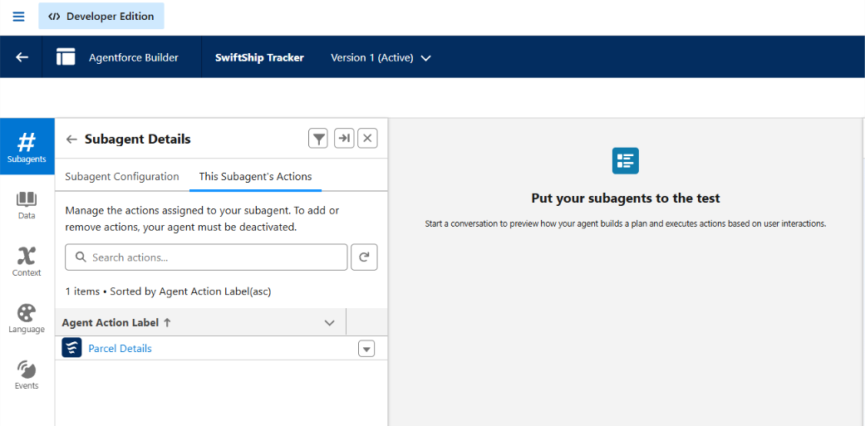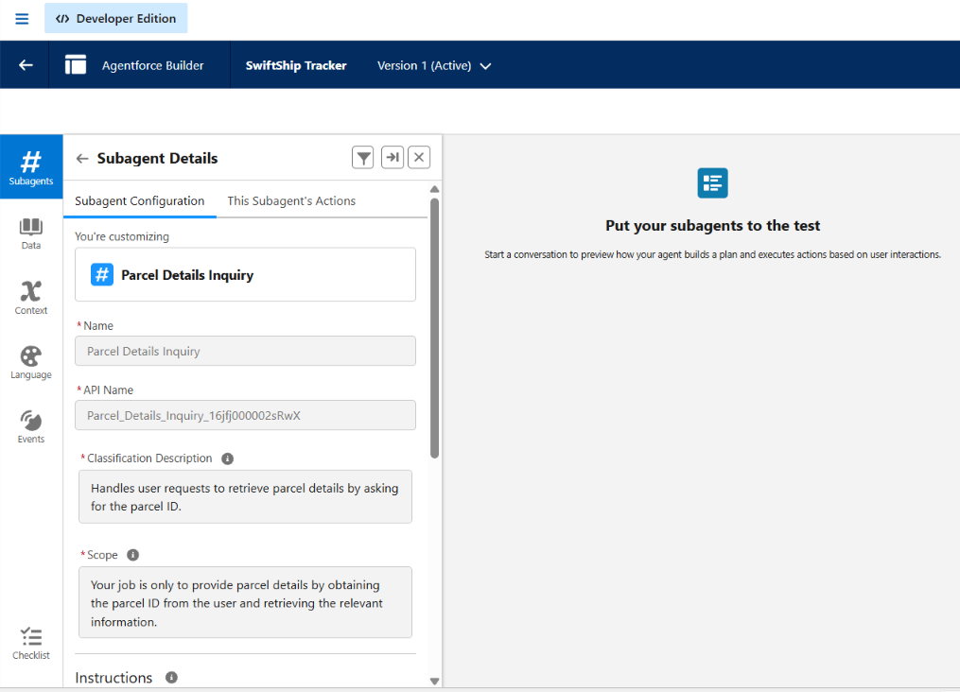

Check the Flow Association Go to Setup → Flows.
  - Locate the Flow named SwiftShip Tracker.
  - Confirm:
    - The Flow is Activated.
    - The Flow includes screens or actions that handle:
    - Parcel ID input
    - Parcel details retrieval
    - Status update or confirmation message
- Open the Flow’s Advanced Settings → ensure Run in System Context (Without Sharing) if data access is restricted.

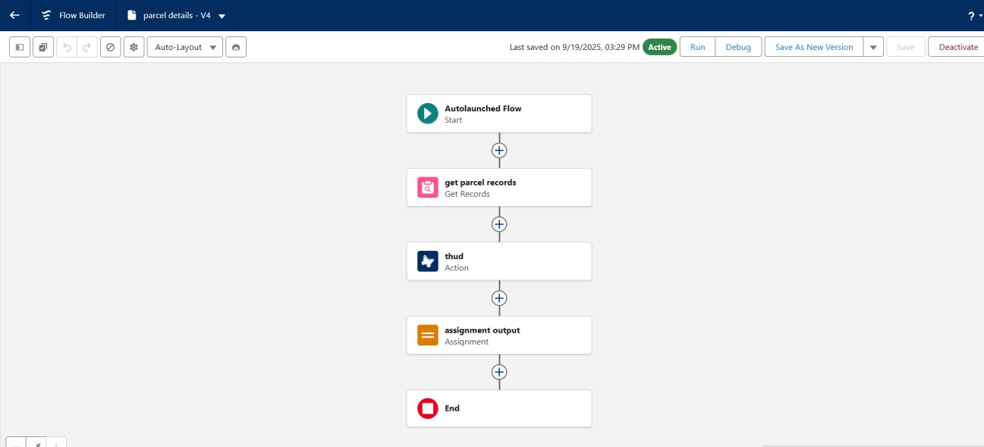

Activate and Test the Agent

- Return to Setup → Agent Builder → Parcel Tracking Agent.
- Click Activate (if not already activated).
- Once active, test using Preview / Try it Out mode:
Type a query such as:
“Track parcel ID P12345” or
“Update delivery status for parcel P67890 to Delivered.”
- Observe the agent’s response.
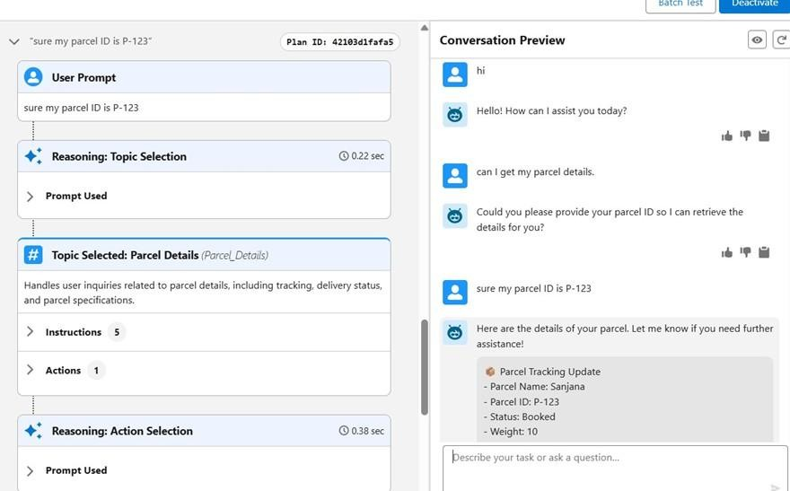

Validate Data in Salesforce

1. After the agent runs the Flow:
- Go to App Launcher → Parcels (Parcel c).

Search for the Parcel ID you used during testing.
Verify:
- The Status or related field is updated.
- Any Flow-created records (bookings, updates) appear correctly.
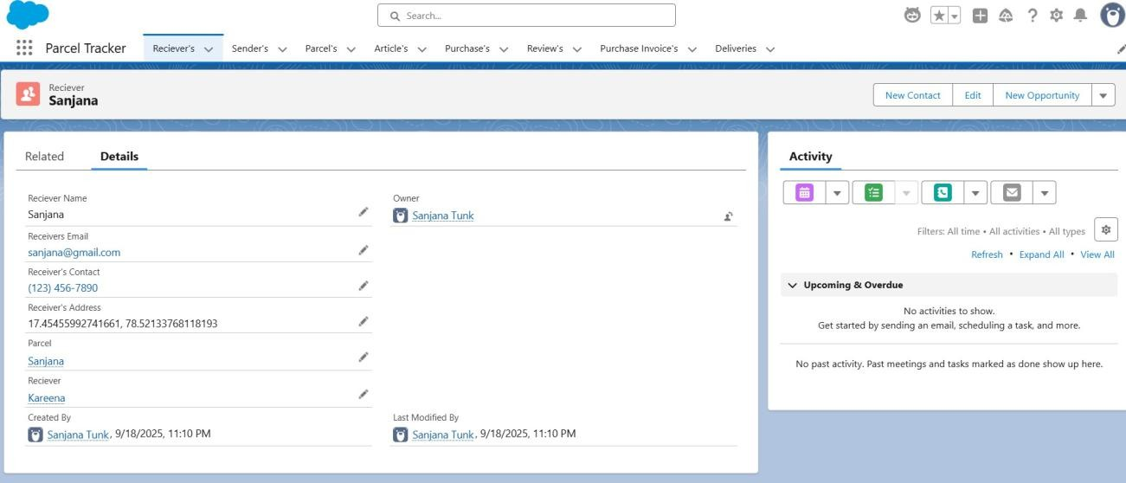

Phase 5: Deployment, Documentation & Maintenance
- In the scope of our SwiftShip Tracker (AgentForce) project implementation:

- The purpose of this phase is to validate that the Parcel Tracking Agent, created using Salesforce Agent Builder, works as intended within the Salesforce Developer Org environment.

- The main goal is to understand how an AI-powered Service Agent can be tested to ensure correct topic recognition, Flow execution, and data retrieval from Salesforce custom objects.

- Testing is conducted within the Developer Org to simulate how the Agent would perform in a live setup, ensuring that permissions, flows, and interactions function correctly before any deployment stage.

- Real-world production testing (UAT or sandbox deployment) is not performed in this project because:

- Developer Edition orgs are standalone environments and do not support production-linked testing environments.
- Enterprise-level AgentForce deployment involves sandbox testing, staging environments, and CI/CD automation, which are outside the scope of this academic/prototype implementation.

Maintenance, Monitoring & Troubleshooting
In the SwiftShip Tracker (AgentForce) project, ongoing maintenance ensures that Parcel, Customer, and Delivery data remain accurate, synchronized, and up to date. Regular monitoring helps detect issues such as misrouted agent queries, failed Flow executions, or performance delays in AgentForce responses. Troubleshooting activities include resolving configuration errors, updating Flow logic, refining agent topics, and improving prompts to enhance user interactions.
Although this project is implemented within a Salesforce Developer Org for learning purposes, in real-world enterprise deployments, these maintenance and monitoring practices are essential. They ensure that AI-powered service agents remain reliable, scalable, and continuously aligned with evolving customer service operations and business goals.

- FUNCTIONAL & PERFORMANCE TESTING

During testing, screenshots were captured from Salesforce to validate vehicle creation, dealer assignment, stock validation triggers, order status updates, batch processing, scheduled reminders, and dashboard analytics. All features were verified to ensure correct functionality and performance.

- ADVANTAGES & DISADVANTAGES

Advantages

  - Centralized parcel and customer information in Salesforce.
  - Provides better visibility into parcel booking and delivery tracking.
  - Automates key logistics processes using Salesforce Flow.
  - Agentforce enables conversational customer support and parcel-status assistance.
  - Prompt Builder supports AI-powered responses and self-service.
  - Reduces manual effort for customers, support teams, and administrators.
  - Provides timely notifications and updates during the delivery process.
  - Experience Cloud can provide customers with convenient access to tracking information.
  - Supports integration with external logistics systems.
  - Can scale to support multiple locations and growing parcel operations.

Disadvantages

  - Requires accurate and up-to-date parcel and customer data.
  - Dependence on Salesforce configuration and automation.
  - Agentforce responses depend on properly configured prompts and available data. ● External logistics integrations may increase implementation complexity.
  - Flow and automation logic require regular maintenance when business processes change.
  - Users need appropriate Salesforce or Experience Cloud access to use the system.
  - Initial Salesforce implementation and configuration can require significant effort.
  - Expanding the system to additional locations or integrations may require further customization.
- Conclusion:

The SwiftShip Tracker demonstrates how Salesforce can be used to build a centralized parcel management and tracking solution. The project integrates custom objects, relationships, Flows, Apex, Email Alerts, Experience Cloud, AgentForce AI, Prompt Builder, security controls, and reporting to support parcel booking, delivery tracking, status updates, and customer communication.

The integration of AgentForce AI with Prompt Builder and Salesforce Flow provides a conversational approach to parcel tracking, enabling customers to obtain shipment information without depending entirely on manual support. The project therefore provides a practical foundation for a scalable and user-friendly parcel management solution.

- FUTURE SCOPE
  - Extend AgentForce capabilities for more parcel-management queries.
  - Enhance real-time delivery tracking.
  - Expand customer self-service through Experience Cloud.
  - Add more advanced delivery-performance analytics.
  - Integrate additional external logistics systems.
  - Improve AI prompts and conversational experiences.
  - Introduce enterprise-level sandbox and CI/CD deployment.
  - Expand automation for additional parcel operations.

The source identifies enterprise deployment, continuous monitoring, prompt refinement, Flow improvement, and AI-agent scalability as areas for future enhancement.

- APPENDIX
  - A. Custom Objects: Parcel, Delivery, Sender, Receiver
  - B. Standard Objects: Account, Contact, Case, Task, EmailMessage, User
  - C. Automation: Flows, Approval Processes, Email Alerts
  - D. Apex: Apex Classes, Batch Apex
  - E. AI: AgentForce AI, Prompt Builder
  - F. UI: Lightning App, Lightning Record Pages, Experience Cloud
  - G. Security: Profiles, Roles, Permission Sets, Sharing Rules, Field-Level Security
  - H. Analytics: Reports & Dashboards
  - I. Testing: Flow, AgentForce, data retrieval, security and permission validation

Thank You

