create table employee_details(id int primary key, name varchar(20), job varchar(20), salary number(10));

begin

insert into employee_details values(7369, 'kumar','clerk', 20000);

insert into employee_details values(7566, ' ram', 'manager ' ,40000);

insert into employee_details values(7654, ' surya', 'salesman ' ,25000);

insert into employee_details values(7499, ' ajay', 'salesman' ,30000);

insert into employee_details values(7521, ' prakash', 'salesman' ,35000);

insert into employee_details values(7788, ' arun', 'analyst' ,40000);

insert into employee_details values(7839, ' siva', 'president' ,80000);

end;

ROLL-UP:

select name, id , job, sum(salary) as salary from employee_details group by rollup(name, id , job);

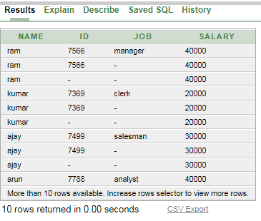

DRILL-UP:

select name, job, salary from employee_details;

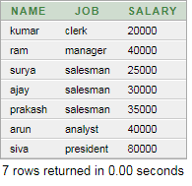

SLICE:

select *from employee_details where salary<40000;

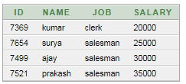

DICE:

select name, job , sum(salary) as "salary" from Employee_details where (salary > 20000 and job = 'salesman') group by name , job order by name asc;

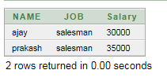

PIVOT:

select salary, max(decode(salary,'40000',name))ANALYST, max(decode(salary,'20000',name))CLERK,max(decode(salary,'40000',name))MANAGER ,max(decode(salary,'25000',name,'30000',name,'35000',name))Salesman, max(decode(salary,'80000',name))President from (select job,salary,name from Employee_details) group by salary order by salary;

