NANDHA ENGINEERING COLLEGE
(Autonomous)
Erode-638 052



LAB RECORD

22CSP10 – OBJECT ORIENTED SOFTWARE ENGINEERING LABORATORY

V - Semester

B.E COMPUTER SCIENCE AND ENGINEERING

Department of Computer Science and Engineering
NANDHA ENGINEERING COLLEGE, ERODE-52

NANDHA ENGINEERING COLLEGE
(Autonomous)
Erode-638 052

BONAFIDE CERTIFICATE

REGISTER NUMBER:

Certified that this is the Bonafide Record of work done by……………………………………………of the V Semester B.E - COMPUTER SCIENCE AND ENGINEERING branch during the Academic Year 2025 – 2026 in the 22CSP10 – OBJECT ORIENTED SOFTWARE ENGINEERING LABORATORY.

……………………….. ….…………………….. Staff-in-charge Head of the Department

Submitted for the End Semester Practical Examination held on…………………………………………….

………………………… ….……………………..
Internal Examiner External Examiner

INDEX

EX.  NO. | DATE | NAME OF THE EXPERIMENTS | PAGE. NO. | MARK | SIGN
1 |  | PASSPORT AUTOMATION SYSTEM | 1
2 |  | BOOK BANK SYSTEM | 10
3 |  | EXAM REGISTRATION AND RESULT SYSTEM | 37
4 |  | STOCK MAINTENANCE SYSTEM | 46
5 |  | ONLINE COURSE RESERVATION SYSTEM | 59
6 |  | E - TICKETING | 69
7 |  | EXPERT SYSTEM FOR MEDICAL DIAGNOSIS | 82
8 |  | CREDIT CARD PROCESSING SYSTEM | 92
9 |  | PAYROLL SYSTEM | 104
10 |  | STUDENT INFORMATION SYSTEM | 114
CONTENT BEYOND THE SYLLABUS
11 |  | ONLINE VOTING SYSTEM | 128
AVERAGE MARKS AWARDED

EX NO: 01 | PASSPORT AUTOMATION SYSTEM
DATE: | PASSPORT AUTOMATION SYSTEM
AIM:
To design UML diagrams and use cases for a Passport Automation System that includes the primary entities such as Applicant, Passport, Application, and Officer by identifying the attributes and methods for each class and specific relationships between classes.
PROCEDURE:
Step 1: Setting Up the Database
Step 2: Backend Setup (Java)
Step 3: Create Java Servlets for API Endpoints
Step 4: Deploy the Java Backend
Step 5: Create a Basic Express Server
Step 6: Set Up HTML Form in Node.js
Step 7: Create an Endpoint to Proxy the Request to Java

UML DIAGRAMS:
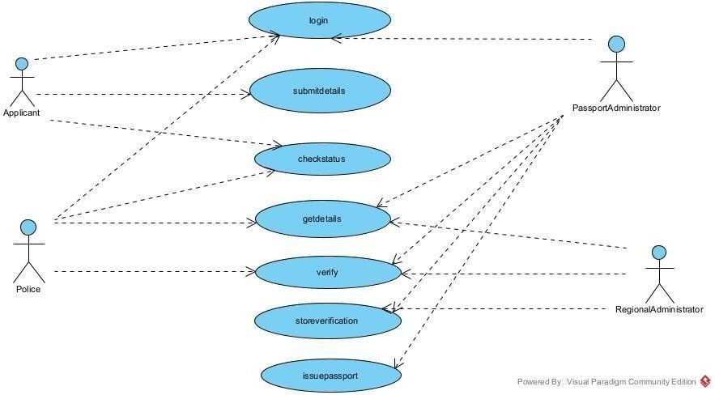
ACTIVITY DIAGRAM

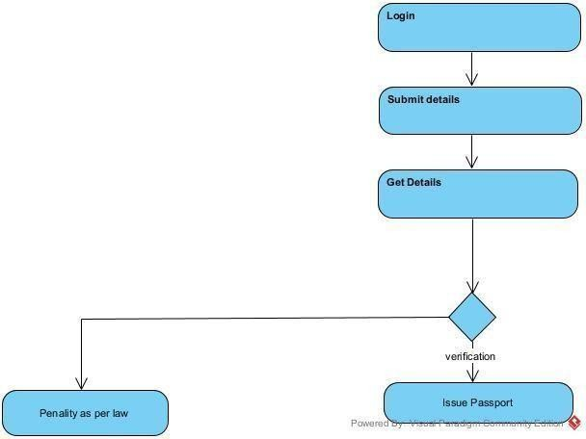

SEQUENCE DIAGRAM
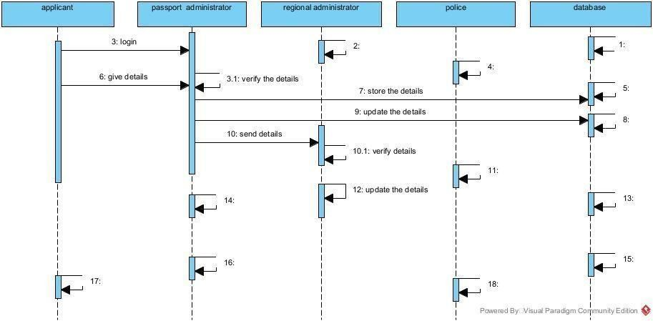
CLASS DIAGRAM
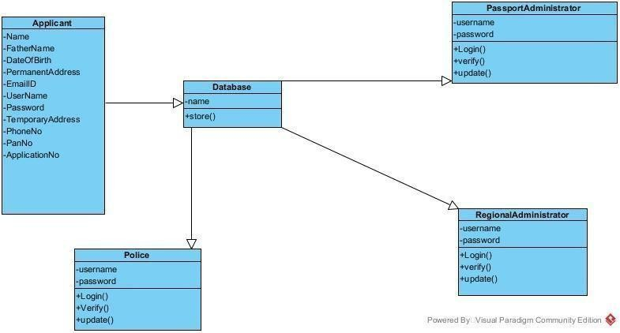

CODING:

Index.html
<!DOCTYPE html>
<html lang="en">
<head>
<meta charset="UTF-8">
<meta name="viewport" content="width=device-width, initial-scale=1.0">
<title>Passport Application</title>
<link rel="stylesheet" href="styles.css">
</head>
<body>
<div class="container">
<h1>Passport Application Form</h1>
<form id="passportForm">
<label for="name">Full Name:</label>

<input type="text" id="name" required>
<label for="dob">Date of Birth:</label>
<input type="date" id="dob" required>
<label for="address">Address:</label>
<textarea id="address" required></textarea>
<label for="passportType">Passport Type:</label>
<select id="passportType" required>
<option value="Regular">Regular</option>
<option value="Diplomatic">Diplomatic</option>
<option value="Official">Official</option>
</select>
<button type="button" onclick="submitForm()">Submit</button>
</form>
</div>
<script src="script.js"></script>
</body>
</html>

Style.css
body {
font-family: Arial, sans-serif; background-color: #f0f0f5; display: flex;
justify-content: center; align-items: center; height: 100vh; margin: 0;
}
.container { width: 300px; padding: 20px;
background-color: #fff;
box-shadow: 0 0 10px rgba(0, 0, 0, 0.1); border-radius: 5px;
}
h1 {
font-size: 1.5em; margin-bottom: 20px; text-align: center;
}
label {
font-weight: bold;
}
input, textarea, select, button { width: 100%;
padding: 8px; margin: 10px 0;

box-sizing: border-box;
}
button {
background-color: #007bff; color: white;
border: none; cursor: pointer;
}
button:hover {
background-color: #0056b3;
}

Script.js
function submitForm() {
// Get data from the form fields
const name = document.getElementById("name").value; const dob = document.getElementById("dob").value;
const address = document.getElementById("address").value;
const passportType = document.getElementById("passportType").value;
// Save the data to localStorage localStorage.setItem("name", name); localStorage.setItem("dob", dob); localStorage.setItem("address", address); localStorage.setItem("passportType", passportType);
// Redirect to confirmation page window.location.href = "confirmation.html";
}

Confirmation.html
<!DOCTYPE html>
<html lang="en">
<head>
<meta charset="UTF-8">
<meta name="viewport" content="width=device-width, initial-scale=1.0">
<title>Confirmation</title>
<link rel="stylesheet" href="styles.css">
</head>
<body>
<div class="container">
<h1>Confirm Your Details</h1>
<p><strong>Full Name:</strong> <span id="confirmName"></span></p>
<p><strong>Date of Birth:</strong> <span id="confirmDob"></span></p>
<p><strong>Address:</strong> <span id="confirmAddress"></span></p>
<p><strong>Passport Type:</strong> <span id="confirmPassportType"></span></p>
<button onclick="editForm()">Edit</button>
<button onclick="finalSubmit()">Confirm</button>
</div>

<script src="confirmation.js"></script>
</body>
</html>

Confirmation.js
document.addEventListener("DOMContentLoaded", function() {
// Retrieve data from localStorage
const name = localStorage.getItem("name"); const dob = localStorage.getItem("dob");
const address = localStorage.getItem("address");
const passportType = localStorage.getItem("passportType");
// Display data on the confirmation page document.getElementById("confirmName").textContent = name; document.getElementById("confirmDob").textContent = dob; document.getElementById("confirmAddress").textContent = address; document.getElementById("confirmPassportType").textContent = passportType;
});
function editForm() {
// Redirect back to the application form for editing window.location.href = "index.html";
}
function finalSubmit() {
alert("Passport application submitted successfully!");
// Clear localStorage after submission localStorage.clear();
// Redirect to a thank-you or landing page window.location.href = "thankyou.html";
}
<!DOCTYPE html>
<html lang="en">
<head>
<meta charset="UTF-8">
<meta name="viewport" content="width=device-width, initial-scale=1.0">
<title>Thank You</title>
<link rel="stylesheet" href="styles.css">
</head>
<body>
<div class="container">
<h1>Thank You!</h1>
<p>Your passport application has been submitted successfully.</p>
</div>
</body>
</html>

OUTPUT:
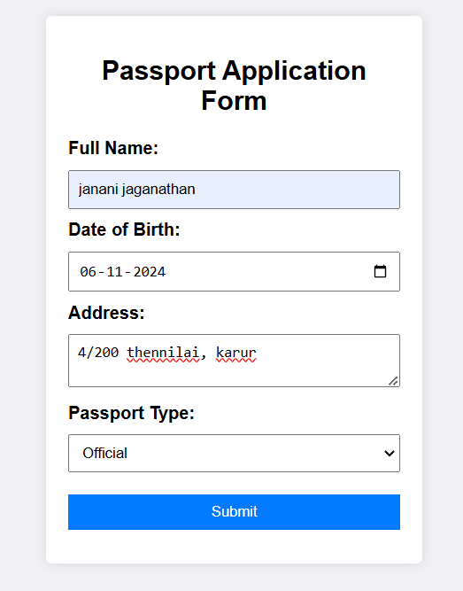
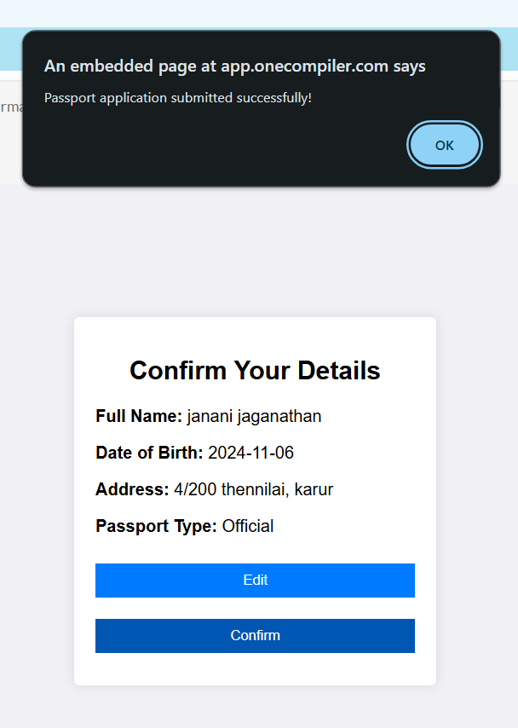
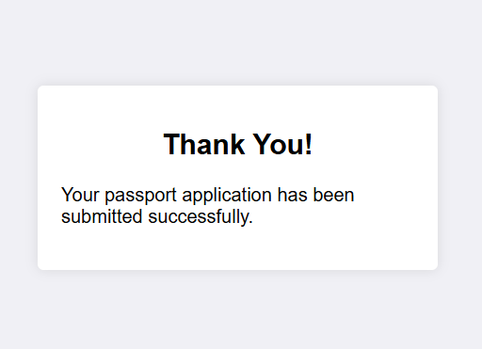

SQL Queries
CREATE TABLE users (
user_id INT AUTO_INCREMENT PRIMARY KEY,
full_name VARCHAR(100) NOT NULL, dob DATE NOT NULL,
gender ENUM('Male', 'Female', 'Other') NOT NULL, email VARCHAR(100) NOT NULL UNIQUE, phone VARCHAR(15),
address TEXT NOT NULL,
created_at TIMESTAMP DEFAULT CURRENT_TIMESTAMP
);
CREATE TABLE passport_applications (
application_id INT AUTO_INCREMENT PRIMARY KEY, user_id INT NOT NULL,
application_date DATE NOT NULL DEFAULT CURRENT_DATE, passport_type ENUM('Regular', 'Diplomatic', 'Official') NOT NULL,
status ENUM('Pending', 'Approved', 'Rejected', 'Under Review') DEFAULT 'Pending', issued_date DATE,
expiry_date DATE,
FOREIGN KEY (user_id) REFERENCES users(user_id)

);
CREATE TABLE application_documents (
document_id INT AUTO_INCREMENT PRIMARY KEY, application_id INT NOT NULL,
document_type ENUM('ID Proof', 'Address Proof', 'Birth Certificate', 'Photograph') NOT NULL,
document_url VARCHAR(255) NOT NULL,
uploaded_date TIMESTAMP DEFAULT CURRENT_TIMESTAMP,
FOREIGN KEY (application_id) REFERENCES passport_applications(application_id)
);
CREATE TABLE payment (
payment_id INT AUTO_INCREMENT PRIMARY KEY,
application_id INT NOT NULL, amount DECIMAL(10, 2) NOT NULL,
payment_date TIMESTAMP DEFAULT CURRENT_TIMESTAMP,
payment_method ENUM('Credit Card', 'Debit Card', 'Net Banking', 'UPI') NOT NULL, payment_status ENUM('Pending', 'Completed', 'Failed') DEFAULT 'Pending', transaction_id VARCHAR(100) UNIQUE,
FOREIGN KEY (application_id) REFERENCES passport_applications(application_id)
);
CREATE TABLE application_status_log (
log_id INT AUTO_INCREMENT PRIMARY KEY,
application_id INT NOT NULL,
status ENUM('Pending', 'Approved', 'Rejected', 'Under Review') NOT NULL, updated_at TIMESTAMP DEFAULT CURRENT_TIMESTAMP,
updated_by VARCHAR(50), remarks TEXT,
FOREIGN KEY (application_id) REFERENCES passport_applications(application_id)
);
INSERT INTO users (full_name, dob, gender, email, phone, address)
VALUES ('John Doe', '1990-05-15', 'Male', 'john.doe@example.com', '1234567890', '123 Main St, Springfield');
INSERT INTO passport_applications (user_id, passport_type) VALUES (1, 'Regular');
INSERT INTO application_status_log (application_id, status, updated_by, remarks) VALUES (1, 'Approved', 'Admin', 'Application has been approved');
INSERT INTO payment (application_id, amount, payment_method, payment_status, transaction_id)
VALUES (1, 100.00, 'Credit Card', 'Completed', 'TXN123456');

Connectivity Coding
import java.sql.Connection; import java.sql.DriverManager; import java.sql.SQLException; public class DatabaseConnection {
private static final String URL = "jdbc:mysql://localhost:3306/passport_system"; private static final String USER = "root";

private static final String PASSWORD = "password";
public static Connection getConnection() throws SQLException { return DriverManager.getConnection(URL, USER, PASSWORD);
}
}
import java.io.IOException; import java.sql.Connection;
import java.sql.PreparedStatement; import java.sql.SQLException;
import javax.servlet.ServletException; import javax.servlet.annotation.WebServlet; import javax.servlet.http.HttpServlet;
import javax.servlet.http.HttpServletRequest; import javax.servlet.http.HttpServletResponse; @WebServlet("/apply")
public class PassportApplicationServlet extends HttpServlet { @Override
protected void doPost(HttpServletRequest request, HttpServletResponse response) throws ServletException, IOException {
String fullName = request.getParameter("fullName"); String dob = request.getParameter("dob");
String address = request.getParameter("address");
String passportType = request.getParameter("passportType"); try (Connection conn = DatabaseConnection.getConnection()) {
String sql = "INSERT INTO passport_applications (user_id, application_date, passport_type, status) VALUES (?, CURDATE(), ?, 'Pending')";
PreparedStatement stmt = conn.prepareStatement(sql); stmt.setInt(1, 1); // Assume user_id is 1 for now stmt.setString(2, passportType); stmt.executeUpdate();
response.setStatus(HttpServletResponse.SC_CREATED); response.getWriter().write("Application submitted successfully.");
} catch (SQLException e) { response.setStatus(HttpServletResponse.SC_INTERNAL_SERVER_ERROR); response.getWriter().write("Error submitting application: " + e.getMessage());
}
}
}
<servlet>
<servlet-name>PassportApplicationServlet</servlet-name>
<servlet-class>PassportApplicationServlet</servlet-class>
</servlet>
<servlet-mapping>
<servlet-name>PassportApplicationServlet</servlet-name>
<url-pattern>/apply</url-pattern>
</servlet-mapping>

MARK ALLOCATION

CONTINOUS INTERNAL ASSESSMENT
Preparation & conduct of experiment | 50
Observation & Result | 30
Record | 10
Viva voice | 10
Total | 100

RESULT:
The Passport Automation System was implemented using HTML, CSS and JavaScript with connectivity managed by Node.js and Java. The data was successfully stored in the database, establishing a functional relationship between the user and the administrator was verified.

FACULTY SIGNATURE

EX NO: 02 | BOOK BANK SYSTEM
DATE: | BOOK BANK SYSTEM
AIM:
The aim of the Book Banking System project is to create a user-friendly application
for managing books, users and transactions in a library. It will enhance operational efficiency for both users and administrators while ensuring data security and integrity.
PROCEDURE:
Step 1: Identify core features and user roles for the Book Banking System.
Step 2: Choose a technology stack and create wireframes for the user interface.
Step 3: Install necessary tools and initialize separate directories for the frontend and backend.
Step 4: Build the user interface using HTML, CSS, and JavaScript, implementing client-side routing.
Step 5: Set up a server, connect to the database and implement RESTful APIs for communication.
Step 6: Conduct thorough testing and deploy the application on a hosting service.

UML DIAGRAMS:
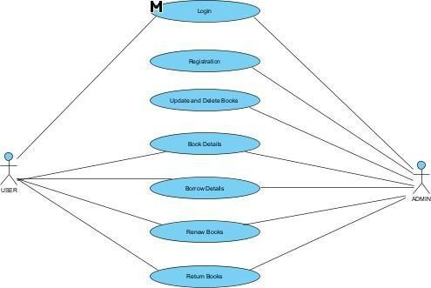

ACTIVITY DIAGRAM
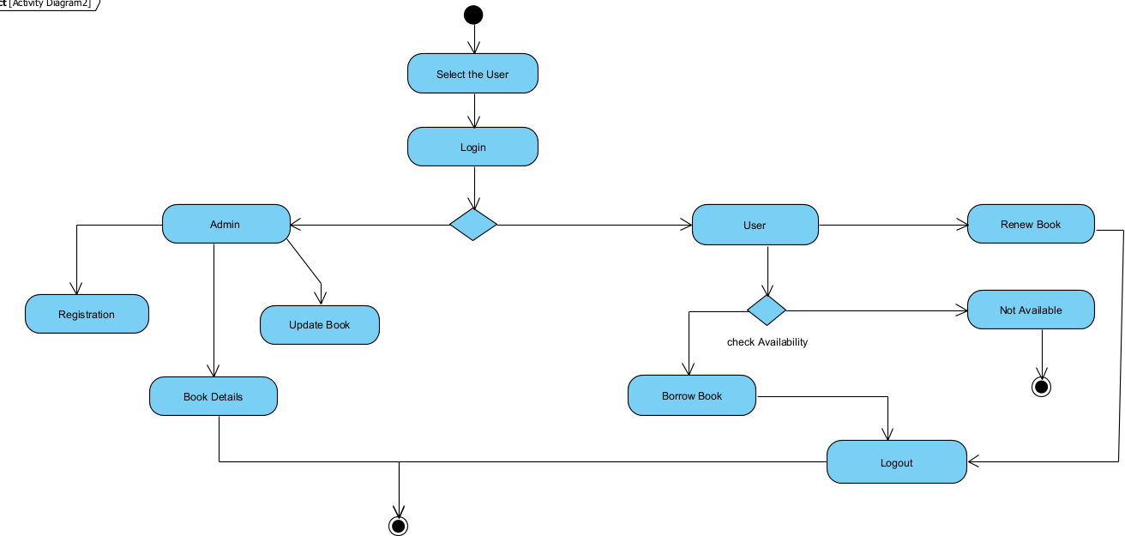

SEQUENCE DIAGRAM
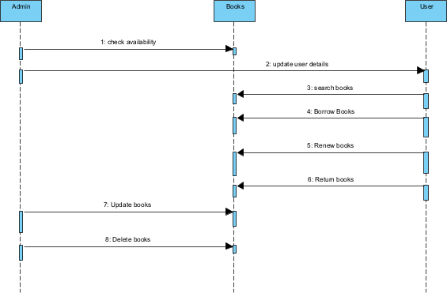

CLASS DIAGRAM
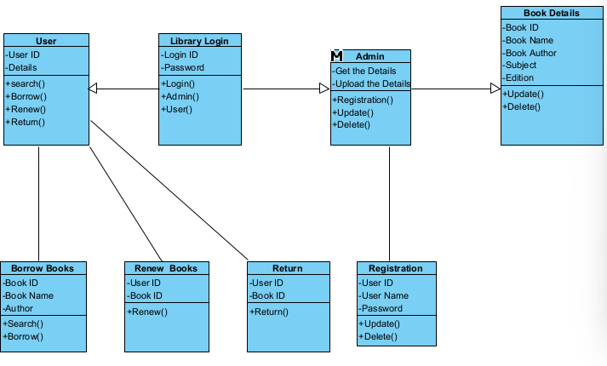
STATE CHART DIAGRAM
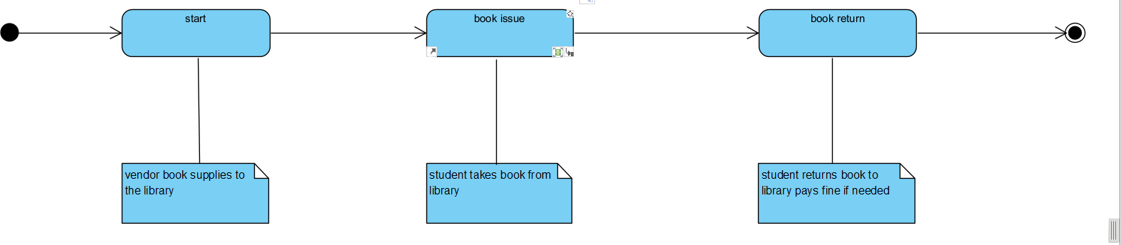
COLLABRATION DIAGRAM
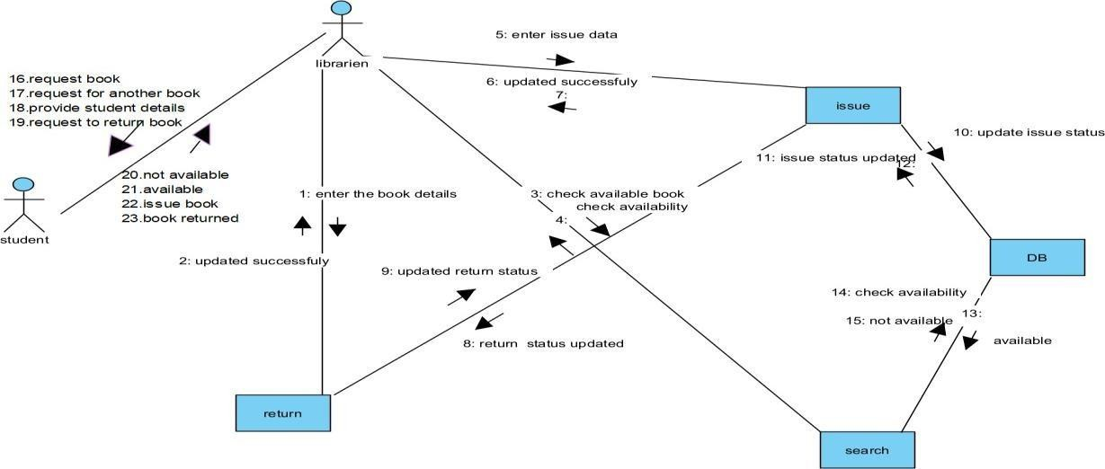

CODING:

Adminlogin.html
<!DOCTYPE html>
<html lang="en">
<head>
<meta charset="UTF-8">
<meta name="viewport" content="width=device-width, initial-scale=1.0">
<title>Admin Login</title>
<link rel="stylesheet" href="https://stackpath.bootstrapcdn.com/bootstrap/4.5.2/css/bootstrap.min.css">
</head>
<body>
<div class="container">
<h1 class="mt-5">Admin Login</h1>
<form action="/api/admin/login" method="POST">
<div class="form-group">
<input type="text" name="username" class="form-control" placeholder="Username" required>
</div>
<div class="form-group">
<input type="password" name="password" class="form- control" placeholder="Password" required>
</div>
<button type="submit" class="btn btn-primary">Login</button>
</form>
<p>Don't have an account? <a href="adminsignup.html">Sign up</a></p>
</div>
</body>
</html>

Adminsignup.html
<!DOCTYPE html>
<html lang="en">
<head>
<meta charset="UTF-8">
<meta name="viewport" content="width=device-width, initial-scale=1.0">
<title>Admin Signup</title>
<link rel="stylesheet" href="https://stackpath.bootstrapcdn.com/bootstrap/4.5.2/css/bootstrap.min.css">
</head>
<body>
<div class="container">
<h1 class="mt-5">Admin Signup</h1>
<form action="/api/admin/signup" method="POST">
<div class="form-group">
<input type="text" name="username" class="form-control"

placeholder="Username" required>
</div>
<div class="form-group">
<input type="password" name="password" class="form- control" placeholder="Password" required>
</div>
<button type="submit" class="btn btn-primary">Sign Up</button>
</form>
<p>Already have an account? <a href="adminlogin.html">Login</a></p>
</div>
</body>
</html>

Admindashboard.html
<!DOCTYPE html>
<html lang="en">
<head>
<meta charset="UTF-8">
<meta name="viewport" content="width=device-width, initial-scale=1.0">
<title>Admin Dashboard</title>
<link rel="stylesheet" href="https://stackpath.bootstrapcdn.com/bootstrap/4.5.2/css/bootstrap.min.css">
</head>
<body>
<div class="container">
<h1 class="mt-5">Admin Dashboard</h1>
<form id="addBookForm">
<div class="form-group">
<input type="text" id="bookName" class="form-control" placeholder="Book Name" required>
</div>
<div class="form-group">
<input type="text" id="bookId" class="form-control" placeholder="Book ID" required>
</div>
<div class="form-group">
<input type="text" id="bookAuthor" class="form-control" placeholder="Book Author" required>
</div>
<button type="submit" class="btn btn-primary">Add Book</button>
</form>
<h2 class="mt-5">Book List</h2>
<ul id="bookList" class="list-group"></ul>
</div>
<script>
// Function to load books from the server function loadBooks() {

fetch('/api/admin/getBooks')
.then(response => response.json())
.then(data => {
const bookList = document.getElementById('bookList'); bookList.innerHTML = ''; // Clear the list data.books.forEach(book => {
const li = document.createElement('li');
li.className = 'list-group-item d-flex justify-content-between align-items-center'; li.textContent = `${book.name} (ID: ${book.id}, Author: ${book.author})`;
const deleteButton = document.createElement('button'); deleteButton.className = 'btn btn-danger btn-sm'; deleteButton.textContent = 'Delete';
deleteButton.onclick = function() { deleteBook(book.id);
};
li.appendChild(deleteButton); bookList.appendChild(li);
});
});
}
// Function to add a book document.getElementById('addBookForm').addEventListener('submit', function(e) {
e.preventDefault(); const bookName =
document.getElementById('bookName').value; const bookId = document.getElementById('bookId').value;
const bookAuthor = document.getElementById('bookAuthor').value; fetch('/api/admin/addBook', {
method: 'POST', headers: {
'Content-Type': 'application/json'
},
body: JSON.stringify({ name: bookName, id: bookId, author: bookAuthor })
})
.then(response => response.json())
.then(data => {
if (data.success) {
alert('Book added successfully!'); loadBooks(); // Refresh the book list
} else {
alert('Error adding book.');
}
});
});
// Function to delete a book function deleteBook(bookId) {

fetch(`/api/admin/deleteBook/${bookId}`, { method: 'DELETE'
})
.then(response => response.json())
.then(data => {
if (data.success) {
alert('Book deleted successfully!'); loadBooks(); // Refresh the book list
} else {
alert('Error deleting book.');
}
});
}
// Load books when the page is loaded window.onload = loadBooks;
</script>
</body>
</html>

Userlogin.html
<!DOCTYPE html>
<html lang="en">
<head>
<meta charset="UTF-8">
<meta name="viewport" content="width=device-width, initial-scale=1.0">
<title>User Login</title>
<link rel="stylesheet" href="https://stackpath.bootstrapcdn.com/bootstrap/4.5.2/css/bootstrap.min.css">
</head>
<body>
<div class="container">
<h1 class="mt-5">User Login</h1>
<form action="/api/user/login" method="POST">
<div class="form-group">
<input type="text" name="username" class="form-control" placeholder="Username" required>
</div>
<div class="form-group">
<input type="password" name="password" class="form-control" placeholder="Password" required>
</div>
<button type="submit" class="btn btn-primary">Login</button>
</form>
<p>Don't have an account? <a href="usersignup.html">Sign up</a></p>
</div>
</body>
</html>

Usersignup.html
<!DOCTYPE html>
<html lang="en">
<head>
<meta charset="UTF-8">
<meta name="viewport" content="width=device-width, initial-scale=1.0">
<title>User Signup</title>
<link rel="stylesheet" href="https://stackpath.bootstrapcdn.com/bootstrap/4.5.2/css/bootstrap.min.css">
</head>
<body>
<div class="container">
<h1 class="mt-5">User Signup</h1>
<form action="/api/user/signup" method="POST">
<div class="form-group">
<input type="text" name="username" class="form-control" placeholder="Username" required>
</div>
<div class="form-group">
<input type="password" name="password" class="form- control" placeholder="Password" required>
</div>
<div class="form-group">
<input type="email" name="email" class="form-control" placeholder="Email" required>
</div>
<button type="submit" class="btn btn-primary">Sign Up</button>
</form>
<p>Already have an account? <a href="userlogin.html">Login</a></p>
</div>
</body>
</html> Userdashboard.html
<!DOCTYPE html>
<html lang="en">
<head>
<meta charset="UTF-8">
<meta name="viewport" content="width=device-width, initial-scale=1.0">
<title>User Dashboard</title>
<link rel="stylesheet" href="https://stackpath.bootstrapcdn.com/bootstrap/4.5.2/css/bootstrap.min.css">
</head>
<body>
<div class="container">
<h1 class="mt-5">User Dashboard</h1>
<h2 class="mt-4">Available Books</h2>

<ul id="bookList" class="list-group"></ul>
</div>
<script> // Function to load books from the server function loadBooks() {
fetch('/api/user/getBooks')
.then(response => response.json())
.then(data => {
const bookList = document.getElementById('bookList'); bookList.innerHTML = ''; // Clear the list data.books.forEach(book => {
const li = document.createElement('li');
li.className = 'list-group-item d-flex justify-content-between align-items- center'; li.textContent = `${book.name} (ID: ${book.id}, Author: ${book.author})`;
const borrowButton = document.createElement('button'); borrowButton.className = 'btn btn-success btn-sm'; borrowButton.textContent = 'Borrow'; borrowButton.onclick = function() { borrowBook(book.id);
};
const returnButton = document.createElement('button'); returnButton.className = 'btn btn-warning btn-sm ml-2'; returnButton.textContent = 'Return';
returnButton.onclick = function()
{ returnBook(book.id);
};
li.appendChild(borrowButton); li.appendChild(returnButton); bookList.appendChild(li);
}
);
});
}
// Function to borrow a book function borrowBook(bookId) {
fetch(`/api/user/borrowBook/${bookId}`, { method: 'POST'
})
.then(response => response.json())
.then(data => {
if (data.success) {
alert('Book borrowed successfully!'); loadBooks(); // Refresh the book list
} else {
alert('Error borrowing book.');
}
}); }

// Function to return a book function returnBook(bookId) {
fetch(`/api/user/returnBook/${bookId}`, { method: 'POST'
})
.then(response => response.json())
.then(data => {
if (data.success) {
alert('Book returned successfully!'); loadBooks(); // Refresh the book list
} else {
alert('Error returning book.');
}
});
}
// Load books when the page is loaded window.onload = loadBooks;
</script>
</body>
</html>

Userbooklist.html
<!DOCTYPE html>
<html lang="en">
<head>
<meta charset="UTF-8">
<meta name="viewport" content="width=device-width, initial-scale=1.0">
<title>Your Borrowed Books</title>
<link rel="stylesheet" href="https://stackpath.bootstrapcdn.com/bootstrap/4.5.2/css/bootstrap.min.css">
</head>
<body>
<div class="container">
<h1 class="mt-5">Your Borrowed Books</h1>
<ul id="borrowedBooksList" class="list-group mt-4"></ul>
<div id="message" class="mt-3"></div>
<p class="mt-4">Want to borrow more books? <a href="searchbook.html">Search Books</a></p>
</div>
<script>
// Function to load borrowed books function loadBorrowedBooks() {
fetch('/api/user/getBorrowedBooks')
.then(response => response.json())
.then(data => {
const borrowedBooksList = document.getElementById('borrowedBooksList'); borrowedBooksList.innerHTML = ''; // Clear previous list

if (data.books.length === 0) {
borrowedBooksList.innerHTML = '<li class="list-group-item">You have not borrowed any books.</li>';
return;
}
data.books.forEach(book => {
const li = document.createElement('li');
li.className = 'list-group-item d-flex justify-content-between align- center'; items- li.textContent = `${book.name} (ID: ${book.id}, Author:
${book.author})`;
const returnButton = document.createElement('button'); returnButton.className = 'btn btn-danger btn-sm'; returnButton.textContent = 'Return'; returnButton.onclick = function() {
returnBook(book.id);
};
li.appendChild(returnButton); borrowedBooksList.appendChild(li);
});
});
}
// Function to return a book function returnBook(bookId) {
fetch(`/api/user/returnBook/${bookId}`, { method: 'POST'
})
.then(response => response.json())
.then(data => {
const messageDiv = document.getElementById('message'); if (data.success) {
messageDiv.innerHTML = '<div class="alert alert-success">Book returned successfully!</div>';
loadBorrowedBooks(); // Refresh the borrowed books list
} else {
messageDiv.innerHTML = '<div class="alert alert-danger">Error returning book.
Please try again.</div>';
}
})
.catch(error => {
const messageDiv = document.getElementById('message');
messageDiv.innerHTML = '<div class="alert alert-danger">An error occurred. Please try again later.</div>';
});
}

// Load borrowed books when the page is loaded window.onload = loadBorrowedBooks;
</script>
</body>
</html>

Searchbook.html
<!DOCTYPE html>
<html lang="en">
<head>
<meta charset="UTF-8">
<meta name="viewport" content="width=device-width, initial-scale=1.0">
<title>Search Books</title>
<link rel="stylesheet" href="https://stackpath.bootstrapcdn.com/bootstrap/4.5.2/css/bootstrap.min.css">
</head>
<body>
<div class="container">
<h1 class="mt-5">Search Books</h1>
<div class="form-group">
<input type="text" id="searchInput" class="form-control" placeholder="Search by title or author" oninput="searchBooks()">
</div>
<h2 class="mt-4">Search Results</h2>
<ul id="searchResults" class="list-group"></ul>
</div>
<script>
// Function to search for books function searchBooks() {
const query = document.getElementById('searchInput').value; fetch(`/api/user/searchBooks?query=${encodeURIComponent(query)}`)
.then(response => response.json())
.then(data => { const resultsList =
document.getElementById('searchResults'); resultsList.innerHTML = ''; // Clear previous results if (data.books.length === 0) {
resultsList.innerHTML = '<li class="list-group-item">No books found.</li>'; return;
}
data.books.forEach(book => {
const li = document.createElement('li');
li.className = 'list-group-item d-flex justify-content-between align- center';
items- li.textContent = `${book.name} (ID: ${book.id}, Author: ${book.author})`; const borrowButton = document.createElement('button'); borrowButton.className = 'btn btn-success btn-sm'; borrowButton.textContent = 'Borrow';

borrowButton.onclick = function() { borrowBook(book.id);
};
li.appendChild(borrowButton); resultsList.appendChild(li);
});
});
}
// Function to borrow a book function borrowBook(bookId) {
fetch(`/api/user/borrowBook/${bookId}`, { method: 'POST'
})
.then(response => response.json())
.then(data => {
if (data.success) {
alert('Book borrowed successfully!'); searchBooks(); // Refresh the search results
} else {
alert('Error borrowing book.');
}
});
}
</script>
</body>
</html> Borrowbook.html
<!DOCTYPE html>
<html lang="en">
<head>
<meta charset="UTF-8">
<meta name="viewport" content="width=device-width, initial-scale=1.0">
<title>Borrow Book</title>
<link rel="stylesheet" href="https://stackpath.bootstrapcdn.com/bootstrap/4.5.2/css/bootstrap.min.css">
</head>
<body>
<div class="container">
<h1 class="mt-5">Borrow a Book</h1>
<form id="borrowForm" onsubmit="borrowBook(event)">
<div class="form-group">
<label for="bookId">Enter Book ID:</label>
<input type="text" id="bookId" class="form-control" placeholder="Book ID" required>
</div>
<button type="submit" class="btn btn-primary">Borrow Book</button>

</form>
<div id="message" class="mt-3"></div>
<p class="mt-4">Want to search for more books? <a href="searchbook.html">Search Books</a></p>
</div>
<script>
// Function to borrow a book function borrowBook(event)
{
event.preventDefault(); // Prevent the default form submission const bookId = document.getElementById('bookId').value; fetch(`/api/user/borrowBook/${bookId}`, {
method: 'POST'
})
.then(response => response.json())
.then(data => {
const messageDiv = document.getElementById('message'); if (data.success) {
messageDiv.innerHTML = '<div class="alert alert-success">Book borrowed successfully!</div>';
document.getElementById('borrowForm').reset(); // Reset the form
} else {
messageDiv.innerHTML = '<div class="alert alert-danger">Error borrowing book.
Please check the Book ID.</div>';
}
})
.catch(error => {
const messageDiv = document.getElementById('message');
messageDiv.innerHTML = '<div class="alert alert-danger">An error occurred. Please try again later.</div>';
});
}
</script>
</body>
</html>
Adminmodel.js
const mongoose = require('mongoose'); const bcrypt = require('bcrypt');
// Define the Admin schema
const adminSchema = new mongoose.Schema({ username: {
type: String, required: true, unique: true, trim: true,
},
email: {

type: String, required: true, unique: true, trim: true, lowercase: true, validate: {
validator: function (v) {
return /^[\w-]+(\.[\w-]+)*@([\w-]+\.)+[a-zA-Z]{2,7}$/.test(v);
},
message: props => `${props.value} is not a valid email!`
},
},
password: { type: String, required: true, minlength: 6,
},
role: {
type: String, enum: ['admin'], default: 'admin',
},
}, {
timestamps: true, // Automatically manage createdAt and updatedAt fields
});
// Pre-save hook to hash the password adminSchema.pre('save', async function(next) {
if (this.isModified('password')) {
this.password = await bcrypt.hash(this.password, 10);
}
next();
});
// Method to compare passwords
adminSchema.methods.comparePassword = async function(candidatePassword) { return await bcrypt.compare(candidatePassword, this.password);
};
// Create the Admin model
const Admin = mongoose.model('Admin', adminSchema); module.exports = Admin;
Bookmodel.js
const mongoose = require('mongoose');
// Define the Book schema
const bookSchema = new mongoose.Schema({ title: {
type: String, required: true, trim: true,

},
author: {
type: String, required: true, trim: true,
},
genre: {
type: String, required: true, trim: true,
},
publicationDate: { type: Date, required: true,
},
ISBN: {
type: String, required: true, unique: true, trim: true,
},
availableCopies:
{ type: Number, required: true, min: 0,
},
}, {
timestamps: true, // Automatically manage createdAt and updatedAt fields
});
// Create the Book model
const Book = mongoose.model('Book', bookSchema); module.exports = Book;
Database.js
const mongoose = require('mongoose');
// MongoDB connection URI
const mongoURI = 'mongodb://localhost:27017/library'; // Change this to your database URI const connectDB = async () =>
{ try {
await mongoose.connect(mongoURI, { useNewUrlParser: true, useUnifiedTopology: true,
});
console.log('MongoDB connected successfully');
} catch (error) {
console.error('MongoDB connection error:', error.message); process.exit(1); // Exit the process with failure

}
};
// Export the connection function module.exports = connectDB;
Usermodel.js
const mongoose = require('mongoose'); const bcrypt = require('bcrypt');
// Define the User schema
const userSchema = new mongoose.Schema({ username: {
type: String, required: true, unique: true, trim: true,
},
email: {
type: String,
required: true, unique: true, trim: true,
lowercase: true, validate: {
validator: function (v) {
return /^[\w-]+(\.[\w-]+)*@([\w-]+\.)+[a-zA-Z]{2,7}$/.test(v);
},
message: props => `${props.value} is not a valid email!`
},
},
password: { type: String, required: true, minlength: 6,
},
role: {
type: String,
enum: ['admin', 'member'], default: 'member',
},
}, {
timestamps: true, // Automatically manage createdAt and updatedAt fields
});
// Pre-save hook to hash the password userSchema.pre('save', async function(next) {
if (this.isModified('password')) {
this.password = await bcrypt.hash(this.password, 10);
}
next();
});

// Method to compare passwords
userSchema.methods.comparePassword = async function(candidatePassword) { return await bcrypt.compare(candidatePassword, this.password);
};
// Create the User model
const User = mongoose.model('User ', userSchema); module.exports = User;

Admin.js
const express = require('express');
const User = require('./models/User'); // Assuming you have a User model const Book = require('./models/Book'); // Assuming you have a Book model const router = express.Router();
// Middleware to authenticate admin
const authenticateAdmin = (req, res, next) => {
// Logic to verify if the user is an admin
// This could involve checking the user's role in the database or token const isAdmin = req.user && req.user.role === 'admin'; // Example check if (!isAdmin) {
return res.status(403).json({ message: 'Access denied' });
}
next();
};
// Get all users
router.get('/users', authenticateAdmin, async (req, res) => { try {
const users = await User.find(); res.json(users);
} catch (error) {
res.status(500).json({ message: 'Server error' });
}
});
// Get all books
router.get('/books', authenticateAdmin, async (req, res) => { try {
const books = await Book.find(); res.json(books);
} catch (error) {
res.status(500).json({ message: 'Server error' });
}
});
// Add a new book
router.post('/books', authenticateAdmin, async (req, res) => { const { title, author, isbn, quantity } = req.body;
try {
const newBook = new Book({ title, author, isbn, quantity });

await newBook.save();
res.status(201).json({ message: 'Book added successfully', book: newBook });
} catch (error) {
res.status(500).json({ message: 'Server error' });
}
});
// Update a book
router.put('/books/:id', authenticateAdmin, async (req, res) => { const { title, author, isbn, quantity } = req.body;
try {
const updatedBook = await Book.findByIdAndUpdate(req.params.id, { title, author, isbn, quantity }, { new: true });
if (!updatedBook) {
return res.status(404).json({ message: 'Book not found' });
}
res.json({ message: 'Book updated successfully', book: updatedBook });
} catch (error) {
res.status(500).json({ message: 'Server error' });
}
});
// Delete a book
router.delete('/books/:id', authenticateAdmin, async (req, res) => { try {
const deletedBook = await Book.findByIdAndDelete(req.params.id); if (!deletedBook) {
return res.status(404).json({ message: 'Book not found' });
}
res.json({ message: 'Book deleted successfully' });
} catch (error) {
res.status(500).json({ message: 'Server error' });
}
});
module.exports = router;

Auth.js
const express = require('express'); const bcrypt = require('bcrypt'); const jwt = require('jsonwebtoken');
const User = require('./models/User'); // Assuming you have a User model const router = express.Router();
// Secret key for JWT
const JWT_SECRET = 'your_jwt_secret'; // Change this to a secure key in production
// User Registration
router.post('/register', async (req, res) => { const { username, password } = req.body; try {
// Check if user already exists

const existingUser = await User.findOne({ username
}); if (existingUser ) {
return res.status(400).json({ message: 'User already exists' });
}
// Hash the password
const hashedPassword = await bcrypt.hash(password, 10);
// Create new user
const newUser = new User({ username, password: hashedPassword }); await newUser .save();
res.status(201).json({ message: 'User registered successfully' });
} catch (error) {
res.status(500).json({ message: 'Server error' });
}
});
// User Login
router.post('/login', async (req, res) => { const { username, password } = req.body; try {
// Find the user
const user = await User.findOne({ username }); if (!user) {
return res.status(400).json({ message: 'Invalid credentials' });
}
// Check password
const isMatch = await bcrypt.compare(password, user.password); if (!isMatch) {
return res.status(400).json({ message: 'Invalid credentials' });
}
// Create JWT token
const token = jwt.sign({ id: user._id }, JWT_SECRET, { expiresIn: '1h' }); res.json({ token });
} catch (error) {
res.status(500).json({ message: 'Server error' });
}
});
// Middleware to authenticate JWT
const authenticateJWT = (req, res, next) => {
const token = req.header('Authorization')?.split(' ')[1]; if (!token) {
return res.sendStatus(403); // Forbidden
}
jwt.verify(token, JWT_SECRET, (err, user) => { if (err) { return res.sendStatus(403); // Forbidden

});
};
}

req.user = user; next();

// Example of a protected route
router.get('/profile', authenticateJWT, (req, res) => {
res.json({ message: 'Welcome to your profile', userId: req.user.id });
});
module.exports = router;

User.js
const express = require('express');
const User = require('./models/User'); // Assuming you have a User model const Book = require('./models/Book'); // Assuming you have a Book model const router = express.Router();
// Middleware to authenticate user
const authenticateUser = (req, res, next) => {
// Logic to verify the user (e.g., using JWT)
const token = req.header('Authorization')?.split(' ')[1]; if (!token) {
return res.status(403).json({ message: 'Access denied' });
}
jwt.verify(token, JWT_SECRET, (err, user)
=> { if (err) {
return res.status(403).json({ message: 'Invalid token' });
}
req.user = user; // Attach user info to request next();
});
}
// Get user profile
router.get('/profile', authenticateUser , async (req, res) => { try {
const user = await User.findById(req.user.id).select('-password'); // Exclude password if (!user) {
return res.status(404).json({ message: 'User not found' });
}
res.json(user);
} catch (error) {
res.status(500).json({ message: 'Server error' });
}
});
// Borrow a book
router.post('/borrow/:bookId', authenticateUser , async (req, res) => { const { bookId } = req.params;
try {
const book = await Book.findById(bookId); if (!book || book.quantity <= 0) {
return res.status(400).json({ message: 'Book not available' });
}
// Update user's borrowed books and decrease book quantity

const user = await User.findById(req.user.id); user.borrowedBooks.push(bookId); book.quantity-= 1;
await user.save(); await book.save();
res.json({ message: 'Book borrowed successfully', book });
} catch (error) {
res.status(500).json({ message: 'Server error' });
}
});
// Return a book
router.post('/return/:bookId', authenticateUser , async (req, res) => { const { bookId } = req.params;
try {
const user = await User.findById(req.user.id);
if (!user || !user.borrowedBooks.includes(bookId)) {
return res.status(400).json({ message: 'You have not borrowed this book' });
}
// Update user's borrowed books and increase book quantity
user.borrowedBooks = user.borrowedBooks.filter(id => id.toString() !== bookId); const book = await Book.findById(bookId);
book.quantity += 1; await user.save(); await book.save();
res.json({ message: 'Book returned successfully', book });
} catch (error) {
res.status(500).json({ message: 'Server error' });
}
});
module.exports = router;

Server.js
const express = require('express'); const app = express();
const mongoose = require('mongoose'); const connectDB = require('./db');
const User = require('./models/userModel'); const Admin = require('./models/adminModel'); const Book = require('./models/bookModel');
// Connect to the database connectDB();
// Middleware
app.use(express.json()); // For parsing application/json
app.use(express.urlencoded({ extended: true })); // For parsing application/x-www-form- urlencoded
// Routes
app.get('/', (req, res) => {

res.send('Welcome to the Library API');
});
// User routes
app.post('/users/register', async (req, res) => { try {
const user = new User(req.body); await user.save();
res.status(201).json({ message: 'User registered successfully' });
} catch (error) {
res.status(400).json({ message: 'Error registering user', error });
}
});
app.post('/users/login', async (req, res) => { try {
const user = await User.findOne({ email: req.body.email });
if (!user || !(await user.comparePassword(req.body.password))) { return res.status(401).json({ message: 'Invalid email or password' });
}
res.json({ message: 'Login successful', user });
} catch (error) {
res.status(500).json({ message: 'Error logging in', error });
}
});
// Admin routes
app.post('/admins/register', async (req, res) => { try {
const admin = new Admin(req.body); await admin.save();
res.status(201).json({ message: 'Admin registered successfully' });
} catch (error) {
res.status(400).json({ message: 'Error registering admin', error });}
});
app.post('/admins/login', async (req, res) => { try {
const admin = await Admin.findOne({ email: req.body.email });
if (!admin || !(await admin.comparePassword(req.body.password))) { return res.status(401).json({ message: 'Invalid email or password' });
}
res.json({ message: 'Login successful', admin });
} catch (error) {
res.status(500).json({ message: 'Error logging in', error });
}
});
// Book routes
app.get('/books', async (req, res) => { try {

const books = await Book.find(); res.json(books);
} catch (error) {
res.status(500).json({ message: 'Error fetching books', error });
}
});
app.post('/books', async (req, res) => { try {
const book = new Book(req.body); await book.save();
res.status(201).json({ message: 'Book added successfully' });
} catch (error) {
res.status(400).json({ message: 'Error adding book', error });
}
});
// Start the server
const PORT = process.env.PORT || 3000; app.listen(PORT, () => {
console.log(`Server is running on http://localhost:${PORT}`);
});

Config.json
{
"database": {
"url": "mongodb://localhost:27017/libraryDB", "options": {
"useNewUrlParser": true, "useUnifiedTopology": true
}
},
"server": { "port": 3000
},
"jwt": {
"secret": "your_jwt_secret_key", "expiresIn": "1h"
},
"admin": { "defaultUsername": "admin",
"defaultPassword": "admin123"
}
}

SQL Queries
CREATE DATABASE
library_management_system; USE library_management_system;

-- Create Users Table CREATE TABLE
users (
id INT AUTO_INCREMENT PRIMARY KEY, username VARCHAR(255) NOT NULL UNIQUE, password VARCHAR(255) NOT NULL,
email VARCHAR(255) NOT NULL UNIQUE,
created_at TIMESTAMP DEFAULT CURRENT_TIMESTAMP
);
-- Create Admins Table CREATE TABLE admins (
id INT AUTO_INCREMENT PRIMARY KEY, username VARCHAR(255) NOT NULL UNIQUE, password VARCHAR(255) NOT NULL,
created_at TIMESTAMP DEFAULT CURRENT_TIMESTAMP
);
-- Create Books Table CREATE TABLE
books (
id INT AUTO_INCREMENT
PRIMARY KEY, title VARCHAR(255) NOT NULL, author VARCHAR(255) NOT NULL,
published_date DATE, available_copies INT DEFAULT 0,
created_at TIMESTAMP DEFAULT CURRENT_TIMESTAMP
);
-- Create Borrowed Books Table CREATE TABLE
borrowed_books (
id INT AUTO_INCREMENT PRIMARY KEY,
user_id INT,
book_id INT,
borrowed_date TIMESTAMP DEFAULT CURRENT_TIMESTAMP,
return_date TIMESTAMP,
FOREIGN KEY (user_id) REFERENCES
users(id), FOREIGN KEY (book_id) REFERENCES books(id)
);

Connectivity:
server/models/db.js
const mysql = require('mysql2'); const db = mysql.createConnection({ host: 'localhost',

user: 'your_mysql_username', // replace with your MySQL username password: 'your_mysql_password', // replace with your MySQL password database: 'library_management_system'
});
db.connect(err => { if (err) {
console.error('Database connection error:', err); return;
}
console.log('Connected to MySQL database');
});
module.exports = db; server/models/userModel.js const db = require('./db'); class User {
static create(username, password, email, callback) {
const sql = 'INSERT INTO users (username, password, email) VALUES (?, ?,
?)'; db.query(sql, [username, password, email], callback);
}
static findByUsername(username, callback) {
const sql = 'SELECT * FROM users WHERE username =
?'; db.query(sql, [username], callback);
}
// Add more methods as needed (e.g., for updating, deleting users)
}
module.exports = User;
server/models/adminModel.js
const db = require('./db'); class Admin {
static create(username, password, callback) {
const sql = 'INSERT INTO admins (username, password) VALUES (?, ?)'; db.query(sql, [username, password], callback);
}
static findByUsername(username, callback) {
const sql = 'SELECT * FROM admins WHERE username = ?'; db.query(sql, [username], callback);
}
}
module.exports = Admin; server/models/bookModel.js const db = require('./db'); class Book {
static create(title, author, publishedDate, availableCopies, callback) {
const sql = 'INSERT INTO books (title, author, published_date, available_copies) VALUES (?,
?, ?, ?)';
db.query(sql, [title, author, publishedDate, availableCopies], callback);

OUTPUT:

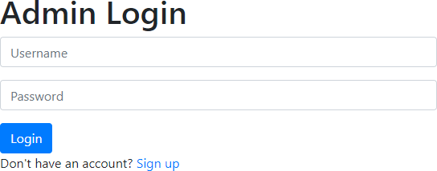
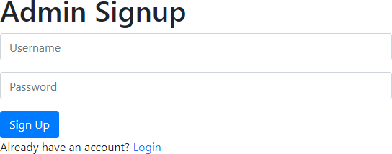

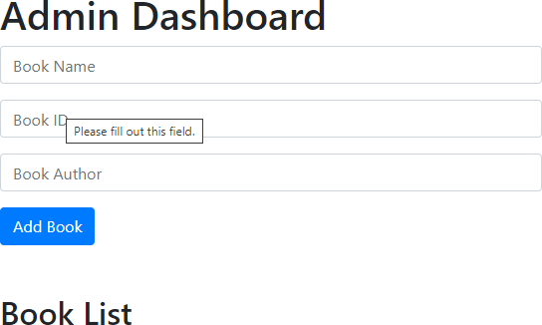

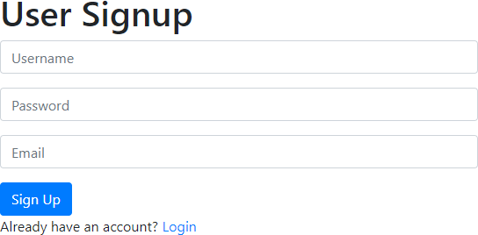
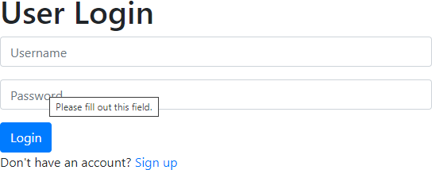

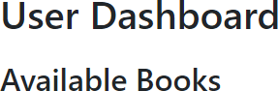
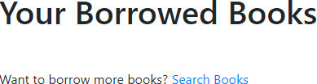

MARK ALLOCATION

CONTINOUS INTERNAL ASSESSMENT
Preparation & conduct of experiment | 50
Observation & Result | 30
Record | 10
Viva voice | 10
Total | 100

RESULT:
The Book Banking System successfully enables users to register, browse, borrow and return books while allowing admins to manage the inventory efficiently. It features a user- friendly interface, secure data handling, and maintains database integrity. Future enhancements could include user reviews, notifications and a recommendation system to further improve user engagement

FACULTY SIGNATURE

EX NO: 03 | EXAMINATION REGISTRATION AND RESULT SYSTEM
DATE: | EXAMINATION REGISTRATION AND RESULT SYSTEM
AIM:
To design a web-based Examination Registration and Result System, featuring separate
interfaces for students and administrators. The student page displays subjects and marks and allows downloading results as a PDF receipt.
PROCEDURE:

System Architecture:
Step 1: Setting Up the Database
Step 2: Backend Setup (Java)
Step 3: Create Java Servlets for API Endpoints
Step 4: Deploy the Java Backend
Step 5: Frontend and API Server Setup (Node.js + Express)
Step 6: Create a Basic Express Server
Step 7: Set Up HTML Form in Node.js
Step 8: Create an Endpoint to Proxy the Request to Java

UML DIAGRAMS:
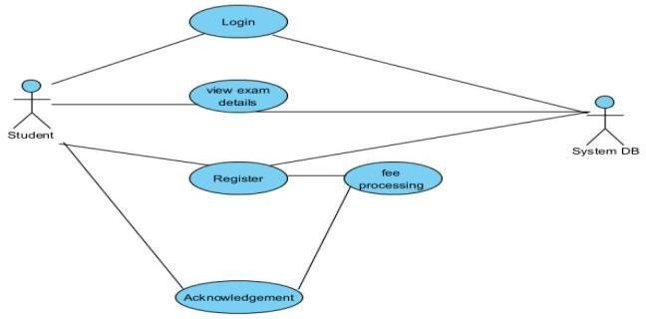
ACTIVITY DIAGRAM
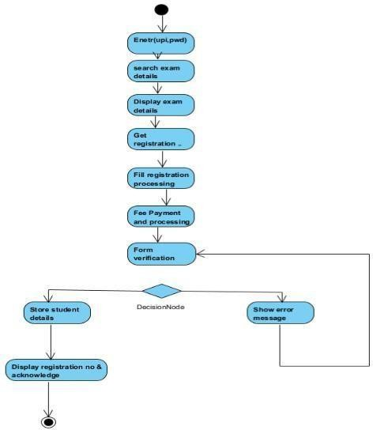

SEQUENCE DIAGRAM
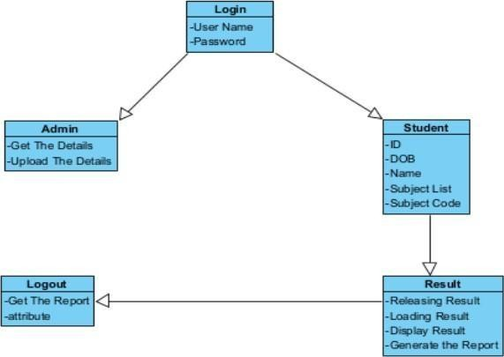
CLASS DIAGRAM
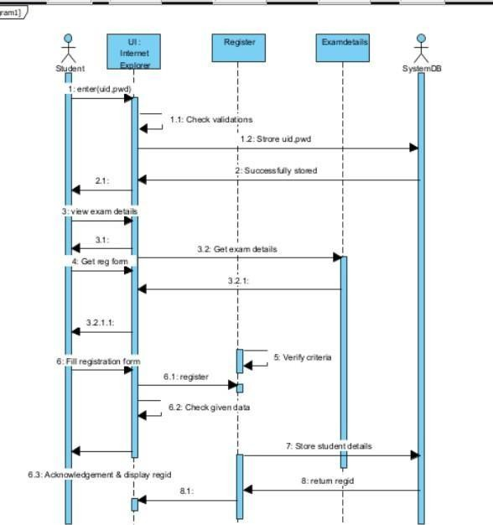
CODING:

Index.html
<!DOCTYPE html>
<html lang="en">
<head>
<meta charset="UTF-8">
<meta name="viewport" content="width=device-width, initial-scale=1.0">
<title>Exam Registration and Result System</title>
<link rel="stylesheet" href="style.css">
</head>
<body>

<h2>Welcome to Exam Registration and Result System</h2>
<button onclick="openStudentForm()">Student</button>
<button onclick="openAdminPage()">Admin</button>
<script>
function openStudentForm() { window.location.href = "student_form.html";
}
function openAdminPage() {
alert("Admin section under development.");
}
</script>
</body>
</html>

Student_form.html
<!DOCTYPE html>
<html lang="en">
<head>
<meta charset="UTF-8">
<meta name="viewport" content="width=device-width, initial-scale=1.0">
<title>Student Registration</title>
<link rel="stylesheet" href="style.css">
</head>
<body>
<h2>Student Registration</h2>
<form onsubmit="displayResult(event)">
<label for="name">Name:</label>
<input type="text" id="name" required><br>
<label for="dob">Date of Birth:</label>
<input type="date" id="dob" required><br>
<label for="regNo">Registration No:</label>
<input type="text" id="regNo" required><br>
<label for="password">Password:</label>
<input type="password" id="password" required><br>
<button type="submit">Submit</button>
</form>
<script>
function displayResult(event) { event.preventDefault();
// Store data locally or send to the server if needed const studentData = {
name: document.getElementById("name").value, dob: document.getElementById("dob").value, regNo: document.getElementById("regNo").value
};
localStorage.setItem("studentData", JSON.stringify(studentData)); window.location.href = "result_page.html";

}
</script>
</body>
</html>

Result_page.html
<!DOCTYPE html>
<html lang="en">
<head>
<meta charset="UTF-8">
<meta name="viewport" content="width=device-width, initial-scale=1.0">
<title>Exam Result</title>
<link rel="stylesheet" href="style.css">
</head>
<body>
<h2>Exam Result</h2>
<div id="result"></div>
<button onclick="downloadPDF()">Download PDF</button>
<button onclick="goHome()">Go Home</button>
<button onclick="logout()">Logout</button>
<script> document.addEventListener("DOMContentLoaded", () => {
const studentData = JSON.parse(localStorage.getItem("studentData")); if (studentData) {
const resultHTML = `
<p>Name: ${studentData.name}</p>
<p>Registration No: ${studentData.regNo}</p>
<h3>Subjects and Marks</h3>
<ul>
<li>Java: 92 (A)</li>
<li>DBMS: 89 (B+)</li>
<li>Computer Networks: 95 (A+)</li>
<li>Operating System: 90 (A)</li>
<li>Deep Learning: 88 (B+)</li>
</ul>
`;
document.getElementById("result").innerHTML = resultHTML;
}
});
function downloadPDF() { window.print();
}
function goHome() { window.location.href = "index.html";
}
function logout() {

localStorage.clear();
alert("Thank you for using the system!"); window.location.href = "index.html";
}
</script>
</body>
</html>

Style.css
body {
font-family: Arial, sans-serif; display: flex;
flex-direction: column; align-items: center; background-color: #f7f8fc; margin: 20px;
}
h2 {
color: #333;
}
button { margin: 8px;
padding: 12px 24px; font-size: 16px; font-weight: bold; border: none; border-radius: 5px; color: white;
cursor: pointer;
transition: background-color 0.3s ease;
}
/* Different colors for each button */ button:nth-of-type(1) {
background-color: #4CAF50; /* Green */
}
button:nth-of-type(2) {
background-color: #2196F3; /* Blue */
}
button:nth-of-type(3) {
background-color: #FF9800; /* Orange */
}
button:nth-of-type(4) {
background-color: #f44336; /* Red */
}
/* Hover effects for buttons */ button:hover {
opacity: 0.9;

}
form { display: flex;
flex-direction: column; padding: 20px; background-color: #ffffff; border: 1px solid #ddd; border-radius: 8px; width: 300px;
box-shadow: 0 4px 8px rgba(0, 0, 0, 0.1);
}
label {
margin: 10px 0 5px; font-weight: bold; color: #333;
}
input[type="text"], input[type="password"], input[type="date"] { padding: 8px;
font-size: 14px; border: 1px solid #ddd; border-radius: 4px; margin-bottom: 15px;
}
#result {
background-color: #e3f2fd; padding: 20px;
border: 1px solid #ddd; border-radius: 8px; margin-bottom: 20px; width: 300px;
box-shadow: 0 4px 8px rgba(0, 0, 0, 0.1);}
<p>Your passport application has been submitted successfully.</p>
</div>
</body>
</html>

OUTPUT:
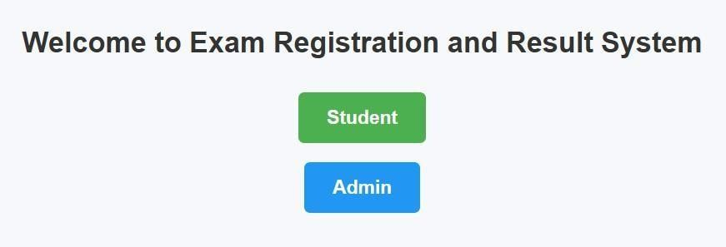
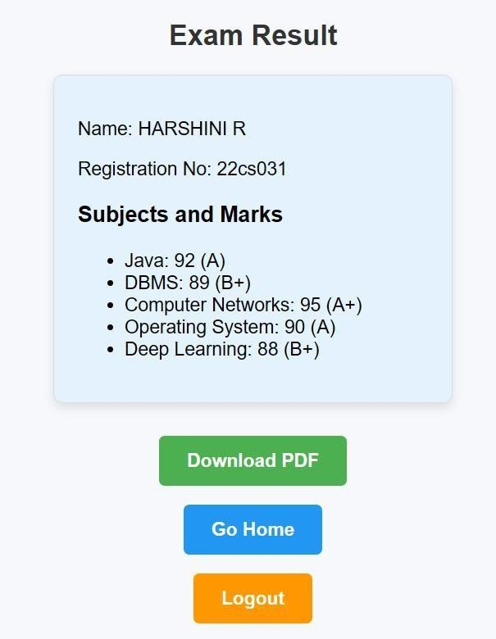
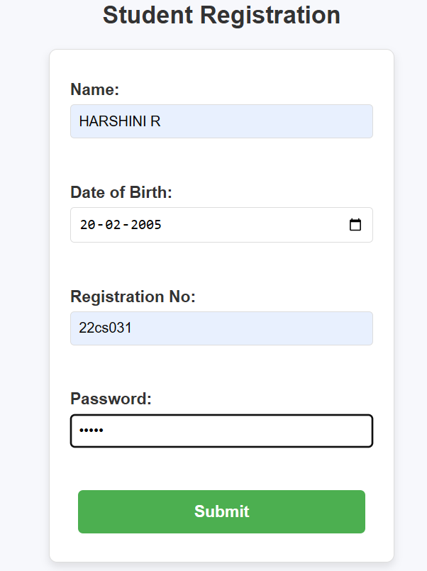

SQL Queries:
-- Create the database
CREATE DATABASE exam_system;
-- Use the database USE exam_system;
-- Create a table to store student information CREATE TABLE students (
reg_no VARCHAR(20) PRIMARY KEY, name VARCHAR(50),
dob DATE,
password VARCHAR(20)
);
-- Create a table to store results CREATE TABLE results ( reg_no VARCHAR(20), subject VARCHAR(50), marks INT,
grade CHAR(2),
FOREIGN KEY (reg_no) REFERENCES students(reg_no)
);

Insert a New Student
INSERT INTO students (reg_no, name, dob, password) VALUES ('12345', 'John Doe', '2000- 01-01', 'password123');

Insert Exam Results
INSERT INTO results (reg_no, subject, marks, grade) VALUES ('12345', 'Java', 92, 'A');

Fetch Student Details and Results
SELECT students.name, students.reg_no, results.subject, results.marks, results.grade FROM students
JOIN results ON students.reg_no = results.reg_no WHERE students.reg_no = '12345';

Connectivity Coding
import java.sql.Connection; import java.sql.DriverManager; import java.sql.PreparedStatement; import java.sql.ResultSet;
import java.sql.SQLException; public class ExamSystemDatabase {
// Database URL, Username, Password
private static final String URL = "jdbc:mysql://localhost:3306/exam_system";
private static final String USERNAME = "root"; // replace with your MySQL username private static final String PASSWORD = "password"; // replace with your MySQL password
// Establish database connection
public static Connection getConnection() throws SQLException {
return DriverManager.getConnection(URL, USERNAME, PASSWORD);
}
public static void insertStudent(String regNo, String name, String dob, String password) { String query = "INSERT INTO students (reg_no, name, dob, password) VALUES (?, ?, ?, ?)"; try (Connection conn = getConnection();
PreparedStatement stmt = conn.prepareStatement(query)) { stmt.setString(1, regNo);
stmt.setString(2, name); stmt.setString(3, dob); stmt.setString(4, password); stmt.executeUpdate();
System.out.println("Student inserted successfully.");
} catch (SQLException e) { e.printStackTrace();
}
}
public static void getStudentResults(String regNo) {
String query = "SELECT students.name, results.subject, results.marks, results.grade "
+ "FROM students JOIN results ON students.reg_no = results.reg_no "
+ "WHERE students.reg_no = ?";
try (Connection conn = getConnection(); PreparedStatement stmt = conn.prepareStatement(query)) {

stmt.setString(1, regNo);
ResultSet rs = stmt.executeQuery(); while (rs.next()) {
System.out.println("Name: " + rs.getString("name")); System.out.println("Subject: " + rs.getString("subject")); System.out.println("Marks: " + rs.getInt("marks")); System.out.println("Grade: " + rs.getString("grade")); System.out.println(" ");
}
} catch (SQLException e) { e.printStackTrace();
}
}
public static void main(String[] args) {
insertStudent("12345", "John Doe", "2000-01-01", "password123"); getStudentResults("12345");
}
}

MARK ALLOCATION

CONTINOUS INTERNAL ASSESSMENT
Preparation & conduct of experiment | 50
Observation & Result | 30
Record | 10
Viva voice | 10
Total | 100

RESULT:
The Examination Registration and Result System was implemented using HTML, CSS and JavaScript, with connectivity managed by Node.js and Java. Student and exam data were successfully stored in the database, and the system verified a functional relationship between the student and the administrator. The result display with a downloadable PDF receipt was implemented effectively, providing a seamless user experience.

FACULTY SIGNATURE

EX NO: 04 | STOCK MAINTANENCE SYSTEM
DATE: | STOCK MAINTANENCE SYSTEM
AIM:
To design a stock maintenance system is aimed at efficiently managing the inventory,
with functionalities for logging in (only authorized users), adding/updating/deleting stock items, and automatically calculating the total amount for each item.
PROCEDURE:
Step 1: Plan the Project Scope and Features Step 2: Set Up the Development Environment Step 3: Create the Database
Step 4: Design the Frontend
Step 5: Implement Backend Logic Step 8: Implement stock management Step 9: Test the Application
Step 10: Deploy the Application

UML DIAGRAMS:
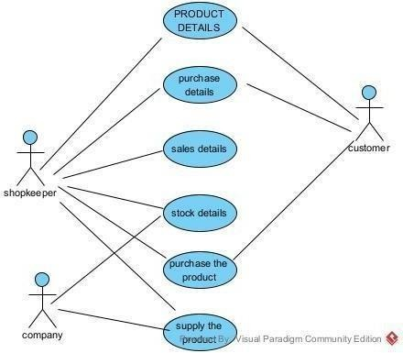
CLASS DIAGRAM
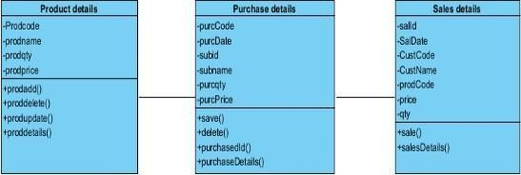

ACTIVITY DIAGRAM
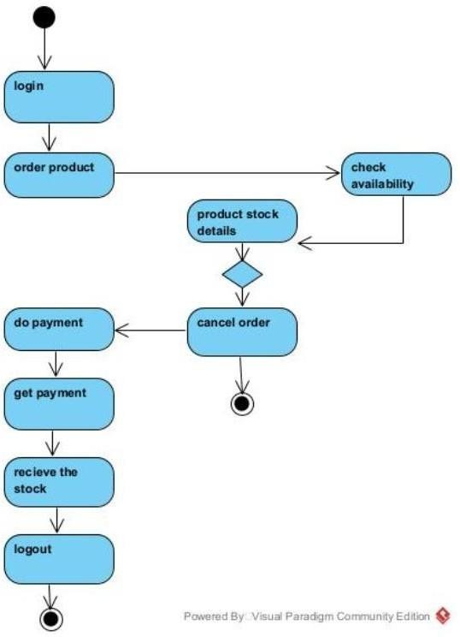

SEQUENCE DIAGRAM
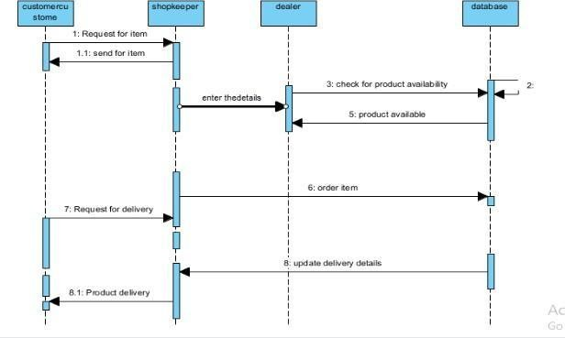

CODING:
INDEX.HTML
<!DOCTYPE html>
<html lang="en">
<head>
<meta charset="UTF-8">
<meta name="viewport" content="width=device-width, initial-scale=1.0">
<title>Stock Maintenance System</title>
<link rel="stylesheet" href="style.css">
</head>
<body>
<div id="loginForm" class="form-container">
<h2>Login</h2>
<label for="username">Username:</label>
<input type="text" id="username" placeholder="Enter username">
<label for="password">Password:</label>
<input type="password" id="password" placeholder="Enter password">

<button onclick="login()">Login</button>
</div>
<div id="stockForm" class="form-container" style="display:none;">
<h2>Stock Maintenance</h2>
<button onclick="logout()">Logout</button>
<form id="stockItemForm">
<label for="itemName">Item Name:</label>
<input type="text" id="itemName" required>
<label for="itemType">Item Type:</label>
<input type="text" id="itemType" required>
<label for="itemCode">Item Code:</label>
<input type="text" id="itemCode" required>
<label for="itemDate">Date:</label>
<input type="date" id="itemDate" required>
<label for="price">Price:</label>
<input type="number" id="price" required>
<label for="quantity">Quantity:</label>
<input type="number" id="quantity" required>
<label for="netWeight">Net Weight:</label>
<input type="number" id="netWeight" required>
<label for="totalAmount">Total Amount:</label>
<input type="number" id="totalAmount" disabled>
<button type="button" onclick="addItem()">Add Item</button>
</form>
<h3>Item List</h3>
<table id="itemTable">
<thead>
<tr>
<th>Item Name</th>
<th>Item Type</th>
<th>Item Code</th>
<th>Date</th>
<th>Price</th>
<th>Quantity</th>
<th>Net Weight</th>
<th>Total Amount</th>
<th>Actions</th>
</tr>
</thead>
<tbody>
<!-- Stock items will be added here dynamically -->
</tbody>
</table>
</div>
<script src="script.js"></script>
</body>
</html>

STYLE.CSS
body {
font-family: Arial, sans-serif; background-color: #f4f4f4; margin: 0;
padding: 0;
}
.form-container { width: 300px; margin: 20px auto; padding: 20px;
background-color: white; border-radius: 10px;
box-shadow: 0 4px 6px rgba(0, 0, 0, 0.1);
}
h2, h3 {
text-align: center;
}
input[type="text"], input[type="password"], input[type="number"], input[type="date"] { width: 100%;
padding: 10px; margin: 8px 0; border-radius: 5px;
border: 1px solid #ccc;
}
button { width: 100%; padding: 10px;
margin: 10px 0; background-color: #28a745; color: white;
border: none; border-radius: 5px; cursor: pointer;
}
button:hover {
background-color: #218838;
}
table { width: 100%;
border-collapse: collapse; margin-top: 20px;
}
table th, table td { border: 1px solid #ccc; padding: 8px;
text-align: center;

}
button.delete-btn { background-color: #dc3545;
}
button.update-btn { background-color: #ffc107;
}

SCRIPT.JS
// Mock user data (you can replace this with backend logic) const validUsername = "admin";
const validPassword = "password123";
// To keep track of the stock items let stockItems = [];
// Function to log in function login() {
const username = document.getElementById('username').value; const password = document.getElementById('password').value;
if (username === validUsername && password === validPassword) { document.getElementById('loginForm').style.display = 'none'; document.getElementById('stockForm').style.display = 'block';
} else {
alert("Invalid username or password");
}
}
// Function to log out function logout() {
document.getElementById('loginForm').style.display = 'block'; document.getElementById('stockForm').style.display = 'none';
}
// Function to calculate total amount function calculateTotalAmount() {
const price = parseFloat(document.getElementById('price').value); const quantity = parseInt(document.getElementById('quantity').value); const totalAmount = price * quantity;
document.getElementById('totalAmount').value = totalAmount.toFixed(2);
}
// Function to add item to the table function addItem() {
const itemName = document.getElementById('itemName').value; const itemType = document.getElementById('itemType').value; const itemCode = document.getElementById('itemCode').value; const itemDate = document.getElementById('itemDate').value; const price = parseFloat(document.getElementById('price').value);
const quantity = parseInt(document.getElementById('quantity').value);
const netWeight = parseFloat(document.getElementById('netWeight').value); const totalAmount = parseFloat(document.getElementById('totalAmount').value);

const item = { itemName, itemType, itemCode, itemDate, price, quantity, netWeight, totalAmount
};
stockItems.push(item); displayItems(); resetForm();
}
// Function to reset the form fields function resetForm() {
document.getElementById('itemName').value = ''; document.getElementById('itemType').value = ''; document.getElementById('itemCode').value = ''; document.getElementById('itemDate').value = ''; document.getElementById('price').value = ''; document.getElementById('quantity').value = ''; document.getElementById('netWeight').value = ''; document.getElementById('totalAmount').value = '';
}
// Function to display all items in the table function displayItems() {
const tbody = document.getElementById('itemTable').getElementsByTagName('tbody')[0]; tbody.innerHTML = '';
stockItems.forEach((item, index) => { const row = tbody.insertRow(); row.innerHTML = `
<td>${item.itemName}</td>
<td>${item.itemType}</td>
<td>${item.itemCode}</td>
<td>${item.itemDate}</td>
<td>${item.price}</td>
<td>${item.quantity}</td>
<td>${item.netWeight}</td>
<td>${item.totalAmount}</td>
<td>
<button class="update-btn" onclick="updateItem(${index})">Update</button>
<button class="delete-btn" onclick="deleteItem(${index})">Delete</button>
</td>
`;
});
}

// Function to update an item function updateItem(index) { const item = stockItems[index];
document.getElementById('itemName').value = item.itemName; document.getElementById('itemType').value = item.itemType; document.getElementById('itemCode').value = item.itemCode; document.getElementById('itemDate').value = item.itemDate; document.getElementById('price').value = item.price; document.getElementById('quantity').value = item.quantity; document.getElementById('netWeight').value = item.netWeight; document.getElementById('totalAmount').value = item.totalAmount; stockItems.splice(index, 1); // Remove the item from array (we'll add it again later after edit) displayItems();
}
// Function to delete an item function deleteItem(index) { stockItems.splice(index, 1); displayItems();
}
// Add event listener for price and quantity inputs to calculate total amount document.getElementById('price').addEventListener('input', calculateTotalAmount); document.getElementById('quantity').addEventListener('input', calculateTotalAmount);
OUTPUT:

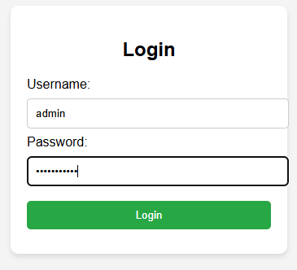

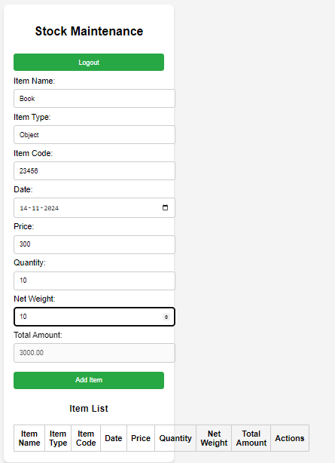
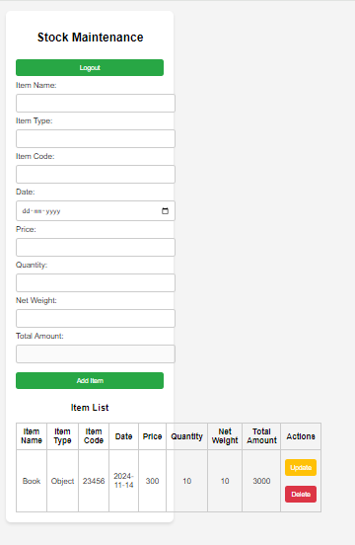

SQL QUERIES
CREATE DATABASE StockManagement; CREATE TABLE Users (
user_id INT AUTO_INCREMENT PRIMARY KEY, username VARCHAR(50) NOT NULL UNIQUE, password VARCHAR(255) NOT NULL
);
CREATE TABLE StockItems (
item_id INT AUTO_INCREMENT PRIMARY KEY,
item_name VARCHAR(100) NOT NULL, item_type VARCHAR(50),
item_code VARCHAR(50) UNIQUE NOT NULL,
item_date DATE,
price DECIMAL(10, 2),
quantity INT,
net_weight DECIMAL(10, 2),
total_amount DECIMAL(10, 2) GENERATED ALWAYS AS (price * quantity) STORED
);
INSERT INTO Users (username, password) VALUES ('admin', 'password123');
INSERT INTO StockItems (item_name, item_type, item_code, item_date, price, quantity, net_weight)
VALUES ('Laptop', 'Electronics', 'LT12345', '2024-11-01', 1000.00, 50, 1.5);
SELECT * FROM StockItems; SELECT * FROM StockItems WHERE item_code = 'LT12345'; UPDATE StockItems
SET price = 950.00, quantity = 60, net_weight = 1.6 WHERE item_code = 'LT12345';
DELETE FROM StockItems WHERE item_code = 'LT12345'; SELECT * FROM Users
WHERE username = 'admin' AND password = 'password123'; SELECT item_name, total_amount FROM StockItems; INSERT INTO Users (username, password)
VALUES ('admin', 'adminpassword123');
-- Adding a laptop
INSERT INTO StockItems (item_name, item_type, item_code, item_date, price, quantity, net_weight)
VALUES ('Laptop', 'Electronics', 'LT001', '2024-11-01', 1200.00, 30, 1.8);
-- Adding a phone
INSERT INTO StockItems (item_name, item_type, item_code, item_date, price, quantity, net_weight)
VALUES ('Smartphone', 'Electronics', 'PH001', '2024-11-02', 800.00, 50, 0.2);
SELECT * FROM StockItems; UPDATE StockItems

SET price = 1150.00, quantity = 40 WHERE item_code = 'LT001'; DELETE FROM StockItems WHERE item_code = 'PH001'; SELECT * FROM StockItems
WHERE item_name LIKE '%Laptop%';
SELECT SUM(total_amount) AS total_inventory_value FROM StockItems;
SELECT * FROM StockItems WHERE quantity < 10;
CONNECTIVITY CODING:
import java.sql.*; import java.util.Scanner;
public class StockMaintenanceSystem {
// Database URL, username, and password
static final String DB_URL = "jdbc:mysql://localhost:3306/StockManagement"; static final String USER = "root"; // Replace with your database username static final String PASS = "password"; // Replace with your database password
// Main Method
public static void main(String[] args) {
try (Connection conn = DriverManager.getConnection(DB_URL, USER, PASS)) { System.out.println("Connected to the database successfully!");
Scanner scanner = new Scanner(System.in); while (true) {
System.out.println("\nStock Maintenance System:"); System.out.println("1. Login"); System.out.println("2. Add Stock Item"); System.out.println("3. Update Stock Item"); System.out.println("4. Delete Stock Item"); System.out.println("5. View All Items"); System.out.println("6. Exit"); System.out.print("Enter your choice: ");
int choice = scanner.nextInt(); scanner.nextLine(); // Consume newline switch (choice) {
case 1 -> login(conn, scanner);
case 2 -> addStockItem(conn, scanner); case 3 -> updateStockItem(conn, scanner); case 4 -> deleteStockItem(conn, scanner); case 5 -> viewAllItems(conn);
case 6 -> {
System.out.println("Exiting... Goodbye!"); scanner.close();
return;
}
default -> System.out.println("Invalid choice. Try again.");

}
}
} catch (SQLException e) { e.printStackTrace();
}
}
// Login Method
public static void login(Connection conn, Scanner scanner) throws SQLException { System.out.print("Enter username: ");
String username = scanner.nextLine(); System.out.print("Enter password: "); String password = scanner.nextLine();
String query = "SELECT * FROM Users WHERE username = ? AND password = ?"; try (PreparedStatement pstmt = conn.prepareStatement(query)) {
pstmt.setString(1, username); pstmt.setString(2, password); ResultSet rs = pstmt.executeQuery(); if (rs.next()) {
System.out.println("Login successful! Welcome, " + username + ".");
} else {
System.out.println("Invalid credentials. Try again.");
}
}
}
// Add Stock Item Method
public static void addStockItem(Connection conn, Scanner scanner) throws SQLException { System.out.print("Enter item name: ");
String itemName = scanner.nextLine(); System.out.print("Enter item type: "); String itemType = scanner.nextLine(); System.out.print("Enter item code: "); String itemCode = scanner.nextLine();
System.out.print("Enter item date (YYYY-MM-DD): "); String itemDate = scanner.nextLine(); System.out.print("Enter price: ");
double price = scanner.nextDouble(); System.out.print("Enter quantity: "); int quantity = scanner.nextInt(); System.out.print("Enter net weight: ");
double netWeight = scanner.nextDouble();
String query = "INSERT INTO StockItems (item_name, item_type, item_code, item_date, price, quantity, net_weight) VALUES (?, ?, ?, ?, ?, ?, ?)";
try (PreparedStatement pstmt = conn.prepareStatement(query)) { pstmt.setString(1, itemName);
pstmt.setString(2, itemType); pstmt.setString(3, itemCode);

pstmt.setString(4, itemDate); pstmt.setDouble(5, price); pstmt.setInt(6, quantity); pstmt.setDouble(7, netWeight); int rows = pstmt.executeUpdate();
System.out.println(rows + " item(s) added successfully.");
}
}
// Update Stock Item Method
public static void updateStockItem(Connection conn, Scanner scanner) throws SQLException
{
System.out.print("Enter item code to update: "); String itemCode = scanner.nextLine(); System.out.print("Enter new price: ");
double price = scanner.nextDouble(); System.out.print("Enter new quantity: "); int quantity = scanner.nextInt();
String query = "UPDATE StockItems SET price = ?, quantity = ? WHERE item_code = ?"; try (PreparedStatement pstmt = conn.prepareStatement(query)) {
pstmt.setDouble(1, price); pstmt.setInt(2, quantity); pstmt.setString(3, itemCode);
int rows = pstmt.executeUpdate();
System.out.println(rows + " item(s) updated successfully.");
}
}
// Delete Stock Item Method
public static void deleteStockItem(Connection conn, Scanner scanner) throws SQLException
{
System.out.print("Enter item code to delete: "); String itemCode = scanner.nextLine();
String query = "DELETE FROM StockItems WHERE item_code = ?"; try (PreparedStatement pstmt = conn.prepareStatement(query)) { pstmt.setString(1, itemCode);
int rows = pstmt.executeUpdate();
System.out.println(rows + " item(s) deleted successfully.");
}
}
// View All Items Method
public static void viewAllItems(Connection conn) throws SQLException { String query = "SELECT * FROM StockItems";
try (Statement stmt = conn.createStatement(); ResultSet rs = stmt.executeQuery(query)) { System.out.printf("%-10s %-15s %-15s %-15s %-10s %-10s %-10s %-15s\n",
"ID", "Name", "Type", "Code", "Date", "Price", "Quantity", "Net Weight"); while (rs.next()) {
System.out.printf("%-10d %-15s %-15s %-15s %-10s %-10.2f %-10d %-15.2f\n", rs.getInt("item_id"),

rs.getString("item_name"), rs.getString("item_type"), rs.getString("item_code"), rs.getDate("item_date"), rs.getDouble("price"), rs.getInt("quantity"), rs.getDouble("net_weight")); }}}}

MARK ALLOCATION

CONTINOUS INTERNAL ASSESSMENT
Preparation & conduct of experiment | 50
Observation & Result | 30
Record | 10
Viva voice | 10
Total | 100

RESULT:
The Stock Maintenance System was implemented using HTML, CSS and JavaScript with connectivity managed by Node.js and Java. The data was successfully stored in the database, establishing a functional relationship between the user and the administrator was verified.

FACULTY SIGNATURE

EX NO: 05 | ONLINE COURSE RESERVATION SYSTEM
DATE: | ONLINE COURSE RESERVATION SYSTEM
AIM:
To develop an online course registration system by designing and organizing all the
required system components, and to implement the complete software using Visual Basic for efficient and user-friendly operation.
PROCEDURE:
Step 1: Plan the Project Scope and Features Step 2: Set Up the Development Environment Step 3: Create the Database
Step 4: Design the Frontend
Step 5: Implement Backend Logic
Step 7: Implement Online course reservation system
Step 9: Test the Application
Step 10: Deploy the Application

UML DIAGRAMS:
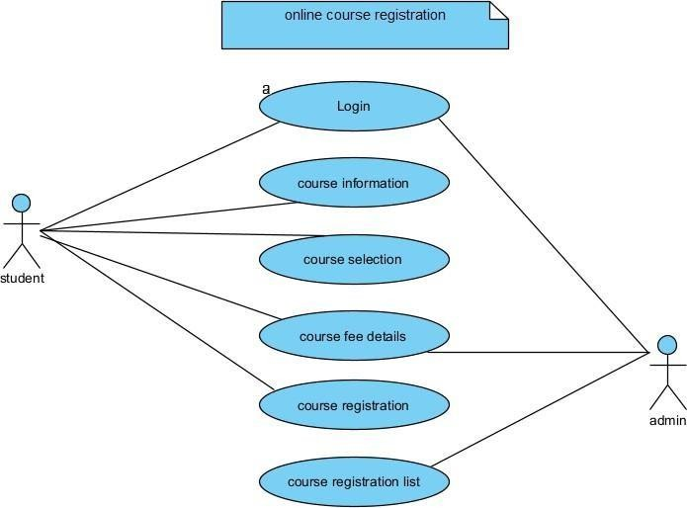
CLASS DIAGRAM
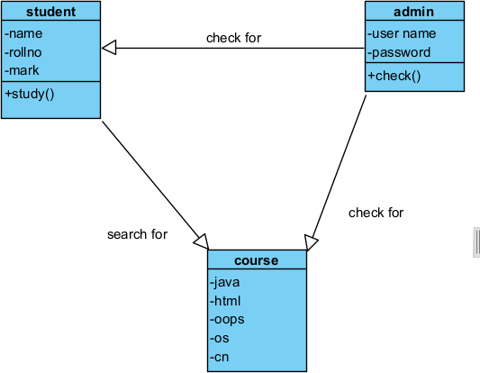

SEQUENCE DIAGRAM
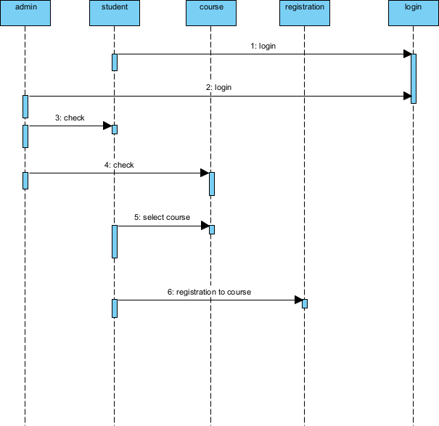

ACTIVITY DIAGRAM
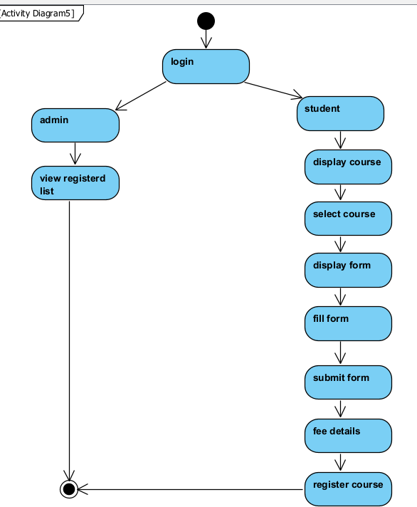

COLLABORATION SYSTEM
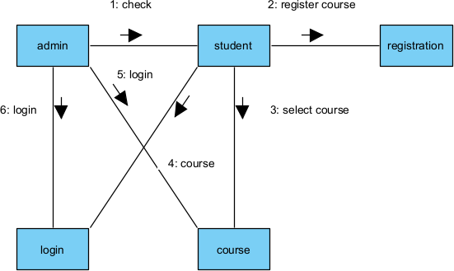

CODING:
INDEX.HTML:
<!DOCTYPE html>
<html lang="en">
<head>
<meta charset="UTF-8">
<meta name="viewport" content="width=device-width, initial-scale=1.0">
<title>Online Course Registration</title>
<link rel="stylesheet" href="styles.css">
</head>
<body>
<header class="header">
<h1>Online Course Registration</h1>
</header>
<main>
<div class="form-container">
<h2>Register for a Course</h2>
<form action="#" method="POST" class="registration-form">
<label for="name">Full Name:</label>
<input type="text" id="name" name="name" placeholder="Enter your full name" required>
<label for="email">Email:</label>
<input type="email" id="email" name="email" placeholder="Enter your email" required>
<label for="phone">Phone Number:</label>
<input type="tel" id="phone" name="phone" placeholder="Enter your phone number" required>
<label for="course">Select Course:</label>
<select id="course" name="course" required>
<option value="" disabled selected>Choose a course</option>

</div>
</main>
<option value="web-development">Web Development</option>
<option value="data-science">Data Science</option>
<option value="ai-ml">AI & Machine Learning</option>
<option value="cyber-security">Cyber Security</option>
</select>
<label for="date">Preferred Start Date:</label>
<input type="date" id="date" name="date" required>
<button type="submit" class="submit-btn">Register</button>
</form>

<footer class="footer">
<p>&copy; 2024 Online Course Registration. All rights reserved.</p>
</footer>
</body>
</html>
<!DOCTYPE html>
<html lang="en">
<head>
<meta charset="UTF-8">
<meta name="viewport" content="width=device-width, initial-scale=1.0"><title>Online Course Registration</title>
<link rel="stylesheet" href="styles.css">
</head>
<body>
<header class="header">
<h1>Online Course Registration</h1>
</header>
<main>
<div class="form-container">
<h2>Register for a Course</h2>
<form action="#" method="POST" class="registration-form">
<label for="name">Full Name:</label>
<input type="text" id="name" name="name" placeholder="Enter your full name" required>
<label for="email">Email:</label>
<input type="email" id="email" name="email" placeholder="Enter your email" required>
<label for="phone">Phone Number:</label>
<input type="tel" id="phone" name="phone" placeholder="Enter your phone number" required>
<label for="course">Select Course:</label>
<select id="course" name="course" required>
<option value="" disabled selected>Choose a course</option>
<option value="web-development">Web Development</option>
<option value="data-science">Data Science</option>

<option value="ai-ml">AI & Machine Learning</option>

<option value="cyber-security">Cyber Security</option>
</select>
<label for="date">Preferred Start Date:</label>
<input type="date" id="date" name="date" required>
<button type="submit" class="submit-btn">Register</button>
</form>
</div>
</main>
<footer class="footer">
<p>&copy; 2024 Online Course Registration. All rights reserved.</p>
</footer>
</body>
</html>

STYLE.CSS:
/* General Styles */ body {
font-family: Arial, sans- serif; margin: 0;
padding: 0;
background-color: #f5f5f5;
}
.header { background-color: #4CAF50; color: white; text-align: center;
padding: 1rem 0;
}
.footer {
background-color: #333; color: white;
text-align: center; padding: 0.5rem 0; position: fixed; width: 100%;
bottom: 0;
}
main {
padding: 2rem; display: flex;
justify-content: center;
}
/* Form Container */
.form-container { background: white; border-radius: 8px;
box-shadow: 0 4px 6px rgba(0, 0, 0, 0.1); padding: 2rem;
width: 100%;

max-width: 400px;
}
/* Form Styles */
.registration-form { display: flex;
flex-direction: column;
}
label {
margin-bottom: 0.5rem; font-weight: bold;
}
input, select, button { margin-bottom: 1rem; padding: 0.75rem; border: 1px solid #ccc; border-radius: 4px; font-size: 1rem;
}
input:focus, select:focus { border-color: #4CAF50;
outline: none;
}
button {
background-color: #4CAF50; color: white;
border: none; cursor: pointer; font-size: 1rem;
transition: background-color 0.3s ease;
}
button:hover {
background-color: #45a049;
}

SUCCESS.HTML:
<!DOCTYPE html>
<html lang="en">
<head>
<meta charset="UTF-8">
<meta name="viewport" content="width=device-width, initial-scale=1.0">
<title>Registration Successful</title>
<link rel="stylesheet" href="styles.css">
</head>
<body>
<header class="header">
<h1>Registration Successful</h1>

</header>
<main>
<div class="success-container">
<h2>Thank you for registering!</h2>
<p>Your registration has been successfully completed.</p>
<a href="index.html" class="btn">Go Back to Home</a>
</div>
</main>
<footer class="footer">
<p>&copy; 2024 Online Course Registration. All rights reserved.</p>
</footer>
</body>
</html>

SERVER.JS:
const express = require("express");
const bodyParser = require("body-parser"); const mongoose = require("mongoose"); const cors = require("cors");
const app = express();
// Middleware
app.use(bodyParser.urlencoded({ extended: true })); app.use(bodyParser.json());
app.use(cors());
// Connect to MongoDB mongoose
.connect("mongodb://127.0.0.1:27017/courseRegistrationDB", { useNewUrlParser: true,
useUnifiedTopology: true,
})
.then(() => console.log("Connected to MongoDB"))
.catch((err) => console.error("Database connection error:", err));
// Create a Schema
const registrationSchema = new mongoose.Schema({ name: String,
email: String, phone: String, course: String, startDate: Date,
});
// Create a Model
const Registration = mongoose.model("Registration", registrationSchema);
// Handle form submissions app.post("/register", (req, res) => {
const { name, email, phone, course, startDate } = req.body; const newRegistration = new Registration({
name,

email, phone, course, startDate,
});
newRegistration
.save()
.then(() => res.status(201).send("Registration Successful!"))
.catch((err) => res.status(500).send("Error registering: " + err.message));
});
// Start the server const PORT = 5000;
app.listen(PORT, () =>
{
console.log(`Server running on http://localhost:${PORT}`);
});

OUTPUT:

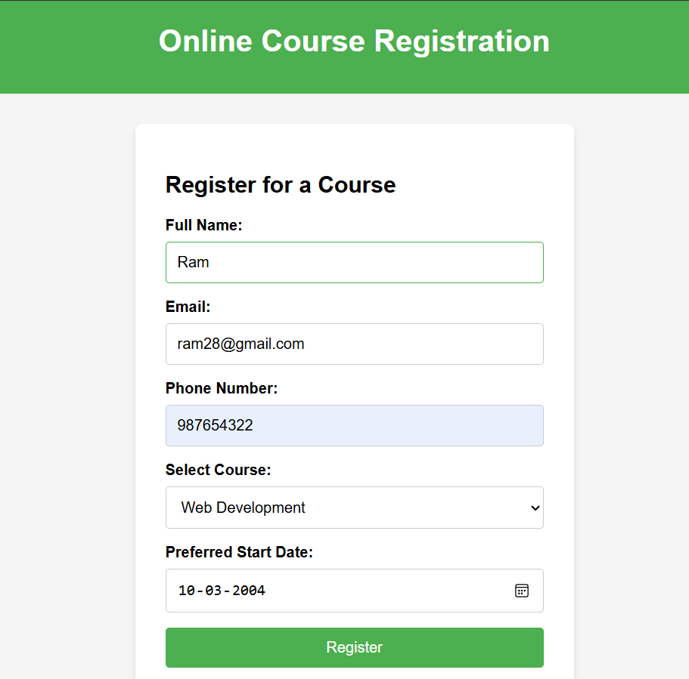

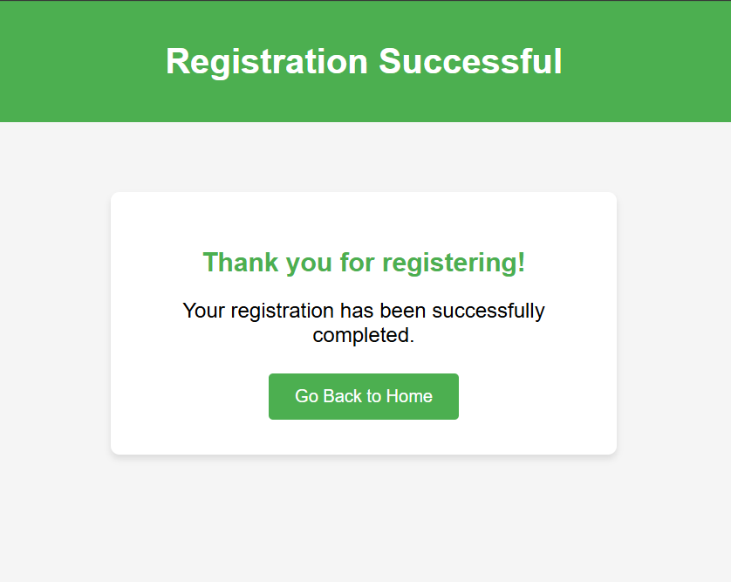
DBMS CONECTIVITY :
import java.io.IOException; import java.sql.Connection; import java.sql.DriverManager;
import java.sql.PreparedStatement; import javax.servlet.ServletException;
import javax.servlet.annotation.WebServlet; import javax.servlet.http.HttpServlet;
import javax.servlet.http.HttpServletRequest; import javax.servlet.http.HttpServletResponse; @WebServlet("/register")
public class RegistrationServlet extends HttpServlet { private static final String DB_URL =
"jdbc:mysql://localhost:3306/OnlineCourseRegistration"; private static final String DB_USER = "root";
private static final String DB_PASSWORD = ""; @Override
protected void doPost(HttpServletRequest request, HttpServletResponse response) throws ServletException, IOException {
String name = request.getParameter("name"); String email = request.getParameter("email"); String phone = request.getParameter("phone"); String course = request.getParameter("course");
String startDate = request.getParameter("start_date"); try {
Connection connection = DriverManager.getConnection(DB_URL, DB_USER, DB_PASSWORD);

String sql = "INSERT INTO Registrations (name, email, phone, course, start_date) VALUES (?, ?, ?, ?, ?)";
PreparedStatement statement = connection.prepareStatement(sql); statement.setString(1, name);
statement.setString(2, email); statement.setString(3, phone); statement.setString(4, course); statement.setString(5, startDate);
int rowsInserted = statement.executeUpdate(); if (rowsInserted > 0) {
response.getWriter().println("Registration successful!");
} else {
response.getWriter().println("Failed to register. Please try again.");
}
connection.close();
} catch (Exception e) { e.printStackTrace();
response.getWriter().println("Error: " + e.getMessage());
}
}}

MARK ALLOCATION

CONTINOUS INTERNAL ASSESSMENT
Preparation & conduct of experiment | 50
Observation & Result | 30
Record | 10
Viva voice | 10
Total | 100

RESULT:
Thus the project to develop online course reservation system was developed using java and to implement the software in Visual Basic is done successfully.

FACULTY SIGNATURE

EX NO: 06 | E-TICKETING
DATE: | E-TICKETING
AIM:
To design and implement an E-Ticketing System for Railway Reservations that allows
users to efficiently book train tickets online. The system provides functionalities for selecting travel details (origin, destination, date, and time), choosing train options and class types, entering passenger information, and generating ticket confirmations.
PROCEDURE:
Step 1: Set Up the Development Environment
Step 2: Create the Database
Step 3: Design the Frontend
Step 4: Implement Backend Logic Step 5: Implement Train Management Step 6: Implement Ticket Booking Step 7: Deploy the Application
UML DIAGRAMS :
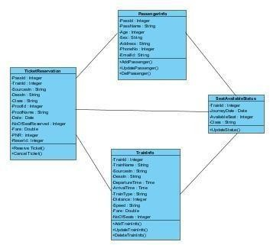

ACTIVITY DIAGRAM
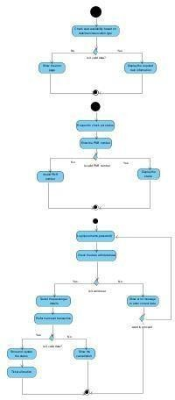

SEQUENCE DIAGRAM
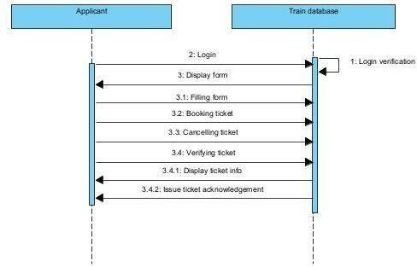

USE CASE DIAGRAM
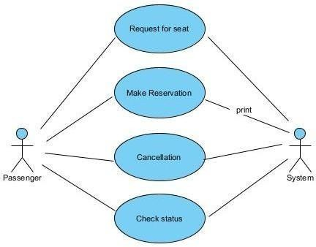
CODING:
INDEX.HTML
<!DOCTYPE html>
<html lang="en">
<head>
<meta charset="UTF-8">
<meta name="viewport" content="width=device-width, initial-scale=1.0">
<title>Railway Reservation System</title>
<link rel="stylesheet" href="style.css">
</head>
<body>
<div class="container">
<h1>Railway Reservation System</h1>
<!-- Booking Form -->
<form id="reservationForm">
<h2>Book Your Ticket</h2>
<label for="origin">Origin:</label>
<input type="text" id="origin" placeholder="Enter origin" required>
<label for="destination">Destination:</label>
<input type="text" id="destination" placeholder="Enter destination" required>
<label for="date">Travel Date:</label>
<input type="date" id="date" required>
<label for="time">Travel Time:</label>
<input type="time" id="time" required>
<label for="train">Select Train:</label>
<select id="train" required>
<option value="">--Select Train--</option>
<option value="Express 101">Express 101</option>

<option value="Intercity 202">Intercity 202</option>
<option value="Regional 303">Regional 303</option>
</select>
<label for="class">Class Type:</label>
<select id="class" required>
<option value="">--Select Class--</option>
<option value="First Class">First Class</option>
<option value="Second Class">Second Class</option>
<option value="Sleeper">Sleeper</option>
</select>
<h3>Passenger Details</h3>
<label for="name">Passenger Name:</label>
<input type="text" id="name" placeholder="Enter name" required>
<label for="age">Age:</label>
<input type="number" id="age" placeholder="Enter age" required>
<label for="gender">Gender:</label>
<select id="gender" required>
<option value="">--Select Gender--</option>
<option value="Male">Male</option>
<option value="Female">Female</option>
<option value="Other">Other</option>
</select>
<button type="button" onclick="bookTicket()">Book Ticket</button>
</form>
<!-- Ticket Display -->
<div id="ticketDetails" style="display: none;">
<h2>Ticket Confirmation</h2>
<div id="ticketContent"></div>
<button onclick="resetForm()">Book Another Ticket</button>
</div>
</div>
<script src="script.js"></script>
</body>
</html>

STYLE.CSS
body {
font-family: Arial, sans-serif; background-color: #f4f4f4; margin: 0;
padding: 0;
}
.container { width: 50%; margin: auto; margin-top: 50px;
background: #ffffff;

padding: 20px; border-radius: 8px;
box-shadow: 0 4px 6px rgba(0, 0, 0, 0.1);
}
h1, h2, h3 {
text-align: center;
}
form { display: flex;
flex-direction: column; gap: 15px;
}
label {
font-weight: bold;
}
input, select, button { padding: 10px;
font-size: 1rem; border-radius: 5px; border: 1px solid #ccc; width: 100%;
}
button {
background-color: #28a745; color: white;
cursor: pointer;
}
button:hover {
background-color: #218838;
}
#ticketDetails { text-align: center; margin-top: 20px;
}
#ticketContent { margin: 20px 0; border: 1px solid #ccc; padding: 10px;
border-radius: 5px; background-color: #f9f9f9;
}

SCRIPT.JS
function bookTicket() {
// Retrieve input values
const origin = document.getElementById('origin').value;
const destination = document.getElementById('destination').value;

const date = document.getElementById('date').value; const time = document.getElementById('time').value; const train = document.getElementById('train').value;
const travelClass = document.getElementById('class').value; const name = document.getElementById('name').value; const age = document.getElementById('age').value;
const gender = document.getElementById('gender').value;
// Validate inputs
if (!origin || !destination || !date || !time || !train || !travelClass || !name || !age || !gender) { alert("Please fill out all fields.");
return;
}
// Generate ticket details const ticketContent = `
<p><strong>Passenger Name:</strong> ${name}</p>
<p><strong>Age:</strong> ${age}</p>
<p><strong>Gender:</strong> ${gender}</p>
<p><strong>Origin:</strong> ${origin}</p>
<p><strong>Destination:</strong> ${destination}</p>
<p><strong>Travel Date:</strong> ${date}</p>
<p><strong>Travel Time:</strong> ${time}</p>
<p><strong>Train:</strong> ${train}</p>
<p><strong>Class:</strong> ${travelClass}</p>
`;
// Display ticket details document.getElementById('ticketContent').innerHTML = ticketContent; document.getElementById('reservationForm').style.display = 'none'; document.getElementById('ticketDetails').style.display = 'block';
}
function resetForm() {
// Reset form document.getElementById('reservationForm').reset();
document.getElementById('reservationForm').style.display = 'block'; document.getElementById('ticketDetails').style.display = 'none';
}

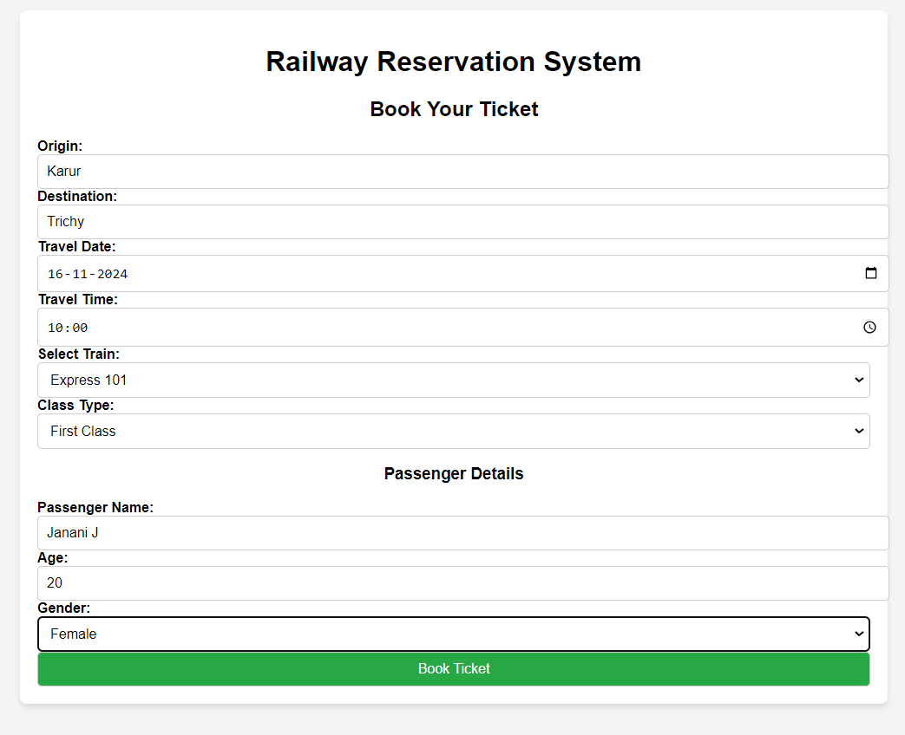
OUTPUT:

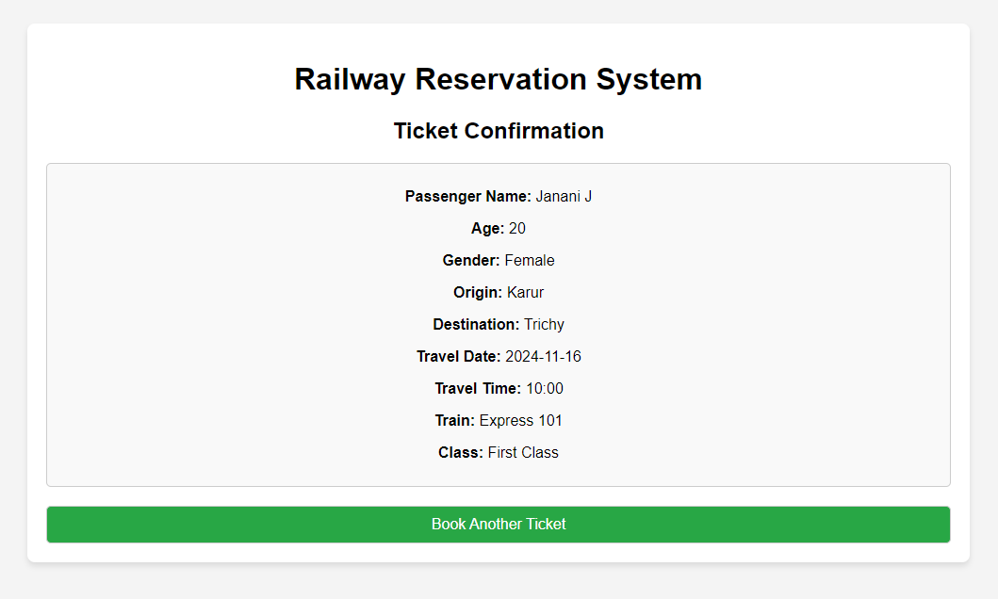

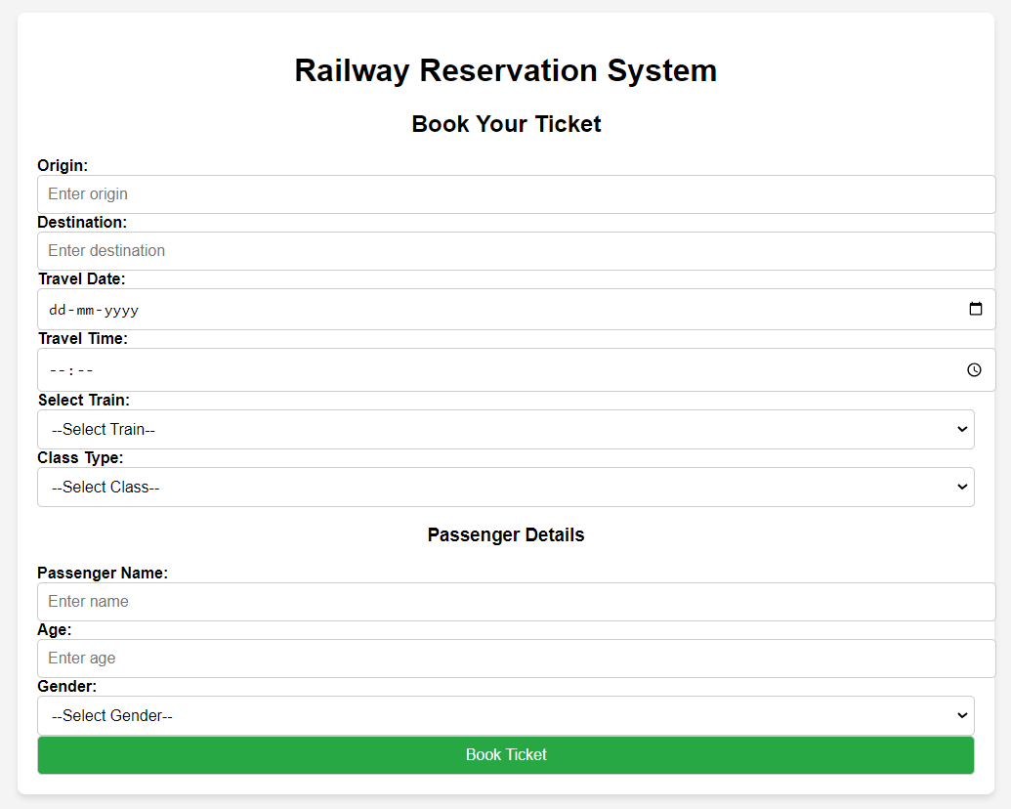

SQL QUERIES
CREATE DATABASE RailwayReservationSystem; USE RailwayReservationSystem;
CREATE TABLE Users (
user_id INT AUTO_INCREMENT PRIMARY KEY, username VARCHAR(50) NOT NULL UNIQUE, password VARCHAR(255) NOT NULL,
full_name VARCHAR(100), email VARCHAR(100),
phone VARCHAR(15)
);
-- Add an admin user
INSERT INTO Users (username, password, full_name, email, phone)
VALUES ('admin', 'admin123', 'Admin User', 'admin@railway.com', '1234567890'); CREATE TABLE Trains (
train_id INT AUTO_INCREMENT PRIMARY KEY,
train_name VARCHAR(100) NOT NULL, train_number VARCHAR(20) UNIQUE NOT NULL, origin VARCHAR(50) NOT NULL,
destination VARCHAR(50) NOT NULL, departure_time TIME,
arrival_time TIME, total_seats INT,

available_seats INT
);
-- Add sample trains
INSERT INTO Trains (train_name, train_number, origin, destination, departure_time, arrival_time, total_seats, available_seats)
VALUES
('Express 101', 'EXP101', 'City A', 'City B', '08:00:00', '12:00:00', 100, 100),
('Intercity 202', 'INT202', 'City C', 'City D', '14:00:00', '18:00:00', 80, 80),
('Regional 303', 'REG303', 'City E', 'City F', '06:00:00', '10:00:00', 120, 120);
CREATE TABLE Tickets (
ticket_id INT AUTO_INCREMENT PRIMARY KEY,
user_id INT, train_id INT,
travel_date DATE NOT NULL,
class_type ENUM('First Class', 'Second Class', 'Sleeper') NOT NULL, passenger_name VARCHAR(100) NOT NULL,
passenger_age INT NOT NULL,
passenger_gender ENUM('Male', 'Female', 'Other') NOT NULL, booking_date TIMESTAMP DEFAULT CURRENT_TIMESTAMP,
total_fare DECIMAL(10, 2),
FOREIGN KEY (user_id) REFERENCES Users(user_id), FOREIGN KEY (train_id) REFERENCES Trains(train_id)
);
-- Add a sample ticket booking
INSERT INTO Tickets (user_id, train_id, travel_date, class_type, passenger_name, passenger_age, passenger_gender, total_fare)
VALUES
(1, 1, '2024-11-20', 'First Class', 'John Doe', 30, 'Male', 120.50);
SELECT * FROM Trains; SELECT *
FROM Trains
WHERE origin = 'City A' AND destination = 'City B'; SELECT train_name, train_number, available_seats FROM Trains
WHERE train_id = 1; -- Replace 1 with the train's ID
-- Example of booking a ticket:
INSERT INTO Tickets (user_id, train_id, travel_date, class_type, passenger_name, passenger_age, passenger_gender, total_fare)
VALUES (1, 1, '2024-11-25', 'Second Class', 'Alice Smith', 25, 'Female', 80.00);
-- Update available seats after booking UPDATE Trains
SET available_seats = available_seats - 1 WHERE train_id = 1;
CONNECTIVITY CODING
import java.sql.Connection; import java.sql.DriverManager;

import java.sql.SQLException; public class DBConnection {
private static final String DB_URL = "jdbc:mysql://localhost:3306/RailwayReservationSystem"; // Replace with your database URL
private static final String DB_USER = "root"; // Replace with your MySQL username private static final String DB_PASSWORD = ""; // Replace with your MySQL password public static Connection connect() {
try {
// Load MySQL JDBC Driver Class.forName("com.mysql.cj.jdbc.Driver");
// Establish connection
return DriverManager.getConnection(DB_URL, DB_USER, DB_PASSWORD);
} catch (ClassNotFoundException | SQLException e) { System.out.println("Connection Failed: " + e.getMessage()); return null;
}
}
}
import java.sql.Connection;
import java.sql.PreparedStatement; import java.sql.ResultSet;
public class UserService {
public boolean authenticateUser(String username, String password) {
String query = "SELECT * FROM Users WHERE username = ? AND password = ?"; try (Connection conn = DBConnection.connect();
PreparedStatement stmt = conn.prepareStatement(query)) {
stmt.setString(1, username); stmt.setString(2, password); ResultSet rs = stmt.executeQuery();
return rs.next(); // Return true if user exists
} catch (Exception e) {
System.out.println("Authentication Failed: " + e.getMessage()); return false;
}
}
}
import java.sql.Connection;
import java.sql.PreparedStatement; import java.sql.ResultSet;
public class TrainService { public void listTrains() {
String query = "SELECT * FROM Trains";
try (Connection conn = DBConnection.connect(); PreparedStatement stmt = conn.prepareStatement(query); ResultSet rs = stmt.executeQuery()) { System.out.println("Available Trains:");

while (rs.next()) {
System.out.println("Train Name: " + rs.getString("train_name")); System.out.println("Train Number: " + rs.getString("train_number")); System.out.println("From: " + rs.getString("origin") + " To: " + rs.getString("destination")); System.out.println("Available Seats: " + rs.getInt("available_seats"));
System.out.println(" ");
}
} catch (Exception e) {
System.out.println("Error Listing Trains: " + e.getMessage());
}
public boolean updateSeatAvailability(int trainId, int seatsToBook) {
String query = "UPDATE Trains SET available_seats = available_seats - ? WHERE train_id
= ? AND available_seats >= ?";
try (Connection conn = DBConnection.connect(); PreparedStatement stmt = conn.prepareStatement(query)) { stmt.setInt(1, seatsToBook);
stmt.setInt(2, trainId); stmt.setInt(3, seatsToBook);
int rowsUpdated = stmt.executeUpdate();
return rowsUpdated > 0; // Return true if seats were successfully updated
} catch (Exception e) {
System.out.println("Error Updating Seats: " + e.getMessage()); return false;
}
}
}
import java.sql.Connection; import java.sql.PreparedStatement; public class TicketService {
public boolean bookTicket(int userId, int trainId, String travelDate, String classType, String passengerName, int passengerAge, String passengerGender, double totalFare) { String query = "INSERT INTO Tickets (user_id, train_id, travel_date, class_type, passenger_name, passenger_age, passenger_gender, total_fare) " +
"VALUES (?, ?, ?, ?, ?, ?, ?, ?)";
try (Connection conn = DBConnection.connect();PreparedStatement stmt = conn.prepareStatement(query)) { stmt.setInt(1, userId);
stmt.setInt(2, trainId); stmt.setString(3, travelDate); stmt.setString(4, classType); stmt.setString(5, passengerName); stmt.setInt(6, passengerAge); stmt.setString(7, passengerGender); stmt.setDouble(8, totalFare);
int rowsInserted = stmt.executeUpdate();
return rowsInserted > 0; // Return true if ticket was successfully booked
} catch (Exception e) {

System.out.println("Error Booking Ticket: " + e.getMessage()); return false;
}
}
}
import java.util.Scanner; public class Main {
public static void main(String[] args) { Scanner scanner = new Scanner(System.in); UserService userService = new UserService();
TrainService trainService = new TrainService(); TicketService ticketService = new TicketService();
System.out.println("Welcome to Railway Reservation System"); System.out.print("Enter Username: ");
String username = scanner.nextLine(); System.out.print("Enter Password: ");
String password = scanner.nextLine();
if (userService.authenticateUser(username, password)) { System.out.println("Login Successful!"); trainService.listTrains();
System.out.print("Enter Travel Date (YYYY-MM-DD): "); String travelDate = scanner.nextLine();
System.out.print("Enter Class Type (First Class/Second Class/Sleeper): "); String classType = scanner.nextLine();
System.out.print("Enter Passenger Name: "); String passengerName = scanner.nextLine(); System.out.print("Enter Passenger Age: "); int passengerAge = scanner.nextInt(); scanner.nextLine(); // Consume newline
System.out.print("Enter Passenger Gender (Male/Female/Other): "); String passengerGender = scanner.nextLine(); System.out.print("Enter Total Fare: ");
double totalFare = scanner.nextDouble();
if (ticketService.bookTicket(1, trainId, travelDate, classType, passengerName, passengerAge, passengerGender, totalFare)) {
trainService.updateSeatAvailability(trainId, seatsToBook); System.out.println("Ticket Successfully Booked!");
} else {
System.out.println("Ticket Booking Failed!");
}
} else {
System.out.println("Invalid Username or Password!");
}
}
}

MARK ALLOCATION

CONTINOUS INTERNAL ASSESSMENT
Preparation & conduct of experiment | 50
Observation & Result | 30
Record | 10
Viva voice | 10
Total | 100

RESULT:
The Railway E-Ticketing System achieved all intended functionalities, providing a seamless experience for users to book train tickets, manage train schedules, and track availability. The project demonstrates the integration of Java, MySQL and web technologies in building a robust and interactive application.

FACULTY SIGNATURE

EX NO: 07 | EXPERT SYSTEM FOR MEDICAL DIAGNOSIS
DATE: | EXPERT SYSTEM FOR MEDICAL DIAGNOSIS
AIM:
To design UML diagrams and use cases for an Expert System for Medical Diagnosis
that includes the primary entities such as Patient, Diagnosis, Symptoms, and Medical Expert by identifying the attributes and methods for each class and specific relationships between classes.
PROCEDURE:
Step 1: Setting Up the Database
Step 2: Backend Setup (Java)
Step 3: Create Java Servlets for API Endpoints
Step 4: Deploy the Java Backend
Step 5: Frontend and API Server Setup (Node.js + Express)
Step 6: Create a Basic Express Server
Step 7: Set Up HTML Form in Node.js
Step 8: Create an Endpoint to Proxy the Request to Java

UML DIAGRAMS:
USE CASE DIAGRAMS

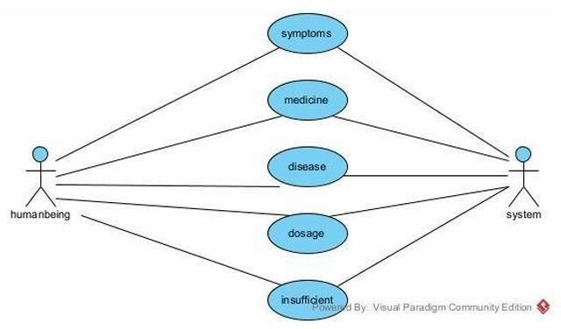

ACTIVITY DIAGRAM
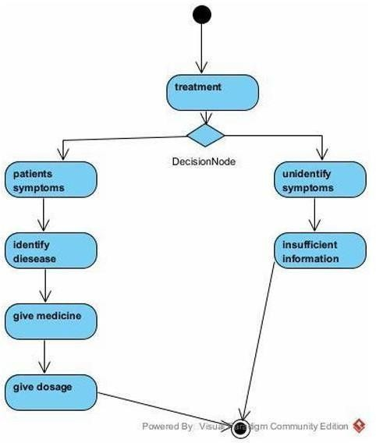
SEQUENCE DIAGRAM

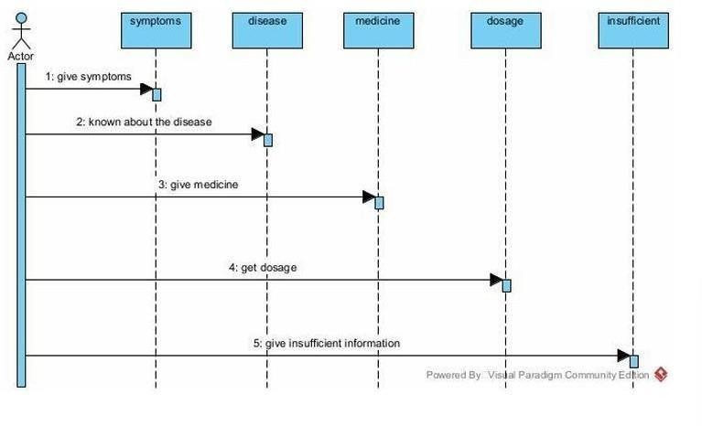

CLASS DIAGRAM

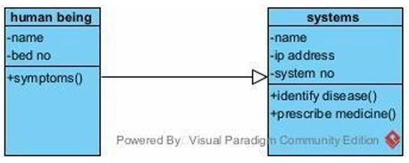

CODING:

index.html
<!DOCTYPE html>
<html lang="en">
<head>
<meta charset="UTF-8">
<meta name="viewport" content="width=device-width, initial-scale=1.0">
<title>Login - Medical Diagnosis</title>
<link rel="stylesheet" href="styles/styles.css">
</head>
<body>
<div class="container">
<h1>Medical Diagnosis System</h1>
<form id="loginForm">
<label for="username">Username:</label>
<input type="text" id="username" name="username" required>
<label for="password">Password:</label>
<input type="password" id="password" name="password" required>
<label for="role">Login As:</label>
<select id="role" name="role" required>
<option value="patient">Patient</option>
<option value="doctor">Doctor</option>
</select>
<button type="submit" class="submit-btn">Login</button>
</form>
</div>
<script src="scripts/app.js"></script>
</body>
</html>

patient-dashboard.html
<!DOCTYPE html>
<html lang="en">
<head>

<meta charset="UTF-8">
<meta name="viewport" content="width=device-width, initial-scale=1.0">
<title>Patient Dashboard</title>
<link rel="stylesheet" href="styles/styles.css">
</head>
<body>
<div class="container">
<h1>Welcome, Patient</h1>
<a href="patient-details.html" class="btn">Enter Your Details</a>
<a href="treatment.html" class="btn">View Treatment Options</a>
<a href="index.html" class="btn">Logout</a>
</div>
</body>
</html>

doctor-dashboard.html
<!DOCTYPE html>
<html lang="en">
<head>
<meta charset="UTF-8">
<meta name="viewport" content="width=device-width, initial-scale=1.0">
<title>Doctor Dashboard</title>
<link rel="stylesheet" href="styles/styles.css">
</head>
<body>
<div class="container">
<h1>Welcome, Doctor</h1>
<a href="patient-details.html" class="btn">View Patient Details</a>
<a href="treatment.html" class="btn">Provide Treatment</a>
<a href="index.html" class="btn">Logout</a>
</div>
</body>
</html>

patient-details.html
<!DOCTYPE html>
<html lang="en">
<head>
<meta charset="UTF-8">
<meta name="viewport" content="width=device-width, initial-scale=1.0">
<title>Patient Details</title>
<link rel="stylesheet" href="styles/styles.css">
</head>
<body>
<div class="container">
<h1>Enter Patient Details</h1>
<form>

<label for="name">Name:</label>
<input type="text" id="name" name="name" required>
<label for="age">Age:</label>
<input type="number" id="age" name="age" required>
<label for="symptoms">Symptoms:</label>
<textarea id="symptoms" name="symptoms" rows="4" required></textarea>
<button type="submit" class="submit-btn">Submit</button>
</form>
</div>
</body>
</html>

treatment.html
<!DOCTYPE html>
<html lang="en">
<head>
<meta charset="UTF-8">
<meta name="viewport" content="width=device-width, initial-scale=1.0">
<title>Treatment</title>
<link rel="stylesheet" href="styles/styles.css">
</head>
<body>
<div class="container">
<h1>Treatment Options</h1>
<p>Based on the symptoms, the system recommends the following treatments:</p>
<ul>
<li>Rest and hydration</li>
<li>Prescribed medications</li>
<li>Follow-up with your doctor</li>
</ul>
<a href="index.html" class="btn">Logout</a>
</div>
</body>
</html>
styles.css body
{
font-family: Arial, sans-serif; margin: 0;
padding: 0;
background-color: #f0f0f5; color: #333;
}
.container {
max-width: 600px; margin: 50px auto; background: #fff; padding: 20px;

border-radius: 8px;
box-shadow: 0 0 10px rgba(0, 0, 0, 0.1);
}
h1 {
text-align: center; color: #4CAF50;
}
label { display: block;
margin: 15px 0 5px; font-weight: bold;
}
input, textarea, select, button { width: 100%;
padding: 10px; margin-top: 5px; border: 1px solid #ccc; border-radius: 4px;
}
button, .btn {
background-color: #4CAF50; color: white;
font-size: 16px; border: none; cursor: pointer; text-align: center;
text-decoration: none; display: block; margin-top: 20px; padding: 10px 0;
}
button:hover, .btn:hover { background-color: #45a049;
}

app.js
// Handle login functionality document.getElementById('loginForm').addEventListener('submit', function (e) { e.preventDefault();
const role = document.getElementById('role').value;
// Redirect based on role if (role === 'patient') {
window.location.href = 'patient-dashboard.html';
} else if (role === 'doctor') { window.location.href = 'doctor-dashboard.html';
}
});

Server.js
const express = require("express"); const mongoose = require("mongoose");
const bodyParser = require("body-parser"); const bcrypt = require("bcryptjs");
const jwt = require("jsonwebtoken"); const PORT = 5000;
const MONGO_URI = "mongodb://localhost:27017/medical-diagnosis"; const JWT_SECRET = "your_jwt_secret";
const app = express(); app.use(bodyParser.json()); mongoose
.connect(MONGO_URI, { useNewUrlParser: true, useUnifiedTopology: true })
.then(() => console.log("MongoDB connected successfully."))
.catch((err) => {
console.error("MongoDB connection error:", err.message);process.exit(1);
});
// User Schema
const UserSchema = new mongoose.Schema({ username: { type: String, required: true, unique: true }, password: { type: String, required: true },
role: { type: String, enum: ["patient", "doctor"], required: true },
});
const User = mongoose.model("User", UserSchema);
// Patient Details Schema
const PatientDetailsSchema = new mongoose.Schema({ name: { type: String, required: true },
age: { type: Number, required: true }, symptoms: { type: String, required: true }, diagnosis: { type: String },
treatment: { type: String },
createdBy: { type: mongoose.Schema.Types.ObjectId, ref: "User", required: true },
});
const PatientDetails = mongoose.model("PatientDetails", PatientDetailsSchema);
// Treatment Schema
const TreatmentSchema = new mongoose.Schema({ symptoms: { type: String, required: true }, treatmentPlan: { type: String, required: true },
});
const Treatment = mongoose.model("Treatment", TreatmentSchema);
// Routes
// 1. Authentication Routes app.post("/index", async (req, res) => {
const { username, password, role } = req.body; try {
const user = await User.findOne({ username, role });
if (!user) return res.status(404).json({ message: "User not found" });

const isMatch = await bcrypt.compare(password, user.password);
if (!isMatch) return res.status(400).json({ message: "Invalid credentials" });
const token = jwt.sign({ userId: user._id, role: user.role }, JWT_SECRET, { expiresIn: "1h"
});
res.json({ token, role: user.role });
} catch (err) {
res.status(500).json({ message: "Server error" });
}
});
// 2. Patient Routes
app.post("/patient-details", async (req, res) => {
const { name, age, symptoms, createdBy } = req.body; try {
const newDetails = new PatientDetails({ name, age, symptoms, createdBy }); await newDetails.save();
res.status(201).json(newDetails);
} catch (err) {
res.status(500).json({ message: "Error saving patient details" });
}
});
app.get("/patient-details/:id", async (req, res) => { try {
const patientDetails = await PatientDetails.findById(req.params.id);
if (!patientDetails) return res.status(404).json({ message: "Details not found" }); res.json(patientDetails);
} catch (err) {
res.status(500).json({ message: "Server error" });
}
});
// 3. Doctor Routes
app.post("/treatment", async (req, res) => {
const { patientId, diagnosis, treatment } = req.body; try {
const patient = await PatientDetails.findById(patientId);
if (!patient) return res.status(404).json({ message: "Patient not found" }); patient.diagnosis = diagnosis;
patient.treatment = treatment; await patient.save();
res.json({ message: "Treatment updated successfully" });
} catch (err) {
res.status(500).json({ message: "Error updating treatment" });
}
});
app.listen(PORT, () => {
console.log(`Server running on http://localhost:${PORT}`);
});

OUTPUT:
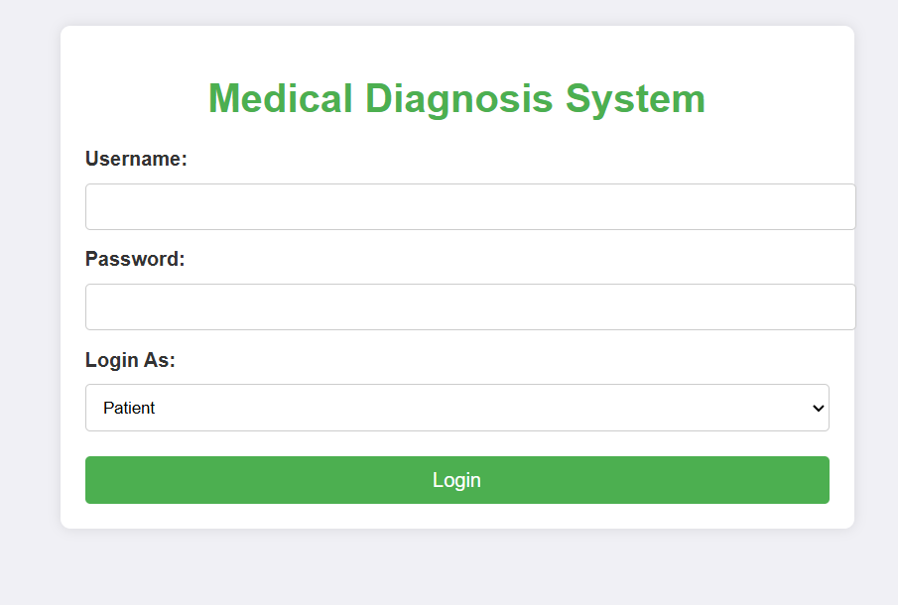
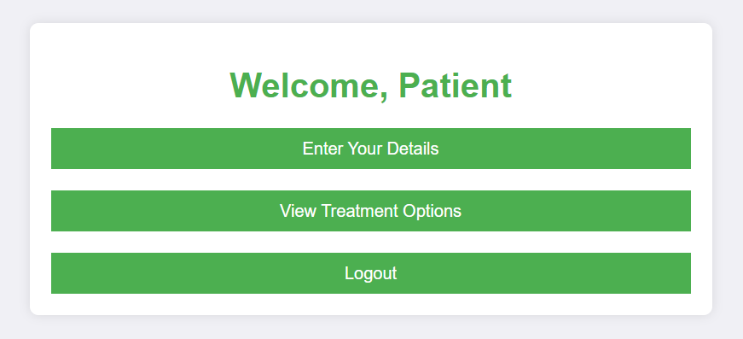
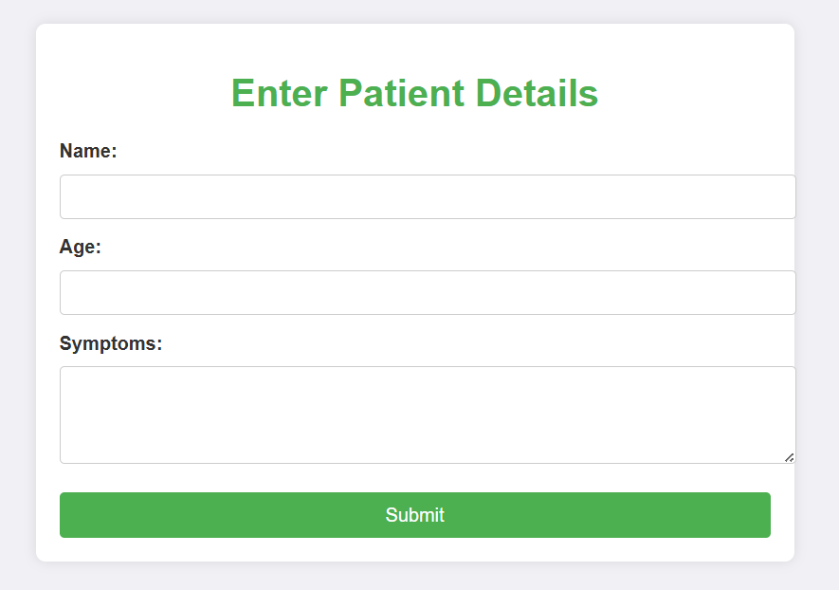

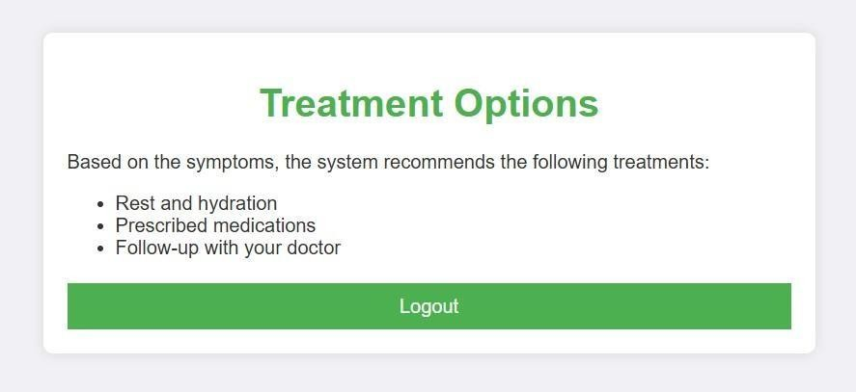

MARK ALLOCATION

CONTINOUS INTERNAL ASSESSMENT
Preparation & conduct of experiment | 50
Observation & Result | 30
Record | 10
Viva voice | 10
Total | 100

RESULT:
The Expert system for medical diagnosis was implemented using HTML, CSS and JavaScript with connectivity managed by Node.js and Java. The data was successfully stored in the database, establishing a functional relationship between the user and the administrator was verified.

FACULTY SIGNATURE

EX NO: 08 | CREDIT CARD PROCESSING SYSTEM
DATE: | CREDIT CARD PROCESSING SYSTEM

AIM:
To design UML diagrams and use cases for a Credit Card Processing System that
includes the primary entities such as Customer and Banker by identifying the attributes and methods for each class and specific relationships between classes.
PROCEDURE:
Step 1: Setting Up the Database
Step 2: Backend Setup (Java)
Step 3: Create Java Servlets for API Endpoints
Step 4: Deploy the Java Backend
Step 5: Frontend and API Server Setup (Node.js + Express)
Step 6: Create a Basic Express Server
Step 7: Set Up HTML Form in Node.js
Step 8: Create an Endpoint to Proxy the Request to Java

UML DIAGRAMS: USE CASE DIAGRAM
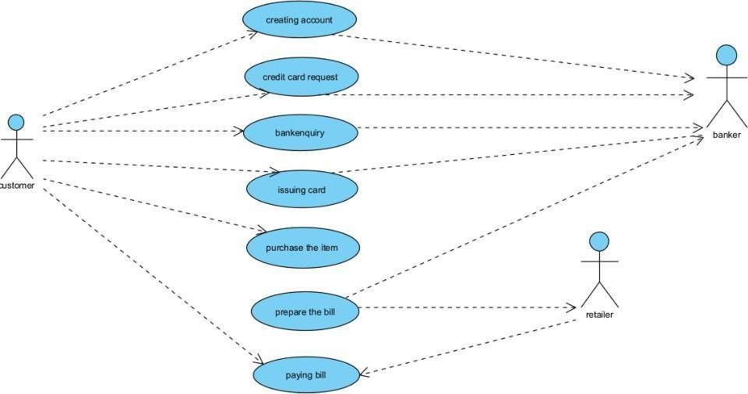

ACTIVITY DIAGRAM

SEQUENCE DIAGRAM

CLASS DIAGRAM
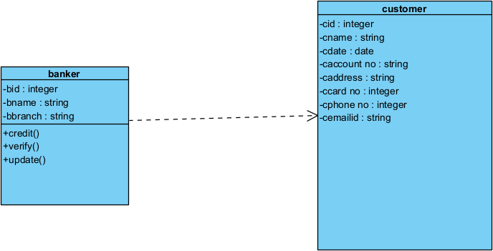
CODING:

Login.html
<!DOCTYPE html>
<html lang="en">
<head>
<meta charset="UTF-8">
<meta name="viewport" content="width=device-width, initial-scale=1.0">
<title>Login Form with Flip Effect</title>
<link rel="stylesheet" href="./login.css">
<script src="./login.js" defer></script>
</head>
<body>
<div class="front">
<h2>Login to Your Account</h2>
<form id="login-form">
<div class="form-group">
<label for="username">Username</label>
<input type="text" id="username" name="user_name" required>
</div>
<div class="form-group">
<label for="password">Password</label>
<input type="password" id="password" name="pass_word" required>
</div>
<input type="submit" value="Login">
</form>
<p class="error" id="error-message" style="display: none;">Invalid credentials, please try again.</p>
<p>Don't have an account? <a href="./registration.html" id="register-link">Create a new account</a></p>
</div>
</body>
</html>

Login.js
// login.js

// Function to handle login form submission function handleLogin(event) {
event.preventDefault(); // Prevent default form submission behavior
// Redirect to the customer page after login window.location.href = "./customer.html";
}
// Attach the event listener to the login form
document.getElementById("login-form").addEventListener("submit", handleLogin);

Registration.html
<!DOCTYPE html>
<html lang="en">
<head>
<meta charset="UTF-8">
<meta name="viewport" content="width=device-width, initial-scale=1.0">
<title>Stylish Registration Form</title>
<link rel="stylesheet" href="styles.css">
<script src="registration.js" defer></script>
</head>
<body>
<div class="container">
<h2>Create an Account</h2>
<form id="registrationForm" action="customer.html" method="get">
<div class="form-group">
<label for="username">Username</label>
<input type="text" id="username" name="username" required>
</div>
<div class="form-group">
<label for="email">Email</label>
<input type="email" id="email" name="email" required>
</div>
<div class="form-group">
<label for="password">Password</label>
<input type="password" id="password" name="password" required>
</div>
<div class="form-group">
<label for="confirmPassword">Confirm Password</label>
<input type="password" id="confirmPassword" name="confirmPassword" required>
</div>
<div id="passwordError">Passwords do not match!</div>
<input type="submit" value="Register">
</form>
<div class="login-link">
Already have an account? <a href="login.html">Login here</a>
</div>
</div>
</body>

</html>

Customer.html
<!DOCTYPE html>
<html lang="en">
<head>
<meta charset="UTF-8">
<meta name="viewport" content="width=device-width, initial-scale=1.0">
<title>Customer Details</title>
<link rel="stylesheet" href="styles.css">
</head>
<body>
<div class="form-container">
<h2>Customer Details</h2>
<form id="customerForm">
<label for="cid">Customer ID:</label>
<input type="number" id="cid" name="cid" required>
<label for="cname">Customer Name:</label>
<input type="text" id="cname" name="cname" required>
<label for="cdate">Creation Date:</label>
<input type="date" id="cdate" name="cdate" required>
<label for="caccountno">Account Number:</label>
<input type="text" id="caccountno" name="caccountno" required>
<label for="caddress">Address:</label>
<input type="text" id="caddress" name="caddress" required>
<label for="ccardno">Card Number:</label>
<input type="number" id="ccardno" name="ccardno" required>
<label for="cphoneno">Phone Number:</label>
<input type="number" id="cphoneno" name="cphoneno" required>
<label for="cemailid">Email ID:</label>
<input type="email" id="cemailid" name="cemailid" required>
<input type="submit" value="Submit">
</form>
</div>
<script src="customer.js"></script>
</body>
</html>

Customer.js
document.getElementById('customerForm').addEventListener('submit', function(event) { event.preventDefault(); // Prevent the form from submitting to the server window.location.href = 'banker.html'; // Redirect to the banker page
});}

Banker.html
<!DOCTYPE html>
<html lang="en">
<head>

<meta charset="UTF-8">
<meta name="viewport" content="width=device-width, initial-scale=1.0">
<title>Banker Details</title>
<link rel="stylesheet" href="banker.css">
</head>
<body>
<div class="form-container">
<h2>Banker Details</h2>
<form id="bankerForm">
<label for="bid">Banker ID:</label>
<input type="number" id="bid" name="bid" required>
<label for="bname">Banker Name:</label>
<input type="text" id="bname" name="bname" required>
<label for="bbranch">Branch:</label>
<input type="text" id="bbranch" name="bbranch" required>
<input type="submit" value="Submit Banker Details">
</form>
<button class="operation-button" onclick="performVerify()">Verify</button>
<button class="operation-button" onclick="performUpdate()">Update</button>
</div>
<script src="banker.js"></script>
</body>
</html>

Banker.js
// Simulate a list of bankers for demonstration const bankers = [
{ id: 1, name: "Akhila", branch: "New York" },
{ id: 2, name: "Jane Smith", branch: "Los Angeles" },
{ id: 3, name: "Michael Johnson", branch: "Chicago" }
];
function getBankerDetails() {
const bid = document.getElementById('bid').value;
const bname = document.getElementById('bname').value; const bbranch = document.getElementById('bbranch').value; return { bid: parseInt(bid), bname: bname, bbranch: bbranch };
}
function performVerify() {
const { bid, bname, bbranch } = getBankerDetails(); const banker = bankers.find(b => b.id === bid);
if (banker) {
alert(`Banker Verified: Name: ${banker.name}, Branch: ${banker.branch}`);
} else {
alert('Banker not found!');
}
}
function performUpdate() {
const { bid, bname, bbranch } = getBankerDetails();

const banker = bankers.find(b => b.id === bid); if (banker) {
banker.name = bname; banker.branch = bbranch;
alert(`Banker details updated: Name: ${bname}, Branch: ${bbranch}`);
} else {
alert('Banker not found for updating!');
}
}
document.getElementById('bankerForm').addEventListener('submit', function(event) { event.preventDefault();
alert("Banker details submitted.");
});

OUTPUT:

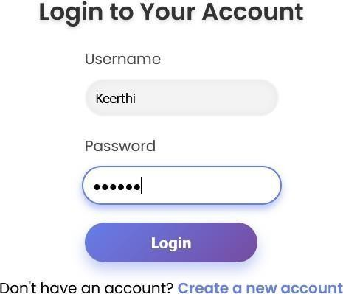

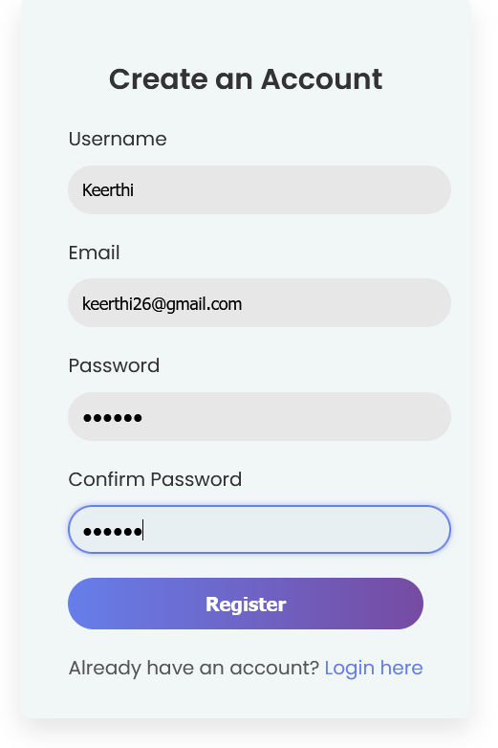

SQL Queries
CREATE TABLE users (
id INT AUTO_INCREMENT PRIMARY KEY, username VARCHAR(50) NOT NULL UNIQUE, password VARCHAR(255) NOT NULL,
role ENUM('customer', 'banker') NOT NULL,
created_at TIMESTAMP DEFAULT CURRENT_TIMESTAMP
);
CREATE TABLE customers (
customer_id INT AUTO_INCREMENT PRIMARY KEY, name VARCHAR(100) NOT NULL,
creation_date DATE NOT NULL,
account_number VARCHAR(20) NOT NULL UNIQUE, address TEXT NOT NULL,
card_number BIGINT NOT NULL UNIQUE, phone_number BIGINT NOT NULL UNIQUE, email VARCHAR(100) NOT NULL UNIQUE
);
CREATE TABLE bankers (
banker_id INT AUTO_INCREMENT PRIMARY KEY, name VARCHAR(100) NOT NULL,
branch VARCHAR(100) NOT NULL,
created_at TIMESTAMP DEFAULT CURRENT_TIMESTAMP

);
INSERT INTO users (username, password, role) VALUES ('customer1', 'hashed_password', 'customer');
INSERT INTO customers (name, creation_date, account_number, address, card_number, phone_number, email)
VALUES ('John Doe', '2024-11-01', '1234567890', '123 Main St, NY', 1234567812345678,
9876543210, 'johndoe@example.com');
INSERT INTO users (username, password, role) VALUES ('banker1', 'hashed_password', 'banker');
INSERT INTO bankers (name, branch) VALUES ('Jane Smith', 'New York');
SELECT id, username, role FROM users WHERE username = 'entered_username' AND password = 'hashed_entered_password';
SELECT * FROM customers WHERE customer_id = 1;
UPDATE customers SET name = 'Updated Name', address = 'Updated Address', phone_number = 9876543211, email = 'updatedemail@example.com' WHERE customer_id
= 1;
SELECT * FROM bankers WHERE banker_id = 1;
UPDATE bankers SET name = 'Updated Banker Name', branch = 'Updated Branch' WHERE banker_id = 1;
DELETE FROM customers WHERE customer_id = 1; DELETE FROM bankers WHERE banker_id = 1; SELECT * FROM bankers
SELECT * FROM customers;

Connectivity Coding(Express.js) const express = require('express'); const mysql = require('mysql2');
const bodyParser = require('body-parser'); const app = express();
app.use(bodyParser.urlencoded({ extended: true })); app.use(bodyParser.json());
const db = mysql.createConnection({ host: 'localhost',
user: 'root',
password: 'your_password', database: 'your_database'
});
db.connect((err) => { if (err) {
console.error('Database connection failed:', err); return;
}
console.log('Connected to the MySQL database');
});
app.listen(3000, () => {
console.log('Server is running on http://localhost:3000');
});

app.post('/login', (req, res) => {
const { username, password } = req.body;
const query = `SELECT * FROM users WHERE username = ? AND password = ?`; db.query(query, [username, password], (err, results) => {
if (err) { console.error(err);
res.status(500).send('Server error'); return;
}
if (results.length > 0) {
res.status(200).send({ message: 'Login successful', user: results[0] });
} else {
res.status(401).send({ message: 'Invalid username or password' });
}});});
app.post('/register', (req, res) => {
const { username, email, password } = req.body;
const checkQuery = `SELECT * FROM users WHERE username = ? OR email = ?`; db.query(checkQuery, [username, email], (err, results) => {
if (err) { console.error(err);
res.status(500).send('Server error'); return;
}
if (results.length > 0) {
res.status(400).send({ message: 'Username or email already exists' });
} else {
const insertQuery = `INSERT INTO users (username, email, password) VALUES (?, ?, ?)`; db.query(insertQuery, [username, email, password], (err, results) => {
if (err) { console.error(err);
res.status(500).send('Server error'); return;
}
res.status(201).send({ message: 'Registration successful' });
});}});});
app.post('/addCustomer', (req, res) => {
const { cid, cname, cdate, caccountno, caddress, ccardno, cphoneno, cemailid } = req.body; const query = `INSERT INTO customers (cid, cname, cdate, caccountno, caddress, ccardno, cphoneno, cemailid)
VALUES (?, ?, ?, ?, ?, ?, ?, ?)`;
db.query(query, [cid, cname, cdate, caccountno, caddress, ccardno, cphoneno, cemailid], (err, results) => {
if (err) { console.error(err);
res.status(500).send('Server error'); return;
}

res.status(201).send({ message: 'Customer added successfully' });
});
});
app.post('/addBanker', (req, res) => { const { bid, bname, bbranch } = req.body;
const query = `INSERT INTO bankers (bid, bname, bbranch) VALUES (?, ?, ?)`; db.query(query, [bid, bname, bbranch], (err, results) => {
if (err) { console.error(err);
res.status(500).send('Server error'); return;
}
res.status(201).send({ message: 'Banker added successfully' });
});
});
app.get('/getCustomer', (req, res) => { const { cid } = req.query;
const query = `SELECT * FROM customers WHERE cid = ?`; db.query(query, [cid], (err, results) => {
if (err) { console.error(err);
res.status(500).send('Server error'); return;
}
if (results.length > 0) { res.status(200).send(results[0]);
} else {
res.status(404).send({ message: 'Customer not found' });
}
});
});
app.get('/getBanker', (req, res) => { const { bid } = req.query;
const query = `SELECT * FROM bankers WHERE bid = ?`; db.query(query, [bid], (err, results) => {
if (err) { console.error(err);
res.status(500).send('Server error'); return;
}
if (results.length > 0) { res.status(200).send(results[0]);
} else {
res.status(404).send({ message: 'Banker not found' });
}
});
});

app.post('/updateBanker', (req, res) => { const { bid, bname, bbranch } = req.body;
const query = `UPDATE bankers SET bname = ?, bbranch = ? WHERE bid = ?`; db.query(query, [bname, bbranch, bid], (err, results) => {
if (err) { console.error(err);
res.status(500).send('Server error'); return;
}
if (results.affectedRows > 0) {
res.status(200).send({ message: 'Banker details updated' });
} else {
res.status(404).send({ message: 'Banker not found' });
}
});
});

MARK ALLOCATION

CONTINOUS INTERNAL ASSESSMENT
Preparation & conduct of experiment | 50
Observation & Result | 30
Record | 10
Viva voice | 10
Total | 100

RESULT:
The Credit Card Processing System was implemented using HTML and JavaScript with connectivity managed by Node.js and Java. The data was successfully stored in the database, establishing a functional relationship between the Customer and the Banker was verified.

FACULTY SIGNATURE

EX NO: 09 | PAYROLL SYSTEM
DATE: | PAYROLL SYSTEM
AIM:
To design and implement a user-friendly Payroll System that securely manages
employee information, automates payroll processing, and generates accurate reports.

PROCEDURE:
Step 1: Set up the MySQL Database with tables for employees, payroll, and authentication. Step 2: Backend Setup in Java using JDBC to connect to the database and handle CRUD operations.
Step 3: Create Java Servlets for API endpoints to manage employees, payroll, and reports. Step 4: Deploy the Java Backend using a servlet container like Apache Tomcat for API accessibility.
Step 5: Frontend Setup in HTML forms and proxy requests to Java backend APIs.

UML DIAGRAMS:
USE CASE DIAGRAMS
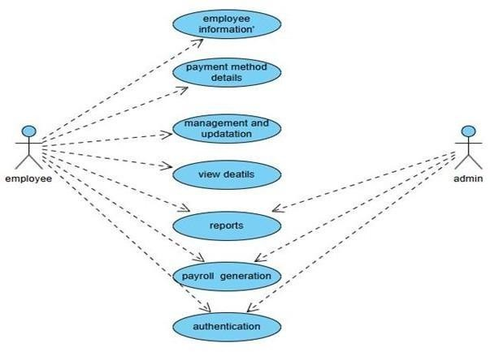

CLASS DIAGRAM
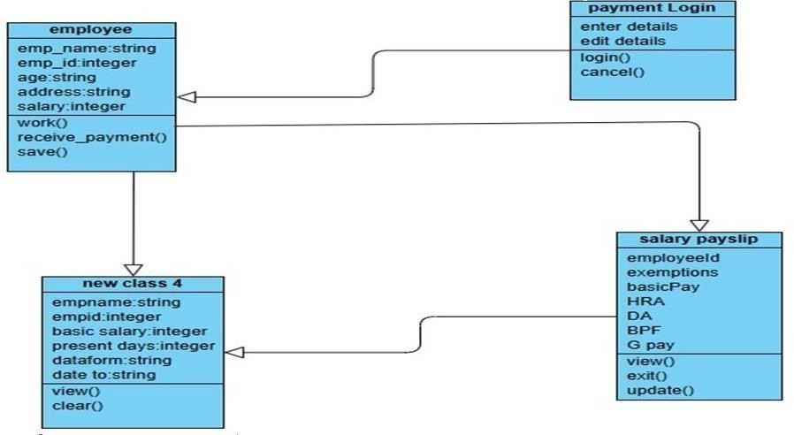

SEQUENCE DIAGRAM
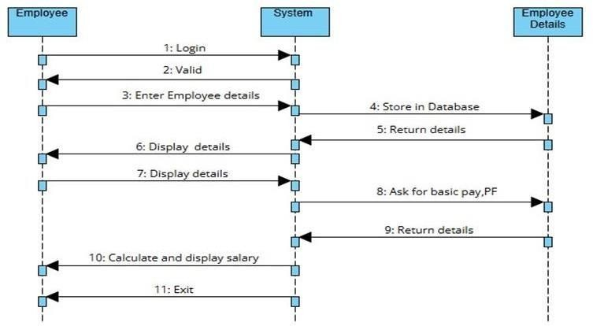

ACTIVITY DIAGRAM
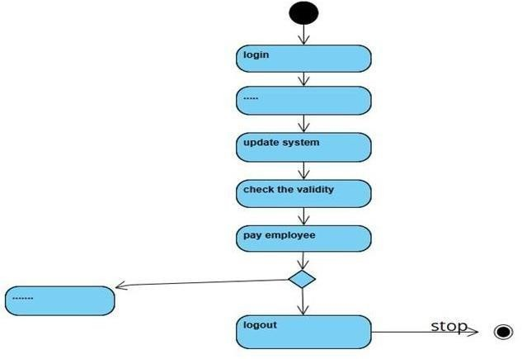
CODING:

Authentication.html
<!DOCTYPE html>
<html lang="en">
<head>
<meta charset="UTF-8">
<meta name="viewport" content="width=device-width, initial-scale=1.0">
<title>Payroll Authentication</title>
<link rel="stylesheet" href="styles.css">
</head>
<body>
<div class="container">
<h1>Payroll System Login</h1>
<form action="#" method="post">
<label for="username">Username:</label>
<input type="text" id="username" name="username" required>
<label for="password">Password:</label>
<input type="password" id="password" name="password" required>
<button type="submit">Login</button>
</form>
</div>
</body>
</html>

dashboard.html
<!DOCTYPE html>
<html lang="en">
<head>

<meta charset="UTF-8">
<meta name="viewport" content="width=device-width, initial-scale=1.0">
<title>Payroll Dashboard</title>
<link rel="stylesheet" href="styles.css">
</head>
<body>
<div class="container">
<header>
<h1>Payroll System Dashboard</h1>
<nav>
<a href="#employee-section">Employees</a>
<a href="#payment-methods">Payment Methods</a>
<a href="#payroll">Payroll</a>
<a href="#reports">Reports</a>
</nav>
</header>
<section id="employee-section">
<h2>Employee Information</h2>
<button>Update Employee</button>
</section>
<section id="payment-methods">
<h2>Payment Methods</h2>
<button>View Payment Methods</button>
</section>
<section id="payroll">
<h2>Payroll Management</h2>
<button>Generate Payroll</button>
<button>View Payroll Details</button>
</section>
<section id="reports">
<h2>Reports</h2>
<button>Generate Report</button>
<button>View Reports</button>
</section>
</div>
</body>
</html>

employee.html
<!DOCTYPE html>
<html lang="en">
<head>
<meta charset="UTF-8">
<meta name="viewport" content="width=device-width, initial-scale=1.0">
<title>Employee Info</title>
<link rel="stylesheet" href="styles.css">
</head>

<body>
<div class="container">
<header>
<h1>Employee Info</h1>
<nav>
<a href="dashboard.html">Dashboard</a>
</nav>
</header>
<main class="horizontal-layout">
<section id="add-employee">
<h2>Add Employee</h2>
<form>
<input type="text" placeholder="First Name" required>
<input type="text" placeholder="Last Name" required>
<input type="email" placeholder="Email" required>
<button>Add</button>
</form>
</section>
<section id="update-employee">
<h2>Update Employee</h2>
<form>
<input type="number" placeholder="Employee ID" required>
<select>
<option>Field</option>
<option>First Name</option>
<option>Last Name</option>
<option>Email</option>
</select>
<input type="text" placeholder="New Value" required>
<button>Update</button>
</form>
</section>
<section id="view-employees">
<h2>View Employees</h2>
<button>View All</button>
</section>
</main>
</div>
</body>
</html>

styles.css
body {
font-family: Arial, sans-serif; margin: 0;
padding: 0;
background-color: #f4f4f9;

color: #333;
}
.container { width: 90%;
max-width: 1200px; margin: 20px auto; background: #fff; border-radius: 8px; padding: 20px;
box-shadow: 0 2px 4px rgba(0, 0, 0, 0.1);
}
h1, h2 {
color: #0056b3; text-align: center;
}
form { display: flex;
flex-direction: column; align-items: center;
}
form label { margin: 10px 0 5px; font-weight: bold;
}
form input { padding: 10px; width: 100%;
max-width: 400px; margin-bottom: 20px; border: 1px solid #ccc; border-radius: 4px;
}
form button { padding: 10px 20px; background: #0056b3; color: #fff;
border: none; border-radius: 4px; cursor: pointer;
}
form button:hover { background: #004494;
}
header nav {
text-align: center; margin: 20px 0;

}
header nav a { margin: 0 10px;
text-decoration: none; color: #0056b3;
font-weight: bold;
}
header nav a:hover { color: #004494;} section {
margin: 20px 0; text-align: center;
}
section button { padding: 10px 15px; margin: 10px; background: #28a745; color: #fff;
border: none; border-radius: 4px; cursor: pointer;
}
section button:hover { background: #218838;
}
OUTPUT:
Authentication.html


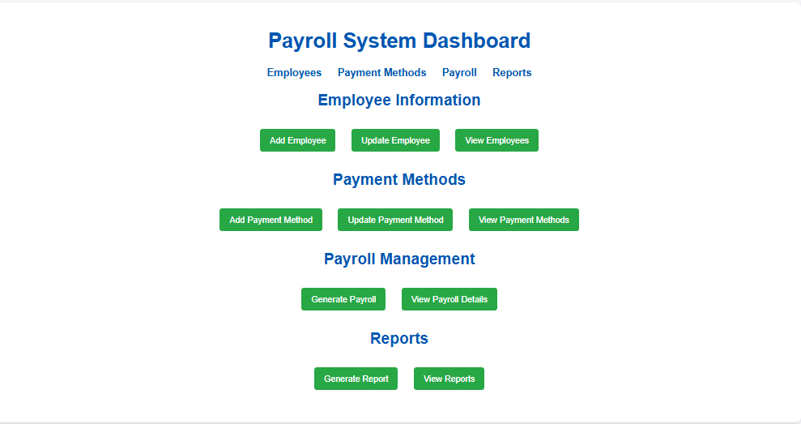
Dashboard.html
Employee.html
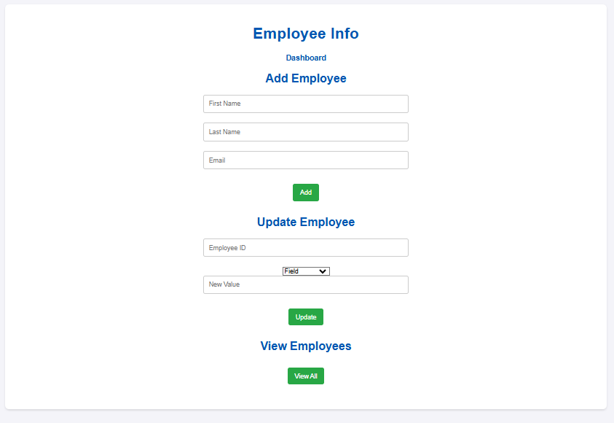

SQL Queries
CREATE DATABASE payroll_system; USE payroll_system;
CREATE TABLE authentication (
user_id INT AUTO_INCREMENT PRIMARY KEY, username VARCHAR(50) UNIQUE NOT NULL,
password_hash VARCHAR(255) NOT NULL, role ENUM('Admin', 'Employee') NOT NULL

);
CREATE TABLE employees (
employee_id INT AUTO_INCREMENT PRIMARY KEY, first_name VARCHAR(50) NOT NULL,
last_name VARCHAR(50) NOT NULL,
email VARCHAR(100) UNIQUE NOT NULL, phone VARCHAR(15),
hire_date DATE NOT NULL, position VARCHAR(50), department VARCHAR(50)
);
CREATE TABLE payment_methods (
payment_id INT AUTO_INCREMENT PRIMARY KEY,
employee_id INT NOT NULL,
payment_type ENUM('Bank Transfer', 'Check', 'Cash') NOT NULL, account_number VARCHAR(20),
bank_name VARCHAR(50),
FOREIGN KEY (employee_id) REFERENCES employees(employee_id) ON DELETE CASCADE
);

Connectivity Coding
import java.sql.Connection; import java.sql.DriverManager; import java.sql.PreparedStatement; import java.sql.ResultSet;
public class PayrollSystem {
// JDBC URL, username, and password
private static final String URL = "jdbc:mysql://localhost:3306/payroll_system"; private static final String USER = "root";
private static final String PASSWORD = "your_password";
// JDBC Connection
public static Connection connect() { try {
Class.forName("com.mysql.cj.jdbc.Driver");
Connection connection = DriverManager.getConnection(URL, USER, PASSWORD); System.out.println("Connected to the database!");
return connection;
} catch (Exception e) {
System.out.println("Connection failed: " + e.getMessage()); return null;
}
}
public static void fetchEmployees() {
String query = "SELECT * FROM employees"; try (Connection connection = connect();

PreparedStatement statement = connection.prepareStatement(query);
ResultSet resultSet = statement.executeQuery()) { System.out.println("Employee List:");
while (resultSet.next()) {
System.out.println("ID: " + resultSet.getInt("employee_id") + ", Name: " + resultSet.getString("first_name") +
" " + resultSet.getString("last_name"));
}
} catch (Exception e) {
System.out.println("Error fetching employees: " + e.getMessage());
}
}
public static void main(String[] args) { fetchEmployees();
}
}

MARK ALLOCATION

CONTINOUS INTERNAL ASSESSMENT
Preparation & conduct of experiment | 50
Observation & Result | 30
Record | 10
Viva voice | 10
Total | 100

RESULT:
The Payroll System was implemented using HTML, CSS with connectivity managed by Java. The data was successfully stored in the database, establishing a functional relationship between the employee and the administrator was verified.

FACULTY SIGNATURE

EX NO: 10 | STUDENT INFORMATION SYSTEM
DATE: | STUDENT INFORMATION SYSTEM

AIM:
To create a system to perform student information system has been designed to carry
out the student information in an educational institution. The information of respective departments can be efficiently computed without much of manual involvement.
PROCEDURE:
Step 1: Setting Up the Database
Step 2: Backend Setup (Java)
Step 3: Create Java Servlets for API Endpoints
Step 4: Deploy the Java Backend
Step 5: Frontend and API Server Setup (Node.js + Express)
Step 6: Create a Basic Express Server
Step 7: Set Up HTML Form in Node.js

UML DIAGRAMS:
USE CASE DIAGRAMS

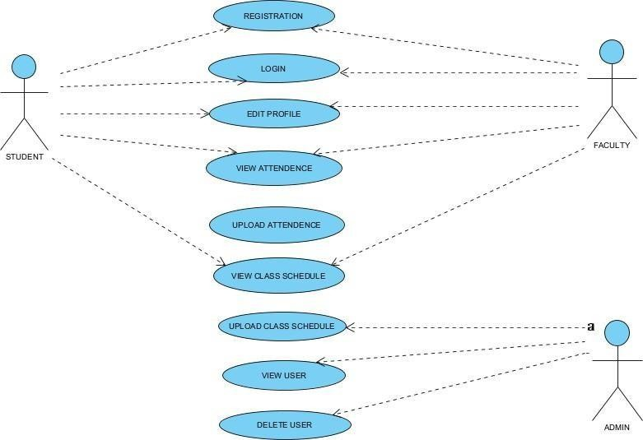

ACTIVITY DIAGRAM
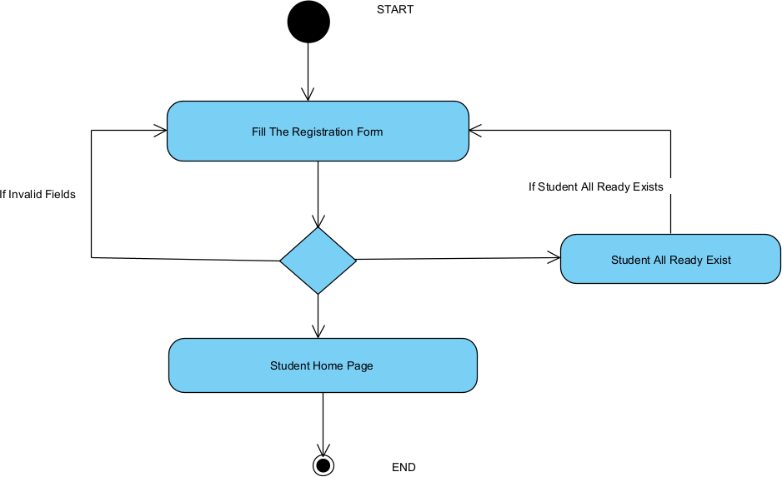

SEQUENCE DIAGRAM

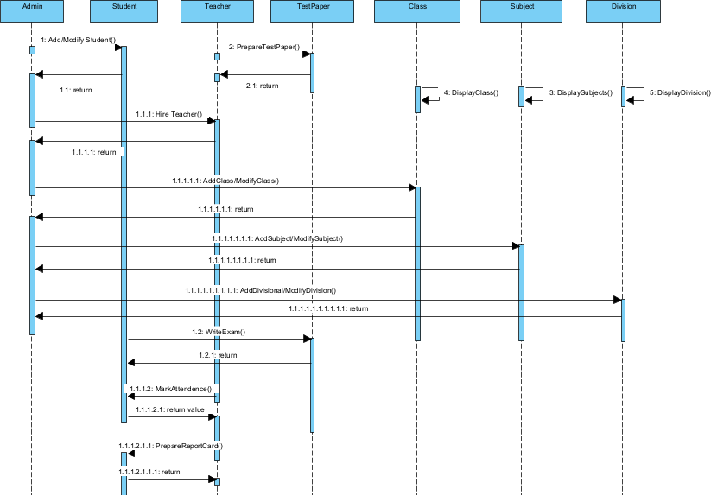

CLASS DIAGRAM
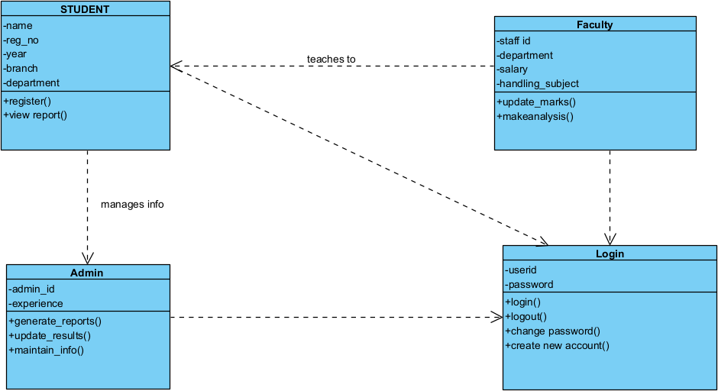

CODING:

Index.html
<!DOCTYPE html>
<html lang="en">
<head>
<meta charset="UTF-8">
<meta name="viewport" content="width=device-width, initial-scale=1.0">
<link rel="stylesheet" href="styles.css">
<title>Student Information System</title>
<style> body {
font-family: Arial, sans-serif; background-color: #f0f0f0; display: flex;
justify-content: center; align-items: center; height: 100vh; margin: 0;
}
.container { background-color: #fff; padding: 20px;
border-radius: 10px;
box-shadow: 0 0 10px rgba(0, 0, 0, 0.1); text-align: center;
}
h1 {
color: #333;
}
.buttons {
margin-top: 20px;
}

.buttons button { background-color: #007bff; color: #fff;
border: none; padding: 10px 20px; margin: 5px;
border-radius: 5px; cursor: pointer;
transition: background-color 0.3s, transform 0.3s;
}
.buttons button:hover { background-color: #0056b3; transform: scale(1.1);
}
</style>
</head>
<body>
<div class="container">
<h1>Student Information System</h1>
<div class="buttons">
<button onclick="location.href='add_student.html'">Add Student</button>
<button onclick="location.href='view_students.html'">View Students</button>
<button onclick="location.href='add_marks.html'">Add Marks</button>
</div>
</div>
</body>
</html> Style.css body {
font-family: Arial, sans-serif; background-color: #f4f4f4; margin: 0;
padding: 0;
}
.container {
max-width: 800px; margin: 20px auto; padding: 20px; background-color: white; border-radius: 8px;
box-shadow: 0 0 10px rgba(0, 0, 0, 0.1);
}
.home-button {
text-align: center; /* Center the button */
margin-top: 20px; /* Add space above the button */
}
h1 {

text-align: center; color: #333;
margin-bottom: 20px;
}
.buttons { display: flex;
justify-content: center; margin-top: 20px;
}
button { margin: 0 10px;
padding: 10px 20px; border: none; border-radius: 5px;
background-color: #28a745; color: white;
cursor: pointer;
transition: background-color 0.3s;
}
button:hover {
background-color: #218838;
}
form { display: flex;
flex-direction: column;
}
label {
margin: 10px 0 5px;
}
input, select { padding: 10px; border: 1px solid #ccc; border-radius: 5px; margin-bottom: 20px;
}
table { width: 100%;
border-collapse: collapse; margin-top: 20px;
}
th, td { padding: 10px; text-align: left;
border-bottom: 1px solid #ddd;
}
tr:nth-child(even) { background-color: #f2f2f2;

}
tr:hover {
background-color: #e0e0e0;
}

add_student.html
<!DOCTYPE html>
<html lang="en">
<head>
<meta charset="UTF-8">
<meta name="viewport" content="width=device-width, initial-scale=1.0">
<link rel="stylesheet" href="styles.css">
<title>Add Student</title>
</head>
<body>
<div class="container">
<h1>Add Student</h1>
<form id="addStudentForm">
<label for="name">Name:</label>
<input type="text" id="name" required>
<label for="regNumber">Registration Number:</label>
<input type="text" id="regNumber" required>
<label for="department">Department:</label>
<select id="department" required>
<option value="" disabled selected>Select Department</option>
<option value="CSE">CSE</option>
<option value="IT">IT</option>
<option value="ECE">ECE</option>
<option value="Chemistry">Chem</option>
<option value="Mech">Mech</option>
<option value="Civil">Civil</option>
<option value="IOT">IOT</option>
<option value="CS">CS</option>
<option value="AIDS">AIDS</option>
<option value="EEE">EEE</option>
</select>
<label for="year">Year:</label>
<select id="year" required>
<option value="" disabled selected>Select Year</option>
<option value="1">1</option>
<option value="2">2</option>
<option value="3">3</option>
<option value="4">4</option>
</select>
<label for="cgpa">CGPA:</label>
<input type="number" id="cgpa" step="0.01" min="0" max="10" required>
<button type="submit">Add Student</button>
</form>

<div class="home-button">
<button onclick="location.href='index.html'">Home</button>
</div>
</div>
<script>
const students = JSON.parse(localStorage.getItem('students')) || []; document.getElementById('addStudentForm').addEventListener('submit', function(event) { event.preventDefault();
const student = {
name: document.getElementById('name').value, regNumber: document.getElementById('regNumber').value, department: document.getElementById('department').value, year: document.getElementById('year').value,
cgpa: document.getElementById('cgpa').value,
};
students.push(student); localStorage.setItem('students', JSON.stringify(students)); alert('Student added successfully!');
location.href = 'view_students.html';
});
</script>
</body>
</html>

add_marks.html
<!DOCTYPE html>
<html lang="en">
<head>
<meta charset="UTF-8">
<meta name="viewport" content="width=device-width, initial-scale=1.0">
<link rel="stylesheet" href="styles.css">
<title>Add Marks</title>
</head>
<body>
<div class="container">
<h1>Add Marks</h1>
<form id="addMarksForm">
<label for="studentName">Student Name:</label>
<input type="text" id="studentName" required>
<label for="subject1">Subject 1:</label>
<input type="number" id="subject1" required>
<label for="subject2">Subject 2:</label>
<input type="number" id="subject2" required>
<label for="subject3">Subject 3:</label>
<input type="number" id="subject3" required>
<label for="subject4">Subject 4:</label>

<input type="number" id="subject4" required>
<label for="subject5">Subject 5:</label>
<input type="number" id="subject5" required>
<label for="totalMarks">Total Marks:</label>
<input type="text" id="totalMarks" readonly>
<button type="submit">Save</button>
</form>
<div class="buttons">
<button onclick="location.href='view_students.html'">Preview Page</button>
<button onclick="location.href='index.html'">Home</button>
</div>
</div>
<script>
document.getElementById('addMarksForm').addEventListener('submit', function(event) { event.preventDefault();
const marks = {
studentName: document.getElementById('studentName').value, subject1: parseFloat(document.getElementById('subject1').value), subject2: parseFloat(document.getElementById('subject2').value), subject3: parseFloat(document.getElementById('subject3').value), subject4: parseFloat(document.getElementById('subject4').value), subject5: parseFloat(document.getElementById('subject5').value),
};
marks.totalMarks = marks.subject1 + marks.subject2 + marks.subject3 + marks.subject4 + marks.subject5;
document.getElementById('totalMarks').value = marks.totalMarks; alert('Marks saved successfully!');
// Implement further logic to save/display marks if needed
});
// Update total marks when subject values change
const subjects = document.querySelectorAll('input[type="number"]'); subjects.forEach(subject => {
subject.addEventListener('input', updateTotalMarks);
});
function updateTotalMarks() { let total = 0; subjects.forEach(subject => {
total += parseFloat(subject.value) || 0;
});
document.getElementById('totalMarks').value = total;
}
</script>
</body>
</html>
}

view_students.html

<!DOCTYPE html>
<html lang="en">
<head>
<meta charset="UTF-8">
<meta name="viewport" content="width=device-width, initial-scale=1.0">
<link rel="stylesheet" href="styles.css">
<title>View Students</title>
</head>
<body>
<div class="container">
<h1>View Students</h1>
<table>
<thead>
<tr>
<th>Name</th>
<th>Registration Number</th>
<th>Department</th>
<th>Year</th>
<th>CGPA</th>
</tr>
</thead>
<tbody id="studentsTableBody">
<!-- Student data will be dynamically inserted here -->
</tbody>
</table>
<div class="home-button">
<button onclick="location.href='index.html'">Home</button>
</div>
<div class="buttons">
<button id="deleteDataButton">Delete All Data</button>
</div>
</div>
<script>
const students = JSON.parse(localStorage.getItem('students')) || []; const tableBody = document.getElementById('studentsTableBody');
// Display student data students.forEach(student => {
const row = document.createElement('tr'); row.innerHTML = `
<td>${student.name}</td>
<td>${student.regNumber}</td>
<td>${student.department}</td>
<td>${student.year}</td>
<td>${student.cgpa}</td>
`; tableBody.appendChild(row);
});

// Add event listener to delete all data document.getElementById('deleteDataButton').addEventListener('click', function() { if (confirm('Are you sure you want to delete all student data?')) { localStorage.removeItem('students');
tableBody.innerHTML = ''; // Clear the table alert('All student data deleted successfully!');
}
});
</script>
</body>
</html>

OUTPUT:

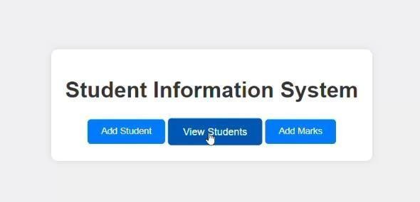
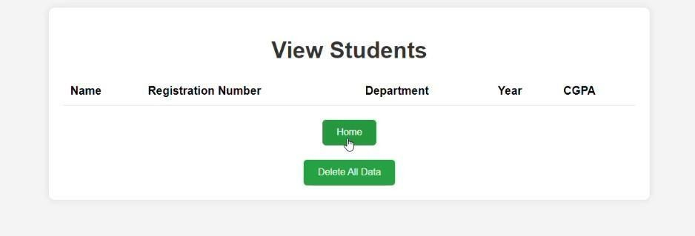

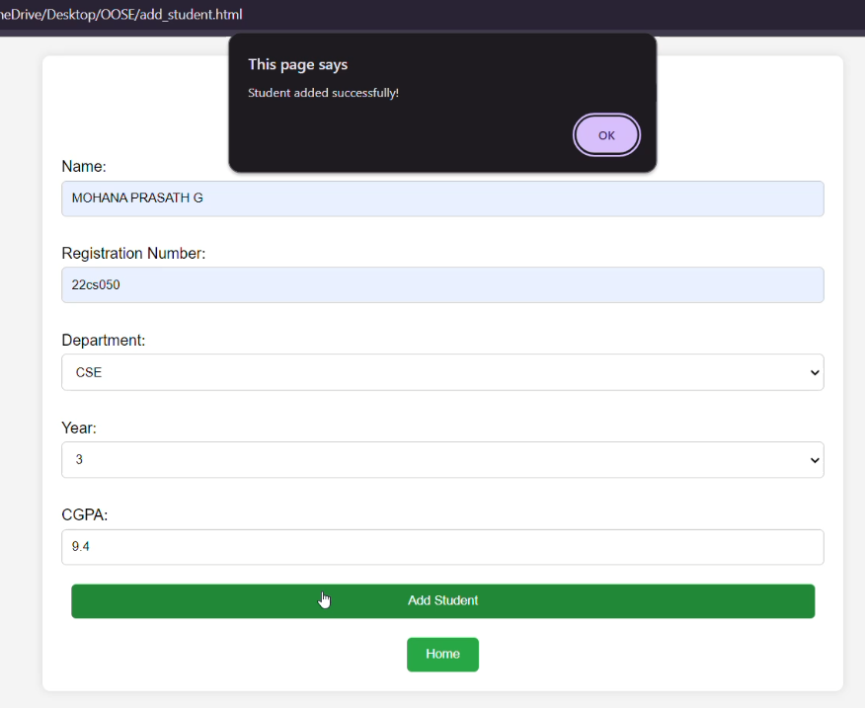
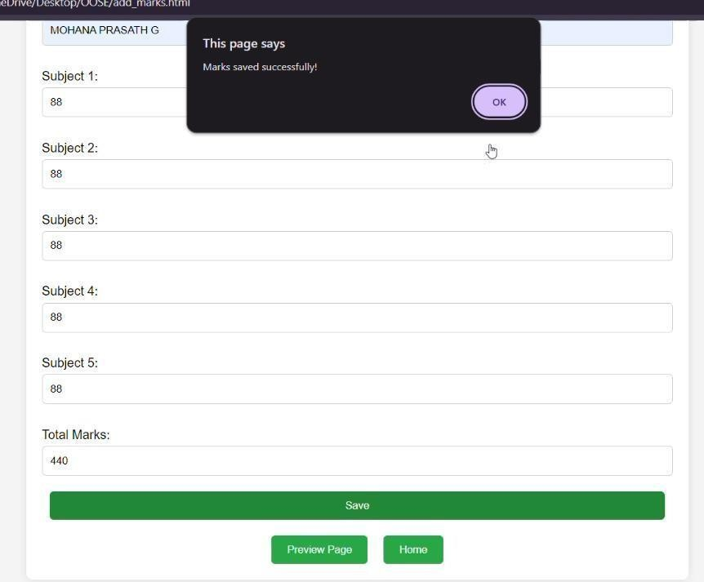

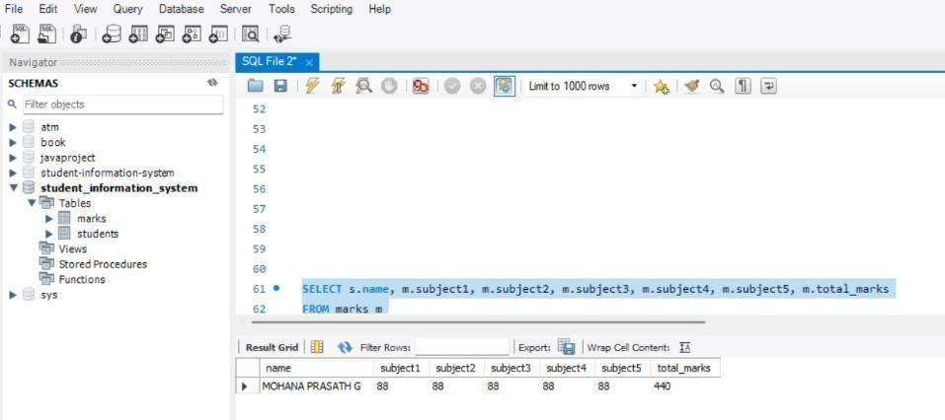

SQL Queries
CREATE DATABASE student_information_system; USE student_information_system;
CREATE TABLE students (
id INT AUTO_INCREMENT PRIMARY KEY, name VARCHAR(100),
reg_number VARCHAR(50), department VARCHAR(50), year INT,
cgpa DECIMAL(3, 2)
);
CREATE TABLE marks (
id INT AUTO_INCREMENT PRIMARY KEY,
student_id INT, subject1 INT, subject2 INT, subject3 INT, subject4 INT, subject5 INT, total_marks INT,
FOREIGN KEY (student_id) REFERENCES students(id) ON DELETE CASCADE
);
SELECT s.name, m.subject1, m.subject2, m.subject3, m.subject4, m.subject5, m.total_marks FROM marks m
JOIN students s ON m.student_id = s.id;

Connectivity Coding
import java.sql.DriverManager; import java.sql.PreparedStatement; import java.sql.ResultSet;
import java.sql.SQLException; import java.sql.Connection;
public class DatabaseConnection {
// Database URL, username and password

private static final String URL = "jdbc:mysql://localhost:3306/student_information_system"; private static final String USER = "admin";
private static final String PASSWORD = "882005"; public static void main(String[] args) {
Connection connection = null; try {
// Establish connection
connection = DriverManager.getConnection(URL, USER, PASSWORD); System.out.println("Connected to the database!");
// Create table if not exists
String createMarksTable = "CREATE TABLE IF NOT EXISTS marks ("
+ "id INT AUTO_INCREMENT PRIMARY KEY,"
+ "student_id INT,"
+ "subject1 INT,"
+ "subject2 INT,"
+ "subject3 INT,"
+ "subject4 INT,"
+ "subject5 INT,"
+ "total_marks INT,"
+ "FOREIGN KEY (student_id) REFERENCES students(id) ON DELETE CASCADE"
+ ");";
PreparedStatement createTableStatement = connection.prepareStatement(createMarksTable); createTableStatement.executeUpdate();
// Insert sample data
String insertMarks = "INSERT INTO marks (student_id, subject1, subject2, subject3, subject4, subject5, total_marks) VALUES (?, ?, ?, ?, ?, ?, ?)";
PreparedStatement insertStatement = connection.prepareStatement(insertMarks); insertStatement.setInt(1, 1); // Assuming student with id 1 insertStatement.setInt(2, 85);
insertStatement.setInt(3, 90);
insertStatement.setInt(4, 78);
insertStatement.setInt(5, 88);
insertStatement.setInt(6, 92); insertStatement.setInt(7, 433); // total marks insertStatement.executeUpdate(); System.out.println("Data inserted successfully!");
// Retrieve data
String selectMarks = "SELECT * FROM marks";
PreparedStatement selectStatement = connection.prepareStatement(selectMarks); ResultSet resultSet = selectStatement.executeQuery();
while (resultSet.next()) { System.out.println("ID: " + resultSet.getInt("id")
+ ", Student ID: " + resultSet.getInt("student_id")
+ ", Subject 1: " + resultSet.getInt("subject1")
+ ", Subject 2: " + resultSet.getInt("subject2")
+ ", Subject 3: " + resultSet.getInt("subject3")
+ ", Subject 4: " + resultSet.getInt("subject4")

+ ", Subject 5: " + resultSet.getInt("subject5")
+ ", Total Marks: " + resultSet.getInt("total_marks"));
}
} catch (SQLException e) { e.printStackTrace();
} finally { try {
if (connection != null) { connection.close(); System.out.println("Connection closed.");
}
} catch (SQLException e) { e.printStackTrace();
}
}
}
}

MARK ALLOCATION

CONTINOUS INTERNAL ASSESSMENT
Preparation & conduct of experiment | 50
Observation & Result | 30
Record | 10
Viva voice | 10
Total | 100

RESULT:
The Student Information System was implemented using HTML, CSS, and JavaScript, with connectivity managed by Node.js and Java. The system successfully stored data in the database, and a functional relationship between students and administrators was verified.

FACULTY SIGNATURE

ONLINE VOTING SYSTEM
(CONTENT BEYOND THE SYLLABUS)
AIM:
To design UML diagrams and use cases for a Online Voting System built using the MERN stack
(MongoDB, Express, React, Node.js). To develop a secure, efficient, and user-friendly online voting system that allows users to cast their votes electronically, ensures accurate vote counting, and provides a transparent and reliable election process.

PROCEDURE:
Step 1: Create MongoDB Collections.
Step 2: Set Up Node.js Backend. Step 3: Develop REST APIs.
Step 4: Connect Backend to MongoDB.
Step 5: Build the React Frontend.
Step 6: Connect React to Backend APIs.
Step 7: Implement Voting Logic. Step 8: Generate Election Results. Step 9: Test the Entire System.
UML DIAGRAMS:
USE CASE DIAGRAMS
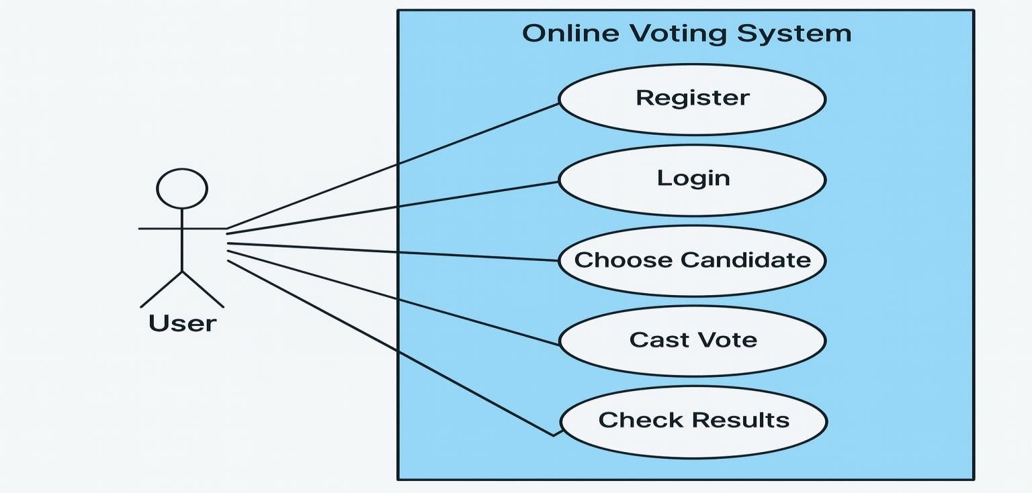

ACTIVITY DIAGRAM
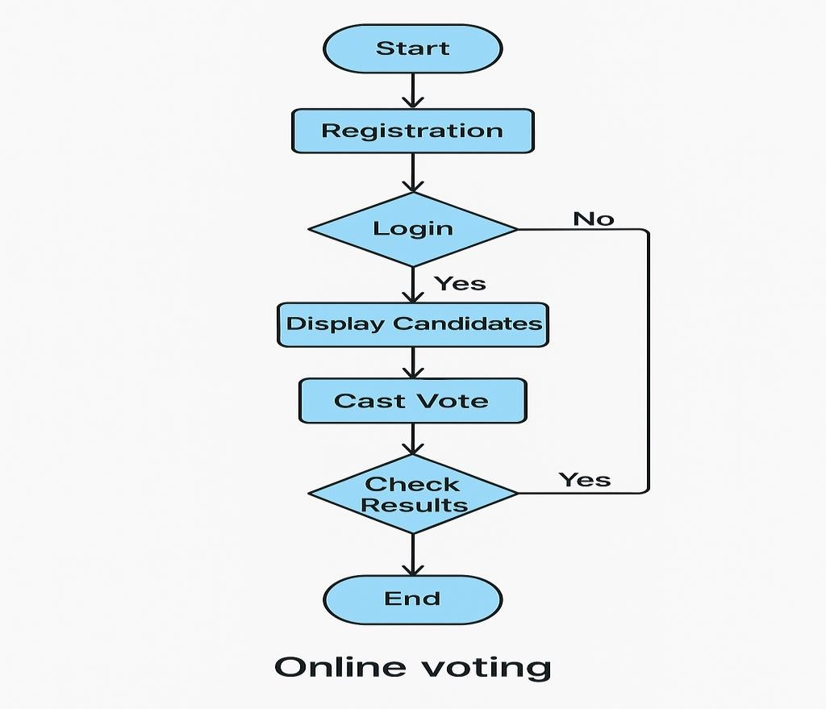

SEQUENCE DIAGRAM
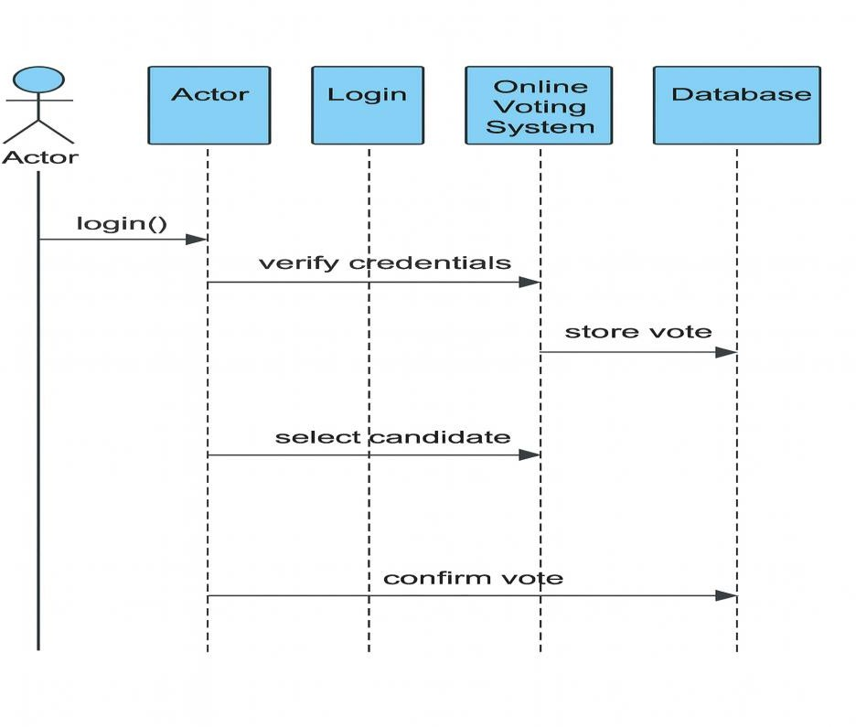

CLASS DIAGRAM
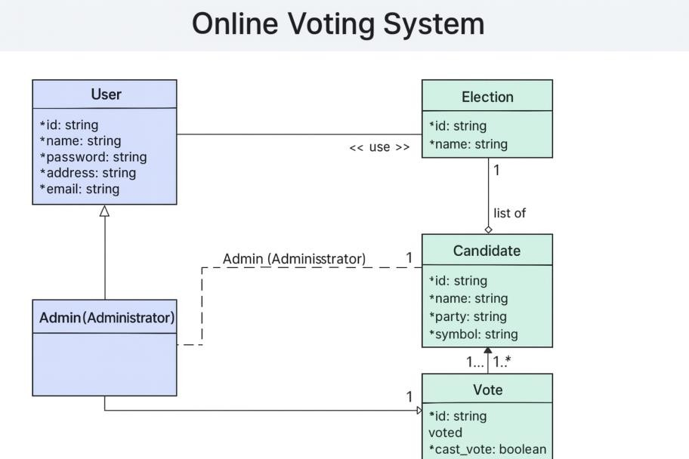

CODING:

FRONTEND:
import { useState, useEffect } from "react"; import { motion } from "motion/react";
import { LogOut, Users, Plus, Calendar, BarChart3, Edit, Trash2, X, TrendingUp } from "lucide- react";
import { Button } from "./ui/button";
import { Tabs, TabsContent, TabsList, TabsTrigger } from "./ui/tabs"; import { CreateElection } from "./CreateElection";
import { EditElection } from "./EditElection";
import { CreateCandidate } from "./CreateCandidate"; import { PublishResult } from "./PublishResult";
import { apiService, Election, CreateElectionData, Candidate, CreateCandidateData } from "../services/api";

interface AdminDashboardProps { onLogout: () => void;
onPublishResult: (electionId: string) => void;
}

export function AdminDashboard({ onLogout,
onPublishResult,
}: AdminDashboardProps) {
const [elections, setElections] = useState<Election[]>([]); const [candidates, setCandidates] = useState<Candidate[]>([]); const [isLoading, setIsLoading] = useState(true);
const [isLoadingCandidates, setIsLoadingCandidates] = useState(true);

const [error, setError] = useState<string | null>(null); const [activeTab, setActiveTab] = useState("elections");
const [editingElection, setEditingElection] = useState<Election | null>(null); const [showEditDialog, setShowEditDialog] = useState(false);

// Load elections and candidates from backend useEffect(() => {
loadElections(); loadCandidates();

// Set up periodic refresh every 30 seconds to catch any data updates const intervalId = setInterval(() => {
loadCandidates();
}, 30000);

return () => clearInterval(intervalId);
}, []);

// Update real-time status every minute useEffect(() => {
const interval = setInterval(() => {
// Force re-render to update real-time status setElections(prev => [...prev]);
}, 60000); // Update every minute

return () => clearInterval(interval);
}, []);

const loadElections = async () => { try {
setIsLoading(true);
const electionsData = await apiService.getAllElections(); setElections(electionsData);
setError(null);
} catch (err) {
setError('Failed to load elections'); console.error('Error loading elections:', err);
} finally { setIsLoading(false);
}
};

const loadCandidates = async () => { try {
setIsLoadingCandidates(true);
const candidatesData = await apiService.getAllCandidates();

setCandidates(candidatesData);
} catch (err) {
console.error('Error loading candidates:', err);
} finally { setIsLoadingCandidates(false);
}
};

const handleCreateElection = async (electionData: CreateElectionData) => { try {
await apiService.createElection(electionData);
await loadElections(); // Reload elections after creation setError(null);
} catch (err) {
setError('Failed to create election'); console.error('Error creating election:', err);
}
};

const handleCreateCandidate = async (candidateData: CreateCandidateData) => { try {
const result = await apiService.createCandidate(candidateData); console.log('Candidate created:', result);

// Force immediate reload of both datasets
await Promise.all([loadCandidates(), loadElections()]);

// Additional refresh after a short delay to ensure database consistency setTimeout(async () => {
await loadCandidates();
}, 1000);

setError(null);
console.log('Candidate created successfully - data refreshed');
} catch (err) {
setError('Failed to create candidate'); console.error('Error creating candidate:', err);
}
};

// Function to calculate real-time election status
const getElectionStatus = (startDate: string, endDate: string): 'Upcoming' | 'Ongoing' | 'Ended' => { const now = new Date();
const start = new Date(startDate); const end = new Date(endDate);

if (now < start) return 'Upcoming'; if (now > end) return 'Ended'; return 'Ongoing';
};

const handleEditElection = (election: Election) => { setEditingElection(election); setShowEditDialog(true);
};

const handleUpdateElection = async (electionData: CreateElectionData) => { if (!editingElection) return;

try {
await apiService.updateElection(editingElection._id, electionData); await loadElections();
setShowEditDialog(false); setEditingElection(null); setError(null);
console.log('Election updated successfully');
} catch (err) {
setError('Failed to update election'); console.error('Error updating election:', err);
}
};

const handleDeleteElection = async (election: Election) => {
if (!confirm(Are you sure you want to delete "${election.title}"? This action cannot be undone.)) { return;
}

try {
await apiService.deleteElection(election._id); await loadElections();
setError(null);
console.log('Election deleted successfully');
} catch (err) {
setError('Failed to delete election'); console.error('Error deleting election:', err);
}
};

const handleCancelEdit = () => { setShowEditDialog(false); setEditingElection(null);
};

// Function to get elections with real-time status const getElectionsWithRealTimeStatus = () => { return elections.map(election => ({
...election,
status: getElectionStatus(election.startDate, election.endDate)
}));
};

const electionsWithStatus = getElectionsWithRealTimeStatus();

// Function to get candidate count for an election const getCandidateCount = (electionId: string) => {
// Ensure both IDs are strings for comparison const count = candidates.filter((c) => {
// Handle both string and ObjectId types
const candidateElectionId = c.electionId?.toString() || c.electionId; return candidateElectionId === electionId;
}).length;

// Debug logging (remove in production) if (electionId && candidates.length > 0) { console.log('Election ID:', electionId);
console.log('Candidates count for this election:', count); console.log('All candidates:', candidates.map(c => ({ name: c.name,
electionId: c.electionId, electionIdString: c.electionId?.toString()
})));
}

return count;
};

// Handle tab changes to refresh data
const handleTabChange = (value: string) => { setActiveTab(value);
// Close edit dialog when switching tabs setShowEditDialog(false); setEditingElection(null);

if (value === 'elections') {
// Refresh data when viewing elections tab loadElections();
loadCandidates();
}

};
return (
<div className="min-h-screen bg-gradient-to-br from-[#d4af37]/10 via-white to-[#1e3a8a]/10">
{/* Header */}
<header className="bg-gradient-to-r from-[#1e3a8a] to-[#1e3a8a]/90 shadow-lg border-b-4 border-[#d4af37]">
<div className="container mx-auto px-6 py-4">
<div className="flex items-center justify-between">
<div>
<h1 className="text-white font-bold text-2xl">Admin Dashboard</h1>
<p className="text-[#d4af37] font-medium">Nandha Engineering College Voting System</p>
</div>
<Button onClick={onLogout} variant="outline"
className="border-[#d4af37] text-[#d4af37] hover:bg-[#d4af37] hover:text-[#1e3a8a] font- medium"
>
<LogOut className="w-4 h-4 mr-2" /> Logout
</Button>
</div>
</div>
</header>

{/* Main Content */}
<main className="container mx-auto px-6 py-8">
<motion.div
initial={{ opacity: 0, y: 20 }}
animate={{ opacity: 1, y: 0 }} transition={{ duration: 0.6 }}
>
{/* Stats Cards */}
<div className="grid md:grid-cols-3 gap-6 mb-8">
<div className="bg-gradient-to-br from-white to-[#1e3a8a]/5 rounded-lg shadow-lg p-6 border-l-4 border-[#1e3a8a] hover:shadow-xl transition-shadow">
<div className="flex items-center justify-between">
<div>
<p className="text-gray-600 mb-1 font-medium">Total Elections</p>
<h3 className="text-2xl font-bold text-[#1e3a8a]">{electionsWithStatus.length}</h3>
</div>
<div className="w-12 h-12 bg-gradient-to-br from-[#1e3a8a]/20 to-[#1e3a8a]/10 rounded- full flex items-center justify-center">
<TrendingUp className="w-6 h-6 text-[#1e3a8a]" />
</div>

</div>
</div>

<div className="bg-gradient-to-br from-white to-[#d4af37]/5 rounded-lg shadow-lg p-6 border-l-4 border-[#d4af37] hover:shadow-xl transition-shadow">
<div className="flex items-center justify-between">
<div>
<p className="text-gray-600 mb-1 font-medium">Total Candidates</p>
<h3 className="text-2xl font-bold text-[#1e3a8a]">{candidates.length}</h3>
</div>
<div className="w-12 h-12 bg-gradient-to-br from-[#d4af37]/20 to-[#d4af37]/10 rounded- full flex items-center justify-center">
<Users className="w-6 h-6 text-[#d4af37]" />
</div>
</div>
</div>

<div className="bg-gradient-to-br from-white to-green-500/5 rounded-lg shadow-lg p-6 border-l-4 border-green-500 hover:shadow-xl transition-shadow">
<div className="flex items-center justify-between">
<div>
<p className="text-gray-600 mb-1 font-medium">Active Elections</p>
<h3 className="text-2xl font-bold text-[#1e3a8a]">
{electionsWithStatus.filter((e) => e.status === "Ongoing").length}
</h3>
</div>
<div className="w-12 h-12 bg-gradient-to-br from-green-500/20 to-green-500/10 rounded- full flex items-center justify-center">
<Plus className="w-6 h-6 text-green-500" />
</div>
</div>
</div>
</div>

{/* Welcome Section */}
<div className="bg-gradient-to-r from-[#1e3a8a]/5 to-[#d4af37]/5 rounded-lg shadow-lg p-6 mb-8 border-l-4 border-[#d4af37] hover:shadow-xl transition-shadow">
<h2 className="text-xl text-[#1e3a8a] mb-2 font-bold">Welcome to Admin Dashboard</h2>
<p className="text-gray-700 font-medium">Manage elections, candidates, and view results from this central hub.</p>
{error && (
<div className="mt-3 p-3 bg-red-50 border border-red-200 rounded-md">
<p className="text-red-600 text-sm">{error}</p>
</div>
)}
</div>

{/* Tabs */}
<Tabs defaultValue="elections" className="space-y-6" onValueChange={handleTabChange}>
<TabsList className="bg-gradient-to-r from-white to-[#d4af37]/10 shadow-lg p-1 border border-[#d4af37]/20">
<TabsTrigger value="elections"
className="data-[state=active]:bg-[#1e3a8a] data-[state=active]:text-white font-medium"
>
Elections
</TabsTrigger>
<TabsTrigger value="create-election"
className="data-[state=active]:bg-[#1e3a8a] data-[state=active]:text-white font-medium"
>
Create Election
</TabsTrigger>
<TabsTrigger value="create-candidate"
className="data-[state=active]:bg-[#1e3a8a] data-[state=active]:text-white font-medium"
>
Create Candidate
</TabsTrigger>
<TabsTrigger value="publish-result"
className="data-[state=active]:bg-[#1e3a8a] data-[state=active]:text-white font-medium"
>
Publish Result
</TabsTrigger>
</TabsList>

<TabsContent value="elections">
<div className="bg-gradient-to-br from-white to-[#1e3a8a]/5 rounded-lg shadow-lg p-6 border border-[#d4af37]/20">
<div className="flex items-center justify-between mb-6">
<h3 className="text-[#1e3a8a] font-bold">All Elections</h3>
<Button onClick={() => { loadElections(); loadCandidates();
}}
variant="outline" size="sm"
className="border-[#1e3a8a] text-[#1e3a8a] hover:bg-[#1e3a8a] hover:text-white font-

medium"

>
Refresh Data

</Button>
</div>
{isLoading || isLoadingCandidates ? (
<div className="text-center py-8">
<p className="text-gray-500">Loading elections and candidates...</p>
</div>
) : (
<div className="grid md:grid-cols-2 lg:grid-cols-3 gap-6">
{electionsWithStatus.map((election) => {
const realTimeStatus = getElectionStatus(election.startDate, election.endDate); const candidateCount = getCandidateCount(election._id);
return (
<div key={election._id}
className="border border-[#d4af37]/30 rounded-lg p-4 hover:border-[#d4af37] transition-all duration-300 bg-gradient-to-br from-white to-[#1e3a8a]/5 shadow-md hover:shadow-lg"
>
<div className="mb-4">
<div className="flex items-start justify-between mb-2">
<h4 className="text-[#1e3a8a] text-lg">{election.title}</h4>
<div className="flex gap-1 ml-2">
{realTimeStatus !== "Ended" && (
<>
<Button variant="ghost" size="sm"
onClick={() => handleEditElection(election)} className="h-8 w-8 p-0 hover:bg-blue-50" title="Edit Election"
>
<Edit className="w-4 h-4 text-blue-600" />
</Button>
<Button variant="ghost" size="sm"
onClick={() => handleDeleteElection(election)} className="h-8 w-8 p-0 hover:bg-red-50" title="Delete Election"
>
<Trash2 className="w-4 h-4 text-red-600" />
</Button>
</>
)}
{realTimeStatus === "Ended" && (
<Button variant="ghost"

size="sm"
onClick={() => handleDeleteElection(election)} className="h-8 w-8 p-0 hover:bg-red-50" title="Delete Completed Election"
>
<Trash2 className="w-4 h-4 text-red-600" />
</Button>
)}
</div>
</div>
<p className="text-gray-600 text-sm mb-2">{election.description}</p>
<p className="text-sm text-gray-600 mb-2">
{new Date(election.startDate).toLocaleString()} - {new Date(election.endDate).toLocaleString()}
</p>
<div className="flex items-center justify-between">
<span className={`inline-block px-3 py-1 rounded-full text-sm font-medium ${ realTimeStatus === "Ongoing"
? "bg-green-100 text-green-700"
: realTimeStatus === "Upcoming"
? "bg-blue-100 text-blue-700"
: "bg-gray-100 text-gray-700"
}`}>
{realTimeStatus}
</span>
<span className="text-xs text-gray-500"> Candidates: {candidateCount}
</span>
</div>
</div>
{realTimeStatus === "Ended" && (
<Button variant="outline" size="sm"
className="w-full border-[#d4af37] text-[#1e3a8a] bg-gradient-to-r from-white to- [#d4af37]/5 hover:bg-gradient-to-r hover:from-[#d4af37] hover:to-[#1e3a8a] hover:text-white transition-all duration-300 font-medium"
onClick={() => onPublishResult(election._id)}
>
Publish Result
</Button>
)}
</div>
);
})}
{electionsWithStatus.length === 0 && !isLoading && (

<p className="text-gray-500 col-span-3 text-center py-8"> No elections created yet
</p>
)}
</div>
)}
</div>
</TabsContent>

<TabsContent value="create-election">
<div className="bg-gradient-to-br from-white to-[#1e3a8a]/5 rounded-lg shadow-lg border border-[#d4af37]/20">
<CreateElection onSubmit={handleCreateElection} />
</div>
</TabsContent>

<TabsContent value="create-candidate">
<div className="bg-gradient-to-br from-white to-[#1e3a8a]/5 rounded-lg shadow-lg border border-[#d4af37]/20">
<CreateCandidate elections={electionsWithStatus} onSubmit={handleCreateCandidate}
/>
</div>
</TabsContent>

<TabsContent value="publish-result">
<div className="bg-gradient-to-br from-white to-[#1e3a8a]/5 rounded-lg shadow-lg border border-[#d4af37]/20">
<PublishResult
elections={elections.filter((e) => e.status === "Ended")} onPublish={onPublishResult}
/>
</div>
</TabsContent>
</Tabs>

{/* Edit Election Dialog */}
{showEditDialog && (
<div className="fixed inset-0 bg-black bg-opacity-50 flex items-center justify-center z-50">
<div className="bg-gradient-to-br from-white to-[#1e3a8a]/5 rounded-lg shadow-xl max-w- 2xl w-full max-h-[90vh] overflow-y-auto m-4 border border-[#d4af37]/20">
<div className="flex items-center justify-between p-4 border-b border-[#d4af37]/30 bg- gradient-to-r from-[#1e3a8a] to-[#1e3a8a]/90">
<h3 className="text-lg font-semibold text-white">Edit Election</h3>
<Button

variant="ghost" size="sm"
onClick={handleCancelEdit}
className="h-8 w-8 p-0 text-white hover:bg-white/20"
>
<X className="w-4 h-4" />
</Button>
</div>
<div className="p-4">
<EditElection election={editingElection} onSubmit={handleUpdateElection} onCancel={handleCancelEdit}
/>
</div>
</div>
</div>
)}
</motion.div>
</main>
</div>
);
}
DASHBOARD:
import { useState, useEffect } from "react"; import { motion } from "motion/react";
import { LogOut, Vote, TrendingUp } from "lucide-react"; import { Button } from "./ui/button";
import { Tabs, TabsContent, TabsList, TabsTrigger } from "./ui/tabs"; import { ElectionCard } from "./ElectionCard";
import { VoterCard } from "./VoterCard";
import { CandidateCard } from "./CandidateCard";
import { apiService, Election, Candidate } from "../services/api";

interface StudentDashboardProps { student: any;
onLogout: () => void; votes: any[];
onVote: (electionId: string, election?: any) => void; onViewResults: (electionId: string) => void; studentVotes?: any[];
setStudentVotes?: (v: any[]) => void;
}

export function StudentDashboard({ student,
onLogout, votes, onVote,

onViewResults,
studentVotes: studentVotesProp, setStudentVotes: setStudentVotesProp,
}: StudentDashboardProps) {
const [elections, setElections] = useState<Election[]>([]); const [candidates, setCandidates] = useState<Candidate[]>([]); const [studentVotes, setStudentVotes] = useState<any[]>([]); const [isLoading, setIsLoading] = useState(true);
const [error, setError] = useState<string | null>(null);

// Load elections, candidates, and student votes from backend useEffect(() => {
loadElections(); loadCandidates();
// If parent passed down studentVotes, use those immediately; otherwise fetch if (studentVotesProp && Array.isArray(studentVotesProp)) { console.log('Using studentVotes from parent prop:', studentVotesProp); setStudentVotes(studentVotesProp);
} else { loadStudentVotes();
}

// Set up periodic refresh to catch new candidates and votes added by admin const intervalId = setInterval(() => {
loadElections(); loadCandidates();
// Don't re-fetch votes on interval if parent is managing them if (!studentVotesProp) loadStudentVotes();
}, 10000); // Refresh every 10 seconds

return () => clearInterval(intervalId);
}, [student.studentId, studentVotesProp]);

const loadElections = async () => { try {
setIsLoading(true);
const electionsData = await apiService.getAllElections(); setElections(electionsData);
setError(null);
} catch (err) {
setError('Failed to load elections'); console.error('Error loading elections:', err);
} finally { setIsLoading(false);
}
};

const loadCandidates = async () => { try {
const candidatesData = await apiService.getAllCandidates(); setCandidates(candidatesData);
} catch (err) {

console.error('Error loading candidates:', err);
}
};

// Load student's votes from backend const loadStudentVotes = async () => { try {
if (student && student.studentId) {
// Fetch all votes for this student from the backend console.log('=== LOADING STUDENT VOTES ===');
console.log('Student ID:', student.studentId);
const studentVotesData = await apiService.getStudentVotes(student.studentId); console.log('Raw votes from backend:', studentVotesData);

if (studentVotesData && studentVotesData.length > 0) { console.log('First vote structure:', {
electionId: studentVotesData[0].electionId, candidateId: studentVotesData[0].candidateId, studentId: studentVotesData[0].studentId, votedAt: studentVotesData[0].votedAt
});
}

setStudentVotes(studentVotesData);
// If parent provided a setter, update it so other parts of the app
// (e.g. App) can stay in sync.
if (setStudentVotesProp) setStudentVotesProp(studentVotesData);
}
} catch (err) {
console.error('Error loading student votes:', err); setStudentVotes([]);
if (setStudentVotesProp) setStudentVotesProp([]);
}
};

// Function to calculate real-time election status
const getElectionStatus = (startDate: string, endDate: string): 'Upcoming' | 'Ongoing' | 'Ended' => { const now = new Date();
const start = new Date(startDate); const end = new Date(endDate);

if (now < start) return 'Upcoming'; if (now > end) return 'Ended'; return 'Ongoing';
};

// Function to get elections with real-time status const getElectionsWithRealTimeStatus = () => { return elections.map(election => ({
...election,
status: getElectionStatus(election.startDate, election.endDate)
}));

};

const electionsWithStatus = getElectionsWithRealTimeStatus();
const ongoingElections = electionsWithStatus.filter((e) => e.status === "Ongoing"); const upcomingElections = electionsWithStatus.filter((e) => e.status === "Upcoming"); const endedElections = electionsWithStatus.filter((e) => e.status === "Ended");

const hasVoted = (electionId: string) => { const voted = studentVotes.some((v) => { const vElectionId = String(v.electionId || ''); const electionIdStr = String(electionId); return vElectionId === electionIdStr;
});

return voted;
};

// Function to get candidate count for an election const getCandidateCount = (electionId: string) => {
const candidateElectionId = candidates.filter((c) => { const cElectionId = c.electionId?.toString() || c.electionId; return cElectionId === electionId;
}).length;
return candidateElectionId;
};

// Function to handle tab changes and refresh data const handleTabChange = (value: string) => {
// Refresh data when switching tabs to ensure latest candidates loadElections();
loadCandidates();
console.log('Tab changed to:', value, 'Refreshing data...');
};

return (
<div className="min-h-screen bg-gradient-to-br from-[#d4af37]/10 via-white to-[#1e3a8a]/10">
{/* Header */}
<header className="bg-gradient-to-r from-[#1e3a8a] to-[#1e3a8a]/90 shadow-lg border-b-4 border-[#d4af37]">
<div className="container mx-auto px-6 py-4">
<div className="flex items-center justify-between">
<div>
<h1 className="text-white font-bold text-2xl">Student Portal</h1>
<p className="text-[#d4af37] font-medium">Welcome, {student.fullName}</p>
</div>
<Button onClick={onLogout} variant="outline"
className="border-[#d4af37] text-[#d4af37] hover:bg-[#d4af37] hover:text-[#1e3a8a] font- medium"
>
<LogOut className="w-4 h-4 mr-2" />

Logout
</Button>
</div>
</div>
</header>

{/* Main Content */}
<main className="container mx-auto px-6 py-8">
<motion.div
initial={{ opacity: 0, y: 20 }}
animate={{ opacity: 1, y: 0 }} transition={{ duration: 0.6 }}
>
{/* Student Info Card */}
<div className="mb-8">
<VoterCard name={student.fullName} studentId={student.studentId} department={student.department} hasVoted={studentVotes.length > 0}
/>
</div>

{/* Tabs */}
<Tabs defaultValue="ongoing" className="space-y-6" onValueChange={handleTabChange}>
<TabsList className="bg-gradient-to-r from-white to-[#d4af37]/10 shadow-lg p-1 border border-[#d4af37]/20">
<TabsTrigger value="ongoing"
className="data-[state=active]:bg-[#1e3a8a] data-[state=active]:text-white font-medium"
>
<Vote className="w-4 h-4 mr-2" /> Ongoing Elections
</TabsTrigger>
<TabsTrigger value="upcoming"
className="data-[state=active]:bg-[#1e3a8a] data-[state=active]:text-white font-medium"
>
Upcoming
</TabsTrigger>
<TabsTrigger value="results"
className="data-[state=active]:bg-[#1e3a8a] data-[state=active]:text-white font-medium"
>
<TrendingUp className="w-4 h-4 mr-2" /> Results
</TabsTrigger>
</TabsList>

<TabsContent value="ongoing">
<div className="bg-gradient-to-br from-white to-[#1e3a8a]/5 rounded-lg shadow-lg p-6 border border-[#d4af37]/20">

<h3 className="text-[#1e3a8a] mb-6 font-bold">Cast Your Vote</h3>
{isLoading ? (
<div className="text-center py-8">
<p className="text-gray-500">Loading elections...</p>
</div>
) : (
<div className="grid md:grid-cols-2 lg:grid-cols-3 gap-6">
{ongoingElections.map((election) => { const voted = hasVoted(election._id);
console.log(Election ${election._id}: hasVoted = ${voted}); return (
<div key={election._id}
className="border border-[#d4af37]/30 rounded-lg p-4 hover:border-[#d4af37] transition-all duration-300 bg-gradient-to-br from-white to-[#1e3a8a]/5 shadow-md hover:shadow-lg"
>
<div className="mb-4">
<h4 className="text-[#1e3a8a] text-lg mb-2">{election.title}</h4>
<p className="text-gray-600 text-sm mb-2">{election.description}</p>
<p className="text-sm text-gray-600 mb-2">
{new Date(election.startDate).toLocaleDateString()} - {new Date(election.endDate).toLocaleDateString()}
</p>
<div className="flex items-center justify-between mb-3">
<span className="inline-block px-3 py-1 rounded-full text-sm font-medium bg- green-100 text-green-700">
{election.status}
</span>
<span className="text-xs text-gray-500"> Candidates: {getCandidateCount(election._id)}
</span>
</div>
</div>
{!voted && (
<Button
onClick={() => onVote(election._id, election)}
className="w-full bg-gradient-to-r from-[#1e3a8a] to-[#1e3a8a]/80 hover:from- [#1e3a8a]/90 hover:to-[#1e3a8a] text-white border-0 shadow-lg hover:shadow-xl transition-all duration-300"
>
<Vote className="w-4 h-4 mr-2" /> Vote Now
</Button>
)}
{voted && (
<div className="w-full">
<div className="flex items-center justify-center gap-2 p-3 bg-gradient-to-r from- green-50 to-green-100 border border-green-200 rounded-lg">
<Vote className="w-4 h-4 text-green-600" />
<span className="text-green-700 font-medium">Voted</span>
</div>
<Button

disabled
className="w-full mt-2 bg-gray-100 text-gray-400 border border-gray-200 cursor-not-allowed"
>
<Vote className="w-4 h-4 mr-2" /> Vote Now
</Button>
</div>
)}
</div>
);
})}
{ongoingElections.length === 0 && !isLoading && (
<p className="text-gray-500 col-span-3 text-center py-8"> No ongoing elections at the moment
</p>
)}
</div>
)}
</div>
</TabsContent> <TabsContent value="upcoming">
<div className="bg-gradient-to-br from-white to-[#1e3a8a]/5 rounded-lg shadow-lg p-6 border border-[#d4af37]/20">
<h3 className="text-[#1e3a8a] mb-6 font-bold">Upcoming Elections</h3>
<div className="grid md:grid-cols-2 lg:grid-cols-3 gap-6">
{upcomingElections.map((election) => (
<div key={election._id}
className="border border-[#d4af37]/30 rounded-lg p-4 hover:border-[#d4af37] transition-all duration-300 bg-gradient-to-br from-white to-[#1e3a8a]/5 shadow-md hover:shadow-lg"
>
<div className="mb-4">
<h4 className="text-[#1e3a8a] text-lg mb-2">{election.title}</h4>
<p className="text-gray-600 text-sm mb-2">{election.description}</p>
<p className="text-sm text-gray-600 mb-2">
{new Date(election.startDate).toLocaleDateString()} - {new Date(election.endDate).toLocaleDateString()}
</p>
<div className="flex items-center justify-between">
<span className="inline-block px-3 py-1 rounded-full text-sm font-medium bg-blue- 100 text-blue-700">
{election.status}
</span>
<span className="text-xs text-gray-500"> Candidates: {getCandidateCount(election._id)}
</span>
</div>
</div>
</div>
))}
{upcomingElections.length === 0 && !isLoading && (
<p className="text-gray-500 col-span-3 text-center py-8">

No upcoming elections scheduled
</p>
)}
</div>
</div>
</TabsContent>

<TabsContent value="results">
<div className="bg-gradient-to-br from-white to-[#1e3a8a]/5 rounded-lg shadow-lg p-6 border border-[#d4af37]/20">
<h3 className="text-[#1e3a8a] mb-6 font-bold">Election Results</h3>
<div className="grid md:grid-cols-2 lg:grid-cols-3 gap-6">
{endedElections.map((election) => (
<div key={election._id}
className="border border-[#d4af37]/30 rounded-lg p-4 hover:border-[#d4af37] transition-all duration-300 bg-gradient-to-br from-white to-[#1e3a8a]/5 shadow-md hover:shadow-lg"
>
<div className="mb-4">
<h4 className="text-[#1e3a8a] text-lg mb-2">{election.title}</h4>
<p className="text-gray-600 text-sm mb-2">{election.description}</p>
<p className="text-sm text-gray-600 mb-2">
{new Date(election.startDate).toLocaleDateString()} - {new Date(election.endDate).toLocaleDateString()}
</p>
<div className="flex items-center justify-between mb-3">
<span className="inline-block px-3 py-1 rounded-full text-sm font-medium bg-gray- 100 text-gray-700">
{election.status}
</span>
<span className="text-xs text-gray-500"> Candidates: {getCandidateCount(election._id)}
</span>
</div>
</div>
<Button
onClick={() => onViewResults(election._id)} variant="outline"
className="w-full border-[#d4af37] text-[#1e3a8a] bg-gradient-to-r from-white to- [#d4af37]/5 hover:bg-gradient-to-r hover:from-[#d4af37] hover:to-[#1e3a8a] hover:text-white transition-all duration-300 font-medium"
>
<TrendingUp className="w-4 h-4 mr-2" /> View Results
</Button>
</div>
))}
{endedElections.length === 0 && !isLoading && (
<p className="text-gray-500 col-span-3 text-center py-8"> No results available yet
</p>
)}

</div>
</div>
</TabsContent>
</Tabs>
</motion.div>
</main>
</div>
);
}
BACK-END :
const express = require('express'); const mongoose = require('mongoose'); const cors = require('cors');
const bcrypt = require('bcryptjs'); const jwt = require('jsonwebtoken');
const nodemailer = require('nodemailer'); require('dotenv').config();

const app = express();
const PORT = process.env.PORT || 5000;

// Middleware app.use(cors());
app.use(express.json({ limit: '50mb' })); app.use(express.urlencoded({ limit: '50mb', extended: true }));

// MongoDB connection
mongoose.connect(process.env.MONGODB_URI || 'mongodb://localhost:27017/voting-system', { useNewUrlParser: true,
useUnifiedTopology: true,
});

// Models
const AdminSchema = new mongoose.Schema({ email: { type: String, required: true, unique: true }, password: { type: String, required: true },
role: { type: String, default: 'admin' }
});

const StudentSchema = new mongoose.Schema({ fullName: { type: String, required: true },
email: { type: String, required: true, unique: true }, studentId: { type: String, required: true, unique: true }, department: { type: String, required: true },
year: { type: String, required: true }, password: { type: String, required: true }, isRegistered: { type: Boolean, default: true }

}, { timestamps: true });

const LoginLogSchema = new mongoose.Schema({ email: { type: String, required: true },
studentId: { type: String },
userType: { type: String, enum: ['admin', 'student'], required: true }, loginTime: { type: Date, default: Date.now },
ipAddress: { type: String }, userAgent: { type: String }
});

const ElectionSchema = new mongoose.Schema({ title: { type: String, required: true },
description: { type: String, required: true }, startDate: { type: Date, required: true }, endDate: { type: Date, required: true },
status: { type: String, enum: ['Upcoming', 'Ongoing', 'Ended'], default: 'Upcoming' }, createdBy: { type: String, required: true }
}, { timestamps: true });

const CandidateSchema = new mongoose.Schema({ name: { type: String, required: true },
position: { type: String, required: true },
electionId: { type: mongoose.Schema.Types.ObjectId, ref: 'Election', required: true }, department: { type: String, required: true },
photoUrl: { type: String },
votes: { type: Number, default: 0 }
}, { timestamps: true });

const VoteSchema = new mongoose.Schema({
electionId: { type: mongoose.Schema.Types.ObjectId, ref: 'Election', required: true }, candidateId: { type: mongoose.Schema.Types.ObjectId, ref: 'Candidate', required: true }, studentId: { type: String, required: true },
votedAt: { type: Date, default: Date.now }
});

const OTPSchema = new mongoose.Schema({ email: { type: String, required: true },
otp: { type: String, required: true },
type: { type: String, enum: ['forgot-password'], required: true },
createdAt: { type: Date, default: Date.now, expires: 600 } // Expires in 10 minutes
});

const Admin = mongoose.model('Admin', AdminSchema); const Student = mongoose.model('Student', StudentSchema);
const LoginLog = mongoose.model('LoginLog', LoginLogSchema);

const Election = mongoose.model('Election', ElectionSchema); const Candidate = mongoose.model('Candidate', CandidateSchema); const Vote = mongoose.model('Vote', VoteSchema);
const OTP = mongoose.model('OTP', OTPSchema);

// Initialize admin account
const initializeAdmin = async () => { try {
const adminExists = await Admin.findOne({ email: 'admin@nec.edu' }); if (!adminExists) {
const hashedPassword = await bcrypt.hash('admin123', 10); await Admin.create({
email: 'admin@nec.edu', password: hashedPassword
});
console.log('Default admin account created: admin@nec.edu / admin123');
}
} catch (error) {
console.error('Error initializing admin:', error);
}
};

// Email configuration
const transporter = nodemailer.createTransport({ service: 'gmail',
auth: {
user: process.env.EMAIL_USER || 'your-email@gmail.com', pass: process.env.EMAIL_PASS || 'your-app-password'
}
});

// Generate OTP
const generateOTP = () => {
return Math.floor(100000 + Math.random() * 900000).toString();
};

// Send OTP email
const sendOTPEmail = async (email, otp) => { const mailOptions = {
from: process.env.EMAIL_USER || 'your-email@gmail.com', to: email,
subject: 'Password Reset OTP - Online Voting System', html: `
<div style="font-family: Arial, sans-serif; max-width: 600px; margin: 0 auto;">
<h2 style="color: #1e3a8a;">Password Reset Request</h2>
<p>You have requested to reset your password for the Online Voting System.</p>

<div style="background-color: #f3f4f6; padding: 20px; border-radius: 8px; text-align: center; margin: 20px 0;">
<h3 style="color: #1e3a8a; margin: 0;">Your OTP Code</h3>
<h1 style="color: #d4af37; font-size: 32px; letter-spacing: 4px; margin: 10px 0;">${otp}</h1>
</div>
<p><strong>Important:</strong></p>
<ul>
<li>This OTP is valid for 10 minutes only</li>
<li>Do not share this OTP with anyone</li>
<li>If you didn't request this, please ignore this email</li>
</ul>
<p>Best regards,<br>Online Voting System Team</p>
</div>
`
};

try {
console.log('Attempting to send OTP email to:', email);
console.log('Email service configured. User:', process.env.EMAIL_USER ? process.env.EMAIL_USER.substring(0, 5) + '...' : 'NOT SET');

await transporter.sendMail(mailOptions); console.log('OTP email sent successfully to:', email); return true;
} catch (error) {
console.error('Error sending OTP email to', email, ':', error.message); console.error('Full error:', error);
return false;
}
};

// Middleware to log login attempts
const logLogin = async (email, studentId, userType, req) => { try {
await LoginLog.create({ email,
studentId, userType, ipAddress: req.ip,
userAgent: req.get('User-Agent')
});
} catch (error) {
console.error('Error logging login attempt:', error);
}
};

// Routes

// Admin login
app.post('/api/admin/login', async (req, res) => { try {
const { email, password } = req.body;

// Find admin
const admin = await Admin.findOne({ email }); if (!admin) {
return res.status(401).json({ message: 'Invalid credentials' });
}

// Check password
const isPasswordValid = await bcrypt.compare(password, admin.password); if (!isPasswordValid) {
return res.status(401).json({ message: 'Invalid credentials' });
}

// Log the login
await logLogin(email, null, 'admin', req);

// Generate token const token = jwt.sign(
{ id: admin._id, email: admin.email, role: 'admin' }, process.env.JWT_SECRET || 'fallback-secret',
{ expiresIn: '24h' }
);

res.json({
message: 'Login successful', token,
user: {
id: admin._id, email: admin.email, role: 'admin'
}
});
} catch (error) {
console.error('Admin login error:', error); res.status(500).json({ message: 'Server error' });
}
});

// Student registration app.post('/api/student/register', async (req, res) => {

try {
const { fullName, email, studentId, department, year, password } = req.body;

// Check if student already exists
const existingStudent = await Student.findOne({
$or: [{ email }, { studentId }]
});

if (existingStudent) {
return res.status(400).json({
message: 'Student already registered with this email or student ID'
});
}

// Hash password
const hashedPassword = await bcrypt.hash(password, 10);

// Create student
const student = await Student.create({ fullName,
email, studentId, department, year,
password: hashedPassword
});

res.status(201).json({
message: 'Registration successful', student: {
id: student._id,
fullName: student.fullName, email: student.email, studentId: student.studentId,
department: student.department, year: student.year
}
});
} catch (error) {
console.error('Student registration error:', error); res.status(500).json({ message: 'Server error' });
}
});

// Student login
app.post('/api/student/login', async (req, res) => {

try {
const { email, studentId, password } = req.body;

// Find student
const student = await Student.findOne({ email, studentId }); if (!student) {
return res.status(401).json({
message: 'Invalid credentials. Please register first if you haven\'t already.'
});
}

// Check password
const isPasswordValid = await bcrypt.compare(password, student.password); if (!isPasswordValid) {
return res.status(401).json({ message: 'Invalid credentials' });
}

// Log the login
await logLogin(email, studentId, 'student', req);

// Generate token const token = jwt.sign(
{ id: student._id, email: student.email, studentId: student.studentId, role: 'student' }, process.env.JWT_SECRET || 'fallback-secret',
{ expiresIn: '24h' }
);

res.json({
message: 'Login successful', token,
user: {
id: student._id,
fullName: student.fullName, email: student.email, studentId: student.studentId,
department: student.department, year: student.year
}
});
} catch (error) {
console.error('Student login error:', error); res.status(500).json({ message: 'Server error' });
}
});

// Forgot password - Send OTP

app.post('/api/student/forgot-password', async (req, res) => { try {
const { email } = req.body;

if (!email) {
return res.status(400).json({ message: 'Email is required' });
}

console.log('Forgot password request for email:', email);

// Check if student exists (case-insensitive search)
const student = await Student.findOne({ email: { $regex: ^${email}$, $options: 'i' } }); if (!student) {
console.log('No student found for email:', email);
return res.status(404).json({ message: 'No account found with this email address' });
}

console.log('Student found:', student.email);

// Generate OTP
const otp = generateOTP(); console.log('Generated OTP:', otp);

// Delete any existing OTPs for this email
await OTP.deleteMany({ email: student.email, type: 'forgot-password' });

// Save new OTP
const savedOTP = await OTP.create({ email: student.email,
otp,
type: 'forgot-password'
});
console.log('OTP saved to database:', savedOTP);

// Send OTP email
const emailSent = await sendOTPEmail(student.email, otp); if (!emailSent) {
console.error('Failed to send OTP email');
return res.status(500).json({ message: 'Failed to send OTP email. Please try again.' });
}
console.log('OTP email sent successfully'); res.json({
message: 'OTP sent successfully to your email address',
email: student.email.replace(/(.{2})(.)(?=.{2})/, (gp1, gp2, gp3) => gp2 + ''.repeat(gp3.length))

});
} catch (error) {
console.error('Forgot password error:', error); res.status(500).json({ message: 'Server error: ' + error.message });
}
});

// Verify OTP
app.post('/api/student/verify-otp', async (req, res) => { try {
const { email, otp } = req.body;

if (!email || !otp) {
return res.status(400).json({ message: 'Email and OTP are required' });
}

console.log('Verifying OTP for email:', email, 'OTP:', otp);

// Find valid OTP (case-insensitive email) const otpRecord = await OTP.findOne({ email: { $regex: ^${email}$, $options: 'i' }, otp,
type: 'forgot-password'
});

if (!otpRecord) {
console.log('Invalid or expired OTP for email:', email);
return res.status(400).json({ message: 'Invalid or expired OTP' });
}

console.log('OTP verified successfully for:', email);

// OTP is valid res.json({
message: 'OTP verified successfully', verified: true
});
} catch (error) {
console.error('OTP verification error:', error); res.status(500).json({ message: 'Server error: ' + error.message });
}
});

// Reset password
app.post('/api/student/reset-password', async (req, res) => { try {

const { email, otp, newPassword } = req.body;

if (!email || !otp || !newPassword) {
return res.status(400).json({ message: 'Email, OTP, and new password are required' });
}

if (newPassword.length < 6) {
return res.status(400).json({ message: 'Password must be at least 6 characters long' });
}

console.log('Reset password request for email:', email);

// Verify OTP one more time (case-insensitive email) const otpRecord = await OTP.findOne({
email: { $regex: ^${email}$, $options: 'i' }, otp,
type: 'forgot-password'
});

if (!otpRecord) {
console.log('Invalid or expired OTP for reset password');
return res.status(400).json({ message: 'Invalid or expired OTP' });
}

console.log('OTP verified, proceeding with password reset');

// Hash new password
const hashedPassword = await bcrypt.hash(newPassword, 10);

// Update student password (case-insensitive) const student = await Student.findOneAndUpdate(
{ email: { $regex: ^${email}$, $options: 'i' } },
{ password: hashedPassword },
{ new: true }
);

if (!student) {
console.log('Student not found for password reset:', email); return res.status(404).json({ message: 'Student not found' });
}

// Delete used OTP
await OTP.deleteOne({ _id: otpRecord._id }); console.log('Password reset successfully for:', student.email);

res.json({
message: 'Password reset successfully', success: true
});
} catch (error) {
console.error('Reset password error:', error); res.status(500).json({ message: 'Server error: ' + error.message });
}
});

// Get all login logs (admin only) app.get('/api/admin/login-logs', async (req, res) => { try {
const logs = await LoginLog.find().sort({ loginTime: -1 }).limit(100); res.json(logs);
} catch (error) {
console.error('Error fetching login logs:', error); res.status(500).json({ message: 'Server error' });
}
});

// Get all registered students (admin only) app.get('/api/admin/students', async (req, res) => { try {
const students = await Student.find({}, '-password').sort({ createdAt: -1 }); res.json(students);
} catch (error) {
console.error('Error fetching students:', error); res.status(500).json({ message: 'Server error' });
}
});

// Election routes
// Create election (admin only) app.post('/api/admin/elections', async (req, res) => { try {
const { title, description, startDate, endDate, createdBy } = req.body;

if (!title || !description || !startDate || !endDate || !createdBy) { return res.status(400).json({ message: 'All fields are required' });
}

const newElection = new Election({ title,
description,
startDate: new Date(startDate),

endDate: new Date(endDate), createdBy
});

await newElection.save();
res.status(201).json({ message: 'Election created successfully', election: newElection });
} catch (error) {
console.error('Error creating election:', error); res.status(500).json({ message: 'Server error' });
}
});

// Get all elections
app.get('/api/elections', async (req, res) => { try {
const elections = await Election.find().sort({ createdAt: -1 }); res.json(elections);
} catch (error) {
console.error('Error fetching elections:', error); res.status(500).json({ message: 'Server error' });
}
});

// Get election by ID
app.get('/api/elections/:id', async (req, res) => { try {
const election = await Election.findById(req.params.id); if (!election) {
return res.status(404).json({ message: 'Election not found' });
}
res.json(election);
} catch (error) {
console.error('Error fetching election:', error); res.status(500).json({ message: 'Server error' });
}
});

// Update election status (admin only) app.put('/api/admin/elections/:id/status', async (req, res) => { try {
const { status } = req.body;

if (!['Upcoming', 'Ongoing', 'Ended'].includes(status)) { return res.status(400).json({ message: 'Invalid status' });
}

const election = await Election.findByIdAndUpdate( req.params.id,
{ status },
{ new: true }
);

if (!election) {
return res.status(404).json({ message: 'Election not found' });
}

res.json({ message: 'Election status updated', election });
} catch (error) {
console.error('Error updating election status:', error); res.status(500).json({ message: 'Server error' });
}
});

// Update election (admin only) app.put('/api/admin/elections/:id', async (req, res) => { try {
const { title, description, startDate, endDate } = req.body;

// Fetch the election first
const election = await Election.findById(req.params.id); if (!election) {
return res.status(404).json({ message: 'Election not found' });
}

const now = new Date();
const existingStart = new Date(election.startDate); const existingEnd = new Date(election.endDate);
const isOngoing = now >= existingStart && now <= existingEnd;

// If election is ongoing, only allow changing the end date/time if (isOngoing) {
if (!endDate) {
return res.status(400).json({ message: 'End date is required when updating an ongoing election'

});

}

const newEnd = new Date(endDate); if (isNaN(newEnd.getTime())) {
return res.status(400).json({ message: 'Invalid end date format' });

}

if (newEnd <= now) {

return res.status(400).json({ message: 'End date must be in the future' });
}

// Apply only endDate change for ongoing elections election.endDate = newEnd;
await election.save();

return res.json({
message: 'Election end date updated successfully', election: election.toObject()
});
}

// For non-ongoing elections (Upcoming or Ended), allow full update if (!title || !description || !startDate || !endDate) {
return res.status(400).json({ message: 'Title, description, start date, and end date are required' });
}

// Check if there are any votes for this election
const voteCount = await Vote.countDocuments({ electionId: req.params.id }); if (voteCount > 0) {
return res.status(400).json({ message: 'Cannot edit election that already has votes' });
}

// Validate dates
const newStart = new Date(startDate); const newEnd = new Date(endDate);

if (isNaN(newStart.getTime()) || isNaN(newEnd.getTime())) { return res.status(400).json({ message: 'Invalid date format' });
}

if (newStart >= newEnd) {
return res.status(400).json({ message: 'End date must be after start date' });
}

// Update all fields for non-ongoing elections election.title = title;
election.description = description; election.startDate = newStart; election.endDate = newEnd; await election.save();

res.json({ message: 'Election updated successfully', election: election.toObject() });
} catch (error) {
console.error('Error updating election:', error);

res.status(500).json({ message: 'Server error' });
}
});

// Delete election (admin only) app.delete('/api/admin/elections/:id', async (req, res) => { try {
const electionId = req.params.id; console.log('Attempting to delete election:', electionId);
// Get the election to check its status
const election = await Election.findById(electionId); if (!election) {
return res.status(404).json({ message: 'Election not found' });
}

// Check election status const now = new Date();
const endDate = new Date(election.endDate); const isCompleted = now > endDate;

// For ongoing/upcoming elections, prevent deletion if there are votes if (!isCompleted) {
const voteCount = await Vote.countDocuments({ electionId }); if (voteCount > 0) {
console.log('Cannot delete ongoing/upcoming election with votes');
return res.status(400).json({ message: 'Cannot delete an election that has votes' });
}
}

console.log('Election status - Completed:', isCompleted, 'Deleting candidates...');

// Delete all candidates for this election first
const candidateDeleteResult = await Candidate.deleteMany({ electionId }); console.log('Deleted candidates:', candidateDeleteResult.deletedCount);

// Delete all votes for this election (for completed elections with votes) if (isCompleted) {
const voteDeleteResult = await Vote.deleteMany({ electionId }); console.log('Deleted votes:', voteDeleteResult.deletedCount);
}

// Delete the election
const deletedElection = await Election.findByIdAndDelete(electionId); console.log('Election deleted successfully:', deletedElection._id);

res.json({
message: 'Election deleted successfully', deletedElection: deletedElection
});
} catch (error) {
console.error('Error deleting election:', error); res.status(500).json({ message: 'Server error: ' + error.message });
}
});

// Candidate routes
// Create candidate (admin only) app.post('/api/admin/candidates', async (req, res) => { try {
const { name, position, electionId, department, photoUrl } = req.body;

if (!name || !position || !electionId || !department) {
return res.status(400).json({ message: 'Name, position, election, and department are required' });
}

// Check if election exists
const election = await Election.findById(electionId); if (!election) {
return res.status(404).json({ message: 'Election not found' });
}

const newCandidate = new Candidate({ name,
position, electionId, department,
photoUrl: photoUrl || ''
});

await newCandidate.save();
// Convert ObjectId to string for frontend compatibility const candidateResponse = {
...newCandidate.toObject(),
electionId: newCandidate.electionId.toString()
};
res.status(201).json({ message: 'Candidate created successfully', candidate: candidateResponse });
} catch (error) {
console.error('Error creating candidate:', error); res.status(500).json({ message: 'Server error' });
}

});

// Get all candidates
app.get('/api/candidates', async (req, res) => { try {
const candidates = await Candidate.find().populate('electionId', 'title').sort({ createdAt: -1 });
// Convert ObjectId to string for frontend compatibility
const candidatesWithStringIds = candidates.map(candidate => ({
...candidate.toObject(),
electionId: candidate.electionId._id.toString()
}));
res.json(candidatesWithStringIds);
} catch (error) {
console.error('Error fetching candidates:', error); res.status(500).json({ message: 'Server error' });
}
});

// Get candidates by election ID app.get('/api/candidates/election/:electionId', async (req, res) => { try {
const candidates = await Candidate.find({ electionId: req.params.electionId }).sort({ createdAt: -1
});
// Convert ObjectId to string for frontend compatibility
const candidatesWithStringIds = candidates.map(candidate => ({
...candidate.toObject(),
electionId: candidate.electionId.toString()
}));
res.json(candidatesWithStringIds);
} catch (error) {
console.error('Error fetching candidates for election:', error); res.status(500).json({ message: 'Server error' });
}
});

// Delete candidate (admin only) app.delete('/api/admin/candidates/:id', async (req, res) => { try {
const candidate = await Candidate.findByIdAndDelete(req.params.id); if (!candidate) {
return res.status(404).json({ message: 'Candidate not found' });
}
res.json({ message: 'Candidate deleted successfully' });
} catch (error) {
console.error('Error deleting candidate:', error); res.status(500).json({ message: 'Server error' });

}
});

// Root route - server status app.get('/', (req, res) => { res.json({
message: 'Online Voting System API Server', status: 'Running',
version: '1.0.0', endpoints: { admin: {
login: 'POST /api/admin/login', loginLogs: 'GET /api/admin/login-logs', students: 'GET /api/admin/students',
createElection: 'POST /api/admin/elections', updateElectionStatus: 'PUT /api/admin/elections/:id/status', createCandidate: 'POST /api/admin/candidates', deleteCandidate: 'DELETE /api/admin/candidates/:id'
},
student: {
register: 'POST /api/student/register', login: 'POST /api/student/login',
forgotPassword: 'POST /api/student/forgot-password', verifyOTP: 'POST /api/student/verify-otp', resetPassword: 'POST /api/student/reset-password'
},
elections: {
create: 'POST /api/admin/elections', getAll: 'GET /api/elections', getById: 'GET /api/elections/:id',
update: 'PUT /api/admin/elections/:id', delete: 'DELETE /api/admin/elections/:id',
updateStatus: 'PUT /api/admin/elections/:id/status'
},
candidates: {
getAll: 'GET /api/candidates',
getByElection: 'GET /api/candidates/election/:electionId'
},
votes: {
submit: 'POST /api/vote',
getStatus: 'GET /api/vote/status/:electionId/:studentId', getResults: 'GET /api/elections/:electionId/results'
},
test: 'GET /api/test'
}
});

});

// Vote endpoints
app.post('/api/vote', async (req, res) => { try {
const { electionId, candidateId, studentId } = req.body;

if (!electionId || !candidateId || !studentId) {
return res.status(400).json({ message: 'Election ID, candidate ID, and student ID are required' });
}

// Check if student has already voted in this election
const existingVote = await Vote.findOne({ electionId, studentId }); if (existingVote) {
return res.status(400).json({ message: 'You have already voted in this election' });
}

// Verify election exists and is ongoing
const election = await Election.findById(electionId); if (!election) {
return res.status(404).json({ message: 'Election not found' });
}

const now = new Date();
const startDate = new Date(election.startDate); const endDate = new Date(election.endDate);

if (now < startDate) {
return res.status(400).json({ message: 'Election has not started yet' });
}

if (now > endDate) {
return res.status(400).json({ message: 'Election has ended' });
}

// Verify candidate exists and belongs to this election
const candidate = await Candidate.findOne({ _id: candidateId, electionId }); if (!candidate) {
return res.status(404).json({ message: 'Candidate not found for this election' });
}

// Create the vote record const vote = new Vote({ electionId,
candidateId, studentId

});
await vote.save();

// Increment candidate vote count
await Candidate.findByIdAndUpdate(candidateId, { $inc: { votes: 1 } });

res.json({
message: 'Vote submitted successfully', voteId: vote._id
});
} catch (error) {
console.error('Vote submission error:', error); res.status(500).json({ message: 'Server error' });
}
});

// Get vote status for a student in an election app.get('/api/vote/status/:electionId/:studentId', async (req, res) => { try {
const { electionId, studentId } = req.params;
const vote = await Vote.findOne({ electionId, studentId }); if (vote) {
const candidate = await Candidate.findById(vote.candidateId);
res.json({ hasVoted: true,
votedFor: candidate ? candidate.name : 'Unknown', votedAt: vote.votedAt
});
} else {
res.json({ hasVoted: false });
}
} catch (error) {
console.error('Vote status error:', error); res.status(500).json({ message: 'Server error' });
}
});

// Get all votes for a student app.get('/api/votes/student/:studentId', async (req, res) => { try {
const { studentId } = req.params; console.log('Fetching votes for student:', studentId);

const votes = await Vote.find({ studentId })
.populate('electionId', '_id title description')
.populate('candidateId', '_id name position');

console.log('Found votes:', votes.length); if (votes.length > 0) { console.log('Sample vote:', votes[0]);
}

// Return array of votes with proper structure res.json(votes);
} catch (error) {
console.error('Get student votes error:', error);
res.status(500).json({ message: 'Server error', error: error.message });
}
});

// Delete a vote record app.delete('/api/vote/:voteId', async (req, res) => { try {
const { voteId } = req.params;

// Find the vote to delete
const vote = await Vote.findById(voteId); if (!vote) {
return res.status(404).json({ message: 'Vote not found' });
}

// Decrement candidate vote count
await Candidate.findByIdAndUpdate(vote.candidateId, { $inc: { votes: -1 } });

// Delete the vote
await Vote.findByIdAndDelete(voteId);

res.json({ message: 'Vote deleted successfully' });
} catch (error) {
console.error('Vote deletion error:', error); res.status(500).json({ message: 'Server error' });
}
});

// Get election results app.get('/api/elections/:electionId/results', async (req, res) => { try {
const { electionId } = req.params;

// Get all candidates for this election with their vote counts
const candidates = await Candidate.find({ electionId }).sort({ votes: -1 });

// Get total votes for this election
const totalVotes = await Vote.countDocuments({ electionId });

// Calculate results
const results = candidates.map(candidate => ({
_id: candidate._id, name: candidate.name,
position: candidate.position, department: candidate.department, votes: candidate.votes,
percentage: totalVotes > 0 ? ((candidate.votes / totalVotes) * 100).toFixed(1) : '0.0'
}));

res.json({ totalVotes, results
});
} catch (error) {
console.error('Results fetch error:', error); res.status(500).json({ message: 'Server error' });
}
});

// Test route
app.get('/api/test', (req, res) => { res.json({ message: 'API is working!' });
});

// Start server app.listen(PORT, async () => {
console.log(Server running on port ${PORT}); await initializeAdmin();
});

module.exports = app;

OUTPUT:
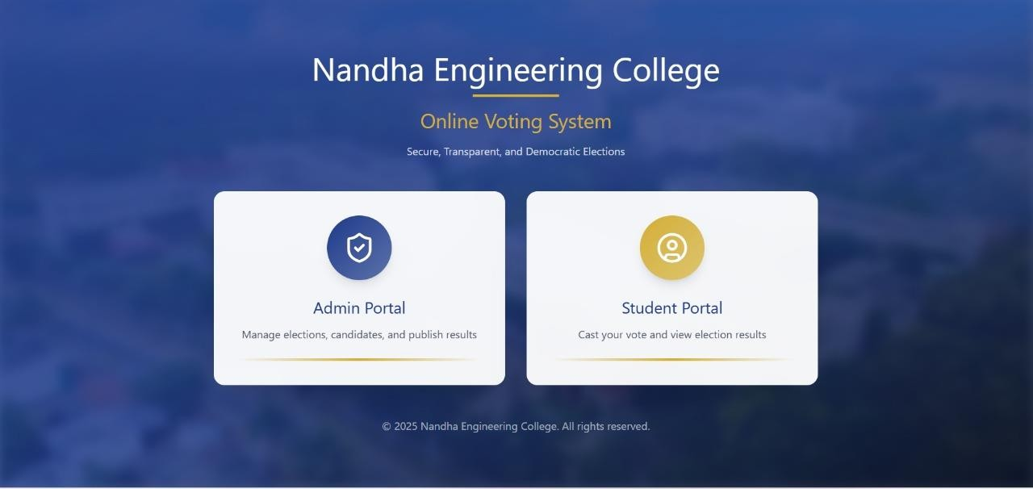
- Login Page
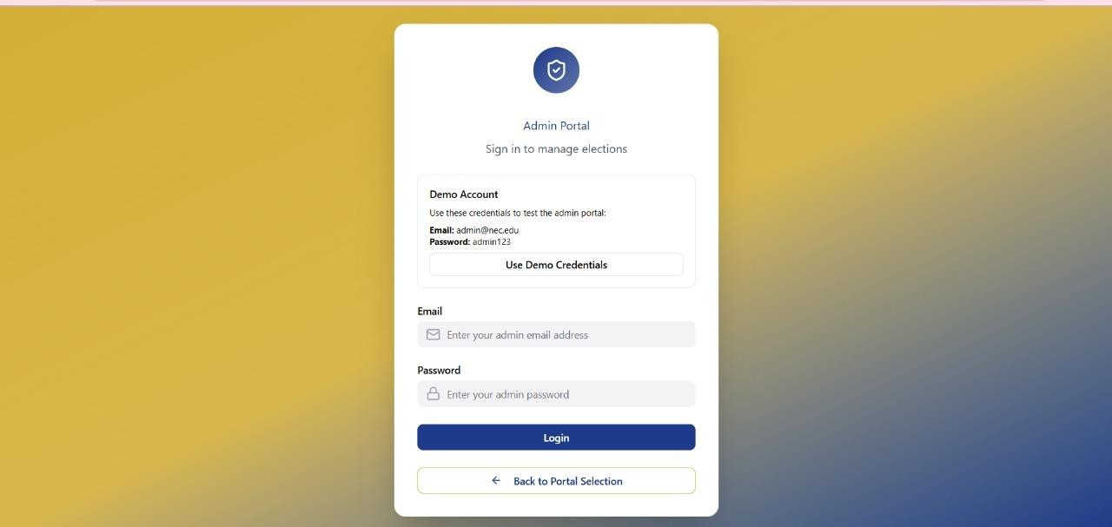
- Admin Page
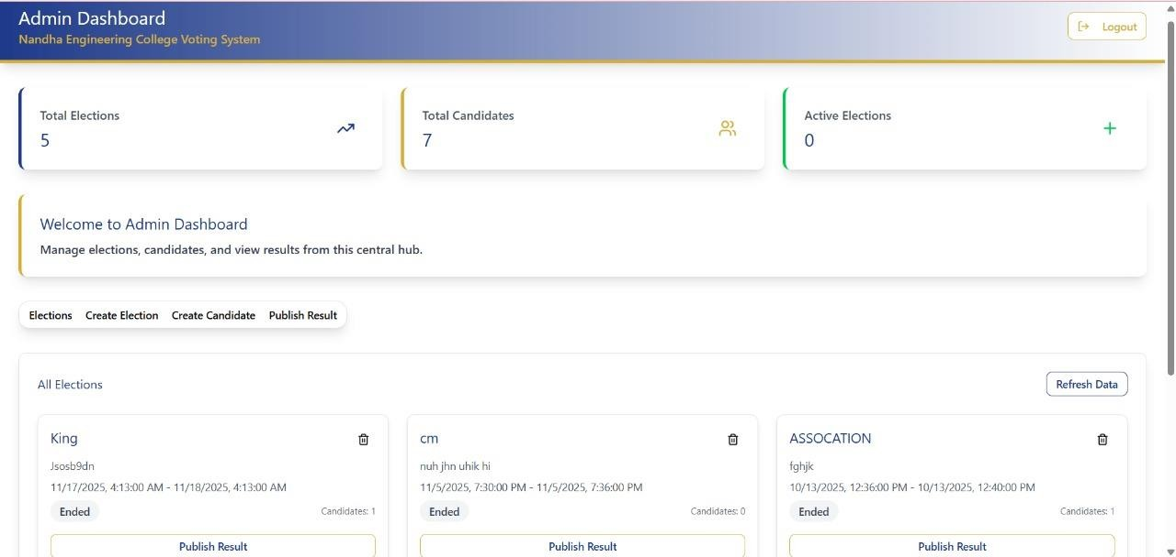
- Admin Dashboard

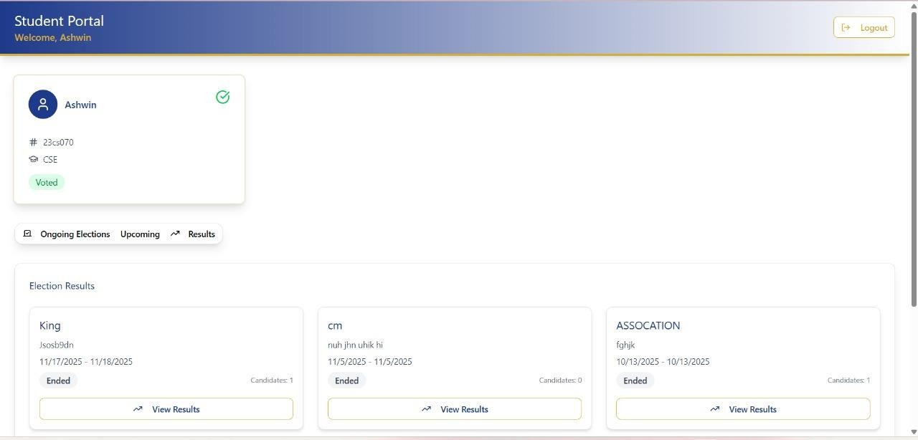
- Student Voting Page
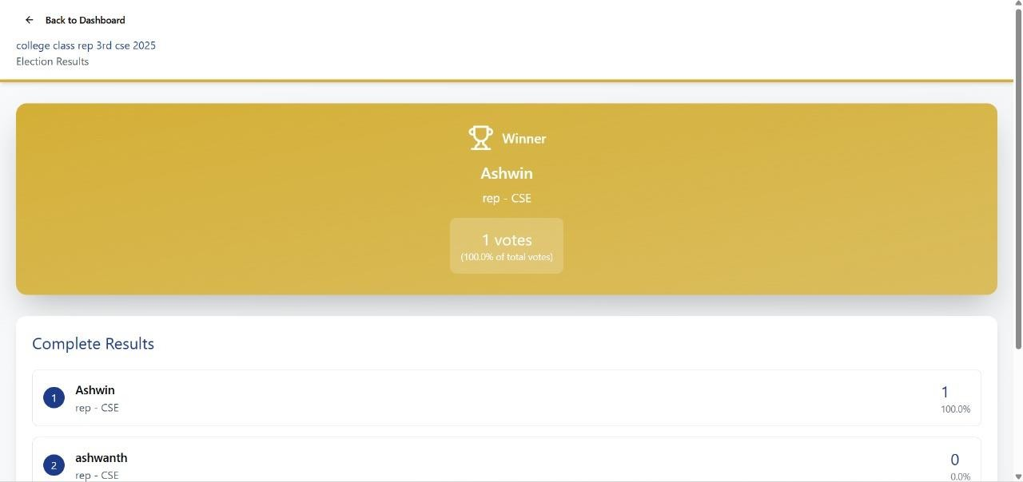
- Result Page

MARK ALLOCATION

CONTINOUS INTERNAL ASSESSMENT
Preparation & conduct of experiment | 50
Observation & Result | 30
Record | 10
Viva voice | 10
Total | 100

RESULT:
The Hospital Management System was implemented using HTML, CSS and JavaScript with connectivity managed by Node.js and Java. The data was successfully stored in the database, establishing a functional relationship between the user and the administrator was verified.

FACULTY SIGNATURE

