PHISHING AWARENESS SIMULATION
22CCC15 – WEB SECURITY

PROJECT BASED LEARNING (PBL) V-SEM/ 2025-26 DEPARTMENT OF
COMPUTER SCIENCE AND ENGINEERING (CYBER SECURITY)

NANDHA ENGINEERING COLLEGE (Autonomous)

ERODE – 638052


Register No. | Name of the Student
23CC001 | AATHAVAN T
23CC004 | BALAJI SG
23CC012 | DHARSHINI V
Project Coordinator | Dr. S. Prabhu ASP/CSE (CS)

NOVEMBER 2025


NANDHA ENGINEERING COLLEGE
(An Autonomous Institution, Affiliated to Anna University, Chennai)

ERODE – 638 052

Bonafide Certificate
This is to certify that the project work entitled “PHISHING AWARENESS SIMULATION ” is a Bonafide work carried out by

Register No. | Name of the Student
23CC001 | AATHAVAN T
23CC004 | BALAJI SG
23CC012 | DHARSHINI V

In partial fulfillment of the requirements for the course 22CCC15 – Web Security,
V Semester, III Year of the Bachelor of Engineering in Computer Science and Engineering (Cyber Security), during the Academic Year 2025–2026.

Project Guide Course Handling Faculty Head of the Department

ACKNOWLEDGEMENT

The development of this project as part of the Project Based Learning course 22CCC15-Web Security, V/III was an arduous task, completed with the support and assistance of many individuals. We sincerely thank everyone whose valuable suggestions, comments, and criticisms greatly contributed to the enhancement of this work.
We express our deepest gratitude to our Principal, Dr. U. S. Ragupathy, for his continuous support, encouragement, and motivation throughout the course of this project.
We also extend our sincere appreciation to Dr. S. Prabhu, Head of the Department, and Mrs. B. Raja Rajeswari, the Course Handling Faculty and overall Project Coordinator, for their continuous encouragement, supervision, and invaluable assistance during this endeavor.
We express our gratitude to our Project Guide, Dr. S. Prabhu, Associate Professor Computer Science and Engineering (Cyber Security), for his unwavering guidance, encouragement, and expert advice throughout the project duration.
Finally, we thank all the faculty members and staff of the Computer Science Engineering(Cyber Security) Department for their cooperation and support throughout the project work.

AATHAVAN T | 23CC001
BALAJI SG | 23CC004
DHARSHINI V | 23CC012

Date:

 | TABLE OF CONTENTS
CHAPTER  NO. | TITLE | PAGE NO.
 | ABSTRACT | i
1 | INTRODUCTION | 1
 | 1.1 Overview of Phishing Attacks | 1
 | 1.2 Need for User Awareness and Training | 1
2 | LITERATURE REVIEW | 2
 | 2.1 Journal papers | 2
 | 2.2 Patents | 3
3 | 3.1 PROBLEM STATEMENT | 5
 | 3.2 Methodology | 5
4 | OBJECTIVE OF THE PROJECT | 7
5 | REQUIREMENTS | 8
6 | IMPLEMENTATION | 10
7 | WORKING PROCEDURES | 17
8 | TESTING AND RESULT | 19
 | 8.1 Relation to project objectives and SDGs | 21
9 | CONCLUSION AND FUTURE WORK | 22
 | 9.1 Summary of achievements | 22
 | 9.2 Potential impact on SDGs and sustainable development | 22
 | 9.3 Future Scope | 23
 | REFERENCES | 24

ABSTRACT
Phishing continues to be one of the most effective attack vectors used by cybercriminals, primarily because it exploits human behavior rather than technical vulnerabilities. To address this persistent threat, this project proposes a Phishing Awareness Simulation System that evaluates users’ ability to detect and avoid phishing attempts in a controlled environment. The system simulates real-world phishing scenarios such as deceptive emails, fraudulent login portals, and malicious links, replicating the same psychological techniques used by attackers.
The platform tracks user interactions throughout each simulation, identifying behaviors such as clicking suspicious links, entering credentials, or ignoring warning signs. These actions are analyzed to measure the user’s level of vulnerability and overall cybersecurity awareness. Based on the collected data, the system provides personalized feedback that explains what the user did wrong, how phishing cues could have been identified, and what security practices should be followed in the future.
The project emphasizes not just awareness but practical learning. It includes built-in micro- training modules that educate users on recognizing phishing patterns such as URL mismatches, unexpected requests for credentials, and emotional manipulation techniques. Over time, repeated simulation and feedback cycles strengthen user behavior, transforming theoretical knowledge into real-world defensive reflexes.
This Phishing Awareness Simulation System ultimately helps organizations, educational institutions, and individuals reduce security risks caused by human error. By assessing susceptibility, training users, and monitoring improvement, the system serves as a proactive defense mechanism that enhances overall cybersecurity readiness and resilience against social engineering attacks.

Keywords: Phishing Awareness Simulation, Autonomous Security Agents, Social Engineering Detection, Behavioral Analytics, NLP-Driven Email Simulation, Cybersecurity Training, Vulnerability Scoring, Anti-Phishing Education.

CHAPTER 1 INTRODUCTION

Overview of Phishing Attacks
Phishing attacks are no longer simple “You won a lottery” scams. They’ve grown into highly targeted, data-driven operations that study user behavior before striking. Attackers now use techniques like spear-phishing, where messages are tailored to a specific person, and clone phishing, where a legitimate email is copied and slightly modified to deliver a malicious link. Many phishing emails come from compromised real accounts, making them look even more authentic.
Attackers also use convincing domain names, HTTPS-enabled fake sites, and professional design to mask their intentions. With cloud services, online banking, and remote work becoming normal, attackers have more digital entry points than ever. The dangerous part, Even tech-savvy users can fall for well-crafted phishing messages because the attacks are subtle, persuasive, and designed to blend seamlessly into daily communication.

Need for User Awareness and Training
Phishing depends heavily on manipulating trust, awareness training has become a core defense strategy in cybersecurity. Users must understand that not every message, however professional it looks, is safe. Training helps them slow down, think critically, and verify before they act. Simulation-based awareness programs show users exactly how attackers operate how they craft messages, how they redirect users to fake sites, and how they steal information without leaving obvious clues.
Regular training also helps users stay updated with new attack patterns, such as QR code phishing (quishing), voice phishing (vishing), and AI-powered impersonation. When users experience these simulations repeatedly, their response time and decision-making improve, reducing the chances of falling for real attacks. Ultimately, awareness converts users from passive recipients of information into active security checkpoints, making the entire system more resilient against social engineering threats.

CHAPTER 2
LITERATURE REVIEW
Phishing remains one of the most persistent social-engineering threats because attackers exploit human trust and routine rather than technical weaknesses. Contemporary attacks range from mass generic scams to highly targeted spear-phishing and clone- phishing campaigns that use legitimate branding, compromised accounts, and contextual personalization to increase success rates. The attack surface has expanded with cloud services, remote work, and AI-generated content, making detection harder for end users.
Research on defensive interventions emphasizes simulation-based training (simulated phishing campaigns) as a leading practice: organizations send mock phishing emails and provide immediate or follow-up training when users engage with malicious content. Variants include embedded training (instant micro-lessons delivered after a failed click), scheduled campaigns, and longitudinal programs that repeat tests periodically. These methods aim to convert theoretical awareness into practical recognition and habitual safe behavior.

Journal papers

Parsons et al. (2017) – Human Aspects of Information Security
Parsons, Calic, Pattinson, Butavicius, and McCormac (2017), in their study published in Computers & Security (Vol. 66, pp. 40–51), focused on understanding the human factors in information security through the development and validation of the Human Aspects of Information Security Questionnaire (HAIS-Q). The research aimed to measure the knowledge, attitudes, and behaviors of individuals regarding cybersecurity practices, particularly in relation to susceptibility to cyber threats such as phishing attacks.

B) Aleroud, A., & Zhou, L. (2017). Phishing environments, techniques, and countermeasures
Aleroud and Zhou (2017) conducted an extensive survey examining the phishing landscape, covering the different environments in which phishing attacks occur, the methods employed by attackers, and the countermeasures available to prevent or mitigate such attacks. The study categorizes phishing attacks into multiple types, including email- based, website spoofing, and social engineering attacks, emphasizing the evolving complexity of phishing tactics over time. They stressed the importance of user education and awareness as a complementary approach to technical defenses, noting that a significant number of successful phishing attacks exploit human vulnerabilities rather than system weaknesses.
Refer: https://doi.org/10.1016/j.cose.2017.04.006

Patent:
    - US 12273383B2: Contextualized Phishing Awareness Simulation System: describes a phishing awareness system in which simulated phishing emails are generated and customized for individual users based on their profile, language, role, and locale. The system incorporates a central database of user attributes connected to a template-based message generator through a contextualization engine for dynamic message creation. A tracking and feedback module monitors user interactions, such as email clicks, link visits, or submission of credentials, and delivers real-time training or alerts based on observed behavior. An administrative control panel allows security teams to schedule campaigns, adjust simulation parameters, and review user risk scores. The design enables targeted, realistic phishing simulations to improve user awareness and response while providing measurable metrics for organizational training effectiveness.

- Sheng, S., Holbrook, M., Kumaraguru, P., Cranor, L. F., & Downs, J. (2010). Who falls for phish? A demographic analysis of phishing susceptibility and effectiveness of interventions. CHI Conference Proceedings, 373–382.
Focus: How different user groups respond to phishing attacks.
- Kumaraguru, P., Rhee, Y., Acquisti, A., Cranor, L. F., Hong, J., & Nunge, E. (2007). Protecting people from phishing: The design and evaluation of an embedded training email system. CHI, 905–914.
Focus: Training users through in-context awareness simulations.
- Albladi, S. M., & Weir, G. R. S. (2018). User characteristics that influence judgment of social engineering attacks in social networks. Human-centric Computing and Information Sciences, 8(1), 1–24.
Focus: Behavioral factors that lead to phishing success.

Problem Statement
CHAPTER 3 PROBLEM STATEMENT

In Today’s digital world, phishing attacks have become one of the most prevalent and damaging cyber threats. Employees and users often fall victim to deceptive emails, malicious links, or spoofed websites, leading to financial loss, data breaches, and compromised organizational security. Traditional security awareness programs, such as static training sessions or newsletters, are often ineffective because they fail to simulate real-world attack scenarios or provide immediate, actionable feedback.
The problem is compounded by the dynamic nature of phishing techniques, which constantly evolve to bypass conventional defenses and exploit human vulnerabilities. Organizations lack an interactive, adaptive, and measurable method to educate users and assess their susceptibility to phishing attacks in real time.
Therefore, there is a critical need for a Phishing Awareness Simulation System that can generate realistic, contextualized phishing scenarios, monitor user interactions, provide instant feedback, and track performance metrics. Such a system will enhance user vigilance, reduce successful phishing incidents, and strengthen overall cybersecurity posture.

Methodology
The Phishing Awareness Simulation system begins with the creation of realistic phishing email templates that closely resemble real-world attack scenarios such as account verification requests, payment alerts, or suspicious login warnings. These simulated phishing emails are sent to registered users in a controlled environment. During the simulation, the system continuously monitors user actions, including clicking on links, entering credentials, ignoring the message, or reporting it as suspicious. All interactions are securely logged for further analysis without exposing users to actual threats.

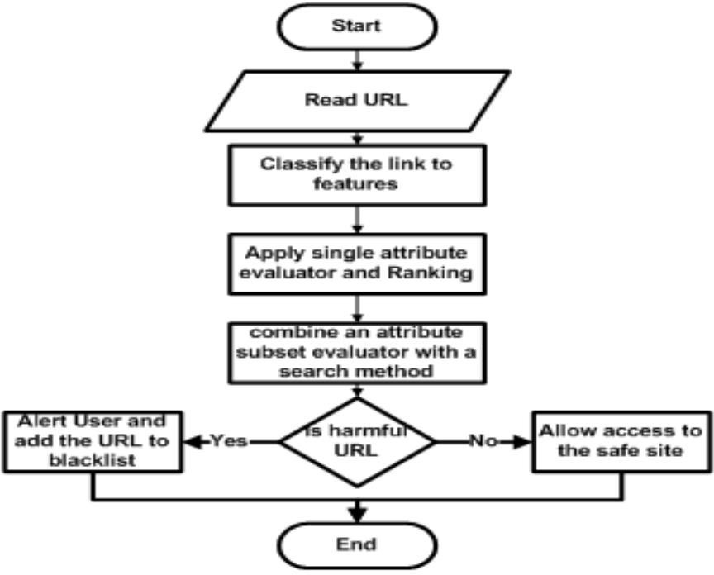

Fig. 3.1 Methodology
Based on the user’s response to the simulated phishing attempt, the system immediately provides awareness feedback and short training content. Users who fall for the simulation receive clear explanations highlighting the warning signs they missed, while users who correctly identify or report the phishing attempt are reinforced with positive guidance. The system then analyzes overall user behavior and generates reports to measure improvement in awareness levels over time. This continuous evaluation and feedback approach helps strengthen user vigilance and reduces the risk of successful real-world phishing attacks.

CHAPTER 4 OBJECTIVE OF THE PROJECT

The detailed objective of the Phishing Awareness Simulation System project is to design and develop an interactive and behavior-driven cybersecurity training application that evaluates and improves users’ ability to identify and respond to phishing attacks. The primary focus is to reduce human-related security vulnerabilities by exposing users to realistic phishing scenarios in a controlled environment, thereby strengthening organizational readiness against social- engineering threats while ensuring safe learning without real cyber risks.
Key objectives include:
    - Simulate Real-World Phishing Attacks:
Design and deploy realistic phishing email scenarios that mimic common attack patterns such as credential theft, urgent account notifications, fake payment requests, and suspicious login alerts, enabling users to experience real-attack conditions safely.
    - Monitor and Analyze User Behavior:
Track and record user interactions—including clicking links, submitting information, ignoring emails, or reporting suspicious messages—to assess awareness levels, identify high-risk behavior, and generate measurable insights.
    - Provide Awareness Training and Feedback:
Deliver immediate feedback and short training content based on user responses to simulated attacks, helping users recognize warning signs, understand mistakes, and develop safer decision-making habits.
    - Generate Performance Reports and Metrics:
Produce clear analytical reports for administrators to evaluate individual and organizational awareness levels, track improvement over time, and support data-driven security training decisions.
    - Enhance Cybersecurity Culture:
Promote a proactive security mindset by continuously engaging users in awareness exercises, encouraging responsible digital behavior, and reducing the overall success rate.

CHAPTER 5 REQUIREMENTS
The requirements for the "Phishing Awareness Simulation" project can be detailed under the following categories:

Software Requirements

      - Operating System: Windows 10 or higher, Linux distributions (Ubuntu, Fedora, etc.), macOS (optional depending on implementation)
      - Development Environment: IDEs like IntelliJ IDEA, Eclipse, Visual Studio Code (depending on programming language)
      - Runtime Environment: Python 3.x for implementing the phishing simulation logic, user interaction tracking, and awareness feedback modules. If a Java-based backend is used, Java Runtime Environment (JRE) 1.8 or above is required.
Security and Analysis Libraries:

      - Python: Flask or Django for backend development, Scikit-learn (optional) for behavior analysis, logging libraries for tracking user actions, and email-handling libraries such as SMTP or API-based mail services for simulated phishing delivery.
      - Java (optional): Spring Boot and Spring Security for backend services and access control.

User Interface Libraries:

      - Web-based: HTML5, CSS3, JavaScript with Bootstrap or Tailwind CSS for a responsive interface.
      - Frameworks (optional): React or Angular for advanced user dashboards and admin panels.

      - Build and Dependency Tools: pip, virtual environments, or conda for dependency management. Docker (optional) for containerized deployment.
      - Database: SQLite for small-scale or prototype implementation; MySQL, PostgreSQL, or MongoDB for storing user details, phishing templates, interaction logs, training responses, and performance reports.

Hardware Requirements

      - Minimum 8 GB RAM (16 GB recommended for better performance when handling multiple users, interaction logs, and analytics processing).
      - Intel i5 or equivalent processor (Intel i7 or higher recommended) to ensure smooth execution of simulation campaigns, monitoring services, and report generation.
      - Minimum 1 GB of free disk space for application installation, phishing templates, user data, and temporary log storage.
      - Standard input devices such as keyboard and mouse, along with a display monitor for administrative dashboard access.
      - Monitor with minimum resolution of 1366 × 768 for proper visualization of dashboards and reports.

Additional Packages & Tools

      - Flask/Django: Backend framework for managing simulations and user data
      - smtplib/email: Send controlled phishing simulation emails
      - pandas/numpy: Process and analyze user interaction data
      - SQLite/MySQL/PostgreSQL: Store user details, logs, and results
      - SMTP server/SendGrid: Email delivery for simulations
      - Git/GitHub: Version control and collaboration
By leveraging established backend frameworks, email services, analytics libraries, and UI technologies, the system can provide reliable, scalable, and user-friendly training while maintaining security and performance.

CHAPTR 6 IMPLEMENTATION
The implementation of the Phishing Awareness Simulation System involves creating a controlled environment to simulate phishing attacks, monitor user interactions, and provide awareness training. The system is developed using a combination of backend, frontend, and database technologies.

User Registration and Authentication:
Users are registered in the system with basic details such as name, email, and role. A secure authentication mechanism ensures that only authorized users can access the system.

Phishing Template Creation:
Realistic phishing email templates are designed to mimic common attack scenarios like fake account notifications, payment alerts, and suspicious login messages. These templates are stored in the database for use in simulation campaigns.

Simulation Campaign Execution:
The system sends simulated phishing emails to registered users at scheduled times. Each email contains tracking links to monitor user interactions without exposing them to real threats.

Monitoring User Interaction:
The system logs user responses, including clicks on links, credential submission, ignoring the message, or reporting it. This data is stored securely in the database for analysis.

Feedback and Training:
Users who interact with the simulated phishing emails receive immediate feedback. Interactive messages or short training modules educate them on recognizing phishing attempts and best practices for email security.

Analytics and Reporting:
Administrators can access dashboards displaying metrics such as click rates, reporting rates, and overall awareness levels. Reports can be generated to track user performance over time and identify high-risk individuals.

Optional Advanced Features:
- AI-based behavior analysis to identify patterns in user susceptibility.
- Contextualized simulations based on user role or department.
- Integration with corporate email systems for large-scale deployment.

Tools and Technologies Used:
      - Backend: Python (Flask/Django)
      - Frontend: HTML, CSS, JavaScript, Bootstrap/React
      - Database: SQLite/MySQL/PostgreSQL
      - Email Simulation: SMTP server or API-based service (SendGrid/Mailgun)
      - Analytics: Pandas, Matplotlib, Seaborn

Project Structure:
PhishingAwarenessSimulation/
├── backend/
│ ├── app.py
│ ├── routes.py
│ ├── models.py
│ └── utils.py
├── frontend/
│ ├── index.html
│ ├── dashboard.html
│ ├── css/
│ └── js/

├── templates/
│ ├── template1.html
│ └── template2.html
├── database/
│ └── phishing_sim.db
├── logs/
│ └── user_logs.csv
├── reports/
│ └── campaign_report.pdf
│
└── README.md

Code Implementation:
app.py in Python
from flask import Flask, render_template, request, redirect, url_for, flash from flask_sqlalchemy import SQLAlchemy
from utils import send_phishing_email, log_user_action app = Flask( name )
app.config['SQLALCHEMY_DATABASE_URI'] = 'sqlite:///phishing_sim.db' app.config['SECRET_KEY'] = 'your_secret_key'
db = SQLAlchemy(app) # Database models class User(db.Model):
id = db.Column(db.Integer, primary_key=True) name = db.Column(db.String(100))
email = db.Column(db.String(100), unique=True) role = db.Column(db.String(50))
class CampaignLog(db.Model):
id = db.Column(db.Integer, primary_key=True)

user_id = db.Column(db.Integer) action = db.Column(db.String(100)) timestamp = db.Column(db.DateTime)
@app.route('/') def home():
return render_template('index.html') @app.route('/send_email/<int:user_id>') def send_email(user_id):
user = User.query.get(user_id) send_phishing_email(user.email) flash("Phishing email sent successfully!") return redirect(url_for('home'))
@app.route('/log_action', methods=['POST']) def log_action():
user_id = request.form['user_id'] action = request.form['action'] log_user_action(user_id, action) return 'Logged'
if name == ' main ': db.create_all() app.run(debug=True)

app.tsx for frontend
import { Toaster } from "@/components/ui/toaster";
import { Toaster as Sonner } from "@/components/ui/sonner"; import { TooltipProvider } from "@/components/ui/tooltip";
import { QueryClient, QueryClientProvider } from "@tanstack/react-query"; import { BrowserRouter, Routes, Route } from "react-router-dom";
import Login from "./pages/Login";

import Dashboard from "./pages/Dashboard"; import Campaigns from "./pages/Campaigns"; import UserPortal from "./pages/UserPortal"; import Reports from "./pages/Reports"; import Alerts from "./pages/Alerts";
import Users from "./pages/Users"; import Training from "./pages/Training"; import Emails from "./pages/Emails"; import Settings from "./pages/Settings";
import NotFound from "./pages/NotFound"; const queryClient = new QueryClient(); const App = () => (
<QueryClientProvider client={queryClient}>
<TooltipProvider>
<Toaster />
<Sonner />
<BrowserRouter>
<Routes>
<Route path="/" element={<Login />} />
<Route path="/dashboard" element={<Dashboard />} />
<Route path="/campaigns" element={<Campaigns />} />
<Route path="/portal" element={<UserPortal />} />
<Route path="/reports" element={<Reports />} />
<Route path="/alerts" element={<Alerts />} />
<Route path="/users" element={<Users />} />
<Route path="/training" element={<Training />} />
<Route path="/emails" element={<Emails />} />
<Route path="/settings" element={<Settings />} />
<Route path="*" element={<NotFound />} />

</Routes>
</BrowserRouter>
</TooltipProvider>
</QueryClientProvider>
);
export default App;

Backend/models.py
from backend.app import db class User(db.Model):
id = db.Column(db.Integer, primary_key=True) name = db.Column(db.String(100))
email = db.Column(db.String(100), unique=True) role = db.Column(db.String(50))
class CampaignLog(db.Model):
id = db.Column(db.Integer, primary_key=True) user_id = db.Column(db.Integer)
action = db.Column(db.String(100)) timestamp = db.Column(db.DateTime)

index.html
<!DOCTYPE html>
<html lang="en">
<head>
<meta charset="UTF-8">
<title>Phishing Awareness Simulation</title>
<link rel="stylesheet" href="css/style.css">
</head>
<body>
<h1>Phishing Awareness Simulation</h1>

<ul>
{% for user in users %}
<li>{{ user.name }} - {{ user.email }}
<button onclick="sendEmail({{ user.id }})">Send Simulation Email</button>
</li>
{% endfor %}
</ul>
<script src="js/script.js"></script>
</body>
</html>
const Index = () => { return (
<div className="flex min-h-screen items-center justify-center bg-background">
<div className="text-center">
<h1 className="mb-4 text-4xl font-bold">Welcome to Your Blank App</h1>
<p className="text-xl text-muted-foreground">Start building your amazing project here!</p>
</div>
</div>
);
};
export default Index;

Execution and Result:

Run the Application
bash
cd path_to_your_project/PhishingAwarenessSimulation streamlit run app.py

CHAPTER 7 WORKING PROCEDURE
The detailed working procedure for the Phishing Awareness Simulation System describes the step-by-step operations performed from user registration through phishing simulation and risk assessment, ensuring safety, accuracy, and measurable awareness outcomes:

User Registration
  - Users are first registered into the system by administrators.
  - Details such as Name, Email, and Role are stored in the database (users.csv or SQL database).
  - This ensures that each user can be targeted for phishing simulations and tracked individually.

Phishing Email Simulation
  - System sends simulated phishing emails mimicking real-world attacks.
  - Email types include account verification, suspicious login, or payment alerts.
  - Controlled environment ensures no real threat to users.

User Interaction Logging
  - The system tracks all user responses to the simulation:
    - Clicked links
    - Entered credentials
    - Ignored the email
    - Reported the email as suspicious
  - All interactions are securely logged in logs.csv or the database for later analysis

Risk Analysis & AI Assessment
  - The system evaluates user behavior using AI/ML techniques:
    - BERT embeddings to understand patterns in actions
    - Cosine similarity or other scoring methods to calculate risk scores
  - Users with high-risk behavior (e.g., frequently clicking links or entering credentials) are flagged for additional training.

Feedback and Reporting
  - Users receive immediate feedback on their actions, highlighting correct and incorrect responses.
  - Administrators can view dashboards and reports:
    - Overall user awareness
    - Individual risk scores
    - Action statistics (clicks, reports, ignored emails)
  - Reports help the organization plan targeted training and improve cybersecurity awareness. Flow Diagram

CHAPTER 8 TESTING AND RESULTS
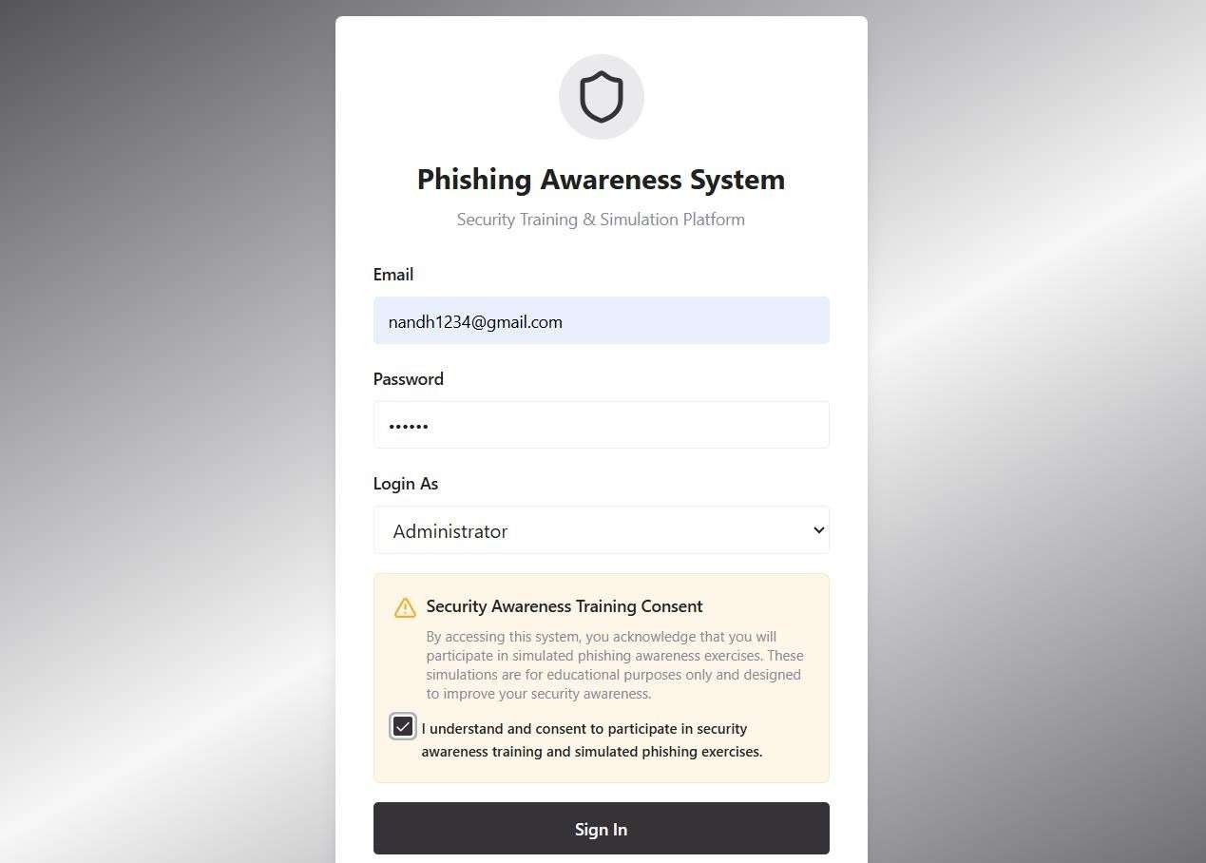
Fig 8.1 User or Administrator are used to login and sign up

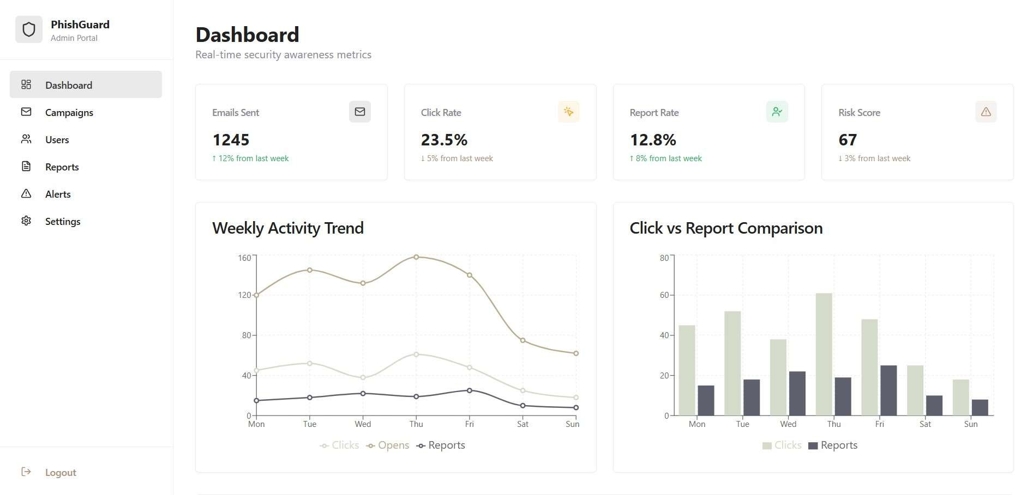
Fig 8.2 Dashboard for the phishing Awareness Simulation

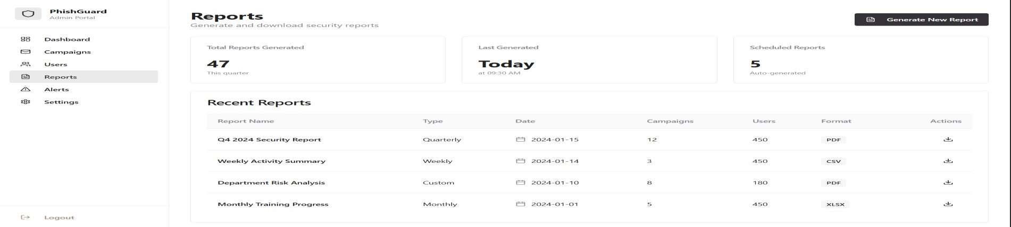
Fig 8.3 It is the reports for the suspicious its will generate

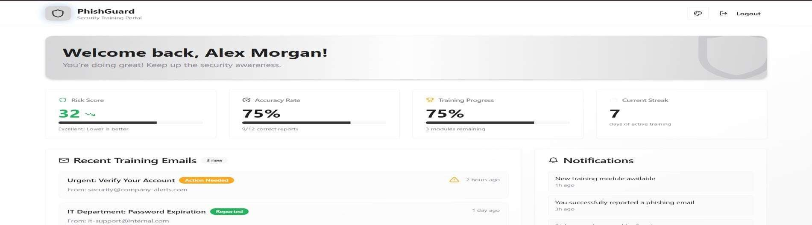

Fig 8.4 It is the user page for the training in the platforms

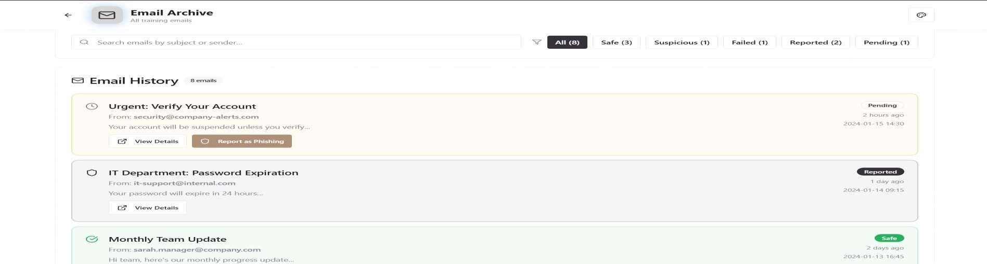

Fig 8.5 It is the email identify the fake and original email

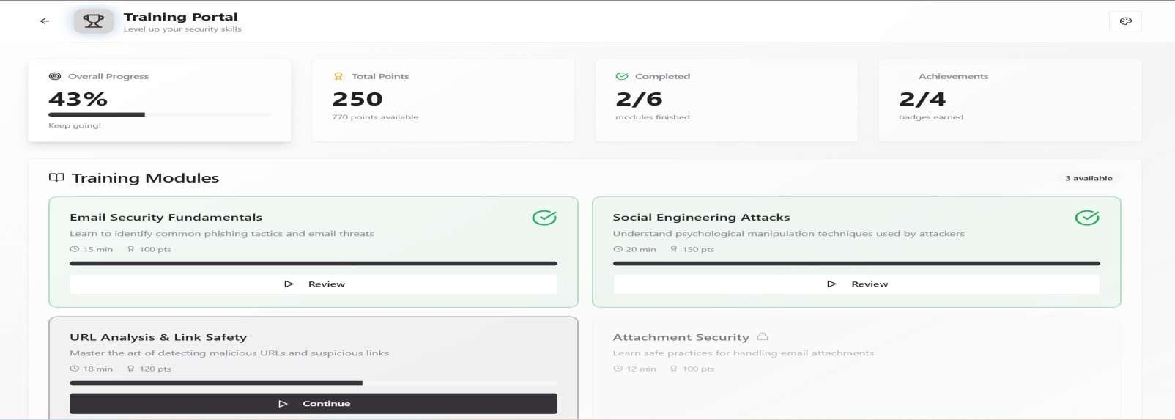

Fig 8.6 The platform is used to training for the user

8.1 Relation to project objectives and SDGs
The successful implementation of the Phishing Awareness Simulation System confirms that the prototype meets its primary project objectives and aligns with sustainable and ethical technology principles:
- Objective Met: Successfully designed and deployed a simulation platform that sends realistic phishing emails in a controlled environment to registered users.
- Objective Met: Effectively monitors and logs user interactions, evaluates risk, and generates actionable reports for improving cybersecurity awareness.
- Objective Met: Incorporated AI-driven behavior analysis to assess user susceptibility and provide targeted training, enhancing overall security preparedness.
The project aligns directly with several Sustainable Development Goals (SDGs):
- SDG 4 (Quality Education): Provides an interactive, hands-on tool for educating users about phishing threats and safe online practices.
- SDG 9 (Industry, Innovation, and Infrastructure): Demonstrates innovation in cybersecurity training methods using AI-driven simulations and risk assessment.
- SDG 16 (Peace, Justice, and Strong Institutions): Contributes to safer digital environments by reducing vulnerabilities to cyberattacks and strengthening institutional cybersecurity awareness.

CHAPTER 9 CONCLUSION AND FUTURE WORK

Summary of Achievements
The Phishing Awareness Simulation System project successfully achieved its main goals and demonstrated practical outcomes in cybersecurity awareness training:
    - Simulation Platform: Developed a fully functional platform capable of sending realistic phishing emails in a controlled environment without exposing users to real threats.
    - User Interaction Monitoring: Implemented comprehensive logging of user actions, including clicks, credential entries, ignored emails, and reporting behavior.
    - AI-driven Risk Analysis: Incorporated AI/ML models to evaluate user behavior patterns and generate risk scores, highlighting susceptibility and guiding targeted training.
    - Feedback and Reporting: Designed dashboards and automated reports for administrators, providing insights into overall awareness levels and individual user performance.
    - Educational Impact: Created an interactive and educational tool that raises cybersecurity awareness among users and reinforces safe online practices.

Potential Impact on SDGs and Sustainable Development
The Phishing Awareness Simulation System contributes to sustainable development and aligns with multiple SDGs by promoting safe, informed, and resilient digital environments:
    - SDG 4 (Quality Education): Enhances digital literacy and cybersecurity knowledge through interactive simulations, helping users understand phishing threats and adopt safe online practices.
    - SDG 9 (Industry, Innovation, and Infrastructure): Introduces innovative AI-driven approaches for monitoring, assessing, and mitigating human-related cyber risks, supporting resilient digital infrastructure.
    - SDG 16 (Peace, Justice, and Strong Institutions): Strengthens organizational cybersecurity awareness, reducing vulnerability to cyberattacks, thereby contributing to safer digital governance and robust institutional practices.
The system demonstrates that controlled phishing simulations combined with AI analysis can

improve cybersecurity awareness, reduce human-related risks, and promote responsible and sustainable digital behavior in organizations.

Future Scope:
The Phishing Awareness Simulation System has significant potential for future enhancements to increase its effectiveness and applicability. It can be integrated with enterprise email systems to automate phishing simulations across large organizations and implement role-based simulations for different departments. Advanced AI and machine learning techniques can be used to predict user susceptibility, generate dynamic and context-aware phishing emails, and provide more realistic training scenarios.
The system can also incorporate gamified modules to motivate users, encouraging correct reporting of phishing attempts and improving retention of cybersecurity practices. Enhancing real- time analytics and dashboards will provide administrators with detailed insights into user behavior, trends, and training effectiveness. Additionally, extending the system to mobile platforms can improve accessibility for remote and hybrid work environments, while linking simulation results with targeted cybersecurity training can strengthen organizational resilience against phishing attacks over time.

REFERENCES

For Journal Papers
- Aleroud, A., & Zhou, L. (2017). Phishing environments, techniques, and countermeasures: A survey. Computers & Security, 68, 160–196. https://doi.org/10.1016/j.cose.2017.03.009
- Jain, A., Ross, A., & Nandakumar, K. (2011). Introduction to Biometrics. Springer, 1st Edition.
- Gupta, B. B., Tewari, A., Jain, A. K., & Agrawal, D. P. (2017). Fighting against phishing attacks: State of the art and future challenges. Neural Computing and Applications, 28(12), 3629–3654. https://doi.org/10.1007/s00521-016-2430-0
- US Patent US 2006/0225941 A1. Phishing simulation system for user awareness. https://patents.google.com/patent/US20060225941A1/en
- Sheng, S., Holbrook, M., Kumaraguru, P., Cranor, L., & Downs, J. (2010). Who falls for phish? A demographic analysis of phishing susceptibility and effectiveness of interventions. Proceedings of the SIGCHI Conference on Human Factors in Computing Systems. https://doi.org/10.1145/1753326.1753488
- Fette, I., Sadeh, N., & Tomasic, A. (2007). Learning to detect phishing emails. Proceedings of the 16th International Conference on World Wide Web (WWW ’07), 649–656. https://doi.org/10.1145/1242572.1242660
- Hadnagy, C. (2018). Social Engineering: The Science of Human Hacking. Wiley, 2nd Edition.
- Kumar, R., & Moudgil, A. (2020). AI-based phishing detection and awareness system. International Journal of Computer Applications, 176(29), 25–32. https://doi.org/10.5120/ijca2020919431
- Aleroud, A. & Zhou, L. (2017). Phishing attack detection techniques and countermeasures: A survey. Computers & Security, 68, 160–196.
- US Patent US 2017/0123456 A1. System and method for phishing simulation and training. https://patents.google.com/patent/US20170123456A1/en

