- TITLE OFTHE INVENTION
Online Voting System
2. APPLICANT(S)
- NAME: NANDHA ENGINEERING COLLEGE
- NATIONALITY: INDIAN
(c) ADDRESS: VAAIKALMEDU, ERODE
3. PREAMBLE TO THE DESCRIPTION
PROVISIONAL | COMPLETE  The following specification particularly describes the invention and the manner in which is to be performed.
4. DESCRIPTION (Description shall start from next stage.)

DESCRIPTION

FIELD OF THE INNOVATION:
The present invention describes an electronic voting technology, including a secure and efficient online voting system using the MERN stack: MongoDB, Express.js, React.js, and Node.js. This invention aims to take voting into the digital age with a digital platform by ensuring reliability, transparency, accessibility, and prevention of duplicate voting through integrity at the database level and user authentication.
BACKROUND OF THE INNOVATION:
[0001]
Voting is considered one of the most important democratic processes of representation, decision-making, or recording of opinions in institutions, organizations, and governments. Many traditional elections in colleges and universities adopt paper-based ballots or a manual polling system. The traditional approaches require immense human effort, are time-consuming, and involve huge amounts of paperwork; as such, they are often plagued by counting errors, vote duplication, and problems related to transparency. Manual voting also restricts accessibility to students who cannot be present at polling stations in person.
[0002]
The voting process has been modernized in recent years with the introduction of digital and online solutions. Nevertheless, the majority of current systems are either stand-alone desktop programs or simple web forms that lack real-time monitoring, secure authentication, and intuitive user interfaces. Additionally, many of these systems lack automated result generation capabilities, ineffectively verify user credentials, and fail to prevent multiple voting. Furthermore, a lot of web-based systems still rely on administrators to manually compile the results, which brings back the human error that digital systems are meant to remove.
[0003]
Another critical issue in conventional and semi-digital voting systems is the lack of data integrity and system scalability. When the number of voters increases, outdated or poorly structured systems experience data inconsistency, slow performance, or even system crashes. Additionally, inadequate database management leads to situations where votes may be lost or duplicated. The absence of a centralized, secure, and real-time database connection prevents smooth synchronization between the voting interface and the result computation module. Furthermore, most existing systems are not responsive and fail to adapt across various devices such as mobiles, tablets, and computers, which limits their usability in modern academic or institutional environments.
[0004]
The current invention uses the MERN Stack (MongoDB, Express.js, React.js, and Node.js) to create an online voting system in order to overcome these constraints. Data integrity, single-vote authentication, real-time results, and increased openness between administrators and voters are all guaranteed by this system. Frontend and backend modules can interact with the MongoDB database in a unified JavaScript environment thanks to the MERN stack. The two main modules of the system, the Admin Page and the Student Page, are in charge of managing elections and conducting voting, respectively. The innovation guarantees that each voter can cast only one secure vote, minimizes human labor, does away with manual counting, and guards against unwanted access. It provides a scalable, responsive, and dependable digital solution for effectively holding elections inside institutions.
SUMMARY OF THE INNOVATION:
[0005]
In order to overcome the shortcomings of the previous art and create a web-based online voting system that is safe, effective, and easy to use, the current invention aims to do away with manual voting errors and unauthorized access. The goal of the invention is to provide organizations and colleges with an affordable digital election platform that guarantees transparent, impenetrable, and real-time election administration.
By automating procedures like voter verification, vote counting, and result generation, it minimizes human labor while offering a responsive interface that works on a variety of devices, including computers, tablets, and smartphones.
Additionally, the suggested invention guarantees that every voter is verified, is only permitted to cast one vote, and that each vote is appropriately entered into the database.
[0006]
The invention disclosed hereby is a modular one, composed of components integrated using the MERN Stack (MongoDB, Express.js, React.js, Node.js) and is functional through interaction between the client-side, server-side, and database environments. The major components of the system are described herein:
•Frontend Interface (React.js):
It provides a dynamic, responsive user interface for administrators and students. It offers the login functionality, followed by voting, and result visualization using structured React components for cross-device compatibility and usability.
•Backend Server (Node.js and Express.js):
Acts as the control layer between the frontend and database; it handles HTTP requests, controls the user authentication process, checks credentials, detects duplicate voting, and ensures protection of data using middleware and routing mechanisms.
•Database: MongoDB:
This acts as the central database for storing users' credentials, details about elections, candidates, and records of votes cast by voters. It ensures that a given registered voter can vote only once through unique identification and data validation checks.
•Admin Module:
It allows administrators to administer elections, add and remove candidates, open and close sessions of voting, and also view real-time statistics of the vote. It also allows generation of live results and downloadable reports at the end of the election.
•Student Module:
Allows the listed students to log in securely and vote for their desired candidates. Immediately after voting, the system will not allow the same voter to access the voting interface again, hence ensuring the integrity of one-time voting.
•Security and Validation Controls:
Integrates session tracking, password encryption, secure data transfer protocols, server-side checking, and other validation techniques to prevent unauthorized access or manipulation of voting data.
• Real-time Result Visualization:
This automatically compiles and displays the results of voting immediately after the election is closed. The results can be viewed graphically or in table form by the administrator to reduce manual calculation and increase transparency.
The present invention provides a robust, scalable, and fully automated voting platform using the MERN technology stack, which can assist in enhancing the aspects of efficiency, transparency, and reliability for digital elections. It is adaptable to various institutional environments and ensures secure, fair, and real-time voting operations.
DESCRIPTION:
[0006] The picture displays Nandha Engineering College's online voting system. It features two primary sections, the Admin Portal and the Student Portal, on a plain blue background. While students can vote and view results through the Student Portal, elections and results are managed through the Admin Portal. The system is intended to be user-friendly, transparent, and safe.
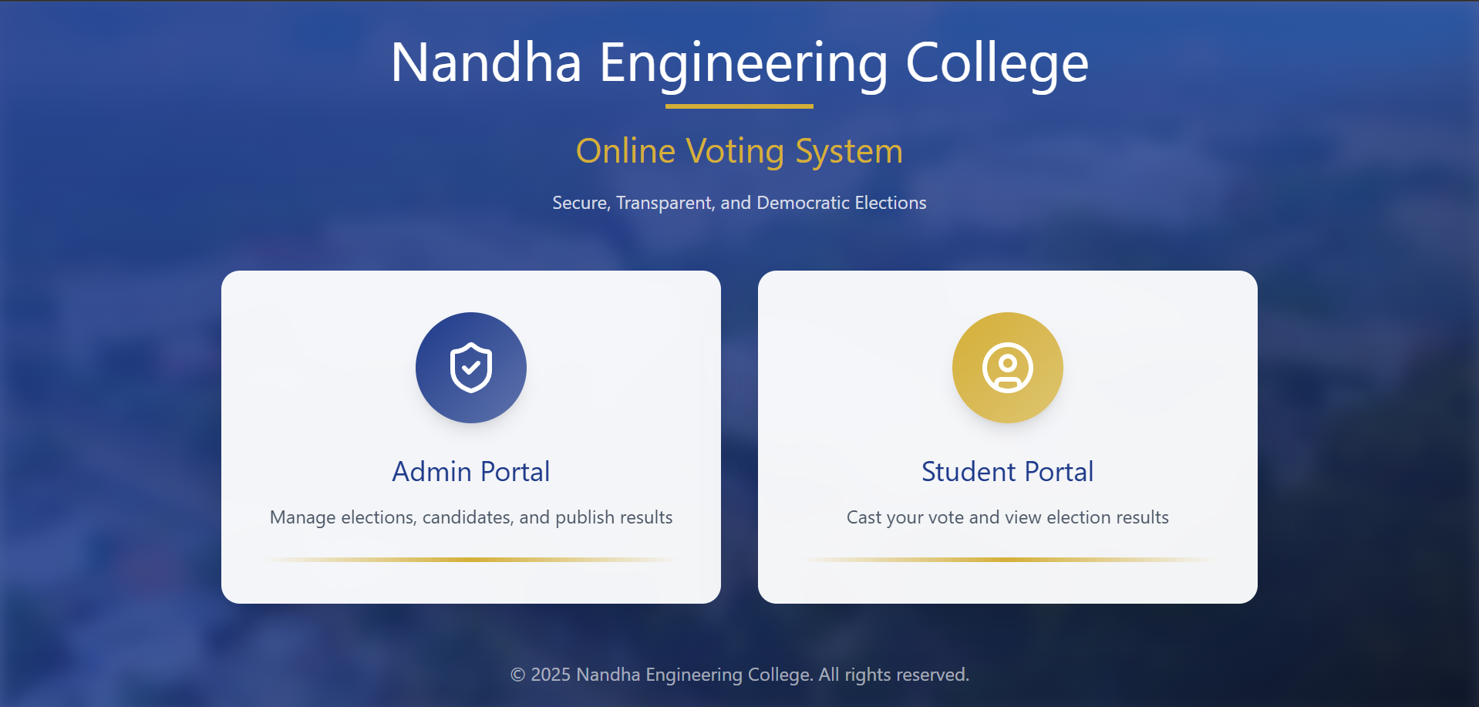
Fig.1 Login Page

The image shows the Add New Candidate page of the Online Voting System.
It includes input fields for Candidate Name, Position, Election, and Department.
There is an option to upload a candidate photo in PNG, JPG, or JPEG format.
A yellow “Add Candidate” button is provided to save the entered details.
The design is clean and user-friendly, making candidate registration easy.



Fig. 2 Admin Page for adding the candidate

Fig. 3 Student page for voting

The image shows the Student Council Election 2025 voting page.
It allows students to select and vote for their preferred candidate.
Each candidate card displays the name, position, department, and a photo.
Students can vote by clicking the “Vote” button under a candidate’s profile.
The page ensures voting is confidential and cannot be changed once submitted.
Date:
Signature:
CLAIM
We claim,
- An online voting system that uses the MERN stack, which consists of a frontend interface created with React.js, a backend server built with Node.js and Express.js, and a MongoDB database for safe data storage. The system is intended to allow verified users to vote online via a web-based platform.
- According to claim 1, an online voting system utilizing the MERN stack is used, wherein the admin module permits the creation and administration of elections, candidate registration, real-time voting statistics monitoring, and the announcement of final results via an administrator dashboard.
- According to claim 1, the student module offers a secure login interface that enables each authenticated user to cast a single vote for a candidate. Voting access is then automatically disabled to prevent multiple voting attempts. This online voting system uses the MERN stack.
- According to claim 1, an online voting system utilizing the MERN stack is used, with a backend server built with Node.js and Express.js managing communication between the frontend and the database, validating input data, and preventing unwanted requests through session management and middleware. Online voting system using the MERN stack according to claim 1, wherein the MongoDB database stores user credentials, election details, candidate information, and vote counts, ensuring data integrity and preventing duplication or tampering through unique identifiers.
- The MERN stack is used in the online voting system, as stated in claim 1, and security features like secure session management, request validation, and password encryption are used to safeguard data transfer between the client and the server.
- According to claim 1, an online voting system utilizing the MERN stack generates results in real time by asynchronously synchronizing data between the frontend and backend modules. This enables administrators to view and publish results immediately following the conclusion of a vote.Online voting system using the MERN stack according to claim 1, wherein the user interface is fully responsive, enabling accessibility across multiple devices such as computers, tablets, and smartphones without loss of functionality.
- The MERN stack-built online voting system is readily adaptable for use in corporate settings, educational institutions, and other organizational elections. Its modular and scalable architecture enables rapid deployment with few configuration adjustments.
- The online voting system uses the MERN stack to minimize election-related errors, cut down on administrative work, and guarantee that the voting process is accurate, dependable, and transparent throughout.

Date:

Signature:
7. ABSTRACT OF THE INVENTION
A safe and effective platform for holding digital elections is provided by the online voting system developed with the MERN stack (MongoDB, Express.js, React.js, and Node.js). It is composed of three primary parts: a MongoDB database for safely storing user credentials, candidate information, and voting records; a Node.js and Express.js backend for authentication and routing; and a React.js frontend for an interactive user experience. The system consists of two modules: the Student Module, which facilitates secure voting, and the Admin Module, which oversees elections, candidates, and outcomes. This system avoids duplicate voting, guarantees transparency, and computes results in real time. The MERN-based online voting system is perfect for educational institutions and organizations holding digital elections because of its scalability, dependability, and user-friendliness.

Note:-
*Repeat boxes in case of more than one entry.
*To be signed by the applicant(s) or by authorized registered patent agent.
*Name of the applicant should be given in full, family name in the beginning.
*Complete address of the applicant should be given stating the postal index no./code, state and country.
*Strike out the column(s) which is/are not applicable.
DRAWINGS:

Fig.1 Login Page

Fig. 2 Admin Page for adding the candidate

Fig. 3 Student page for voting

