CLIMATEPRED AI
An Explainable Machine Learning Framework for Urban Heat Prediction, Climate Trend Analysis and Climate Risk Intelligence
21CEO310T – Global Warming and Climate Change | LLT / CLA-2 Working Model | Technical Report
Balasudhan R (RA2411003012164) · Deepshika (RA2411003012122) · SRM Institute of Science and Technology, Kattankulathur · November 2026

1. Introduction

Problem statement
Urbanisation, loss of vegetation and a warming climate are making Indian cities hotter, and heat is now one of the deadliest climate hazards in Tamil Nadu. Ordinary weather apps report what the temperature will be, but not why, where the risk is concentrated, how the pattern is changing, or what could reduce it. This project builds a software-only, explainable machine-learning framework that answers those questions for six Tamil Nadu cities: Chennai, Coimbatore, Madurai, Tiruchirappalli, Salem and Tirunelveli.

Scientific background
Near-surface air temperature is governed by the surface energy balance: incoming shortwave solar radiation is partitioned into sensible heat (warming the air), latent heat (evaporation, which depends on moisture and vegetation) and storage in surfaces. Cloud cover reduces incoming radiation; humidity and rainfall increase latent cooling; wind removes heat by advection; and the thermal inertia of the land means today's temperature strongly conditions tomorrow's. Urban heat islands arise when impervious, low-albedo surfaces and reduced vegetation shift this balance towards sensible heat. A warming climate raises the baseline on which these local effects sit, so the frequency of extreme hot days rises faster than the mean.

Research gap and objectives
Most student climate projects either forecast a single temperature series or show a dashboard of past data. Our contribution is the integration of (1) leakage-free next-day temperature prediction across multiple cities, (2) a documented heat-risk classification, (3) SHAP explanations of every prediction, (4) an honest unseen-city generalisation test and (5) a what-if Climate Intervention Simulator, in one reproducible pipeline with a working web interface. Objectives: predict next-day maximum temperature; identify high-heat periods and locations; quantify how humidity, radiation, cloud, wind and rainfall relate to temperature; compare five ML algorithms with MAE, MSE and R²; and explain predictions and evaluate hypothetical cooling scenarios.

Dataset
NASA POWER Daily API (MERRA-2 reanalysis + CERES satellite radiation), 1 Jan 2015 – 31 Oct 2025, 3 957 days × 6 cities = 23 742 records, 9 parameters: T2M, T2M_MAX, T2M_MIN (°C), RH2M (%), PRECTOTCORR (mm/day), WS2M (m/s), ALLSKY_SFC_SW_DWN (MJ/m²/day), CLOUD_AMT (%), PS (kPa). The data are real, public and re-downloaded by the notebook itself. We note that reanalysis on a ~50 km grid smooths neighbourhood-scale urban heat islands and is not a station measurement.

2. Methodology

System architecture
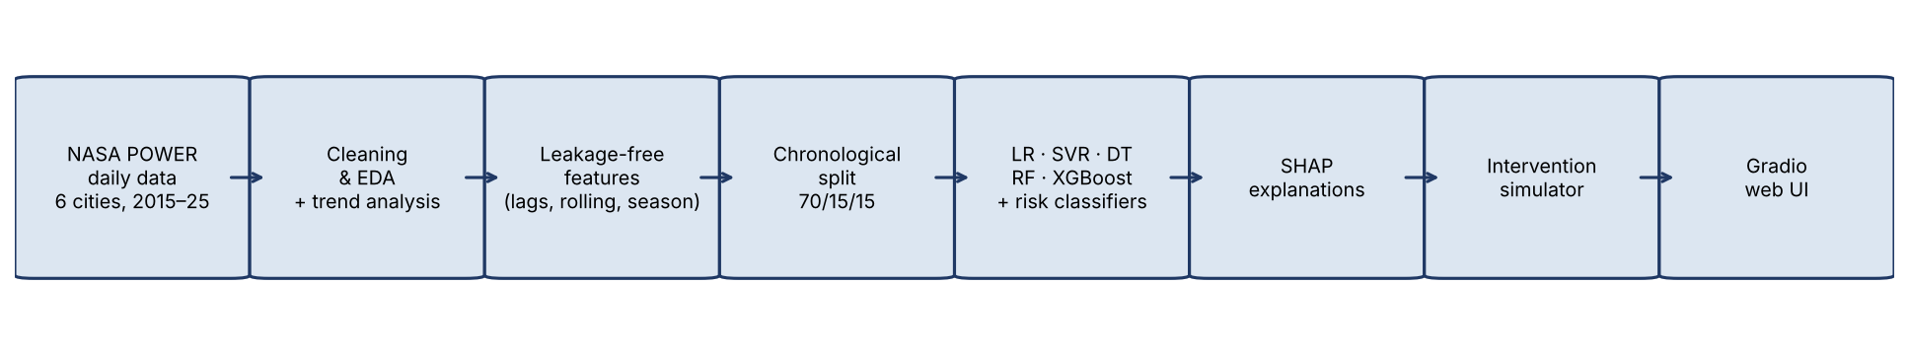
Figure 1. Pipeline: NASA POWER data → cleaning & EDA → leakage-free features → chronological split → 6 regressors + 3 classifiers → SHAP → scenario simulator → Gradio web UI.

Data preprocessing and EDA
The NASA CSV header block was parsed, YEAR + day-of-year converted to dates, the -999 sentinel mapped to missing (none present after download), duplicates checked (none), and a physical sanity check applied (Tmax ≥ Tmean ≥ Tmin). Outliers were detected with the IQR rule per city but deliberately kept: extreme days are the physically real events the project studies. EDA showed a strong seasonal cycle peaking in April–May (coastal Chennai peaks later and is more humid), T2M_MAX correlating positively with solar radiation (r ≈ +0.46) and negatively with humidity (r ≈ −0.60), cloud (−0.43) and rainfall (−0.39). A ten-year trend analysis (2015–2024) found the annual mean roughly flat in this short window while the number of hot days (Tmax ≥ 38 °C) rose in Chennai, Coimbatore and Salem (+4 to +8 days per decade) — extremes shifting faster than averages, as climate science predicts, though ten years is too short to establish a climate normal.
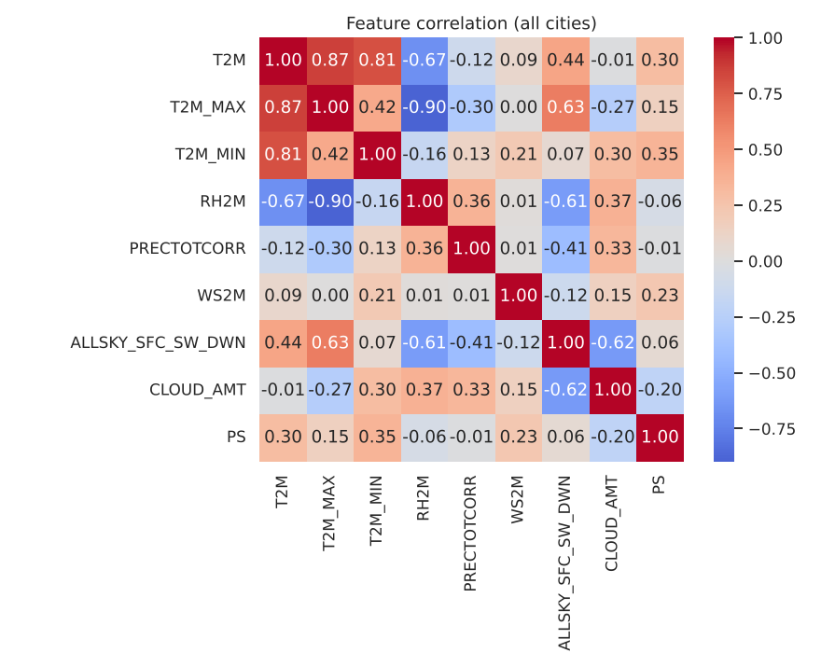
Figure 2. Feature correlation heatmap (all cities).

Feature engineering and data split
Task: predict tomorrow's maximum temperature from information available today. Features (24): today's nine observations, Tmax lags (1, 2, 3, 7 days), 7- and 30-day rolling means and 7-day rolling std, yesterday's Tmin, 3-day rainfall sum, diurnal range, cyclic day-of-year, month, latitude and longitude. Tomorrow's humidity, rain or radiation are never used, since they are unknown at prediction time. The split is strictly chronological: train 2015-02 → 2022-08 (70 %), validation 2022-08 → 2024-03 (15 %), test 2024-03 → 2025-10 (15 %). Model selection and hyper-parameter tuning used only the validation set; the test set was touched once. Generalisation was additionally checked with 5-fold expanding-window TimeSeriesSplit and a leave-one-city-out experiment.

ML algorithms
Regression (same features, target and split for all): Persistence baseline (tomorrow = today), Linear Regression, Ridge, Support Vector Regression (RBF kernel, C = 10), Decision Tree (depth 8), Random Forest (300 trees), XGBoost (600 rounds; depth and learning rate tuned on validation → depth 5, lr 0.02). Classification of heat risk: per-city percentile thresholds computed on training data only — Normal (< P90), Elevated (P90–P97.5), Extreme (≥ P97.5, ≈ the hottest nine days a year) — with Logistic Regression, Random Forest and XGBoost classifiers. Explainability: SHAP TreeExplainer on the final XGBoost model. Reproducibility: fixed seed 42, library versions printed, saved joblib models, metrics CSVs and figures, requirements.txt.

3. Results

Model comparison (chronological test period, Mar 2024 – Oct 2025)
Model | MAE (°C) | MSE | RMSE (°C) | R²
Persistence (baseline) | 1.137 | 2.389 | 1.546 | 0.827
Linear Regression | 1.064 | 1.919 | 1.385 | 0.861
SVR (RBF) | 1.009 | 1.757 | 1.326 | 0.873
Decision Tree | 1.078 | 2.002 | 1.415 | 0.855
Random Forest | 1.014 | 1.773 | 1.332 | 0.872
XGBoost (default) | 1.016 | 1.758 | 1.326 | 0.873
XGBoost (tuned, final model) | 1.002 | 1.720 | 1.312 | 0.876

Every learned model beats the naïve persistence forecast, and the non-linear models (SVR, Random Forest, XGBoost) beat the linear ones. Gains over persistence are modest (~12 % lower MAE) because daily temperature is strongly autocorrelated; this is the honest, expected behaviour for this task. Five-fold time-series CV confirms the ranking (MAE: LR 0.997 ± 0.041, RF 0.965 ± 0.043, XGB 0.957 ± 0.042). The train/test gap is small for XGBoost (0.76 vs 1.02 °C) and largest for Random Forest (0.55 vs 1.01 °C), indicating mild over-fitting that regularisation keeps in check. Per-city test MAE ranges from 0.79 °C (Chennai) to 1.14 °C (Tiruchirappalli).
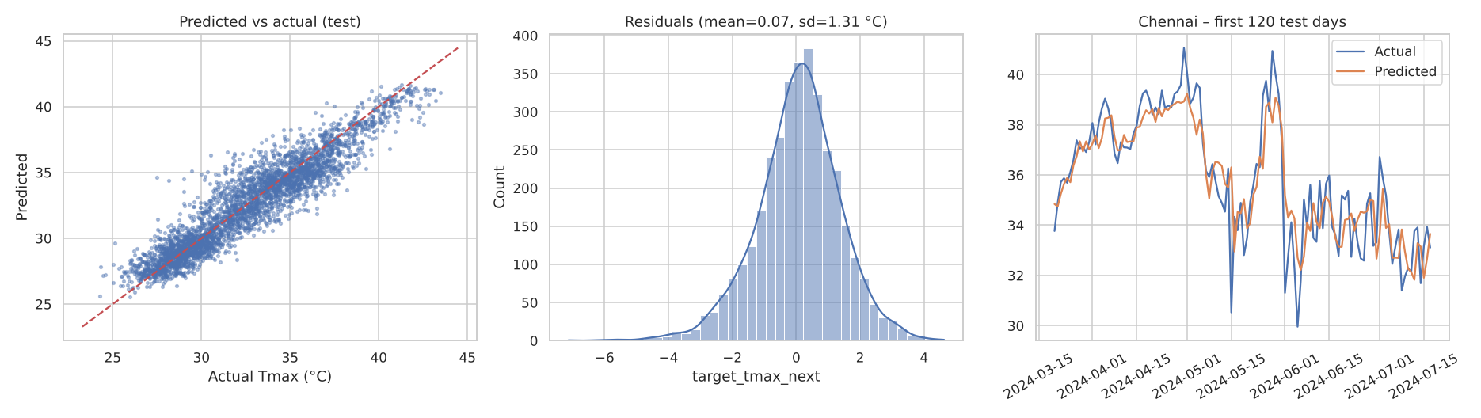
Figure 3. Tuned XGBoost on the test period: predicted vs actual, residual distribution (mean ≈ 0, sd ≈ 1.3 °C), and a 120-day forecast strip for Chennai.

Generalisation to unseen cities
Held-out city | XGBoost MAE | R² | Persistence MAE
Chennai | 0.833 | 0.887 | 0.866
Coimbatore | 0.901 | 0.891 | 1.029
Madurai | 1.207 | 0.793 | 1.308
Tiruchirappalli | 1.171 | 0.821 | 1.291
Salem | 1.097 | 0.837 | 1.208
Tirunelveli | 1.015 | 0.802 | 1.117

Trained on five cities and tested on the sixth, the model still beats persistence everywhere, so it learned transferable climate relationships rather than city identity.

Heat-risk classification (test)
Classifier | Accuracy | Precision (macro) | Recall (macro) | F1 (macro) | ROC-AUC (OvR)
Logistic Regression | 0.887 | 0.627 | 0.794 | 0.682 | 0.960
Random Forest | 0.918 | 0.734 | 0.777 | 0.723 | 0.976
XGBoost | 0.949 | 0.784 | 0.684 | 0.720 | 0.980

Accuracy is high and ROC-AUC ≈ 0.98, but macro-recall shows that the rare Extreme class is the hardest to catch — the confusion matrices in the notebook report this honestly. Logistic Regression with class balancing has the best recall for extremes, XGBoost the best overall accuracy; for a public-health use, recall on Extreme would be the metric to optimise.

Explainability (SHAP)
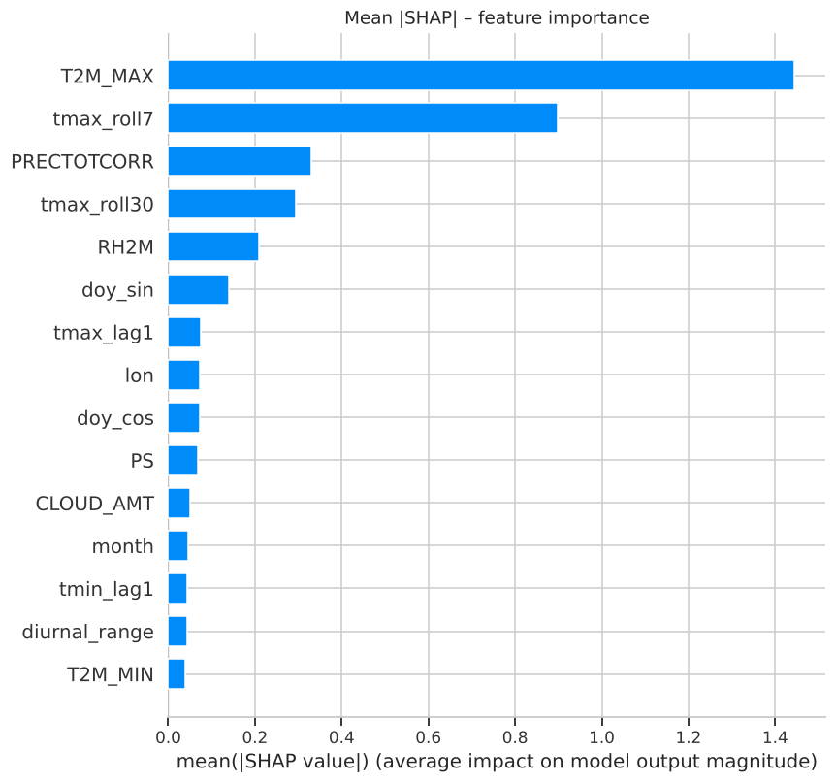
Figure 4. Mean |SHAP| feature importance, final XGBoost model.
Today's Tmax and the 7-/30-day rolling means dominate (thermal persistence), followed by rainfall and humidity (latent cooling), seasonality (day-of-year) and solar radiation/cloud cover. Dependence plots show high humidity and high rainfall push predictions down and high solar radiation pushes them up — consistent with the surface energy balance described in Section 1. For the hottest test day (Salem, 17 Apr 2024, actual 41.3 °C, predicted 41.7 °C) the waterfall plot attributes +4 °C to the hot preceding week and dry air.

Climate Intervention Simulator
For Chennai's hottest test day (30 Apr 2024, baseline prediction 38.9 °C, Extreme) the model responds to a −15 % solar-radiation scenario (shade/albedo) with −0.16 °C, to +10 pp humidity with −10 % radiation (greening/water bodies) with −0.31 °C, to +1.5 m/s wind with −0.15 °C and to the combined scenario with −0.32 °C; averaged over the whole test period the greening scenario lowers predicted Tmax by 0.33 °C. The effects are small and should be read as the model's learned sensitivity, not a causal estimate: the inputs are grid-scale weather, so neighbourhood interventions are only proxied. A +3 °C stress test raises the prediction by +0.6 °C on that day and +1.2 °C on average, showing the model's damped response to single-day anomalies.

Working demonstration
A Gradio web application (last notebook cell, and standalone app.py) loads the trained models: the user selects a city and date, receives the next-day Tmax, heat-risk category and the top SHAP drivers, and moves sliders for radiation, cloud, humidity and wind to compare baseline and scenario predictions live. The displayed metrics come from the actual test experiment.

4. Environmental relevance, limitations and conclusion
The framework turns public climate data into actionable heat intelligence: it shows which cities and weeks are at risk, why (dry, clear, hot spells), and how the predicted heat responds to the physical levers that urban planners control — shade, albedo, greening, water bodies and ventilation. The rising count of ≥ 38 °C days in several cities over 2015–2024 illustrates the central message of global-warming science: extremes shift faster than averages, and adaptation must target them.
Limitations: reanalysis is not station data and satellite land-surface temperature differs from air temperature; a ten-year window cannot establish long-term warming; risk thresholds are statistical (health-based heat-index thresholds could be added); scenario outputs are associational, not causal; predictions are research outputs, not official IMD forecasts. Future work: Landsat land-surface temperature and NDVI for true neighbourhood-scale heat-island mapping, heat-index targets, and multi-day horizons.
Conclusion: a reproducible, explainable, multi-city ML framework was built on real NASA data. Tuned XGBoost achieves test MAE 1.00 °C and R² 0.876 for next-day maximum temperature, beats persistence on every unseen city, classifies heat risk with 95 % accuracy, and explains each prediction through SHAP, with a working interactive demonstration.

References
- NASA POWER Project, Daily API (MERRA-2, CERES SYN1deg), https://power.larc.nasa.gov/ (data retrieved 13 Nov 2026).
- Lundberg, S. M. & Lee, S.-I. (2017). A Unified Approach to Interpreting Model Predictions (SHAP). NeurIPS.
- Chen, T. & Guestrin, C. (2016). XGBoost: A Scalable Tree Boosting System. KDD.
- Oke, T. R. (1982). The energetic basis of the urban heat island. Q. J. R. Meteorol. Soc.
- IPCC (2021). Climate Change 2021: The Physical Science Basis, Chapter 11 – Weather and climate extreme events.
- India Meteorological Department – Heat-wave criteria and FAQ, https://mausam.imd.gov.in/.

