**EXPERIMENT-1**

BUS RESERVATION SYSTEM

**SDLC**

SDLC stands for Software Development Life Cycle. It is a process used by software development teams to design, develop, test, and deploy high-quality software efficiently. The SDLC consists of several phases, each with its own set of activities and goals.

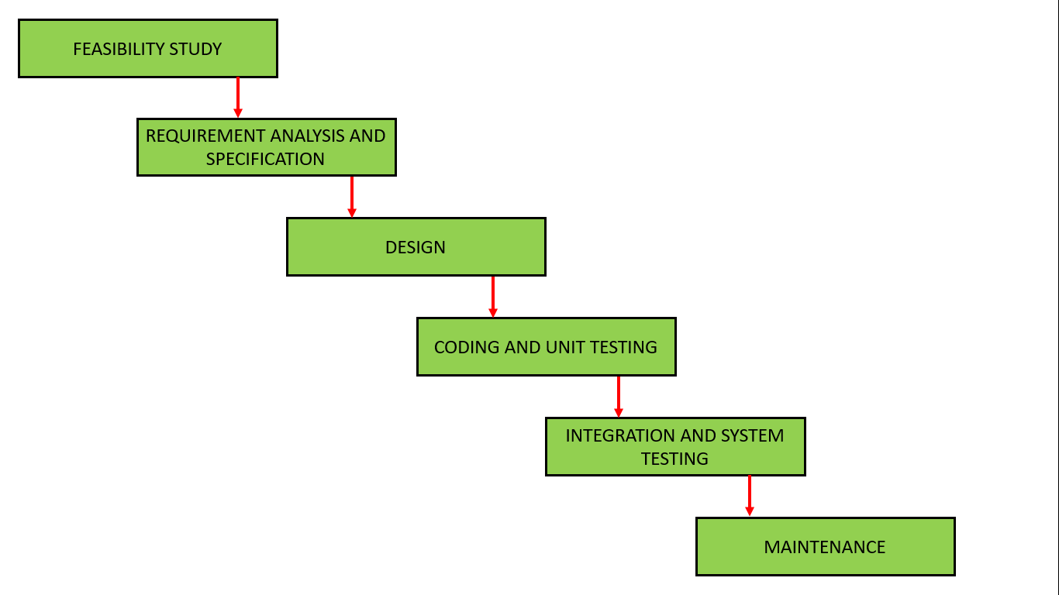

**Figure no.1**-SDLC water fall model

**FEASIBLITY STUDY**

A feasibility study for an bus reservation in the Software Development Life Cycle (SDLC) would typically involve assessing the practicality and viability of developing such a system. Here's how the feasibility study might break down:

1. **Technical Feasibility:**
   * Evaluate the technical requirements for building the bus reservation, including software and hardware needs.
   * Assess the availability of necessary technology, tools, and expertise to develop the system.
2. **Financial Feasibility:**
   * Estimate the costs associated with developing, implementing, and maintaining the bus reservation.
   * Compare the projected costs with the expected benefits or savings to determine if the investment is justified.
3. **Operational Feasibility:**
   * Evaluate how the bus reservation would fit into the organization's existing workflows and processes.
   * Assess the impact on day-to-day operations, including changes in responsibilities, training needs, and potential disruptions.
4. **Legal and Regulatory Feasibility:**
   * Identify any legal or regulatory requirements that may impact the development or use of the bus reservation.
   * Assess potential risks related to data privacy, security, and confidentiality, and develop strategies to mitigate these risks.
5. **Schedule Feasibility:**
   * Develop a timeline for the development, testing, and deployment of the bus reservation.
   * Determine if the proposed timeline is realistic and achievable within the constraints of budget and resources.

**REQUIREMENT ANALYSIS AND SPECIFICATION**

Requirement analysis and specification for an Bus reservation (IMS) involves gathering and documenting the needs, objectives, and constraints of the stakeholders involved in the interview process. This is a crucial phase in the Software Development Life Cycle (SDLC) as it lays the foundation for designing and developing the system.

1. **Stakeholder Identification:**
   * Identify all the stakeholders involved in the interview process, including HR managers, recruiters, interviewers, candidates, and administrators.
2. **Gathering Requirements:**
   * Conduct interviews, surveys, and workshops with stakeholders to understand their needs and expectations from the system.
   * Collect data on the current interview process, pain points, and areas for improvement.
3. **Functional Requirements:**
   * Define the core functions of the Bus reservation, such as:
     + Candidate scheduling and availability tracking.
     + Interviewer assignment and scheduling.
     + Notification and reminder system for all stakeholders.
     + Interview feedback collection and analysis.
     + Reporting and analytics capabilities.
     + Security and access control measures.
4. **Non-Functional Requirements:**
   * Define performance requirements, such as system response time and scalability.
   * Specify reliability requirements, including system uptime and data backup procedures.
   * Define usability requirements to ensure the system is intuitive and easy to use for all stakeholders.
   * Specify any legal or regulatory requirements that the system must adhere to.
5. **System Architecture:**
   * Define the overall architecture of the Bus reservation, including:
     + Client-server architecture or cloud-based solution.
     + Database management system (DBMS) for storing candidate and interview data.
     + Integration points with other HR systems and tools.
     + Technology stack (programming languages, frameworks, etc.).
6. **User Interface Design:**
   * Create wireframes or mockups of the user interface based on stakeholder feedback and usability best practices.
   * Ensure the interface is intuitive, accessible, and consistent across different devices and screen sizes.
7. **Requirements Specification Document:**
   * Document all the gathered requirements, including functional and non-functional requirements, system architecture, and user interface design.
   * Use standardized templates and notation techniques (such as Use Case diagrams, UML diagrams, etc.) to clearly communicate the requirements to developers and other stakeholders.
8. **Validation and Verification:**
   * Review the requirements specification document with stakeholders to ensure it accurately captures their needs and expectations.
   * Validate the requirements against real-world scenarios and use cases to identify any gaps or inconsistencies.
   * Obtain sign-off from key stakeholders to proceed to the next phase of the SDLC.

**DESIGN**

Designing an bus reservation involves several steps in the Software Development Life Cycle (SDLC), including requirements gathering, system design, implementation, testing, deployment, and maintenance. Here's an outline of the design

1. Requirements Gathering
2. System Design
3. Prototyping
4. Development
5. Testing
6. Deployment
7. Maintenance

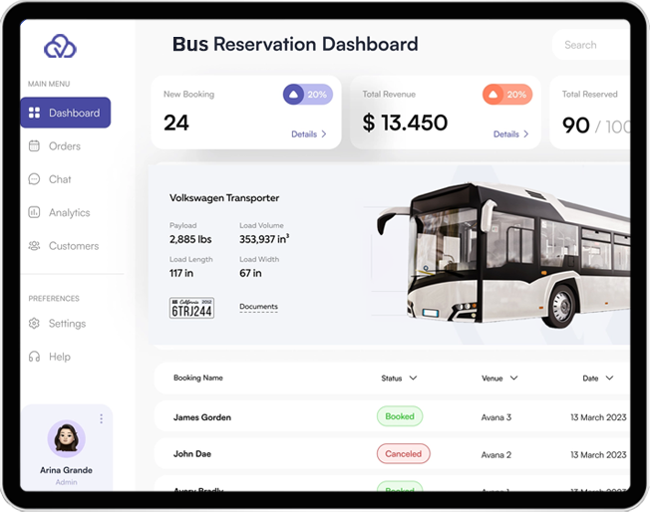

Top of Form

Bottom of Form

Figure no.2-Design of bus reservation

**CODING AND UNIT TESTING**

Coding and unit testing are essential components of the Software Development Life Cycle (SDLC) when developing an bus reservation. Here's how they apply to this specific project:

1. **Coding:**
   * During the coding phase, developers translate the design specifications of the bus reservation into actual code using programming languages such as Java, Python, or JavaScript, depending on the requirements and preferences of the development team.
   * The code should be written following best practices, such as using clear and meaningful variable names, modularizing code into functions or classes, and adhering to coding standards and style guides.
   * Code should be properly documented using comments to explain complex logic, algorithms, or any areas that might be unclear to other developers or future maintainers of the system.
2. **Unit Testing:**
   * Unit testing involves testing individual units or components of the bus reservation in isolation to ensure they function correctly.
   * Developers write unit tests for each function, method, or module, covering both normal and edge cases to verify that the code behaves as expected under various scenarios.
   * Test cases should include inputs, expected outputs, and assertions to validate the actual output against the expected outcome.
   * Continuous integration (CI) practices can be implemented to automatically run unit tests whenever new code is pushed to the repository**,** ensuring that any changes do not introduce regressions or breaking changes.

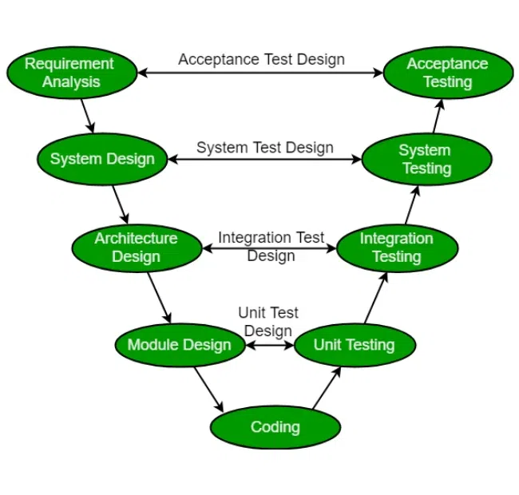

**Figure no. 3**

**INTEGERATION AND SYSTEM TESTING**

**Integration Testing:** Integration testing is a phase in the Software Development Life Cycle (SDLC) where individual units or components of the software are combined and tested as a group. In the context of an bus reservation, integration testing involves testing the integration of different modules such as user authentication, scheduling, candidate management, and reporting.

Here are some key aspects of integration testing for an bus reservation:

1. Interface Testing
2. Data Flow Testing
3. Functionality Testing
4. Compatibility Testing
5. Error Handling Testing

**System Testing:** System testing is a phase in the SDLC where the entire software application is tested as a whole to ensure that it meets the specified requirements and functions correctly in the intended environment. In the case of an bus reservation, system testing involves testing the entire system, including all modules and components, to validate its functionality, performance, security, and usability.

Here are some key aspects of system testing for an bus reservation:

1. Functional Testing
2. Performance Testing
3. Security Testing
4. Usability Testing
5. Compatibility Testing
6. Regression Testing

**MAINTANENCE**

Maintenance of a topic bus reservation in the software development lifecycle (SDLC) involves several key aspects to ensure its smooth functioning and longevity:

1. Regular Updates: Stay updated with the latest technologies and trends in topic interview management to enhance system performance and security.
2. Bug Fixes: Continuously monitor the system for any bugs or errors and promptly address them to prevent disruptions in workflow.
3. Database Maintenance: Regularly backup and optimize the database to ensure data integrity and prevent data loss.
4. User Support: Provide ongoing support and training to users to help them effectively utilize the system and troubleshoot any issues they encounter.