Additional Benefit Subsistence Security (BUB) and Social Support (SOB)

Functional Design

Author(s)
Version 0.1 (September 2nd 2010)
Status Draft
Number of pages 51
Language Dutch (Nederlands)
Date created 2/09/2010 10:54:00
Date modified 6/10/2011 7:10:00

© Copyright 2010 – Daxx

Table of Contents
1 Introduction 4
2 Overview, definitions and terms 5
2.1 Parties involved 5
2.1.1 Service Centre 5
2.1.2 (Regional) Professional Alliance Secretariat 5
2.1.3 Social- and security fund 5
2.1.4 (Professional) Center 6
2.1.5 Payment Institution (UI) 6
2.2 Joint Committee (Paritair Committee, P.C.) 6
2.3 BUB – Additional Benefit Subsistence Security 6
2.3.1 What? 6
2.3.2 Application procedure – overview 6
2.3.3 Payment Procedure – overview 7
2.4 SOB – Social Support 8
2.4.1 What? 8
2.4.2 Application procedure – overview 8
2.4.3 Payment Procedure – overview 9
3 Plan of Approach 11
3.1 Asset Management Environment 11
3.1.1 Extensions functionality 11
3.1.2 Design 11
4 Extensions Asset Management environment 12
4.1 Customized Form 12
4.1.1 Introduction 12
4.1.2 Extension of configuration screens 12
4.1.3 Additional screens per asset type 12
4.1.4 Configuring web forms 13
4.1.5 Completing Web Forms Anonymously 16
4.2 Tasks or “additional functionality” 17
4.2.1 Task definition 17
4.2.2 Additional functionality overview 17
4.2.3 Defining new tasks 17
4.2.4 Tasks in the user environment 23
4.2.5 Tasks and rights management 25
5 Design Additional Benefit Subsistence Security (BUB) – PC 109 26
5.1 Overview and design of entities (Data objects) 26
5.1.1 Person 26
5.1.2 Company 27
5.1.3 File 28
5.1.4 Certificate 29
5.1.5 Payment 30
5.1.6 Other Employers 30
5.1.7 Configuration- and base tables 31
5.2 Application Procedure (Functional description) 34
5.2.1 Creating an application file – Service centre 34
5.2.2 Verification of membership – Professional Alliance Secretariat 37
5.2.3 Entering File Data – Center 38
5.3 Payment Procedure (Functional description) 38
5.3.1 Secured Excel files 39
5.3.2 Creation of Excel file for unemployment certificate (Center) 39
5.3.3 Unemployment verification (UI) 39
5.3.4 Process unemployment certificates (Professional Alliance) 40
5.3.5 Processing Payments (Professional Alliance/Center) 40
6 Design Social Support – PC 120.00 41
6.1 Overview and design entities (data objects) 41
6.1.1 Person 41
6.1.2 Company 42
6.1.3 File 43
6.1.4 Certificate 45
6.1.5 Payment 45
6.1.6 Other employers 46
6.1.7 Configuration- and base tables 46
6.2 Application Procedure (Functional description) 47
6.2.1 Creating unemployment file – Service centre 48
6.2.2 Verification membership – Professional Alliance Secretariat 48
6.2.3 Verification of data + submission (Center) 49
6.2.4 Inserting payment codes (Center) 49
6.3 Payment procedure (Functional description) 49
6.3.1 Creation of Excel file for inventory of days of unemployment (Center) 49
6.3.2 Unemployment verification (UI) 49
6.3.3 Process unemployment certificates (Center) 50
6.3.4 Processing Payments (Center) 50

Introduction
This functional design principally describes the Additional Benefit Subsistence Security (BUB) and Social Support (SOB). However, this functional design for a platform to be developed, goes beyond just BUB and SOB. The intention is to include multiple compensations and schemes in this platform, allowing these procedures to be streamlined and the data of all separate compensations to be collected in one application.

The intention is to create a web-based environment to which all parties have access. This makes it possible to realize important savings in paper, ink and shipment costs.

Overview, definitions and terms
Below you’ll find a brief overview of definitions, concepts and terms that are important for image-forming.

Parties involved
The following parties are involved in the work flow of the different applications and payments:
- Member
- Service Centre
- (Regional) Professional Alliance Secretariat
- Social- and Security Fund
- Center
- Payment Institution (UI)

Service Centre
In addition to its activities on the work floor (through the professional centers) the ACV also has a regional extension: the regional ACV-alliances. Flanders has 12 ACV-alliances, Wallonia 8 and then there is the alliance Brussels-Halle-Vilvoorde.

These ACV alliances take care of the services to members. This concerns advice and administration concerning unemployment and payment of unemployment benefits, trade union training, legal aid, collection and administration of union contributions, answering various questions (for instance about child benefit, retirement, scholarships, failure, ...). In order to bring these services as close to the members as possible, about 150 ACV service centers were extended on a regional level.

(Regional) Professional Alliance Secretariat
The ACV is active on the work floor. The 'ACV-professional centers’ make sure that everything goes according to the rules at every company.

The direct contact of the professional centers is the union delegate. He / she may help in case of questions or problems specific to your company or sector (salary- and labor conditions, contributions, funds, subsistence security, ...).

If necessary, every union delegate can always fall back to the personnel of the professional center. The provide support for difficult files or social conflicts.

Within the ACV, different professional centers are active, ACV-CSC METEA is one of these.

Social- and security fund

Presentation
The employer- and employee organizations can establish funds for subsistence security under the flag of the joint committees and sub committees. Their statutes are recorded in collective labor agreements, that need to be declared generally binding by the Queen.

The aim of these funds is to:
- finance, grant and pay social benefits;
- finance and organize the professional training of employees and youth;
- finance and ensure the safety and health of employees in general.

The benefits granted by these regional funds differ from sector to sector.

The financing of the subsistence funds is done by contributions, paid by the employers that fall under the statutes of the fund. The collection of the contribution can be done directly by the fund itself or through the State Service for Social Security.

(Professional) Center
ACV consists of several professional centers. Every center covers the various regional processional centers. ACV-CSC METEA in Brussels is one of these centers.

Payment Institution (UI)
ACV also fulfills the role of Payment Institution. This means that ACV performs the payments of unemployment and illness benefits to its members. It is important to keep the administration strictly separates as a professional center and a payment center. Every professional center cann0t have access to sensitive information regarding the number of days worked/unemployed. This information is only accessible to the payment institution.

Joint Committee (Paritair Committee, P.C.)
In Belgium, the largest part of the salary negotiations for the private sector takes place in the joint committees. These joint committees are always attended by the representatives of the employers and employees. A joint committee is chaired by a social mediator who works for the Ministry of employment and work.

For SOB and BUB, the following PCs apply:
- P.C. 120 (SOB): JOINT COMMITTEE VOOR DE TEXTIELNIJVERHEID EN HET BREIWERK
- P.C. 109 (BUB): JOINT COMMITTEE VOOR HET KLEDING- EN CONFECTIEBEDRIJF

BUB – Additional Benefit Subsistence Security

What?
The collective labor agreement (P.C. 109) for additional benefits subsistence security applies to the employers and to the companies that fall under the joint committee for apparel and clothing companies. Fully and partly unemployed entitled to benefits, that are not entitled to the early retirement in accordance with the collective labor agreement concluded May 22nd in the joint committee for apparel- and clothing companies are granted an additional benefit for subsistence security if they meet the requirements. Please also see “109-00 Additional benefit subsistence security 20090324.PDF”

Application procedure – overview
The current procedure for the application of an additional benefit subsistence security contains various steps. The intention is to involve as many parties as possible in the new application, reducing the process of creation, copying and forwarding of notices to a minimum.

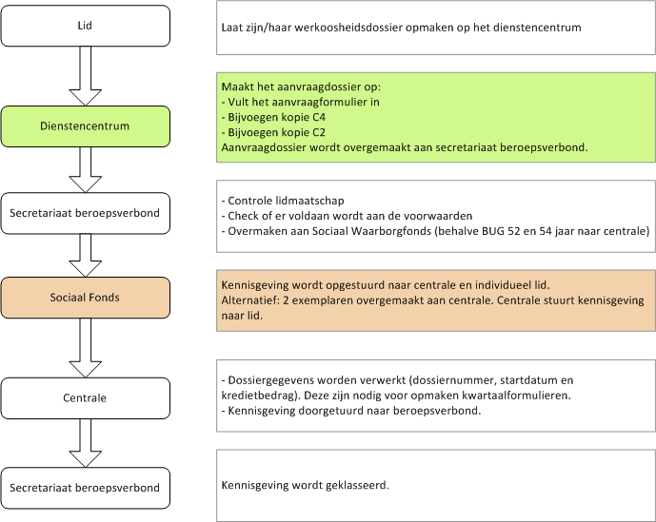

Payment Procedure – overview
Regarding payments it is preferred to have as many parties participate as possible in the application to be built for BUB. The current procedure, step by step:

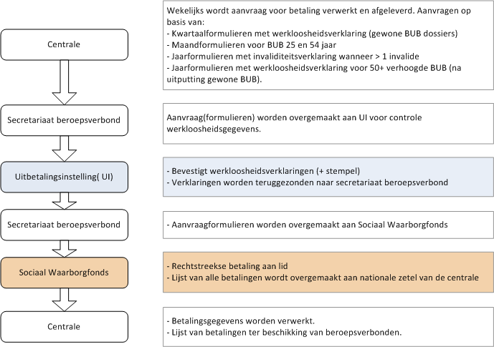

SOB – Social Support

What?
Workers that meet the conditions that are discarded by a company that falls under the PC Textile and Knitwear (P.C. 120), receive an additional unemployment compensation of 2,48 EUR/day (system: six-day week) for each beneficiary days of unemployment.

Application procedure – overview
The current procedure for the application of “Social Support”:

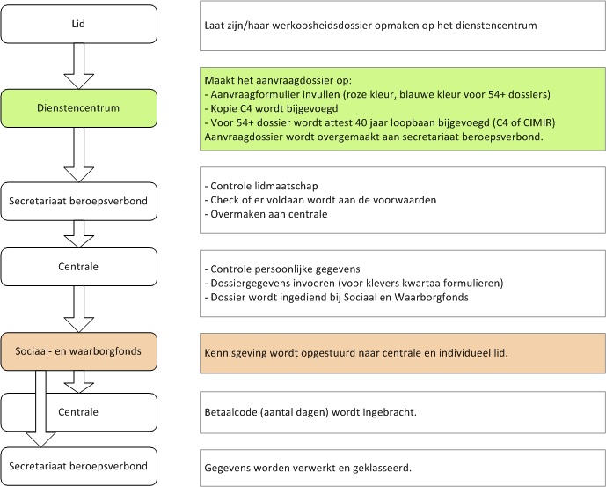

Payment Procedure – overview
The payment is currently subject to a lot of paperwork. In this new application, a solution will be offered. The current procedure for payments of the Social Supervisor is:

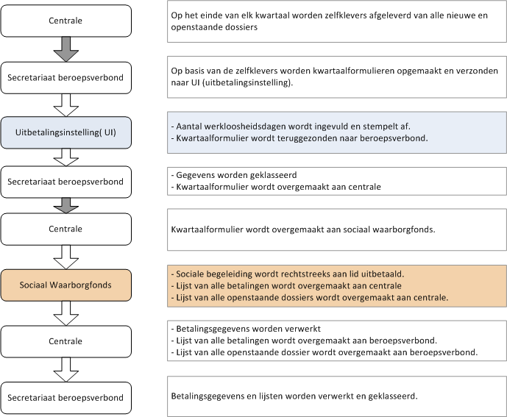

Plan of Approach
There are two paths that can be chosen for the development of SOB and BUB. The choice is between the development of a new application (customized software) or to continue building on top of the Asset Management Platform.

Asset Management Environment
In the current Asset Management Environment, investments were made in functionality that is generally useful and applicable to many projects and ‘assets’ or ‘objects’. This functionality can be the basis for the BUB and SOB application. In addition to the current functionality, additional functionality is required. 80% of this functionality is described in the document “Facility Management; Expansion HRM, accounting, …; Functional design”. This contains ideas and recommendations to extend the application to make it even more versatile.

When the choice is made to implement BUB and SOB into the Asset Management System, it can be extended with new and useful functionality. If this second option is chosen, the BUB and SOB process contains two parts, being:
- Expansion Asset Management Environment functionality
- Designing environment for BUB and SOB (configuration)

Extensions functionality
Extending the environment includes the following parts (these are further discussed in the next chapter):
- Customized forms (dynamic configuration of lay-out)
- Rights on a field level in stead of asset level (probably not necessary, and therefore not prepared)
- Linking tasks and functionality to asset types
- Configuring customized import/export

Design
Designing the adjusted and extended environment means a proper configuration for both BUB and SOB. This means:
- Creating and configuring assets used by BUB
- Creating and configuring assets used by SOB
- Creating tasks linked to certain users(rights)
- Creating adjusted screens/forms linked to tasks (and users)
- Creating and configuring import/export, linked to tasks (import/export for reading and creating files with payments, ...)

Extensions Asset Management environment
In order to make the Asset Management Environment compatible with BUB and SOB, several necessary extensions are required. These extensions are described in this chapter. The subsequent chapters focus on the design and the configuration of the (extended) Asset Management Environment.

It is not the intention to integrate BUB and SOB into the Asset Management Environment. It will be an independent environment with generally useful extensions. The specific functionality, such as importing approvals and / or payments of the Fund, are done through SQL Server Integration Services (SSIS) to the extent possible or through sub programs to be called externally. This will be addressed later in this chapter.

Customized Form

Introduction
Different types of data have to be entered and maintained for SOB and BUB. Attempts are made to digitize the current forms to the extent possible, while maintaining the size and the lay-out. This means that it should be possible to enter all necessary data using one screen. This means the following data for a BUB file:
- Personal information
- Details previous employer(s)
- File data
- …

For this reason, we want to combine multiple asset types on one screen. This extension has been described in the document “Facility Management - Extension HRM, accounting, … (Functional Design)” under chapter “Web forms”. Here, we will repeat pieces of text and extend these and adjust several parts, specifically for BUB and SOB.

Extension of configuration screens
The current Asset Management Environment supports the option of configuring the view of every asset type. That way, every asset type has a unique view- and update screen. For this feature, an option should be added to define additional screens for a certain asset type.

Additional screens per asset type
In the creation of a new asset type, a screen is defined using the wizard. This wizard will remain unchanged. The screen that is to be configured, is the standard view.

Through “Edit Asset type” one should be able to configure additional screens for a certain asset type. These screens can in turn be linked to certain tasks or sub tasks. This way, more targeted forms can be created for inserting or editing certain attributes, focused on the details required in a certain phase of a process (task).

Defining a new screen
When defining a new screen the following data should be stored:

Name | Data type | Comments
ScreenUId | Numeric | Unique Identifier
DynEntityConfigUId | Numeric | Links to DynEntityConfigUid of DynEntityConfig. This is a one to one relation (for each DynEntityConfig record there is at least one AttributePanel record. This, to note explicitly that the UID field is used in stead of the ID field, to create the link.
Name | Text
NameTranslationId | Numeric | All screens must be Multilanguage. This functionality is not yet implemented
Status | List | Status of the screen (design, runtime)
Title | Text | Title appearing at the top of the page
TitleTranslationId | Numeric | Multilanguage functionality not yet implemented.
Subtitle | Text | Any subtitle appearing at the top of the page
SubtitleTranslationId | Numeric | Multilanguage functionality not yet implemented.
PageText | Text | Text being displayed at the top of the page
PageTextTranslationId | Numeric | Multilanguage functionality not yet implemented.
Comment | Text
UpdateUserId
UpdateDate

One ore more panels are linked to a screen, as with the standard screen. The same table is used to this, however, extended with one field: ScreenUID.

Name | Comments
AttributePanelUid | Unique ID for every attribute panel (unique record number)
AttributePanelId | Unique ID for one specific panel. This remains unchanged when this panel is linked to one new version of the same asset type (table DynEntityConfig).
ScreenUId | Link to the screen. For the default screen (-1) will be entered here.
DynEntityConfigUId | Links to DynEntityConfigUid of DynEntityConfig. This is a one to one relation (for each DynEntityConfig record there is at least one AttributePanel record). This, to note explicitly that the UID field is used in stead of the ID field, to create the link.
Name
NameTranslationId
DisplayOrder | The order of the view on the screen. The field also depends on the field Screenlayout in the table DynEntityConfig. This field determines how panels are displayed (number of columns etc.)
Description
HeaderLabel | Label, displayed as a header of the panel (UI)
HeaderLabelTranslationId
Comment
UpdateUserId
UpdateDate

This allows for the creation of unlimited new screens with different layouts and content. These screens are not visible by default. These screens can only be used when linked to a certain task or to an online web page (read on).

Configuring web forms
Configuring an additional form will again be done through a wizard. The functionality already available will be used and extended with the option for building forms based on multiple asset types.

However, the configuration of the ‘default screen’ should be given the same new options as configuring additional screens. This is not implemented yet. So, all logic/functionality for creating and configuring screens (default or extra) must be the same with the same possibilities. It must be possible to create a default screen with links to extra assets so the default screen can be used without adding extra screens …This allows for the creation of a default screen that is automatically linked to other asset types, and that fully (or partially, depending on the attributes selected on the panel) in the screen. This allows for the configuration of the ‘standard screen’ for a BUB file in such a way that, by default, all details of the person and the previous employer are fully displayed.

The wizard will go through the steps below:
- Entering details of additional screen
  - Name
  - Description
  - Status (design, …)
  - Use (for tasks, surveys, …)
- Selecting (additional) asset types
- Choosing screen display (arrangement of the panels)
- Defining the panels
- Linking the attributes of one or more asset types to the panels
- Arranging the attributes in the individual panels in the desired order

Overview additional screens
The first page that is displayed at the additional screens is an overview of the previously created additional screens. Here, screens can be removed, adjusted, or additional screens can be added through the link “New screen layout …”.

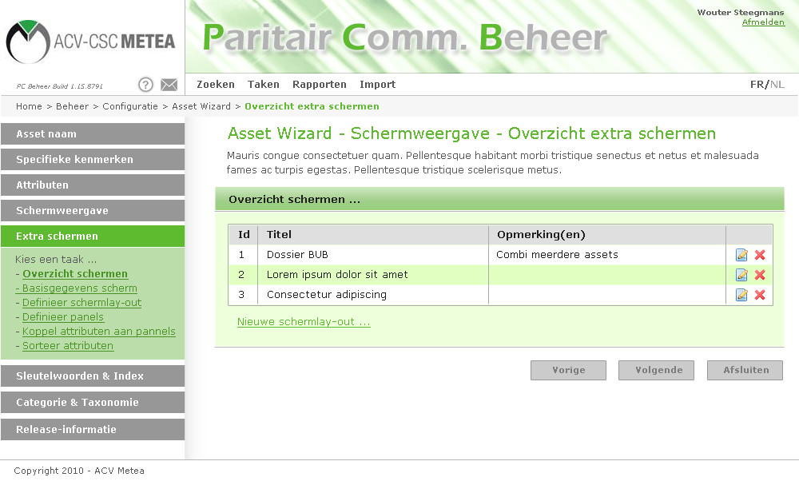
It is more transparent when using the same left column menu for all configuration options, so also for configuring the extra screens. So change this behavior by removing the screens icon in the asset overview and add the functionality in the left column. By doing so, you also use/integrate the same Look & Feel, which is not the case with the new developed extra screens forms.

When creating or adjusting an asset type and / or the additional screens, it is important to use the same mechanism of “historic data”. When an asset type is adjusted, a new release is created. This release also means the additional screens.

New Screen Creation
When a new screen is created through the link “New screen layout” general meta data has to be entered first, such as name, description …

A very important element here is linking additional asset types. It has to be possible to integrate all asset types linked to the asset type that is being configured and for which a new screen layout is generated, into the screen. This gives the end user are more extensive overview of all information in the file, which makes completing the file much easier and faster.

The current Asset Management Environment doesn’t allow display of multiple asset types in one screen. Linked asset types are displayed as a selection box (in edit-mode) or as a link (in view-mode). To create one completely new file, the following steps would have to be taken:
- Creating user
- Creating previous employer
- Creating any other previous employers
- Creating/verifying district (if not available, create it)
- Creating file to which all previously mentioned assets are linked

In the new form, all information should be available in one screen. It should be possible to easily look up linked asset types through a popup (Ajax). If the asset does not exist yet (for instance, the previous employer has not yet been included in the system) all fields will be entered in the complete form (read on for screen view).

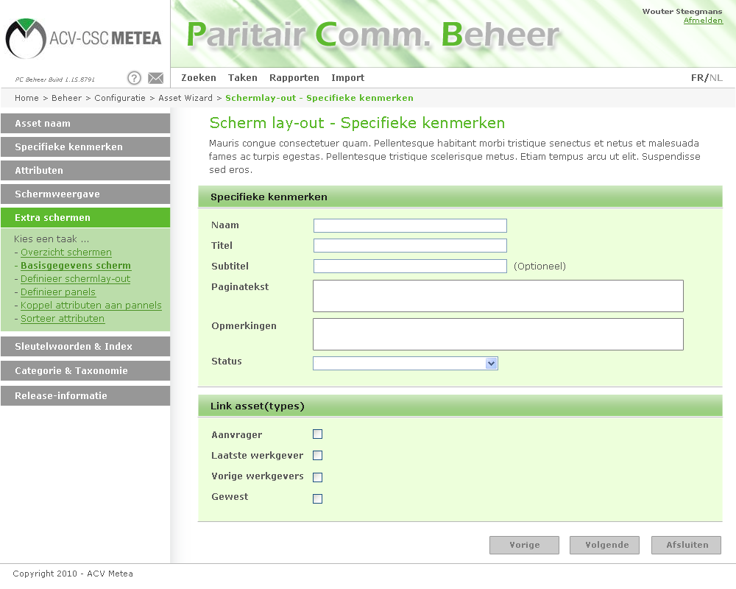

Selecting additional asset types
Important element of the screen above is the block “Link asset(types)”. Here, one can specify whether additional asset types have to be included in the screen layout. The labels of these asset types are retrieved, based on the labels assigned to the basic asset type (asset type for which the configuration, and thus the additional screen is being configured). In this case, it concerns the asset type file (for BUB or SOB). The asset type Person is linked to the asset type file, with the “Applicant” label. This label is used in the overview for adding additional asset types.

All attributes of the asset types selected, can be selected at a later stage to be linked to a Panel.

! | Technically speaking, the most useful approach has to be chosen. The easiest would probably to be collect all attributes of a linked asset type on one panel. This way, DataBounding can be linked to the Panel, for instance. This is an option that can/may be developed.

Choosing Screen view
Just as with the buildup of the default screen, a screen layout has to be selected. This idea was also used here. However, two options were added. These two additional options should be implemented into the “default screen”.

Idea behind the two additional options is that, at the bottom, a column can be created that covers the full width. The number 99 indicates that it concerns the last Panel in the row. If 4 panels were created for a certain asset type, 1, 2 and 3 will be divided in the columns. Panel 4 is displayed under the previous columns and covers the full width.

The two extra screen layouts aren’t implemented yet. The file AssetCreationWizard_ExtraScreen_Layouts.v1.00.psd is included in the Bugs/Images folder in case of the need of the graphics for the two new layouts.

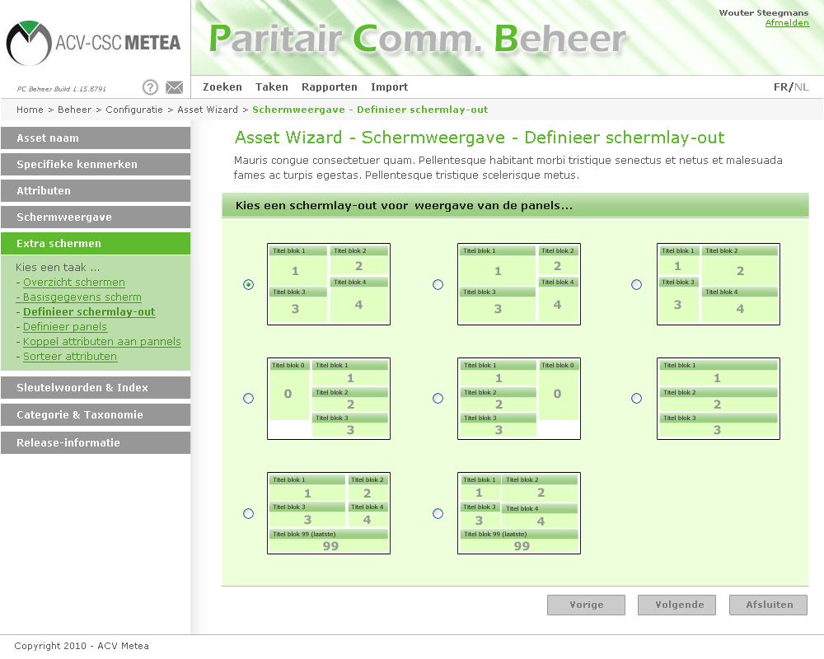

Arranging attributes by panels
The remainder of the process is similar to the process of defining and configuring the default screen. The only difference is that more asset types are available, containing more attributes.

As previously indicated, it is a good option to collect the attributes of linked asset types in one panel per linked asset type.

Completing Web Forms Anonymously
Through the option of creating and modeling new forms dynamically, it becomes interesting to design forms for registrations, surveys etc. This additional feature makes it interesting to post forms on the internet and not just in a protected intranet environment.

Registration- and survey forms for instance, should have the option to be completed anonymously. It concerns the collection of data. It has to be possible to gather and store the data of anonymous users through an internet user or a system user and to store them in the Asset Management System.

! | This feature will not be necessary for BUB and SOB for the time being. However, it is a useful feature for surveys, polls or even the collection of information or registration. This part is described here, since it probably means little additional work to implement, on top of the extended adjustments to the forms and screen views.

Tasks or “additional functionality”
In the document “Facility Management; Extension HRM, accounting, … - Functional Design” (FO_HRMAsset_v0.1.doc) an entire chapter is devoted to processes and tasks. The concept of “tasks” we describe here, is just a little part of the contents of the previously mentioned chapter. Therefore, we will not repeat the text, but will immediately describe the necessary extensions.

Task definition
We consider the concept “task” to be an extension of functionality to the Asset Management Environment. Additional functionality, not in terms of environment in general, but specifically linked to a certain asset type. This helps us distinguish the following additional functionality (tasks) for the asset type BUBFile:
- New file creation
- Overview (result page) verifying membership
- Approval & amount import
- Printing unemployment certificates
- Importing unemployment certificates
- Payment import

The idea is to create a mechanism for adding features specifically for certain assets. At the same time, the mechanism has to be designed in such that no program work is required to the Asset Management Environment or that adjustments have to be made to it.

Additional functionality overview
An overview of possible functionality extensions:
- Saving a search query and launching it through a task (→ set of results)
For instance to obtain an overview of all files that need approval (based on the file status)
- Launching a Batch process to the data.
Any output or results can be saved to the log files or sent through e-mail. This will be done as SQL Server Integration Services (SSIS).
- File import
This will be done through SSIS as well.
- File export
This can be done in two ways. Based on a set of results (search query) for a certain asset type, or through additional functionality in SQL Server (through SSIS).
Both aren’t implemented yet. See also below.
- New Asset Creation (based on a provided asset type).
- Printing report
It has to be possible to link a report to a set of results. This is done by including parameters into the report that can be entered runtime through a web form.

! | SQL Server Integration Services replaces the former DTS Packages (Data Transformation Services). More information about SSIS: http://www.microsoft.com/sqlserver/2008/en/us/integration.aspx.

Defining new tasks
A new task can only be added through the management environment. A task should also be explicitly linked to a user. By default, tasks are therefore NOT displayed with a user.

Based on the overview of possible functional extensions of an asset type above we foresee a FunctionType attribute, which indicates which feature is linked to the task. We distinguish the list below:
- 1 : ShowResultSet
- 2 : LaunchBatch
- 3 : ImportFile
- 4 : ExportFile
- 5 : CreateAsset
- 6 : PrintReport

For every feature added to an asset type, the data below is stored (in the table DynEntityExtraFunctionality):

Name | Data type | Comments
Id | Numeric | Identifier
Name | Text | Name of the task (additional feature).
Description/Help | Text | Description of the task
FunctionType | List | ShowResultSet, LaunchBatch, …
FunctionData | Xml | Additional parameters, for instance the search query for the set of results. These should be stored in XML-format. This way, new contracts can be dynamically added in the future, without having to adjust the data model.
DynEntityConfigId | Link | Link to the configuration of the asset type. The feature is linked to this
SortPriority | Numeric | Priority Sort/index to sort the tasks. See below for more information (4.2.4.1)
UpdateUserId | Asset | Link to the user who created/adjusted the task
UpdateDate | Date/Time | Date of creation/adjustment of the task

Launching a search query
When a user performs a task of the type “Launch search query” the user immediately sees a set of results based on the search parameters entered during configuration. This way, all files of which the membership has to be verified, for instance, can be displayed and processed through one click.

The creation of a new task of this type is done as follows:
- Create a new item in the step “Additional feature” in the creation/adjustment of an asset type
- Enter the necessary data
- Choose “Launch list of results” under “Type of Feature”

After selecting this feature, an additional button is to appear, called “Config set of results”. Through this button, the search screen will be launched. However, in stead of the button “Search” the button “Save search query” will be displayed. After setting the right search query and saving it using the adjusted button, the management environment will be displayed again.

When the search query is linked, an additional link has to be displayed allowing the search query to be tested. If the search query is being tested, the set of results should be displayed in a new (popup) screen.

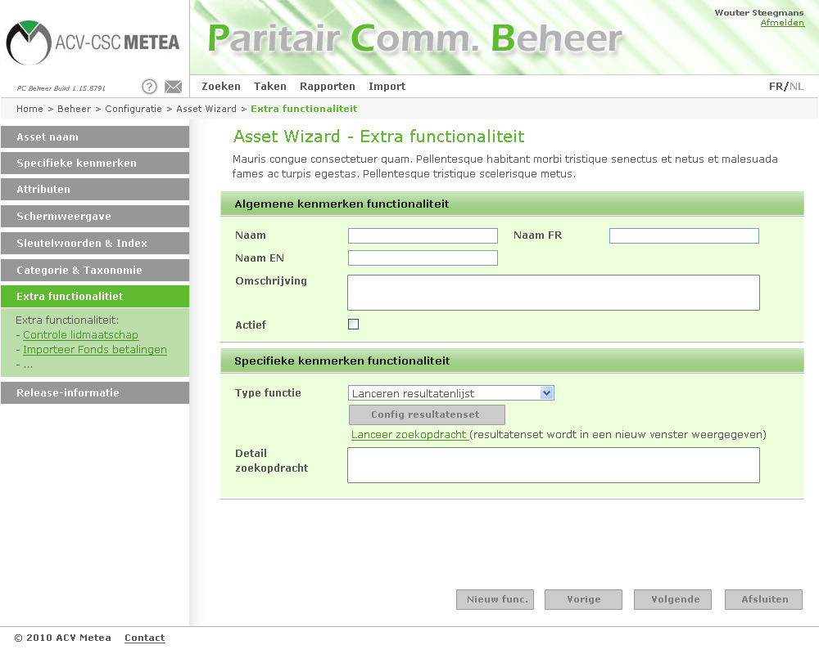

The developed solutions differs from the proposed UI above. Please check the buglist for problems and usability with the changed lay-out.

Configuring the set of results is done using the familiar screens. Below the “regular” search screen has been pictured. However, the set of results is to be set using all search options (tabs).

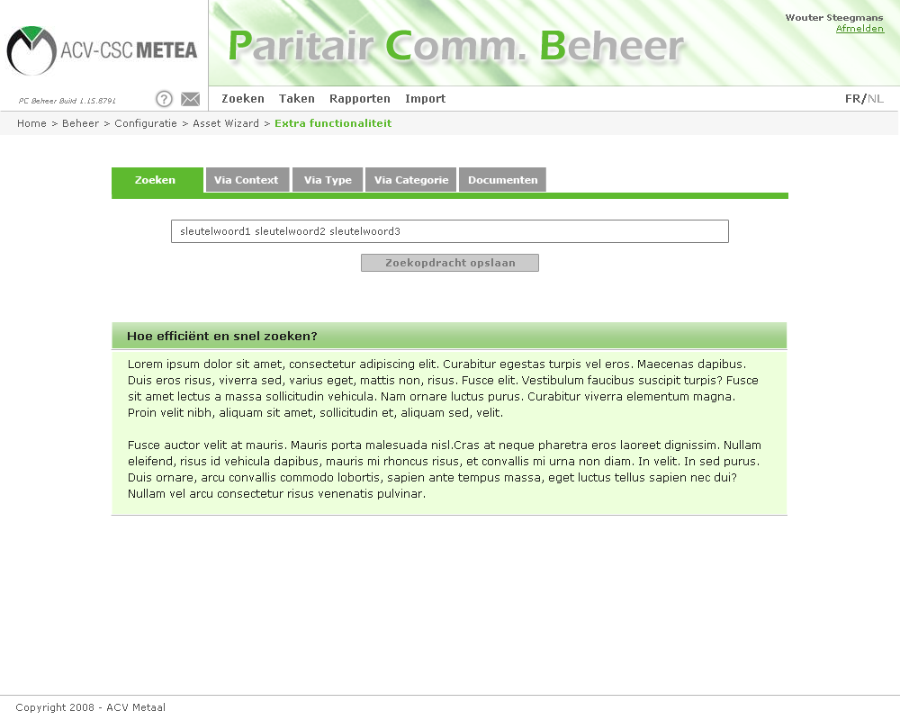

Launching (Batch) processing
Launching a Batch processing means that a predefined process is applied to the data in the database. This can be anything, for instance a routine task that verifies for every exhausted file whether the status is correct and adjusts the status if it isn’t .

The configuration should allow two types of processing:
- Launching an SQL Server Integration Service
- Launching a program (exe file) → on the server

When a (batch) process is started by an end user, no result screen of the process will be displayed. There will only be notification of the fact that the process was submitted to the server.
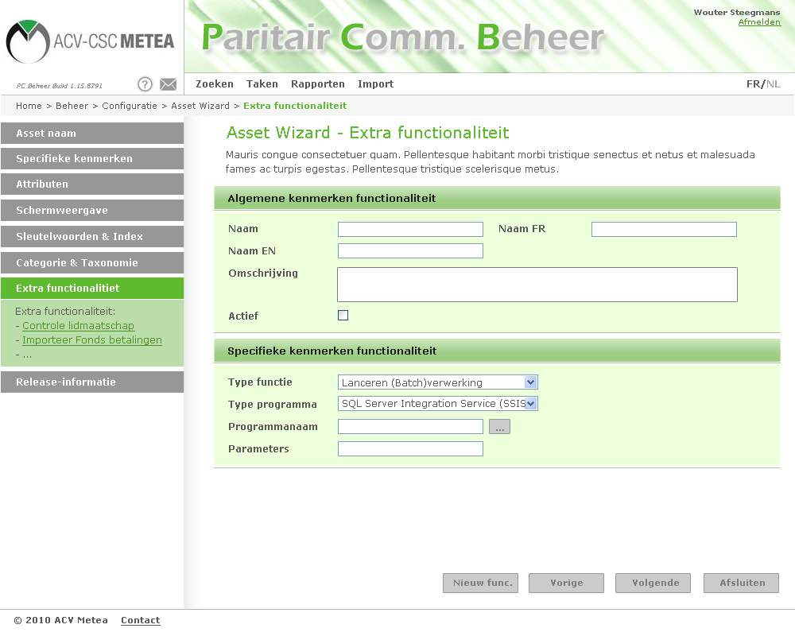

Launching SSIS Packages without parameters works (just created some simple packages to test). Launching SSIS Packages with parameters isn’t working:
- Unable to “save” a parameter. Disappears when re-opening the task?
- Please provide some more of the technical implementation details about running SSIS packages in the BUB & SOB application.
- What method is used to launch packages (one of these? http://blogs.msdn.com/b/michen/archive/2007/03/22/running-ssis-package-programmatically.aspx)

Test-scenario for SSIS-package with a parameter:
- SSIS Packages created with Package scope variable
- This parameter is set in the parameters section of BUB & SOB by using the DTS/SSIS command line notation: \Package.Variables[User:paramname].Value

More questions:
- Are these dtsx packages copied to a folder in the website root, or is just the path saved to the dtsx package?
- Is it possible to give runtime parameter values to the package, for ex. the username?

Import files
Comparable to the screens above, the manager will be able to add the import of files to a certain asset type. Importing files is also done using a SSIS or an external program (this way, the Asset Management Environment does not have to be adjusted).

The following fields should be available and editable:
- File (through selection button)
- Type of import software (SSIS or exe)
- Software name
- Parameters (optional)

The imported files should all be copied to a folder on the server (defined in web.config). Through this folder, the file will be imported. Files should also change name, making them unique. To this end, the date and time will be added as a prefix (yyyymmddhhnnss_filename.extension).

Please provide some technical information how to use the input folder, stored in the web.config, into the SSIS package. Wit the use of?:
Runtime parameters (see also suggestion above)
- Special use of the parameters?

Export files
Exporting files allows for easy creation of new types of export files. The export file type will only be Excel for the time being.

An export file is created (just like import) through an SOL Server Integration Service. The file created will be submitted to the end user through a download link.

The export files isn’t working yet, there is no functionality to configure it. Export files must be possible using:
- SSIS or an external program (same as import file)
- Export to an excel (and/or xml file) based on a preconfigured resultset (search)

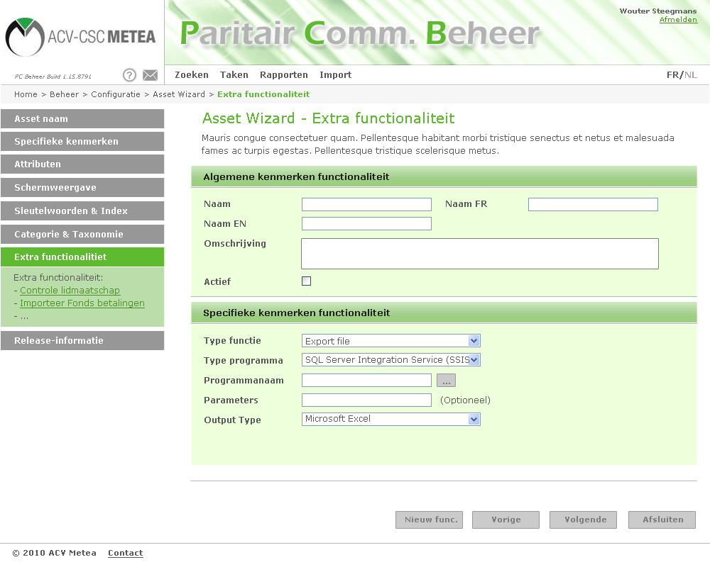

New Asset Creation
A new asset can always be created through the standard functionality of the Asset Management Environment. However, additional screen views can be attached to an asset. The creation of an asset through an adjusted screen may be interesting, especially when multiple asset types are combined in one screen.

This is why additional features were created for the creation of a new asset. The asset type should not be selected, as the task is linked to the type. The screen should be selected however. If necessary, an additional header can be entered, which will appear at the top of the new asset.

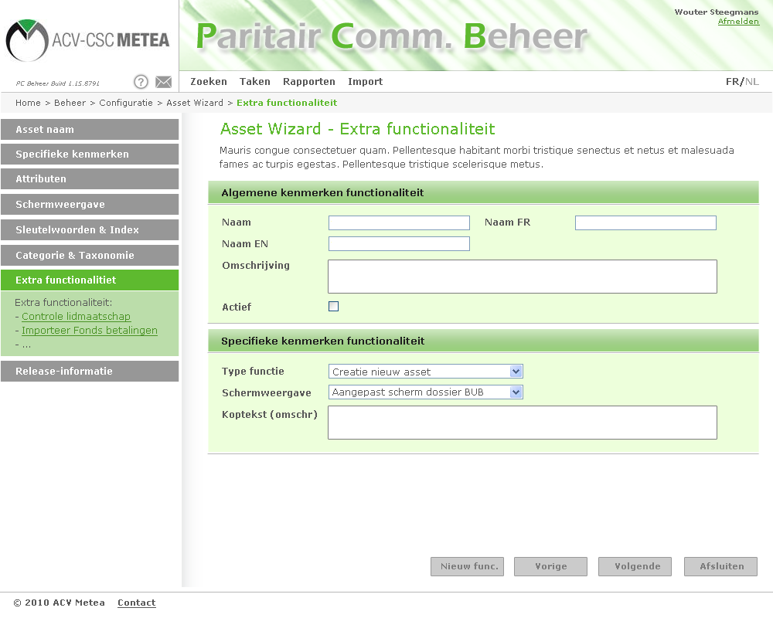

This isn’t working (see bug list).
It must also be possible to select default screens, so not only the extra added screens. So it’s maybe a good idea to just merge all the screens in one option where you have to define one screen as the default screen. So all functionality for the screens in one tab in the left column.

Printing report (Crystal Reports)
In the current procedures, a lot of forms and documents are used. These forms are not likely to disappear entirely. This is why a sort of Mail Merge feature has to be provided in the form of Crystal Reports reports, linked to an asset type.

In linking the report, the attribute or attributes of the asset type that are to be linked to the parameter(s) of the CR report should be specified. This way, a report containing all information of the open file can be selected by clicking one link.

This option is completely absent. For this option, it is important that a link can be created between the report and the asset. See also the extra added screen preview. TODO

Tasks in the user environment
Tasks are always linked to a certain asset type and to a certain category (the category of the asset type). Tasks are displayed on two locations:
- In the detailed view of an asset
- Via the “Tasks” menu

The “Tasks” menu
The tasks menu is always visible. This link leads to a page containing a tree structure on the left. When clicking branches of this tree, the linked tasks are displayed on the right. Since, for the Joint Committee a tree structure is created with a branch for every Joint Committee and a sub-branch for every scheme, the tasks can be quickly located and found.

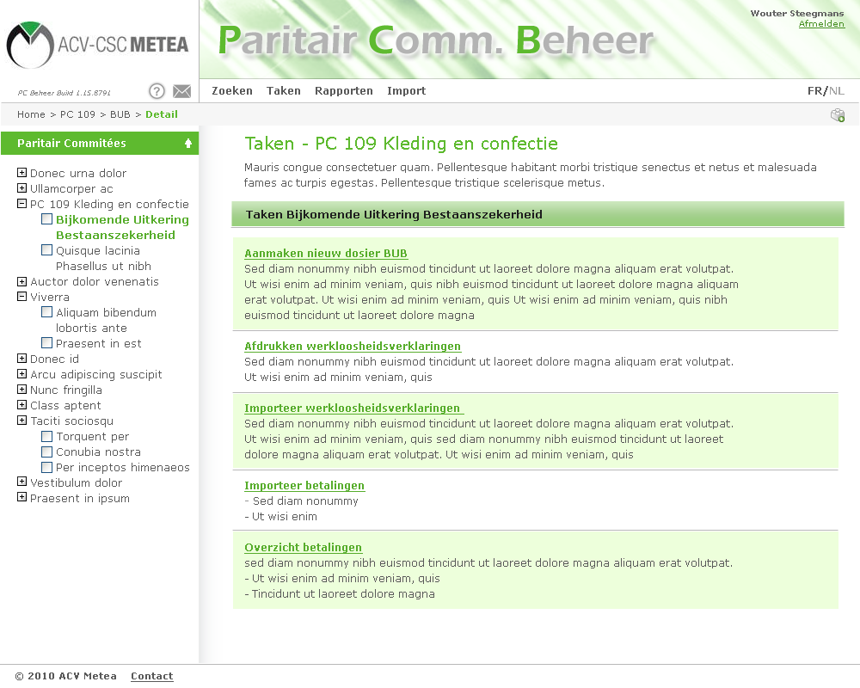

Tasks are now listed based on the taxonomy/category of the asset (file). That’s OK. But it’s not interesting to list all the assettypes below a certain taxonomy item. Just read all the tasks attached to the assettypes and list them.

In the screenshot example above, you see PC 109 Kleding en confectie (PC 109 Clothes and confection), below the next taxonomy item Bijkomende Uitkering bestaanszekerheid (Additional Benefit Substence Security). When clicking this taxonomy item, the user must see a list of all tasks attached to one or more asset types that are linked to the taxonomy item. In most cases, the tasks will be linked to the “file/dossier” assettype.

Maybe an interesting but very simple and easy addition is to add a SortPriority field to tasks. So using this SortPriority field, the tasks can be easily sorted in a convenient way for the user.

Tasks in the asset view.
In the asset view (non-edit mode) all tasks are listed that are linked to the asset type displayed. This way, a task can be launched quickly that is related to the open asset type.

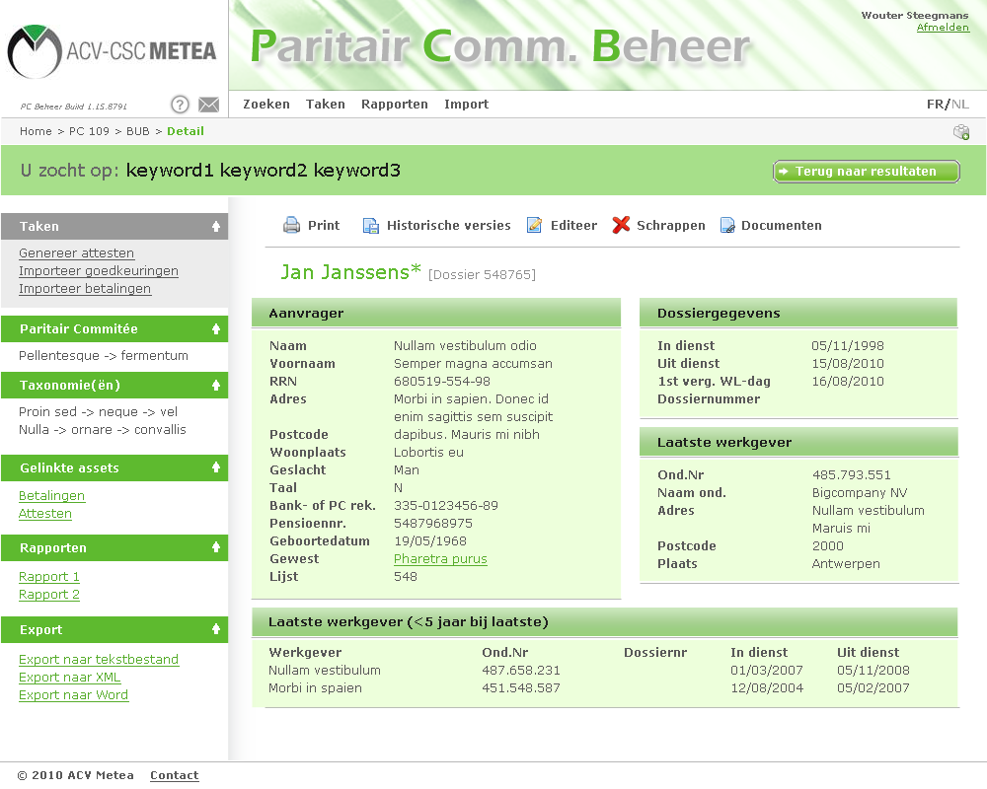
Tasks are only displayed if the user logged in has explicitly been given access to those tasks. By default, no tasks are being displayed (see next article).

Some UI adaptions:
- Make the tasks grey, with a grey background (see screenshot above)
- In the left column, Paritair Commitée must replace the defaulit Category (taxonomy)
- Align all text in the left column. No, the links for each block are aligned completely left.

I can’t test it yet, but reports also must be included in the left column. The functionality to link a report with an asset has to work here. So for example, a default official document for the request will be configured in a CR report. This official document can be printed just clicking the link because the link is configured and the active file on screen will be printed (sent to CR).

Also a problem in the current version are all the required asset management fields. As shown in the screenshots above, these are not present. The idea is to use the asset management system (as done), but not using this functionality. So the fields:
- Revision
- Barcode
- User
- Owner

are not useful for the end user. I suggest creating some similar functionality as the auto generate name. Revision will be updated automatically, and barcode, user and owner can be filled in automatically by using the logged in user and by auto generating a barcode. On top of this, it has to be possible to NOT necessary select these fields for every screen, or with the option to make them invisible.

Tasks and rights management
By default, nobody is linked to a task. This link has to be made in the “Management environment” by an Administrator. Ideal would be the use of integrated authentication and authorization (for instance through NetSqlAzMan). In this phase, this will not be implemented and tasks will be linked to a used one to one. Roles and rights are not used.

Linking tasks to users
Assigning rights to users should be extended with tasks. The same way rights (rules) are assigned, tasks are to be linked to users.

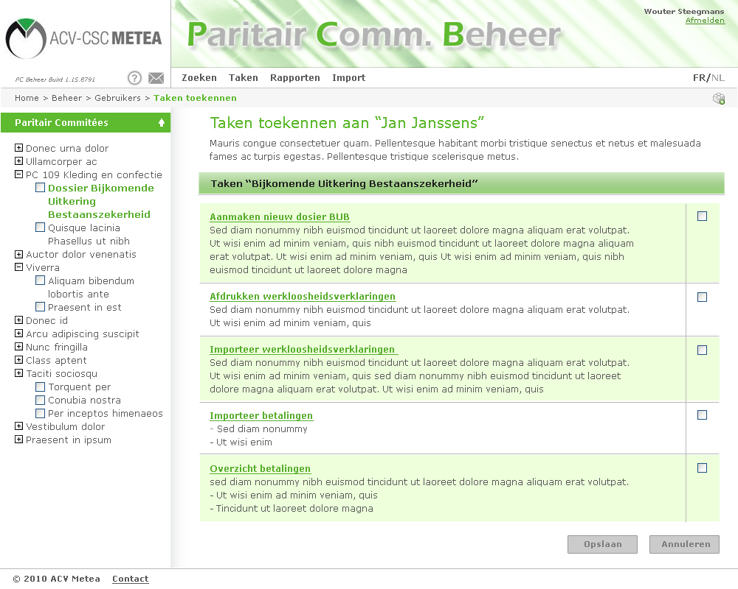

Tasks are always linked to an asset type. This type, in turn, is linked to a category. To make assigning tasks easy and manageable, a screen with the fill category structure at the bottom is displayed after selecting a user. Under this category structure you’ll find all asset types for which tasks are available.

The example above shows that, in the previous screen, the user Jan Janssens was selected for the assignment of tasks. At the left of the screen, the category structure is displayed (comparable to the screen under The “Tasks” menu). When an asset type is selected, in the example above, this is the asset type “File Additional Benefit Subsistence Security”, an overview is displayed at the right of all available tasks in this type. Using simple selection boxes, tasks can be linked to a user. Only the tasks explicitly linked, will be shown in the task overview for the user (through the Tasks menu) or will appear in the left column in an asset view of the asset type involved.

Not working (see bug list).

Design Additional Benefit Subsistence Security (BUB) – PC 109
This chapter describes the data flows and processes provided in the part for the Additional Benefit Subsistence Security.

The procedures in this document are the “new” procedure proposals. However, these are to be approved. We aim to everything digital to the extent possible in order to reduce paper flow.

Overview and design of entities (Data objects)
Below you’ll find an overview of various entities necessary for the BUB component:
- Person (Person)
- Company (Company)
- File (File)
- Certificate (Certificate)
- Payment (Payment)

- Installment (Installment - Config)
- Amount (Amount – Config)
- District (District – Config)

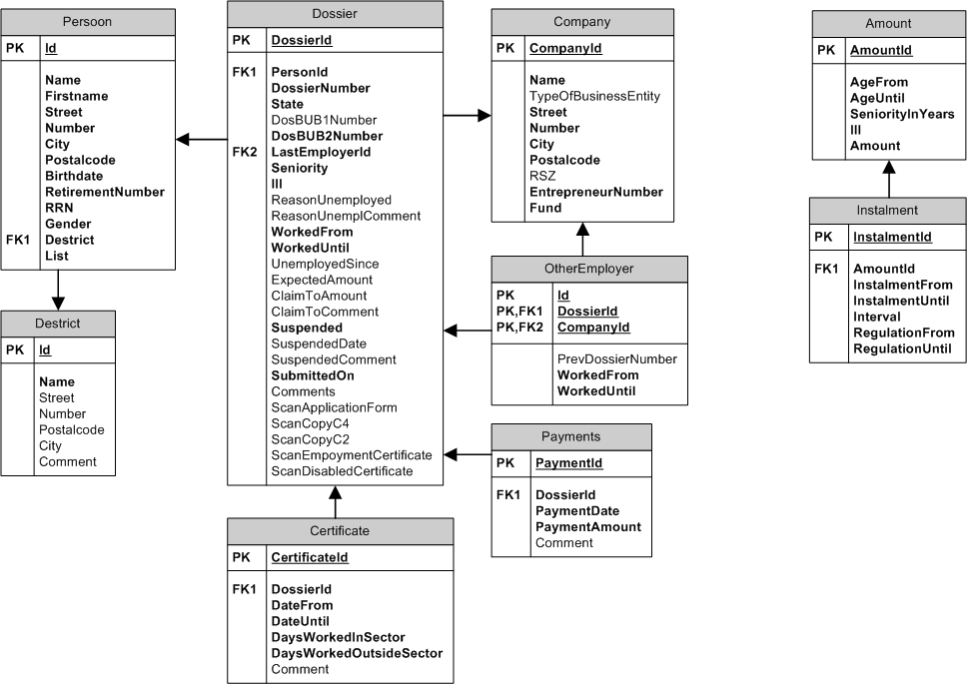

Person
The entity person speaks for itself. Of each person the data below is tracked (data model):

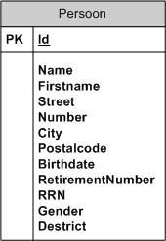

Name | Type | Comments
Id | Numeric | Unique ID for every individual (unique record number)
Name | Text | The name of the person
Firstname | Text | First name of the person
Street | Text | Street
Number | Text | Number
City | Text | City
Postalcode | Text | Postcode
Birthdate | Date | Date of Birth
RetirementNumber | Numeric | Retirement Number
RRN | Numerike | Rijksregisternummer (State Register Number)
Gender | Bit | Gender (M/F)
Destrict | Numeric | District (link to the district table)
List | Numeric | List number

Company
The “company” contains all information regarding the most recent employers of the various members (persons).

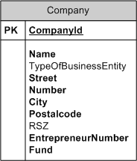

Name | Type | Comments
CompanyId | Numeric | Unique ID for every company/employer (unique record number)
Name | Text | The name of the person
TypeOfBusinessEntity | Text | Legal form
Street | Text | Street
Number | Text | Number
City | Text | City
Postcode | Text | Zip code
RSZ | Text | Replaced by Entrepreneur Number
EntrepreneurNumber | Text | Entrepreneur Number
Fund | Numeric | Fund

File
The file contains all information about the application, the approval, the acknowledgement and the payments (linked entity) of the application additional benefit subsistence security.

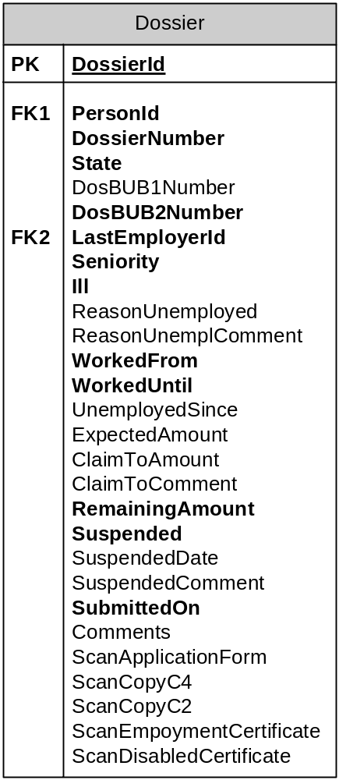

Name | Type | Comments
FileId | Numeric | Unique ID for every file (unique record number)
FileNumber | Numeric | File number (possibly different with unique FileId (recordId)
Status | Numeric | Status of the file:  0: New - New file (membership is to be verified)  1: MembershipOK  2: Running - Running  8: Suspended - Suspended (on resuming work)  15: Cancelled - Rejected/Cancelled  16 Ended - Ended
DosBUB1Number | Numeric | Referral to a previous file BUB (1)
DosBUB2Number | Numeric | Referral to a previous file BUB (2)
LastEmplyerId | Numeric | Link to company the applicant last worked
Seniority | Numeric | Seniority (number of months)
Ill | Bit | Does the applicant fall under the long-term illness scheme?
ReasonUnemployed | Text (Char) | Reason of unemployment (code)
ReasonUmemplComment | Text | Reason of unemployment (text, description, comment)
WorkedFrom | Date | Worked from (date) …
WorkedUntil | Date | Worked until (date) …
UnemplyedSince | Date | Unemployed since (date)
ExpectedAmount | Numeric | Amount to be expected for the applicant
ClaimToAccount | Numeric | Amount to which the applicant is entitled (granted by the fund)
ClaimToComment | Text | Comments with the amount to which the applicant is entitled
RemainingAmount | Numeric | The remaining amount that is to be paid (increased with every payment).
Suspended | Bit | Was the file suspended (due to renewed employment)
SuspendedDate | Date | Date of suspension of the file
SubmittedOn | Date | Creation and Submission date of the file
Comments | Text | General comments with the file
ScanApplicationForm | Binary | Scan of the application form
ScanCopyC4 | Binary | Scan of C4
ScanCopyC2 | Binary | Scan of the C2 form
ScanEmploymentCertificate | Binary | Scan of the employment form
ScanDisableCertifcate | Binary | Scan of certificate of unemployment

? | Are the fields DosBUB1Number and DosBUB2Number still necessary if we track all historic data of all files?

Certificate
Every three months, and in some cases annually, certificates need to be completed confirming that the applicant is still unemployed. The Certificate entity contains the details of these forms, even when they have been issued (printed and sent).

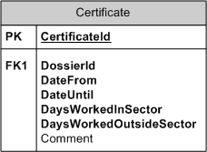

Name | Type | Comments
CertificateId | Numeric | Unique ID for every attest (unique record number)
FileId | Numeric | File number to which the certificate relates
DateFrom | Date | Period to which the certificate applies (start date)
DateUntiil | Date | Period to which the certificate applies (end date)
DaysWorkedInSector | Numeric | The number of days worked by the applicant. Work belonging in the same sector as BUB.
DaysWorkOutsideSector | Numeric | The number of days worked by the applicant outside of the sector.
Comment | Text | Description, comments regarding the attest or the number of days worked.

Payment
After every proven period of unemployment, the fund will proceed to pay. The Payment entity contains all payments made for a certain file (date + amount.

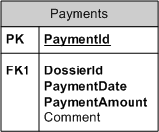

Name | Type | Comments
PaymentId | Numeric | Unique ID for every payment (unique record number)
FileId | Numeric | File number to which the payment relates
PaymentDate | Date | Date of payment (fixed payment dates of the fund)
PaymentAmount | Numeric | The amount paid
Comment | Text | Comment(s)

Other Employers
If the applicant has been employed by more than one employer during the past 5 years, these other employers have to be listed as well.

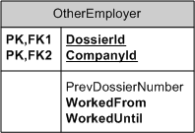

Name | Type | Comments
FileId | Numeric | File of the applicant listing his past 5 employers
CompanyId | Numeric | The company that employed the applicant
PrevFileNumber | Numeric | The previous file number
WorkedFrom | Date | Start date of the applicant with the company involved
WorkedUntil | Date | End date, date of retirement with the company

? | What is the use of tracking the file number with the various previous employers? What file number does this relate to? (can be found on the form “Application Additional Benefit Subsistence Security (document 1)”

Configuration- and base tables
In addition to the entities above, there are various entities that contain configuration data. These are required for calculation and to determine the degree of entitlement of a person.

Installment
The installments define when payments should be made. The standard installment is every other three months. In some cased (with employees over 50, with over 20 years of seniority who receive 3718,40 EUR ) the amount is divided over 5 brackets every other three months and afterwards, annual payment. This information is stored in the “Installment” entity.

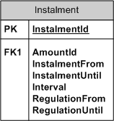

Name | Type | Comments
InstalmentId | Numeric | Unique ID for every installment configuration (unique record number)
AmountId | Numeric | Amount paid, link to entity “Amount”
InstalmentFrom | Numeric | To which installments the amount applies (for instance: installment 1 through 5. Afterwards, a different scheme/ amount applies)
InstalmentUntil | Numeric | Up to which bracket (installment) the amount applies
Interval | Numeric | Number of months between installments (3 months default)
RegulationFrom | Date | As of which date do the installments and the amounts linked apply. These can be changed by a decision of the Joint Commitee or by an index adjustment.
RegulationUntil | Date | Up to which date the installments and the amounts linked apply.

The settings above were created for the scheme below:

For those entitled to 3718,40EUR payment shall be done as follows:
The first 5 brackets of 247,89 EUR are paid per period of 3 months of full unemployment.
The remaining amount is paid per bracket of 247,89 EUR for each proven additional period of 1 year of uninterrupted unemployment.
If one has not used up the entire amount at the time of retirement, the remaining amount will be paid, with a maximum of 495,79 EUR.

The compensation for long-term illness (495,79 EUR) is paid in one installment.

For late and approved applications the Fund – even after all periods of full unemployment have been proven – only pays a disc of 247,89 EUR per month until the entire credit is exhausted.

Amount
The amount entity is the further configuration of the amounts and the installments. Both entities are mutually linked.

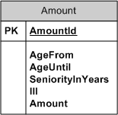

Name | Type | Comments
AmountId | Numeric | Unique ID for every amount (unique record number)
AgeFrom | Numeric | As of which (applicant) age) the amount applies
AgeUntil | Numeric | Up to which (applicant) age the amount applies
SeniorityInYears | Numeric | Minimal seniority of the applicant for the amount
Ill | Bit | Is the mount linked to the fact that the applicant is suffering long-term illness (other scheme)
Amount | Numeric | Amount corresponding to the age and seniority

To give some examples of the use of the two entities above; the following text has been included in the regulations concerning the BUB:

AMOUNTS

A. For fully unemployed:

Age Amount

< 30 j. 123,95 EUR
30 – 35 j 247,89 EUR
35 – 40 j 371,84 EUR
40 – 45 j 619,73 EUR
45 – 50 j 743,68 EUR
> 50 j 1239,47 EUR

Employees over 50 years of age that have at least 20 years of seniority in the sector, are given a social supervisor of 3718,40 EUR.

B. For people suffering a long-term illness:

495,79 EUR regardless of the age.

PAYMENT

The maximum lump sum per payment is 247,89 EUR.

The configuration below will be the result of the regulation above:

Installment Entity

InstalmentId | AmountId | InstalmentFrom | InstalmentUntil | Interval | RegulationFrom | RegulationUntil
1 | 1 | 1 | 999 | 3 | 1/1/1980 | Null
2 | 2 | 1 | 999 | 3 | 1/1/1980 | Null
…
6 | 6 | 1 | 999 | 3 | 1/1/1980 | Null
7 | 7 | 1 | 5 | 3 | 1/1/1980 | Null
8 | 7 | 6 | 999 | 12 | 1/1/1980 | Null
9 | 8 | 1 | 1 | 1 | 1/1/1980 | Null

Amount Entity

AmountId | AgeFrom | AgeUntil | SeniorityInYears | Ill | Amount
1 | 0 | 29 | -1 | False | 123,95
2 | 30 | 34 | -1 | False | 247,89
…
5 | 45 | 49 | -1 | False | 743,68
6 | 50 | 999 | -1 | False | 123,47
7 | 50 | 999 | 20 | False | 3718,40
8 | 0 | 999 | -1 | True | 495,79

District
This entity contains all districts.

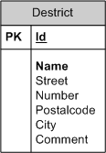

Name | Type | Comments
Id | Numeric | Unique ID for every district (unique record number)
Name | Text | Name of the district
Street | Text
Number | Text
Postcode | Text
City | Text
Comment | Text

Application Procedure (Functional description)
Below, you’ll find a description of the procedure that needs to be used for an application. There is a subdivision for every process and those involved in this process. This information is based on the Process Flow Diagram, described under “Application procedure – ”.

In the description below, new proposals are made to accelerate and facilitate the process flow and to make sure less paper is used and sent through (internal) mail.

The status is kept for every file. Based on this status, reports or overviews can be generated. Based on the status certain tasks can be performed, such as an overview of the files that are to be approved.

Status of the file:
0: New - New file (membership is to be verified)
1: MembershipOK - Membership is OK. (file is to be activated based on decision Fund)
2: Running - Running (at regular intervals, unemployment statements are printed for payment
8: Suspended - Suspended (on resuming work)
15: Cancelled - Rejected/Cancelled
16 Ended - Ended

Creating an application file – Service centre
The starting point of an application is the service centre. This is where the applicant goes with his C4 and where the application form is completed. The application form is completed digitally.

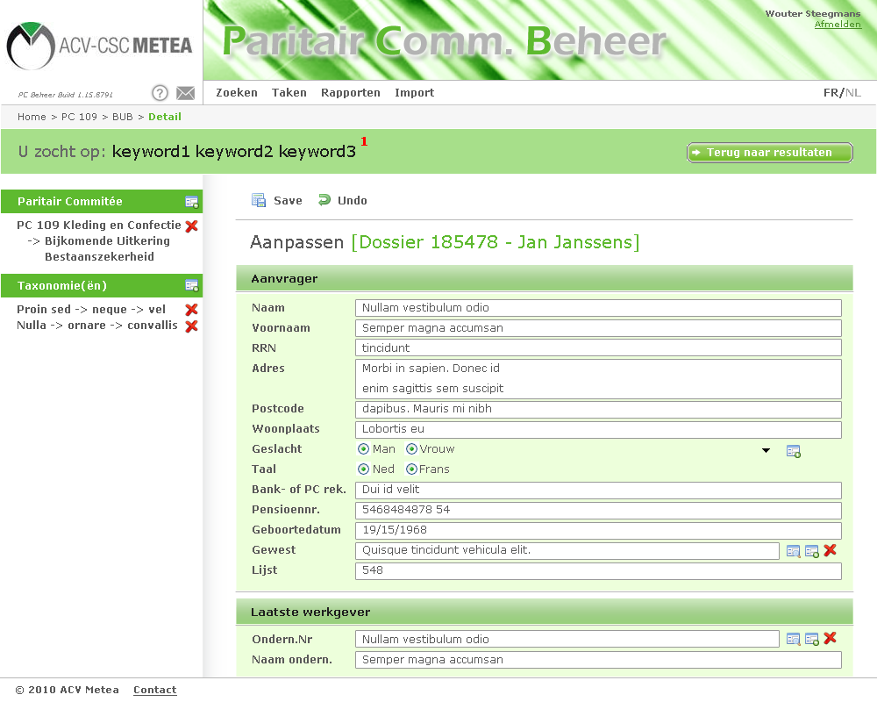
Figure 1: Entering/adjusting details BUB file
Figure 2: Overview (view) file
The service centre creates a new file and populates the files below (deviating the image above!)
- Person (looked up, if not available it will be entered)
  - Name
  - First name
  - Rijksregisternummer (State Register Number)
  - Address
  - Zip code
  - City
  - Bank- OR PC-account number
- Previous employer (looked up, if not available it will be entered)
  - RSZ-nr or entrepreneur number
  - Company name
  - Address
  - Zip code
  - City
- File data
  - Date of employment
  - Date of retirement
  - First compensated day of employment
  - File number (if BUB was previously enjoyed)
  - Scan of C4
  - Scan of C2
  - Scan of application form (if still used)
- Other employers (if less than 5 years with the same company)
  - Company (fine every company, if not available it is entered)
    - Company name
    - RSZ-number or Entrepreneur Number
    - File number (if BUB was previously enjoyed)
    - Date of employment
    - Date of retirement

? | The form “Application Additional Benefit Subsistence Security (document 1) can also be provided as a report. The data will be digitally entered in the service centre. If the Fund has a paper file, it can be printed.

Verification of membership – Professional Alliance Secretariat
The professional alliance will regularly process the new files and verify the membership.

The professional alliance will complement the form with any missing details. The status should be changed to MembershipOK.

Once the file is complete, it is sent to the National Fund. They will process it and determine the amount of entitlement of the applicant.

? | The procedure has been designed in such a way that nothing requires paper until the file has to be transferred to the National Fund. Here, negotiations should be reinitiated with the fund to see whether files can be transferred digitally, for instance as:  - PDF files (whether or not with a digital signature)  - Excel files (whether or not with a digital signature)

Tasks
In order to streamline the different steps in the BUB process (and other processes), tasks are provided that are linked to a user or a user group. This makes a number of tasks available to a certain user that are to be performed by him/her in the context of processing the BUB file.

The tasks below are available to BUB (can be extended):
- Entering new file (service centre)
- Verification of membership new files (professional alliance secretariat )
- Activating File (center)
- Printing unemployment certificates
- Importing unemployment certificates
- Importing payments

Figure 3: Tasks linked to BUB

Entering File Data – Center
As a final step, the file should be “activated”. This means that the amount and the number of payments are entered (based on the decision of the Fund).

The center complements the file with the data below (among other data):
- File
  - ExpectedAmount
  - ClaimToAmount (entitled amount, approved by Fund)
  - ClaimToComment (any comments with the approval/decision of the Fund)
  - State -> Running (2) (the file is activated, payments are made at regular intervals)

Payment Procedure (Functional description)
As soon as the file is approved and activated, payments can be made on the prescribed dates. In order to do this, it should be proved that those entitled are still unemployed, every time. To this end, unemployment statements are printed that have to be completed and stamped by the Payment Institution (IU). These stamped application forms are submitted to the fund that proceeds to pay.

? | The paragraph above is the procedure currently used. However, efforts should be made to eliminate the paper process in the middle and to transition into a full digital variant.  For instance:  - Use of secured Excel files  - Use of certified PDF files  The new protocol to be used should be submitted to the PC for approval. A possible way is the use of secured Excel files. Below a possible design is described.

Secured Excel files
As of Microsoft Excel 2002 a file can be given a digital signature. This makes it possible to guarantee that the file can no longer be changed after the inclusion of the digital signature in the file.

A digital signature makes it possible to replace paper certificates with a stamp by an Excel file with a digital signature. Below, we’ll describe a possible proposal for the unemployment statements.

Links to more information about the digital signature in Excel:
- http://support.microsoft.com/kb/820738/
- http://articles.techrepublic.com.com/5100-10878_11-5259668.html

Creation of Excel file for unemployment certificate (Center)
Every week, the Center creates an Excel file containing all files for which an unemployment certificate should be delivered by the Payment Institution. In stead of printing paper certificates, one Excel file is created (by the application) containing all files for which a payment should be made. This file is submitted to the Payment Institution for approval of all files.

Payment Interval
Payments by the Fund are made by default every other three months. However, there are exceptions, as described in “Configuration- and base tables”.

The selection criteria for the files for which an unemployment certificate needs to be issued by the Payment Institutions are as follows (Query):
- All open files that are not suspended
- Files for which the amount has not yet been exhausted (ClaimToAmount > RemainingAmount)
- Files for which the interval has passed (3 months by default, but it can also be 1 year, … → see the configuration in the basic tables per file)

The easiest is to go through all intervals and to select the files for every interval. For more information, see “Error: Reference source not found” under “Configuration- and base tabless”.

The value “InPaymenBatch” should be set to 1 (True) for all selected files. This means that the file is in the process of payment (first unemployment certificate, after approval to Fund for payment).

! | This feature and next import / export should be implemented using SQL Server Integration Services (SSIS) or an external program.

Unemployment verification (UI)
The payment institution receives an Excel file from the center containing all files for which an unemployment certificate needs to be issued. The Payment Institution verifies all files in the Excel File and complements the data below:
- Uninterrupted unemployment YES/NO
- Unemployment interrupted from __/__/__ to __/__/__ due to ……………………………

When all files have been processed, the UI will add a digital signature to the file. This way, all subsequent parties can verify whether the file has been changed since the changes of the payment institution.

Process unemployment certificates (Professional Alliance)
The professional alliance receives the Excel File containing all unemployment certificates of the Payment Institution (by e-mail or secured FTP). This file is read into the program, updating the files in case of any interruption of unemployment.

The Excel file is also sent (by FTP or e-mail) to the Social Fund. They will use the data to proceed to payment.

The Fund can update this file or continue to use their own (text)file to provide the Center with feedback of the payments made.

Processing Payments (Professional Alliance/Center)
The file of the Fund containing the payments made is read and the files and the linked payments are updated.

For every file for which a payment was made, the field “InPaymenBatch” should be set to 0 (False) again in addition to storing the payment details (in a separate table). This way, the fill will be placed in the queue for a next payment.

If the maximum amount is exhausted after the final payment, (RemainingAmount = 0), the status of the file should be adjusted (State -> 16 – Ended).

In this case, there is no need to notify the professional alliances, as they have access to the files and payments.

? | If the files of the Fund will continue to be used, the layout of these files is required. Both for the files of approvals and the files containing the payments.

Design Social Support – PC 120.00
[...]

Overview and design entities (data objects)
Below an overview of the various entities used for SOB:
- Person
- Company
- File
- Certificate
- Payment

- (Payments)Period (Installment - Config)
- Amount (Amount – Config)
- District (District – Config)

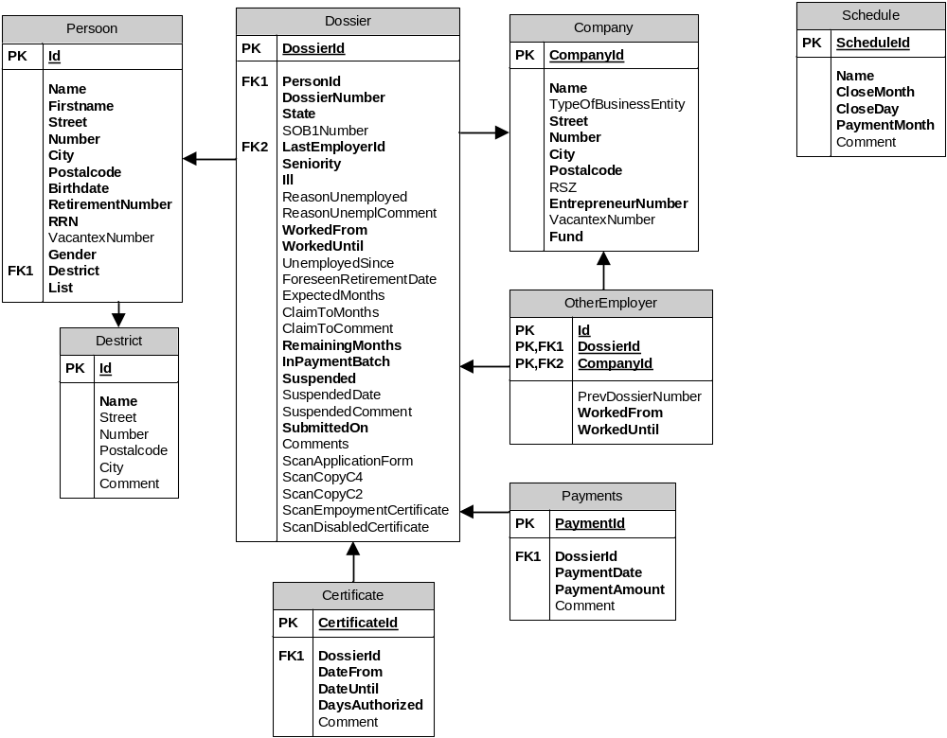

Person
The details kept of every person (applicant).
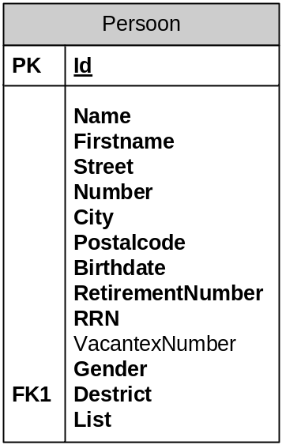

Name | Type | Comments
Id | Numeric | Unique ID for every person (unique record number)
Name | Text | The name of the person
Firstname | Text | First name of the person
Street | Text | Street
Number | Text | Number
City | Text | City
Postalcode | Text | Postcode
Birthdate | Date | Date of Birth
RetirementNumber | Numeric | Retirement Number
RRN | Numeric | Rijksregisternummer (State Register Number)
VacantexNumber | Numeric | Vacantex number
Gender | Bit | Gender (M/F)
Destrict | Numeric | District (link to the district table)
List | Numeric | List number

? | Would it be an option to centralize the details for persons in one table, both for BUT, SOB and for future other compensations?

Company
The “company” contains all information regarding the most recent employer(s).

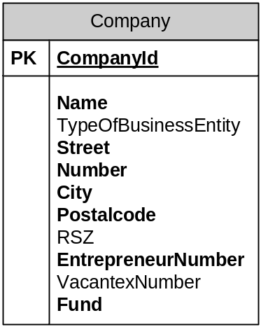

Name | Type | Comments
CompanyId | Numeric | Unique ID for every company/employer (unique record number)
Name | Text | The name of the person
TypeOfBusinessEntity | Text | Legal form
Street | Text
Number | Text
City | Text
Postcode | Text
RSZ | Text | Replaced by Entrepreneur Number
EntrepreneurNumber | Text | Entrepreneur Number
VacantexNumber | Numeric | Vacantex number of the company
Fund | Numeric | Fund

File
This entity contains all information regarding the SOB file.

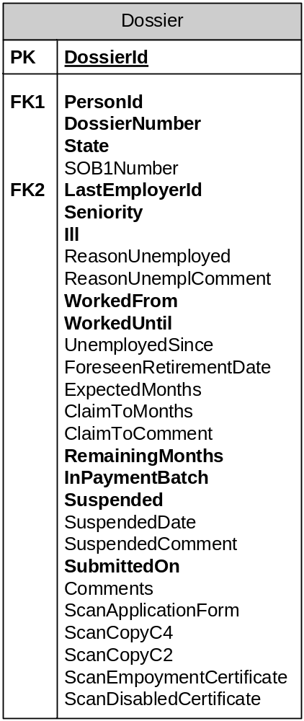

Name | Type | Comments
FileId | Numeric | Unique ID for every file (unique record number)
FileNumber | Numeric | File number (possibly different with unique FileId (recordId)
Status | Numeric | Status of the file:  0: New - New file (membership is to be verified)  1: MembershipOK  2: Running - Running  8: Suspended - Suspended (on resuming work)  15: Cancelled - Rejected/Cancelled  16 Ended - Ended
DosSOB1Number | Numeric | Referral to a previous file SOB (1)
LastEmployerId | Numeric | Link to company the applicant last worked
Seniority | Numeric | Seniority (number of months)
Ill | Bit | Does the applicant fall under the long-term illness scheme?
ReasonUnemployed | Text (Char) | Reason of unemployment (code)
ReasonUmemplComment | Text | Reason of unemployment (text, description, comment)
WorkedFrom | Date | Worked from (date) …
WorkedUntil | Date | Worked until (date) …
UnemployedSince | Date | Unemployed since (date)
ForeseenRetirmentDate | Date | (Foreseen date of (early) retirement
ExpectedMonths | Numeric | Expected number of months of compensation for the applicant
ClaimToMonths | Numeric | Number of months to which the applicant is entitled (allocated by fund)
ClaimToComment | Text | Comments with the amount to which the applicant is entitled
RemainingMonths | Numeric | Number of remaining months.
Suspended | Bit | Is the file suspended (due to renewed employment)
SuspendedDate | Date | Starting date of file suspension
SubmittedOn | Date | Date of creation and submission of the file
Comments | Text | General comments with the file
ScanApplicationForm | Binary | Scan of the application form
ScanCopyC4 | Binary | Scan of C4
ScanCopyC2 | Binary | Scan of the C2 form
ScanEmploymentCertificate | Binary | Scan of the employment form
ScanDisableCertifcate | Binary | Scan of certificate of disability

Certificate
Every three months, certificates need to be completed confirming that the applicant is still unemployed. The Certificate entity contains the data of these forms.

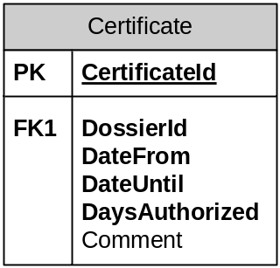
Comments
Name | Type | Comments
CertificateId | Numeric | Unique ID for every attest (unique record number)
FileId | Numeric | File number to which the certificate relates
DateFrom | Date | Period to which the certificate applies (start date)
DateUntiil | Date | Period to which the certificate applies (end date)
DaysAuthorized | Numeric | Number of days of benefit entitlement for unemployment benefit (in other words: number of days SOB will be paid in proportion of €2.48/day
Comment | Text | Description, comments regarding the attest or the number of days worked.

Payment
After each proven period of unemployment, the fund will proceed to pay. The Payment entity contains all payments completed for a certain file (date + amount).

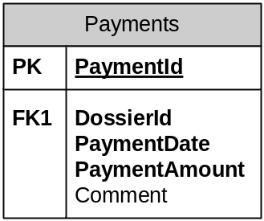

Name | Type | Comments
PaymentId | Numeric | Unique ID for every payment (unique record number)
FileId | Numeric | File number to which the payment relates
PaymentDate | Date | Date of payment (fixed payment dates of the fund)
PaymentAmount | Numeric | The amount paid
Comment | Text | Comment(s)

? | Does the fund send data regarding the payments made? If so, please include file and file layout.

Other employers
If the applicant has been employed by one or more employer during the past 5 years, these other employers should be listed as well.

Name | Type | Comments
FileId | Numeric | File of the applicant listing his past 5 employers
CompanyId | Numeric | The company that employed the applicant
PrevFileNumber | Numeric | The previous file number
WorkedFrom | Date | Start date of the applicant with the company involved
WorkedUntil | Date | End date, date of retirement with the company

Configuration- and base tables
In addition to the entities above, there are several entities containing configuration details. These are necessary to make calculations and to determine the entitlement of people (number of months). By using these tables, new agreements can be easily implemented in the future, without or with little programming.

Schedule
All payments are always made on the exact same moment. The period is 3 months (quarter).

BETALING

Bank account

Time of payment
The social assistance is paid every quarter. The following directional data can be taken into account:

Date of conclusion Payment date
1st quarter 30 April mid May
2nd quarter 15 August late August
3rd quarter 31 October mid November
4th quarter 31 January mid February

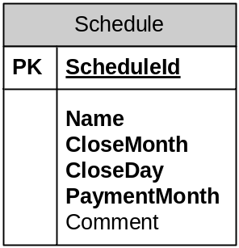

Name | Type | Comments
ScheduleId | Numeric | Identifier
Name | Text | Description (“1st quarter”, …)
CloseMonth | Numeric | Closing month of the term (April, August, October and January)
CloseDay | Numeric | Closing date of the period(30, 15, 31, 31)
PaymentMonth | Text | Description when payment will be completed (approximation
Comment | Text | Comments

Application Procedure (Functional description)
Below, the procedure is described that is to be used during the application for Social Support. The process is subdivided in various steps, at every step the person involved in the process is listed. This information is based on the Process Flow Diagram, described under “Application procedure – overview”.

In the description below, the current flow is being deviated from. This way, a proposal is made to accelerate and facilitate the process flow and to use and send less paper through (internal) mail.

The status is tracked for every file. Based on this status, reports or overviews van be created. Based on the status, certain tasks can be performed as well, such as an overview of which files are to be approved.

Status of the file:
0: New - New file (membership is to be verified)
1: MembershipOK - Membership is OK. (file is to be activated based on decision Fund)
2: Running - Running (at regular intervals, unemployment statements are printed for payment
8: Suspended - Suspended (on resuming work)
15: Cancelled - Rejected/Cancelled
16 Ended - Ended

Creating unemployment file – Service centre
The starting point of an application is the service centre. This is where the applicant goes with C4 form and any other forms. The application form will be filed digitally by the service centre. The functionality and the screen lay out largely correspond with the one of BUB (PC 109.00). See “Creating an application file – Service centre”.
The service centre creates a new file and completes the fields below.
- Person (looked up, if not available it is entered)
  - Name
  - First name
  - Address
  - Zip code
  - City
  - Date of Birth
  - Rijksregisternummer (State Register Number)
- Last employer (looked up, if not available it is entered)
  - RSZ-no, or entrepreneur no.
  - Vacantex number
  - Company name
  - Address
  - Zip code
  - City
- File data
  - Start of employment
  - Retirement
  - First compensated day of employment
  - File number (if SOB was enjoyed earlier)
  - Scan of C4
  - Scan of C2
  - Scan application form (if still used)

? | The form “First application form for additional unemployment compensation – Section SOCIAL ASSISTANCE” can also be provided as a report in the application. In that case the date will be digitally entered in the service centre, and if necessary, printed for the Fund.

Verification membership – Professional Alliance Secretariat
The professional alliance will process the files and verify the membership at regular intervals.

The professional alliance will complement the file with any missing details. The status should be changed into MembershipOK.

When the file is complete, it is dent to the National Fund. They will process it and determine the entitlement of the applicant.

? | The procedure is designed as such that everything is done without paper, until a file has to be transferred to the National Fund. Here, negotiations have to be reinitiated with the fund, to see if files can be transferred digitally, for instance:  - PDF files (whether or not with a digital signature)  - Excel files (whether or not with a digital signature)

? | In the current process flow, the file is sent to the center first. Is this still necessary in this new form?

Verification of data + submission (Center)
? | Could this step be skipped?

Inserting payment codes (Center)
As a final step, the file is to be “activated”. This means that the number of payments is entered (based on the decision of the Fund).

The center complements the form with the data below (among other data):
- File
  - ExpectedMonths
  - ClaimToMonths (entitled amount, approval by Fund)
  - ClaimToComment (any comments with the approval/decision of the Fund)
  - State -> Running (2) (the file is activated, payments are made at regular intervals)

Payment procedure (Functional description)
As soon as the file is approved and activated, payments can be made on the prescribed dates. In order to do this, it should be proved that those entitled are still unemployed, every time. To this end, unemployment statements are printed that have to be completed and stamped by the Payment Institution (IU). These stamped application forms are submitted to the fund that proceeds to pay.

? | The paragraph above is the procedure currently used. However, efforts should be made to eliminate the paper process in the middle and to transition into a full digital variant.  For instance:  - Use of secured Excel files  - Use of certified PDF files  The new protocol to be used should be submitted to the PC for approval. A possible way is the use of secured Excel files. See “Secured Excel ”.

Creation of Excel file for inventory of days of unemployment (Center)
At the end of every quarter the Center creates an Excel file containing all files for which an unemployment certificate should be delivered by the Payment Institution. In stead of printing paper certificates, one Excel file is created (by the application) containing all files for which a payment should be made. This file is submitted to the Payment Institution for approval of all files.

Payment Interval
Payments by the Fund are made by default every other three months. The configuration regarding the quarters can be found under “Configuration- and base tables”.

The selection criteria for the files for which an unemployment certificate needs to be issued by the Payment Institutions are as follows (Query):
- All open files that are not suspended
- Files for which the amount has not yet been exhausted (ClaimToMonths > RemainingMonths)

The value “InPaymenBatch” should be set to 1 (True) for all selected files. This means that the file is in the process of payment (first unemployment certificate, after approval to Fund for payment).

Unemployment verification (UI)
The payment institution receives an Excel file from the center containing all files for which an unemployment certificate needs to be issued. The Payment Institution verifies all files in the Excel File and complements the data below::
- Uninterrupted unemployment YES/NO
- Number of days entitled to benefit (for unemployment benefit)
- Date

When all files have been processed, the UI will add a digital signature to the file. This way, all subsequent parties can verify whether the file has been changed since the changes of the payment institution.

Process unemployment certificates (Center)
The professional alliance receives the Excel File containing all unemployment certificates of the Payment Institution (by e-mail or secured FTP). This file is read into the program, updating the files in case of any interruption of unemployment.

The Excel file is also sent (by FTP or e-mail) to the Social Fund. They will use the data to proceed to payment.

The Fund can update this file or continue to use their own (text)file to provide the Center with feedback of the payments made.

Processing Payments (Center)
The file of the Fund containing the payments made is read and the files and the linked payments are updated.

For every file for which a payment was made, the field “InPaymenBatch” should be set to 0 (False) again in addition to storing the payment details (in a separate table). This way, the fill will be placed in the queue to be selected for a next payment.

If the maximum amount is exhausted after the final payment, (RemainingAmount = 0), the status of the file should be adjusted (State -> 16 – Ended).
In this case, there is no need to notify the professional alliances, as they have access to the files and payments.

? | If the files of the Fund will continue to be used, the layout of these files is required. Both for the files of approvals and the files containing the payments.

