SUPERSTORE SALES
PERFORMANCE ANALYTICS
A Complete Data Analytics Case Study
Prepared by SARTHAK BALIYAN
Data Analyst Internship — SWYNEX Technologies
Task 4: Final Data Analytics Project
September 2026

Executive Summary
This case study presents a complete, end-to-end data analytics workflow performed on the Superstore Sales dataset — a real-world retail dataset covering 8,399 orders placed between January 2009 and December 2012. The project spans four stages: data cleaning, exploratory data analysis, interactive dashboard design, and business insight synthesis.
The analysis surfaces a critical business problem hiding beneath a seemingly healthy top line: while the business is profitable overall (10.2% margin), over half of all individual orders (50.8%) actually lose money. The root cause traces to the Furniture category, which drives significant sales volume but earns a fraction of the margin of Technology and Office Supplies — driven largely by heavy losses on Tables and Bookcases.

1. Problem Statement
Superstore's leadership wants to understand why company-wide profit margins remain modest despite strong total sales. Specifically, this project set out to answer:
- Which product categories and sub-categories drive the most sales, and which drive the most profit?
- Are there hidden loss-making segments that a top-line view of “total sales” and “total profit” would obscure?
- What role does discounting play in eroding profitability?
- How has performance trended over time, and are there seasonal patterns worth planning around?
The goal was to move beyond high-level totals and produce an interactive tool that lets stakeholders explore these questions themselves, filtered by region, customer segment, and order priority.

2. Dataset Information
Attribute | Detail
Dataset | Superstore Sales (Canada)
Source | Public dataset, GitHub mirror (curran/data)
Size | 8,399 orders × 21 columns
Time period | January 2009 – December 2012
Key fields | order_date, ship_date, sales, profit, discount, product_category, product_sub_category, region, customer_segment, order_priority

3. Data Cleaning Process (Task 1)
The raw dataset was inspected and cleaned using Python (pandas). The following issues were identified and resolved:
Issue Found | Fix Applied
order_date / ship_date stored as text | Converted to proper datetime type
Misspelled province “Saskachewan” (913 rows) | Standardized to “Saskatchewan”
63 missing values in product_base_margin | Imputed using category-level median
Inconsistent column naming (spaces/mixed case) | Standardized to snake_case
1,672 rows with placeholder “Not Specified” priority | Kept as its own explicit category, not imputed
4 rows with repeated order_id + product_name | Verified as legitimate repeat line items, not duplicates
Result: 8,399 rows retained (none dropped), 0 missing values remaining, all data types corrected.

4. Exploratory Data Analysis (Task 2)
With a clean dataset, statistical analysis in Python (pandas, matplotlib) uncovered the following patterns:

4.1 Furniture: high volume, low margin
Furniture generates $5.18M in sales — nearly as much as Technology's $5.98M — but earns only a 2.3% profit margin, versus 14.8% for Technology and 13.8% for Office Supplies.
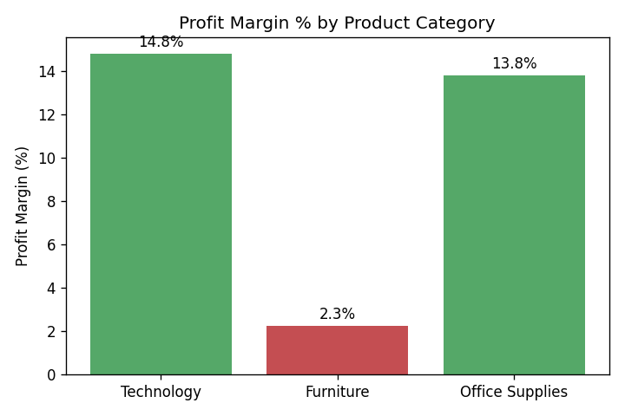
Figure 1: Profit margin % by product category

4.2 Over half of all orders are unprofitable
50.8% of the 8,399 orders have negative profit — despite the business being profitable overall. This points to a systemic pricing issue rather than a handful of bad orders.
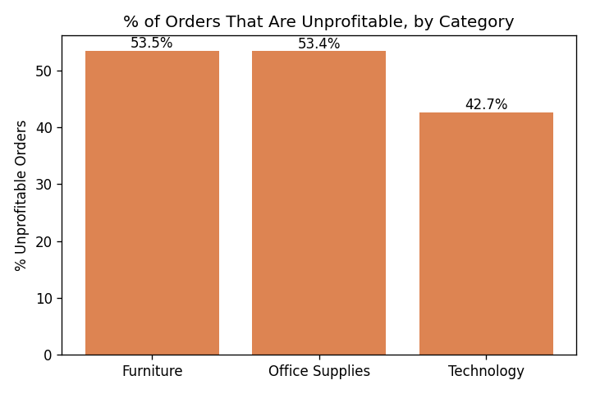
Figure 2: % of orders that are unprofitable, by category

4.3 Losses concentrated in specific sub-categories
Tables (-$99,063) and Bookcases (-$33,582) are responsible for the majority of the Furniture category's poor performance. One single order in Office Machines lost $14,140 alone.
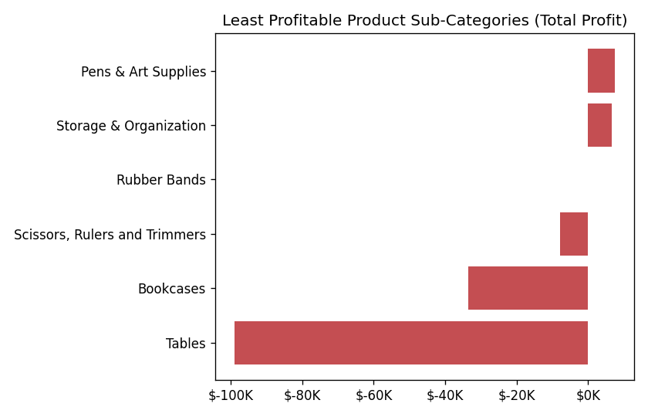
Figure 3: Least profitable product sub-categories

4.4 Discounting is not the driver
The correlation between discount level and profit is only -0.037 — essentially no relationship. This rules out excessive discounting as the cause of the losses; the issue lies in underlying product cost and pricing structure.

4.5 Sales declined, then partially recovered
Annual sales fell from $4.21M (2009) to $3.44M (2011), a ~12% drop, before a modest recovery to $3.72M in 2012.
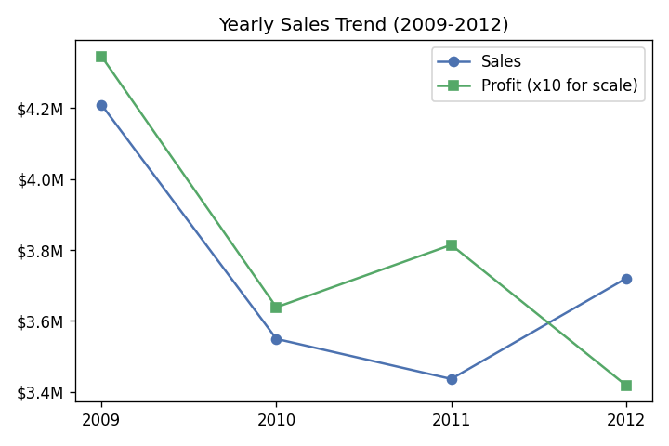
Figure 4: Yearly sales trend, 2009–2012

5. Interactive Dashboard (Task 3)
The findings above were consolidated into an interactive Power BI dashboard, allowing stakeholders to explore the data by Region, Customer Segment, and Order Priority.
Total Sales  $14.92M | Total Profit  $1.52M | Profit Margin  10.2% | Unprofitable Orders  50.8%

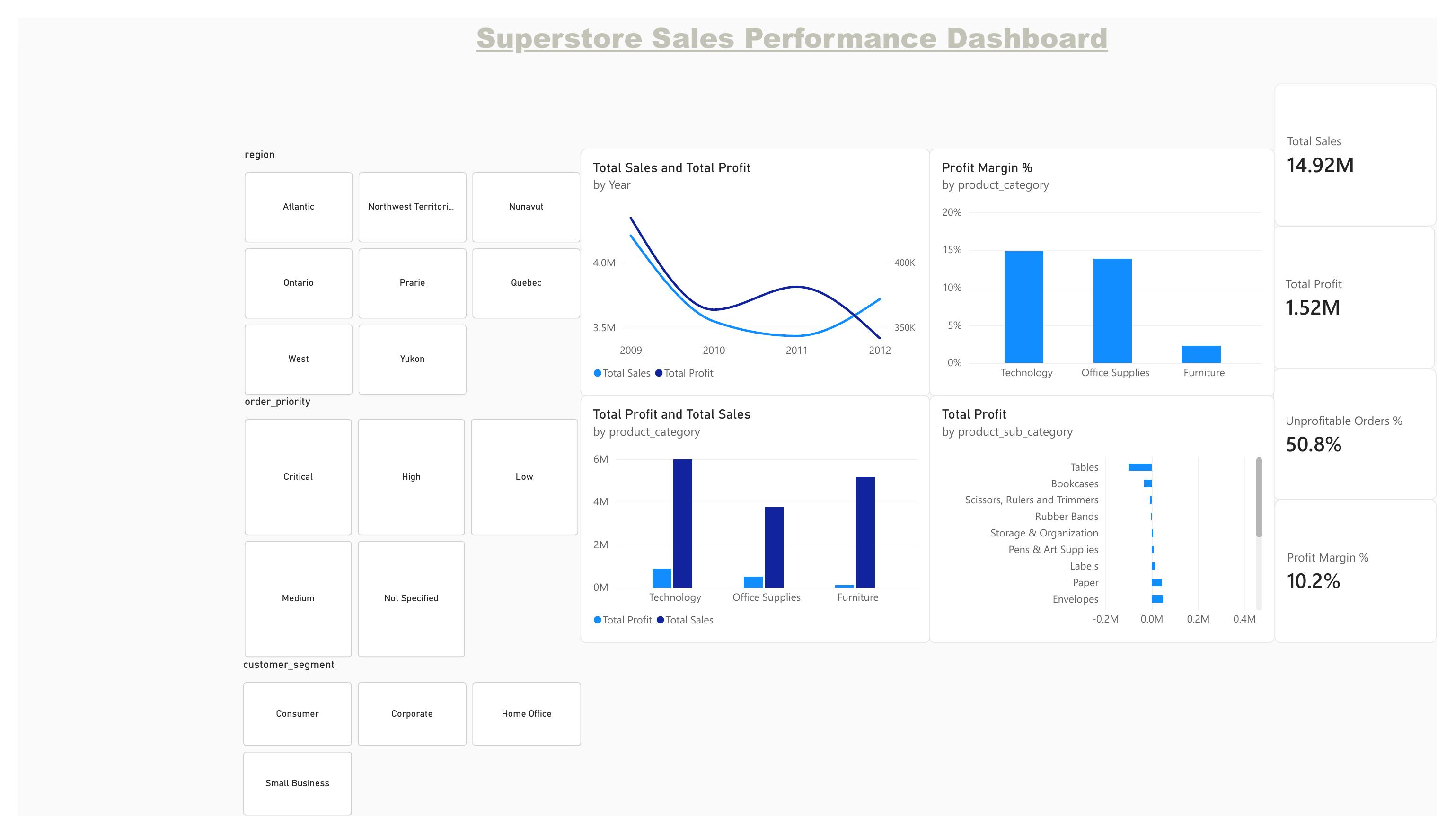
Figure 5: Superstore Sales Performance Dashboard (Power BI)
The dashboard includes four KPI cards, four charts (category comparison, margin comparison, yearly trend, and sub-category losses), and three interactive slicers, all updating simultaneously when a filter is applied.

6. Key Business Insights & Recommendations
# | Insight | Recommended Action
1 | Furniture sells at Technology-level volume but 2.3% margin | Review Furniture pricing/supplier costs; consider phasing out the worst-performing SKUs
2 | 50.8% of orders are unprofitable despite healthy overall margin | Investigate per-order cost structure, not just category-level pricing
3 | Tables and Bookcases drive most Furniture losses | Renegotiate supplier terms or reprice these two sub-categories specifically
4 | Discounting is not correlated with the losses | Focus cost-reduction efforts on production/shipping cost, not sales discount policy
5 | Sales declined 12% from 2009–2011 before recovering | Investigate what drove the 2012 recovery and replicate those conditions

7. Conclusion
This project demonstrates a full analytics lifecycle — from raw, messy data to a decision-ready interactive dashboard. The most valuable output is not the headline profit figure, but the discovery that half of all orders lose money, concentrated in a specific, addressable part of the product catalog. This is the kind of insight a surface-level report would miss, and it directly informs where SWYNEX (or any retailer) should focus margin-improvement efforts.

8. Project Links
- Task 1 – Data Cleaning: GitHub link
- Task 2 – Exploratory Data Analysis: GitHub link
- Task 3 – Interactive Dashboard: GitHub link
- Task 4 – Full Case Study (this document): GitHub link

