Gradual Onset Performance Task (gradCPT) Instructions

Installation and of gradCPT app
- Download the MyAppInstaller_mcr.exe – This process will require admin privilege. You may see something similar to the following dialog box, make sure you download anyway.
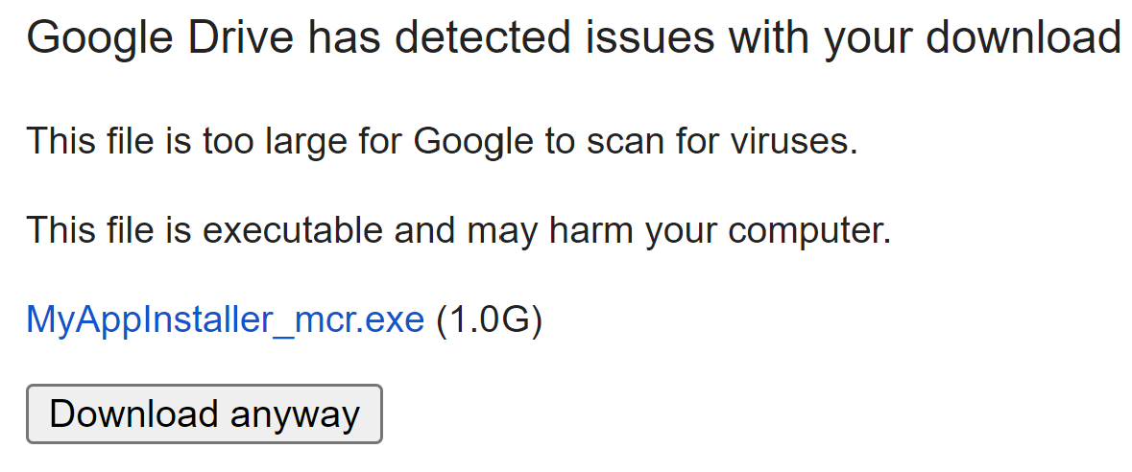
- Once downloaded, run the matlab runtime installation file in your downloads folder: MyAppInstaller_mcr.exe.
  - When you first run this installation file, if the following dialog box is initiated, make sure you press “More info”, then “Run anyway”.
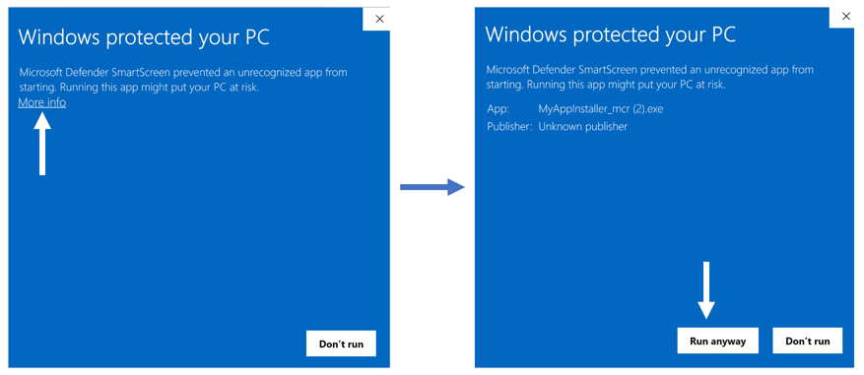
  - This will initiate the gradCPT installer (see below). The default installation is strongly suggested. All program files will be downloaded to the following path: C:\Program Files\gradCPTv01\application\ . For the rest of the installation, the defaults are also appropriate. Below is a visual of the instillation process.
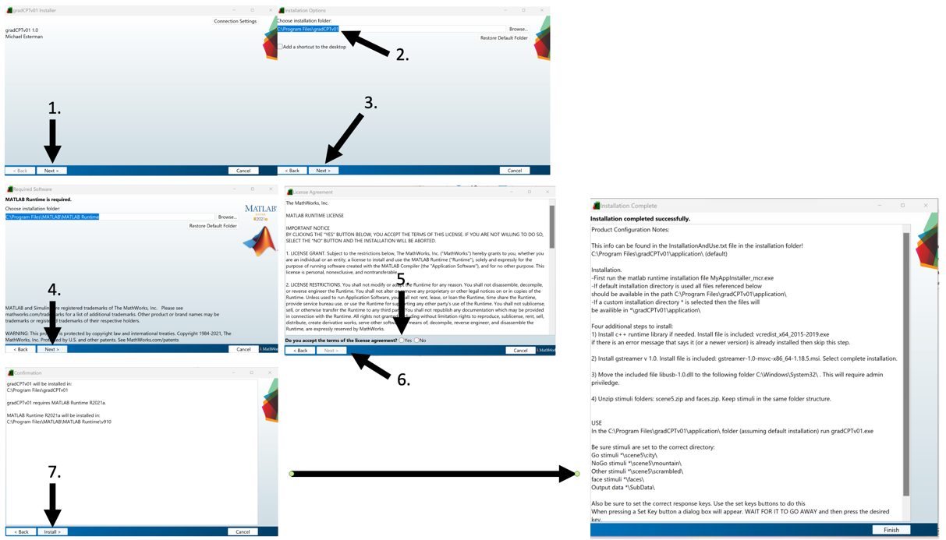

- Install additional programs as needed. The additional required programs can be found in the following path: C:\Program Files\gradCPTv01\application\
  - Install c++ runtime: Run the following file: vcredist_x64_2015-2019.exe
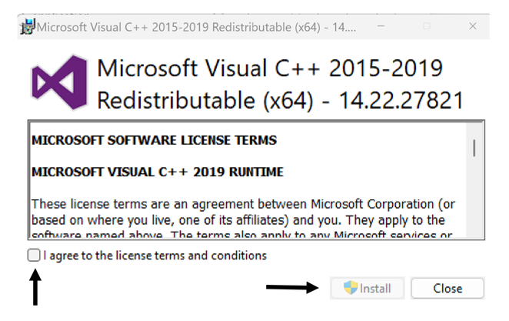
    - If there is an error message that your computer already has c++ runtime installed (see below), skip this step.
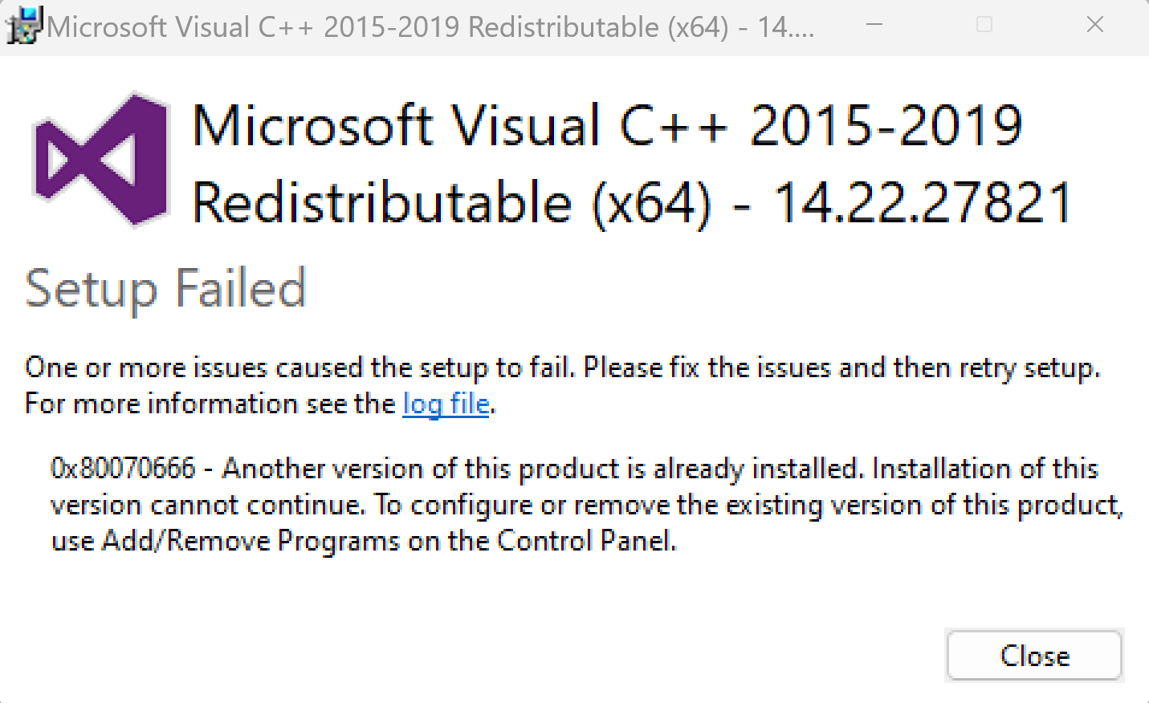
  - Install gstreamer: Run the following file: gstreamer-1.0-msvc-x86_64-1.18.5.msi
    - Follow the prompts to install gstreamer (see below). Make sure you install the Complete Setup Type.
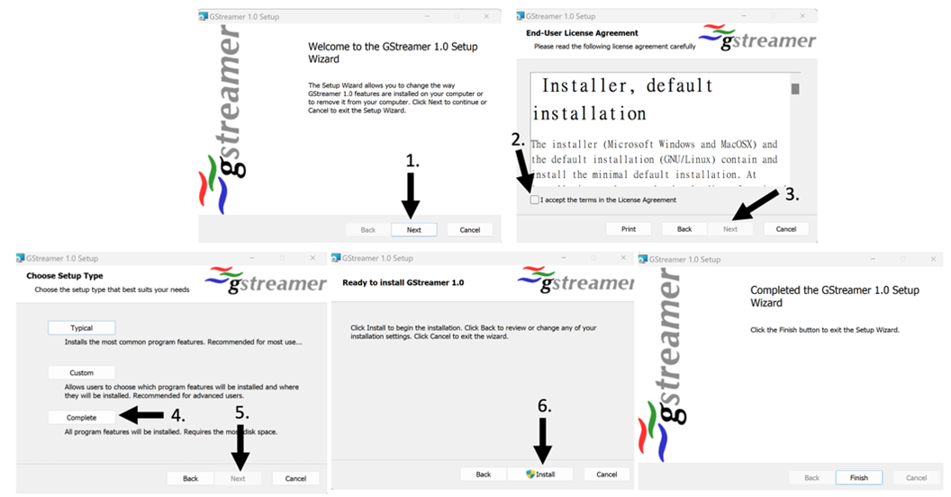
- Move or copy the included file libusb-1.0.dll to the following folder: C:\Windows\System32\
  - This will require admin privilege.

- Unzip stimuli folders: scene5.zip and faces.zip. Keep stimuli in the same folder structure, and make sure you extract the folder to C:\Program Files\gradCPTv01\application (see below). Once you unzip these files folders, you can delete the zipped files.
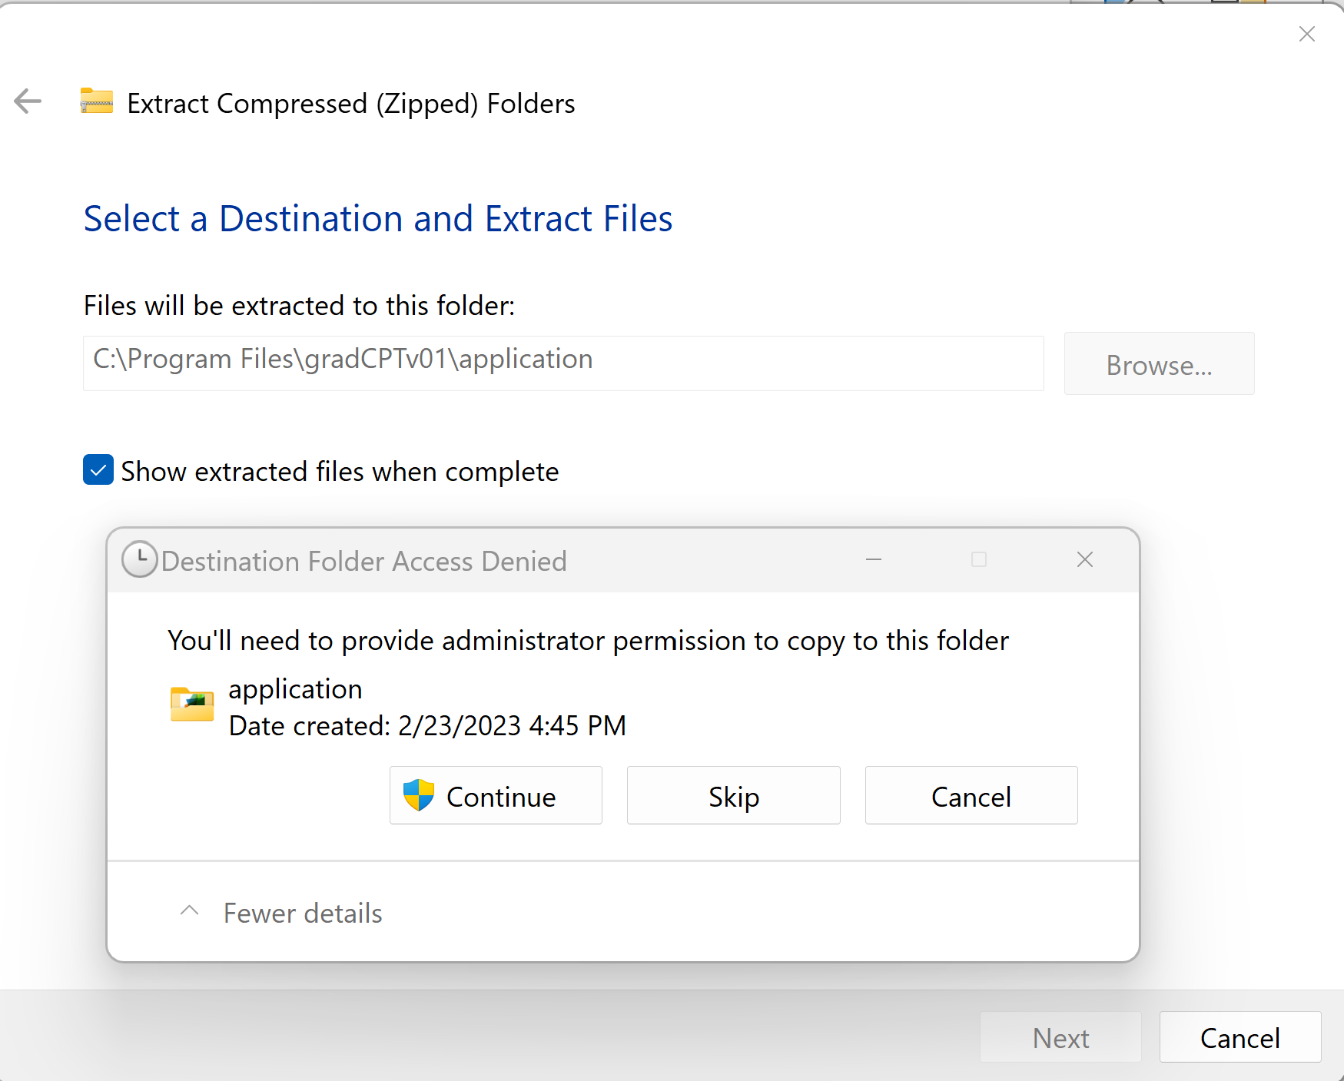
- The files in the folder should now look like this:
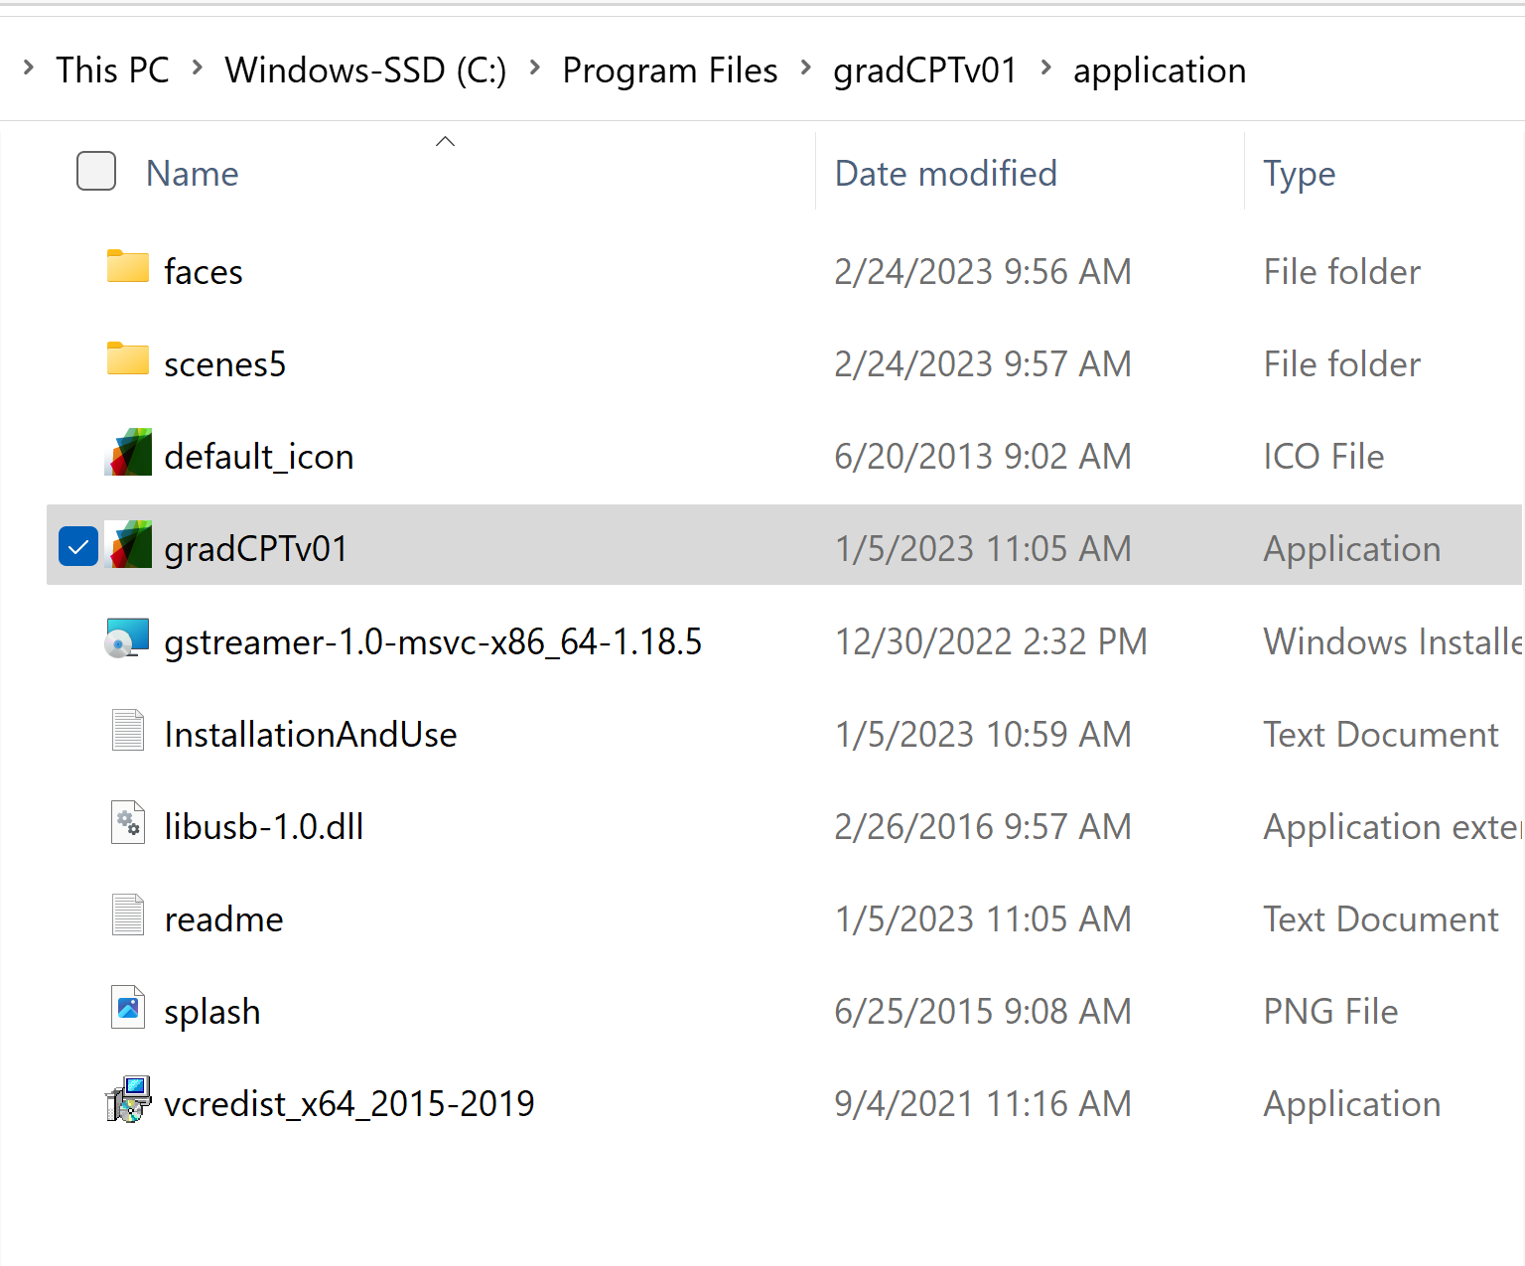
- Make a new folder to save app settings and participant data. This folder should NOT be placed in the application or Program Files directory. Instead create it somewhere in within your user directory. For example:
C:\Users\USERNAME\Documents\gradCPT\DataOutput\

Setup of the gradCPT app before the MRI scanner
- Set screen resolution of the laptop to 1024 x 768.
- In the C:\Program Files\gradCPTv01\application\ folder (assuming default installation) run “gradCPTv01.exe”.
  - This will initiate the gradCPT GUI
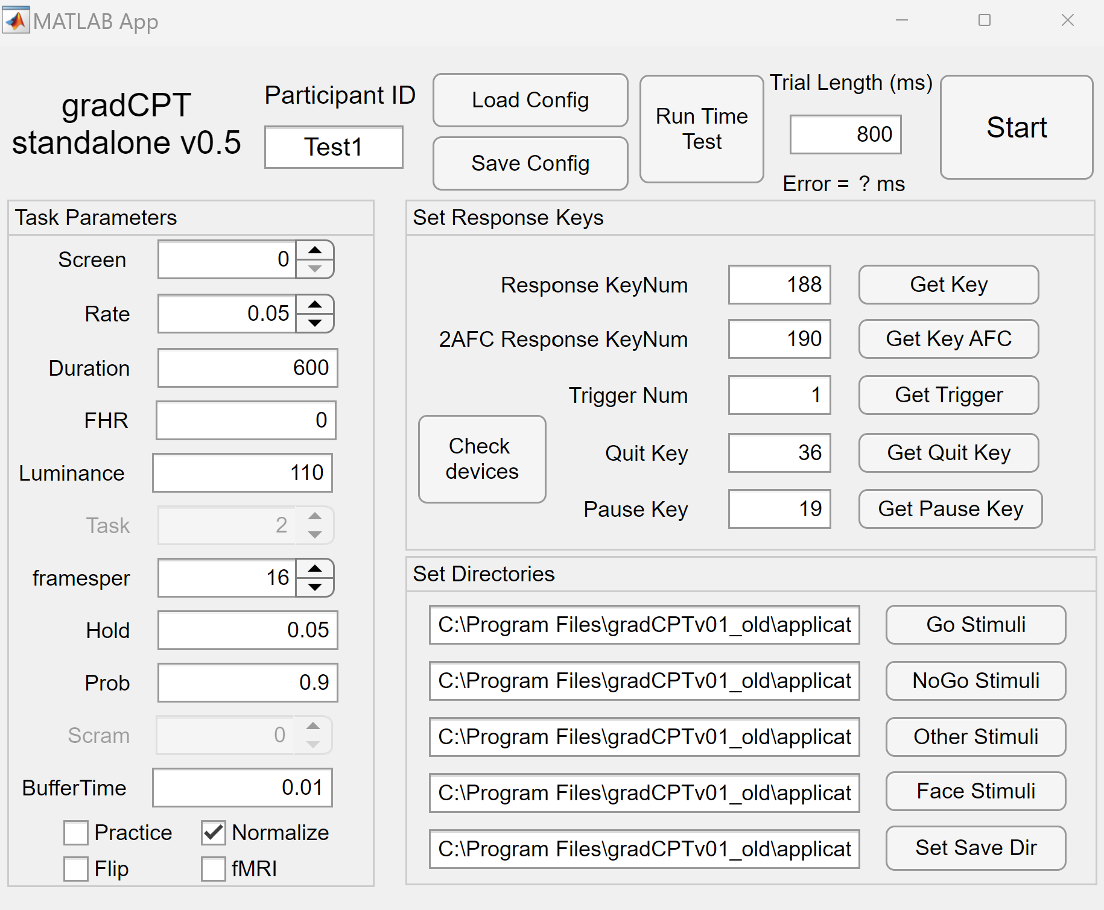

- Set up directories:
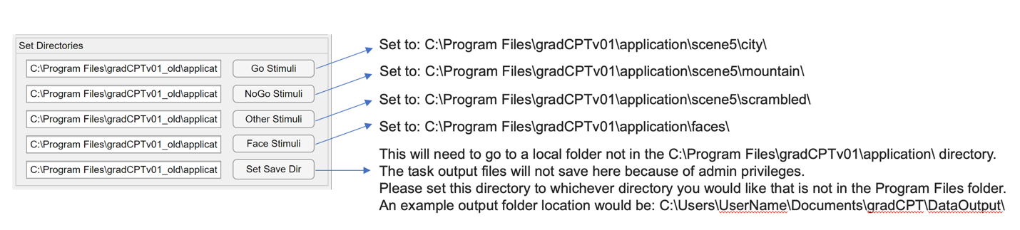
- Set up Keys
  - To set up the response key, complete the following:
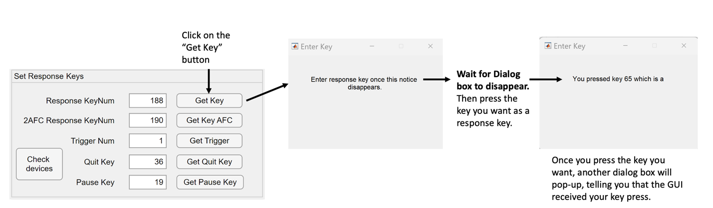
  - At this point in the set up, you will also need to do this for the Quit Key.
  - Additional notes
    - You cannot use the spacebar key.
    - Also, to prevent error, never close out of a dialog box. They will go away on their own.
- Once you are done, press the “Save Config” button at the top of the GUI, and close the program
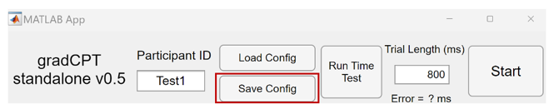
- Check that the app installed correctly.
  - After you have closed out of the GUI, start it again (run “gradCPTv01.exe)
  - Once the GUI starts, click “Load Config”
    - Navigate to the Save Dir directory you defined earlier, and a file should be save there named: ExpParams.mat
    - Select this file and all the parameters you just entered in the previous section, should now be loaded
  - Change the Task Parameters to run a test of the set-up
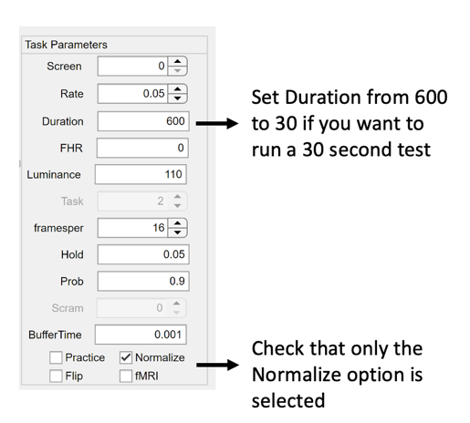
  - Press the Start button
  - This will eventually initiate a start screen, follow the directions on the screen (press any button to start).
  - Press the response button, that you have set previously, to every city scene and withhold response from mountain scenes.
  - Once this is done, check that the data has been recorded correctly
    - Navigate to the data folder which is your Save Dir you defined above.
    - Open the QC file for verification. If value of Omissions_Tot is close to 1, there may be button-press detection issues.

Setup of the gradCPT app at the MRI scanner
- Set screen resolution of the laptop to 1024 x 768. If stimuli appear warped, try 800 x 600.
- At the MRI scanner, plug in the projector, trigger, and button box into the computer.
- Once these devices are plugged into the device, run gradCPTv01.exe
- Identify the MRI trigger number/key
  - Once the GUI has initiated, identify the MRI trigger number/key
    - One suggestion, open up a text file, initiate a scan, and see what number/key is output
    - Check with the MRI technician if they know the trigger number/key
- Set the trigger
  - Once you know trigger number/key:
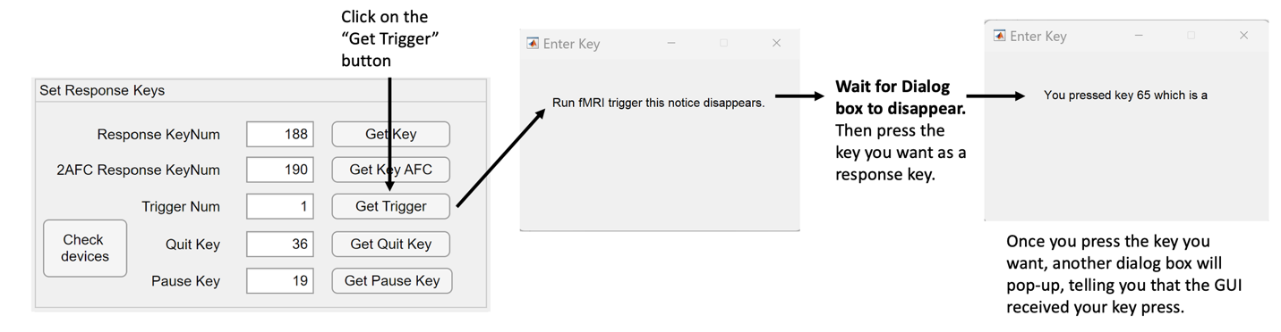
- Identify the button box number/key
  - Once you have identified the trigger, you will need to identify the button box number/key.
    - Open a text file, press the button/key on the response device for your scanner, and see what key/number displays on that text file.
- Set response key
  - Once you have identified the button box number/key:
- Next, in the Task Parameters section:
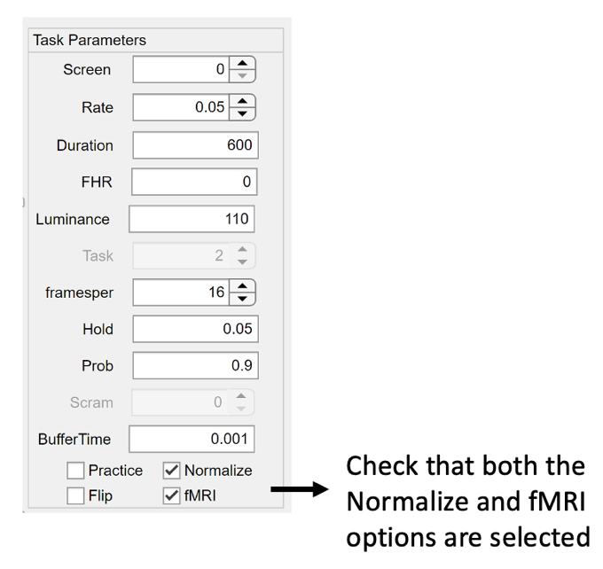
- Once your trigger and button box are identified, and all of the devices needed to run the gradCPT at the MRI scanner are plugged into the computer (projector, trigger, and button box), press the Run Time Test button.

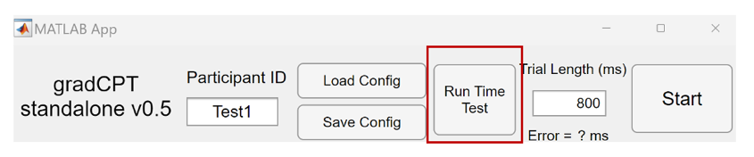

  - It will run the gradCPT multiple times. You do not need to do anything. This will take a couple of minutes.
  - You will know it finished successfully once it has stopped running and an error value is now populated in the window:
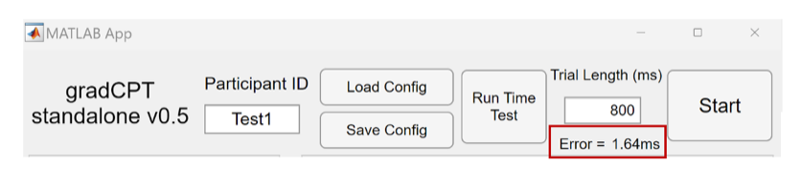
- Once the Run Time Test is complete, press the “Save Config” button again.
- Check that the app is configured for your scanner
  - If you want to run a shorter version of the task, change the Task Parameters of Duration from 600 to 30.
  - Press the Start button at the top right of the GUI
  - This should initiate the task which should freeze at a start screen.
    - If you just want to check that the app works with the current parameters, you can press the trigger number/key on your computer keyboard to start the task
    - If you want to check that the computer and the MRI scanner are communicating and working with the apps current parameters, you can initiate a scan sequence on the MRI scanner and see if the task starts with the first trigger sent by the MRI scanner
    - You will also want to check the button box, by using it to press to all cities scenes and withholding from pressing to all mountain scenes
    - You will also want to check if the size of the stimuli (scenes) are correct (see image below)
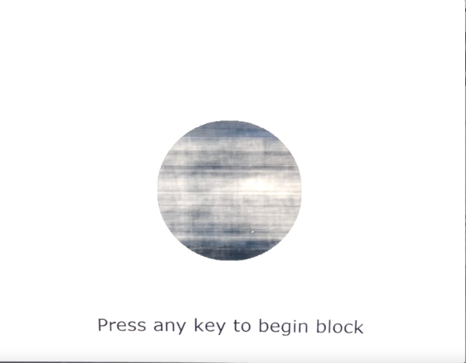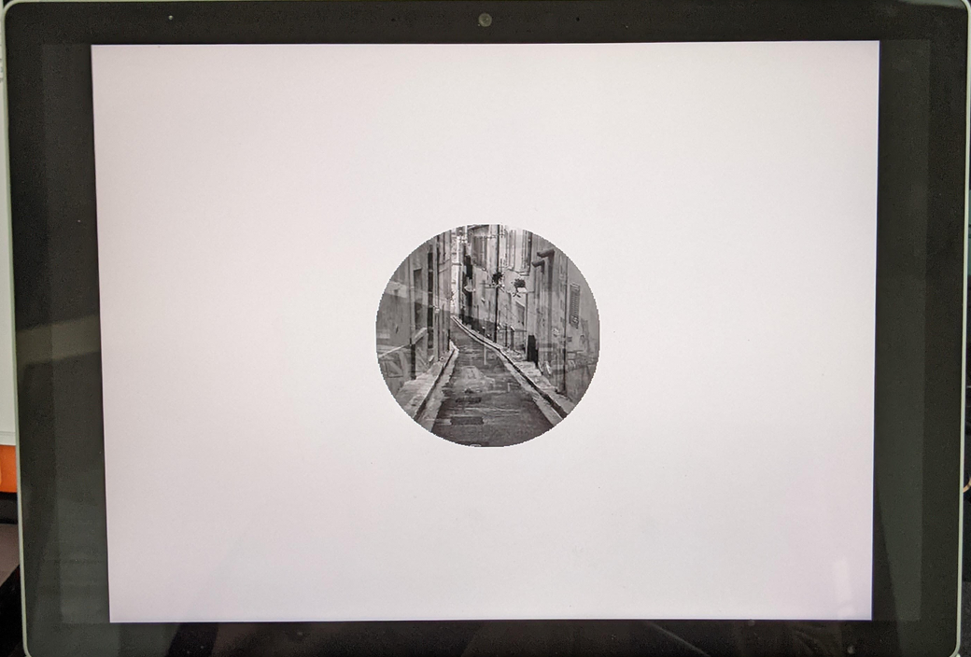
  - Once this is done, check that the data has been recorded correctly
    - Navigate to the data folder which is your Save Dir you defined above.
    - Open the QC file “OutputFileName_QC.txt” for verification. If value of Omissions_Tot is close to 1, there may be button-press detection issues.

Practice for participant before entering MRI scanner

- Go to the following link on a laptop: https://gradcpt.org/one-time-task/WXkOQm49GVreClFvNiTv
- Have the participant complete the practice, with the experimenter reading the instructions, and monitoring for questions.
- Once the following screen appears the experimenter can exit (escape) and close the window:
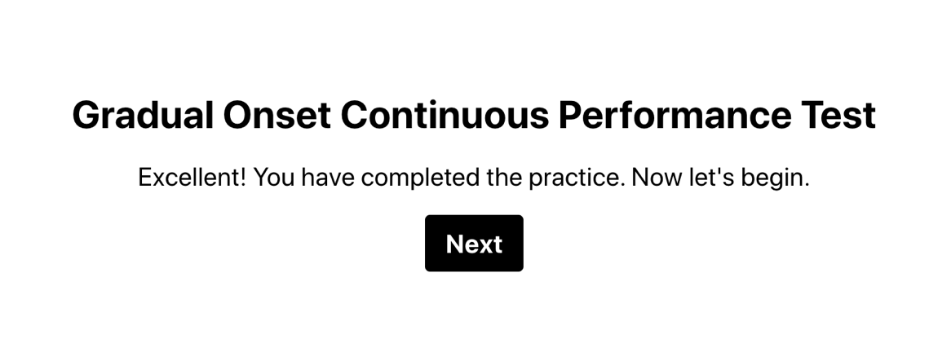
- Ask the participant “You are going to complete this task while in the MRI scanner later. Do you have any questions or would you like to do the practice again?”
- If the participant wants to repeat the practice, repeat step 1-4.

General Use of gradCPT app at the fMRI scanner
- Set screen resolution of the laptop to 1024 x 768. If stimuli appear warped, try 800 x 600.
- Once at the MRI scanner, plug in the projector, button box, and trigger to the computer.
- run “gradCPTv01.exe”
- Press the “LoadConfig” button you will need to select “ExpParams.mat” from the set Save Dir that you set in the Setup of the gradCPT app before scanner. This will load all the parameters you set previously during the installation and set up portion of this protocol.
- Check the Task Parameters are set to run the 8-minute version of the gCPT.
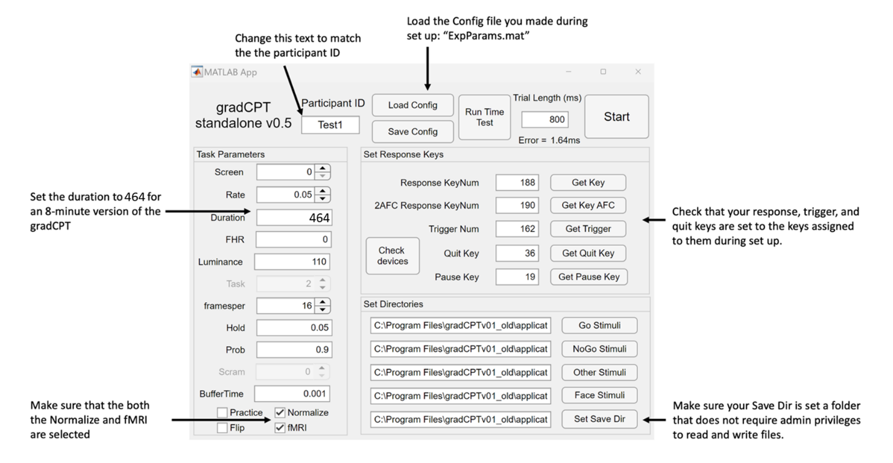

- Remind the participant of the instructions for this task:

[show participant/orient them to the response button].
“For this task you will see pictures of cities and mountains. When you see a city picture press the button as quickly as you can. When you see a mountain picture, don't press the button. Do you have any questions? Remember, it is supposed to be challenging, so just do your best. You will do the task for about 8 minutes.”

Data:
Data will be automatically saved to the directory you identified in the “Save Dir”

