-- Raw Data
select * from dbo.telecom_churn
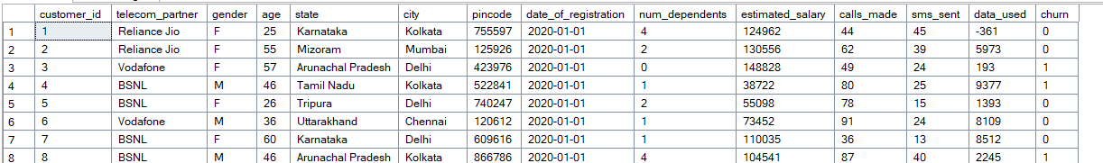

-- Create a Cleaned View
CREATE VIEW vw_Cleaned_Telecom AS
SELECT customer_id, telecom_partner, gender, age, state, city,
CAST(date_of_registration AS DATE) AS Registration_Date,
num_dependents,
estimated_salary,
-- Handling negative usage values
CASE WHEN calls_made < 0 THEN 0 ELSE calls_made END AS calls_made,
CASE WHEN sms_sent < 0 THEN 0 ELSE sms_sent END AS sms_sent,
CASE WHEN data_used < 0 THEN 0 ELSE data_used END AS data_used,
churn
FROM telecom_churn;

select * from vw_Cleaned_Telecom
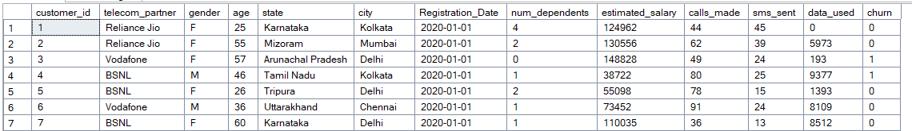

select * , case when age<25 then '18-24'
when age between 25 and 40 then '25-40'
when age between 41 and 60 then '41-60'
Else '60+'
end as Age_Group,
CASE WHEN calls_made <= 20 THEN 'Low Usage (0-20)'
WHEN calls_made BETWEEN 21 AND 60 THEN 'Medium Usage (21-60)'
ELSE 'High Usage (61+)'
END AS usage_tier,
case when estimated_salary <50000 then 'Low Income'
when estimated_salary between 50001 and 100000 then 'Mid Income'
else 'High Income'
end as Income_Segment
from vw_Cleaned_Telecom
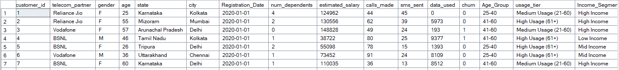

-- Churn Rate by Partner
select telecom_partner,sum(churn) as Total_Churn,count(customer_id) as Total_Customer, (cast(SUM(churn) as float)/cast(count(customer_id) as float))*100 as Churn_Percentage from vw_Cleaned_Telecom group by telecom_partner

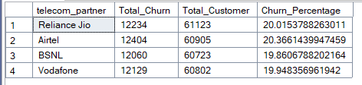

--Usage Correlation: Do users who make fewer calls churn more?
SELECT
CASE
WHEN calls_made <= 20 THEN 'Low Usage (0-20)'
WHEN calls_made BETWEEN 21 AND 60 THEN 'Medium Usage (21-60)'
ELSE 'High Usage (61+)'
END AS usage_tier,
COUNT(customer_id) AS total_customers,
SUM(churn) AS churned_customers,
ROUND(CAST(SUM(churn) AS FLOAT) / COUNT(customer_id) * 100, 2) AS churn_rate
FROM vw_Cleaned_Telecom
GROUP BY
CASE
WHEN calls_made <= 20 THEN 'Low Usage (0-20)'
WHEN calls_made BETWEEN 21 AND 60 THEN 'Medium Usage (21-60)'
ELSE 'High Usage (61+)'
END;
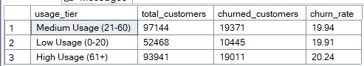

-- High-Value At-Risk: Which "High Income" customers have low usage but haven't churned yet?
SELECT
CASE
WHEN calls_made <= 20 THEN 'Low Usage (0-20)'
WHEN calls_made BETWEEN 21 AND 60 THEN 'Medium Usage (21-60)'
ELSE 'High Usage (61+)'
END AS usage_tier,
COUNT(customer_id) AS total_customers,
SUM(churn) AS churned_customers,
ROUND(CAST(SUM(churn) AS FLOAT) / COUNT(customer_id) * 100, 2) AS churn_rate
FROM vw_Cleaned_Telecom where estimated_salary between 50001 and 100000
GROUP BY
CASE
WHEN calls_made <= 20 THEN 'Low Usage (0-20)'
WHEN calls_made BETWEEN 21 AND 60 THEN 'Medium Usage (21-60)'
ELSE 'High Usage (61+)'
END;

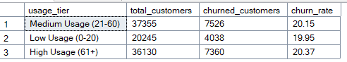

-- Total Customers
select count(customer_id) as Total_Customer from vw_Cleaned_Telecom

