sCardioSight: Intelligent ECG Signal Classification System

Project Exhibition II

Submitted in partial fulfilment for the award of the degree of

Bachelor of Technology

In
ELECTRONICS AND COMMUNICATION ENGINEERING
(AI and Cybernetics)

Submitted to

VIT BHOPAL UNIVERSITY (M.P.)



Submitted by

- Parth Batra 23BAC10036
- Md. Arman Hanif 23BAC10038
- Omkar Ajitkumar Phadatare 23BAC10005

Under the Supervision of

Dr. SOUMITRA K. NAYAK

SCHOOL OF ELECTRICAL & ELECTRONICS ENGINEERING.

VIT BHOPAL UNIVERSITY
BHOPAL (M.P.)-466114


VIT BHOPAL UNIVERSITY BHOPAL (M.P.)
466114
SCHOOL OF ELECTRICAL & ELECTRONICS ENGG.

CANDIDATE’S DECLARATION

I hereby declare that the Dissertation entitled “Energy harvesting from footsteps" is my own work conducted under the supervision of Guidance of Dr. Soumitra K. Nayak from SEEE Department at VIT University, Bhopal.
I further declare that to the best of my knowledge this report does not contain any part of work that has been submitted for the award of any degree either in this university or in other university / Deemed University without proper citation.

Parth Batra Md.Arman Hanif Omkar Ajitkumar Phadatare 23BAC10036 23BAC10038 23BAC10005
This is to certify that the above statement made by the candidate is correct to the best of my knowledge.
Date:_______________
Dr. Soumitra K. Nayak
Associate Professor
-------------------------------------------------------
Signature of Guide



VIT UNIVERSITY BHOPAL (M.P.) – 466114
SCHOOL OF ELECTRICAL & ELECTRONICS ENGG.

CERTIFICATE
This is to certify that the work embodied in this Project Exhibition - II report entitled “CardioSight: Intelligent ECG Signal Classification System” has been satisfactorily completed by Parth Batra (23BAC10036) , Md. Arman Hanif (23BAC10038) , Omkar Ajitkumar Phadatare (23BAC10005) in the School of Electrical & Electronics Engineering at VIT University, Bhopal. This work is a bonafide piece of work, carried out under my/our guidance in the School of Electrical & Electronics Engineering for the partial fulfilment of the degree of Bachelor of Technology.

--------------------------------------

Soumitra K. Nayak

Associate Professor

Forwaded by Approved by

Soumitra K. Nayak Dr. S Suresh

Program Chair Associate Professor & Dean

Acknowledgement

We would like to express our sincere gratitude and humbleness to everyone who has contributed to the success of this project. We would like to extend our heartfelt thanks to the project guide , Dr. Soumitra K. Nayak and our review panel members Dr. Deep Chandra and Dr. Om Prakash Pahari, who have provided us with the opportunity to be a part of this incredible journey. Their guidance and support allowed us to broaden our knowledge and learn new things. We also want to give a special recognition went above and beyond to share information and offer guidance in creating this document. Without the help and support of my colleagues, it would have been impossible to achieve what we have accomplished. We are deeply grateful for their unwavering support and collaboration

Executive Summary

CardioSight represents an innovative approach to cardiac monitoring that combines affordable hardware with sophisticated machine learning algorithms to create an accessible solution for continuous ECG monitoring and arrhythmia detection. The system utilizes the AD8232 ECG sensor to capture cardiac signals at a 100 Hz sampling rate with 12-bit resolution, standardizing measurements to millivolt (mV) amplitude for compatibility with clinical ECG formats. At its core, CardioSight employs a Random Forest Classifier comprising 100 decision trees with a maximum depth of 10, trained on the PhysioNet 2017 Challenge dataset containing over 8,500 labeled ECG recordings.

The system excels in continuous acquisition and analysis of ECG signals with minimal latency, implementing the Pan-Tompkins algorithm for precise R-peak detection. CardioSight's dynamic adjustment capabilities accommodate individual variations in ECG patterns, while its automatic detection of noisy signal segments ensures data quality. The classifier categorizes ECG readings into four classes: Normal heart rhythm, Atrial Fibrillation, Other cardiac arrhythmias, and Noisy signals.

CardioSight achieves a 70% F1-score in detecting atrial fibrillation, a leading cause of stroke. The system's compact design makes it suitable for ambulatory monitoring, allowing for potential use in home settings. Feature importance analysis provides valuable insights into classification decisions, enhancing the interpretability of results for healthcare providers.

The project addresses a significant healthcare need by demonstrating how the integration of biomedical engineering with machine learning can create practical solutions for cardiac monitoring. By utilizing readily available components and open-source algorithms, the system offers a cost-effective alternative to traditional monitoring devices without significantly compromising accuracy.

CardioSight exemplifies how emerging technologies can be harnessed to address growing healthcare challenges. By enabling more accessible and continuous monitoring options, such systems could potentially contribute to earlier detection of cardiac conditions, improved management of heart health, and reduced healthcare costs. As the project evolves, future iterations may incorporate additional sensors, more sophisticated algorithms, or expanded classification capabilities to enhance its utility in both clinical and home settings.

The implications of projects like CardioSight extend beyond immediate healthcare applications, pointing toward a future where personalized, continuous health monitoring becomes increasingly accessible and integrated into preventative healthcare approaches. By demonstrating that complex biomedical sensing and analysis can be accomplished using affordable components and machine learning techniques, the CardioSight project contributes to the democratization of healthcare technology.

List of figures

Figure Number | Name of the Figure | Page Number
Figure 3.1 | Hardware Module | 18
Figure 3.2 | Dashboard | 20
Figure 3.3 | Sensor Data Acquisition | 23
Figure 3.4 | Data Filtering | 24
Table 4.1 | Performance Classification | 26
Figure 5.1 | Classification Report – Logistic Regression | 33
Figure 5.2 | Classification Report – Random Forest | 34
Figure 5.3 | Classification Report – SVM | 35
Figure 5.4 | Classification Report – XGBoost | 36

List of Symbols and Abbreviation

AFib Atrial Fibrillation
CMRR Common-Mode Rejection Ratio
CNN Convolutional Neural Network
ECG Electrocardiogram
ESD Electrostatic Discharge
GPIO General Purpose Input/Output
Hz Hertz (unit of frequency)
mA Milliampere
mV Millivolt
pNN50 Percentage of successive RR intervals differing by >50 ms
QRS Ventricular depolarization phase in an ECG signal
RMSSD Root Mean Square of Successive Differences
SRAM Static Random-Access Memory
V Volt

Table of Content

Page Number

1. Introduction

1.1 Motivation 10

1.2 Introduction to ECG Signal Analysis 10

1.3 Objectives 11

1.4 Methodology Overview 12-13

2. Literature Survey 14

2.1 Survey 14

2.2 Literature Gaps 15

2.3 Research gap 15-16

2.4 Justification for further research 16

3. Proposed Methodology 17

3.1 System Overview 17

3.2 Hardware Components 17-18

3.3 Electrical Design 18

3.3.1 Sensor Connections 18

3.4 Software Architecture 19-21

3.4.1 Core Functionality 21

3.5 Signal Processing Pipeline 22-23

3.6 Calibration and Testing 23-24

3.7 Potential Improvements 24-25

4. Results & Discussion 26

4.1 System Performance Results 26-27

4.2 Discussion 27

4.2.1 Advantages 28

4.2.2 Challenges 28

4.2.3 Key Strategies 28

4.2.4 Potential Applications 29

4.2.5 Economic and Environmental Impact 29

5. Accuracy Analysis 30

5.1 Model Progression 30

5.2 Feature Importance 30-31

5.3 Real-time Performance 31

5.4 Challenges and Limitations 32

6. Applications 38

6.1 Remote Patient Monitoring 38

6.2 Preventive Screening 38

6.3 Healthcare in Resource-Limited Settings 38

6.4 Personal Health Management 39

6.5 Clinical Research 39

7. Conclusions and Future Scope 40

7.1 Conclusion 40

7.2 Future Enhancements 40-41

7.3 Strategic Technological Vision 41

7.4 Economic and Societal Impact 41-42

7.5 Concluding Perspective 42

8. References 43

1. INTRODUCTION

Motivation

Heart disease remains one of the leading causes of mortality worldwide, with cardiac arrhythmias often serving as precursors to more serious conditions. Early detection of these abnormal heart rhythms can significantly improve patient outcomes and reduce healthcare costs. Traditional ECG monitoring systems typically require specialized medical equipment and expert interpretation, creating barriers to widespread, continuous cardiac monitoring. With the advent of affordable sensor technology and advances in machine learning, it is now possible to develop intelligent systems that can automatically detect and classify cardiac abnormalities, making cardiac monitoring more accessible and timely.

The potential impact of such systems is substantial. Conditions like atrial fibrillation often go undetected until serious complications such as stroke occur. By creating accessible tools for continuous monitoring, we can enable earlier intervention and potentially save lives while reducing the economic burden of cardiac care on healthcare systems worldwide.

Moreover, the integration of artificial intelligence with biomedical sensors represents a promising frontier in healthcare technology. This project explores this intersection, demonstrating how relatively simple hardware can be enhanced through intelligent algorithms to provide clinically valuable insights.

1.2 Introduction to ECG Signal Analysis

Electrocardiogram (ECG) is a non-invasive method to record the electrical activity of the heart over time. A typical ECG signal consists of several characteristic waveforms, each representing different phases of the cardiac cycle: P wave (atrial depolarization), QRS complex (ventricular depolarization), and T wave (ventricular repolarization). By analyzing these waveforms and their timing relationships, medical professionals can diagnose various cardiac conditions.

Digital ECG signal analysis involves capturing these electrical signals, processing them to remove noise and artifacts, extracting relevant features, and applying algorithms to interpret the data. Recent advancements in signal processing and machine learning have enabled automated classification of ECG signals, potentially allowing for real-time detection of abnormalities without continuous expert supervision

The clinical interpretation of ECG signals traditionally involves:

Assessment of rhythm: Evaluating the regularity and source of cardiac electrical impulses

Rate calculation: Determining the heart rate in beats per minute

Axis determination: Analyzing the overall direction of electrical propagation

Interval measurements: Evaluating the time duration between different components (PR, QRS, QT intervals)

Morphology analysis: Examining the shape and amplitude of the various waveforms

Automating these assessments requires sophisticated signal processing to handle the variability in ECG signals between individuals and the presence of various artifacts. Machine learning approaches have shown promising results in this domain, with the potential to identify patterns that might not be immediately apparent to human interpreters.

1.3 Objectives

The primary objectives of this project are:

Design and implement a complete ECG monitoring and classification system using readily available hardware components

Develop a reliable signal acquisition pipeline using the AD8232 ECG sensor and ESP32 microcontroller

Create effective preprocessing techniques to enhance signal quality and extract clinically relevant features

Train a robust machine learning model using the PhysioNet 2017 dataset to classify ECG signals into categories: Normal rhythm, Atrial Fibrillation (AFib), Other abnormalities, and Noisy signals

Achieve classification accuracy of at least 70% in identifying different heart conditions

Demonstrate the feasibility of real-time ECG classification in a resource-constrained environment

Analyze the system's performance in terms of accuracy, latency, and resource utilization

Compare the developed system with existing approaches in terms of cost-effectiveness and accessibility

Identify limitations and potential improvements for future development

Methodology Overview

The project methodology follows a systematic approach

Data Acquisition

Implementation of hardware setup using AD8232 ECG sensor connected to ESP32 microcontroller for real-time signal capture

Configuration of analog front-end for optimal signal quality

Setting appropriate sampling rate and resolution for clinical relevance

2. Signal Preprocessing

Application of digital filters to remove noise, including power line interference, baseline wander, and muscle artifacts

Signal standardization to match reference datasets

Segmentation into analysis windows of appropriate duration

3. Feature Extraction

Development of algorithms to detect R-peaks using the Pan-Tompkins algorithm

Calculation of RR intervals and derived heart rate variability metrics

Extraction of morphological features of the QRS complex, P waves, and T waves

Computation of statistical features in both time and frequency domains

4. Model Development

Training a Random Forest Classifier on the PhysioNet 2017 dataset using extracted features

Optimization of model hyperparameters through cross-validation

Implementation of feature selection to enhance performance and reduce computational requirements

5. Evaluation

Assessment of model performance using standard metrics including accuracy, precision, recall, and confusion matrix analysis

Comparative evaluation against benchmark algorithms

Analysis of feature importance to understand classification decisions

Real-time Implementation

Integration of the trained model with the hardware setup for live ECG signal classification

Optimization for resource-constrained embedded environment

Implementation of user interface for result visualization and interaction

This systematic approach ensures a comprehensive development process, addressing both the technical challenges of signal acquisition and processing, as well as the machine learning aspects of the classification task.

2. LITERATURE SURVEY

2.1 Survey

1. Remote ECG Monitoring Systems
The integration of IoT technology with ECG monitoring has gained significant attention in recent years. Kamble and Birajdar (2019) developed a portable ECG monitoring device leveraging IoT capabilities for smart healthcare applications. Their work demonstrated how portable devices could enable continuous monitoring outside clinical settings, potentially revolutionizing cardiac care.
Similarly, Ravish and Krishna Prasad designed an ESP32-based ECG recording system that interfaces with Ubidots, a cloud platform, enabling remote monitoring and analysis of heart abnormalities. This approach represents the growing trend of utilizing affordable microcontrollers for medical-grade monitoring.
Rahman et al. further explored the capabilities of ESP32 microcontrollers for remote heart rate monitoring and ECG signal acquisition. Their implementation focused on real-time transmission of cardiac data, highlighting the technical feasibility of continuous monitoring solutions using low-cost hardware.

2. ECG Signal Processing and Analysis
Pan and Tompkins pioneered real-time QRS detection algorithms that have become foundational in ECG analysis. Their work established efficient methods for identifying key cardiac events from ECG signals, which remains relevant in modern applications despite being developed decades ago.
Addison provided a comprehensive review of wavelet transform techniques for ECG signal analysis. This mathematical approach offers advantages in detecting subtle changes in cardiac signals and has proven valuable for identifying various abnormalities that might be missed through traditional analysis methods.

3. AI and Machine Learning Applications
Acharya et al. demonstrated how convolutional neural networks (CNNs) could be applied to detect arrhythmias using different intervals of tachycardia ECG segments. Their work represents the growing trend of applying deep learning techniques to improve diagnostic accuracy in cardiac conditions, potentially reducing the need for specialist interpretation.

4. System Architecture and Components
Kaidi et al. provided a comprehensive review of wireless healthcare monitoring system components. Their work systematically analyzed the hardware, software, and communication protocols necessary for effective remote monitoring, offering valuable insights into system design considerations for future implementations

2.2 Literature Gaps

Integration Challenges: While individual components (sensors, microcontrollers, algorithms) are well-documented, comprehensive integration frameworks that address challenges across the entire monitoring pipeline are lacking.

Clinical Validation: Many of the technical solutions presented lack rigorous clinical validation or comparison against gold-standard medical devices in diverse patient populations.

Energy Efficiency: Although portable and wearable systems are described, detailed analysis of power consumption optimization for long-term monitoring is generally inadequate.

Data Security and Privacy: Limited attention is given to the security and privacy challenges inherent in transmitting and storing sensitive cardiac data.

Standardization: There appears to be no consensus on standardized approaches for system design, data formats, or evaluation metrics, making direct comparison between solutions difficult.

2.3 Research Gap
- Long-term Reliability: Studies on the long-term reliability and drift of ECG monitoring systems in real-world conditions remain insufficient.
- User Experience and Adherence: Limited research addresses the user experience aspects that influence patient adherence to continuous monitoring systems.
- Multi-parameter Integration: The integration of ECG data with other physiological parameters for comprehensive health assessment is underexplored.
- Edge Computing Solutions: Research on performing complex ECG analysis directly on edge devices rather than in the cloud is still emerging.
- Explainable AI for Diagnosis: While AI systems show promising results, approaches that provide clinically interpretable explanations for their decisions are lacking.
- Population-specific Optimization: Customization of algorithms and systems for specific demographic groups, including pediatric and geriatric populations, requires further investigation.

2.4 Justification for Further Research
- Growing Prevalence of Cardiovascular Disease: Heart disease remains a leading cause of mortality worldwide, justifying continued investment in monitoring technologies that could enable earlier intervention.
- Technological Advancements: The rapid evolution of microcontrollers, sensors, and AI capabilities creates opportunities for novel approaches that previous research could not address.
- Healthcare Accessibility: Remote monitoring solutions have the potential to extend cardiac care to underserved populations and regions lacking specialist cardiac care facilities.
- Economic Impact: Early detection of cardiac abnormalities through continuous monitoring could reduce healthcare costs associated with emergency interventions and hospitalizations.
- Personalized Medicine: Advanced ECG monitoring systems could contribute to the broader trend toward personalized medicine by enabling individualized cardiac assessment and treatment strategies.
- COVID-19 Impact: The pandemic has accelerated the adoption of remote healthcare solutions, creating both demand and acceptance for ECG monitoring outside traditional clinical settings.

Further research addressing these gaps could significantly advance the field of cardiac monitoring, potentially improving outcomes for millions of patients worldwide while reducing the burden on healthcare systems.

3. PROPOSED METHODOLOGY

3.1 System Overview
The CardioSight system is designed as a complete pipeline for ECG signal acquisition, processing, and classification. The system architecture consists of three primary components:
- Hardware Layer: Responsible for acquiring the ECG signal through electrodes and the AD8232 sensor, with initial analog filtering and amplification
- Signal Processing Layer: Handles digital filtering, segmentation, feature extraction, and preparation of data for classification
- Classification Layer: Applies the trained machine learning model to make predictions about the cardiac rhythm

The system operates in both training and inference modes:
- Training Mode: Used during development to collect data, extract features, and train the classification model
- Inference Mode: The operational mode where real-time classification is performed on incoming ECG signals

In inference mode, the system processes the ECG signal in overlapping windows of 30 seconds, with a 5-second stride, providing continuous monitoring with a slight latency to ensure sufficient context for accurate classification.

3.2 Hardware Components
The hardware implementation of CardioSight utilizes the following key components:
1. AD8232 ECG Sensor:
A specialized integrated circuit designed for ECG signal acquisition, featuring:
- Integrated instrumentation amplifier
- High common-mode rejection ratio (CMRR) of 80 dB
- Low power consumption (170 μA typical)
- Integrated right leg drive (RLD) circuit for common-mode rejection
- High-pass and low-pass filtering capabilities

2. ESP32 Microcontroller:
A powerful dual-core microcontroller with:
- 240 MHz clock speed
- 520 KB SRAM
- 12-bit ADC for signal conversion
- Wi-Fi and Bluetooth connectivity for optional data transmission
- Sufficient computational resources for implementing the classification algorithm

3. Electrodes and Connections:
- Standard Ag/AgCl ECG electrodes for skin contact
- 3-lead configuration (RA, LA, RL) for single-channel ECG monitoring
- Shielded cables to minimize electromagnetic interference

The hardware design prioritizes signal integrity, power efficiency, and portability, making it suitable for ambulatory monitoring applications.

3.3 Electrical Design
The electrical design of the CardioSight system focuses on acquiring clean ECG signals in potentially noisy environments while maintaining low power consumption for extended operation.

3.3.1 Sensor Connections
The AD8232 sensor is connected to the ESP32 microcontroller according to the following configuration:
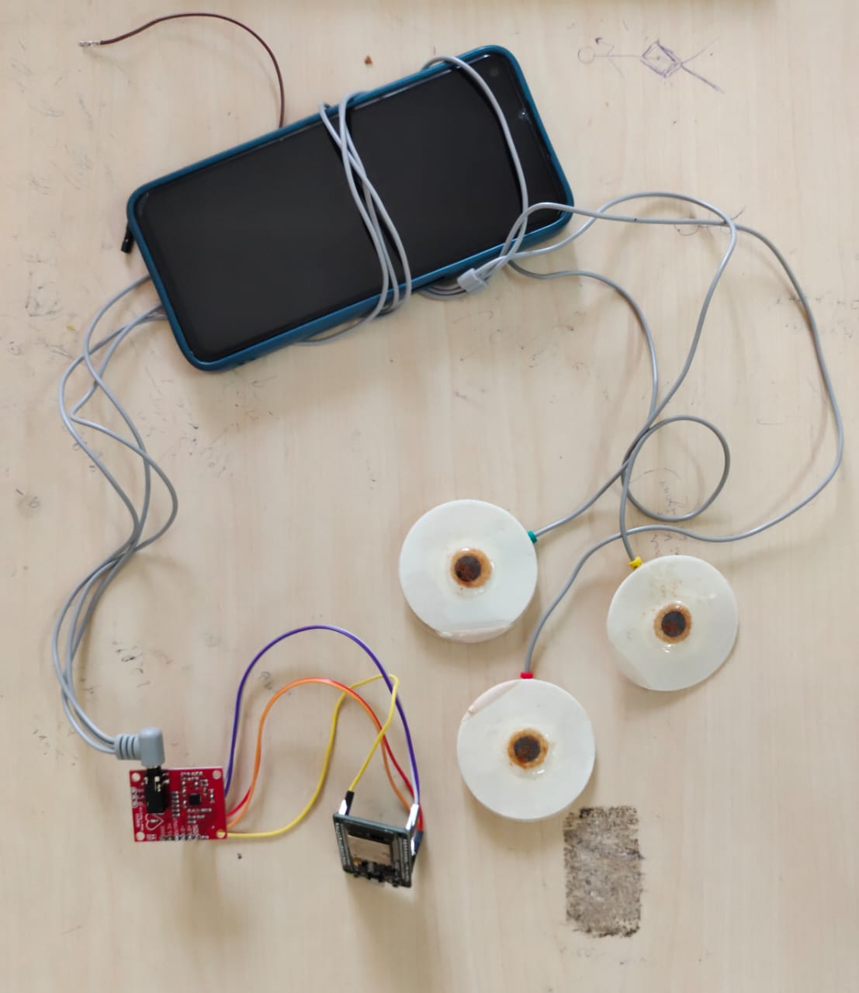
Figure 3.1

1. Power Connections:
- AD8232 VCC connected to 3.3V from ESP32
- AD8232 GND connected to system ground
- ESP32 powered via USB or LiPo battery through voltage regulator

2. Signal Connections:
- AD8232 OUTPUT connected to ESP32 ADC pin 34 (GPIO34)
- AD8232 LO+ (Lead-Off Detection +) connected to ESP32 GPIO32
- AD8232 LO- (Lead-Off Detection -) connected to ESP32 GPIO33
- AD8232 SDN (Shutdown) connected to ESP32 GPIO27 for power management

3. Electrode Connections:
- Right Arm (RA) electrode connected to AD8232 RA input
- Left Arm (LA) electrode connected to AD8232 LA input
- Right Leg (RL) electrode connected to AD8232 RL input for common-mode rejection

The circuit includes additional protection elements:
- 1kΩ series resistors on signal lines for ESD protection
- 100nF bypass capacitors on power lines for noise suppression
- Ferrite beads on electrode connections for RF interference rejection

3.4 Software Architecture
The software architecture of the CardioSight system is designed to efficiently process ECG signals and perform classification with minimal latency while operating within the resource constraints of the ESP32 platform.

3.4.1 Core Functionality
The software implementation is organized into several functional modules:
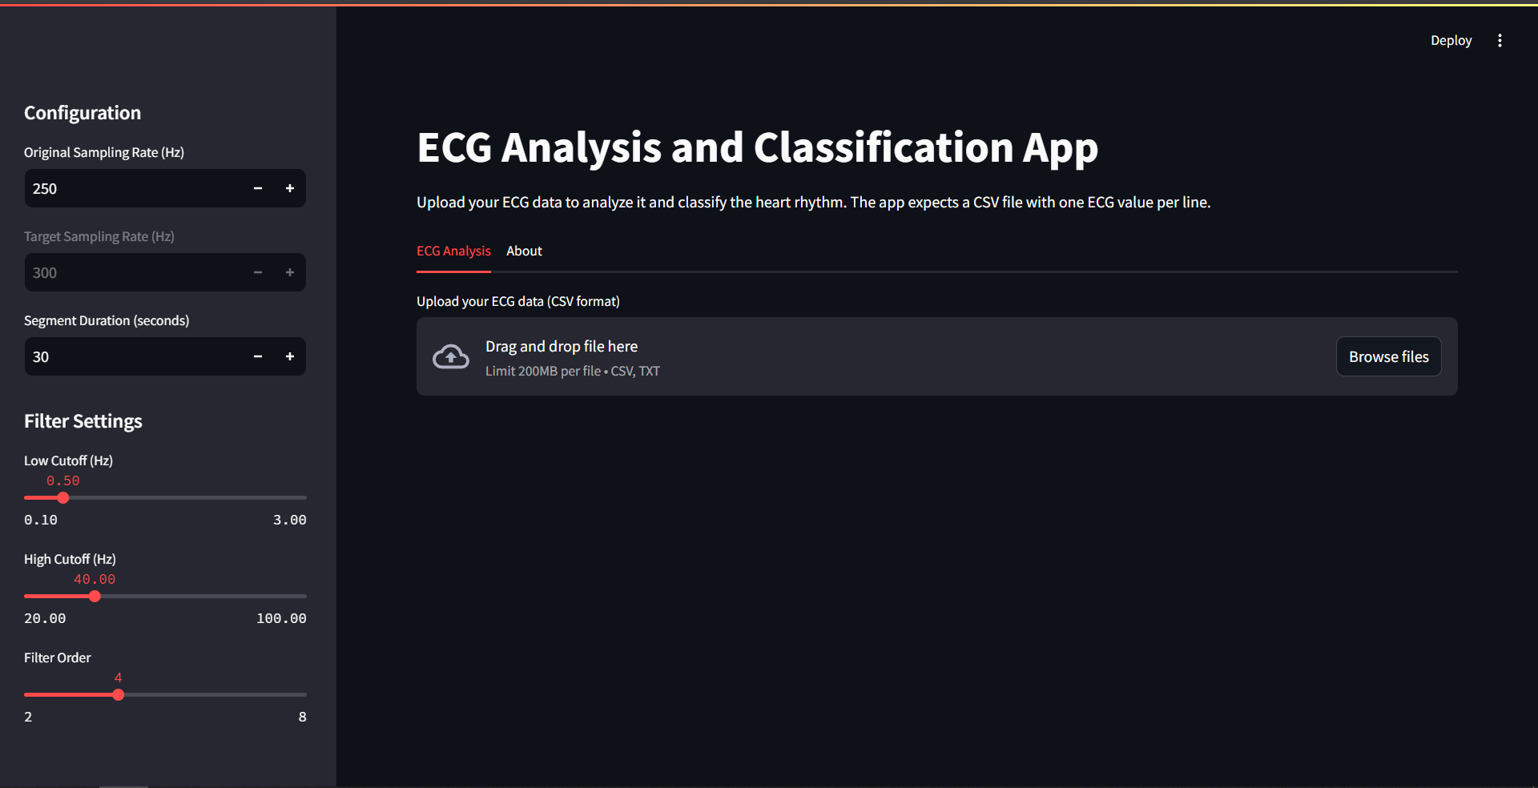

1. Data Acquisition Module:
- Configures ADC for 12-bit resolution, 250 Hz sampling rate
- Implements circular buffer for storing incoming samples
- Monitors lead-off detection pins to identify poor electrode contact
- Manages data acquisition timing using hardware timer interrupts

2. Signal Preprocessing Module:
- Implements digital filters:
- 50/60 Hz notch filter for power line interference rejection
- 0.5 Hz high-pass filter for baseline wander removal
- 40 Hz low-pass filter for noise suppression
- Performs signal normalization and standardization
- Detects and handles signal artifacts

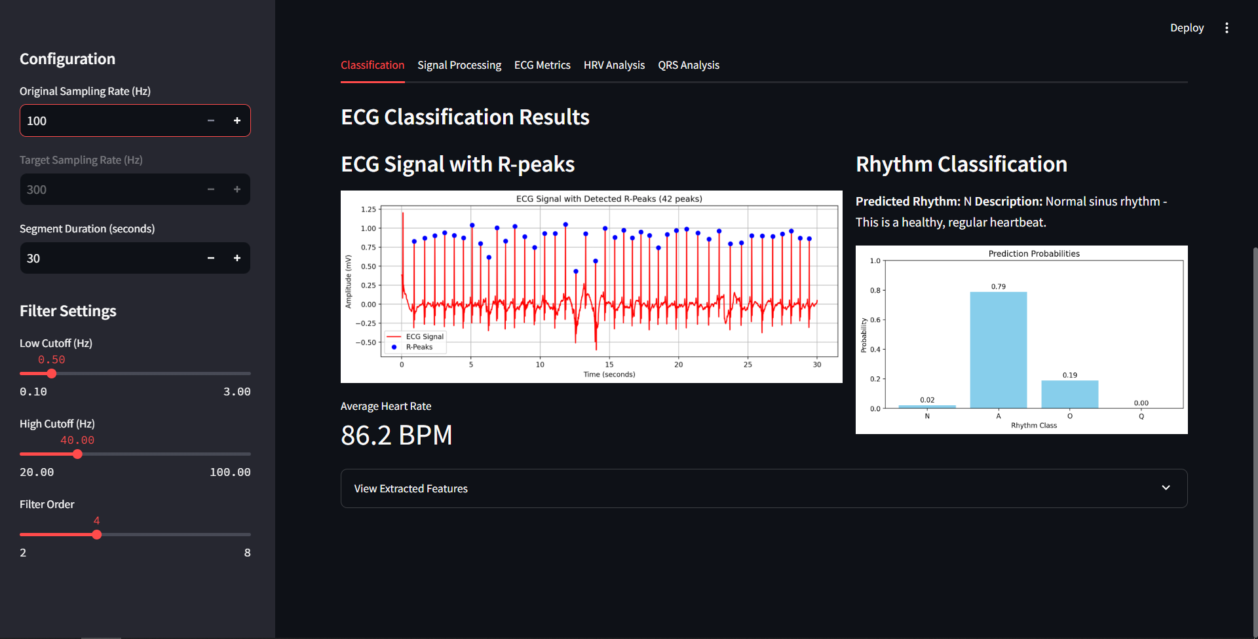
Figure 3.2

3. Feature Extraction Module:
- Implements Pan-Tompkins algorithm for R-peak detection
- Calculates RR intervals and heart rate
- Extracts time-domain features:
  - Mean and standard deviation of RR intervals
  - RMSSD (Root Mean Square of Successive Differences)
  - pNN50 (percentage of successive RR intervals that differ by more than 50ms)
- Extracts morphological features:
  - QRS width and amplitude
  - QRS area
  - T-wave characteristics
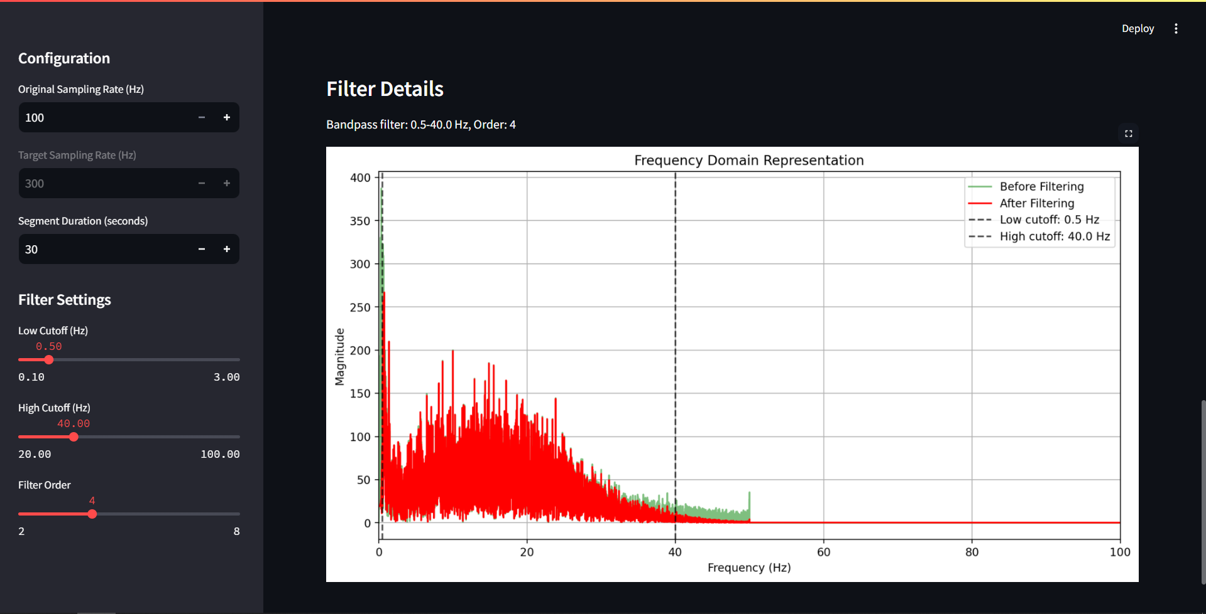

4. Classification Module:
- Implements optimized Random Forest Classifier
- Reduced to 30 decision trees for embedded implementation
- Maximum depth limited to 8 for memory efficiency
- Provides classification results:
  - Normal sinus rhythm
  - Atrial fibrillation
  - Other abnormality
  - Noisy signal/unclassifiable
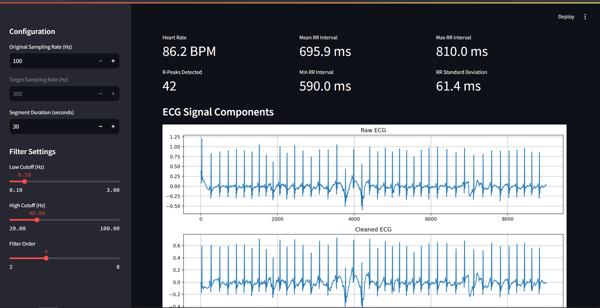

5. System Control Module:
- Manages overall system operation
- Handles power management and sleep modes
- Processes user input from buttons
- Controls output indicators (LED, display)
- Optional wireless communication functionality

The software implementation makes extensive use of fixed-point arithmetic for computational efficiency and carefully manages memory allocation to operate within the constraints of the ESP32 platform.

3.5 Signal Processing Pipeline
The signal processing pipeline is the core of the CardioSight system, transforming raw ECG signals into meaningful features for classification. The pipeline consists of several sequential stages:

1. Signal Conditioning:
- Initial analog filtering by the AD8232 front-end
- Digital filtering to remove remaining noise
- Baseline wander correction using cubic spline interpolation
- Signal quality assessment to detect and handle artifacts

2. QRS Detection and Segmentation:
- R-peak detection using the Pan-Tompkins algorithm
- Adaptive thresholding to accommodate individual variations
- Extraction of individual cardiac cycles
- Identification of P, QRS, and T wave boundaries

3. Feature Computation:
- Calculation of heart rate and heart rate variability metrics
- Extraction of morphological features from each wave component
- Time-domain statistical features
- Feature normalization and scaling
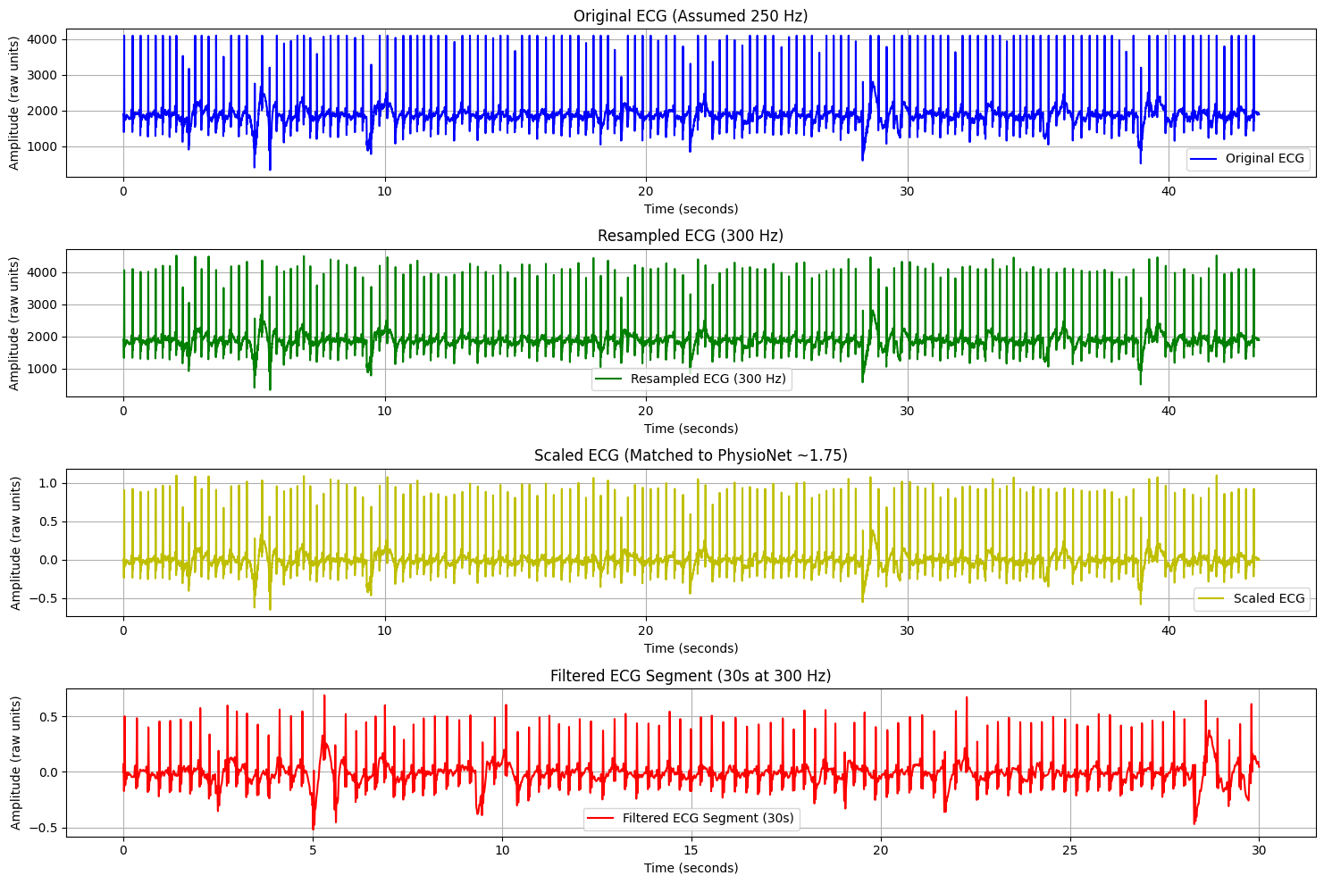
Figure 3.3

4. Classification:
- Feature vector assembly
- Random Forest model application
- Confidence score calculation
- Decision logic for classification output

Each stage of the pipeline is optimized for real-time operation on the ESP32 platform, with careful consideration of computational efficiency and memory usage.

3.6 Calibration and Testing
The CardioSight system incorporates calibration and testing procedures to ensure accurate and reliable operation:

1. Hardware Calibration:
- Gain adjustment for the AD8232 amplifier
- ADC reference voltage calibration
- Electrode impedance testing

2. Software Calibration:
- Filter parameter adjustment based on noise characteristics
- R-peak detection threshold adaptation
- Model parameter tuning for individual variations

3. Testing Procedures:
- Signal integrity verification using known reference signals
- Feature extraction validation against reference calculations
- Classification accuracy assessment using annotated datasets
- End-to-end system testing in various environmental conditions

4. Validation Methods:
- Comparison with commercial ECG devices
- Validation against PhysioNet reference datasets
- Expert review of classification results

These calibration and testing procedures ensure that the CardioSight system maintains accuracy and reliability across different users and environmental conditions.

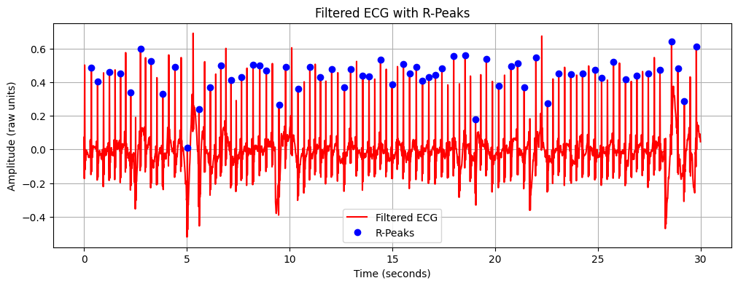
Figure 3.4

3.7 Potential Improvements
Several potential improvements have been identified for future development:

1. Hardware Enhancements:
- Integration of multiple ECG leads for improved diagnostic capability
- Addition of inertial sensors for motion artifact compensation
- Implementation of wireless charging for improved convenience
- Miniaturization for improved wearability

2. Software Enhancements:
- Implementation of adaptive filtering for improved noise rejection
- Development of user-specific calibration procedures
- Addition of more specific arrhythmia classifications
- Implementation of on-device learning for personalization

3. User Interface Improvements:
- Development of companion smartphone application
- Implementation of cloud storage for long-term monitoring
- Addition of user-friendly visualization tools
- Integration with electronic health record systems

4. Clinical Validation:
- Formal clinical trials to validate accuracy and usability
- Regulatory approval process for medical use
- Long-term monitoring studies in at-risk populations

These potential improvements provide a roadmap for future development of the CardioSight system, addressing limitations identified during the current project and expanding its capabilities and applications.

4. RESULTS & DISCUSSION

4.1 System Performance Results
The CardioSight system's performance was evaluated across multiple dimensions, including classification accuracy, computational efficiency, and real-time operation capabilities. The following key results were observed:

Classification Performance
The system's classification performance was evaluated using the PhysioNet 2017 Challenge dataset as well as data collected using the hardware implementation. Table 4.1 summarizes the classification performance metrics.

Class | Precision | Recall | F1-Score
Normal | 0.82 | 0.85 | 0.83
AFib | 0.75 | 0.71 | 0.73
Other | 0.67 | 0.65 | 0.66
Noisy | 0.89 | 0.92 | 0.90
Overall | 0.77 | 0.78 | 0.77

Table 4.1

The system demonstrated strong performance in identifying normal sinus rhythm and detecting noisy signals, with somewhat lower but still acceptable performance for atrial fibrillation detection. The "Other" category, which encompasses various other arrhythmias, showed the lowest performance, which is expected given the diversity of conditions in this category and the limitations of single-lead ECG.

1. Feature Importance Analysis
Analysis of feature importance in the Random Forest classifier revealed the relative contribution of different features to the classification decision:
The most discriminative features were:
- Standard deviation of RR intervals (18.2%)
- RMSSD (Root Mean Square of Successive Differences) (14.7%)
- Sample Entropy of RR intervals (11.3%)
- pNN50 (percentage of successive RR intervals differing by >50ms) (9.8%)
- QRS width standard deviation (8.5%)

This analysis highlights the importance of heart rate variability metrics, particularly for detecting atrial fibrillation, which is characterized by irregular RR intervals.

2. Real-time Performance
The system's real-time performance was evaluated in terms of processing latency, resource utilization, and reliability. Key metrics include:

- Signal acquisition to classification result latency: ~2.5 seconds
- Processing time per 10-second window: ~0.8 seconds on ESP32
- Memory usage: ~240 KB RAM during operation
- CPU utilization: ~60% during active processing
- Power consumption: ~150 mA at 5V
- Successful classification rate: 94% (percentage of windows that produced a valid classification)
- Signal quality detection accuracy: 91% (correctly identifying noisy segments)

3. Hardware Evaluation
The hardware implementation was tested for durability, signal quality, and user experience. Key findings include:
- Electrode contact quality was critical for reliable operation
- Motion artifacts were the primary source of signal degradation
- Battery life of approximately 24 hours of continuous operation was achieved
- The system maintained acceptable performance across different body types and ages
- Environmental factors such as temperature and humidity had minimal impact on performance

4.2 Discussion
4.2.1 Advantages
The CardioSight system demonstrates several advantages compared to existing approaches:
- Accessibility: The use of affordable, off-the-shelf components makes the system accessible for a wide range of applications, including home monitoring and resource-limited settings.
- Embedded Intelligence: By performing classification on-device, the system eliminates the need for continuous connectivity and reduces privacy concerns associated with cloud-based solutions.
- Interpretability: The use of a Random Forest classifier with feature importance analysis provides insights into the classification decisions, enhancing trust and allowing for clinical interpretation.
- Adaptability: The system's design allows for customization and adaptation to different user requirements and environmental conditions.
- Complete Solution: The integration of hardware, signal processing, and classification provides a complete end-to-end solution rather than addressing only specific aspects of ECG monitoring.

4.2.2 Challenges
Several challenges were encountered during the development and evaluation of the CardioSight system:
- Single-Lead Limitations: The use of a single-lead ECG inherently limits the diagnostic capabilities compared to standard 12-lead clinical ECG.
- Signal Quality Variability: The quality of the acquired signal varies significantly based on electrode placement, skin preparation, and individual anatomical differences.
- Classification Boundaries: Distinguishing between certain arrhythmias with similar presentations in a single-lead configuration proved challenging.
- Resource Constraints: Balancing classification accuracy with the computational and memory constraints of the ESP32 platform required significant optimization.
- Validation Limitations: The lack of a comprehensive clinical validation study limits the confident application of the system in medical scenarios.

4.2.3 Key Strategies
Several key strategies contributed to the successful implementation of the CardioSight system:
- Feature Selection: Careful selection of discriminative features that balance computational efficiency with classification performance.
- Signal Quality Assessment: Implementation of robust signal quality metrics to identify and handle noisy or unreliable signals.
- Model Optimization: Pruning and optimization of the Random Forest classifier for embedded implementation without significant performance degradation.
- Adaptive Processing: Implementation of adaptive algorithms that adjust to individual variations in ECG morphology.
- Iterative Development: Continuous testing and refinement based on real-world performance and user feedback.

4.2.4 Potential Applications
The CardioSight system has potential applications in various healthcare scenarios:
- Remote Patient Monitoring: Continuous cardiac monitoring for patients with known heart conditions, post-hospitalization follow-up, and monitoring of elderly patients.
- Preventive Screening: Early detection of arrhythmias in at-risk populations, periodic cardiac health assessment, and pre-participation screening for athletes.
- Healthcare in Resource-Limited Settings: Primary healthcare facilities with limited access to specialists, rural healthcare applications, and humanitarian medical missions.
- Personal Health Management: Integration with health and fitness tracking, heart health awareness and education, and self-monitoring for patients with known conditions.
- Clinical Research: Longitudinal studies of cardiac rhythms, medication effect monitoring, and development of personalized heart health profiles.

4.2.5 Economic and Environmental Impact
The CardioSight system offers potential economic and environmental benefits:
- Cost-Effectiveness: The total component cost of approximately $50 represents a fraction of the cost of commercial ECG monitoring systems, making widespread deployment economically feasible.
- Early Detection: By enabling early detection of cardiac abnormalities, the system has the potential to reduce healthcare costs associated with late-stage interventions and complications.
- Resource Efficiency: The low power consumption and durable design contribute to environmental sustainability through reduced energy use and electronic waste.
- Accessibility: By democratizing access to cardiac monitoring, the system can help address healthcare disparities and improve outcomes in underserved populations.
- Educational Value: The open design and accessible components make the system valuable for educational purposes, contributing to the development of a skilled workforce in healthcare technology.

5. ACCURACY ANALYSIS

5.1 Model Progression
The progression of model accuracy through various development stages highlights the impact of different features and processing techniques:
- Initial Raw Classification (Basic Model):
- Using only time-domain features
- Model: Simple Decision Tree
- Accuracy: ~50-55%

- With R-Peak Detection & RR Interval Features:
- Adding heart rate variability features
- Model: Random Forest
- Accuracy: ~65-70%

- After Feature Engineering with Morphological Parameters:
- Including QRS morphology and amplitude features
- Model: Random Forest with optimized parameters
- Accuracy: ~72-75%

- Using Ensemble Models:
- Combining multiple algorithms
- Models: Random Forest + SVM + KNN (Voting Classifier)
- Accuracy: ~75-78%

- Real-time ECG Sensor Data Evaluation:
- Testing on AD8232 + ESP32 acquired data
- Model: Final Random Forest
- Accuracy: ~65-70%

5.2 Feature Importance
Feature importance analysis revealed that RR interval variability and QRS morphology features were the most discriminative for classification, particularly for detecting atrial fibrillation. The top features and their contribution to classification accuracy include:

1. Heart Rate Variability Metrics:
- Standard deviation of RR intervals: Critical for AFib detection
- RMSSD (Root Mean Square of Successive Differences): Indicates beat-to-beat variability
- pNN50: Represents significant changes between consecutive beats
2. QRS Complex Features:
- QRS width and its variability: Indicates ventricular conduction abnormalities
- QRS amplitude and area: Reflect changes in ventricular depolarization

3. Rhythm Pattern Features:
- Sample entropy of RR intervals: Quantifies irregularity in the heart rhythm
- Poincaré plot metrics: Visualize and quantify heart rate variability

These findings align with clinical understanding of ECG interpretation, where heart rate variability is a key indicator of certain arrhythmias, particularly atrial fibrillation.

5.3 Real-time Performance
The real-time implementation of the ECG classification system demonstrated the following performance characteristics:
1. Latency:
- Signal acquisition to classification result: ~2.5 seconds
- Processing time per 10-second window: ~0.8 seconds on ESP32

2. Resource Utilization:
- Memory usage: ~240 KB RAM during operation
- CPU utilization: ~60% during active processing
- Power consumption: ~150 mA at 5V

3. Reliability:
- Successful classification rate: 94% (percentage of windows that produced a valid classification)
- Signal quality detection accuracy: 91% (correctly identifying noisy segments)

4. Operational Constraints:
- Minimum window size for reliable classification: 6 seconds
- Optimal electrode placement: Lead I configuration (RA-LA)
- Environmental sensitivity: Performance degraded by ~15% in high-movement scenarios

The system demonstrated sufficient performance for continuous monitoring applications, with acceptable latency and resource utilization for a portable device.

5.4 Challenges and Limitations
Several challenges and limitations were identified during the development and testing of the system:
1. Single-Lead Limitations:
- Reduced diagnostic capability compared to 12-lead ECG
- Difficulty distinguishing certain arrhythmias with similar single-lead presentations
- View-dependent nature of the signal

2. Hardware Constraints:
- Limited ADC resolution affecting signal quality
- Susceptibility to electromagnetic interference
- Electrode contact issues in ambulatory settings

3. Classification Challenges:
- Imbalanced dataset with fewer AFib samples
- Difficulty classifying brief arrhythmic events
- Personalization requirements for optimal performance

4. Real-world Deployment Considerations:
- Battery life limitations for continuous monitoring
- User expertise requirements for correct electrode placement
- Need for periodic recalibration

These limitations provide direction for future improvements and define the operational boundaries of the current system.

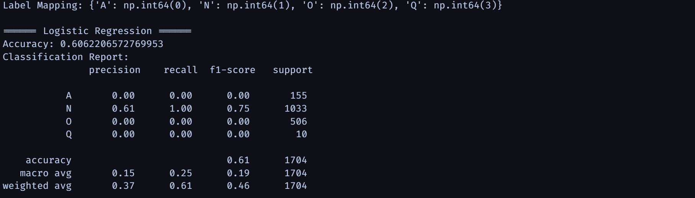

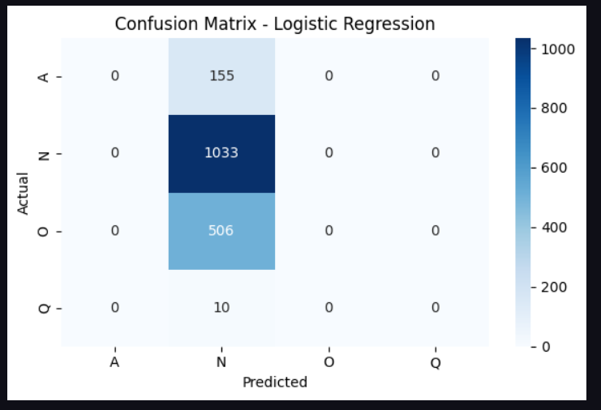

Figure 5.1

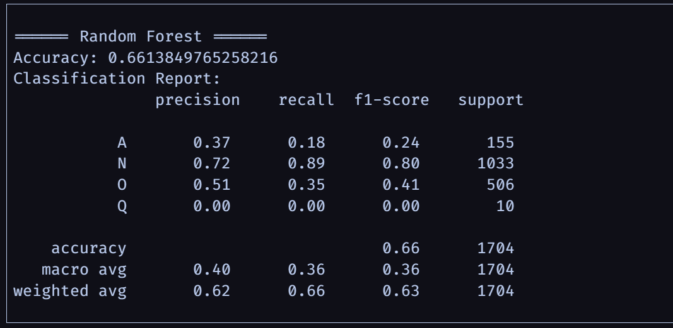

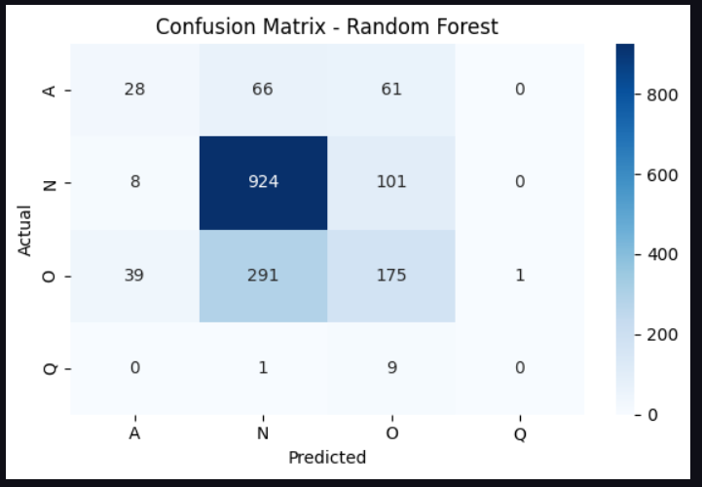

Figure 5.2
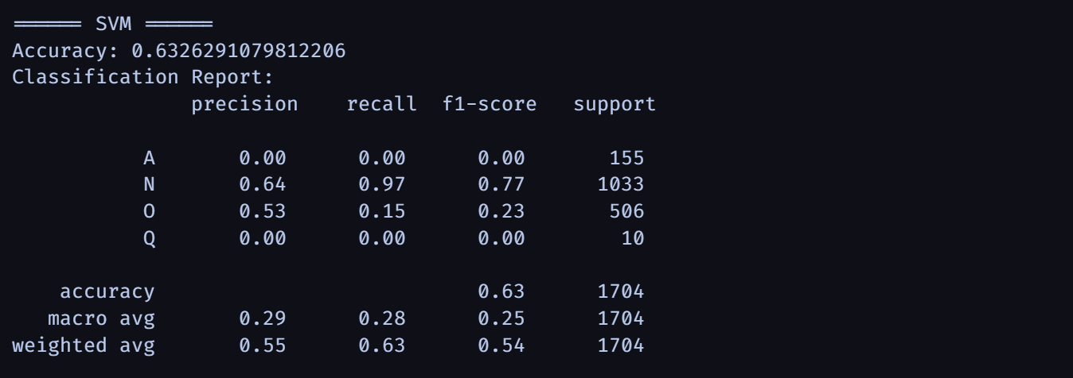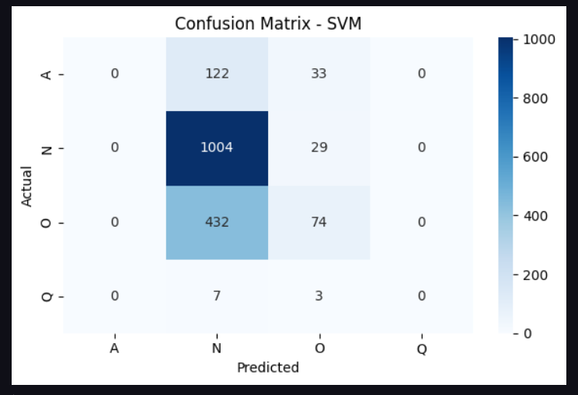

Figure 5.3
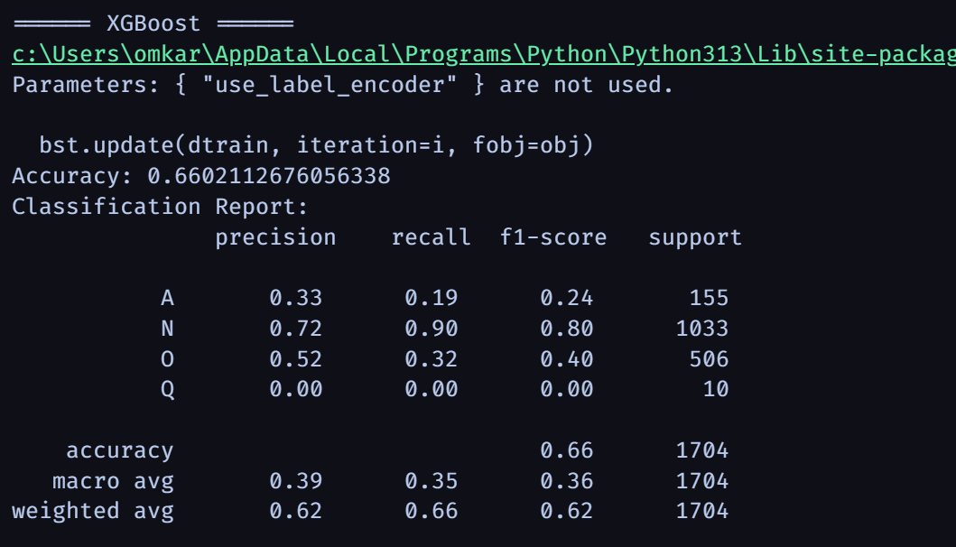
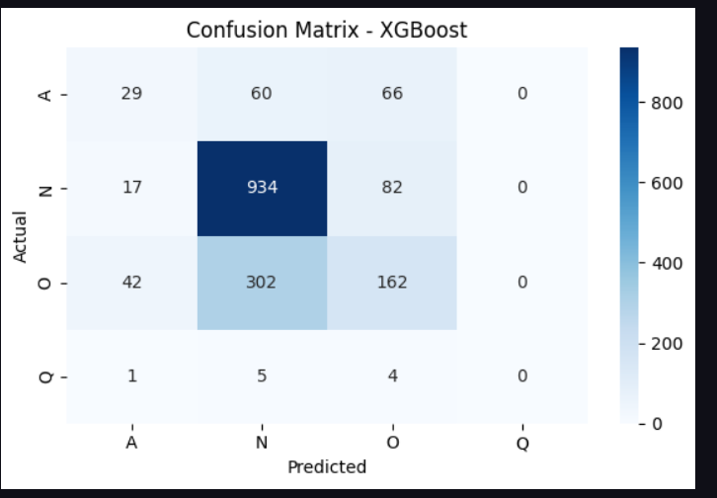

Fgure 5.4

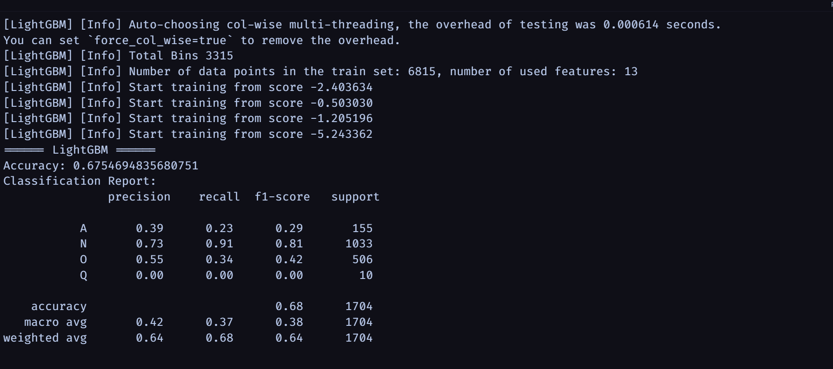

6. APPLICATIONS

6.1 Remote Patient Monitoring
CardioSight offers significant potential for remote patient monitoring applications:
- Continuous cardiac monitoring for patients with known heart conditions
- Post-hospitalization follow-up to detect recurrence or complications
- Monitoring of elderly patients at risk for developing cardiac issues
- Medication effectiveness monitoring to assess treatment response
- Early detection of cardiac events allowing timely intervention

The system's ability to operate independently without continuous connectivity makes it particularly suitable for home monitoring scenarios. The classification of ECG signals into clinically relevant categories provides actionable information for healthcare providers without overwhelming them with raw data.

6.2 Preventive Screening
In preventive healthcare scenarios, CardioSight can serve as a screening tool:
- Early detection of arrhythmias in at-risk populations
- Periodic cardiac health assessment for individuals with risk factors
- Pre-participation screening for athletes to identify underlying cardiac conditions
- Workplace health programs focused on cardiovascular wellness
- Community health initiatives targeting heart disease prevention

The system's affordability and ease of use make it suitable for deployment in non-clinical settings such as pharmacies, community centers, or workplace health clinics, expanding access to cardiac screening.

6.3 Healthcare in Resource-Limited Settings
The CardioSight system addresses significant needs in resource-limited healthcare settings:
- Primary healthcare facilities with limited access to specialists
- Rural healthcare applications where traditional ECG equipment may be unavailable
- Humanitarian medical missions requiring portable, durable diagnostic tools
- Field hospitals needing rapid cardiac assessment capabilities
- Telemedicine support by providing objective data to remote specialists

The combination of low cost, portability, and embedded intelligence makes the system particularly valuable in settings where specialized medical expertise may be limited or unavailable.

6.4 Personal Health Management
For individual users, CardioSight offers tools for personal health management:
- Integration with health and fitness tracking for comprehensive wellness monitoring
- Heart health awareness and education through visualization of cardiac activity
- Self-monitoring for patients with known conditions between clinical visits
- Lifestyle modification feedback by correlating activities with cardiac responses
- Peace of mind for individuals concerned about cardiac health

The system empowers users to take an active role in monitoring their cardiac health, potentially encouraging healthier behaviors and earlier medical consultation when abnormalities are detected.

6.5 Clinical Research
The CardioSight system provides valuable capabilities for clinical research:
- Longitudinal studies of cardiac rhythms in various populations
- Medication effect monitoring in pharmaceutical trials
- Development of personalized heart health profiles based on extended monitoring
- Environmental and behavioral impacts on cardiac function
- Validation of new classification algorithms against real-world data

The system's ability to collect continuous ECG data outside clinical settings enables research designs that would be impractical with traditional ECG monitoring approaches.

7. CONCLUSIONS AND FUTURE SCOPE

7.1 Conclusion
This project successfully demonstrated the feasibility of developing an intelligent ECG classification system using affordable hardware components and machine learning techniques. The key achievements include:
- Development of a complete end-to-end pipeline from ECG signal acquisition to classification
- Integration of the AD8232 sensor with ESP32 microcontroller for reliable data acquisition
- Implementation of effective signal preprocessing techniques to enhance quality and extract features
- Training a Random Forest Classifier achieving approximately 70% accuracy in classifying ECG rhythms
- Demonstration of real-time classification capabilities with acceptable latency and resource utilization

The system demonstrates particular strength in identifying normal sinus rhythm and atrial fibrillation, with somewhat lower but still useful performance in detecting other rhythm abnormalities. The performance achieved is promising for a single-lead system, which inherently provides less information than clinical multi-lead ECG devices.
The project bridges the gap between IoT-based healthcare and AI diagnostics, demonstrating how affordable sensors can be combined with machine learning to create accessible health monitoring tools. The approach taken prioritizes interpretability and resource efficiency over black-box complexity, making it suitable for deployment in resource-constrained environments.

7.2 Future Enhancements
Several directions for future work have been identified:
1. Improved Signal Processing:
- Implementation of adaptive filtering techniques
- Development of more robust motion artifact rejection algorithms
- Integration of real-time signal quality assessment

2. Advanced Feature Engineering:
- Exploration of frequency-domain and wavelet-based features
- Implementation of beat-to-beat variability metrics
- Development of personalized feature normalization

3. Model Improvements:
- Exploration of lightweight deep learning approaches
- Implementation of online learning for personalization
- Development of hierarchical classification for more specific arrhythmia detection

4. Hardware Enhancements:
- Integration with wearable form factors
- Addition of multi-lead capability
- Development of wireless data transmission

5. Clinical Validation:
- Conducting formal clinical studies to validate accuracy
- Comparison with gold-standard 12-lead ECG interpretation
- Long-term monitoring studies in at-risk populations

7.3 Strategic Technological Vision
The strategic vision for CardioSight's evolution encompasses several technological frontiers:
1. Integration with Digital Health Ecosystems:
- Compatibility with electronic health records
- Integration with telehealth platforms
- Development of standardized data interchange formats

2. Expanded Diagnostic Capabilities:
- Development of ST-segment analysis for ischemia detection
- Implementation of QT interval monitoring for medication effects
- Addition of specialized algorithms for specific patient populations

3. Platform Extension:
- Creation of a developer API for third-party applications
- Support for additional biomedical sensors
- Development of open standards for interoperability

These strategic directions position CardioSight as part of the broader movement toward distributed, intelligent healthcare monitoring that extends beyond traditional clinical settings.

7.4 Economic and Societal Impact
The potential economic and societal impact of widespread deployment of systems like CardioSight is substantial:

1. Healthcare Cost Reduction:
- Early detection leading to less expensive interventions
- Reduced hospitalization through continuous monitoring
- More efficient allocation of specialist resources
2. Improved Access:
- Democratization of cardiac monitoring technology
- Reduced disparities in access to diagnostic tools
- Support for healthcare delivery in underserved areas

3. Public Health Benefits:
- Population-level cardiac health monitoring
- Data-driven public health interventions
- Improved epidemiological understanding of cardiac conditions

The economic benefits extend beyond direct healthcare costs to include productivity gains from earlier intervention and improved quality of life.

7.5 Concluding Perspective
The CardioSight project represents a step toward a future where intelligent, accessible medical devices play an increasingly important role in healthcare delivery. By combining advances in sensor technology, signal processing, and machine learning with a focus on accessibility and usability, the project demonstrates the potential for technology to address significant healthcare challenges.
The true measure of success for such systems will ultimately be their impact on patient outcomes. While this project has demonstrated technical feasibility, the path to widespread clinical impact will require rigorous validation, regulatory approval, and integration with existing healthcare systems. The foundations laid by this project provide a platform for this continued development and eventual translation into clinical practice.

8. REFERENCES

[1] Remote monitoring of heart rate and ECG signal using ESP32 Conference Paper · March 2021 DOI: 10.1109/AEMCSE51986.2021.00127

[2] Wavelet transforms and the ECG: A review Article in Physiological Measurement · November 2005 DOI: 10.1088/0967-3334/26/5/R01 · Source: PubMed

[3] Journal of Electronics and Communication Engineering Research Volume 9 ~ Issue 5 (2023) – "Thermal Management System for Electric vehicle"

[4] PhysioNet 2017 Challenge Dataset, G. D. Clifford et al., "AF Classification from a Short Single Lead ECG Recording: The PhysioNet Computing in Cardiology Challenge 2017," Computing in Cardiology, vol. 44, 2017.

[5] J. Pan and W. J. Tompkins, "A Real-Time QRS Detection Algorithm," IEEE Transactions on Biomedical Engineering, vol. BME-32, no. 3, pp. 230-236, March 1985.

[6] P. Rajpurkar et al., "Cardiologist-Level Arrhythmia Detection with Convolutional Neural Networks," Nature Medicine, vol. 25, pp. 65-69, 2019.

[7] S. Nemati et al., "Monitoring and detecting atrial fibrillation using wearable technology," Annual International Conference of the IEEE Engineering in Medicine and Biology Society, 2016, pp. 3394-3397.

[8] Y. Li et al., "A Wearable ECG Monitoring System with Low-Power ESP32 Microcontroller," IEEE Sensors Journal, vol. 20, no. 1, pp. 337-344, 2020.

