Important: The safety operating instructions must be legally signed by the OU management, and the employees who handle the substance must be instructed accordingly in the files.

Date: 01.03.2023  OU: 6.5  OI no.: 3361 | Safety Operating Instructions  (Machinery, equipment, working procedures) | 
Workplace,  activity: | Electrical safety interlock (ESI) for use with experimental devices using >60V inside the MOUSE Instrument.
 | - Scope of Application
 | These safety operating instructions apply to any device that uses 230V inside the MOUSE vacuum chamber. These devices have to be connected via the Electronic Safety Interlock (ESI).
 | - Hazards to people and the environment
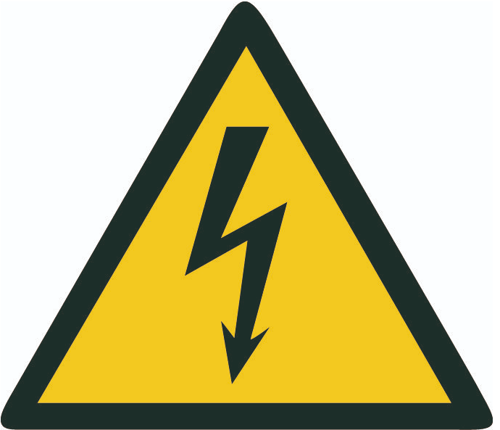 | - Danger of electric shock
 | - Protective measures and rules of conduct
- You MUST connect any device that uses voltages in excess of 60V inside the MOUSE chamber via this safety interlock. Do not bypass.
- This includes 230V heaters, electrical field generators, tensile equipment, etc.
- The ESI ensures these voltages are disconnected when vacuum is not present in the chamber
- Do not exceed 10A on the load. The relays, sockets and fuses are rated for 10A cont.
 | - Conduct in the event of incidents
 | - In case of electric shock of >60V, follow the procedure in 5. An Electrocardiogram (ECG) MUST be obtained from a hospital.
 | - Conduct in the event of accidents; first aid
 | - Keep calm, ensure electrical devices are off (use emergency stops if needed).  - Remove the injured person from danger area, initiate first aid measures  - Emergency call 112, then BAM internal emergency call 4444  - Call in first responders  - Report accident to line manager
 | - Servicing, disposal
- In case of a trip of the built-in resettable RCD/Fuse, it can be reset from the back of the ESI without opening the enclosure
- Two cylindrical fuses are included, one 1A fuse for the system power (24V), and a 10A fuse for the interlocked circuit. These are located on the IEC 60320 C14 connectors at the back of the device, a spare is stored in the same location. Contact the instrument responsible once both are burnt out.
- Internal repairs and maintenance work may only be carried out by authorised personnel
- In case the RED signal lamp is illuminated, cease operations, and contact the instrument responsible. The internal relays are then in an unidentical state, and need to be replaced.
- To ensure proper disposal see HV 09/12 Operational environmental protection
Date: | Line Manager´s signature:
xx/xx/xxxx
(Date of approval)

