Open 🡪interlij

Select🡪

java-> Mevan

Hybernate select

Create table in mysql🡪

mysql> create table book(

-> book_id int(10) primary key unique,

-> title varchar(20) unique,

-> auther varchar(20),

-> price float(10));

Add dependencies in pom.xml

1.hybernate

2.mysql

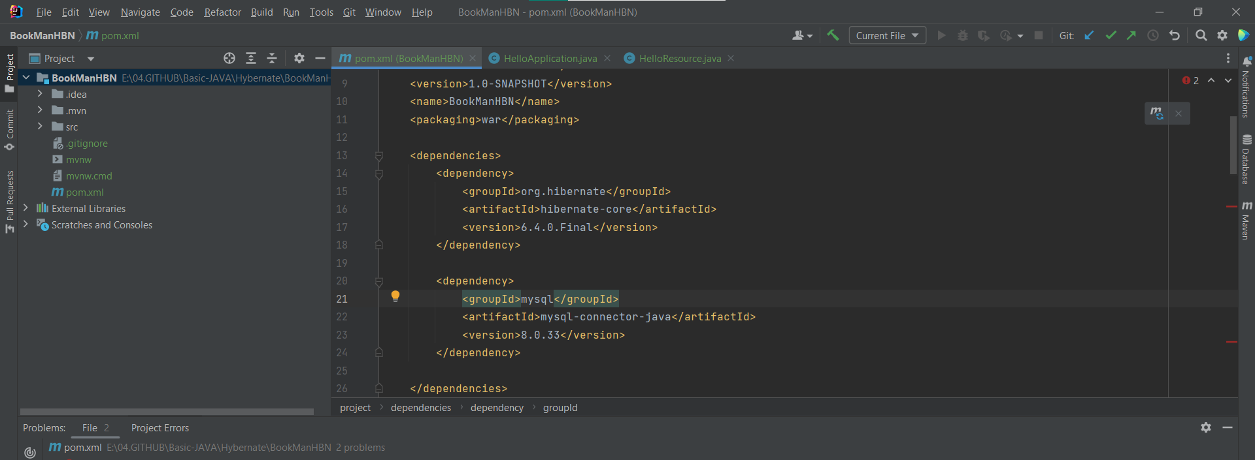

Create java class inside src🡪 main

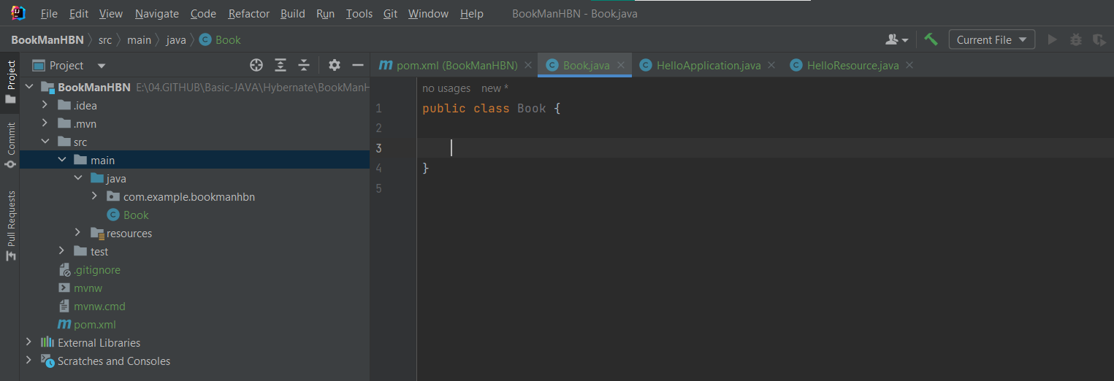

Add fields in database table as variales and generate getters setters

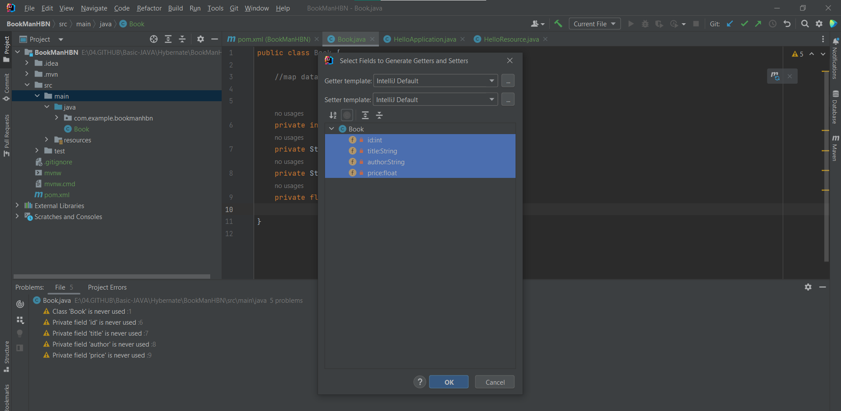

Inside Resource file create a file call 🡪 hibernate.cfg.xml

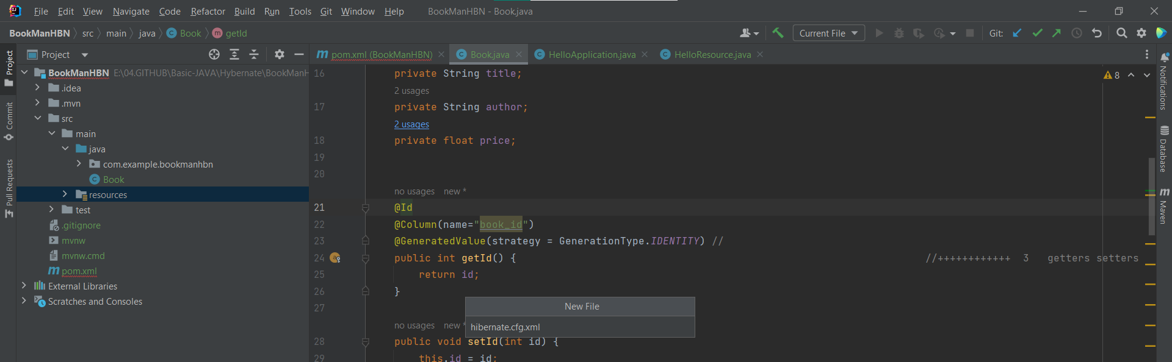



Create class BookManager