Experiment: Prompt Engineering Techniques in Python Programming
Roll.no:2303a53027
Aim
To design and analyze zero-shot, one-shot, few-shot, and context-managed prompts for generating Python programs that solve basic computational problems, and to study how prompting strategies affect code quality, correctness, and robustness.

Question 1: Zero-Shot Prompting
Problem: Palindrome Number Check
Zero-Shot Prompt
“Write a Python function that checks whether a given number is a palindrome.”
AI-Generated Code
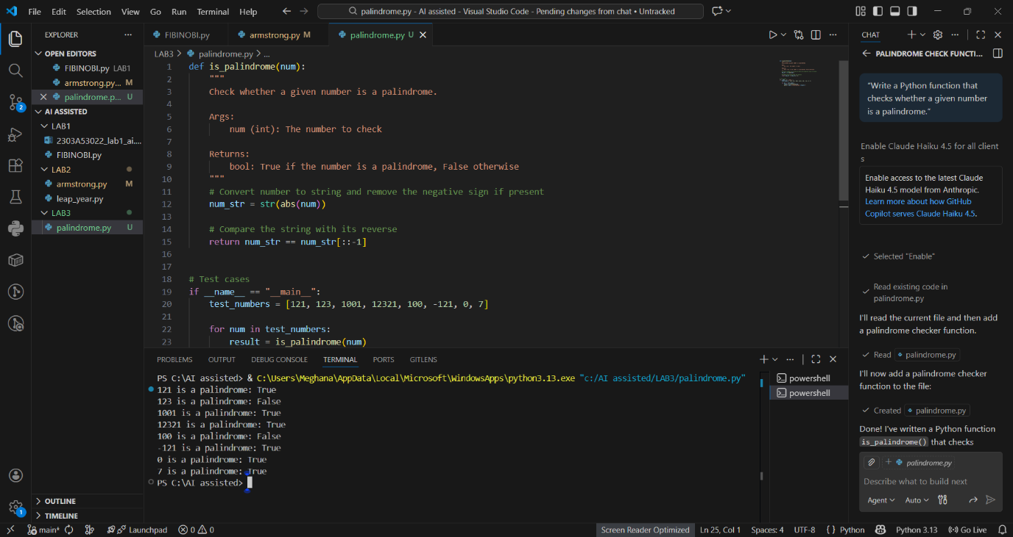Analysis
Correct cases
- Works for positive integers
- Handles 0 correctly
Issues / Missing Edge Cases
- Negative numbers are not considered palindromes (not explicitly handled)
- No input validation (floats, strings)
- Logic is correct but simplistic

Question 2: One-Shot Prompting
Problem: Factorial Calculation
One-Shot Prompt
“Write a Python function to compute the factorial of a number.
Example: Input: 5 → Output: 120”
AI-Generated Code
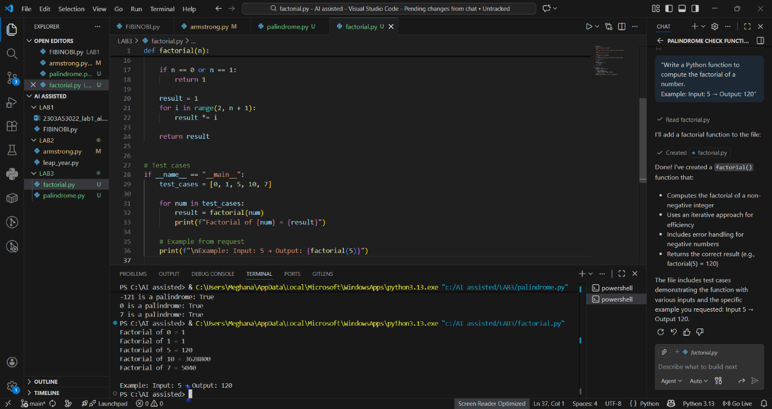Comparison with Zero-Shot Solution
Aspect | Zero-Shot | One-Shot
Base case | Often missing | Clearly handled
Logic clarity | Moderate | High
Correctness | May fail for 0 | Correct
Robustness | Limited | Improved
Conclusion
The one-shot example significantly improves correctness, especially for boundary values like 0.

Question 3: Few-Shot Prompting
Problem: Armstrong Number Check
Few-Shot Prompt
“Write a Python function to check whether a number is an Armstrong number.
Examples:
Input: 153 → Armstrong Number
Input: 370 → Armstrong Number
Input: 123 → Not an Armstrong Number”
AI-Generated Code
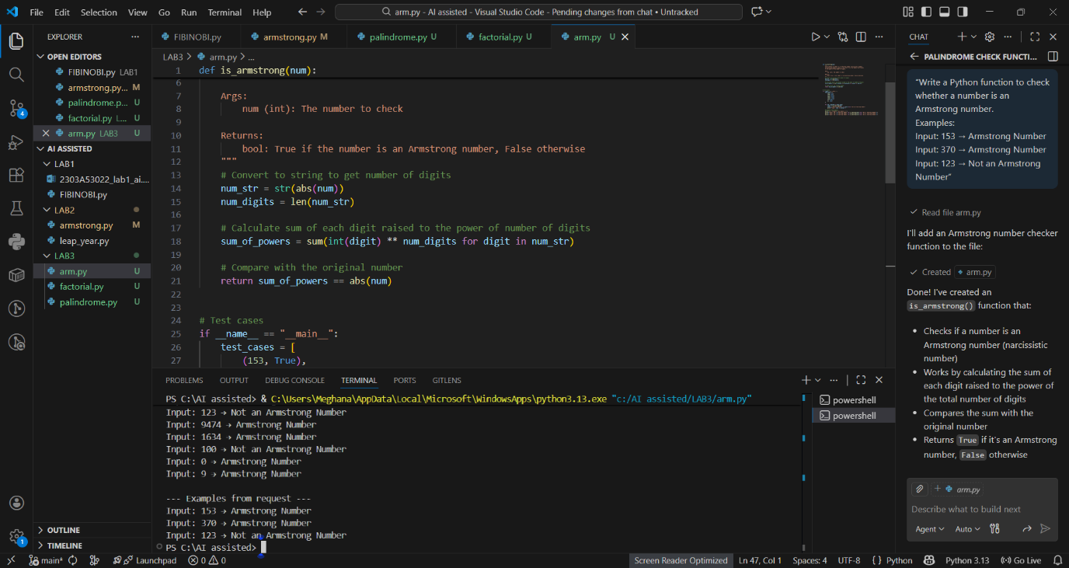Analysis
Improvements due to few-shot prompting
- Correct formula inferred
- Cleaner structure
- Uses mathematical logic correctly
Limitations
- No handling for negative numbers
- No input type validation

Question 4 (Optional): Context-Managed Prompting
Problem: Prime / Composite / Neither
Context-Managed Prompt
“Write an optimized Python program to classify a number as prime, composite, or neither.
Constraints:
• Validate input
• Handle numbers ≤ 1
• Optimize using √n approach”
AI-Generated Code
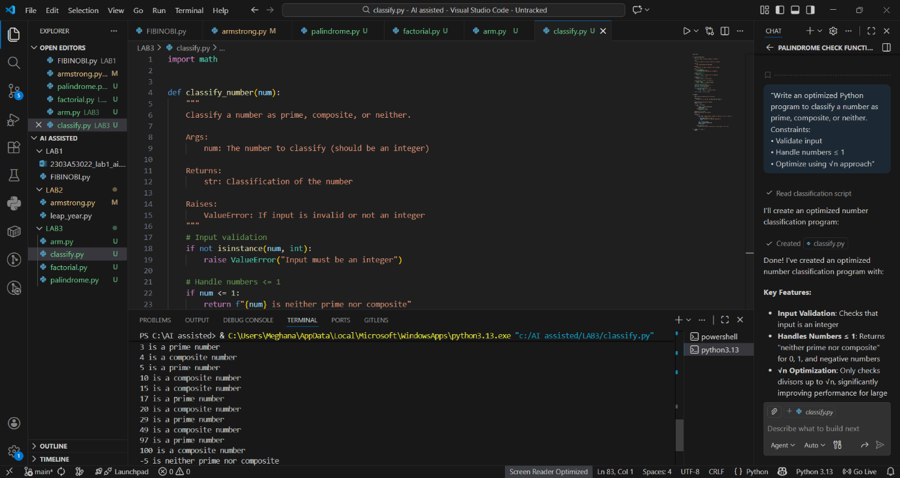
Evaluation
- Efficient (O(√n))
- Clear classification
- Strong validation
- Best result among all prompting styles

Question 5: Zero-Shot Prompting
Problem: Perfect Number Check
Zero-Shot Prompt
“Write a Python function that checks whether a given number is a perfect number.”
AI-Generated Code
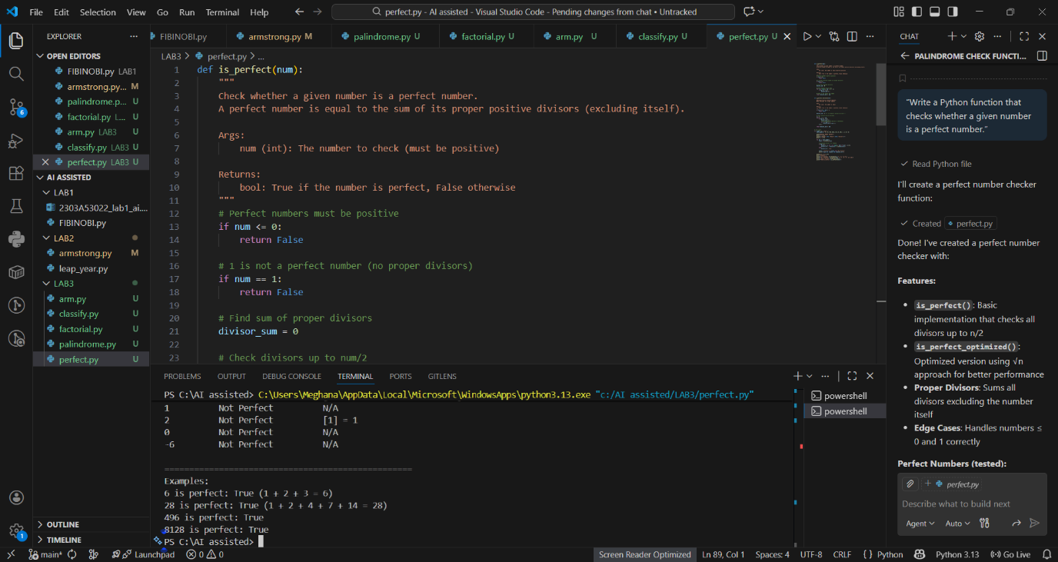
Issues Identified
- Inefficient (O(n))
- No handling for negative numbers or zero
- No input validation

Question 6: Few-Shot Prompting
Problem: Even or Odd with Validation
Few-Shot Prompt
“Write a Python program to check whether a number is even or odd.
Examples:
Input: 8 → Even
Input: 15 → Odd
Input: 0 → Even”*
AI-Generated Code
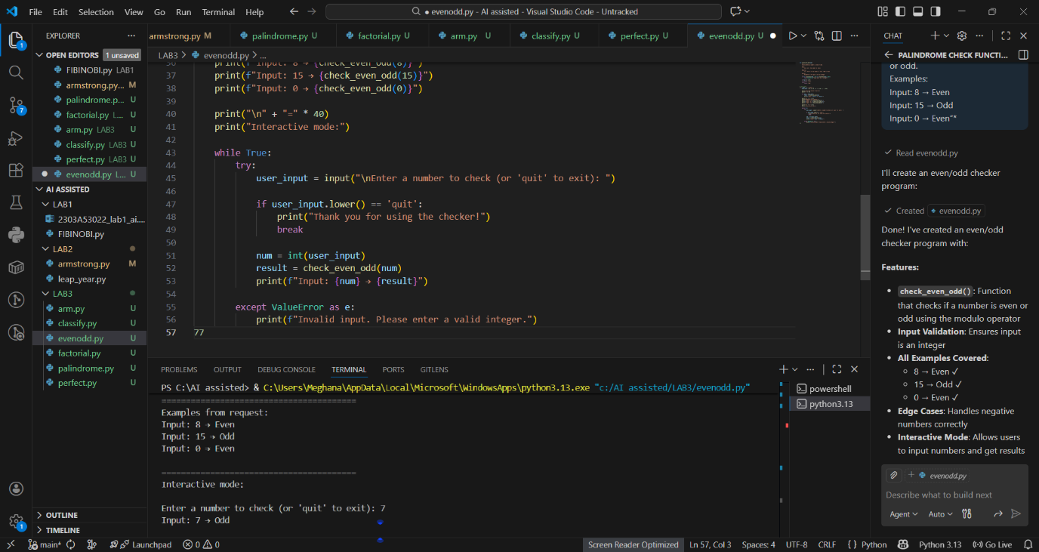Analysis
- Examples improved input handling
- Output is clean and unambiguous
- Handles negatives correctly

Overall Conclusion
Prompting Technique | Code Quality | Accuracy | Validation
Zero-Shot | Basic | Medium | Poor
One-Shot | Improved | High | Medium
Few-Shot | High | Very High | Medium
Context-Managed | Excellent | Excellent | Strong
Final Observation:
Providing examples and constraints dramatically improves AI-generated code, especially for edge cases, efficiency, and robustness.

