AI-Assisted Code Refactoring Report

Task 1: Refactoring Data Transformation Logic

AI Prompt Used:
Suggest a more Pythonic way to refactor this loop using list comprehensions while preserving output.

Legacy Code:
values = [2, 4, 6, 8, 10]
doubled = []
for v in values:
doubled.append(v * 2)
print(doubled)

Refactored Code:
values = [2, 4, 6, 8, 10]
doubled = [v * 2 for v in values]
print(doubled)

Explanation:
The explicit loop was replaced with a list comprehension, which is more concise and Pythonic. List comprehensions improve readability and performance for simple transformations.

Output:
[4, 8, 12, 16, 20]
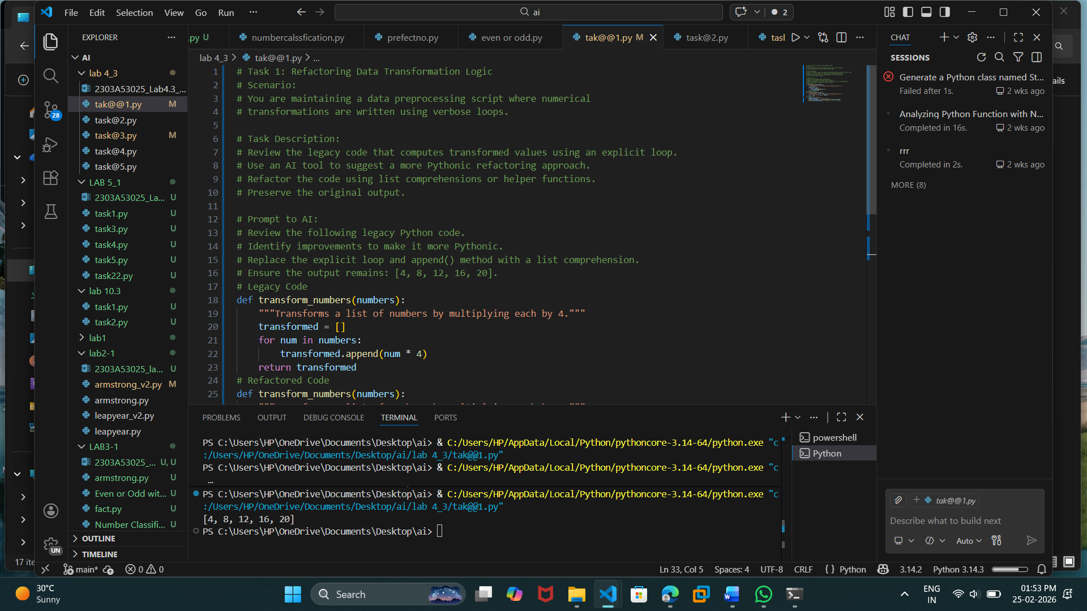

Task 2: Improving Text Processing Code Readability

AI Prompt Used:
How can I refactor repeated string concatenation into a more efficient and readable approach?

Legacy Code:
words = ['Refactoring', 'with', 'AI', 'improves', 'quality']
message = ''
for w in words:
message += w + ' '
print(message.strip())

Refactored Code:
words = ['Refactoring', 'with', 'AI', 'improves', 'quality']
message = ' '.join(words)
print(message)

Explanation:
Instead of repeated string concatenation, the join() method is used. This is more efficient and readable because it avoids creating multiple intermediate string objects.

Output:
Refactoring with AI improves quality
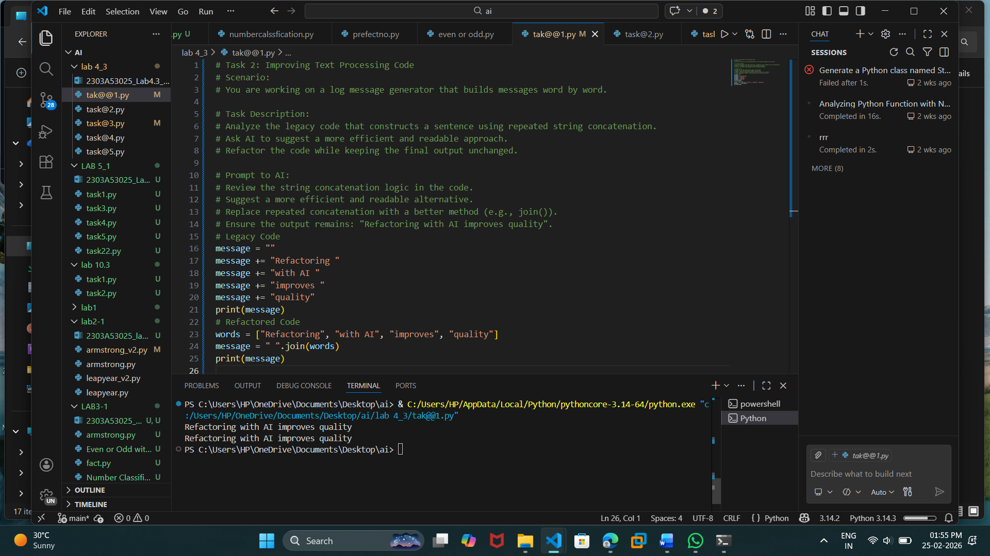

Task 3: Safer Access to Configuration Data

AI Prompt Used:
Suggest a safer and cleaner way to access dictionary keys that may not exist.

Legacy Code:
config = {'host': 'localhost', 'port': 8080}
if 'timeout' in config:
print(config['timeout'])
else:
print('Default timeout used')

Refactored Code:
config = {'host': 'localhost', 'port': 8080}
print(config.get('timeout', 'Default timeout used'))

Explanation:
The dictionary get() method is used to safely retrieve values. If the key does not exist, a default message is returned without raising a KeyError.

Output:
Default timeout used
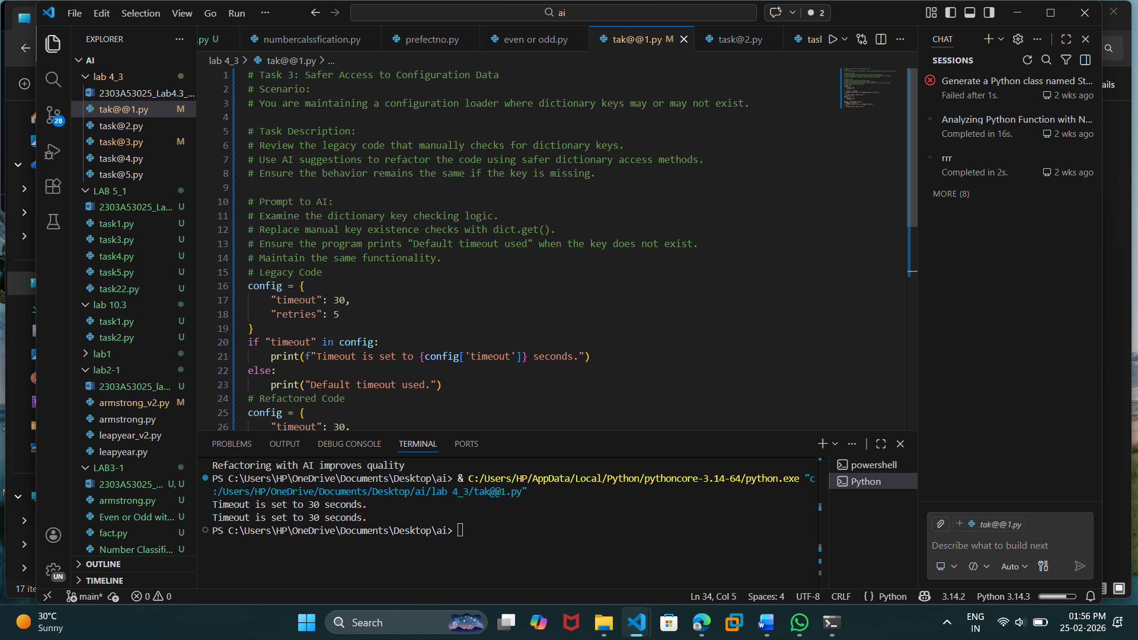

Task 4: Refactoring Conditional Logic for Scalability

AI Prompt Used:
How can I replace multiple if-elif conditions with a more scalable mapping approach?

Legacy Code:
action = 'divide'
x, y = 10, 2
if action == 'add':
result = x + y
elif action == 'subtract':
result = x - y
elif action == 'multiply':
result = x * y
elif action == 'divide':
result = x / y
else:
result = None
print(result)

Refactored Code:
action = 'divide'
x, y = 10, 2
operations = {
'add': lambda a, b: a + b,
'subtract': lambda a, b: a - b,
'multiply': lambda a, b: a * b,
'divide': lambda a, b: a / b
}
result = operations.get(action, lambda a, b: None)(x, y)
print(result)

Explanation:
A dictionary mapping actions to functions is used. This approach is cleaner and scalable because new operations can be added without modifying conditional logic.

Output:
5.0
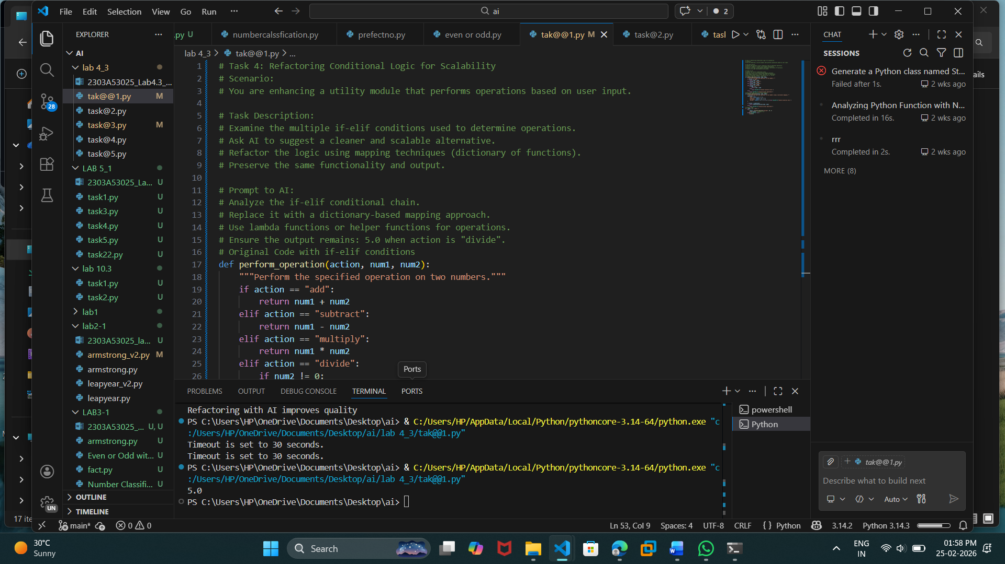

Task 5: Simplifying Search Logic in Collections

AI Prompt Used:
How can I simplify manual search logic in a list into a more concise Pythonic approach?

Legacy Code:
inventory = ['pen', 'notebook', 'eraser', 'marker']
found = False
for item in inventory:
if item == 'eraser':
found = True
break
print('Item Available' if found else 'Item Not Available')

Refactored Code:
inventory = ['pen', 'notebook', 'eraser', 'marker']
found = 'eraser' in inventory
print('Item Available' if found else 'Item Not Available')

Explanation:
The 'in' keyword is used to check membership directly. This eliminates the need for a manual loop and improves readability.

Output:
Item Available
