CODE FOR JDBC
QUERY EXECUTED: SELECT * FROM UER WHERE SL_NO =?
package CRUD;
import java.sql.Connection;
import java.sql.PreparedStatement;
import java.sql.ResultSet;
public class CRUD_Test {
public static void main(String[] args) {
CRUD_Test objTest = new CRUD_Test();
// 1. Insert new fresh data (Create) - Jinu & Jawad replaced with Amit & Riya
// Unique serial numbers are used so MILIND(1), SHALINI(2), and RAJESH(3) stay intact.
objTest.create_data("4", "Amit", "amit@gmail.com");
objTest.create_data("5", "Riya", "riya@gmail.com");
// 2. Update data (Update) - Changing Riya (Sl No 5) to a new profile (Sl No 55)
objTest.update_data("5", "55", "Riya Sharma", "riyasharma@gmail.com");
// 3. Delete data (Delete) - Removing Amit (Sl No 4) completely from the database
objTest.delete_data("4");
// 4. Read data (Read) - Placed LAST so the console outputs the accurate final table
objTest.read_data("2");
}
// CREATE METHOD
public void create_data(String sl_no, String name, String email) {
DB_Connection obj_DB_Connection = new DB_Connection();
Connection connection = obj_DB_Connection.get_connection();
PreparedStatement ps = null;
try {
String query = "insert into user(sl_no,name,email) values (?,?,?)";
ps = connection.prepareStatement(query);
ps.setString(1, sl_no);
ps.setString(2, name);
ps.setString(3, email);
System.out.println(ps);
ps.executeUpdate();
} catch (Exception e) {
System.out.println(e);
}
}
// READ METHOD (Formatted into columns)
public void read_data(String sl_no) {
DB_Connection obj_DB_Connection = new DB_Connection();
Connection connection = obj_DB_Connection.get_connection();
PreparedStatement ps = null;
ResultSet rs = null;
try {
String query = "select * from user where sl_no = ?";
ps = connection.prepareStatement(query);
ps.setString(1, sl_no);;
System.out.println("\n" + ps);
rs = ps.executeQuery();
// Print table border headers
System.out.println("+-------+----------------------+---------------------------------+");
System.out.printf("| %-5s | %-20s | %-31s |\n", "Sl No", "Name", "Email");
System.out.println("+-------+----------------------+---------------------------------+");
// Loop through entries and cleanly pad columns dynamically
while (rs.next()) {
System.out.printf("| %-5s | %-20s | %-31s |\n",
rs.getString("sl_no"),
rs.getString("name"),
rs.getString("email"));
}
// Print table bottom border
System.out.println("+-------+----------------------+---------------------------------+");
} catch (Exception e) {
System.out.println(e);
}
}
// UPDATE METHOD
public void update_data(String sl_no, String new_sl_no, String name, String email) {
DB_Connection obj_DB_Connection = new DB_Connection();
Connection connection = obj_DB_Connection.get_connection();
PreparedStatement ps = null;
try {
String query = "update user set sl_no=?,name=?,email=? where sl_no=?";
ps = connection.prepareStatement(query);
ps.setString(1, new_sl_no);
ps.setString(2, name);
ps.setString(3, email);
ps.setString(4, sl_no);
System.out.println(ps);
ps.executeUpdate();
} catch (Exception e) {
System.out.println(e);
}
}
// DELETE METHOD
public void delete_data(String sl_no) {
DB_Connection obj_DB_Connection = new DB_Connection();
Connection connection = obj_DB_Connection.get_connection();
PreparedStatement ps = null;
try {
String query = "delete from user where sl_no=?";
ps = connection.prepareStatement(query);
ps.setString(1, sl_no);
System.out.println(ps);
ps.executeUpdate();
} catch (Exception e) {
System.out.println(e);
}
}
}

OUTPUT:
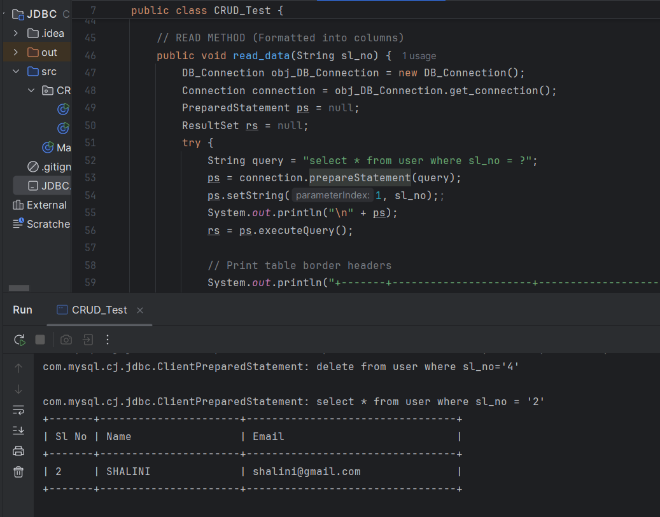
ALTER COMMAND:
package CRUD;
import java.sql.Connection;
import java.sql.PreparedStatement;
public class UpdateRunner {
public static void main(String[] args) {
UpdateRunner runner = new UpdateRunner();
runner.alter_table();
}
public void alter_table() {
DB_Connection obj_DB_Connection = new DB_Connection();
Connection connection = obj_DB_Connection.get_connection();
PreparedStatement ps = null;
try {
String query = "ALTER TABLE user ADD COLUMN phone VARCHAR(15)";
ps = connection.prepareStatement(query);
ps.executeUpdate();
System.out.println("Table altered successfully!");
} catch (Exception e) {
System.out.println(e);
}
}
}

OUTPUT:
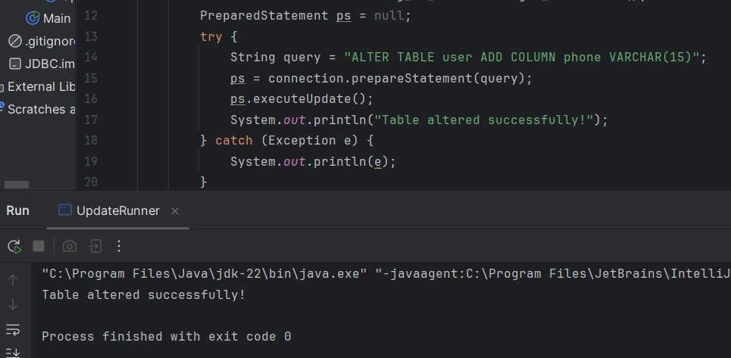

TRUNCATE COMMAND:
package CRUD;
import java.sql.Connection;
import java.sql.PreparedStatement;
public class UpdateRunner1 {
public static void main(String[] args) {
UpdateRunner1 runner = new UpdateRunner1();
runner.truncate_data();
}
public void truncate_data() {
DB_Connection obj_DB_Connection = new DB_Connection();
Connection connection = obj_DB_Connection.get_connection();
PreparedStatement ps = null;
try {
String query = "truncate table user";
ps = connection.prepareStatement(query);
ps.executeUpdate();
System.out.println("Table truncated successfully!");
} catch (Exception e) {
System.out.println(e);
}
}
}
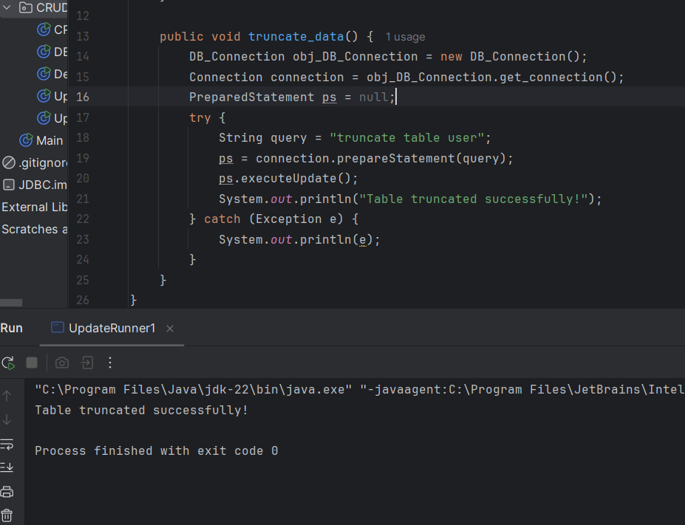

CONNECTION TO MONGODB:
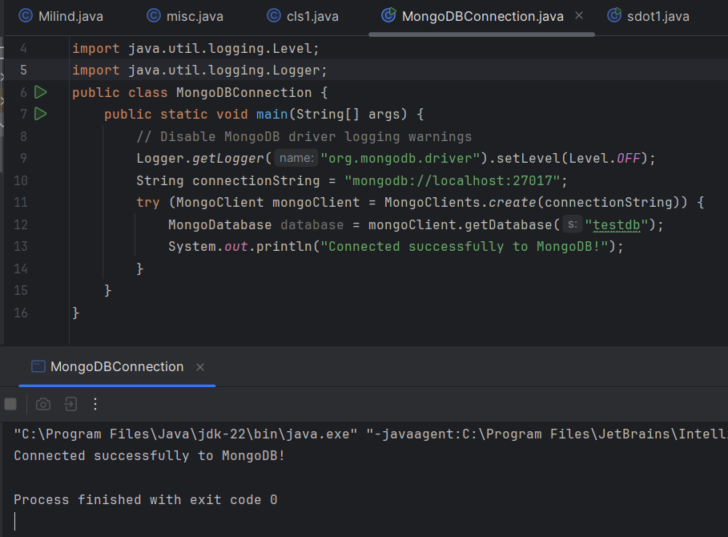
(CONNECTED SUCCESSFULLY)

