import com.mongodb.client.MongoClient;
import com.mongodb.client.MongoClients;
import com.mongodb.client.MongoDatabase;
import com.mongodb.client.MongoCollection;
import com.mongodb.client.FindIterable;
import com.mongodb.client.model.Filters;
import com.mongodb.client.model.Updates;
import org.bson.Document;
public class MongoCRUDExample {
public static void main(String[] args) {
java.util.logging.Logger.getLogger("org.mongodb.driver").setLevel(java.util.logging.Level.OFF);
MongoCRUDExample runner = new MongoCRUDExample();
runner.create_data();
runner.read_data();
runner.update_data();
runner.read_data();
runner.delete_data();
runner.read_data();
}
public void create_data() {
try (MongoClient mongoClient = MongoClients.create("mongodb://localhost:27017")) {
MongoDatabase database = mongoClient.getDatabase("CollegeDB");
MongoCollection<Document> collection = database.getCollection("Students");
Document student = new Document("id", 101)
.append("name", "John")
.append("department", "CSE")
.append("cgpa", 8.7);
collection.insertOne(student);
System.out.println("Document Inserted Successfully");
} catch (Exception e) {
System.out.println(e);
}
}
public void read_data() {
try (MongoClient mongoClient = MongoClients.create("mongodb://localhost:27017")) {
MongoDatabase database = mongoClient.getDatabase("CollegeDB");
MongoCollection<Document> collection = database.getCollection("Students");
FindIterable<Document> students = collection.find();
System.out.println("+-------+----------------------+----------------------+-------+");
System.out.printf("| %-5s | %-20s | %-20s | %-5s |\n", "ID", "Name", "Department", "CGPA");
System.out.println("+-------+----------------------+----------------------+-------+");
boolean hasData = false;
for (Document doc : students) {
hasData = true;
Object idObj = doc.get("id");
String idStr = (idObj != null) ? idObj.toString() : "";
String name = doc.getString("name");
String dept = doc.getString("department");
Object cgpaObj = doc.get("cgpa");
String cgpaStr = (cgpaObj != null) ? cgpaObj.toString() : "";
System.out.printf("| %-5s | %-20s | %-20s | %-5s |\n", idStr, name, dept, cgpaStr);
}
if (!hasData) {
System.out.printf("| %-61s |\n", "No records found in collection.");
}
System.out.println("+-------+----------------------+----------------------+-------+");
} catch (Exception e) {
System.out.println(e);
}
}
public void update_data() {
try (MongoClient mongoClient = MongoClients.create("mongodb://localhost:27017")) {
MongoDatabase database = mongoClient.getDatabase("CollegeDB");
MongoCollection<Document> collection = database.getCollection("Students");
collection.updateOne(
Filters.eq("id", 101),
Updates.set("cgpa", 9.2)
);
System.out.println("Document Updated Successfully");
} catch (Exception e) {
System.out.println(e);
}
}
public void delete_data() {
try (MongoClient mongoClient = MongoClients.create("mongodb://localhost:27017")) {
MongoDatabase database = mongoClient.getDatabase("CollegeDB");
MongoCollection<Document> collection = database.getCollection("Students");
collection.deleteOne(Filters.eq("id", 101));
System.out.println("Document Deleted Successfully");
} catch (Exception e) {
System.out.println(e);
}
}
}
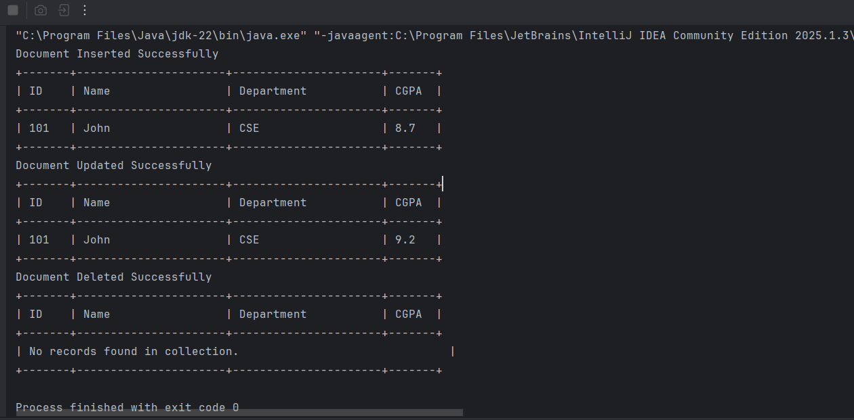
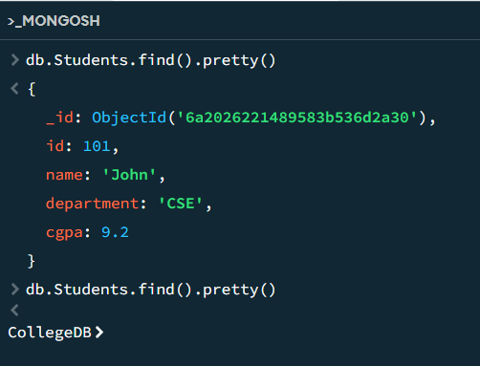

package CRUD;
import com.mongodb.client.MongoClient;
import com.mongodb.client.MongoClients;
import com.mongodb.client.MongoDatabase;
import com.mongodb.client.MongoCollection;
import com.mongodb.client.FindIterable;
import com.mongodb.client.model.Filters;
import com.mongodb.client.model.Updates;
import org.bson.Document;
import java.util.Arrays;
import java.util.List;
public class MongoCRUDManyExample {
public static void main(String[] args) {
java.util.logging.Logger.getLogger("org.mongodb.driver").setLevel(java.util.logging.Level.OFF);
MongoCRUDManyExample runner = new MongoCRUDManyExample();
runner.create_many_data();
runner.read_data();
runner.update_many_data();
runner.read_data();
runner.delete_many_data();
runner.read_data();
}
public void create_many_data() {
try (MongoClient mongoClient = MongoClients.create("mongodb://localhost:27017")) {
MongoDatabase database = mongoClient.getDatabase("CollegeDB");
MongoCollection<Document> collection = database.getCollection("Students");
Document student1 = new Document("id", 102)
.append("name", "Alice")
.append("department", "CSE")
.append("cgpa", 8.9);
Document student2 = new Document("id", 103)
.append("name", "Bob")
.append("department", "ECE")
.append("cgpa", 7.8);
Document student3 = new Document("id", 104)
.append("name", "Charlie")
.append("department", "CSE")
.append("cgpa", 8.5);
List<Document> studentList = Arrays.asList(student1, student2, student3);
collection.insertMany(studentList);
System.out.println("Batch Documents Inserted Successfully!");
} catch (Exception e) {
System.out.println(e);
}
}
public void read_data() {
try (MongoClient mongoClient = MongoClients.create("mongodb://localhost:27017")) {
MongoDatabase database = mongoClient.getDatabase("CollegeDB");
MongoCollection<Document> collection = database.getCollection("Students");
FindIterable<Document> students = collection.find();
System.out.println("+-------+----------------------+----------------------+-------+");
System.out.printf("| %-5s | %-20s | %-20s | %-5s |\n", "ID", "Name", "Department", "CGPA");
System.out.println("+-------+----------------------+----------------------+-------+");
boolean hasData = false;
for (Document doc : students) {
hasData = true;
Object idObj = doc.get("id");
String idStr = (idObj != null) ? idObj.toString() : "";
String name = doc.getString("name");
String dept = doc.getString("department");
Object cgpaObj = doc.get("cgpa");
String cgpaStr = (cgpaObj != null) ? cgpaObj.toString() : "";
System.out.printf("| %-5s | %-20s | %-20s | %-5s |\n", idStr, name, dept, cgpaStr);
}
if (!hasData) {
System.out.printf("| %-61s |\n", "No records found in collection.");
}
System.out.println("+-------+----------------------+----------------------+-------+");
} catch (Exception e) {
System.out.println(e);
}
}
public void update_many_data() {
try (MongoClient mongoClient = MongoClients.create("mongodb://localhost:27017")) {
MongoDatabase database = mongoClient.getDatabase("CollegeDB");
MongoCollection<Document> collection = database.getCollection("Students");
collection.updateMany(
Filters.eq("department", "CSE"),
Updates.set("cgpa", 9.5)
);
System.out.println("Matching Documents Updated Successfully!");
} catch (Exception e) {
System.out.println(e);
}
}
public void delete_many_data() {
try (MongoClient mongoClient = MongoClients.create("mongodb://localhost:27017")) {
MongoDatabase database = mongoClient.getDatabase("CollegeDB");
MongoCollection<Document> collection = database.getCollection("Students");
collection.deleteMany(Filters.eq("department", "CSE"));
System.out.println("Matching Documents Deleted Successfully!");
} catch (Exception e) {
System.out.println(e);
}
}
}

