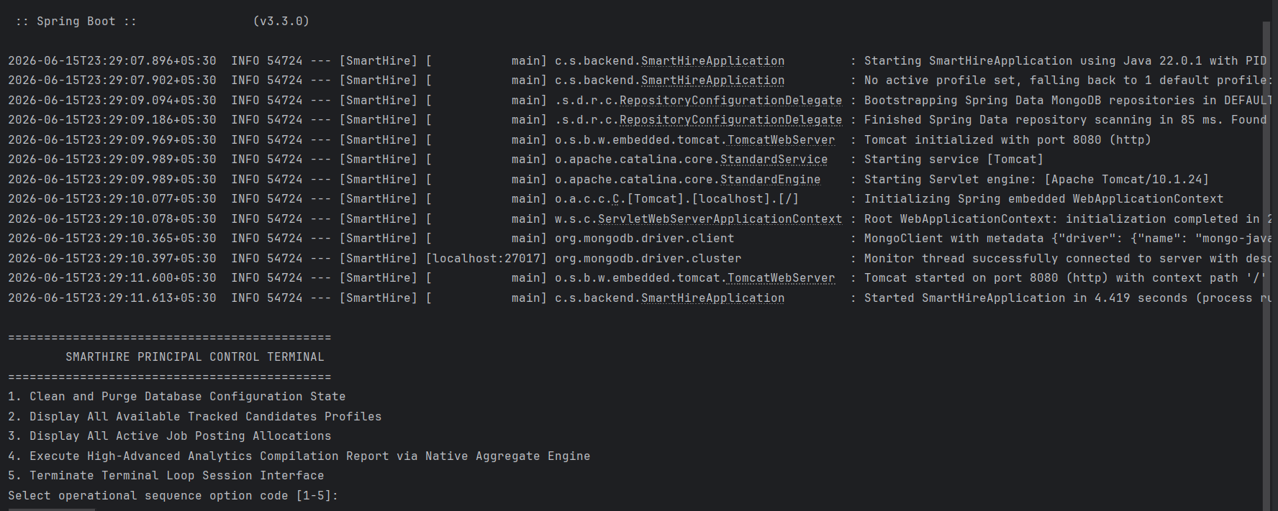

The system is now fully successfully connected to springBoot

