GRE分析软件_V1.0.4程序测试调试流程

时间：2015/12/16

背景：软件程序调试测试项目和步骤；

|  |  |  |  |  |
| --- | --- | --- | --- | --- |
| 编号 | 项目 | 描述 | 是/否通过 | 结果 |
| 1 | 以太网标准数据包测试 | Checkpacket/eth_tcp.pcap eth_udp.pcap | 通过 | 附件1 |
| 2 | 非分片独立PPP封装包 | Checkpacket/gre_tcp.pcap gre_udp.pcap | 通过 | 见附件1 |
| 3 | gre包内多ppp分片独立包 | p.154 | 通过 | 附件3 |
| 4 | gre协议IP分片包 | P.2526-2527 | 通过 | 附件4 |
| 5 | gre分片包 | Checkpacket/gre_fragment.pcap | 通过 | 附件5 |
| 6 | ppp 非IP协议数据包 | 1093.pcap | 通过 | 附件6 |
| 7 | ppp_ip字段不完全 | 10223.pcap | 通过 | 附件7 |
| 8 | pcap_caplen参数错误 | 10223.pcap | 通过 | 已修复 |
| 9 | 1-99.pcap混合测试 | 1-99.pcap | 通过 | 附件9 |
| 10 | 7358-7458.pcap混合测试 | 7358-7458.pcap | 通过 | 附件10 |
| 11 | 全部数据包混合测试 | multi.pcap |  |  |
|  |  |  |  |  |
|  |  |  |  |  |
|  |  |  |  |  |
|  |  |  |  |  |
|  |  |  |  |  |
|  |  |  |  |  |
|  |  |  |  |  |
|  |  |  |  |  |
|  |  |  |  |  |
|  |  |  |  |  |
|  |  |  |  |  |
|  |  |  |  |  |
|  |  |  |  |  |
|  |  |  |  |  |
|  |  |  |  |  |
|  |  |  |  |  |
|  |  |  |  |  |
|  |  |  |  |  |
|  |  |  |  |  |
|  |  |  |  |  |
|  |  |  |  |  |
|  |  |  |  |  |
|  |  |  |  |  |
|  |  |  |  |  |
|  |  |  |  |  |
|  |  |  |  |  |
|  |  |  |  |  |
|  |  |  |  |  |
|  |  |  |  |  |
|  |  |  |  |  |
|  |  |  |  |  |
|  |  |  |  |  |
|  |  |  |  |  |
|  |  |  |  |  |
|  |  |  |  |  |
|  |  |  |  |  |
|  |  |  |  |  |
|  |  |  |  |  |
|  |  |  |  |  |
|  |  |  |  |  |
|  |  |  |  |  |
|  |  |  |  |  |
|  |  |  |  |  |

附件1：



附件3:



附件4：



附件5：



附件6：



附件7：

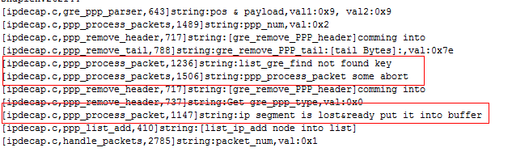

附件9：



附件10：

