GraphLab Cheatsheet

Contents

GraphLab Cheatsheet 1

Environment 1

Plot into the iPython notebook 1

Images 1

Show an image 1

Plotting 2

Box Whisker Plot 2

Scatter Plot 2

Regression 3

Create a regression model 3

Coefficients of a regression model 3

SFrames 3

Add a column to an Sframe 3

Apply a function to an Sframe column 3

Max of a column 3

Mean of a column 4

Random partition of an Sframe 4

Summary of a column 4

Visualize columns 5

# Classifiers

## Logistic Classifier

sentiment_model = graphlab.logistic_classifier.create(train_data,

target='sentiment',

features=['word_count'],

validation_set=test_data)

## Show ROC Curve for Classifier

sentiment_model = graphlab.logistic_classifier.create(train_data,

target='sentiment',

features=['word_count'],

validation_set=test_data)

sentiment_model.evaluate(test_data, metric='roc_curve')

sentiment_model.show(view='Evaluation')

# Environment

## Plot into the iPython notebook

graphlab.canvas.set_target('ipynb')

# Images

## Show an image

<img src="house-1925069082.jpg">

# Plotting

## Box Whisker Plot

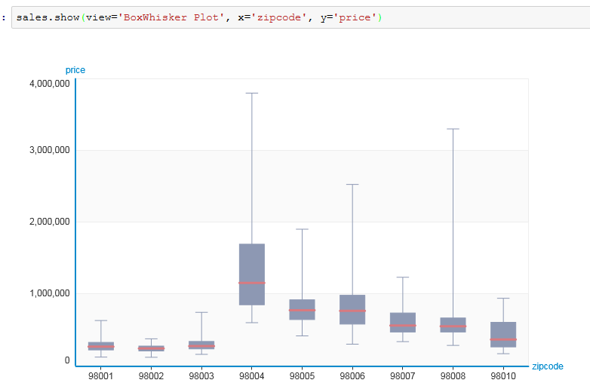

## Scatter Plot

sales.show(view="Scatter Plot", x="sqft_living", y="price")

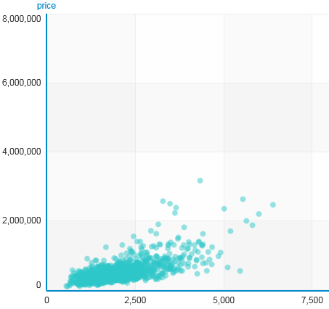

# Regression

## Create a regression model

sqft_model = graphlab.linear_regression.create(train_data, target='price', features=['sqft_living'])

## Coefficients of a regression model

sqft_model.get('coefficients')

# SFrames

## Add a column to an Sframe

sf['Full Name'] = sf['First Name'] + ' ' + sf['Last Name']

|  |  |  |  |  |
| --- | --- | --- | --- | --- |
| **First Name** | **Last Name** | **Country** | **age** | **Full Name** |
| Bob | Smith | United States | 24 | Bob Smith |
| Alice | Williams | Canada | 23 | Alice Williams |
| Malcolm | Jone | England | 22 | Malcolm Jone |

## Apply a function to an Sframe column

def transform_country(country):

if country == 'USA':

return 'United States'

else:

return country

sf['Country'] = sf['Country'].apply(transform_country)

## Max of a column

sf['age'].max()

## Mean of a column

sf['age'].mean()

## Random partition of an Sframe

train_data,test_data = sales.random_split(.8,seed=0)

## Sort an SFrame

giraffe_reviews = giraffe_reviews.sort('predicted_sentiment', ascending=False)

## Summary of a column

sf['Country'].show()

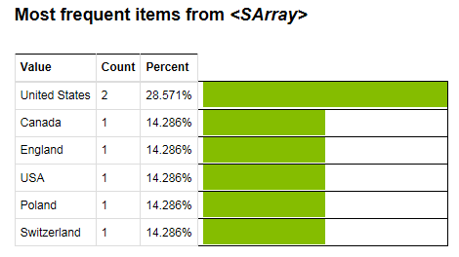

## Visualize columns

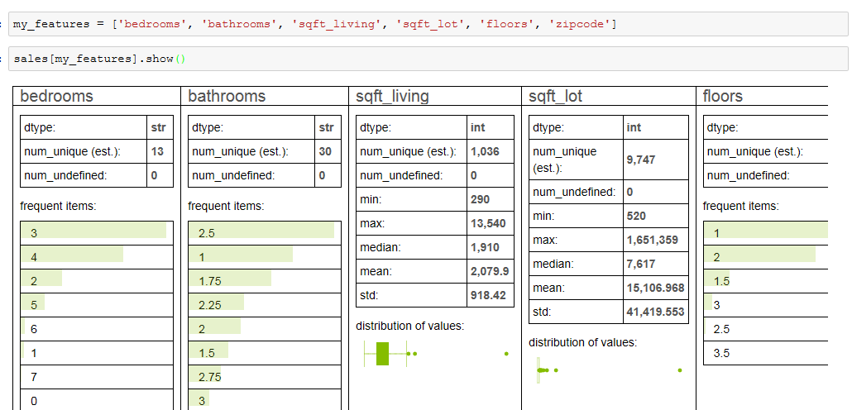

# Text Analytics

## Word Count

products['word_count'] = graphlab.text_analytics.count_words(products['review'])

