EV3 Cheatsheet

Contents

Infra-Red Sensor 1

Detect When an Object Is Close 1

Testing an Infra-Red Sensor 1

Touch Sensor – Wait for Button to be Pressed 2

# Infra-Red Sensor

## Detect When an Object Is Close

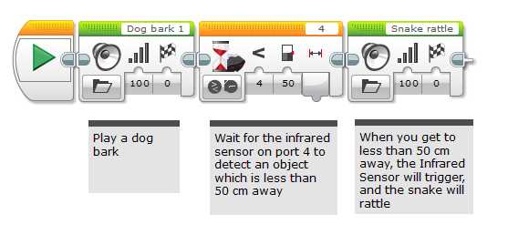

## Testing an Infra-Red Sensor

Attach an infra-red sensor to port 4 with a cable

Down in the lower right-hand corner of the EV3 app, select the Port View:

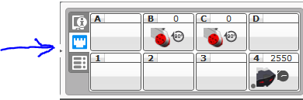

The Infra-Red sensor is shown in the lower right-hand corner. The number above it is proportional to the distance of the closest object. If an object gets close to the robot (or vice versa), that number will decrease. This verifies that the infra-red sensor is working properly.

# Touch Sensor – Wait for Button to be Pressed

