github_cheatsheet

Contents

github_cheatsheet 1

add/add Conflicts 2

Clone a Private Repository 2

Example: Create a local repository directory, and clone the github repository to the local machine 3

Force a Push to a Github Repository 3

GitHub Flow Process 5

Examples 5

• Example Github Flow 5

Merge Binary Files 5

Throw Out All Changes and Revert to the Origin Master 6

Undo a git add 6

Appendix 1 - Example Github Flow (a.k.a. “Feature Branch”) Session 6

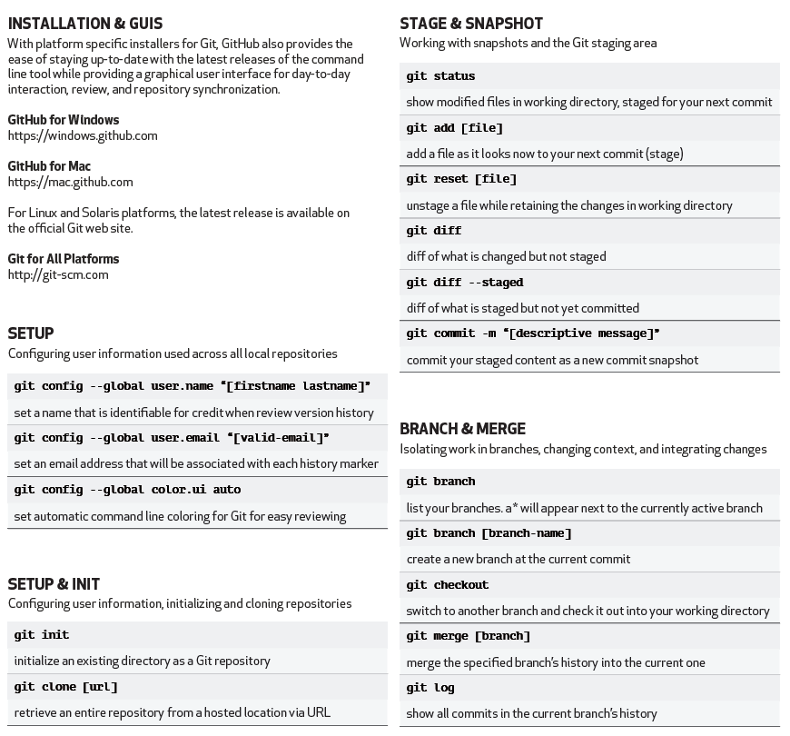

# add/add Conflicts

<https://www.dmuth.org/node/1428/git-101-how-handle-merge-conflicts>

# Clone a Private Repository

git clone https://Prettyfield:<insert_pwd_here>@github.com/savitech/notebooks.git

## Example: Create a local repository directory, and clone the github repository to the local machine

Create the git local repository

mb-bbeauchamp:dev bruce$

mb-bbeauchamp:dev bruce$ pwd

/Users/bruce/dev

mb-bbeauchamp:dev bruce$ **git init**

Initialized empty Git repository in /Users/bruce/dev/.git/

Clone the github repository into the local repository

mb-bbeauchamp:dev bruce$ **git clone https://github.com/BAPrettyfield/CheatSheets.git cheatsheets**

Cloning into 'cheatsheets'...

remote: Enumerating objects: 96, done.

remote: Counting objects: 100% (96/96), done.

remote: Compressing objects: 100% (68/68), done.

remote: Total 1707 (delta 55), reused 69 (delta 28), pack-reused 1611

Receiving objects: 100% (1707/1707), 43.63 MiB | 8.16 MiB/s, done.

Resolving deltas: 100% (999/999), done.

mb-bbeauchamp:dev bruce$ ls

cheatsheets

mb-bbeauchamp:dev bruce$ cd cheatsheets

mb-bbeauchamp:cheatsheets bruce$ ls

Cassandra_Cheatsheet.docx github_cheatsheet.docx

DevCenter Cheatsheet.docx iPython_cheatsheet.docx

GraphLab_Cheatsheet.docx jupyter_cheatsheet.docx

Hadoop Cheatsheet.docx linux_cheatsheet.docx

Lego_Robotics_Cheatsheet.docx mac_cheatsheet.docx

Oracle_Cheatsheet.docx machine_learning_cheatsheet.docx

Postgres Cheatsheet.docx markdown_cheatsheet.docx

Python_Cheatsheet.docx pySpark_Cheatsheet.docx

R Cheatsheet.docx scikit_learn_cheatsheet.docx

R Cheatsheet2.docx sparkSQL_cheatsheet.docx

README.md spark_cheatsheet.docx

Ruby Cheatsheet.docx sql_cheatsheet.docx

Scikit-learn algorithm cheat-sheet.pptx tableau_cheatsheet.docx

Unix Cheatsheet.docx tableau_example_workbooks

bitbucket cheatsheet.docx windows_cmd_cheatsheet.docx

conda-cheatsheet.pdf ~$Cheatsheet.docx

conda_cheatsheet.docx ~$Spark Cheatsheet.docx

educational_subjects.docx ~$c_cheatsheet.docx

ev3_cheatsheet.docx ~$doop Cheatsheet.docx

# Force a Push to a Github Repository

git push origin master –-force

# GitHub Flow Process

a.k.a. “Git Feature Workflow” and “Feature Branches”

See: <https://gist.github.com/blackfalcon/8428401>

Note: The original document describing this approach was

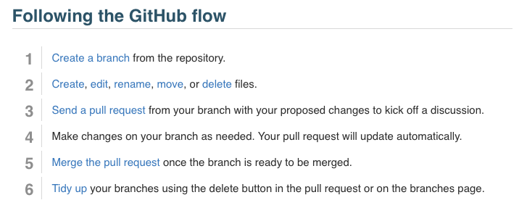

Figure 1 - https://help.github.com/articles/github-flow/

1. Create a branch in github.

<https://help.github.com/articles/creating-and-deleting-branches-within-your-repository/>

1. something

## Examples

# Example Github Flow

# Merge Binary Files

Problem:

c:\gitrepo\CheatSheets>git pull

warning: Cannot merge binary files: Python_Cheatsheet.docx (HEAD vs. 47369c46c4becd577b1522576620109121823c9e)

Auto-merging Python_Cheatsheet.docx

CONFLICT (content): Merge conflict in Python_Cheatsheet.docx

Automatic merge failed; fix conflicts and then commit the result.

Solution:

c:\gitrepo\CheatSheets>git checkout --theirs -- Python_Cheatsheet.docx

c:\gitrepo\CheatSheets>git commit -m "fixing merges"

[master 188d4cb] fixing merges

c:\gitrepo\CheatSheets>git push

# Throw Out All Changes and Revert to the Origin Master

git reset --hard origin/master

# Undo a git add

To **undo git add** . use **git** reset (no dot)

# Appendix 1 - Example Github Flow (a.k.a. “Feature Branch”) Session

a.k.a. “git_feature_workflow”

Last login: Mon Oct 8 13:07:40 on ttys002

**➜ ~** pwd

/Users/bbeauchamp

**➜ ~** cd ..

**➜ /** cd Users

**➜ /Users** cd bbeauchamp

**➜ ~** ls

...

**dev**

**...**

**➜ ~** cd dev

**➜ dev** cd data-science

**➜ data-science** **git:(master) ✗** cd eta

**➜ eta** **git:(master) ✗** cd ocean_eta

**➜ ocean_eta** **git:(master) ✗** ls

Actual Distance ETA Annotated 2018-04-17.ipynb

DTW Annotated 2018-04-13.ipynb

IMO List From Schedules.ipynb

Ocean_Generic_ETA_Model_Training_Baseline.ipynb

Ocean_Leg_ETA_Model_Training_km-rem.ipynb

Ocean_Leg_ETA_Model_Training_km-rem_speed.ipynb

Total Distance ETA.ipynb

**ship_sched**

**vessel_odpair_eta**

**➜ ocean_eta** **git:(master) ✗** cd vessel_odpair_eta

**➜ vessel_odpair_eta** **git:(master) ✗** git pull

Already up to date.

**➜ vessel_odpair_eta git:(master) ✗ git checkout -b vessel_odpair_model**

**Switched to a new branch 'vessel_odpair_model'**

**➜ vessel_odpair_eta** **git:(vessel_odpair_model) ✗** ls

**data**

**➜ vessel_odpair_eta** **git:(vessel_odpair_model) ✗** mkdir notebooks

**➜ vessel_odpair_eta** **git:(vessel_odpair_model) ✗** cd notebooks

**➜ notebooks** **git:(vessel_odpair_model) ✗** pwd

/Users/bbeauchamp/dev/data-science/eta/ocean_eta/vessel_odpair_eta/notebooks

Note: Here I moved the jupyter notebook I wanted to commit, to the notebooks directory.

**➜ notebooks** **git:(vessel_odpair_model) ✗** ls

vessel_leg_turnaround_transit_modeler.ipynb

**➜ notebooks** **git:(vessel_odpair_model) ✗** git add vessel_leg_turnaround_transit_modeler.ipynb

**➜ notebooks** **git:(vessel_odpair_model) ✗** git commit -m "Initial commit of the vessel_leg transit modeler."

[vessel_odpair_model 72b8370] Initial commit of the vessel_leg transit modeler.

1 file changed, 5486 insertions(+)

create mode 100644 eta/ocean_eta/vessel_odpair_eta/notebooks/vessel_leg_turnaround_transit_modeler.ipynb

**➜ notebooks** **git:(vessel_odpair_model) ✗** git push origin vessel_odpair_model

Counting objects: 7, done.

Delta compression using up to 8 threads.

Compressing objects: 100% (6/6), done.

Writing objects: 100% (7/7), 37.74 KiB | 5.39 MiB/s, done.

Total 7 (delta 3), reused 0 (delta 0)

remote: Resolving deltas: 100% (3/3), completed with 3 local objects.

remote:

remote: Create a pull request for 'vessel_odpair_model' on GitHub by visiting:

remote: https://github.com/savitech/data-science/pull/new/vessel_odpair_model

remote:

To https://github.com/savitech/data-science.git

* [new branch] vessel_odpair_model -> vessel_odpair_model

**➜ notebooks** **git:(vessel_odpair_model) ✗** pwd

/Users/bbeauchamp/dev/data-science/eta/ocean_eta/vessel_odpair_eta/notebooks

**➜ notebooks** **git:(vessel_odpair_model) ✗** git branch

**➜ notebooks** **git:(vessel_odpair_model) ✗** git status

On branch vessel_odpair_model

Untracked files:

(use "git add <file>..." to include in what will be committed)

../../../../cust/ciri/

../../../../cust/pg/2018/

../../../../cust/pg/pg_lanes_export_2017-05-18.csv

../.gitignore

nothing added to commit but untracked files present (use "git add" to track)

**➜ notebooks** **git:(vessel_odpair_model) ✗** git add vessel_leg*.ipynb

**➜ notebooks** **git:(vessel_odpair_model) ✗** git commit -m "Add modeler notebook which calculates the median speed for a particular vessel on a particular leg. Used to model vessel ETA on that leg."

[vessel_odpair_model 396006f] Add modeler notebook which calculates the median speed for a particular vessel on a particular leg. Used to model vessel ETA on that leg.

1 file changed, 1190 insertions(+), 5486 deletions(-)

rewrite eta/ocean_eta/vessel_odpair_eta/notebooks/vessel_leg_turnaround_transit_modeler.ipynb (83%)

**➜ notebooks** **git:(vessel_odpair_model) ✗** git push origin vessel_odpair_model

Counting objects: 7, done.

Delta compression using up to 8 threads.

Compressing objects: 100% (6/6), done.

Writing objects: 100% (7/7), 1.08 KiB | 1.08 MiB/s, done.

Total 7 (delta 4), reused 0 (delta 0)

remote: Resolving deltas: 100% (4/4), completed with 4 local objects.

To https://github.com/savitech/data-science.git

72b8370..396006f vessel_odpair_model -> vessel_odpair_model

**Note: Repeat the above process for additional files to be added...**

**➜ notebooks** **git:(vessel_odpair_model) ✗** git push origin vessel_odpair_model

Everything up-to-date

**➜ notebooks** **git:(vessel_odpair_model) ✗** ls

extract_median_abs_err.ipynb

readme.txt

vessel_leg_turnaround_transit_modeler.ipynb

**➜ notebooks** **git:(vessel_odpair_model) ✗** git branch

Then use github