iPython_cheatsheet

Contents

iPython_cheatsheet 1

Execute OS Commands 1

Force plots to be inline 1

Open iPython notebook 1

Where iPython notebooks are stored 2

# Execute OS Commands

Use ! followed by the underlying OS command, like for unix:

!pwd

output:

/Users/bbeauchamp/Documents/school/reproducible_data_analysis

# Force plots to be inline

%matplotlib inline

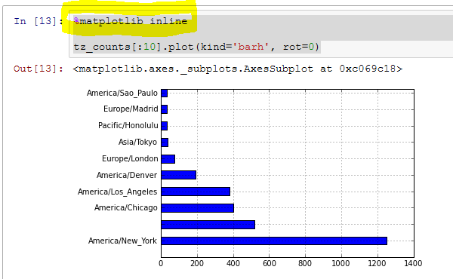

# Open iPython notebook

C:\Users\Bruce>ipython notebook

[W 08:26:33.769 NotebookApp] ipywidgets package not installed. Widgets are unavailable.

[I 08:26:33.789 NotebookApp] Serving notebooks from local directory: C:\Users\Bruce

[I 08:26:33.789 NotebookApp] 0 active kernels

[I 08:26:33.789 NotebookApp] The IPython Notebook is running at: http://localhost:8888/

[I 08:26:33.789 NotebookApp] Use Control-C to stop this server and shut down all kernels (twice to s

kip confirmation).

# Where iPython notebooks are stored

C:\Users\Bruce