mac_cheatsheet

Table of Contents

Application Search on mac (Spotlight Search) 1

Disable Sleep 2

Dock 2

Move the Dock to a Different Monitor 2

Excel 2

Import a CSV File as All Text Columns 2

Files 3

Change File Permissions 3

Convert a JSON file to a PrettyPrint version 3

Open a Text File from the Command Line 3

Unzip a File 3

Finder 3

Copy File Paths from the Finder 3

Show Path Bar 3

Store the Clipboard contents as a PrettyPrint JSON file 3

Force an Application to Quit 3

Jupyter Notebook Keyboard Shortcuts 4

Lock the Screen and Keyboard 4

Scan Images from a Canon Printer 4

Screenshot 4

Screenshot to file 4

Screenshot to clipboard 5

Show Desktop 5

Transfer a File to a Remote Server 5

# Application Search on mac (Spotlight Search)

command-space

# Disable Sleep

Useful if you want to be able to run ipython notebooks overnight without them stopping when the mac goes idle.

<http://www.benzado.com/blog/post/346/pmset-noidle>

# start background process to disable sleep

pmset noidle &

# save its process ID so we can terminate it later

PMSETPID=$!

...have your fun here...

# kill pmset so the computer can sleep if it wants to

kill $PMSETPID

# Dock

## Move the Dock to a Different Monitor

Starting with **OS X** 10.10 Yosemite, there's a new method for moving just the **dock** to another **display**without making changes to your primary **display** in System Preferences. To try it, simply move your mouse or trackpad cursor to the very bottom of the**display** where you want your **dock** to appear and hold it there

# Excel

## Import a CSV File as All Text Columns

1. Open a new spreadsheet.
2. Select the first cell as your insert point.
3. On the Excel Data menu, choose Data >> Get External Data >> Import Text File…
4. Choose “Delimited”, then click “Next>”.
5. Select all columns.
6. Click the Text radio button.
7. Click “Finish”

# Files

## Change File Permissions

Select a folder or a disk, then choose File > Get Info.

Click the lock icon to unlock it, then enter an administrator name and password.

Click the Action pop-up menu , then choose “Apply to enclosed items.”

## Convert a JSON file to a PrettyPrint version

cat unformatted.json | python -m json.tool > formatted.json

## Open a Text File from the Command Line

open -e <filename>

## Unzip a File

Right-click on the file >> Open With >> Archive Utility

# Finder

## Copy File Paths from the Finder

1. Navigate to the file or folder you wish to copy the path for
2. Right-click (or Control+Click, or a Two-Finger click on trackpads) on the file or folder in the Mac Finder
3. While in the right-click menu, hold down the OPTION key to reveal the “Copy (item name) as Pathname” option, it replaces the standard Copy option
4. Once selected, the file or folders path is now in the clipboard, ready to be pasted anywhere

## Show Path Bar

<https://www.techjunkie.com/show-path-finder-title-bar/>

## Store the Clipboard contents as a PrettyPrint JSON file

pbpaste | python -m json.tool > formatted.json

# Force an Application to Quit

How to force a **Mac app** to **quit**. Choose Force **Quit** from the Apple () menu, or press Command-Option-Esc. This is similar to pressing Control-Alt-Delete on a PC. Select the **app** in the Force **Quit** window, then click Force**Quit**.

# Jupyter Notebook Keyboard Shortcuts

esc-L Toggle Line Numbers

# Lock the Screen and Keyboard

Control+Shift+Power

# Scan Images from a Canon Printer

Go to Launchpad, select "Image Capture".

In Scan Mode, select "Flatbed".

Select an area to scan, by drawing a rectangle around the desired area in the preview.

Click the "Scan" button.

# Screenshot

## Screenshot to file

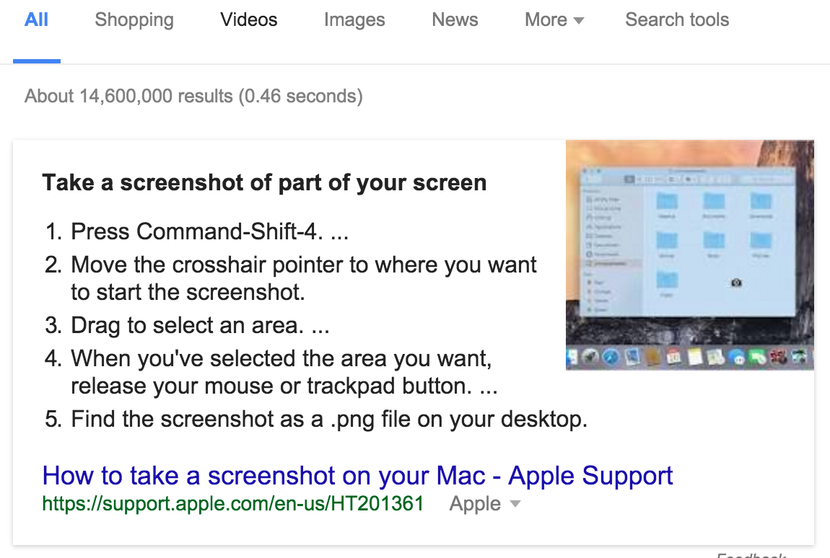

## Screenshot to clipboard

Full screenshot: Control + Command + Shift + 3

Select Area: Control + Command + Shift + 4 tool).

# Show Desktop

fn-F11

# Transfer a File to a Remote Server

FileZilla