Tableau Cheetsheet

Contents

Tableau Cheetsheet 1

Dates and Times 2

Date Time Text Format which Imports Automatically Into Tableau 2

Parse an ISO 8601 Date Field into a Tableau Date 2

Show Measure by Hour and Day of Week 3

# Dates and Times

## Date Time Text Format which Imports Automatically Into Tableau

Note: This is one form of ISO 8601.

2016-11-15T18:12:49Z

## Parse an ISO 8601 Date Field into a Tableau Date

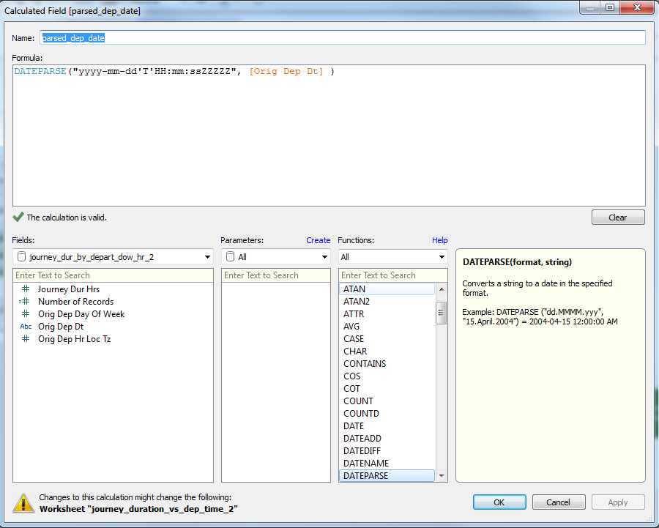

where the string being parsed in an ISO date in the form **2015-12-15T07:36:25+00:00.**

The format characters are specified at <http://userguide.icu-project.org/formatparse/datetime>.

## Show Measure by Hour and Day of Week

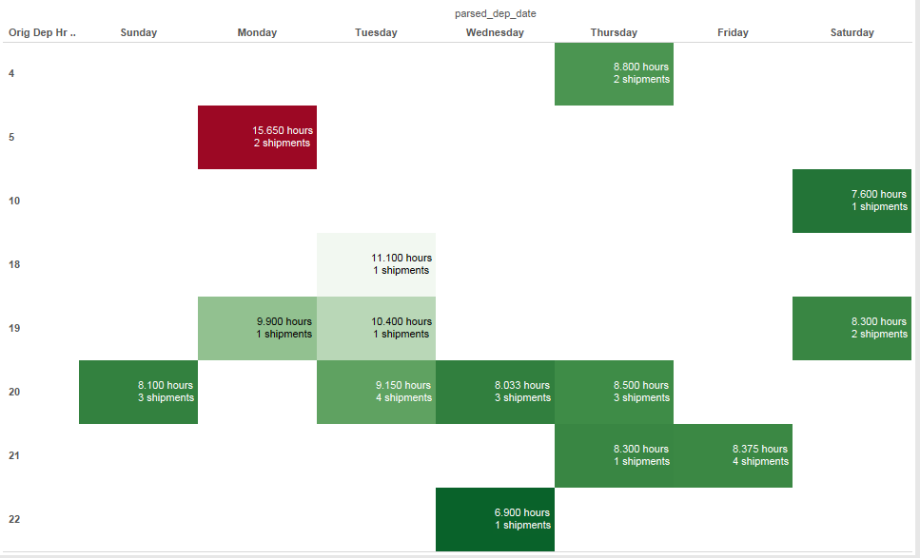

MIMEX_journey_event_time.twbx

**Description of "journey_duration_vs_dep_time_2"**

Average of Journey Dur Hrs and sum of Number of Records broken down by parsed_dep_date Weekday vs. Orig Dep Hr Loc Tz. Color shows average of Journey Dur Hrs. The marks are labeled by average of Journey Dur Hrs and sum of Number of Records.

**Marks**

|  |
| --- |
| The mark type is Square. |
| The marks are labeled by average of Journey Dur Hrs and sum of Number of Records. |
| Stacked marks is on. |

**Shelves**

|  |  |
| --- | --- |
| **Rows:** | Orig Dep Hr Loc Tz |
| **Columns:** | Weekday of parsed_dep_date |
| **Text:** | Average of Journey Dur Hrs and sum of Number of Records |
| **Color:** | Average of Journey Dur Hrs |

**Dimensions**

**Orig Dep Hr Loc Tz** has 8 members on this sheet

Members: 10; 20; 21; 22; 4; ...

**Parsed_dep_date Weekday** has 7 members on this sheet

Members: Friday; Saturday; Thursday; Tuesday; Wednesday; ...

The formula is DATEPARSE("yyyy-mm-dd'T'HH:mm:ssZZZZZ", [Orig Dep Dt] )

**Measures**

**Average of Journey Dur Hrs** ranges from 6.900 to 15.650 on this sheet.

**Sum of Number of Records** ranges from 1 to 4 on this sheet.

The formula is 1

**Data Source Details**

|  |  |
| --- | --- |
| **Data Source:** | journey_dur_by_depart_dow_hr_2 |
| **Type:** | Delimited Text File |
| **Directory:** | C:/Users/bbeauchamp/Documents/Data Analytics/Customers_and_Projects/Michelin Mexico |
| **File Name:** | journey_dur_by_depart_dow_hr_2.csv |
| **Field Separator:** | Comma |
| **Has Header Row:** | Yes |