**CustomerSupportLogger**

**GithubLink:** [BARANIDHARAN-S-Git/CustomSupportLogger (github.com)](https://github.com/BARANIDHARAN-S-Git/CustomSupportLogger)

1)Create Asp.NetMvc project.

2)Push It to Github and test it in Jenkins.

3)Open Azure Portal and Create new mssql Database and Use it in the SSMS,By giving Servername,Login and Password.

4)Create Table CustLogInfo and UserInfo in the SSMS.

5)Create class libraries DAL and DALTest.

6)Add dependencies and References.

7)In the Controller created View for Login,CustomerComplaints and write the HTML code for Login page ,CustomerComplaints page in the View.

8)After Successful Login,It redirects to the customercomplaints page ,Where the User can write the Complaints.

9)After submitting the Details we can see the Customer Details in the SSMS.

10)write a TestCases in the DALTest Library and verify the condition.

11)Push the code to Github and Test it in the Jenkins.

12)Using This Project,Create Image in the Docker.

13)Run the Project and See the Output in the Browser.

OUTPUT:

AZURE:

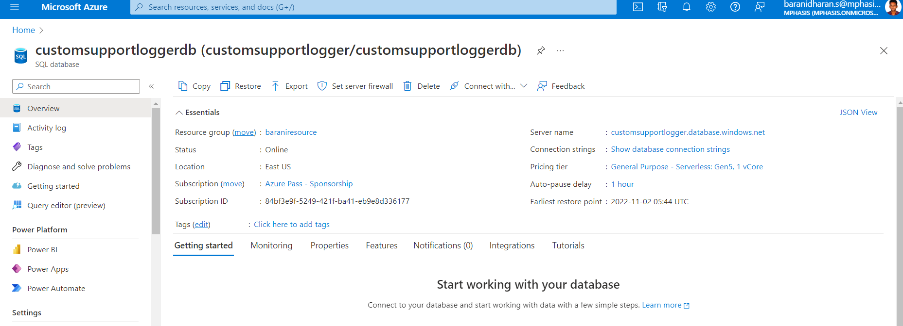

TESTINGTESTCASES:

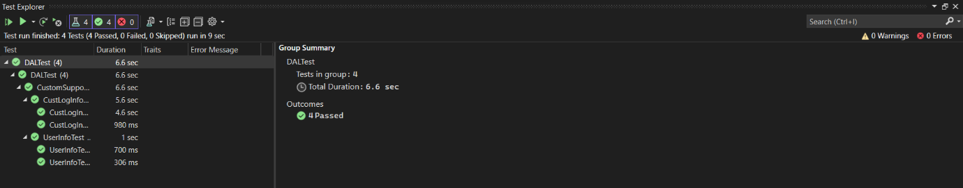

LOGINPAGE:

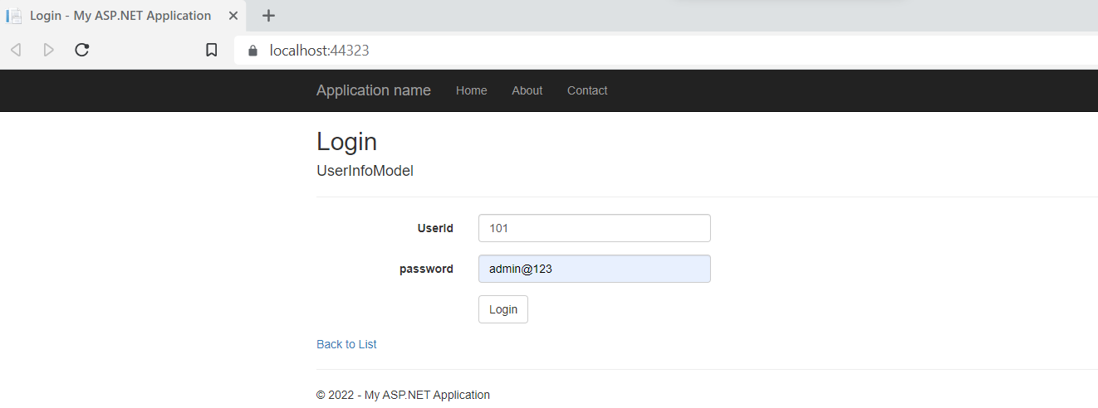

CUSTOMERCOMPLAINTPAGE:

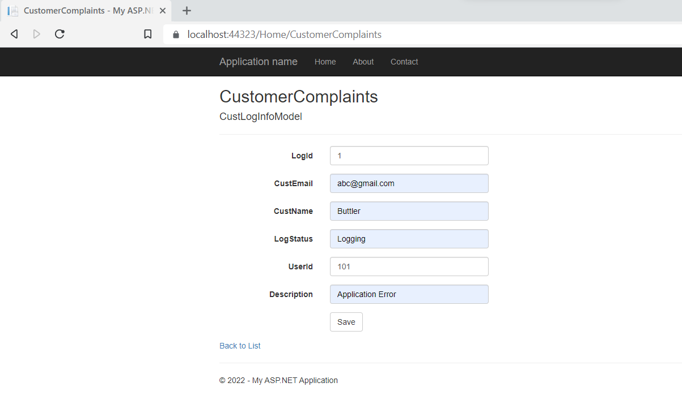

SSMS:

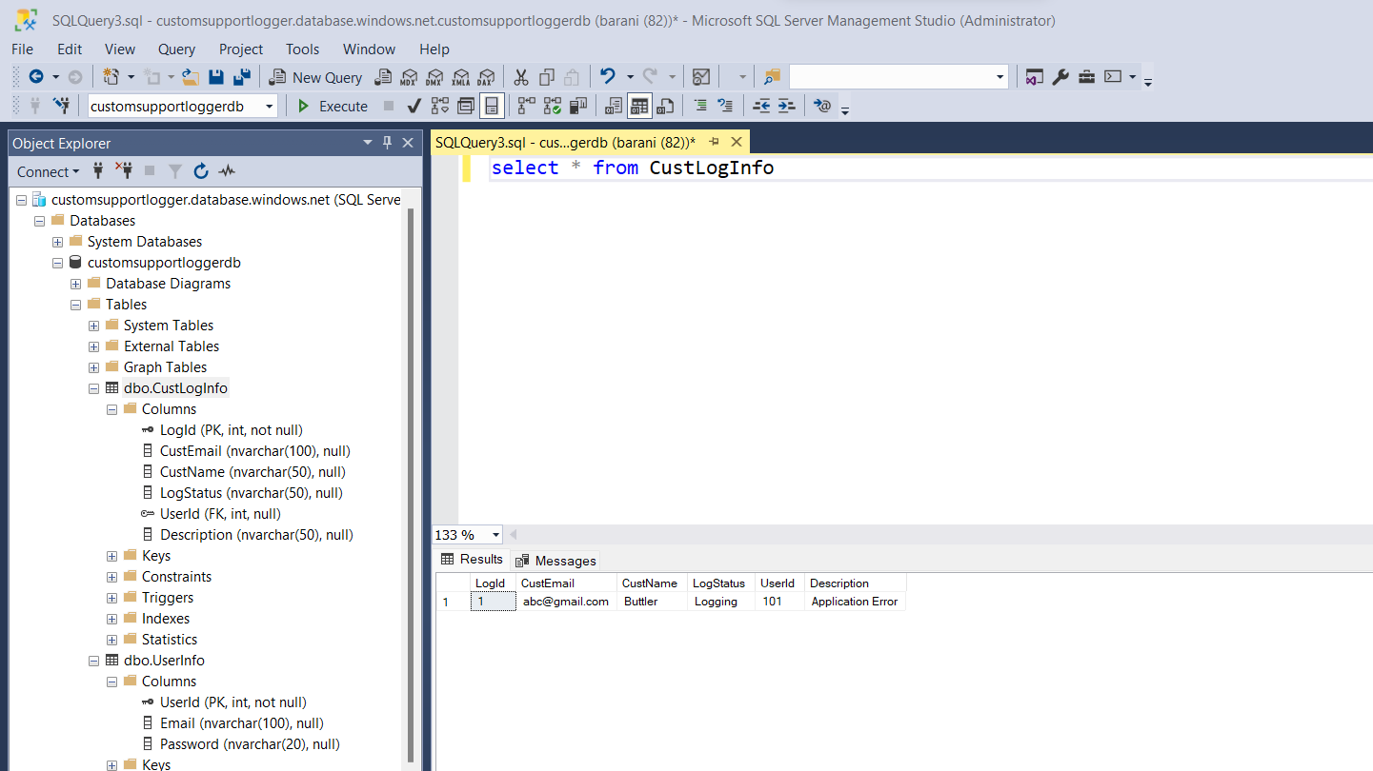

DOCKER: 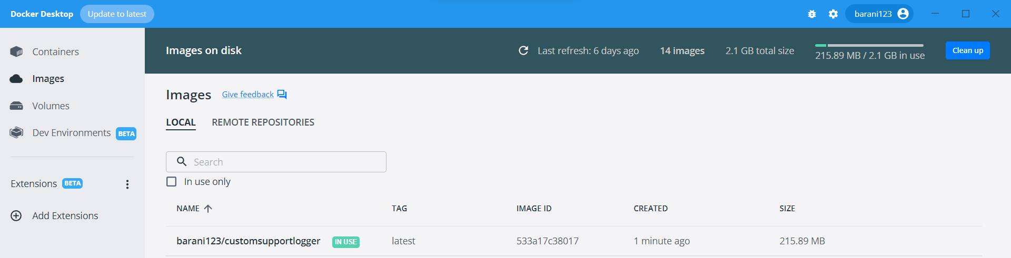

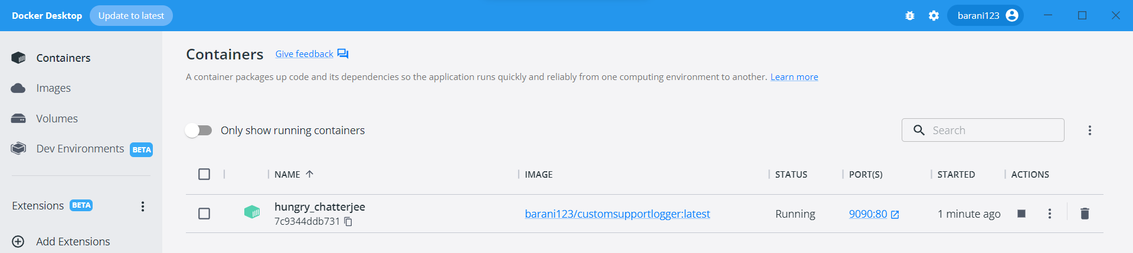

JENKINS:

