EMS Full Stack App-requirement

GithubLink: [BARANIDHARAN-S-Git/EMS (github.com)](https://github.com/BARANIDHARAN-S-Git/EMS)

1)Created Data Access Layer will be a type of Class Library.

2)Data Access Layer will create a Database using Entity Framework Code First Approach and implement Database functionalities save details,Get all the details,Get details by code,Update Details and Delete Details.

3)Added entity class DeptMaster with the public properties.

4)Added Entity class Empprofile with the public properties.

5)created Context Class inherting DbContext Classs.

6)Added one more class inheriting DropCreateDatabaseIfModelChanges<ContextClass> and added some default data into the DeptMaster,Empprofile table by overriding the Seed Method.

7)Database Functionalities for EmpProfile entity using Data Repository pattern:Saving details,Get all details,det details by code,update details,and delete details is created,Similarly to the DeptMaster table.

8)Created Business Logic Layer will be a type of Class Library.

9)Business Logic Layer invoke functionalities from the DAL Class.

10)Added a Data Access Layer reference to this Business Logic Layer.

11)Added a Class to invoke Functionalities from the Data Access Layer.

12)Created ASP.Net Web Application ,This Application Contains RESTful Services to concume functionalities from Business Logic Layer.

13)Added Web API Controller with action method to issue a GET,POST,PUT and DELETE Request.

14)Used attribute based routing while implementing the above functionalities.

15)Used POSTMAN to test this Aplication.

OUPUT:

GETALLEMPPROFILE:

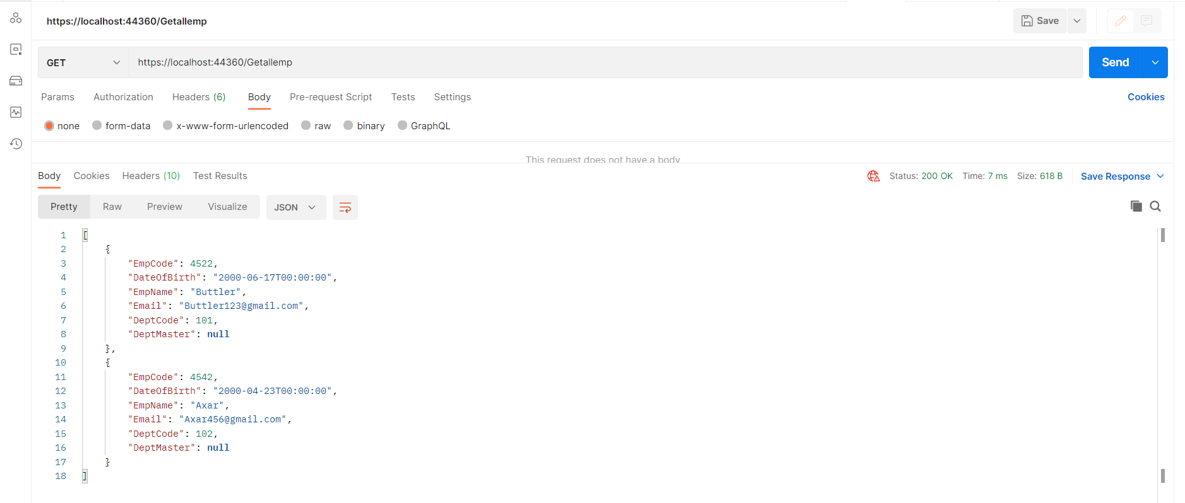

GETEMPPROFILEBYCODE:

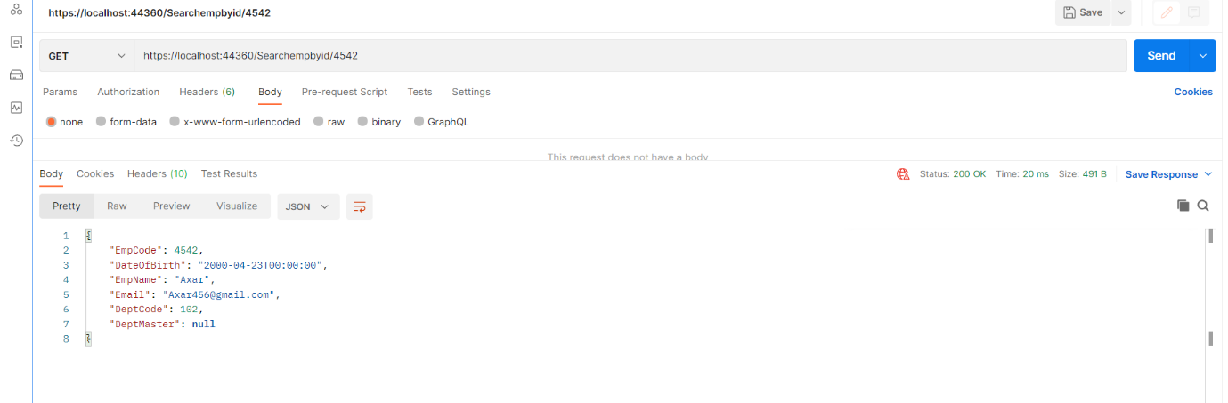

POSTEMPPROFILE:

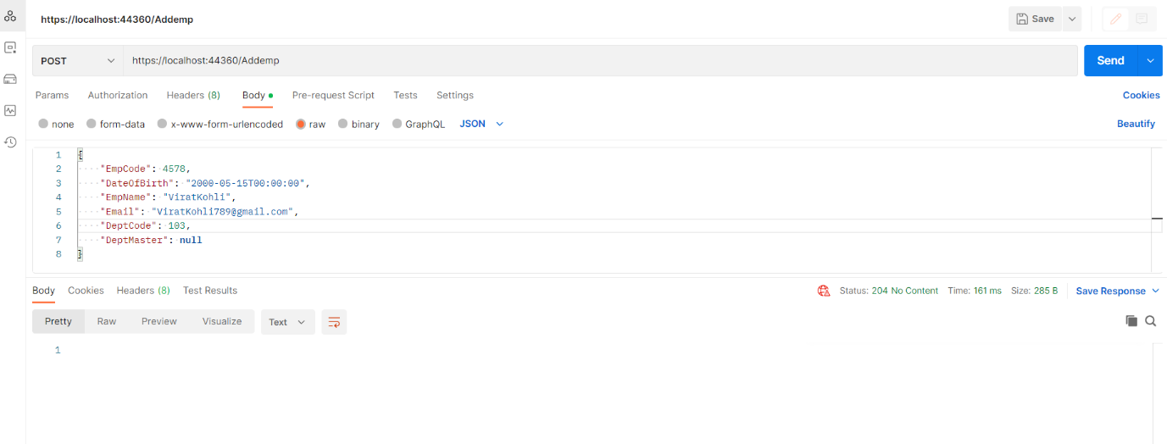

AFTERPOSTEMPPROFILE:

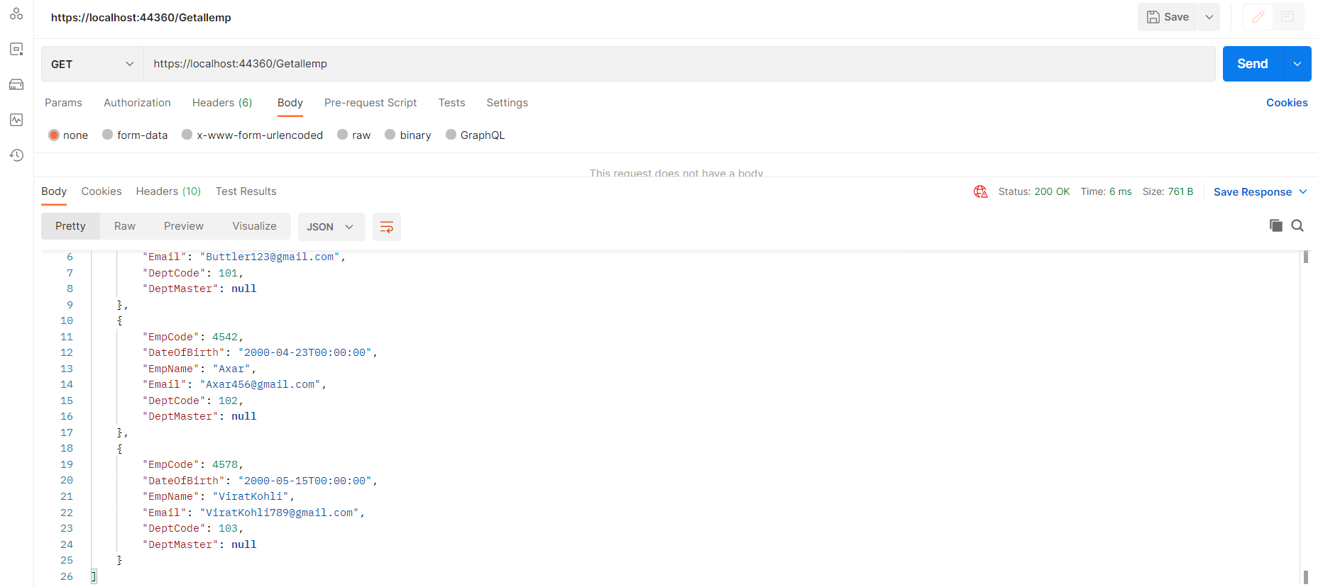

PUTEMPPROFILE:

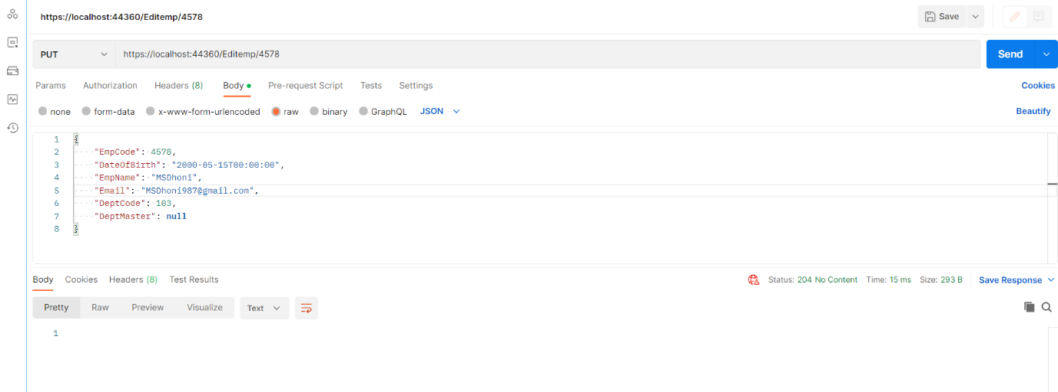

AFTERPUTEMPPROFILE:

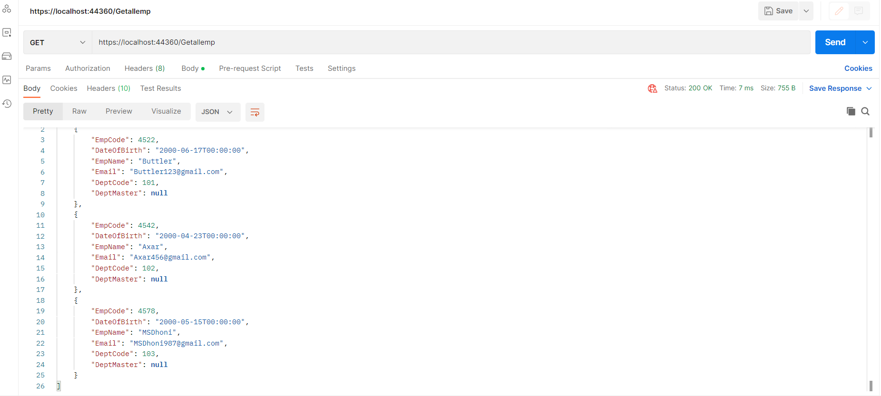

DELETEEMPPROFILE:  
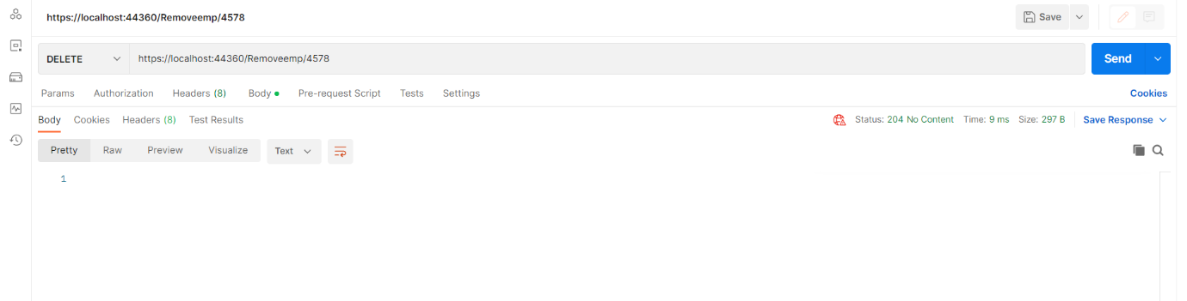

AFTERDELETEEMPPROFILE:  
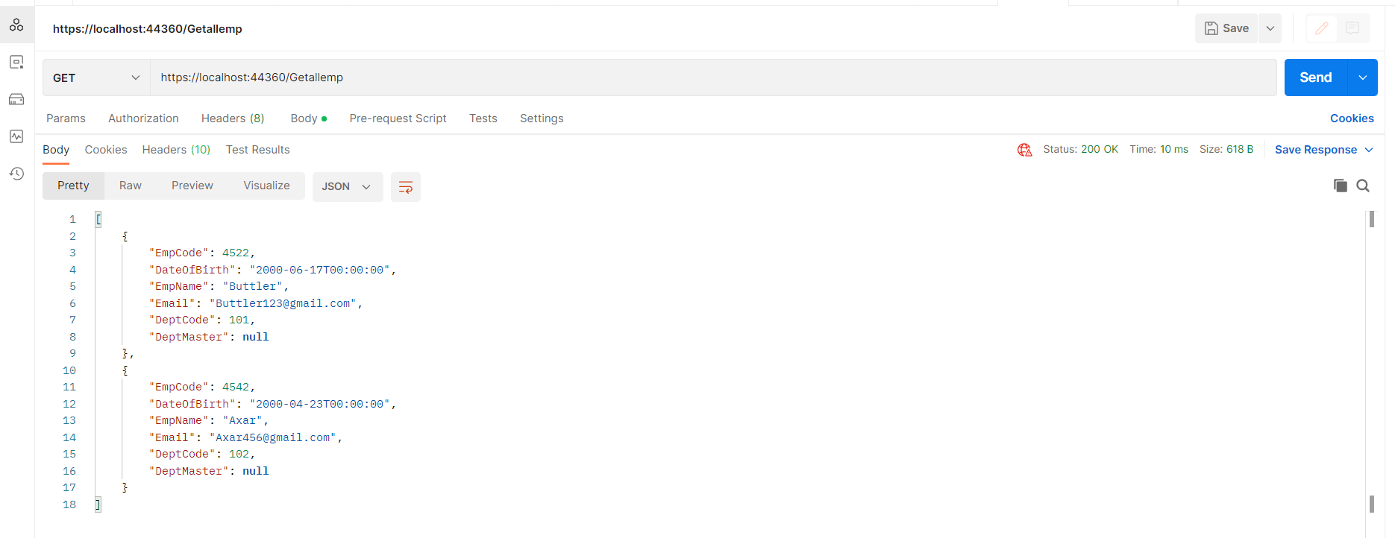

GETALLDEPTMASTER:

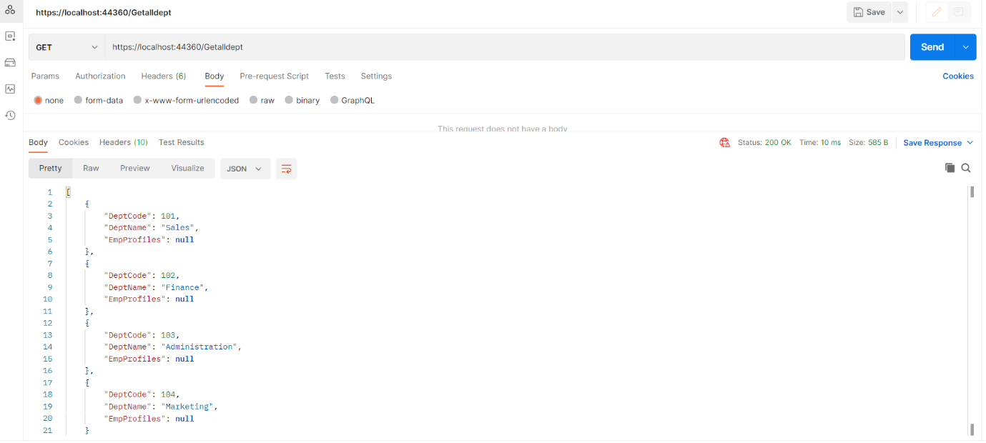

GETDEPTMASTERBYCODE:

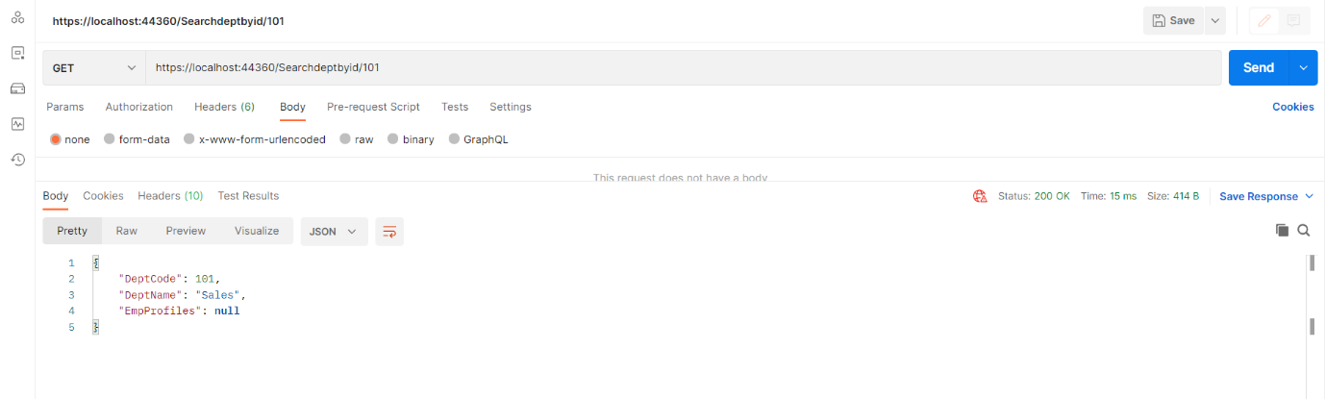

POSTDEPTMASTER:

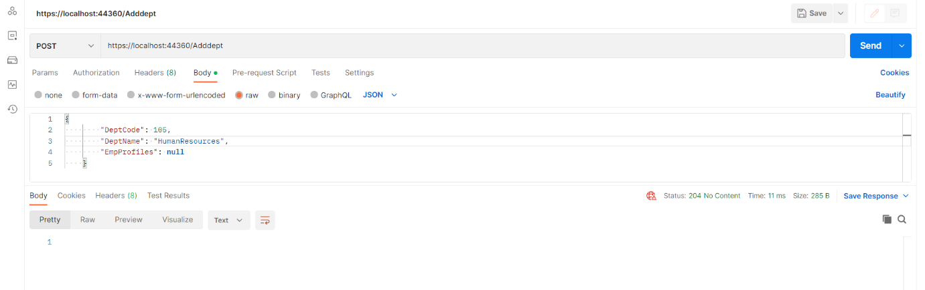

AFTERPOSTDEPTMASTER:

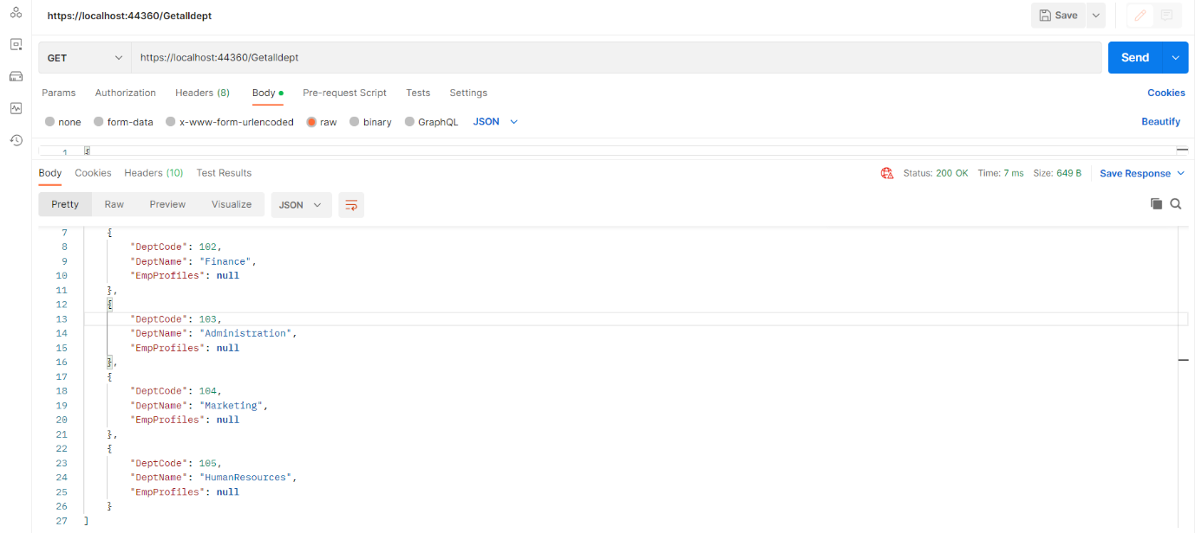

PUTDEPTMASTER:

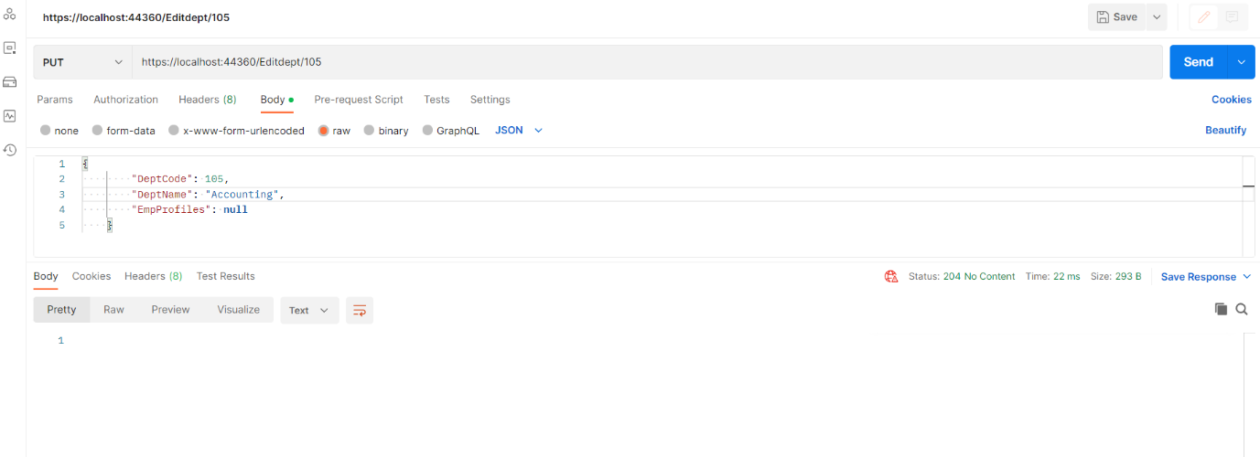

AFTERPUTDEPTMASTER:  
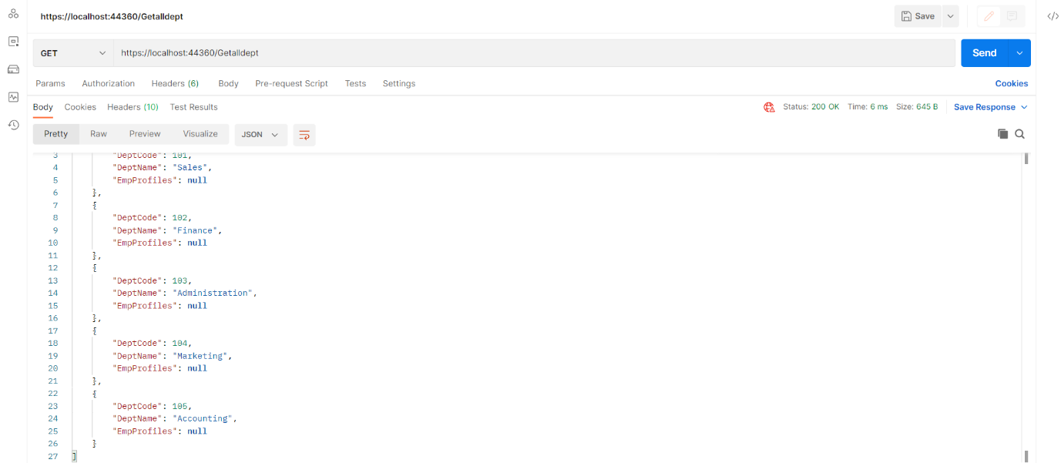

DELETEDEPTMASTER:

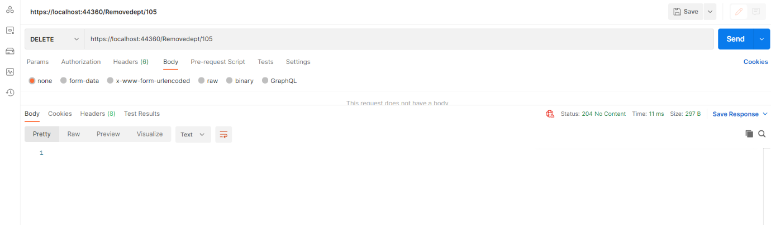

AFTERDELETEDEPTMASTER:

