Ecommerce Site To Sell Laptops

GithubLink: [BARANIDHARAN-S-Git/Ecommerce (github.com)](https://github.com/BARANIDHARAN-S-Git/Ecommerce)

1)Created Database EcommerceDatabase with tables:Order Table,Product Table,Invoice Table,User Table.

2)Add Some products in the ProductTable.

3)Created ASP.Net MVC Project.

4)Added Entity Framework in the Project.

5)Used Database First Approach created Model Class in the Project.

6)In the Home Controller,Created Method to Show the Laptops Available to sell,AddToCart,ViewCart,Remove the product from the Cart.

7)Created Views For the Respective Method.

8)In the Output It display the LaptopImage with The Price,It has the Option Like Add To Cart User Can Click Add To Cart It Redirect To The Add To Cart View where It display Product Name,Product Price With The Description Of the Product and It asks the User For the Count Of the Product To Purchase.

9)After User Entered Count Of the Product It again Redirects To the Index View ,In the Top It Display The Total Bill Of the Product.

10)It has The option View Cart ,Where all the Product Purchased By User Is Shown.

11)In View Cart User Has The Option To Remove The Product.

12)After Submit The Product In the View Cart It Displays Success Message In the Index View ,The Data Will Be Stored In the Order Table And Invoice Table.

OUTPUT:

INDEX: 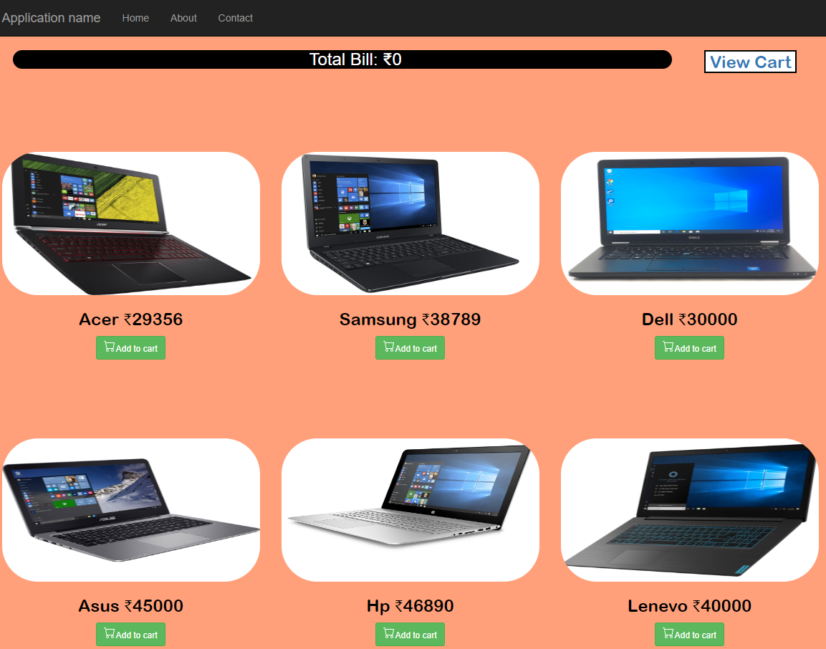

ADDTOCART:

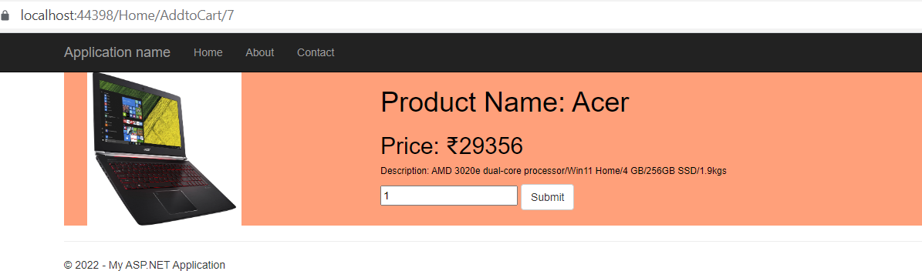

INDEXTOTALBILL:

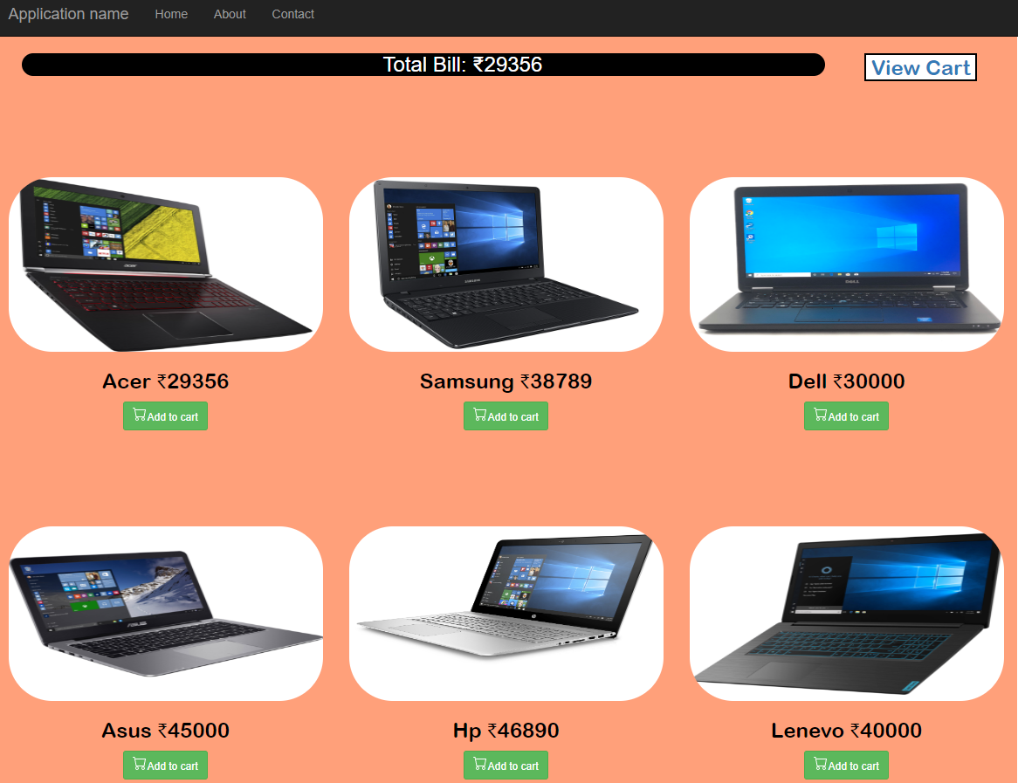

VIEWCART: 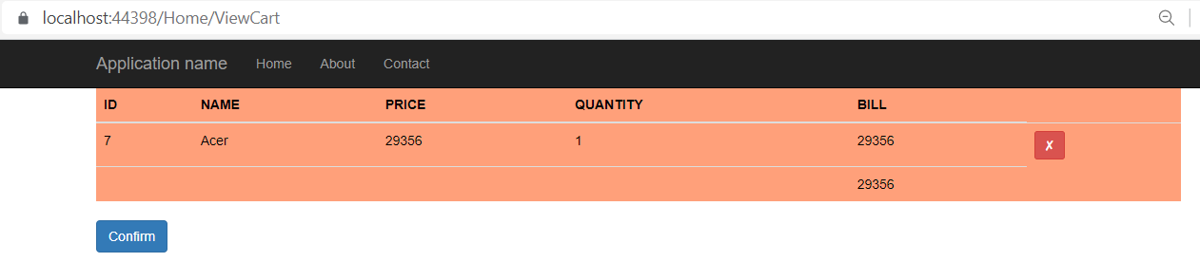

SUCCESSMESSAGE:

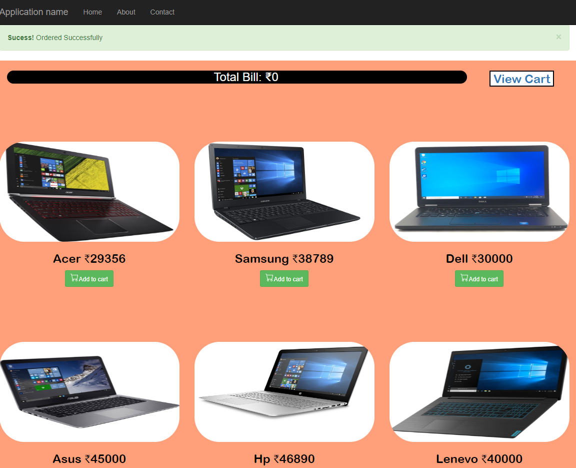

INVOICETABLE:

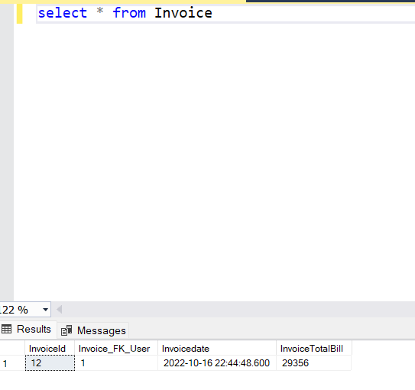

ORDERTABLE:  
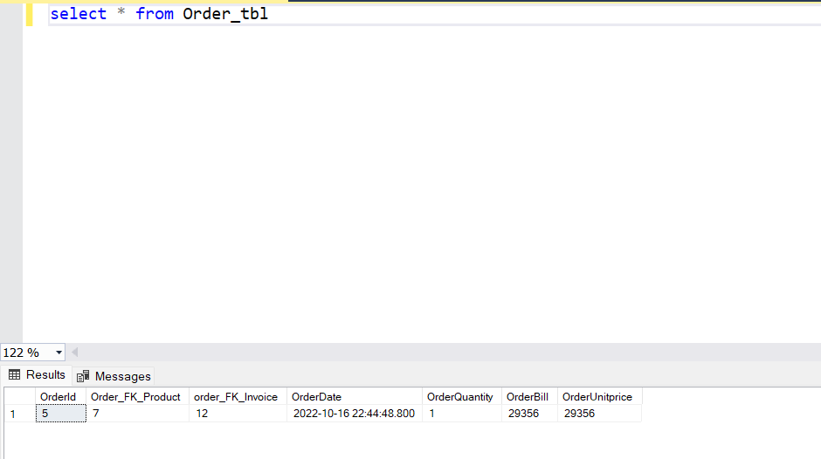

PRODUCTTABLE:

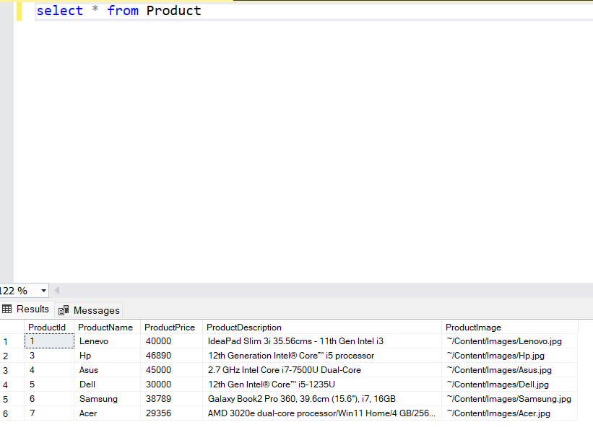

USERTABLE:

