GithubLink: [BARANIDHARAN-S-Git/Studentdata (github.com)](https://github.com/BARANIDHARAN-S-Git/Studentdata)

Step1:create a text document-“textdocumentname:Studentdata”.

Step2:Enter the student details is the text document.

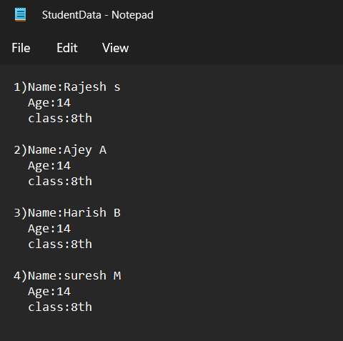

Step3:Write the c# code in VScode

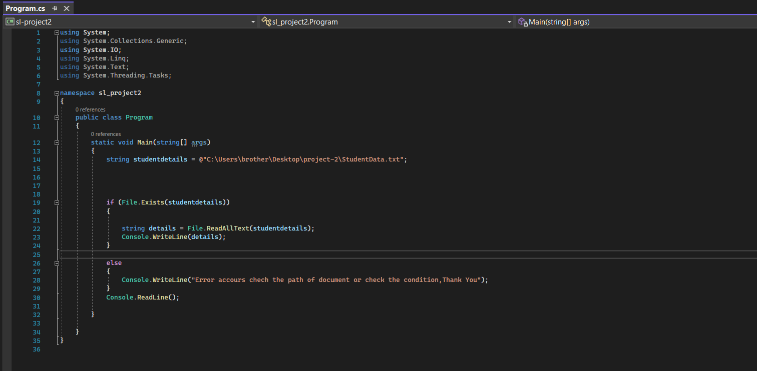

Step4:Run the code whether to see the notepad text document is executed.

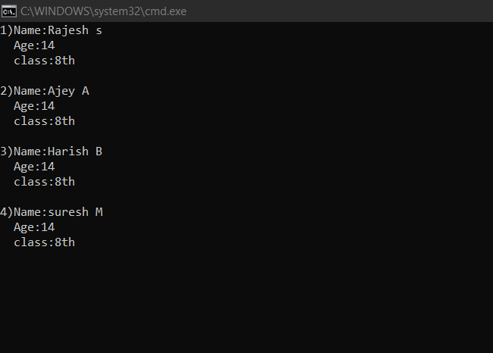

Step5:To push the code into the github and ingnore the file(filename:ignore.log)and update all other documents.First want to create a .gitgnore where we want to write the type of the file to be ignored(*.log).

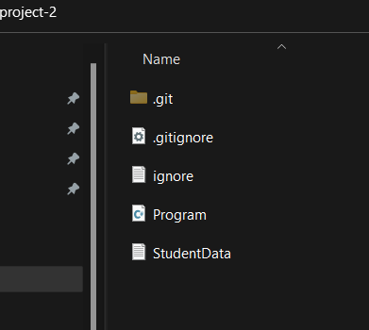

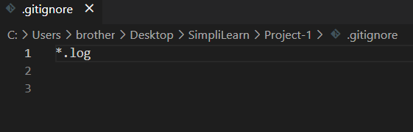

It has the text document Studentdata to be uploaded successfullt in github and Ignore.log file to be ignored.

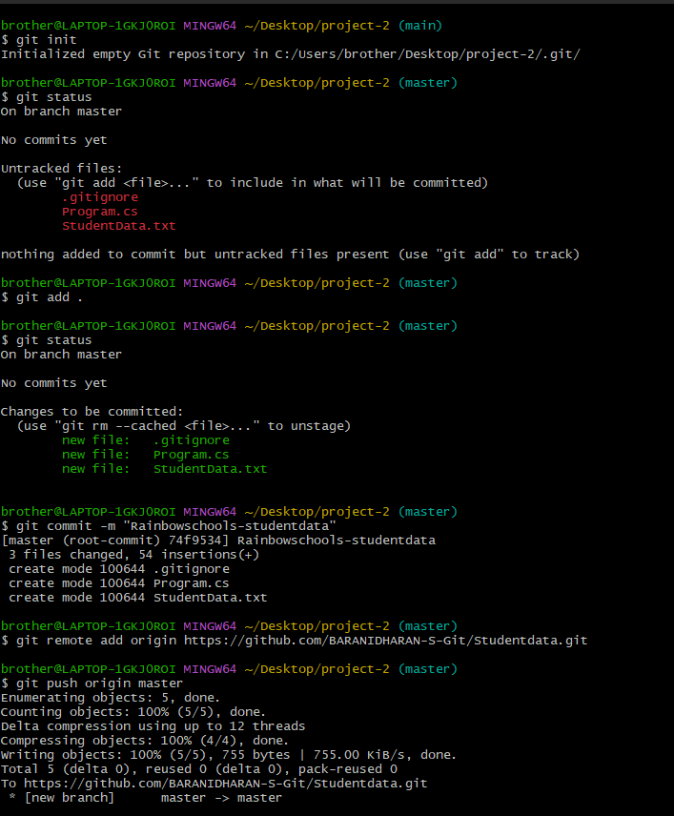

GitBash code to push the file into repo

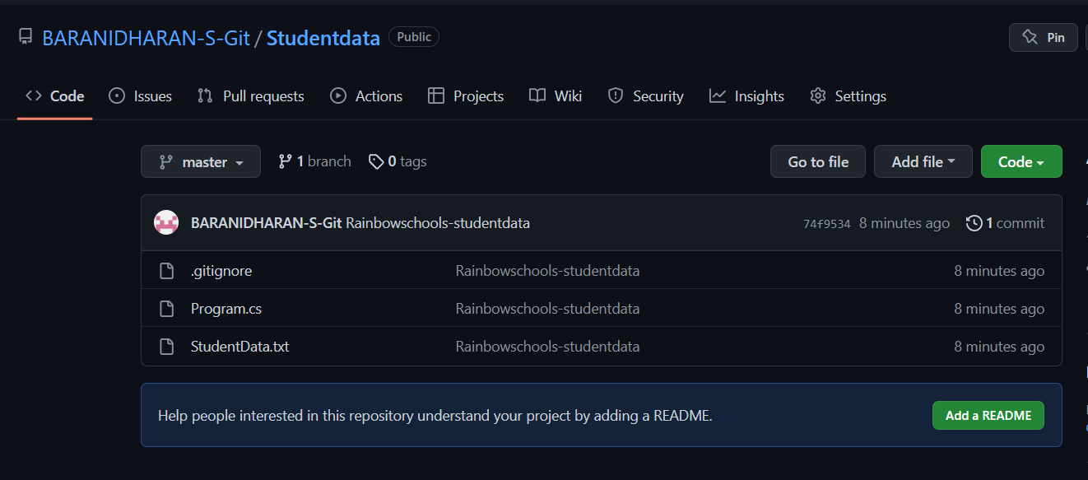

It’s a git repo where the document Studentdata,and other files successfully uploaded and Ignore.log file is ignored.