User Story
User Story 1:
As an instructor, I want to provide CS students with a machine language simulation tool, so that they can experiment with low-level programming concepts without needing physical hardware.
User Story 2:
As a CS student, I want to run my BasicML program in the UVSim so I can understand how assembly-level instructions interact with CPU and memory.

Use Cases

Use Case 1: File Input by User
Actor: User
System: File handling and loader subsystem
Goal: Load a program file into memory for execution or editing
Steps:
- Launch program.
- Prompt user to select a file from any directory.
- Receive file selection input.
- Validate file existence and format (4-digit or 6-digit words).
- Confirm file contains no more than 100 lines (old format) or 250 lines (new format).
- Read file contents word by word (5 characters for old, 6 for new format).
- Parse and store valid words into sequential memory addresses.
- If invalid format or too many lines, raise error and re-prompt.
- Display file contents in GUI for user inspection and editing.

Use Case 2: Execute BRANCH (Opcode 40 / 040 for new format)
Actor: Instruction execution unit
System: Program counter and control flow logic
Goal: Jump unconditionally to a specific memory address
Steps:
- Parse opcode from instruction (2-digit or 3-digit opcode depending on format).
- Identify operand (target address, supporting 2- or 3-digit addresses).
- Verify target address within valid range (00-99 old, 000-249 new).
- Set program counter to target address.
- Continue execution from new memory location.

Use Case 3: Execute READ (Opcode 10 / 010 for new format)
Actor: Instruction execution unit
System: Input handling and memory writing logic
Goal: Store user input into specified memory location
Steps:
- Parse opcode from instruction.
- Identify target memory address from operand.
- Prompt user for input.
- Receive input from console.
- Store input value in identified memory address.
- Increment program counter.

Use Case 4: Execute HALT (Opcode 43 / 043 for new format)
Actor: Instruction execution unit
System: Program state and control logic
Goal: End program execution
Steps:
- Parse opcode from instruction.
- Set halted flag to True.
- Output message to console showing halt location and accumulator value.
- Stop instruction cycle.

Use Case 5: Execute BRANCHNEG (Opcode 41 / 041 for new format)
Actor: Instruction execution unit
System: Program counter and accumulator logic
Goal: Branch to a new address if accumulator is negative
Steps:
- Parse opcode from instruction.
- Identify operand (target address).
- Check if accumulator < 0.
- If true, set program counter to operand.
- Else, increment program counter.

Use Case 6: Execute BRANCHZERO (Opcode 42 / 042 for new format)
Actor: Instruction execution unit
System: Program counter and accumulator logic
Goal: Branch to a new address if accumulator is zero
Steps:
- Parse opcode from instruction.
- Identify operand (target address).
- Check if accumulator == 0.
- If true, set program counter to operand.
- Else, increment program counter.

Use Case 7: Execute LOAD (Opcode 20 / 020 for new format)
Actor: Instruction execution unit
System: Memory management and code processor
Goal: Successfully load a value into the accumulator
Steps:
- Parse function code.
- Identify target memory address from operand.
- Fetch value from identified memory address.
- Copy fetched value into accumulator register.
- Increment program counter.

Use Case 8: Execute STORE (Opcode 21 / 021 for new format)
Actor: Instruction execution unit
System: Memory management subsystem
Goal: Store the value in the accumulator into memory
Steps:
- Parse function code.
- Identify target memory address from operand.
- Copy value from accumulator to memory at identified address.
- Increment program counter.

Use Case 9: Execute ADD (Opcode 30 / 030 for new format)
Actor: Instruction execution unit
System: Arithmetic logic unit (ALU)
Goal: Add a value from memory to the accumulator
Steps:
- Parse function code.
- Identify memory address from operand.
- Fetch value from memory.
- Add value to accumulator.
- Store result in accumulator.
- Increment program counter.

Use Case 10: Execute SUBTRACT (Opcode 31 / 031 for new format)
Actor: Instruction execution unit
System: Arithmetic logic unit (ALU)
Goal: Subtract a memory value from the accumulator
Steps:
- Parse function code.
- Identify memory address from operand.
- Fetch value from memory.
- Subtract value from accumulator.
- Store result in accumulator.
- Increment program counter.

Use Case 11: Execute DIVIDE (Opcode 32 / 032 for new format)
Actor: Instruction execution unit
System: Arithmetic logic unit (ALU)
Goal: Divide the accumulator by a value from memory
Steps:
- Parse function code.
- Identify memory address from operand.
- Fetch value from memory.
- If value ≠ 0, divide accumulator by value.
- Store result in accumulator.
- If value == 0, raise divide-by-zero error and halt.
- Increment program counter unless halted.

Use Case 12: Execute MULTIPLY (Opcode 33 / 033 for new format)
Actor: Instruction execution unit
System: Arithmetic logic unit (ALU)
Goal: Multiply accumulator by a value from memory
Steps:
- Parse function code.
- Identify memory address from operand.
- Fetch value from memory.
- Multiply value by accumulator.
- Store result in accumulator.
- Increment program counter.

Use Case 13: Convert 4-Digit File to 6-Digit File Format
Actor: User
System: File conversion utility within the application
Goal: Convert an existing 4-digit word format file into the new 6-digit word format file for extended memory and functionality
Steps:
- User opens the conversion tool from the application GUI or menu.
- Prompt user to select a 4-digit format file from any directory.
- Validate the selected file contains only valid 4-digit words and does not exceed 100 lines.
- Read each line of the file sequentially.
- For each line:
  - If the first two digits match a valid function opcode, convert using the 0XX0XX format (e.g., 1007 → 010007).
  - Otherwise, treat as numerical value and convert using the 00XXXX format (e.g., 5555 → 005555).
- Reject the file if any invalid or ambiguous lines are detected.
- Prompt user to save the new 6-digit file in a user-chosen directory with a new filename.
- Save the converted file respecting the 250-line max and six-digit word format.
- Confirm conversion success and optionally open the new file in the editor.

Use Case 14: Color Scheme Customization
Actor: User
Goal: Customize the color scheme of the application
Steps:
- Launch the application.
- Navigate to color settings (through GUI or a config file).
- Select a primary and an off-color from a color picker or by entering RGB/Hex values.
- Apply changes instantly or restart the app to see changes.
- Ensure readability of text with the selected color scheme.

Use Case 15: Load and Save Files from Custom Directories
Actor: User
Goal: Load and save files from user-specified directories
Steps:
- Launch the program.
- Use the "Open" button to navigate and load files from any directory.
- Edit the file as necessary.
- Save the file to any directory or under a new name using the "Save" button.

Functional specifications
Functional:
1. The system shall display a ‘load program file’ button.
2. The system GUI shall exhibit a primary color, used as the main background color. The primary color shall default to UVU green (Hex# 4C721D).

3. The system GUI shall exhibit a secondary color, used for clickable buttons and text. The secondary color shall default to white (Hex# FFFFFF).

4. The system colors shall be user-configurable via a configuration file or in-app option without recompilation.

5. The system shall allow users to open a text file when the ‘load program file’ button is clicked. The text file shall be imported via a user-chosen directory.

6. The system shall raise an error if one or more words in the text file are not valid 4- or 6-digit signed integers.

7. The system shall load the contents of the chosen file into editable memory via the GUI, allowing user review before execution.

8. The system shall allow a user to make changes to their file inside the GUI including cut, copy, paste, add, delete, and edit operations.

9. The system GUI shall allow a user to save their file to a user-chosen directory with optional renaming.

10. The program shall begin operation at the first location in memory (000) when the ‘run program’ button is clicked.

11. The system’s memory access shall be restricted to valid address space (000–249).
12. The system shall display a ‘run program’ button, allowing an open file to be executed.
13. The system shall open a user-input popup when a READ command (010XXX) is encountered in the program.

14. The system shall read the contents of the input field in the input popup into memory when the user clicks the ‘submit’ button in the popup window.

15. The system’s execution shall support various 6-digit opcodes within the range 010–043:
15a. Opcode 010: Read a word from the keyboard into a specific location in memory
15b. Opcode 011: Write a word from a specific location in memory to screen
15c. Opcode 020: Load a word from a specific location in memory into the accumulator

15d. Opcode 021: Store a word from the accumulator into a specific location in memory

15e. Opcode 030: Add a word from a specific location in memory to the word in the accumulator

15f. Opcode 031: Subtract a word from a specific location in memory from the word in the accumulator

15g. Opcode 032: Divide the word in the accumulator by a word from a specific location in memory

15h. Opcode 033: Multiply a word from a specific location in memory to the word in the accumulator

15i. Opcode 040: Branch to a specific location in memory
15j. Opcode 041: Branch to a specific location in memory if the accumulator is negative

15k. Opcode 042: Branch to a specific location in memory if the accumulator is zero
15l. Opcode 043: HALT: stop the program
16. The system shall display an accumulator value, with the accumulator being a memory register with the same size and functions of the other memory registers.

17. The system shall reset the accumulator to 0 and memory to all zeros when a new file is loaded in.

18. The system shall end program execution when a HALT command (043XXX) is encountered.

19. The system shall display the contents of memory (up to 250 entries) in a scrollable, editable table format, confirming when a program is successfully loaded.

20. The system shall display output in a separate text area when the program executes a WRITE instruction (011XXX).

21. The system shall prevent the user from running the program if no file is loaded or if the file contains format errors.

22. The system shall allow the user to close the application in the GUI.
23. The system shall initialize all memory cells (000–249) and the accumulator to 0 when a new file is loaded in.

24. The system shall reject malformed instructions (such as: invalid characters, unsupported opcodes, or incorrect word length).

25. The system shall raise an error on division by zero.
26. The system’s accumulator and register values exceeding ±999999 shall wrap using modulo 1,000,000.

27. The system shall display error messages coinciding with errors that might be encountered (ex. bad words in a file, missing words, trying to access out-of-range memory).

28. The system shall support multiple files open at once via GUI tabs or windows. 4-digit files shall be automatically converted to 6-digit format before editing or running.

29. The system shall only allow files with words of consistent size, either 4-digit or 6-digit words.

Non-functional:
1. The system shall be built using tiered architecture.
2. The system shall avoid crashes through input validation and exception handling.
3. The system shall make it clear to the user if the file chosen isn’t of the correct format (e.g., wrong length, illegal characters, too many lines).

4. The system shall be compatible with Python 3+.
5. The system shall be compatible with Windows and macOS.
6. The system shall execute the program and remain responsive (≤ 3 seconds for 250 instructions).

Class Diagram

+----------------------------------------------+
| ColorConfig
+----------------------------------------------+
| - filename: str
| - primary: str
| - off: str
+----------------------------------------------+
| + __init__(filename="colors.json")
| + is_valid_hex(color: str): bool
| + load_colors(): void
+-----------------------------------------------+
▲
| used by
+-----------------------------------------------------------+
| UVSimGUI
+-----------------------------------------------------------+
| - root: Tk
| - sim: UVSim
| - load: Load_Program
| - colors: ColorConfig
| - memory_entries: list[Entry]
| - output_lines: list[str]
| - file_loaded: bool
| - run_button: Button
| - mem_canvas: Canvas
| - accumulator_var: StringVar
+-------------------------------------------------------------+
| + __init__(root: Tk)
| + build_widgets(): void
| + load_file(): void
| + save_file(): void
| + save_memory_entry(index: int, value: str)
| + sync_entries_to_memory(): bool
| + run_program(): void
| + step_through_program(): void
| + show_read_popup(operand: int): int
| + update_memory_display(): void
| + update_output(): void
| + clear_output(): void
| + open_file_in_new_window(): void
+--------------------------------------------------------------+
▲ ▲ ▲
| | |
uses| has-a uses|
| | |
+-------------------------+ +------------------------------------+ +--------------------------------------+
| UVSim | Load_Program | Convert
+--------------------------+ +--------------------------------------+ +-----------------------------------+
| - cpu: CPU | - memory: Memory | + convert_to_int(word): int or False
| - memory: Memory +-------------------------------------------+ +---------------------------------+
+---------------------------+ | + __init__(): void
| + run(): void | + load_program(filename: str): void
+----------------------------+ +------------------------------------------------+

▲
| has-a
|
+----------------------------------------------------------------+
| CPU
+----------------------------------------------------------------+
| - accumulator: int
| - program_counter: int
| - halted: bool
+------------------------------------------------------------------+
| + __init__()
| + execute(instruction: int, memory: Memory): void
+-------------------------------------------------------------------+
▲
uses
|
+----------------------------------------------+
| Memory
+-----------------------------------------------+
| - memory: list[MemoryRegister]
| - read_callback
| - waiting_for_input: bool
+------------------------------------------------+
| + __init__()
| + write(address: int, value: int): void
| + read(address: int): int
+-------------------------------------------------+
▲
has-a
|
+----------------------------+
| MemoryRegister
+-----------------------------+
| - value: int
+----------------------------+
| + __init__(value=0)
| + set(value: int): void
| + get(): int
| + __repr__(): str
+---------------------------+
▲
| called by
|
+----------------+
| main.py
+----------------+
| + main(): void
+-----------------+

Class Descriptions

ColorConfig
- Loads GUI color themes from a colors.json file.
- Validates hex format.
- Allows customization of primary and off UI colors.

UVSimGUI
- Main GUI class that handles user interaction.
- Manages widgets, program loading, file handling, memory view, and execution.
- Coordinates between Load_Program, UVSim, and ColorConfig.

Load_Program
- Responsible for loading instruction files into memory.
- Parses .txt files and handles file format validation.

Convert
- Static class or helper for converting between formats.
- Ensures compatibility between legacy (4-digit) and modern (6-digit) formats.

UVSim
- Simulator core.
- Ties together CPU and memory.
- Executes the program loaded in memory via CPU instructions.

CPU
- Core processor emulation.
- Handles opcodes, accumulator logic, branching, and program counter.
- Executes instructions by operating on Memory.

Memory
- Stores all instructions and values.
- Offers read and write operations with safety checks and callback support.

MemoryRegister
- Represents a single memory cell (integer value).
- Provides getter/setter and string conversion.

main.py
- Entry point for launching the GUI application.

UVSim Software Simulator
User Manual

1. Introduction
UVSim is a Python-based software simulator designed to execute programs written in BasicML—a simplified educational machine language. This application provides a graphical user interface (GUI) using the tkinter library and supports both legacy and modern instruction formats. The simulator enables file loading, editing, execution, and debugging of machine code programs.

2. System Requirements
- Python Version: Python 3.x (Tkinter is typically included)
- Operating System: Cross-platform (Windows, macOS, Linux)
- Libraries: Only tkinter (included with Python)

3. Launching the Application
To launch UVSim:
- Open a terminal or command prompt.
- Navigate to the directory where main.py is located.
- Run the following command:
python3 main.py

4. Application Overview
Upon launching, the main interface presents several buttons and a program editor.
- Load Program File – Load a .txt file with BasicML instructions.
- Run Program – Execute the loaded instruction set.
- Save Program File – Save current instructions to a file.
- Instruction Editor – Edit instructions directly in the GUI.
- Popup Windows – Separate file tabs allow multiple files to be open at once.
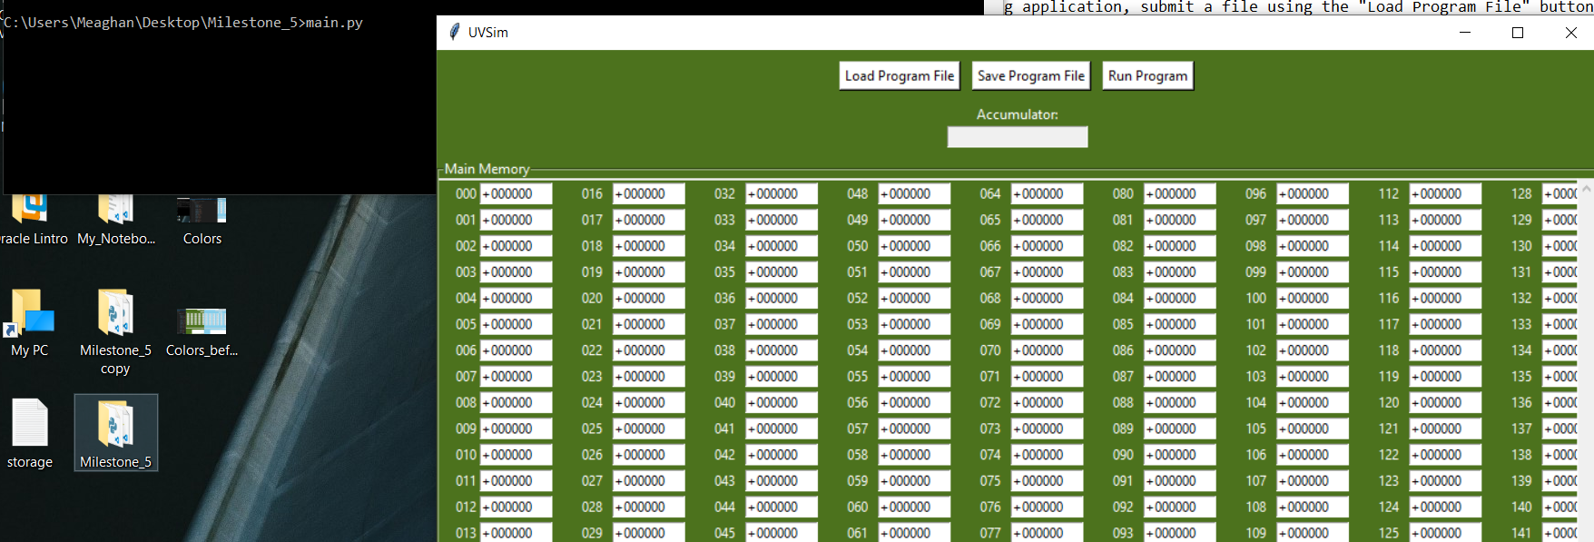

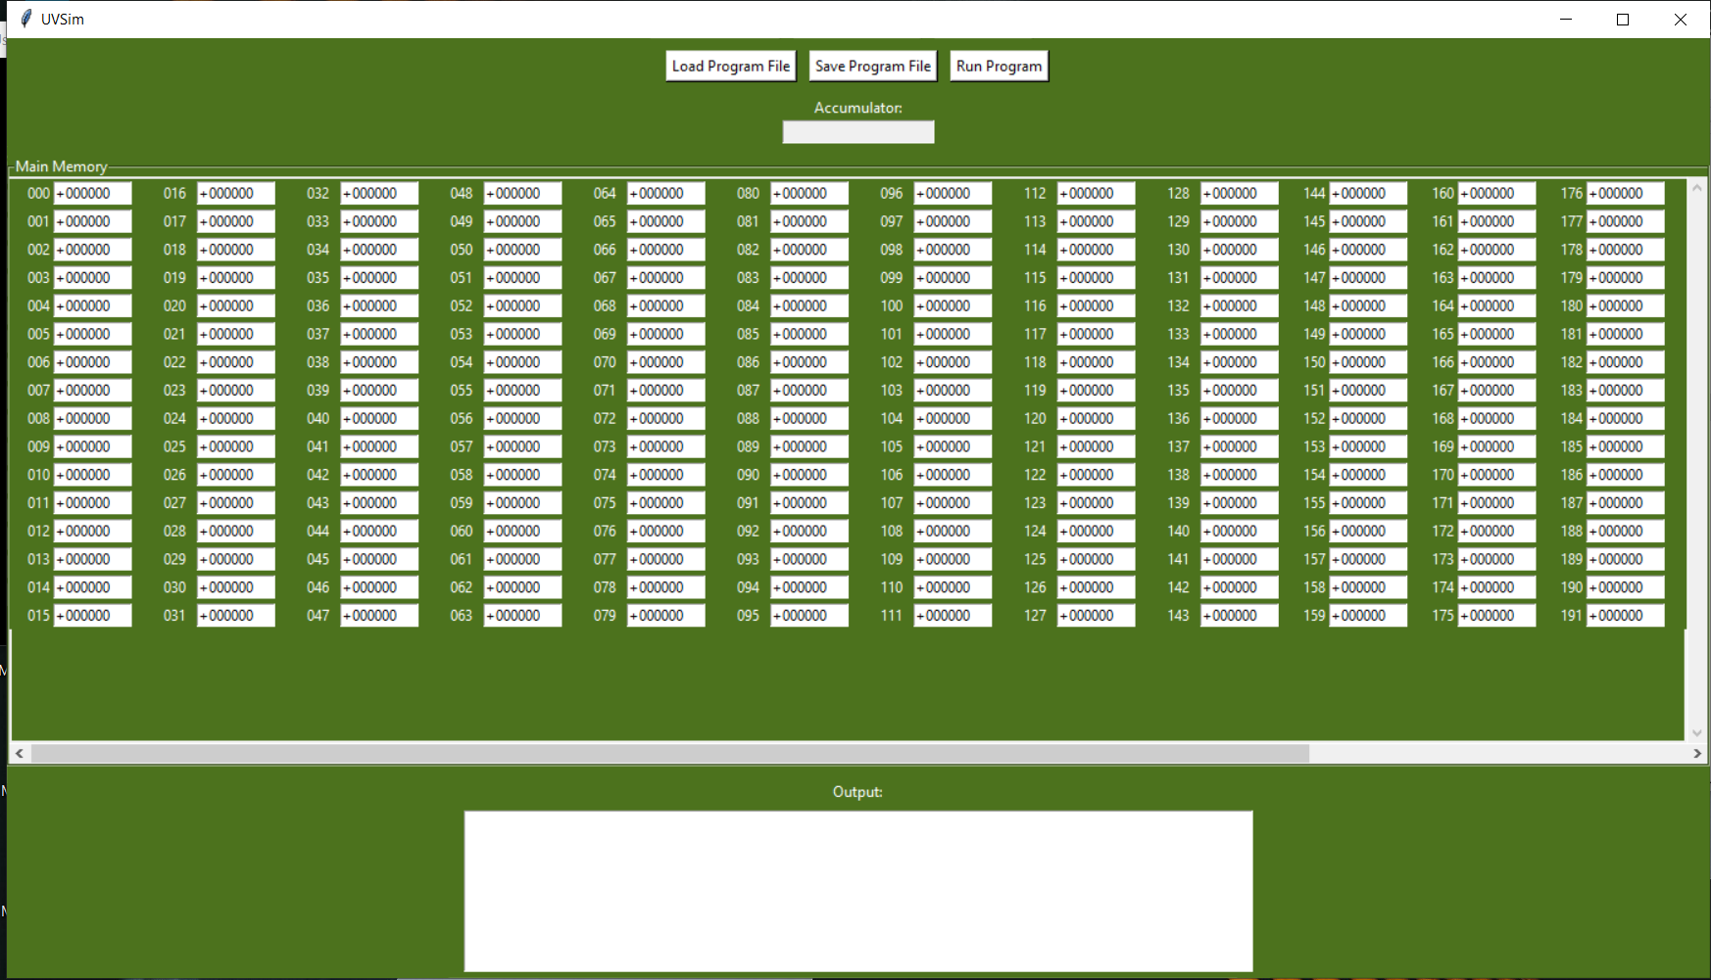

5. How to Use UVSim

5.1 Loading and Running Programs

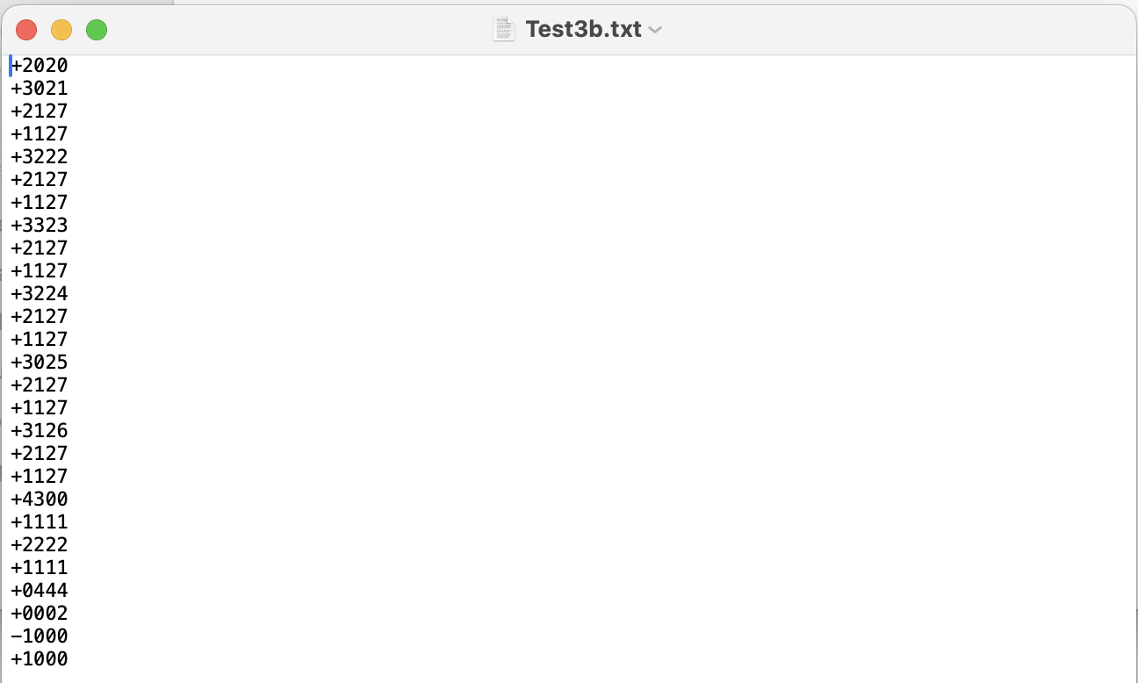
- Click Load Program File to import a .txt file.
- Click Run Program to begin execution.
- For input instructions (opcode READ), a pop-up will request user input. Enter the value and click Submit.
- Upon HALT, the program stops and returns output.
- To execute a new file, repeat the above process.

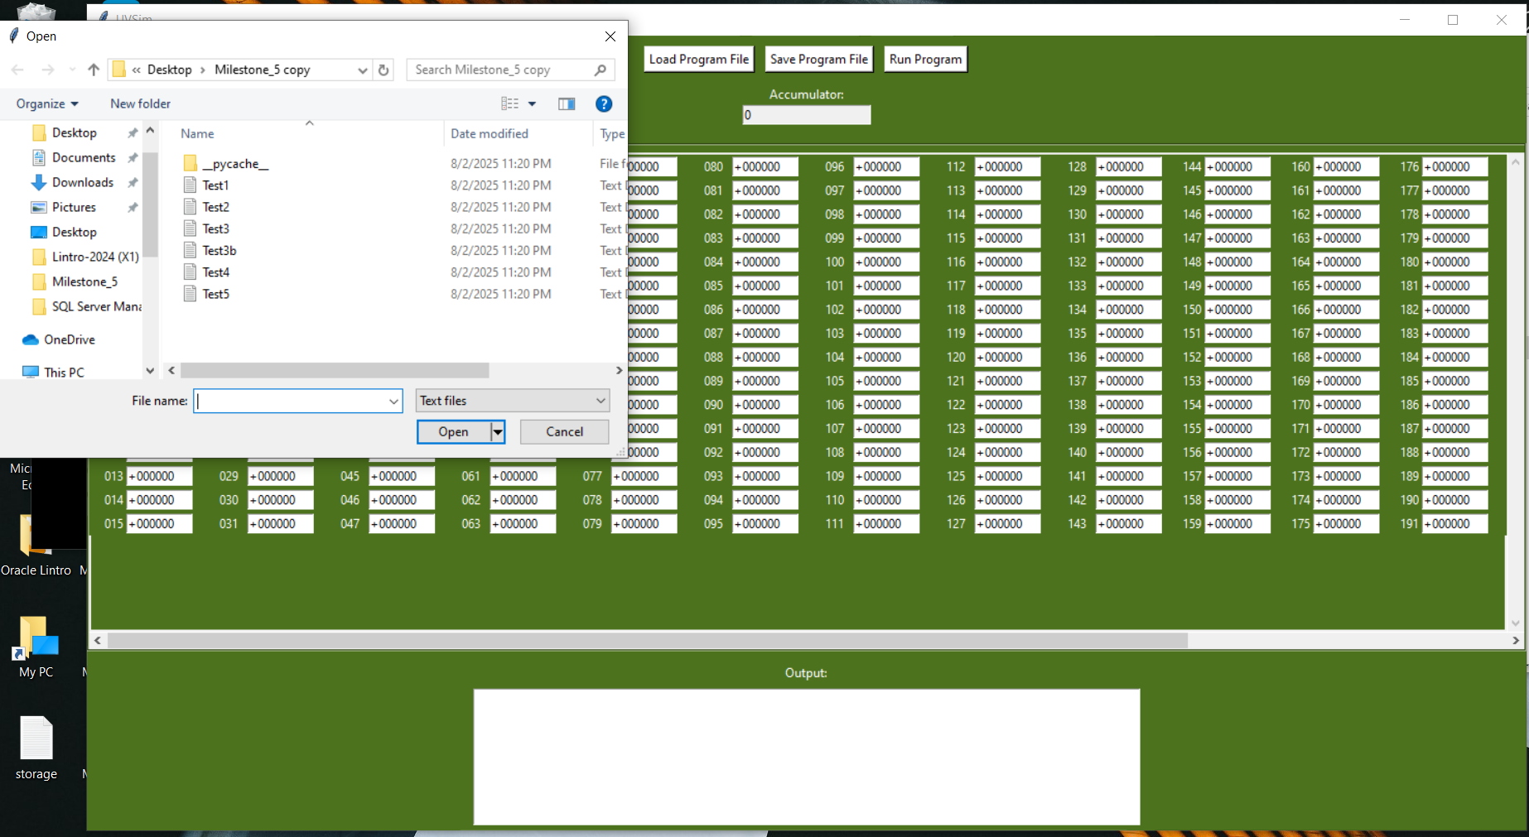

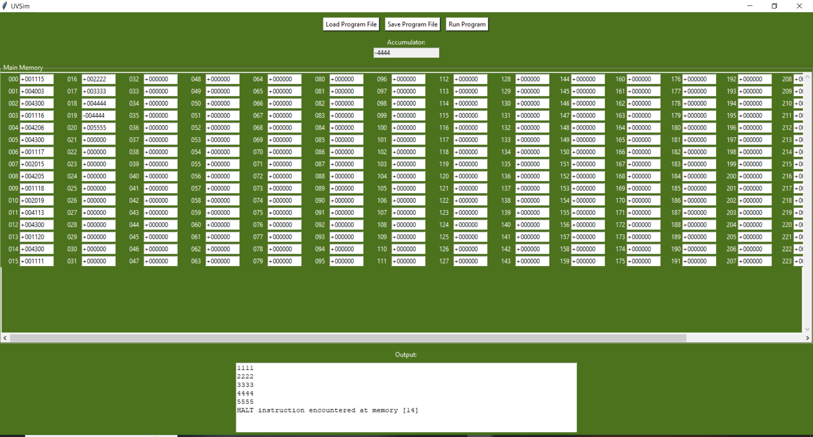

5.2 Editing Instructions in GUI
- Add, delete, cut/copy/paste, and modify lines directly.
- File must not exceed the memory limit:
  - Legacy format: max 100 lines (00–99)
  - New format: max 250 lines (000–249)

6. File Format Specifications

6.1 BasicML File Structure
- Plain text (.txt) file
- One signed integer instruction per line
- Must include a HALT instruction:
  - Legacy: +4300
  - New: +043000

6.2 Formats
- Legacy (4-digit): +1020, -3001, etc.
- New (6-digit): +010035, +030250, etc.
- File must be consistently formatted with all lines of equal digit length.
- Files mixing both formats will trigger an error.

7. BasicML Instruction Set

7.1 Legacy Opcodes (4-digit)
Opcode | Operation | Description
10 | READ | Input a value to memory
11 | WRITE | Output a value from memory
20 | LOAD | Load memory value into accumulator
21 | STORE | Store accumulator into memory
30 | ADD | Add memory value to accumulator
31 | SUBTRACT | Subtract memory value from accumulator
32 | DIVIDE | Divide accumulator by memory value
33 | MULTIPLY | Multiply accumulator by memory value
40 | BRANCH | Jump to memory location
41 | BRANCHNEG | Jump if accumulator is negative
42 | BRANCHZERO | Jump if accumulator is zero
43 | HALT | End program execution

7.2 New Opcodes (6-digit)
Opcode | Operation
010 | READ
011 | WRITE
020 | LOAD
021 | STORE
030 | ADD
031 | SUBTRACT
032 | DIVIDE
033 | MULTIPLY
040 | BRANCH
041 | BRANCHNEG
042 | BRANCHZERO
043 | HALT

8. Customizing the Interface Colors

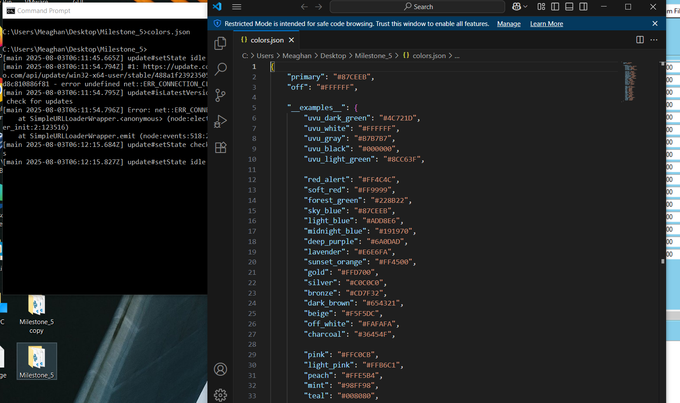
The program's color scheme can be customized by editing the colors.json file:
- Navigate to the file location and open colors.json.
- Edit the primary and off color hex codes:
{
"primary": "#4C721D",
"off": "#FFFFFF"
}
- Hex code format must start with # followed by six characters (0–9, A–F).
- Save changes and re-launch the program.
- If errors appear, ensure the hex codes are valid.

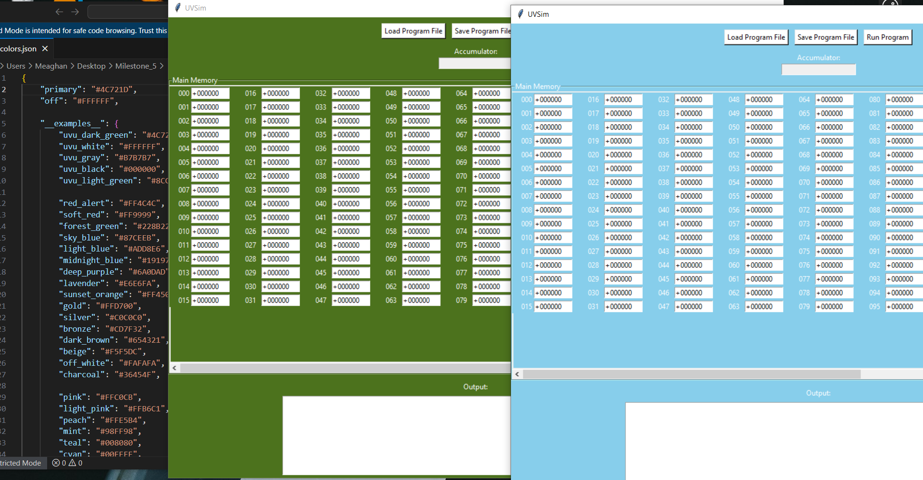

9. File Conversion and Compatibility
- Legacy 4-digit files are automatically converted to 6-digit instructions internally.
- The simulator supports up to 250 memory addresses for 6-digit files.
- Avoid mixing instruction formats within a single file.

10. Error Handling and Debugging
If errors occur:
- The application halts and reports the issue.
- A detailed error log is saved in a .txt file.
- Example issues:
  - Invalid opcode
  - Improper formatting
  - Instruction exceeding memory limit

11. Example Instruction Breakdown

4-Digit Format
- +1235
  - 12 → Opcode
  - 35 → Memory Location

6-Digit Format
- +010035
  - 010 → Opcode
  - 035 → Memory Location

12. Testing Instructions
To test your code:
- Create a .txt file with valid instructions.
- Load it in UVSim.
- If no errors occur, the code executes.
- If errors occur, check the log file and correct any formatting issues.

13. Notes
- You can load multiple program files simultaneously via GUI tabs.
- Only one program can be executed at a time.
- Values used for computation (not as instructions) should be placed after the HALT opcode.
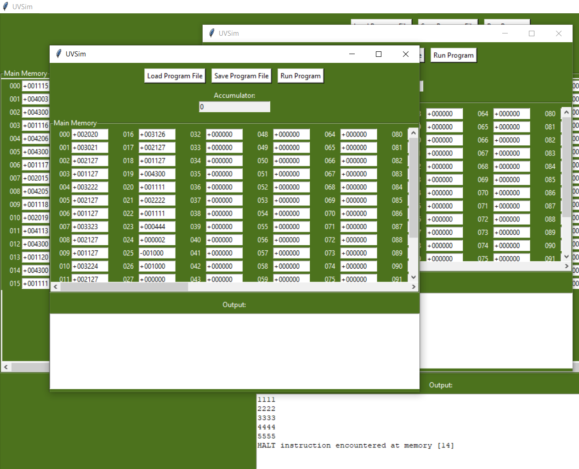

14. Support
For bug reports or feature requests, please submit issues to the GitHub Repository.

