BINARY TO GRAY CODE CONVERTER.

A digital circuit that translates binary numbers into Gray code is called a binary to Gray code converter. When two consecutive values in a binary numeral system change by just one bit, it's referred to as gray code, often called reflected binary code. Because of this characteristic, gray code can help reduce errors in digital systems, which is beneficial for applications like rotary encoders and digital communications error correction.

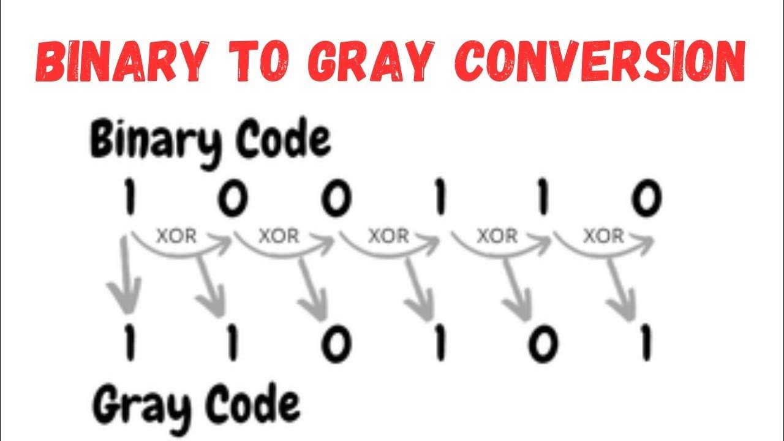

**XOR Operation**

The XOR (exclusive OR) operation compares two bits and returns:

* **1** if the bits are different
* **0** if the bits are the same

**XOR Operation**

The XOR (exclusive OR) operation compares two bits and returns:

* **1** if the bits are different
* **0** if the bits are the same.

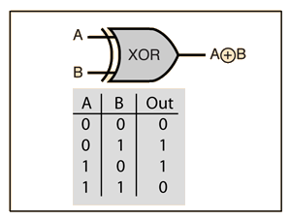

**C Code Example**

Here’s a simple C program to convert a binary number to Gray code:

// C program to convert binary number to Gray Code

#include <stdio.h>

#include <math.h>

int main()

{

unsigned long long int binNum = 0;

unsigned long long int gray = 0;

int a = 0;

int b = 0;

int i = 0;

printf("Enter a binary number: ");

scanf("%llu", &binNum);

while (binNum != 0) {

a = binNum % 10;

binNum = binNum / 10;

b = binNum % 10;

if ((a && !b) || (!a && b)) {

gray = gray + pow(10, i);

}

i++;

}

printf("The gray code: %llu", gray);

return 0;

}

Possible Mistakes and Errors in Binary to Gray Code Conversion

Incorrect XOR operation: Ensuring accurate bitwise XOR operations is crucial. Mistakes in applying XOR logic can lead to incorrect gray code values.

# Conclusion and Summary

Binary to gray code conversion is a vital concept in digital systems and computer science. Gray code's distinctive property of single-bit transitions makes it advantageous for error detection, rotary encoders, and digital circuits. Understanding the conversion algorithm, implementing code, and recognizing potential pitfalls are crucial for successfully leveraging this technique. This document provided a comprehensive guide to binary to gray code conversion, equipping readers with the knowledge and skills to apply it effectively in their endeavors.