**PROGRAM NO:**

**DATE:**

**AIM:** Implement various validation in UI

Mainactvity.java

package com.example.myapplication1;

import androidx.appcompat.app.AppCompatActivity;

import android.os.Bundle;

import android.view.View;

import android.widget.Button;

import android.widget.CheckBox;

import android.widget.EditText;

import android.widget.RadioButton;

import android.widget.RadioGroup;

import android.widget.Toast;

public class MainActivity extends AppCompatActivity {

EditText e_name, e_email, e_pwd;

RadioGroup gender;

RadioButton e_female, e_male;

CheckBox checkBox;

@Override

protected void onCreate(Bundle savedInstanceState) {

super.onCreate(savedInstanceState);

setContentView(R.layout.activity_main);

// Initialize UI elements

e_name = findViewById(R.id.e_name);

e_email = findViewById(R.id.e_email);

e_pwd = findViewById(R.id.e_pwd);

gender = findViewById(R.id.gender);

e_female = findViewById(R.id.e_female);

e_male = findViewById(R.id.e_male);

checkBox = findViewById(R.id.checkBox);

// Set up the submit button

Button submitButton = findViewById(R.id.e_button);

submitButton.setOnClickListener(this::onClickSubmit);

}

public void onClickSubmit(View view) {

if (checkedAllFields()) {

Toast.makeText(this, "SUCCESSFUL", Toast.LENGTH_SHORT).show();

}

}

private boolean checkedAllFields() {

// Check Name

if (e_name.getText().toString().trim().isEmpty()) {

e_name.setError("Please Enter Your Name");

return false;

}

// Check Email

String s_email = e_email.getText().toString().trim();

if (s_email.isEmpty()) {

e_email.setError("Email required");

return false;

} else {

String checkEmailPattern = "^[a-zA-Z0-9._%+-]+@[a-zA-Z0-9.-]+\\.[a-zA-Z]{2,}$";

if (!s_email.matches(checkEmailPattern)) {

e_email.setError("Select a valid email");

return false;

}

}

// Check Password

if (e_pwd.getText().toString().length() < 8) {

e_pwd.setError("Please enter a valid password");

return false;

}

// Check Gender

if (gender.getCheckedRadioButtonId() == -1) {

e_female.setError("Please choose gender");

Toast.makeText(this, "Select gender", Toast.LENGTH_SHORT).show();

return false;

}

// Check Agreement

if (!checkBox.isChecked()) {

checkBox.setError("Please agree!");

Toast.makeText(this, "Please agree to the terms", Toast.LENGTH_SHORT).show();

return false;

}

return true;

}

}

Activity_main.xml

<?xml version="1.0" encoding="utf-8"?>

<LinearLayout xmlns:android="http://schemas.android.com/apk/res/android"

android:layout_width="match_parent"

android:layout_height="wrap_content"

android:orientation="vertical">

<LinearLayout

android:layout_width="match_parent"

android:layout_height="wrap_content"

android:orientation="horizontal">

<TextView

android:id="@+id/textView3"

android:layout_width="match_parent"

android:layout_height="75dp"

android:text="Registration Form"

android:textAlignment="center"

android:textColor="#D82020"

android:textSize="24sp" />

</LinearLayout>

<LinearLayout

android:layout_width="match_parent"

android:layout_height="wrap_content"

android:orientation="horizontal">

<TextView

android:id="@+id/textView4"

android:layout_width="120dp"

android:layout_height="wrap_content"

android:text="Name"

android:textSize="20sp" />

<EditText

android:id="@+id/e_name"

android:layout_width="0dp"

android:layout_height="wrap_content"

android:layout_weight="1"

android:inputType="text" />

</LinearLayout>

<LinearLayout

android:layout_width="match_parent"

android:layout_height="wrap_content"

android:orientation="horizontal">

<TextView

android:id="@+id/textView5"

android:layout_width="120dp"

android:layout_height="wrap_content"

android:text="Email"

android:textSize="20sp" />

<EditText

android:id="@+id/e_email"

android:layout_width="0dp"

android:layout_height="wrap_content"

android:layout_weight="1"

android:inputType="textEmailAddress" />

</LinearLayout>

<LinearLayout

android:layout_width="match_parent"

android:layout_height="wrap_content"

android:orientation="horizontal">

<TextView

android:id="@+id/textView6"

android:layout_width="120dp"

android:layout_height="wrap_content"

android:text="Password"

android:textSize="20sp" />

<EditText

android:id="@+id/e_pwd"

android:layout_width="0dp"

android:layout_height="wrap_content"

android:layout_weight="1"

android:inputType="textPassword" />

</LinearLayout>

<LinearLayout

android:layout_width="match_parent"

android:layout_height="wrap_content"

android:orientation="vertical">

<TextView

android:id="@+id/gender_text"

android:layout_width="wrap_content"

android:layout_height="wrap_content"

android:text="Gender"

android:textSize="20sp" />

<RadioGroup

android:id="@+id/gender"

android:layout_width="match_parent"

android:layout_height="wrap_content">

<RadioButton

android:id="@+id/e_female"

android:layout_width="wrap_content"

android:layout_height="wrap_content"

android:text="Female" />

<RadioButton

android:id="@+id/e_male"

android:layout_width="wrap_content"

android:layout_height="wrap_content"

android:text="Male" />

</RadioGroup>

</LinearLayout>

<LinearLayout

android:layout_width="match_parent"

android:layout_height="wrap_content"

android:orientation="horizontal">

<CheckBox

android:id="@+id/checkBox"

android:layout_width="wrap_content"

android:layout_height="wrap_content"

android:text="I Agree" />

</LinearLayout>

<LinearLayout

android:layout_width="match_parent"

android:layout_height="wrap_content"

android:orientation="horizontal">

<Button

android:id="@+id/e_button"

android:layout_width="wrap_content"

android:layout_height="wrap_content"

android:onClick="onClickSubmit"

android:text="Submit" />

</LinearLayout>

</LinearLayout>

OUTPUT:

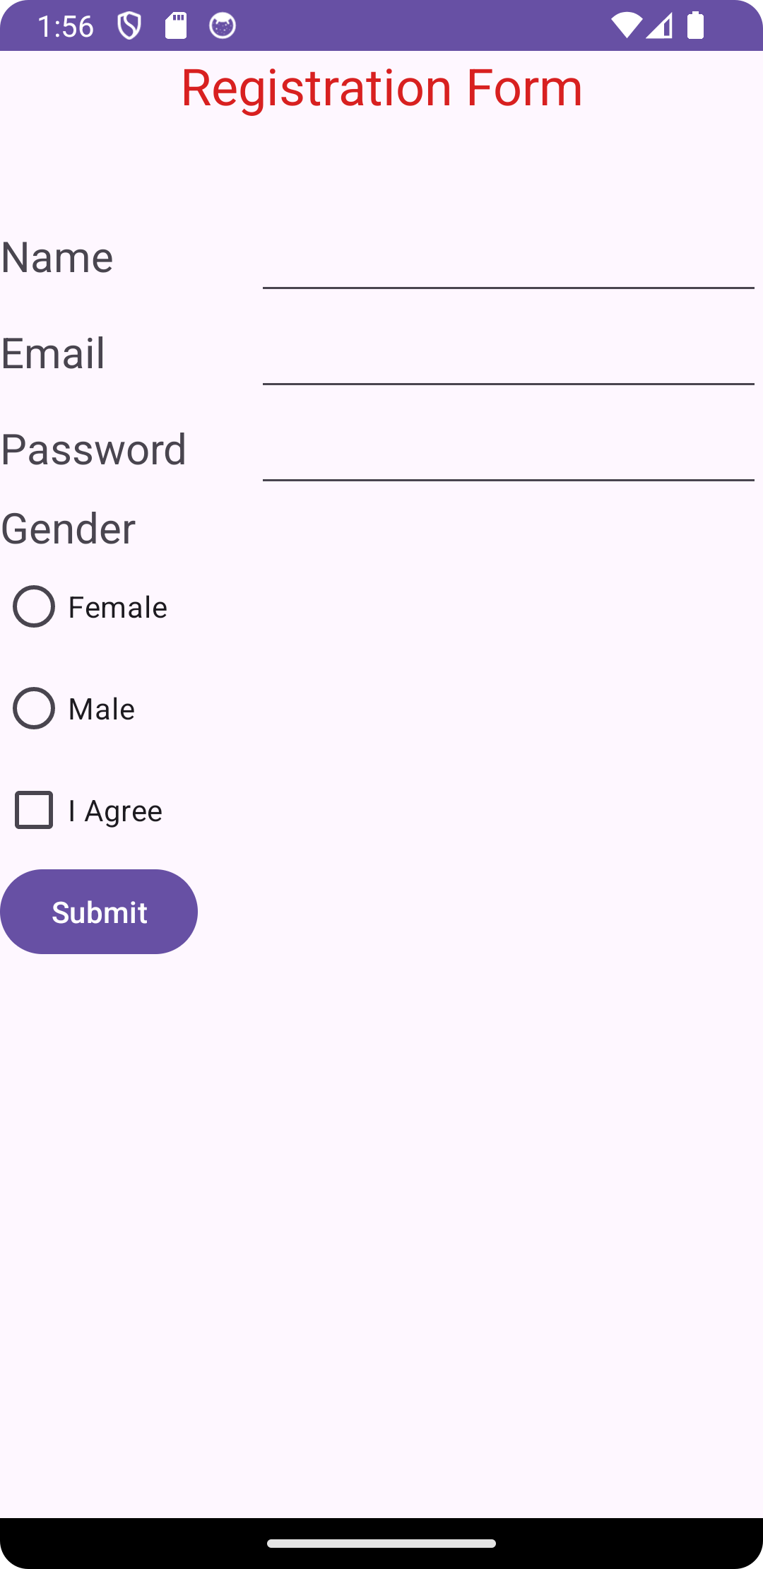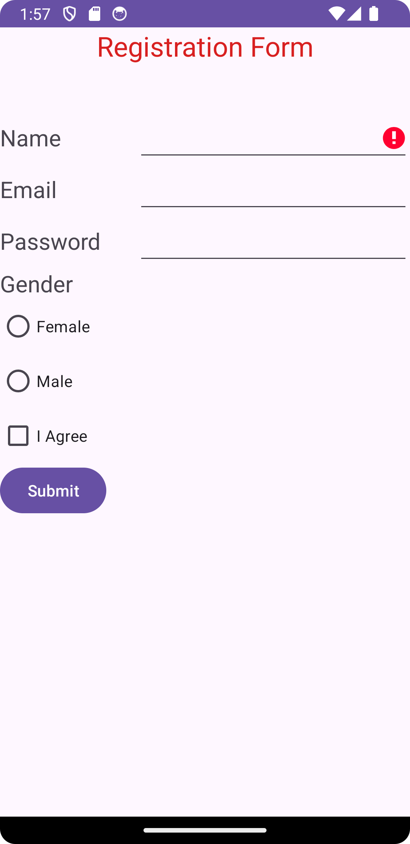

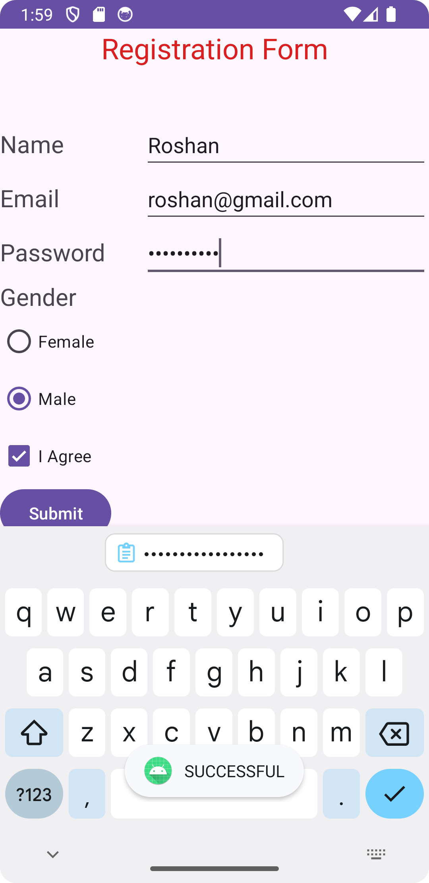

**PROGRAM NO:**

**DATE:**

**AIM**: Design a Registration activity and store registration details in local

memory of phone using intents and shared perferences.

**USING INTENT**

**Mainactvity.java**