727721EUCS013

Anusree E

1).QUESTION 1:

Question 1 : Adding a product to cart and checkout :

• Verify that user is able to add a product to the cart Add to cart

• Verify that user can view the contents in the cart

• Verify that once user clicks on checkout button “Your information” form should be displayed

• Verify that once user fills the form and clicks on continue button entire product overview should be displayed

• Print the name of the product and the price of the product

• Assert the title of the page is ‘Swag Labs’

• Asser t the URL of the page is ‘https://www.saucedemo.com/checkout-step-two.html’

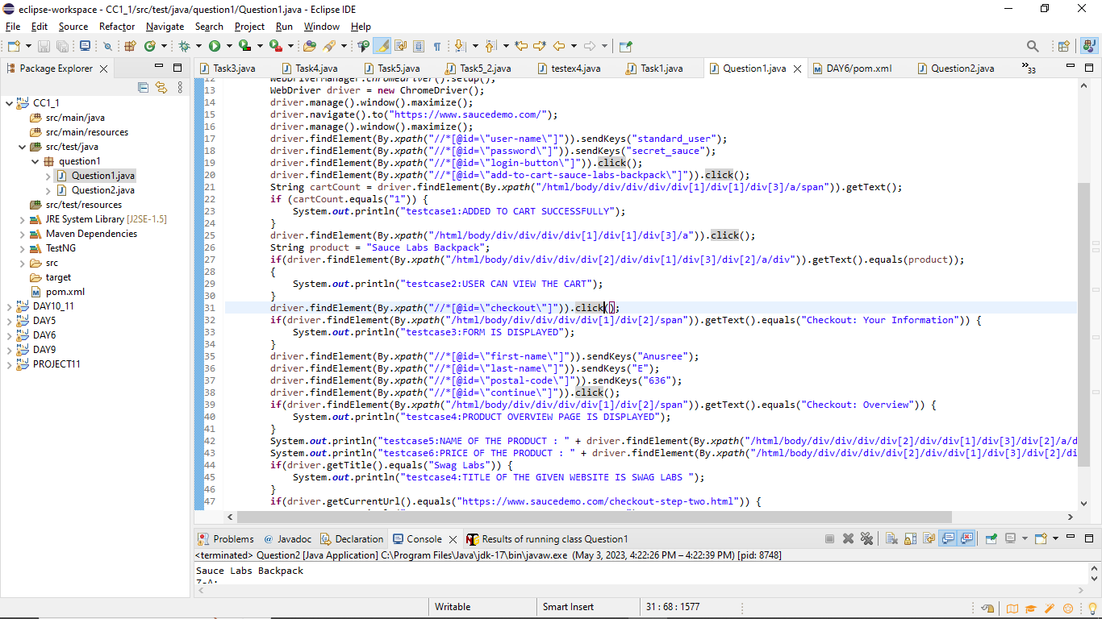

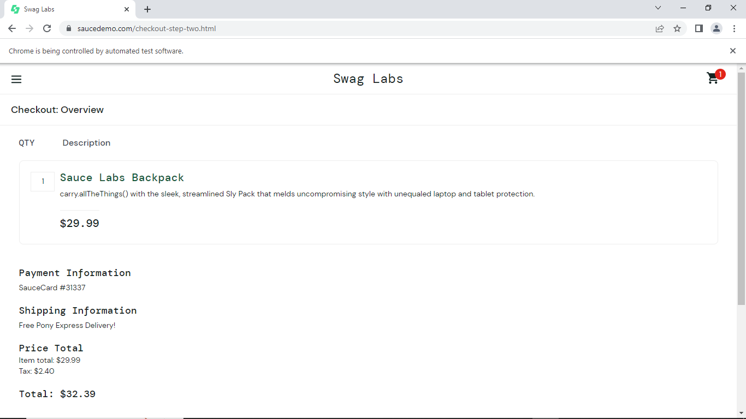

2).QUESTION 2:

Filter option :

• Verify that user is able to apply filter name wise from A-Z and Z-A

• Print the first product name while filtering from A-Z and print 1st product name while filtering from Z-A

• Verify the user is able to apply filter from low price to high price and high price to low price

• Print the 1 st product price while filtering from high to low and print 1st product price while filtering from low to high