Select AI Agent on Oracle Autonomous Database
Implementation Guide — NL2SQL, RAG, and Custom PL/SQL + Python Tools
Verified against Oracle AI Database 26ai (23.26.3.2.0)
github.com/BASoapbox/ACME-Corp-Select-AI-Agent-Project

Table of Contents
Table of Contents 2
1. Overview 3
1.1 What gets built 3
1.2 Script order 4
2. Prerequisites 5
2.1 The two principals 5
2.2 Region and model availability 5
2.3 Grants that NL2SQL actually honours 5
3. Custom Tools 6
3.1 What the database is actually doing 6
3.2 Python tools — Embedded Python Execution 6
3.3 Authentication: reading the password from OCI Vault 7
3.4 Two traps inside the wrapper 8
4. Gotchas That Survive Working Code 10
5. When Something Fails 11
5.1 Is the object actually valid? 11
5.2 Does it work standalone? 11
5.3 What did the agent actually do? 11
Appendix A — Sample Questions and Expected Answers 12
A.1 SQL tool 12
A.2 RAG tool 12
A.3 Trend tool 13
A.4 Forecast tool 13
A.5 Anomaly tool 13
A.6 Python tool 14
A.7 Multi-tool questions 14
Appendix B — Repository Layout 15

1. Overview
This guide accompanies a working repository of SQL scripts that build a complete Select AI Agent stack on Oracle Autonomous Database: natural-language SQL over live tables, retrieval-augmented generation over policy documents, and four custom tools — three in PL/SQL and one running Python inside the database through OML4Py Embedded Python Execution.
Everything here has been executed end to end against a live 26ai database. Where behaviour differs from older Oracle documentation or from earlier database versions, this guide records what the database actually did.

1.1 What gets built
Object | Name | Purpose
NL2SQL profile | ACME_NL2SQL_PROFILE | Natural language to SQL over GL tables
RAG profile | ACME_RAG_PROFILE | Narration grounded in vector search
Vector index | ACME_VECTOR_INDEX | Chunked, embedded copies of the source PDFs
Tools (6) | ACME_SQL_TOOL, ACME_RAG_TOOL, ACME_TREND_TOOL, ACME_FORECAST_TOOL, ACME_ANOMALY_TOOL, ACME_PYTHON_TOOL | What the agent can do
Agent | ACME_ANALYST | Role, persona, and the explicit tools array
Task | ACME_ANALYST_TASK | The routing instruction
Team | ACME_ANALYST_TEAM | The unit you actually call

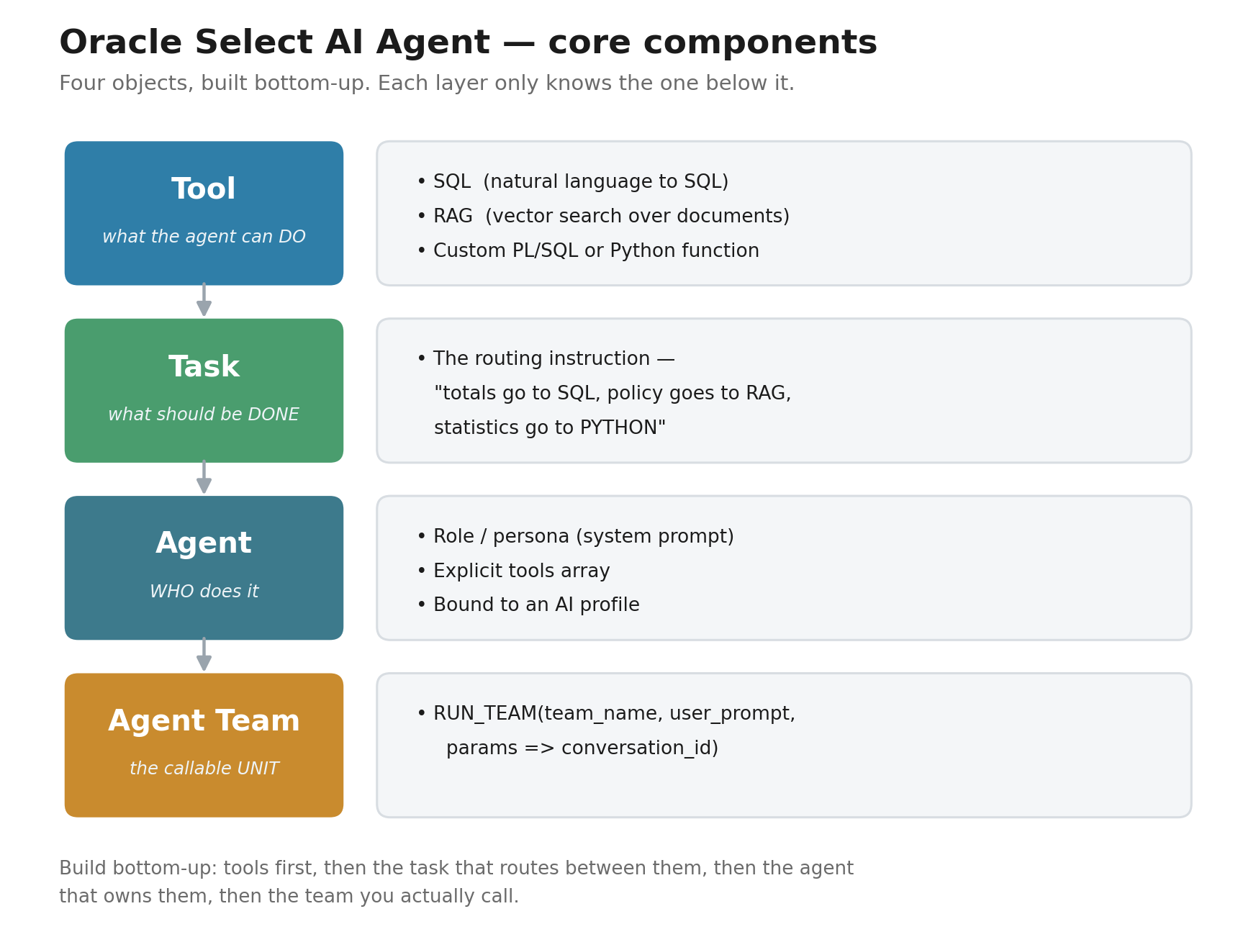
Figure 1 — The four core components, built bottom-up.

1.2 Script order
Script | Run as | What it does
SA_00_create_schema.sql | ADMIN | Creates the schema. Reads the password from OCI Vault, or prompts.
SA_01_admin_setup.sql | ADMIN | Resource Principal, DBMS_CLOUD grants, OML roles, EPE network ACL
SA_02_ddl_dml.sql | schema | Seven tables and the GL dataset, including three deliberate anomalies
SA_03_agent_setup.sql | schema | Comments, profiles, vector index, six tools, agent, task, team
SA_04_operations.sql | schema | Twelve independent operational recipes — run only what you need
SA_05_cleanup.sql | schema | Tear down the agent stack
Configuration: All environment values live in SA_ENV.sql, which every script includes with @SA_ENV. It is the only file you edit, and it is gitignored. No password appears in any script.

2. Prerequisites
Most failures in this stack are provisioning problems wearing a misleading error message. Walking this list first is considerably faster than meeting them one ORA- at a time.

2.1 The two principals
There are two identities involved, and administrator rights only cover one of them. This is the single most common reason a correct script fails on a fresh tenancy.
Principal | What it does | Covered by your admin role?
You, a human user | Creates the database, bucket, vault, schema | Yes
The database, via its Resource Principal | Calls Generative AI, reads the RAG documents, reads Vault | No — needs its own policy
The database authenticates as itself. Without a policy naming that principal, every Generative AI call and every vector-index build fails no matter who you are.
allow any-user to manage generative-ai-family in compartment <db-compartment>
where request.principal.type = 'autonomousdatabase'
allow any-user to read object-family in compartment <bucket-compartment>
where request.principal.type = 'autonomousdatabase'
allow any-user to read secret-bundles in compartment <vault-compartment>
where request.principal.type = 'autonomousdatabase'
Compartments: These often name different compartments — databases, buckets and vaults are frequently separated. A policy only reaches its own compartment and its descendants, so siblings need the policy created in their shared parent.

2.2 Region and model availability
OCI Generative AI is not available in every region, and the models available differ between the regions where it is. A model that works in one region may simply not exist in another. Verify before configuring:
oci generative-ai model-collection list-models -c <compartment-ocid> \
--query 'data.items[?"lifecycle-state"==`ACTIVE`]."display-name"'

2.3 Grants that NL2SQL actually honours
A direct grant on every source table is the simplest thing that works:
GRANT SELECT ON acme_gl_transactions TO ACME_CORP;
It is often said that NL2SQL silently ignores role-granted privileges. Testing that directly — a table in a separate schema, SELECT granted only to a role, that role granted to the agent schema, no direct grant — NL2SQL answered correctly. What it cannot use is a role the session has not enabled, and a freshly granted role is not automatically a default role. Run ALTER USER <schema> DEFAULT ROLE ALL, and check SELECT role FROM session_roles. If the role is missing there, ordinary SQL fails too, which separates a privilege problem from a model problem in one query.

3. Custom Tools
A custom tool is an ordinary PL/SQL function that the agent calls with named parameters. Registering it takes three things: an instruction telling the model when to use it, the function name, and — optionally — a description of its inputs.

3.1 What the database is actually doing
From the outside, a custom tool looks like any other PL/SQL function. The agent reads the instruction text, decides the function is relevant to the question, introspects the function's argument metadata to work out how to call it, calls it with named parameters, and feeds the returned text back into its reasoning loop.
That introspection step matters more than it sounds. It is performed against the compiled object, so a function that exists but is INVALID produces an agent-level error that reads like a missing object or a missing grant. Section 5 covers that failure in detail.
BEGIN
DBMS_CLOUD_AI_AGENT.CREATE_TOOL(
tool_name => 'ACME_TREND_TOOL',
attributes => '{
"instruction" : "Analyse expense trends over time for ACME Corp departments.
Returns period-over-period changes and growth rates.",
"function" : "ACME_TREND_ANALYSIS"
}'
);
END;
/
Write the instruction like a docstring. It is the only thing the model reads when deciding whether to call your function. Say when to use it, what it takes, and what it gives back.
Parameters map by name, and introspection sends whatever the data dictionary holds. Oracle stores an ordinary identifier in upper case, so p_department is supplied as "P_DEPARTMENT". Never declare a tool function’s parameters as quoted identifiers: "p_department" is stored lower case, the agent faithfully sends the lower-case name, the bind does not land, and the parameter’s DEFAULT fires instead — with no error raised anywhere. The tool returns valid JSON computed from the wrong input.

3.2 Python tools — Embedded Python Execution
The Python tool runs pandas and numpy inside the database through OML4Py Embedded Python Execution. There is no external Python environment anywhere: the wrapper queries the data in PL/SQL, serialises it to JSON, hands it to a registered Python function through pyqEval, and returns the result.
Four configuration steps are needed, and each fails differently when missing, so you tend to meet them in sequence:
Step | What | Symptom when missing
1 | GRANT PYQADMIN | sys.pyqScriptCreate raises a privilege error
2 | GRANT OML_DEVELOPER | pyqEval returns HTTP 404 even though the script is in USER_PYQ_SCRIPTS
3 | pyqAppendHostAce | ORA-20101: Host ACL not configured
4 | A valid OML auth token | Authentication failure at call time
The EPE network ACL is not the normal one. Embedded Python Execution uses a separate PYQSYS-managed ACL. DBMS_NETWORK_ACL_ADMIN.APPEND_HOST_ACE has no effect on it at all.
-- signature is (USERNAME, HOST_ROOT_DOMAIN) -- schema first, two arguments
EXEC pyqAppendHostAce('ACME_CORP', 'adb.us-ashburn-1.oraclecloudapps.com');
Root domain, not hostname. You pass the root domain; Oracle expands and stores the full instance hostname. What pyqGetHostAce returns back will therefore look different from what you passed in. That is correct, not a bug.

3.3 Authentication: reading the password from OCI Vault
Embedded Python Execution authenticates with a short-lived OML token, obtained through an OAuth password-grant exchange. The token expires roughly every hour, so the wrapper refreshes it on every call rather than relying on anyone to remember.
That exchange needs a real username and password in the POST body — which raises the obvious question of where the password comes from.

What does not work
The intuitive answer is to store the password in a DBMS_CLOUD credential and read it back when needed. That is not possible, and not because of a missing view name. Oracle deliberately does not expose a stored credential's password through any view, function or procedure. USER_CREDENTIALS and ALL_CREDENTIALS will confirm a credential exists and show its username — never its password. A credential store you could SELECT out of would not be meaningfully different from a plaintext table.
Oracle's own OML4Py reference implementation resolves this by hardcoding the password in the PL/SQL body. That works, and it is the documented approach, but it leaves a live password in an access-controlled function.

What does work
The credential store is one-way, but the Vault itself is not. OCI Vault has a REST API, and the database can call it with its own Resource Principal — the same identity it already uses for Generative AI and Object Storage. The password never appears in the script.
CREATE OR REPLACE FUNCTION acme_get_secret(p_secret_ocid IN VARCHAR2)
RETURN VARCHAR2 IS
v_resp DBMS_CLOUD_TYPES.resp;
v_b64 VARCHAR2(32767);
BEGIN
v_resp := DBMS_CLOUD.SEND_REQUEST(
credential_name => 'OCI$RESOURCE_PRINCIPAL',
uri => 'https://secrets.vaults.<region>.oci.oraclecloud.com'
|| '/20190301/secretbundles/' || p_secret_ocid,
method => 'GET');
v_b64 := JSON_VALUE(DBMS_CLOUD.GET_RESPONSE_TEXT(v_resp),
'$.secretBundleContent.content');
RETURN UTL_RAW.CAST_TO_VARCHAR2(
UTL_ENCODE.BASE64_DECODE(UTL_RAW.CAST_TO_RAW(v_b64)));
END acme_get_secret;
/
One policy statement enables it:
allow any-user to read secret-bundles in compartment <c>
where request.principal.type = 'autonomousdatabase'
Why this is better than a prompt. Vault-first also removes a second problem. If you type the password when creating the schema and separately store it in Vault, you have two copies that can silently drift apart. With the Vault as the single source, SA_00 creates the user with it and the Python tool reads the same secret.

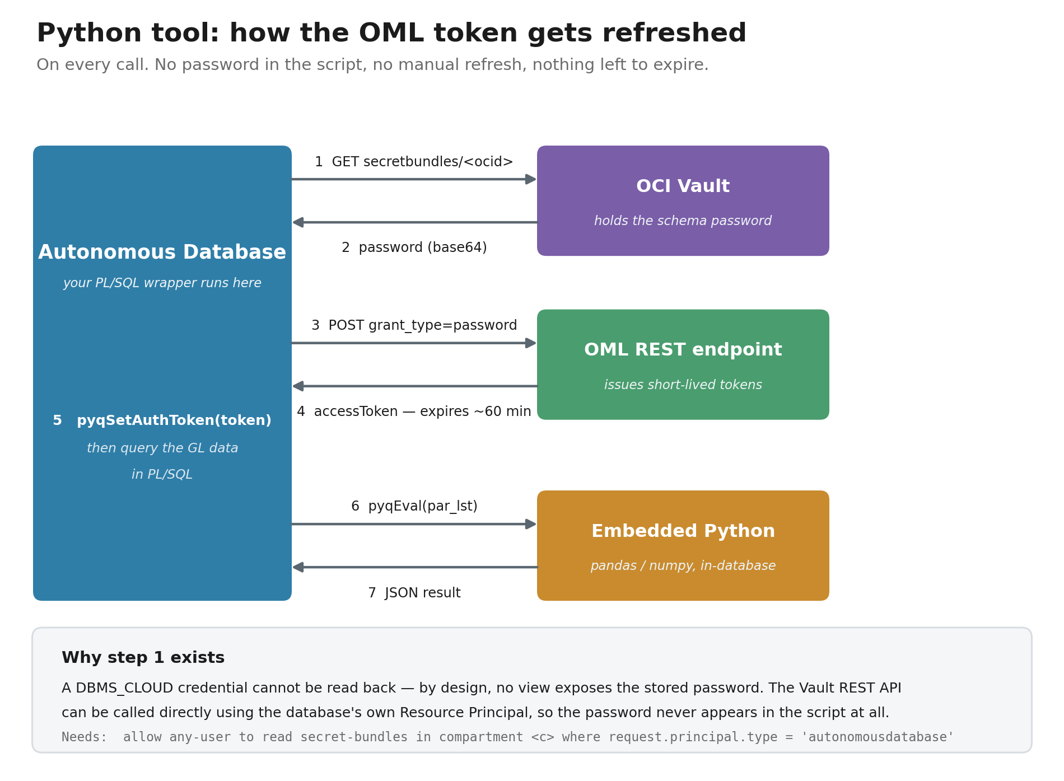
Figure 2 — Token refresh on every call. Steps 1 and 2 replace the hardcoded password.

3.4 Two traps inside the wrapper
Both compile cleanly and fail only at run time.
Passing data to Python. The data_json parameter must reach Python as a quoted string. Unquoted, pyqEval deserialises it for you and Python receives a native list, so json.loads() fails with "the JSON object must be str, bytes or bytearray, not list".
-- WRONG -- Python receives a list
v_par_lst := '{"data_json":' || v_data || '}';
-- CORRECT -- quoted string value
v_par_lst := '{"data_json":"' || REPLACE(v_data, '"', '\"') || '"}';
Logging from a function called by SQL. A function invoked from a SQL statement cannot perform DML — every attempt to write to an error-log table raises ORA-14551. Route logging through a procedure marked autonomous instead:
CREATE OR REPLACE PROCEDURE acme_log_error(p_source VARCHAR2, p_msg VARCHAR2) IS
PRAGMA AUTONOMOUS_TRANSACTION;
BEGIN
INSERT INTO acme_error_log(error_source, error_msg) VALUES(p_source, p_msg);
COMMIT;
END;
/
Also: Do not call oml.connect() inside an EPE function. The Python engine is already running in the database; connecting back in trips the ACL. Query in PL/SQL, pass through par_lst, and let Python compute only.

4. Gotchas That Survive Working Code
These are not bugs in the scripts. They are behaviours of the framework that will still catch you when you adapt the working code to your own schema.
Behaviour | What happens | What to do
"region" in an AI profile | Not reproducible on 23.26.3.2.0. Two profiles identical but for this attribute both succeeded. The my$cloud_domain placeholder also turns up in errors raised by profiles that never set region, on requests that plainly reached the API. | Omit it anyway — it buys nothing. Do not chase my$cloud_domain in an error URL; it is a rendering artifact, not a malformed endpoint.
tools array on CREATE_AGENT | Optional in the API. Omit it and the agent still creates, RUN_TEAM still runs, and an answer comes back with no tool having fired and no error raised. What arrives instead of data is model-dependent — across four runs one model simply echoed the question back. | Always list tools explicitly, and check USER_AI_AGENT_TOOL_HISTORY. An empty history under a confident answer is the only reliable tell.
profile_name placement | Raises ORA-20052: Invalid tool attribute - profile_name. The call fails immediately and no tool is created. | It belongs inside tool_params. You find out at once if it does not, so there is no silent misconfiguration to hunt for later.
narrate vs chat | Vector search runs on the narrate action. Testing a RAG profile with SELECT AI chat answers from training data and looks like success. | Test with something that exists only in your documents.
conversation_id | SYS_GUID() returns 32 hex characters with no hyphens and is rejected with ORA-20050 "Invalid value for conversation id". | Use DBMS_CLOUD_AI.CREATE_CONVERSATION — note DBMS_CLOUD_AI, not DBMS_CLOUD_AI_AGENT.
DROP_TEAM | No orphan AGENT$<team> profile was found on 23.26.3.2.0 — not after CREATE_TEAM, not after RUN_TEAM, not after DROP_TEAM — and recreating a team under the same name succeeds. | Nothing required. The cleanup script still drops that profile defensively, which costs nothing if your version behaves differently.
UPDATE_PROFILE / UPDATE_AGENT / UPDATE_TASK | Correct — no procedure is named UPDATE_*. But in-place modification does exist: SET_ATTRIBUTE and SET_ATTRIBUTES, in both packages. | Use SET_ATTRIBUTE. The agent-package signature takes the object type second: SET_ATTRIBUTE(object_name, object_type, attribute_name, attribute_value). Drop-and-recreate is only needed for a full rebuild; recreating under the same name keeps referencing objects valid.
max_tokens | Defaults to 1024 — far too low once the agent is interpreting, generating SQL, and narrating a result. Truncation produces baffling output. | Set it explicitly, but check the model’s ceiling first. Llama 4 models cap maxTokens at 4096 and reject anything higher with HTTP 400 straight from the inference endpoint, in an error that never mentions your profile. 4000 is safe.
conversation attribute | Defaults to false, so multi-turn context is off unless you ask for it. | Set "conversation" : "true".
Literal & in your data | SQL*Plus and SQLcl treat & as a substitution prefix. A value like "P&L report" prompts for a variable, the prompt cancels, and the INSERT is silently skipped. | SET DEFINE '^' and use ^var for substitutions.
numpy.std vs SQL STDDEV | numpy divides by n (population); SQL STDDEV divides by n-1 (sample). Both correct, different numbers. | Use STDDEV_POP() in SQL when the two must agree.

5. When Something Fails
Each layer's errors impersonate a different layer's problems, so work bottom-up. Three checks, in this order, each ruling out a category.

5.1 Is the object actually valid?
A PL/SQL object with a compile error still gets created — it just gets created INVALID. The database raises ORA-24344: success with compilation error, and most drivers treat that as a warning rather than an exception. python-oracledb, cx_Oracle and many JDBC setups will all report success for an object that fails the moment anything calls it.
SELECT object_name, status FROM user_objects WHERE status <> 'VALID';
SELECT line, position, text FROM user_errors
WHERE name = 'ACME_PYTHON_EXPENSE_ANALYSIS' ORDER BY sequence;
This is worth running as a habit after creating any PL/SQL object. It costs nothing when the object is valid, and when it is not, it is the difference between a five-second fix and starting at the wrong end of the stack.
What it looks like from the agent: ORA-20052: Procedure not found. That reads like a missing object or a missing grant. Neither is true — the agent tried to introspect the function's argument metadata and introspection fails against an INVALID object.

5.2 Does it work standalone?
SELECT acme_trend_analysis('Engineering', 6) FROM dual;
This bypasses the agent entirely and rules out tool registration, routing, and the reasoning loop. If it works here but fails through the agent, the problem is in the registration or the call, not the function.

5.3 What did the agent actually do?
SELECT tool_name, agent_name, start_date, SUBSTR(tool_output,1,200)
FROM user_ai_agent_tool_history
ORDER BY start_date DESC FETCH FIRST 10 ROWS ONLY;
Every invocation is logged with its inputs and output. Right tool with sensible parameters and good data but a wrong final answer is a narration problem — usually the task instruction, which is a different fix altogether. Wrong tool is a routing problem. An error in the output is a function problem. The view tells the three apart, which is more than the error messages do.
Views changed in 26ai: USER_AI_AGENTS (not USER_AI_AGENT_AGENTS), USER_CLOUD_VECTOR_INDEXES (not USER_CLOUD_AI_VECTOR_INDEXES), and the teams view column is AGENT_TEAM_NAME. The vector store backing table is <INDEX_NAME>$VECTAB.

Appendix A — Sample Questions and Expected Answers
These can be sent to ACME_ANALYST_TEAM through RUN_TEAM or any chat front end. Expected answers are based on the shipped GL dataset: five departments, nine periods (JAN–SEP 2025), with three deliberate anomalies planted for the analysis tools to find.
DECLARE
l_conv VARCHAR2(36);
l_resp CLOB;
BEGIN
l_conv := DBMS_CLOUD_AI.CREATE_CONVERSATION();
l_resp := DBMS_CLOUD_AI_AGENT.RUN_TEAM(
team_name => 'ACME_ANALYST_TEAM',
user_prompt => 'What were Engineering expenses in August 2025?',
params => '{"conversation_id":"' || l_conv || '"}');
DBMS_OUTPUT.PUT_LINE(l_resp);
END;
/
Reuse the conversation id across turns to keep multi-turn context. A fresh id starts a new conversation.

A.1 SQL tool
Translates natural language to SQL and runs it against the live GL tables.
What are the total expenses by department for Q1 2025? | Finance $348,000 · Engineering $67,000 · Operations $3,500. Q1 = JAN/FEB/MAR-2025. These are the source-of-truth figures for validating the other tools.
Which department had the highest total expenses from January to September 2025? | Finance — approximately $1.49M across 9 periods, driven by salaries, audit and professional services.
What were Engineering department expenses in August 2025? | Approximately $176,000 — well above the Engineering monthly average, from a cloud migration project ($95,000) and architecture consulting ($40,000). The largest single-period spike in the dataset.
What period close tasks are still open for March 2025? | Obtain Level 2 approvals for items >$10K · Prepare management P&L report · SOX control sign-off · Archive reconciliation documentation · Lock period in ERP system.
How many expense transactions does Finance have in the GL? | Counts rows in ACME_GL_TRANSACTIONS for department_code 410 with account_type = EXPENSE — approximately 30.
Show me all expense accounts in the chart of accounts. | 6000 Salaries and Wages · 6100 Software Licenses · 6200 Cloud Infrastructure · 6300 Travel and Entertainment · 6400 Professional Services · 6500 Office Supplies · 6600 Training and Development.

A.2 RAG tool
Semantic search over the seven source PDFs in the vector index. Answers cite the source document.
What is the reconciliation policy for ACME Corp? | All balance sheet accounts reconciled monthly within 5 business days of period close. Items over $10,000 require Level 2 approval; intercompany balances above $50,000 require CFO sign-off. (reconciliation_policy.pdf)
What are the SOX compliance requirements? | SOX 404 control requirements — reconciliation as a key control, electronic sign-off, and a 7-year documentation retention period. (sox_compliance_reference.pdf)
What is the period close checklist? | The month-end sequence: verify balances in Fusion ERP, execute automated reconciliations, review exception reports, obtain approvals, archive results — within 10 business days. (period_close_checklist.pdf)
How does data flow from Fusion to the data lake? | The extract, transform and load pipeline covering GL export format, staging and transformation rules. (fusion_to_datalake_flow.pdf)
If RAG answers look generic, you are probably testing the profile with the chat action rather than narrate. Ask something that exists only in your documents — a threshold, a retention period — and check the answer cites a source.

A.3 Trend tool
acme_trend_analysis() applies LAG() to compute period-over-period change and growth rate.
Show me the expense trend for the Engineering department. | Growth from ~$22K (JAN-2025) to ~$63K (SEP-2025), with a large spike in AUG-2025 (~$176K) from the cloud migration project.
How have Finance expenses trended over the past 9 months? | Relatively stable at ~$143K–$165K per period, with a spike in MAY-2025 (~$279K) from the annual audit ($85K) and ERP consulting ($62K). Underlying salary cost is consistent at $120–125K/month.
Which department has the fastest growing expenses? | Sales shows the strongest consistent upward trend — ~$60K/month in Q1 rising to ~$76K/month by Q3, excluding the JUN-2025 conference anomaly.
Show me expense trends across all departments for the last 6 periods. | A JSON array of the 6 most recent period/department combinations with total_expense, prior_expense and growth_pct.

A.4 Forecast tool
acme_expense_forecast() runs ordinary least-squares linear regression over the historical periods and projects forward.
Forecast Engineering expenses for the next 3 periods. | Regression over 9 periods with a positive slope elevated by the AUG-2025 spike. Expect projections in the $70K–$90K range.
What will Sales expenses look like over the next quarter? | A consistent upward trend, slope approximately $1,800–$2,000 per period, projecting into the $78K–$85K range.
Forecast total company expenses for the next 3 periods. | Aggregate regression dominated by Finance and Engineering volumes — projected totals in the $400K–$500K per period range.
Will Finance expenses increase or decrease next quarter? | A slight positive slope driven by salary costs, distorted upward by the MAY-2025 audit spike. The tool reports the slope, projections and historical_periods count.
Spikes move the line. The regression includes the anomalies by design. With only nine periods, one spike visibly shifts both slope and intercept — worth saying out loud when presenting a forecast.

A.5 Anomaly tool
acme_anomaly_detect() computes each department's mean and standard deviation across all periods, then flags any period deviating more than the threshold from that mean. Three anomalies are planted in the dataset.
Are there any unusual spending patterns in our GL data? | At a 30% threshold: Engineering AUG-2025 (~$176K vs ~$47K average, ~+274%) · Finance MAY-2025 (~$279K vs ~$166K, ~+68%) · Sales JUN-2025 (~$144K vs ~$72K, ~+100%). Returned ordered by deviation magnitude.
Which departments have had spikes above 50% of normal? | Engineering AUG-2025 and Sales JUN-2025 clearly exceed 50%; Finance MAY-2025 is approximately 68% above average.
Flag any months where a department spent more than 20% above average. | All three anomaly periods. Operations and Corporate show none — their spending is relatively flat.
Has Engineering had any months with abnormal spending? | August 2025 — approximately $176,000 against a monthly average of ~$47,000, a deviation of about 274%, driven by a cloud migration project ($95,000) and architecture consulting ($40,000).

A.6 Python tool
OML4Py Embedded Python Execution via pyqEval. Data is queried in PL/SQL and passed to Python as a JSON parameter; numpy computes the statistics.
Give me a Python statistical analysis of Engineering expenses including moving averages. | mean $63,055.56 · std dev $42,667.61 · min $22,000 (JAN-2025) · max $176,000 (AUG-2025) · peak period AUG-2025 · three-period moving averages · AUG-2025 flagged at the 30% threshold.
What is the standard deviation of Finance monthly expenses? | Population std dev $41,199.01 against a mean of $165,444.44, driven by the MAY-2025 audit spike. The eight non-spike months average ~$148K with a std dev of only ~$9K — the underlying salary base is very stable.
Two numbers, both right. numpy.std() is population standard deviation (divides by n); SQL STDDEV() is sample (divides by n-1). For Finance that is $41,199 versus $43,698. Use STDDEV_POP() when the SQL and Python tools must agree.
Token handling. No manual pyqSetAuthToken() is needed — the wrapper refreshes the OML token on every call using the password read from OCI Vault. If the Python tool errors, check ACME_ERROR_LOG for refresh failures.

A.7 Multi-tool questions
These test whether the agent routes to more than one tool in a single response — the behaviour that distinguishes an agent from a single-purpose NL2SQL query.
What are Finance expenses and what approval is required for large transactions? | SQL for live Finance period totals, plus RAG for the $10K Level 2 approval threshold from reconciliation_policy.pdf.
Is Engineering spending trending up and what should we expect next quarter? | TREND to confirm the trajectory, plus FORECAST to project the next three periods.
Are there anomalous periods and what is the statistical context? | ANOMALY to flag the three periods, optionally supplemented by PYTHON for the standard-deviation context explaining why they are significant.
Verify the routing, not just the answer. A plausible reply is not evidence the right tool ran. Check USER_AI_AGENT_TOOL_HISTORY — it records every invocation with its inputs and output.

Appendix B — Repository Layout
github.com/BASoapbox/ACME-Corp-Select-AI-Agent-Project
SA_ENV.sql.template | Copy to SA_ENV.sql and edit. The only file you change.
SA_00 … SA_05 | The six scripts, in execution order.
rag-kb/ | Seven sample finance PDFs for the vector index.
docs/ | This guide and its diagrams.
CHECKLIST.md | Prerequisites, with a way to prove each one.
README.md | Quick start.

Licensed under UPL 1.0. Verified against Oracle AI Database 26ai (23.26.3.2.0) in us-ashburn-1.

