Assignment
DEEKSHITHA BATHULA
AIML INTERN

Using MySQL, create 2 tables of your choice
Perform "Where" with "AND", " OR" and "NOT" conditional operations
Also perform "Order By" and "LIKE"

- Creating a table
CREATE TABLE students (
student_id INT PRIMARY KEY,
name VARCHAR(30),
age INT,
city VARCHAR(30)
);

CREATE TABLE subjects (
subject_id INT PRIMARY KEY,
subject_name VARCHAR(30),
marks INT
);

INSERT INTO students VALUES
(1, 'Deekshitha', 20, 'Hyderabad'),
(2, 'Harini', 22, 'Chennai'),
(3, 'Riya', 21, 'Hyderabad'),
(4, 'Priya', 23, 'Delhi'),
(5, 'Teena', 20, 'Mumbai');

INSERT INTO subjects VALUES
(101, 'Maths', 85),
(102, 'Science', 90),
(103, 'English', 78),
(104, 'Computer', 95);

SELECT * FROM students;
SELECT * FROM subjects;
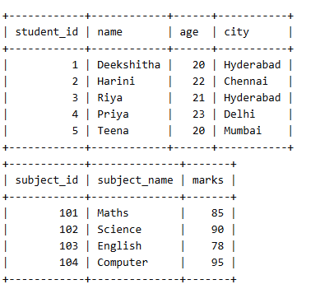
- WHERE with AND
SELECT * FROM students
WHERE city = 'Hyderabad' AND age > 20;
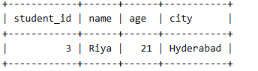
- WHERE with OR
SELECT * FROM students
WHERE city = 'Hyderabad' OR city = 'Delhi';
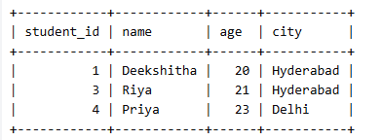
- WHERE with NOT
SELECT * FROM students
WHERE NOT city = 'Hyderabad';
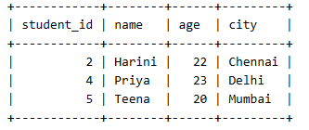
- ORDER BY
SELECT * FROM students
ORDER BY age ASC;
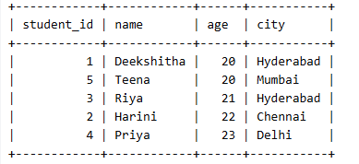
- LIKE
SELECT * FROM students
WHERE name LIKE 'D%';
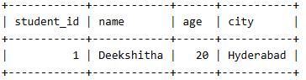
SELECT * FROM students
WHERE name LIKE '%i%';
