E-Commerce 100K - Python & Statistical Analysis
Exploratory analysis, hypothesis testing and customer segmentation performed in Python (pandas, scipy, matplotlib) on the cleaned dataset.

1. Descriptive Overview
Metric | Value
Total orders | 100,000
Total revenue | Rs. 1,512,741,925
Average order value | Rs. 15,127.42 (95% CI: Rs. 15,054 - Rs. 15,201)
Average unit price | Rs. 7,500.35
Average quantity per order | 3.00 units
Average rating (all orders) | 3.00 / 5

2. Revenue Trend
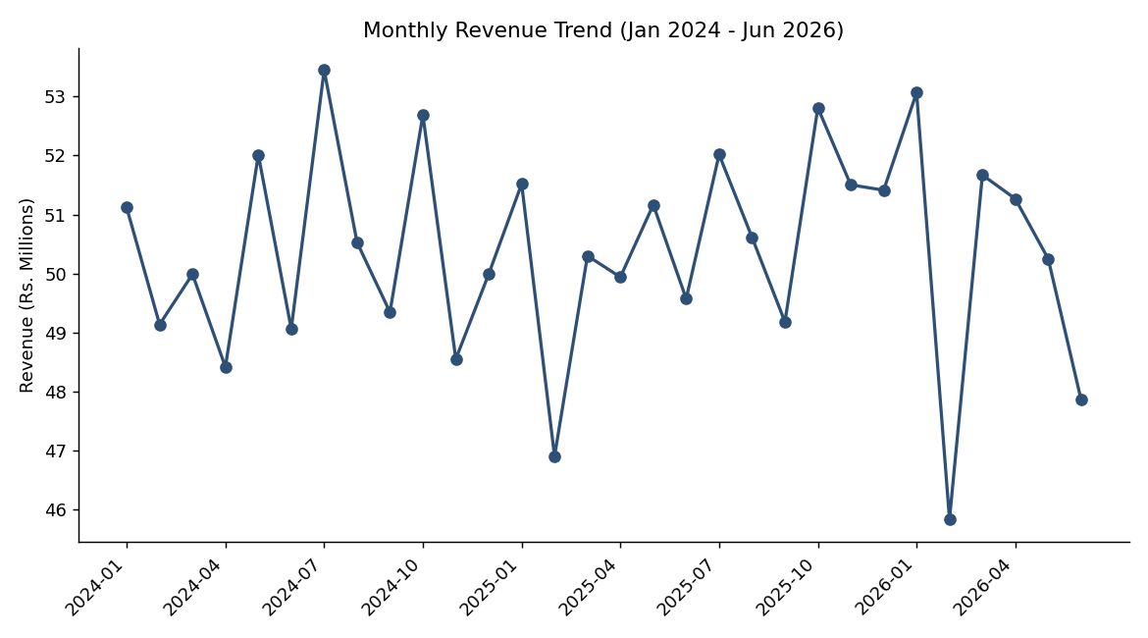
Fig 1. Monthly revenue, Jan 2024 - Jun 2026 (Jul 2026 excluded - partial month, only 1 day of data)
Revenue oscillates in a tight band of roughly Rs.46M-Rs.53M per month with no sustained upward or downward trend across the 30 full months in the dataset. There are a couple of low months (Feb 2025, Feb 2026) which is consistent with February simply having fewer days, and a few high months around mid-year and year-start peaks, but nothing that rises to a statistically distinguishable seasonal pattern given the swings are within the normal month-to-month noise range.

3. Revenue by Category
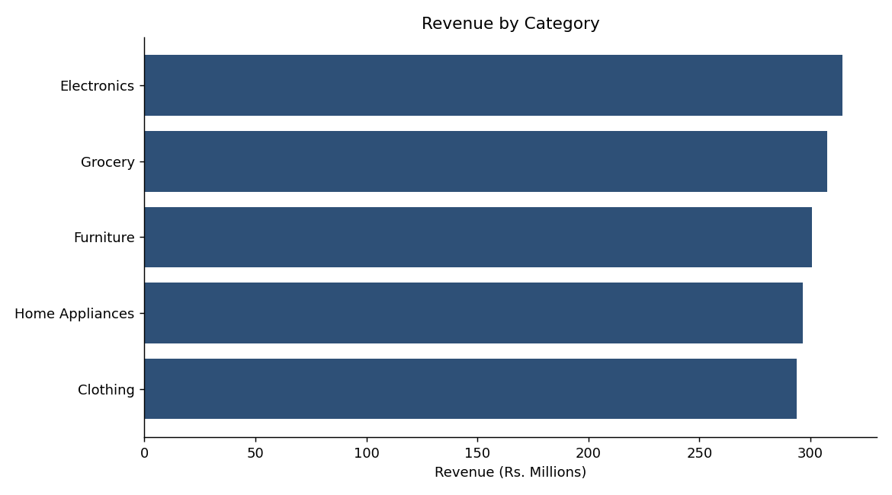
Fig 2. Total revenue by product category
Categories are within about 7% of each other (Rs.293.6M to Rs.314.3M) - Electronics leads narrowly, Clothing trails narrowly. Confirmed statistically in Section 6: this spread is not significant.

4. Order Status Distribution
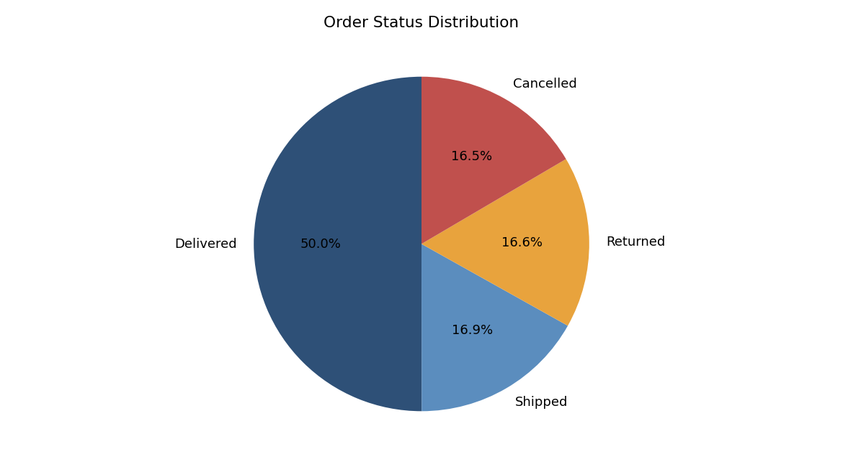
Fig 3. Share of orders by fulfilment outcome
Half of all orders (50.0%) reach Delivered status. The remaining half splits almost evenly across Shipped (16.9%), Returned (16.6%) and Cancelled (16.5%). A combined 33% return-or-cancel rate is high by typical e-commerce benchmarks (industry norms are often single digits to low teens) and is worth flagging to operations regardless of which category or payment method it comes from, since Section 6 shows it isn't concentrated in any one segment - it's a broad, systemic rate.

5. Customer Purchase Behavior
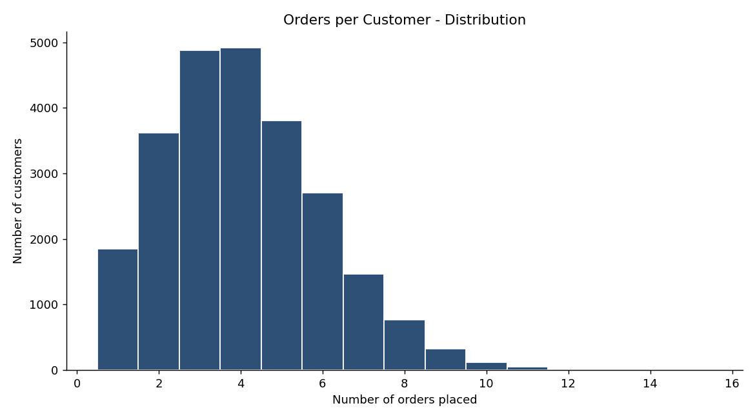
Fig 4. Distribution of number of orders placed per customer
Most customers who order at all place between 3 and 5 orders; very few are true one-time buyers (7.5%) and a small tail places up to 15 orders. This is a healthy repeat-purchase shape - see Section 7 for the RFM view of who these repeat customers are.

6. Hypothesis Tests
Each test below checks whether an apparent difference in the data is likely to be real or just random noise, using a 5% significance threshold (p < 0.05 = statistically significant).
Question | Test | Result | Conclusion
Does order value differ by customer segment (New/Returning/VIP)? | One-way ANOVA | F=0.89, p=0.41 | Not significant - segments spend the same on average
Does order value differ by product category? | One-way ANOVA | F=0.98, p=0.41 | Not significant - categories earn similar order values
Is fulfilment outcome linked to category? | Chi-square | chi2=14.15, p=0.29 | Independent - no category drives more returns/cancellations
Is fulfilment outcome linked to payment method? | Chi-square | chi2=4.24, p=0.98 | Independent - payment method doesn't predict returns/cancellations
Does price correlate with rating? | Pearson correlation | r=0.008, p=0.09 | No correlation - price does not drive satisfaction scores

Taken together, these tests say the differences visible in the bar charts (Section 3, Section 4) are within normal sampling variation, not real business effects. That is itself a useful, if less dramatic, finding - see Business Insights Report for what to do with it.

7. RFM Customer Segmentation
Every customer who has placed at least one order was scored on Recency (days since last order), Frequency (order count) and Monetary value (total spend), each split into quartiles, then combined into five segments.
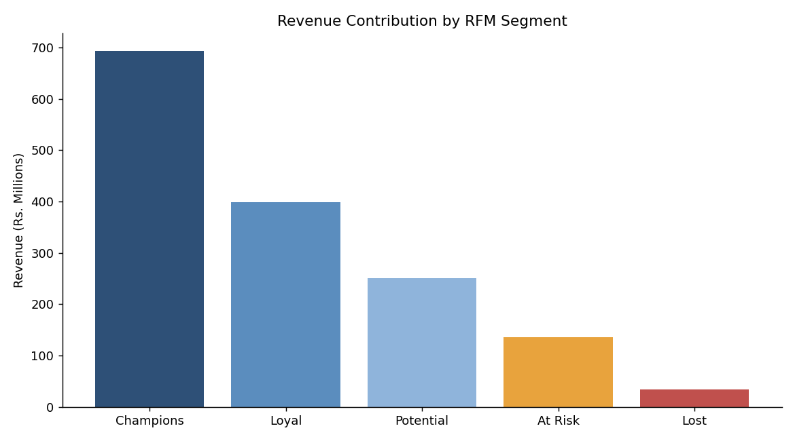
Fig 5. Total revenue contributed by each RFM segment
Segment | Customers | Revenue | % of Revenue
Champions | 6,726 | Rs. 693,932,892 | 45.9%
Loyal | 5,854 | Rs. 398,922,242 | 26.4%
Potential | 5,424 | Rs. 250,232,865 | 16.5%
At Risk | 4,338 | Rs. 135,454,417 | 9.0%
Lost | 2,192 | Rs. 34,199,509 | 2.3%

27.4% of active customers (Champions) generate 45.9% of all revenue - a real, meaningful concentration, unlike the flat segment/category splits in Section 6. This is the segmentation that should drive retention and marketing spend, not the CustomerSegment column (New/Returning/VIP) that ships with the raw data, since Section 6 shows that field has no measurable relationship with spend.

8. Return / Cancellation Pattern Check
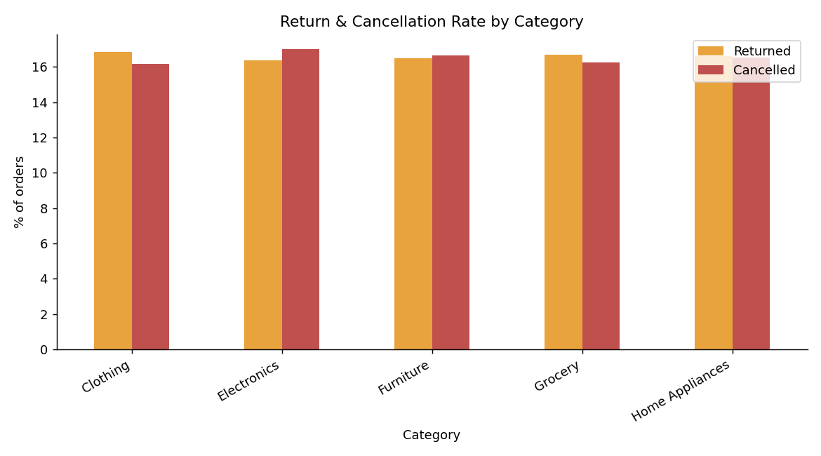
Fig 6. Return and cancellation rate by category
Consistent with the chi-square result in Section 6, return and cancellation rates hover in a narrow 16-17% band across every category. There is no single problem category to target - if returns/cancellations are to be reduced, the fix needs to be operational (packaging, delivery reliability, fraud/COD friction) rather than category-specific.

9. Methodology Notes
- All monetary figures use the cleaned Orders table (see Data Quality Report for handling of the OrderValue vs. computed-value discrepancy).
- Rating-based analysis, where relevant, is restricted to Delivered orders (IsDeliveredRating = 'Y') per the data-quality decision.
- The partial final month (Jul 2026) is excluded from all trend and growth calculations.
- Significance threshold used throughout: alpha = 0.05.
- Full code: python_analysis.py (pandas, scipy.stats, matplotlib).

