Assignment-07(Lab-7.5)
Course : AI Assisted Coding
Topic:- Error Debugging with AI: Systematic approaches to finding and fixing bugs
Student Details:
Name : Batti Chandan Singh
Hall Ticket No : 2303A51515
Batch : 22

Task-01
Final Optimal Prompt
Fix only the errors in the voting eligibility code and add validation for invalid or non-numeric age input without changing the main logic
Code Screenshot
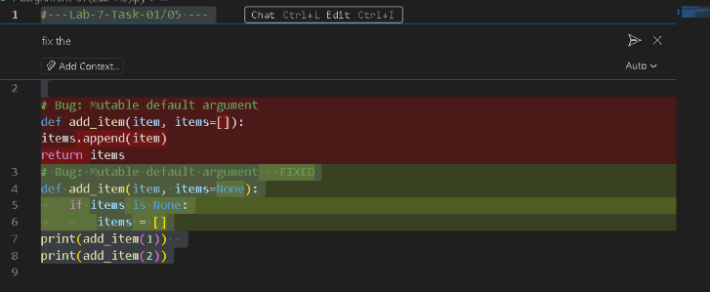
Output Screenshot
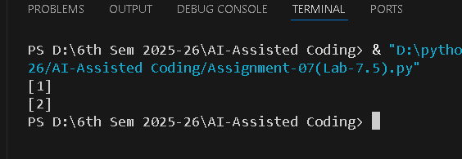
Explanation/Justification/Observation (100 words / 5 – 6 sentence)
The bug occurs because the default list is shared across all function calls. AI helps identify the issue and fixes it by replacing the mutable default with None. A new list is created on each call, preventing unexpected behaviour.

Task-02
Final Optimal Prompt
Correct the string vowel/consonant code and add error handling for numbers, symbols, or empty input while keeping the original structure.
Code Screenshot
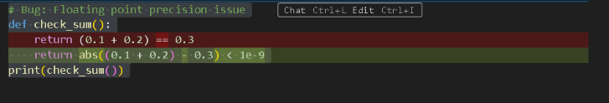
Output Screenshot
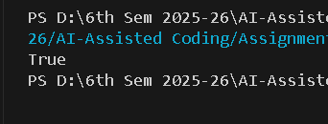
Explanation/Justification/Observation (100 words / 5 – 6 sentence)
Floating-point arithmetic cannot reliably compare decimal values directly. AI suggests using a tolerance check (abs(diff) < epsilon) to avoid precision errors. This ensures a correct and reliable comparison.

Task-03
Final Optimal Prompt
Fix errors in the class-based library program and add simple input validation without rewriting or optimizing the logic
Code Screenshot
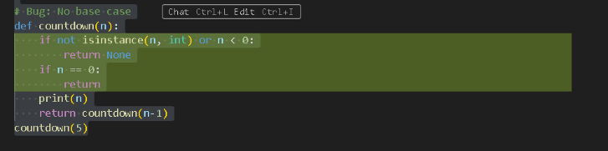
Output Screenshot
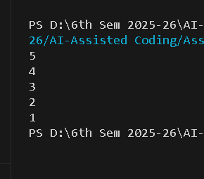
Explanation/Justification/Observation (100 words / 5 – 6 sentence)
The original function lacked a base case, causing infinite recursion. AI introduces a stopping condition (n <= 0), allowing the function to terminate safely.

Task-04

Final Optimal Prompt
Correct the attendance class code and add basic validation for wrong or empty inputs without altering the program design
Code Screenshot

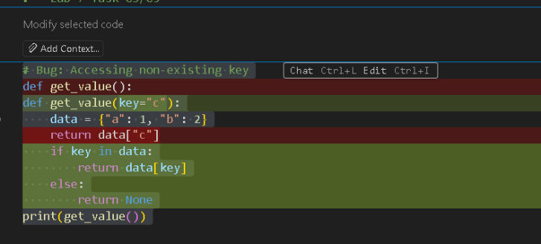Output Screenshot
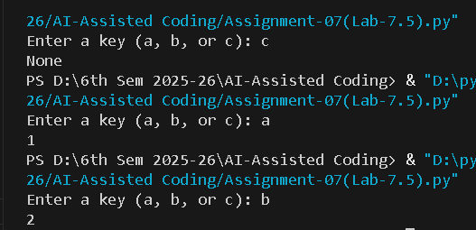
Explanation/Justification/Observation (100 words / 5 – 6 sentence)

Accessing a missing key raises a Key Error. AI fixes this using .get() with a default message, preventing crashes and improving program reliability.

Tack-05
Final Optimal Prompt
Fix the ATM menu errors and add checks for invalid menu choices or non-numeric inputs while keeping the same program flow
Code Screenshot
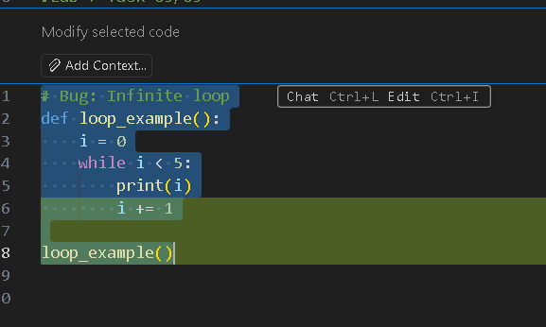
Output Screenshot
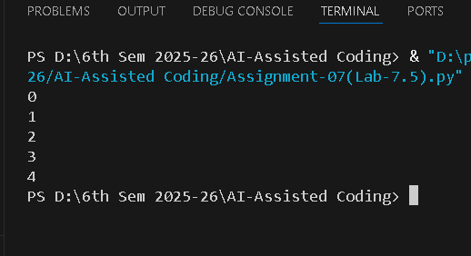
Explanation/Justification/Observation (100 words / 5 – 6 sentence)
The loop condition was correct, but the variable never changed, causing an infinite loop. AI fixes it by incrementing I inside the loop.
Tack-06
Final Optimal Prompt
Correct the tuple unpacking issue without altering the original values
Code Screenshot
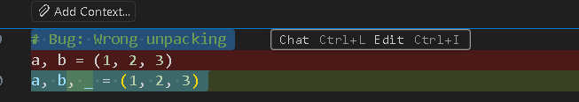
Output Screenshot
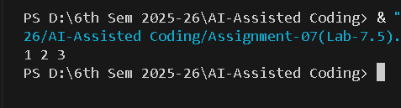
Explanation/Justification/Observation (100 words / 5 – 6 sentence)
The bug occurs because the tuple contains 3 values but only 2 variables. AI corrects the mismatch by adding another variable or using _ to ignore the extra value.

Tack-07
Final Optimal Prompt
Fix the mixed indentation so the code runs properly; do not change any logic
Code Screenshot

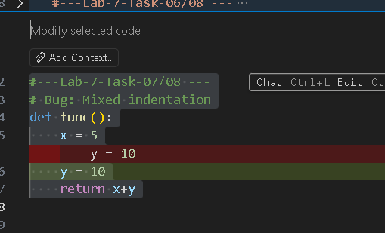Output Screenshot
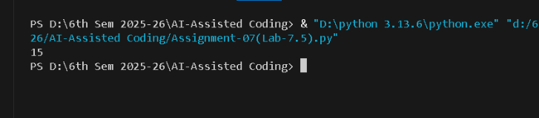
Explanation/Justification/Observation (100 words / 5 – 6 sentence)
Tabs and spaces were mixed, causing an indentation error. AI normalizes indentation using consistent spaces, ensuring the code runs correctly.

Tack-08
Final Optimal Prompt
Fix only the module import error so the sqrt function works correctly
Code Screenshot
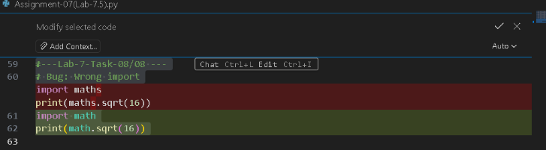
Output Screenshot
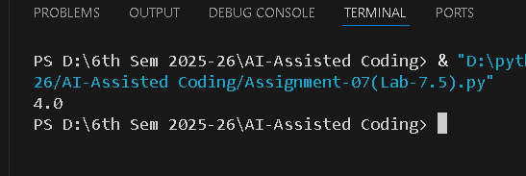
Explanation/Justification/Observation (100 words / 5 – 6 sentence)
The module name was incorrect (maths does not exist). AI corrects it to math, ensuring proper module import and execution.

