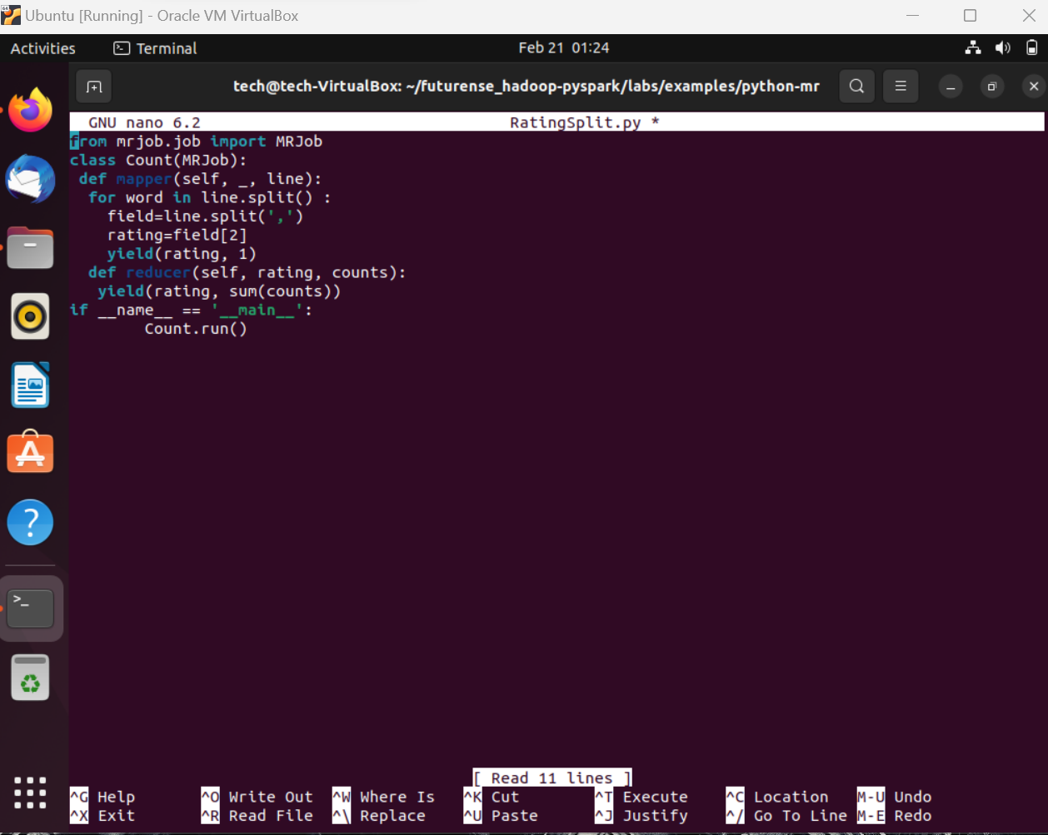

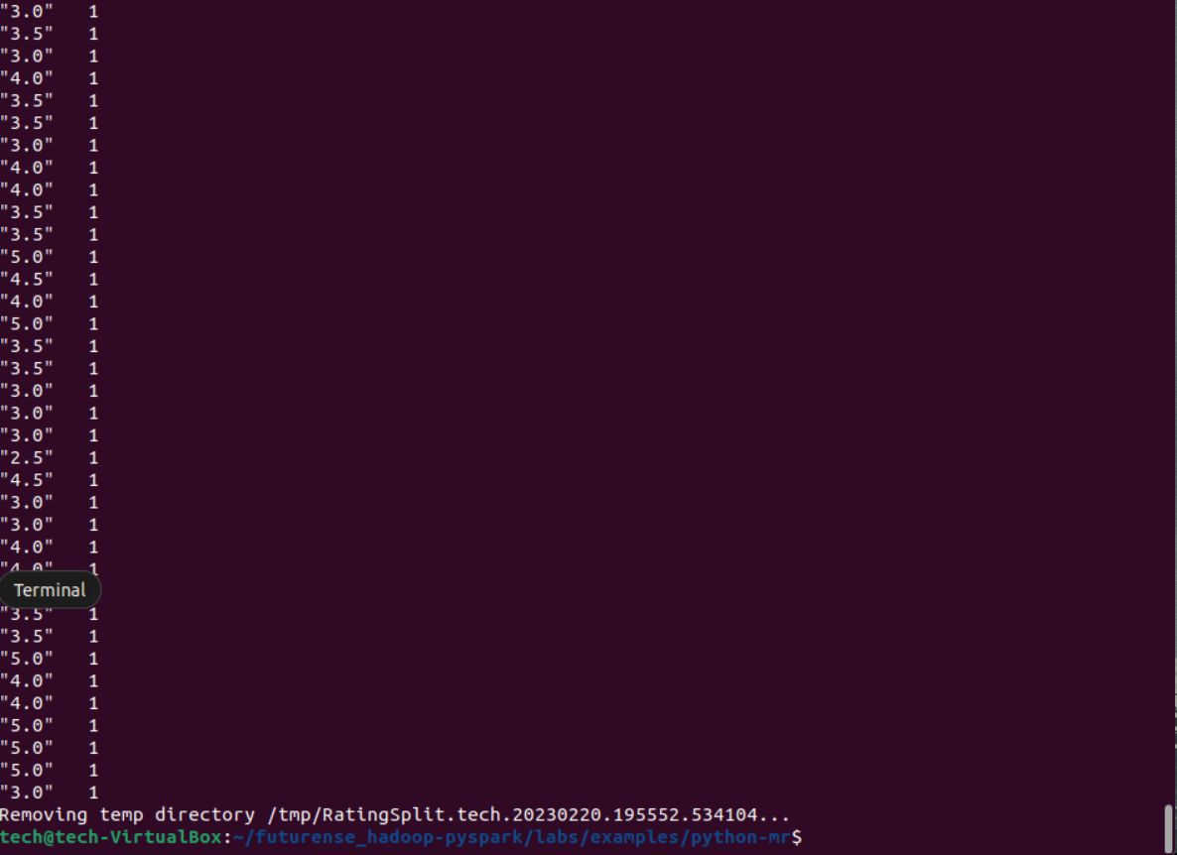

cp ratings.csv ~/ratings.csv

hadoop fs -put ratings.csv hdfs://localhost:9000/user/training

hadoop fs -ls hdfs://localhost:9000/user/training

cd futurense_hadoop-pyspark/labs/examples/python-mr/

ls -l

python3 RatingSplit.py -r hadoop hdfs://localhost:9000/user/training/ratings.csv