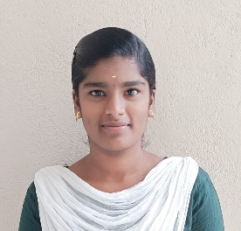

**BAVANI M**

**Mobile :9500788728**

# E-mail Id: [bavani87bavani28@gmail.com](mailto:bavani87bavani28@gmail.com)

# LinkedIn ID: https://www.linkedin.com/in/bavani-m-a23103249/

**GitHub :** https://github.com/BAVANI-M-123/Resume

**CAREER OBJECTIVE:**

To look forward for an opportunity to apply my knowledge with group of motivated individuals who wish to work towards the advancement of the company and its goals.

**EDUCATIONAL QUALIFICATION:**

|  |  |  |  |
| --- | --- | --- | --- |
| **Qualification** | **Institutions** | **Marks in CGPA/percentage** | **Year OF PASSING** |
| B. E. **ELECTRONICS AND COMMUNICATION ENGINEERING** | Karpagam Academy of Higher Education | 8.3  (up to 4 semester) | 2025  (pursuing) |
| HSC | Govt. Hr. Sec. School, Barur | 78.742 | 2021 |
| SSLC | Govt. Hr. Sec. School, Barur | 64 | 2019 |

**PROJECT DETAILS**

**TITLE**:

Density based traffic control system using Arduino

**DESCRIPTION:**

To regulate traffic flow based on vehicle density. By dynamically adjusting signal timings, it helps manage congestion and maintain a steady flow of vehicles.

## **INTERNSHIP**

* Undergone an internship in Python by Pantech e learning for 15 days.

**CERTIFICATION**

* Certified in Introduction to Python from Infosys
* Certified Excel Basics Data Analysis with Python from IBM
* Certified Introduction to C from Solo learn.

## **WORKSHOPS**

* Attended Advances in Optical Communication organized conducted by IIT Madras

**AREA OF INTEREST**

* VLSI design
* Embedded system
* Web development
* Data Analyst

## **TECHNICAL SKILLS**

* C
* Python (pursuing)
* SQL(Basic)
* Computer Components: MS Word, PowerPoint

# STRENGTH:

* Extrovert
* Adaptable
* Punctual
* Team work

# LANGUAGES KNOWN:

* English
* Tamil

# Declaration :

I Bavani M hereby declare that the information started above is true to the best of my knowledge.

Place: coimbatore

Date: 15.03.2024 [Bavani M]