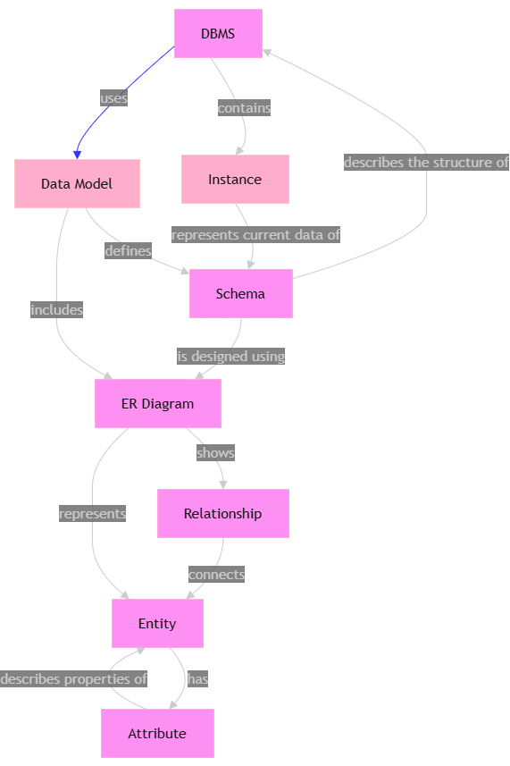
- Construct a concept map linking the following terms: DBMS,Schema, Instance, Data Model, ER Diagram, Entity, Attribute,Relationship.

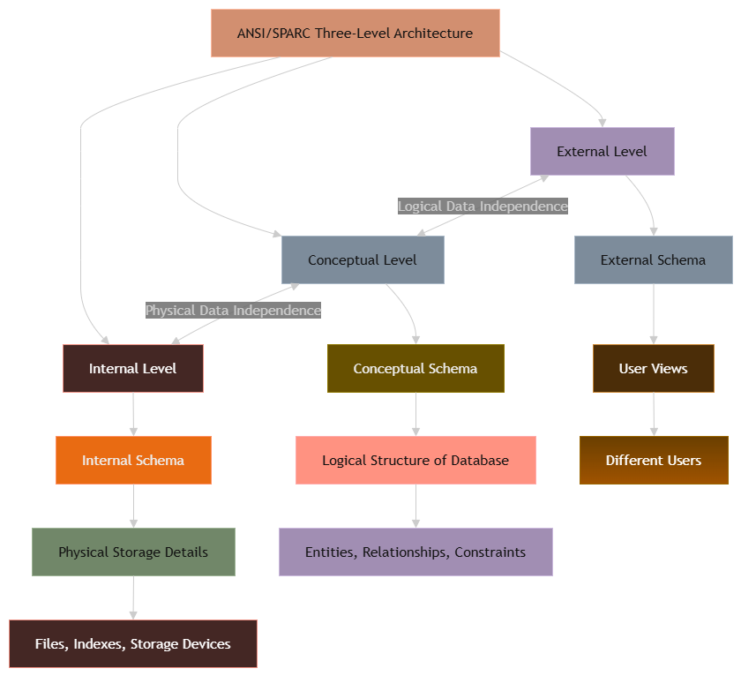
2)Create a concept map for the three-level ANSI/SPARC architecture
showing data independence at each level.

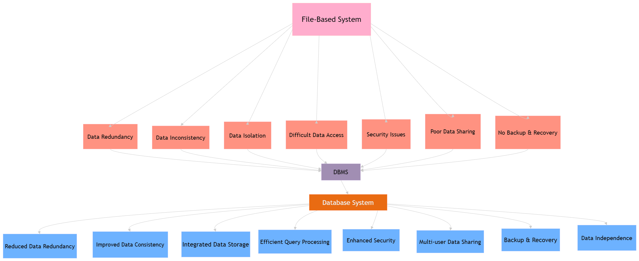
3) Map the relationship between file-based systems and databasesystems, highlighting the problems solved by DBMS.

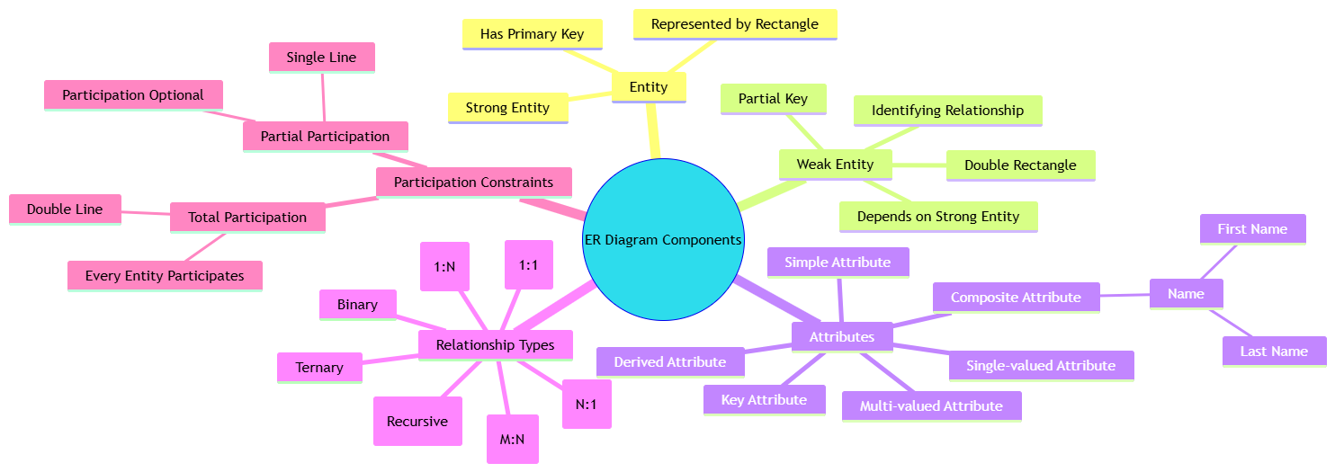
4) Design a concept map for ER diagram components: entity, weakentity, attribute types, relationship types, and participationconstraints.
5) Construct a concept map comparing Hierarchical, Network, andRelational data models with their key properties.

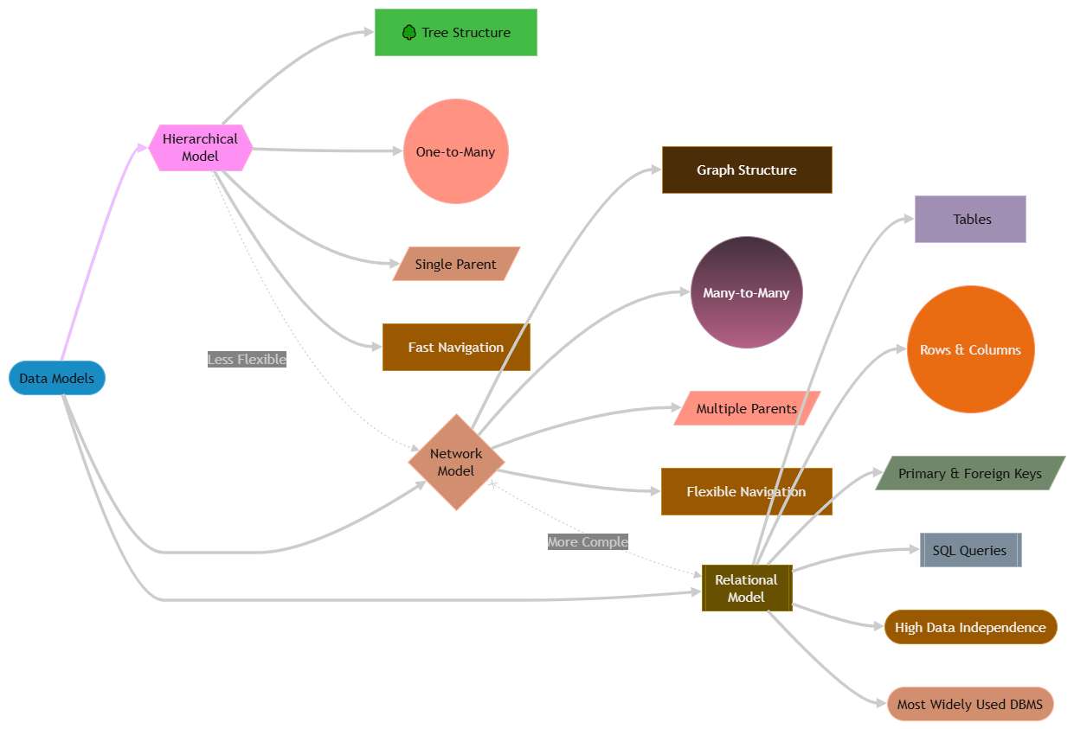

6) Develop a concept map for the EER model showing how it extends the basic ER model with generalization, specialization, and aggregation.
aggregation.

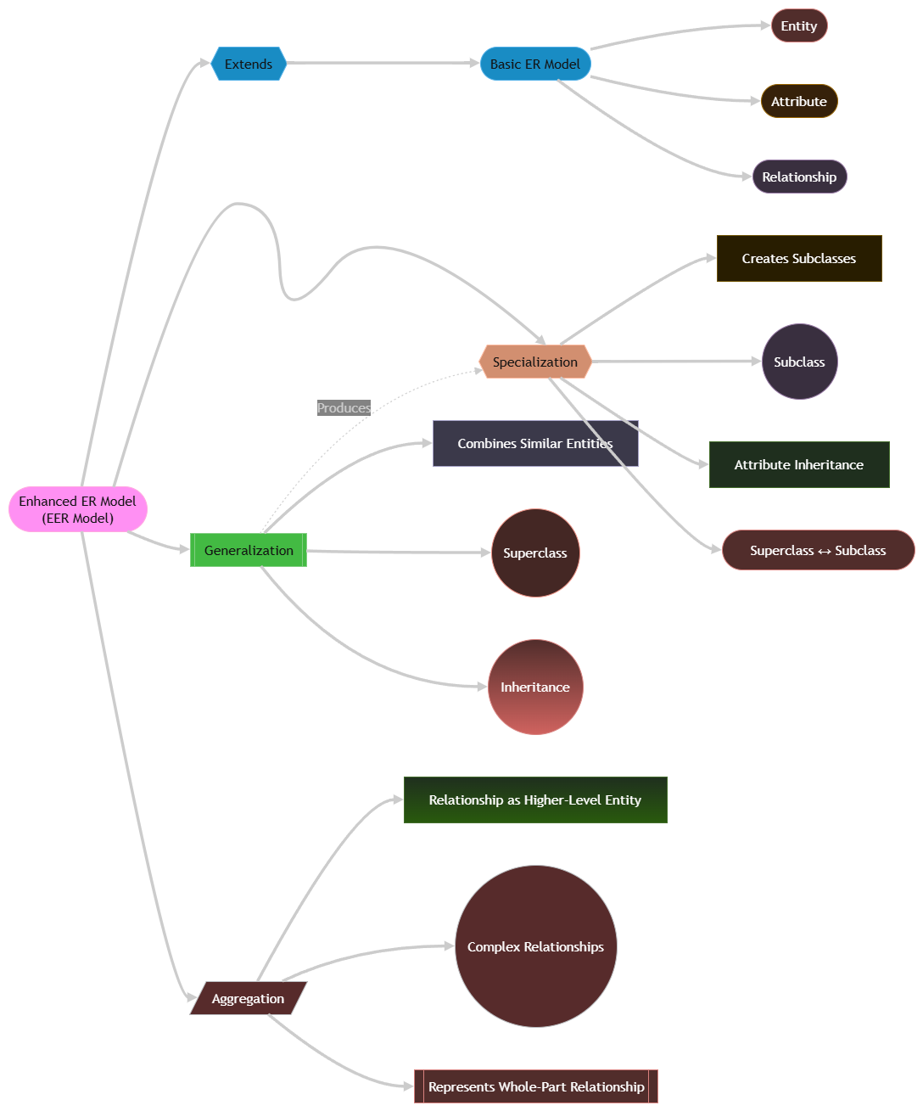

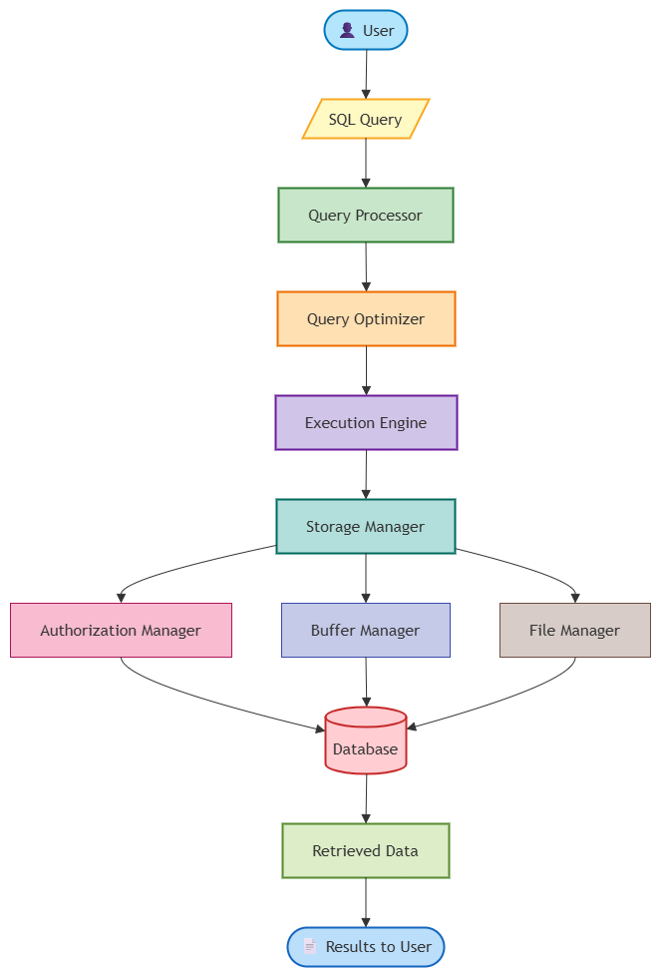
7) Create a visual concept map for the DBMS software architecture, illustrating the flow from user request to data retrieval.
illustrating the flow from user request to data retrieval.

8)Map the data models discussed in CO1 to real-world applicationsand explain the suitability of each model.

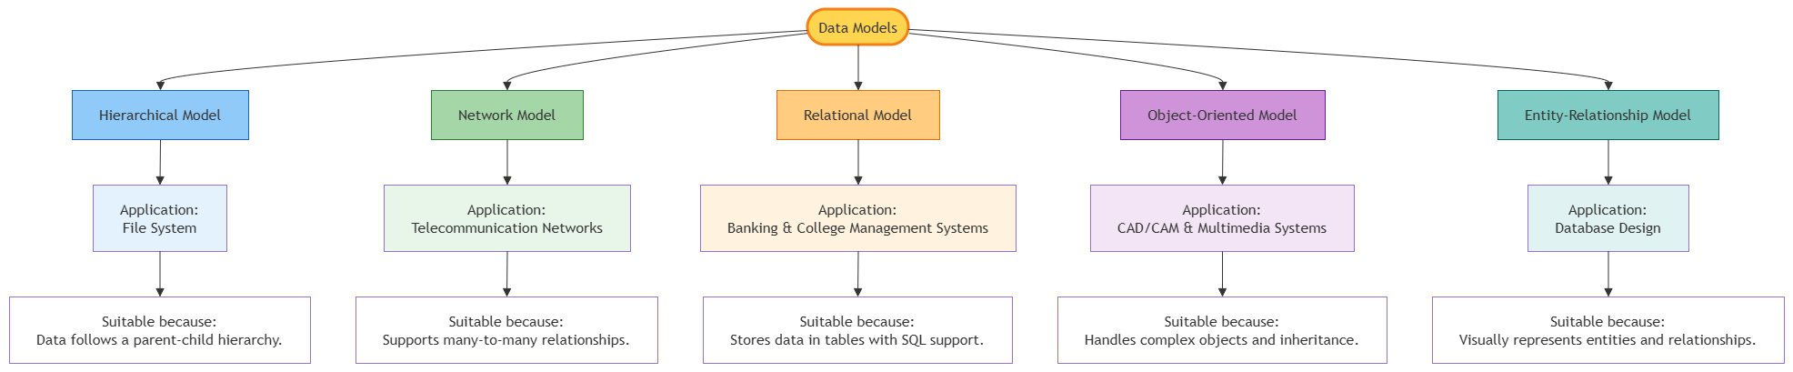

9) Construct a concept map for schemas and instances, showing how they relate to physical and logical data independence.
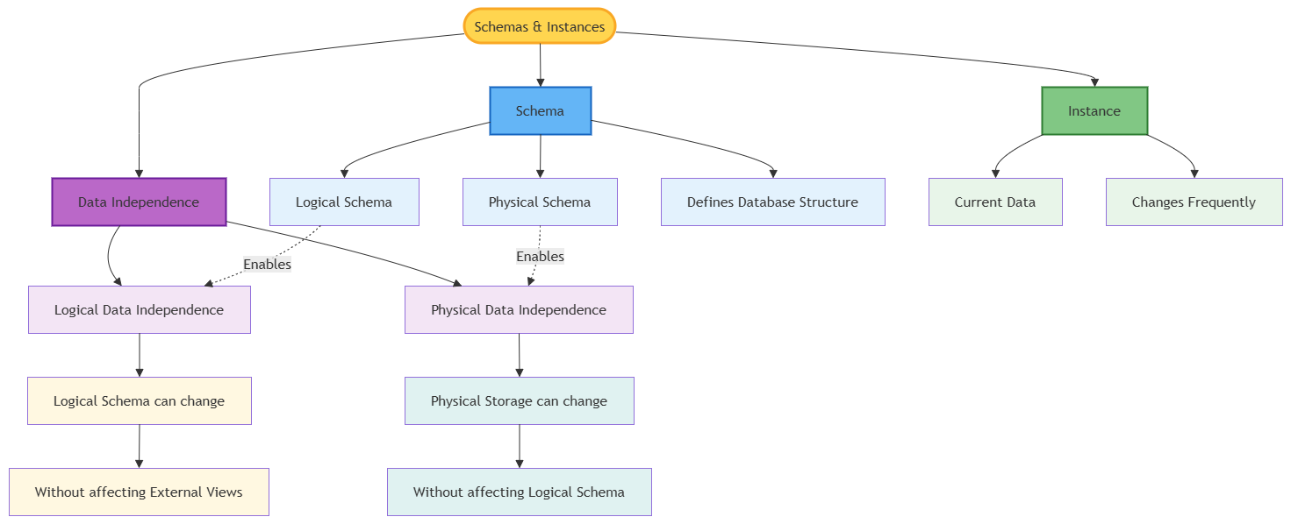

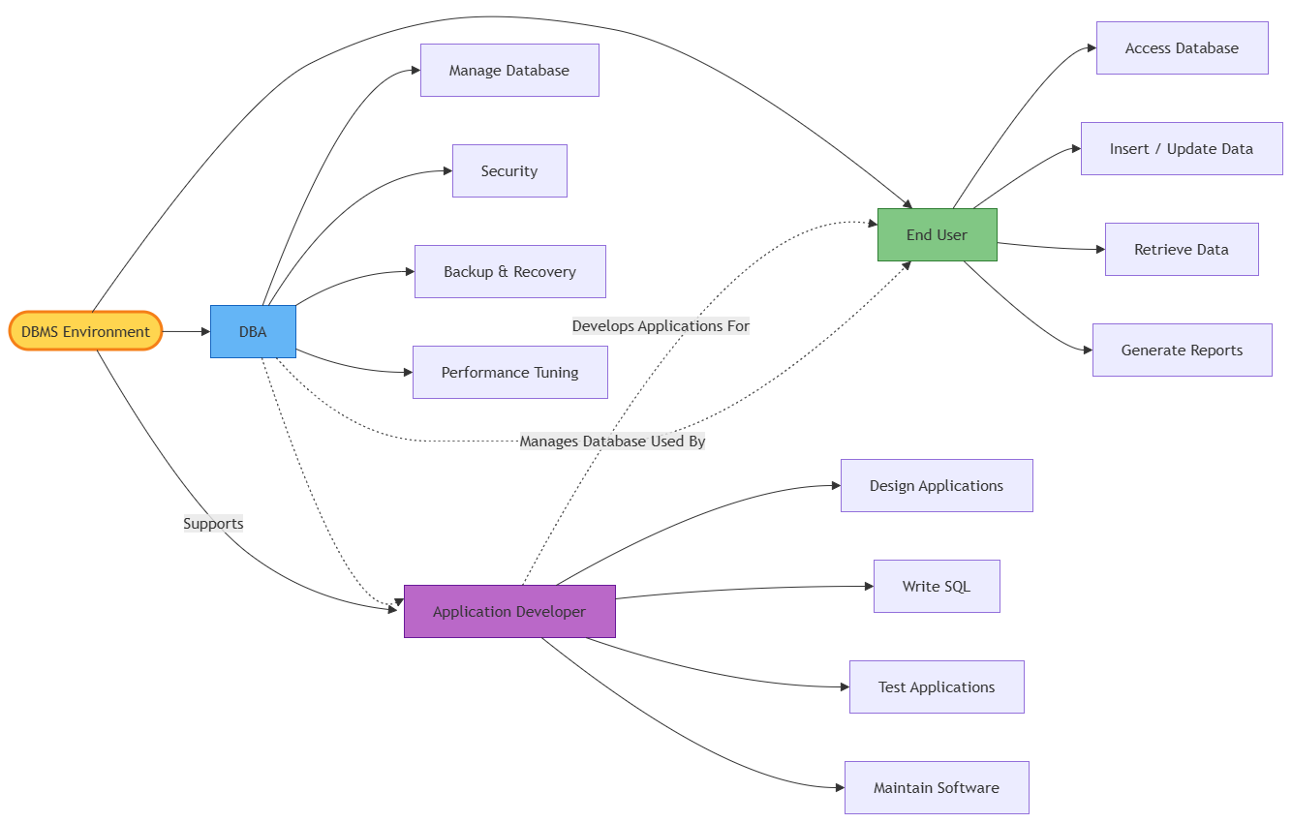
10)Design a concept map for the roles and responsibilities in a DBMS : DBA, End User, Application Developer.
environment: DBA, End User, Application Developer.

