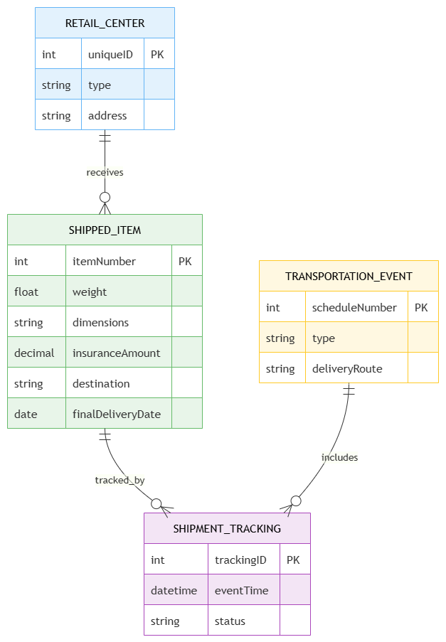
- UPS product tracking system
2) Course Management System
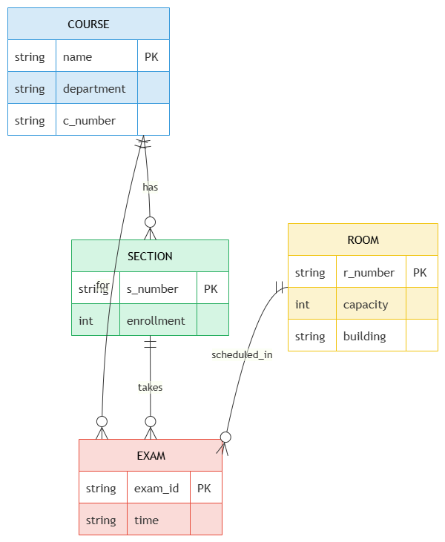

3) University Regiser’s Office Management System
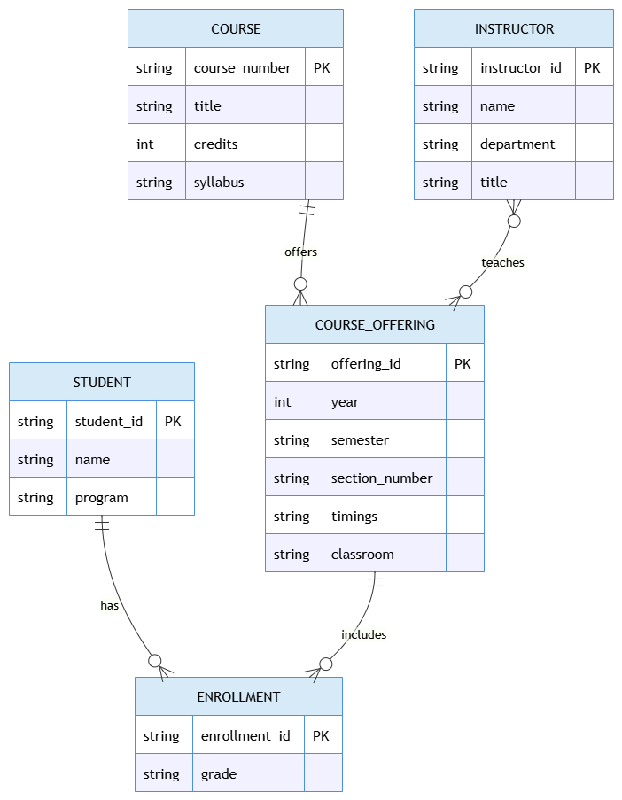
4) Hospital Management System
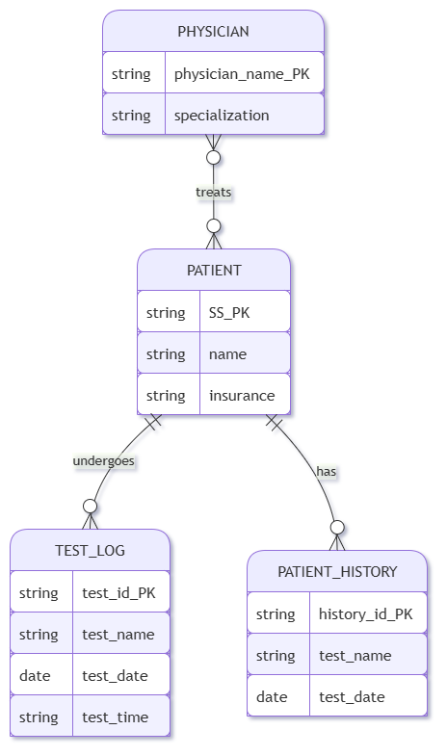

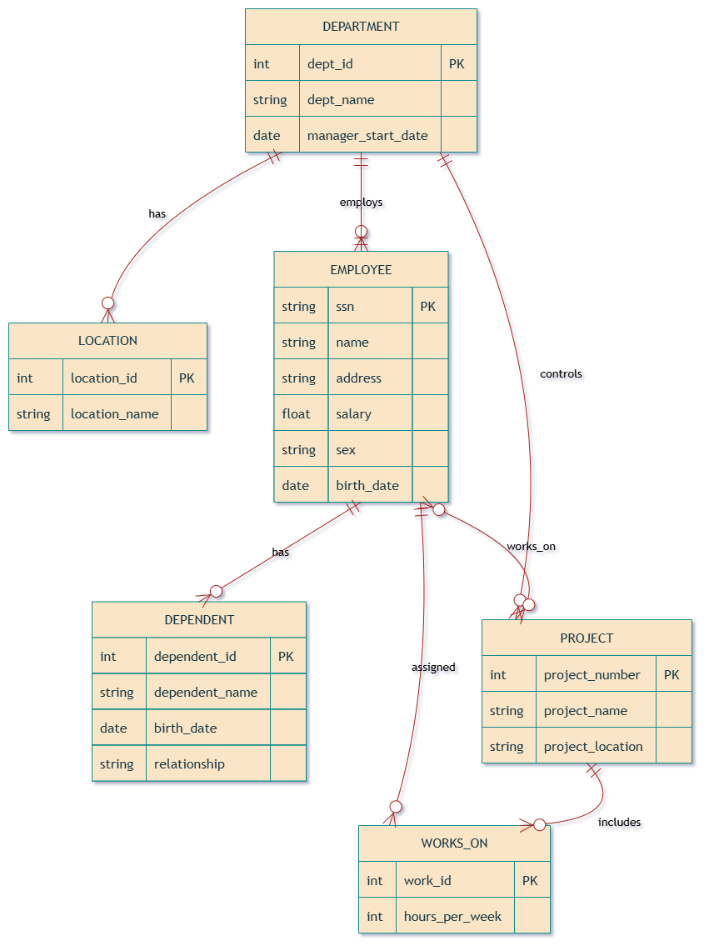
5) Company Project Management System

6) Explain schema and instance with examples. Distinguish between logical schema, physical schema, and view schema.

1. Schema
A schema is the overall design or structure of a database. It defines tables, attributes, data types, and relationships.

Example of Schema
STUDENT(StudentID, Name, Department)
COURSE(CourseID, Title, Credits)
This structure remains relatively stable.

2. Instance
An instance is the actual data stored in the database at a particular moment.
Student id | Name | Department
101 | Bavani | cse
102 | hema | Bio
If a new student is added, the instance changes, but the schema remains the same.
Schema vs Instance
Schema | Instance
Database blueprint | Current data
Changes rarely | Changes frequently
Defined by DBA | Updated by the user
Eg: Table structure | Example: rows in the table

Difference between Logical, Physical, and View Schema

Feature | Logical Schema | Physical Schema | View Schema
Describes | Database structure | Storage implementation | User's view
Focus | Tables and relationships | Files, indexes, and blocks | Visible data
Level | Conceptual | Internal | External
Changes | Occasionally | May change for optimization | Depends on user needs
Eg | STUDENT table definition | B+ tree index on StudentID | Faculty view of students

7) Identify the entities, attributes, and relationships for aBank Management System and construct its ERdiagram.
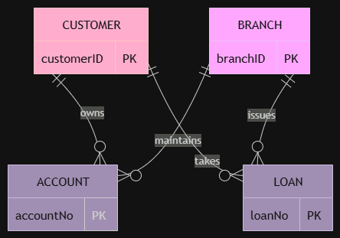

8) Explain the Extended ER (EER) model. Describe theconcepts of generalization, specialization, and aggregation.
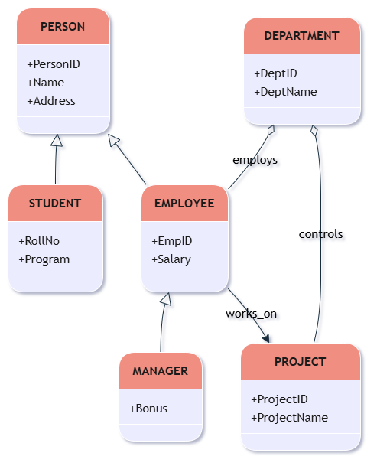

9) Design an EER diagram for a Hospital Management System incorporating inheritance and weak entities.

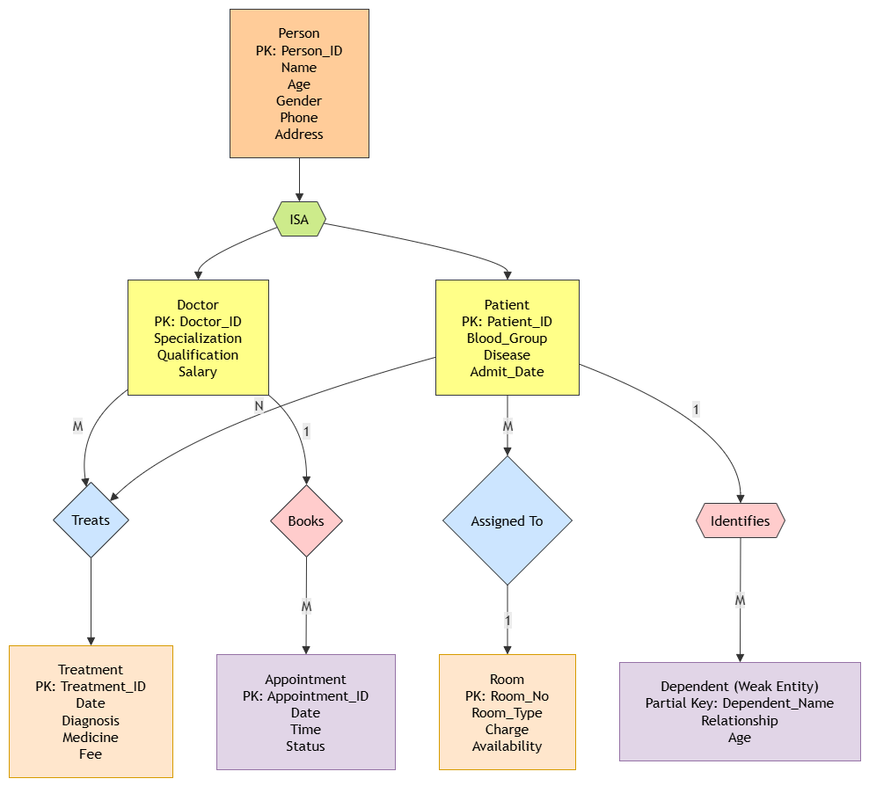

10) Explain the role of a DBA (Database Administrator) and the responsibilities associated with the position.
