| **NAME:** | BAVATHARANI S |
| --- | --- |
| **ROLL NUMBER:** | 7376221EC125 |
| **SEAT NUMBER:** | 143 |
| **PROJECT ID:** | 25 |
| **PROBLEM STATEMENT:** | GRIEVANCE PORTAL |

1. **INTRODUCTION:**

This Grievance Portal is specifically designed for faculty members of their respective colleges, utilizing the LAMP stack (Linux, Apache, MySQL, PHP). This platform allows faculty to confidentially submit their issues and concerns, with the option to remain anonymous or include their identity. The portal aims to report the issue that the faculties are facing in the college premises.It has different subcategories for example: mess, transport, timings and so on. With a user-friendly interface and secure backend, the portal supports effective communication and fosters a positive working environment within the college.

**PURPOSE:**

The main purpose of this project is to create a dedicated portal for faculty members of a college to easily and securely submit their grievances. By providing a platform where issues can be reported anonymously or personally, the portal ensures that faculty concerns are addressed promptly and effectively, fostering a better working environment and improving communication within the college. Using the LAMP stack (Linux, Apache, MySQL, PHP), the portal offers a user-friendly and reliable solution for managing and resolving faculty grievances.

* 1. **REQUIREMENTS:**

1) Linux OS

2) Apache HTTP Server

3) MySQL Database Server

4) PHP,HTML,CSS, Javascript(Visual Studio Code/Sublime Code Editor)

interpreter in the Linux OS System

**1.3 SCOPE OF THE PROJECT:**

* The scope of this project includes developing a secure and user-friendly portal specifically for faculty members to submit their grievances within their respective colleges.
* The user is supported with both anonymous and personal submissions, ensuring confidentiality and privacy.
* It will streamline the grievance submission and management process, enabling efficient resolution of issues.
* If the reported issue is being reported again by another user that the grievance portal will not accept it and if the issue that is faculty reported goes beyond the rules that the portal will not accept it.
* The project will utilize the LAMP stack (Linux, Apache, MySQL, PHP) for robust backend support and easy maintenance. The scope also covers the deployment, testing, and training of users to ensure effective utilization of the portal, ultimately aiming to improve faculty satisfaction and enhance communication within the institution.

**1.4 SYSTEM OVERVIEW:**

**Users:**

1. **Faculty:**

Faculty members have to login the page using their bit-sathy email address to submit their grievances, which are categorized into personal and public issues. Personal grievances pertain to individual concerns, while public grievances affect multiple faculty members or the entire faculty community. Users can post their issues, select the grievance type, and submit it online. The portal allows faculty to track the status of their grievances and receive updates on the progress and resolution. Administrators have access to a dashboard where they can review, categorize, and assign grievances to relevant departments for resolution. Faculty members are notified of any updates and can provide feedback once their issues are resolved. This streamlined process ensures that all grievances are addressed promptly and effectively.

**2.** **Admin:**

Administrators have access to a dashboard where they can review, categorize, and assign grievances to relevant departments for resolution. In this dashboard,the admin can view the issue that faculty has reported.If the issue is valid it will be consulted with respective coordinates for example:if the issue is regarding mess then the issue will be discussed with the manager and the solution will be provided accordingly.After the discussion with the respective head the admin will reply to the concerned faculty and the feedback will be received by them.

**1.2 PROJECT FLOW:**

* Faculty members log in to the portal using their email ID and password.
* If the login details are correct, they are granted access to the portal. If incorrect, an error message "Invalid username or password" is displayed.
* After logging in, faculty members are taken to their dashboard where they can submit grievances.
* Faculty members can choose to submit a personal grievance (related to individual issues) or a public grievance (affecting multiple faculty members or the entire community).
* They can post an issue and submit it through the portal.
* Administrators review all submitted grievances.
* They categorize grievances as personal or public and assign them to the appropriate departments for resolution.
* Faculty members can track the status of their submitted grievances through their dashboard.
* They receive updates on the progress and resolution of their issues.
* Faculty members are notified of any updates or changes in the status of their grievances
* Once a grievance is resolved, faculty members can provide feedback on the resolution process.

**3.1 WORKING MECHANISM:**

The Grievance Portal for faculty members operates using the LAMP stack, which includes Linux as the operating system, Apache as the web server, MySQL as the database, and PHP as the server-side scripting language. The front-end interface is built with HTML and CSS, providing a user-friendly experience for faculty members to log in, submit grievances, and track their status. On the back-end, PHP handles form submissions, interacts with the MySQL database to authenticate users, store and retrieve grievance details, and manage administrative functions. Apache serves as the web server, processing requests and delivering content to users. This combination of technologies ensures a robust, efficient, and secure platform for managing grievances.

HTML AND CSS Create a login page where faculty members enter their email ID and password.PHP Handle the form submission and check credentials against the MySQL database. MYSQL Store user credentials and authenticate users.If credentials are correct, users are redirected to their dashboard; otherwise, an error message is shown.

On the dashboard, faculty members can submit grievances categorized as personal or public. PHP processes, inserting the grievance details into the MySQL database. Administrators, upon logging in, access their dashboard where they can review all submitted grievances. They categorize and assign grievances to the appropriate departments for resolution. The system allows faculty to track the status of their grievances through their dashboard, with PHP fetching and displaying the current status from the MySQL database.

Notifications about updates or changes in grievance status are sent via PHP scripts, ensuring faculty members are kept informed. Once a grievance is resolved, faculty members can provide feedback , which is also processed and stored in the database using PHP. Apache serves all the web pages and processes user requests, ensuring the system runs smoothly and efficiently. This integrated approach ensures a seamless experience for both faculty members and administrators in managing and resolving grievances.

**1.2** **WORKFLOW CHART:**

**User Interface:**

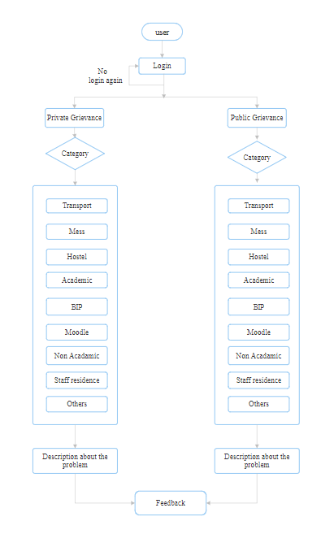

**Admin’s Interface:**

