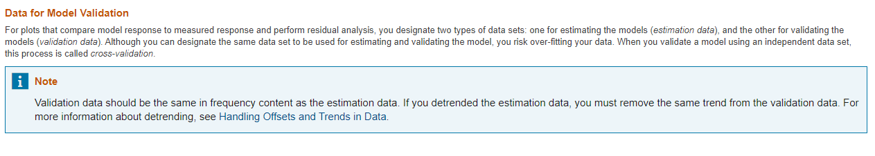

<https://www.mathworks.com/help/ident/data-preparation.html>

<https://www.mathworks.com/help/ident/ug/ways-to-prepare-data-for-system-identification.html>

<https://www.mathworks.com/help/ident/ug/handling-offsets-and-trends-in-data.html>