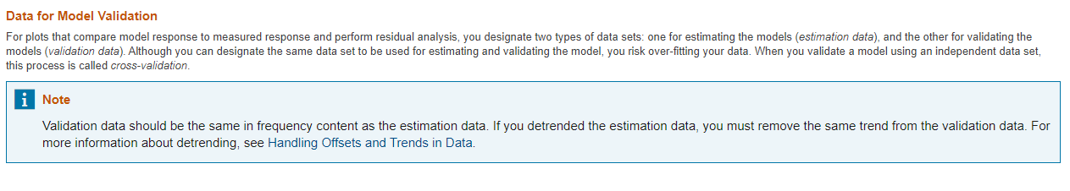

<https://www.mathworks.com/help/ident/data-preparation.html>

<https://www.mathworks.com/help/ident/ug/ways-to-prepare-data-for-system-identification.html>

<https://www.mathworks.com/help/ident/ug/handling-offsets-and-trends-in-data.html>

Merge experimental data or merge models after estimation

<https://www.mathworks.com/help/ident/examples/dealing-with-multi-experiment-data-and-merging-models.html>