| Metric | Value |
| --- | --- |
| Cronbach's Alpha | 0.7048706 |
| Number of Observations | 0.7048706 |

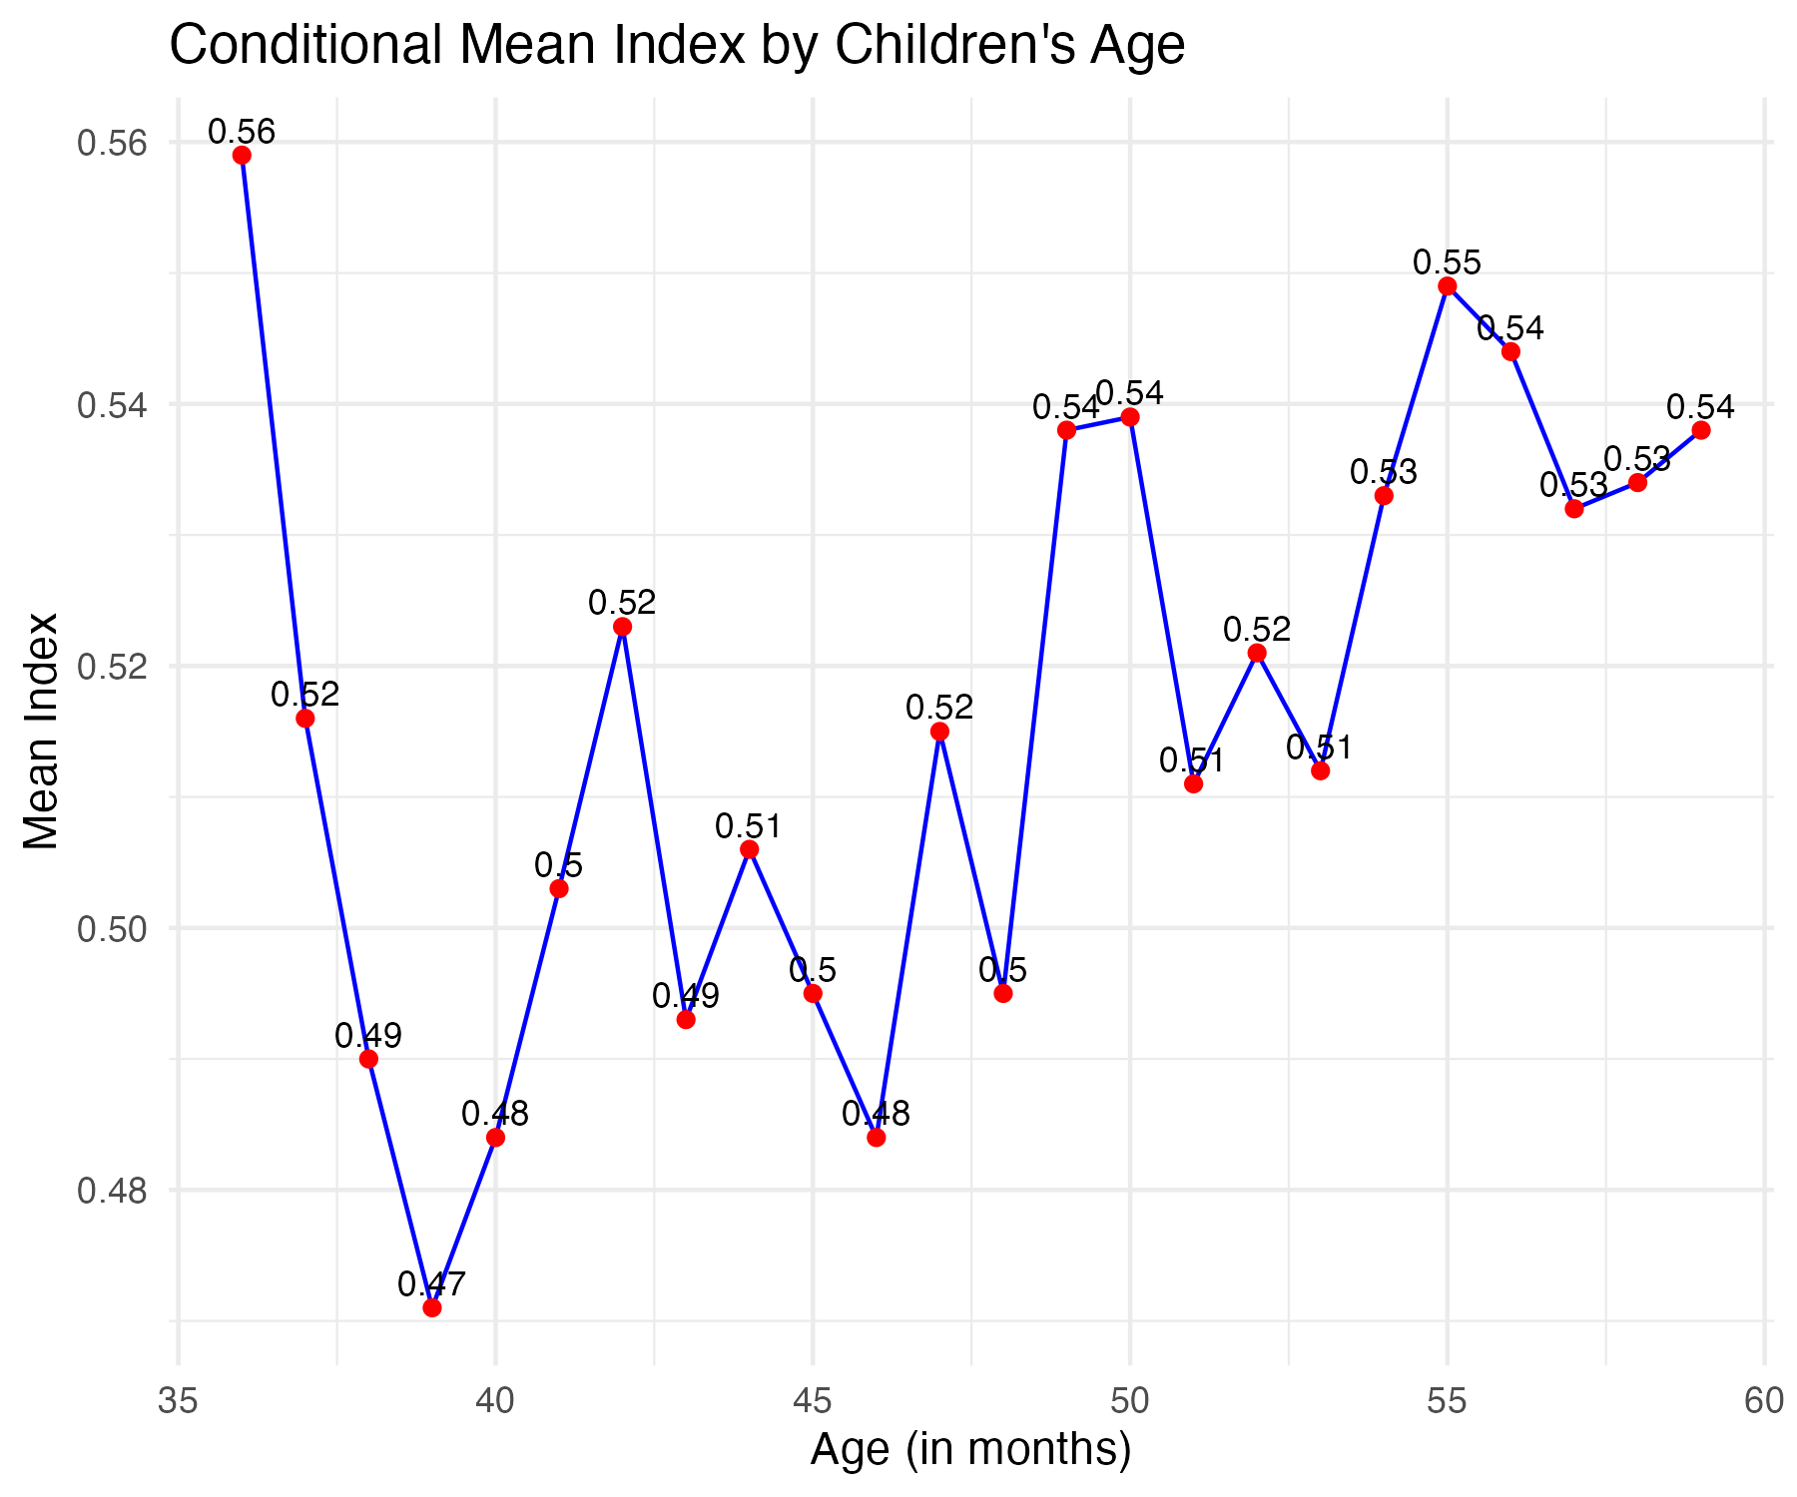

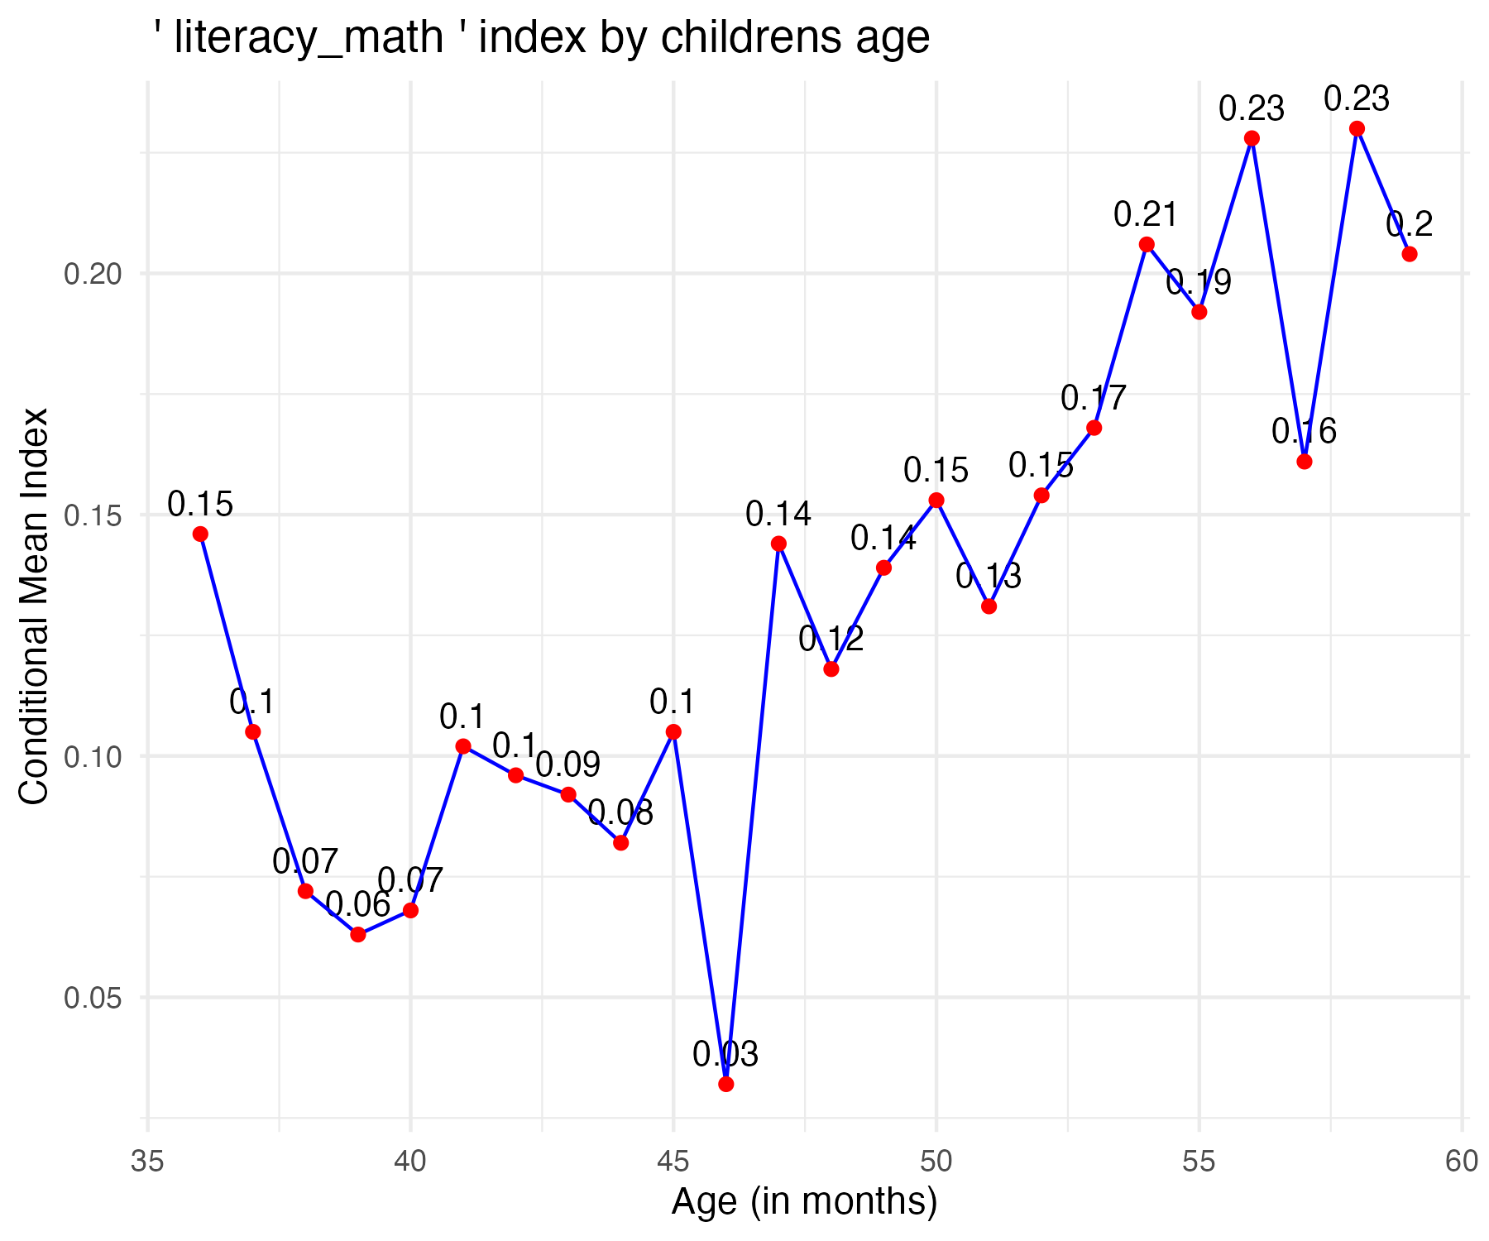

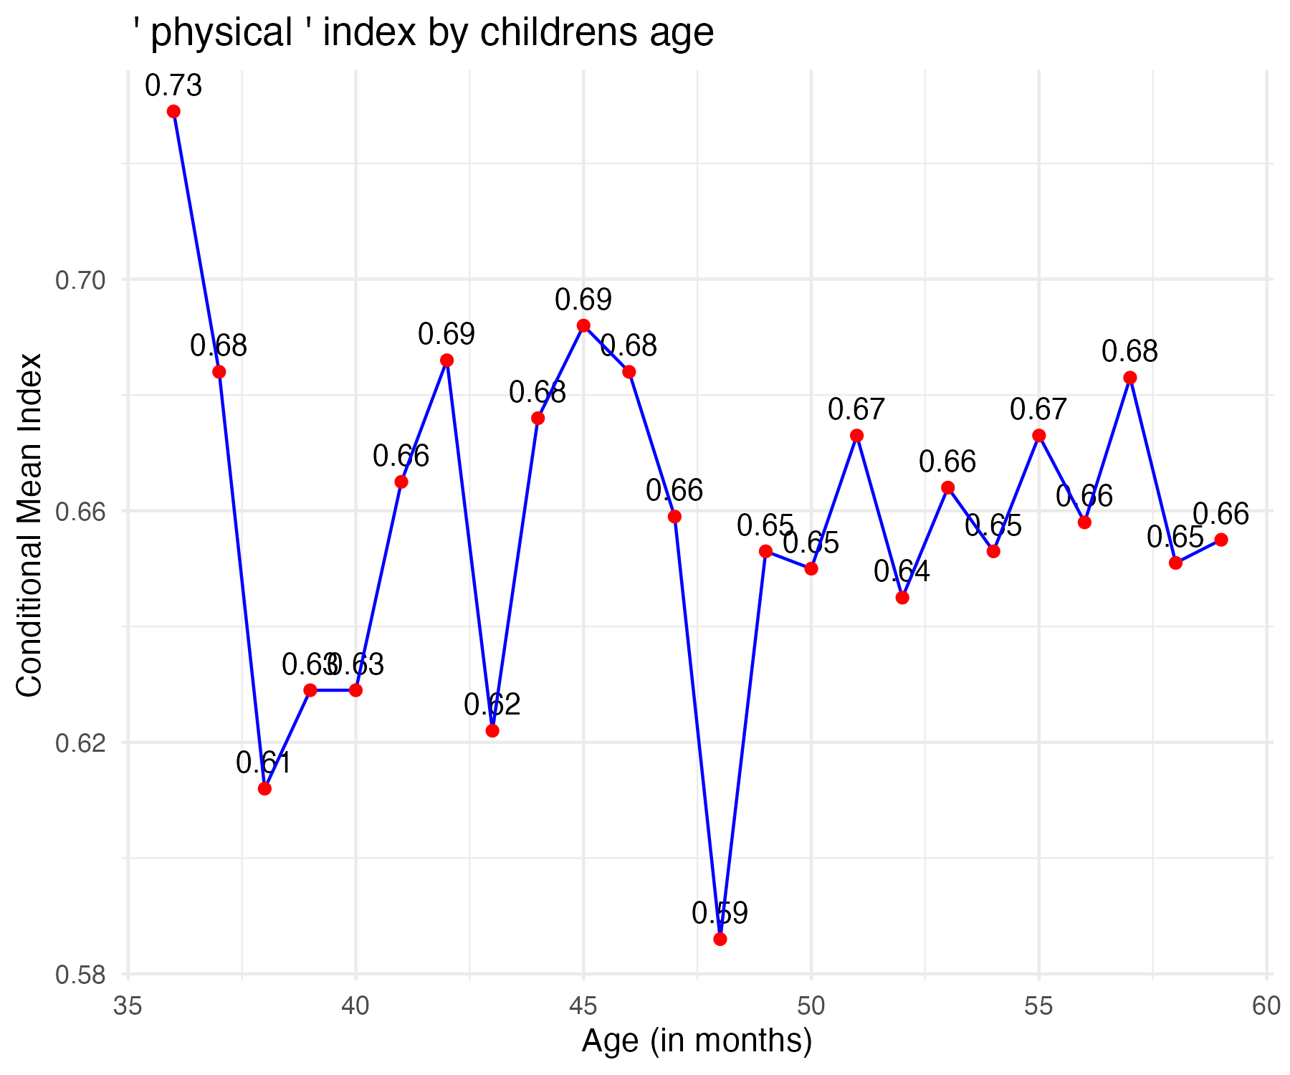

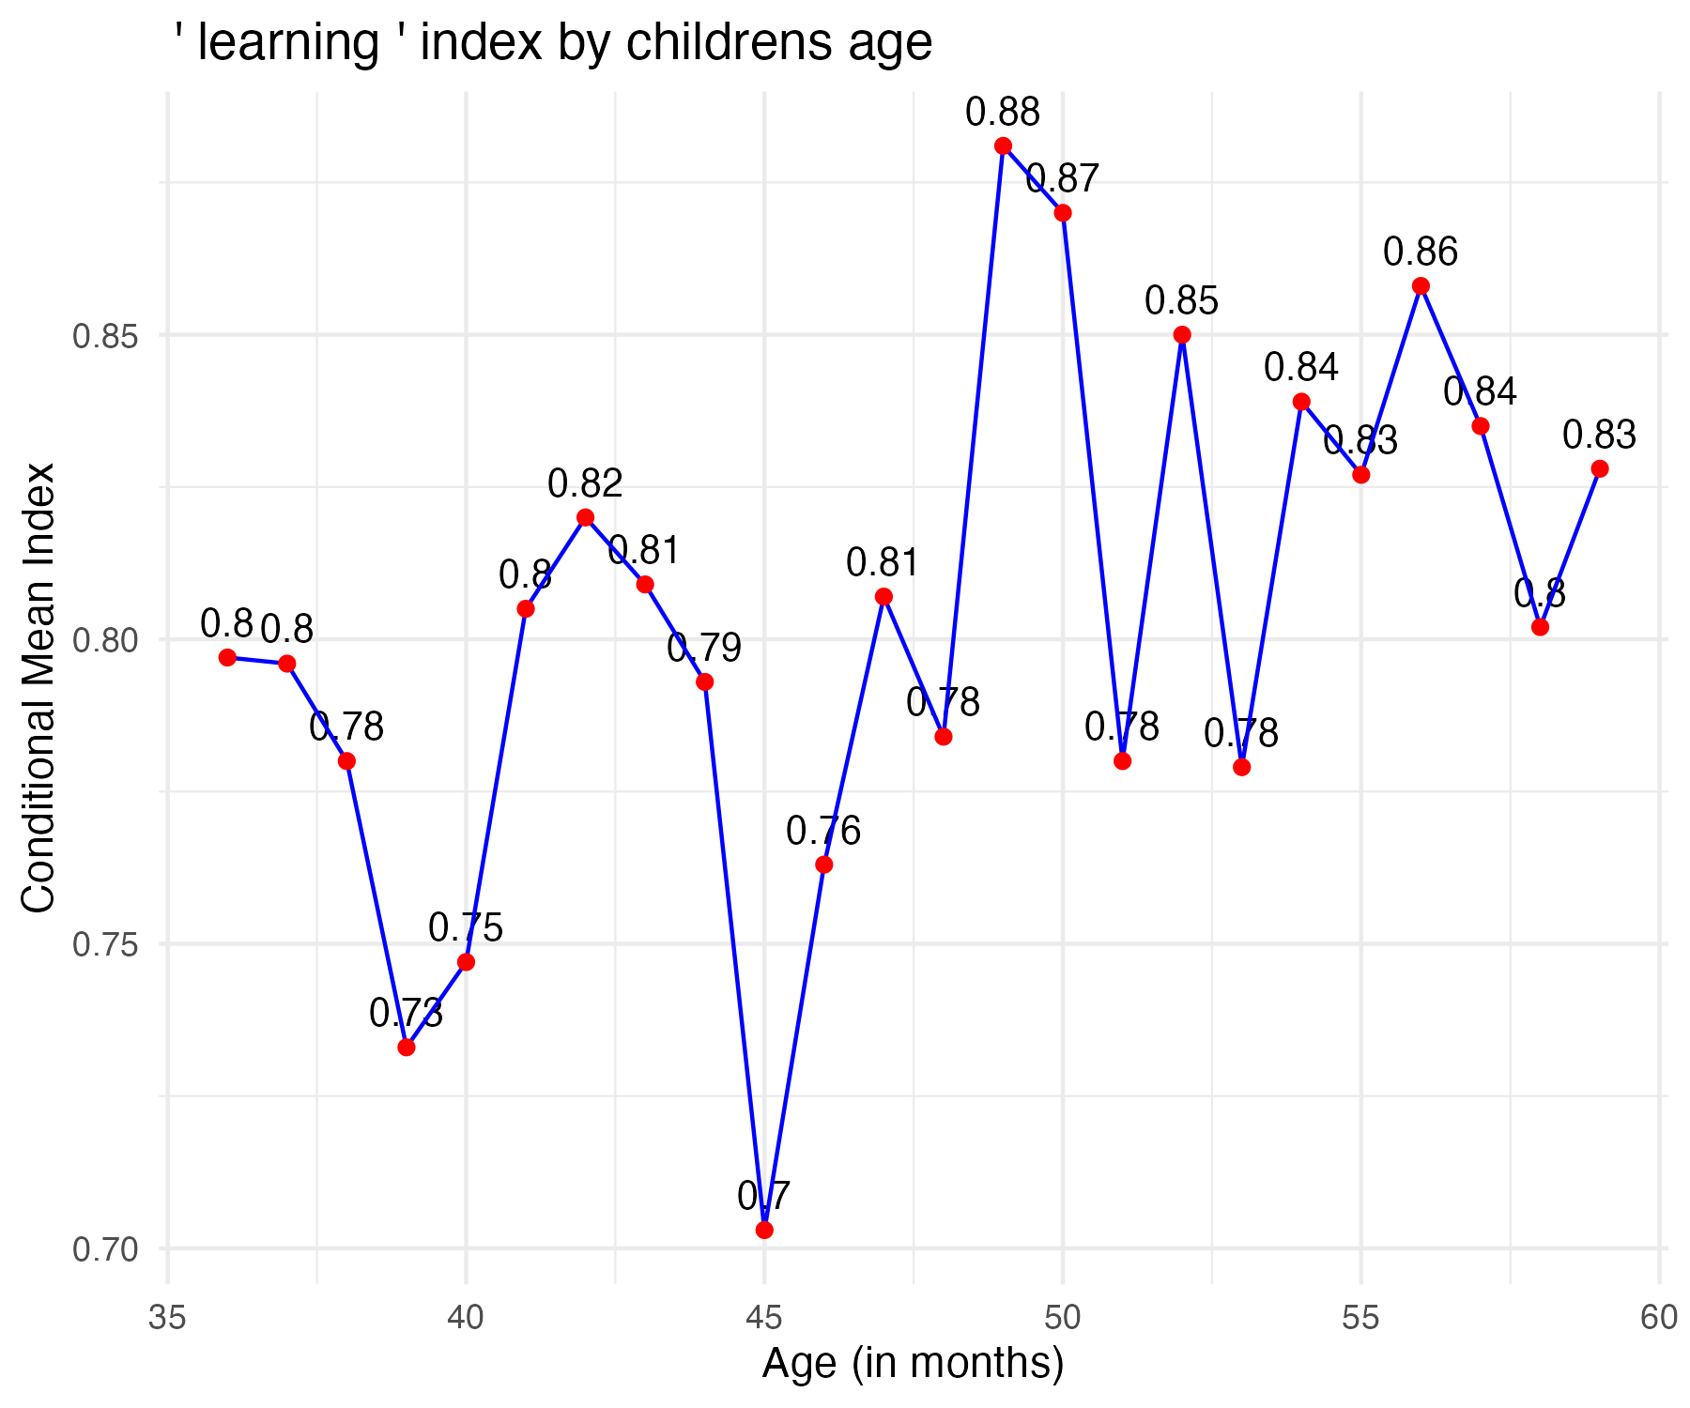

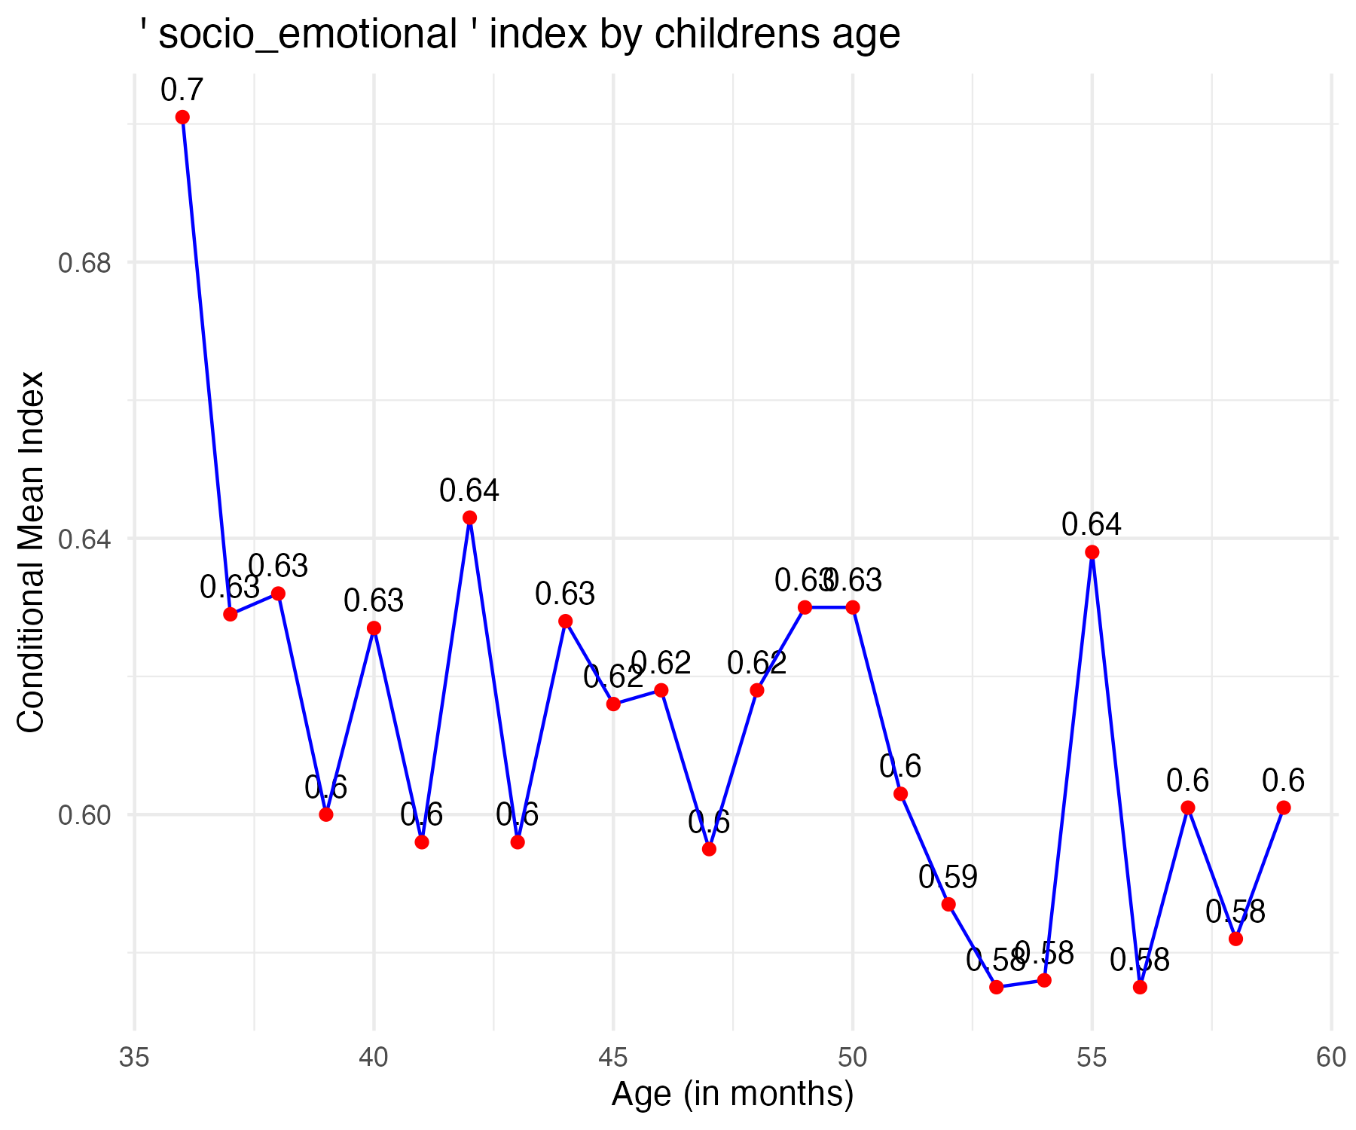

| Index | Coefficient | Std_Error | p_value | R_Squared | N | Overall_Index |
| --- | --- | --- | --- | --- | --- | --- |
| overall | 0.001714784 | 0.0006316844 | 0.006680926913394278 | 0.002951956719 | 2,491 | 0.5160509 |
| literacy_math | 0.006084915 | 0.0008763911 | 0.000000000004874413 | 0.019000155209 | 2,491 | 0.1341544 |
| physical | -0.00006526766 | 0.0009164709 | 0.943231334632326335 | 0.000002037666 | 2,491 | 0.6563369 |
| learning | 0.002818581 | 0.0010389595 | 0.006715888153617480 | 0.002948197017 | 2,491 | 0.8061184 |
| socio_emotional | -0.002204509 | 0.0008579717 | 0.010243978054908624 | 0.002645467475 | 2,491 | 0.6110449 |